ALL SAINTS SUNDAY
November 2, 2025

Have you ever seen a circular genealogical chart? Your name goes in the middle. One half of the chart holds your paternal ancestors, and the other half lists your maternal relatives. By the time you go out nine generations your name is surrounded on the chart by 1022 people from whom you are directly descended.
That is a crowd much bigger than most of us find surrounding us in our churches on any given Sunday. And the cloud of witnesses that we celebrate on this day is much bigger than that crowd of ancestors. When we sing the Sanctus, we can increase the volume on the organ, because we are singing with more than those we can see in the room. We are singing with “the church on earth and the hosts of heaven.”
The goodness that we see in the saints is different from the righteousness bestowed through Christ, for it is only God through Christ Who can make us truly saints by forgiving sings. In other words, we are all made saints in Baptism, and we exercise our sainthood by living out the gift of being forgiven.
So look in the mirror. You will see not only a person shaped by generations of ancestral inheritance; you will see a person shaped by the glorious inheritance given to all the saints. You will see the face of a forgiven sinner and God’s ability to make saints of us all.

Sundays and Seasons

And blessèd are the ones we overlook;
The faithful servers on the coffee rota, (rotation; coffee hour hosts)
The ones who hold no candle, bell or book
But keep the books and tally up the quota,
The gentle souls who come to ‘do the flowers’,
The quiet ones who organise the fete,
Church sitters who give up their weekday hours,
Doorkeepers who may open heaven’s gate.
God knows the depths that often go unspoken
Amongst the shy, the quiet, and the kind,
Or the slow healing of a heart long broken
Placing each flower so for a year’s mind.
Invisible on earth, without a voice,
In heaven their angels glory and rejoice.

Malcolm Guite

Mourning is sorrow for the loss of those dear to us. Those who have turned to God lose the things they held dear in this world. For they no longer delight in the things they delighted in before. And until the love of eternal things is formed in them, they are stricken by a certain grief. They will therefore be comforted by the Holy Spirit, who especially because of this is called the Paraclete, the Comforter. Thus by letting go of temporal delight, they may enjoy what which is eternal.

Augustine, fourth century
In the Name of Jesus

INTRODUCTION

In holy baptism God makes saints out of sinners. In holy communion God forgives the sins of all the saints. In the assembly today we give thanks for all the saints "who from their labors rest," who have fought the good fight, who have gained the crown. In the same breath we petition our God for the strength to hear and to heed the admonitions of the Lord Jesus in today's gospel. Recalling that we have been sealed by the Spirit and sustained by the Savior's body and blood, we keep on keeping on as God gives us breath, to the praise of God's glory.

All Saints Day

The custom of commemorating all of the saints of the church on a single day goes back at least to the third century. All Saints Day celebrates the baptized people of God, living and dead, who make up the body of Christ. On this day or the following Sunday, many congregations will remember the faithful who have died during the past year.

GATHERING

PRE-SERVICE MUSIC I’ll Fly Away Medley New Song Praise Band
(All Public Domain)

ANNOUNCEMENTS

As you are able please rise

GATHERING SONG 427 For All Your Saints, O Lord

THE GREETING AND PRAYER OF THE DAY

P: The grace of our Lord Jesus Christ, the love of God, and the communion of the Holy
Spirit be with you all.

C: And also with you.

P: Let us pray. Almighty God, You have knit Your people together in one communion in
the mystical body of Your Son, Jesus Christ our Lord. Grant us grace to follow Your
blessed saints in lives of faith and commitment, and to know the inexpressible joys You
have prepared for those who love You, through Jesus Christ, our Savior and Lord, Who
lives and reigns with You and the Holy Spirit, one God, now and forever.

C: Amen.

The assembly is seated

WORD

FIRST READING Daniel 7: 1-3, 15-18

The book of Daniel was written in the second century B.C.E., when the Syrian king Antiochus Epiphanes was severely persecuting the Jews. Daniel's vision of the four beasts serves to proclaim the message that human kings will come and go, but the kingdom will ultimately belong to God and to God's people.

¹In the first year of King Belshazzar of Babylon, Daniel had a dream and visions of his head as he lay in bed. Then he wrote down the dream: ²I, Daniel, saw in my vision by night the four winds of heaven stirring up the great sea, ³and four great beasts came up out of the sea, different from one another.
¹⁵As for me, Daniel, my spirit was troubled within me, and the visions of my head terrified me. ¹⁶I approached one of the attendants to ask him the truth concerning all this. So he said that he would disclose to me the interpretation of the matter: ¹⁷"As for these four great beasts, four kings shall arise out of the earth. ¹⁸But the holy ones of the Most High shall receive the kingdom and possess the kingdom forever--forever and ever."

The Word of the Lord.

Thanks be to God.

THE PSALM: Psalm 149 Antiphon by Walter Pelz

Choir sings refrain first, followed immediately by the congregation
and as indicated
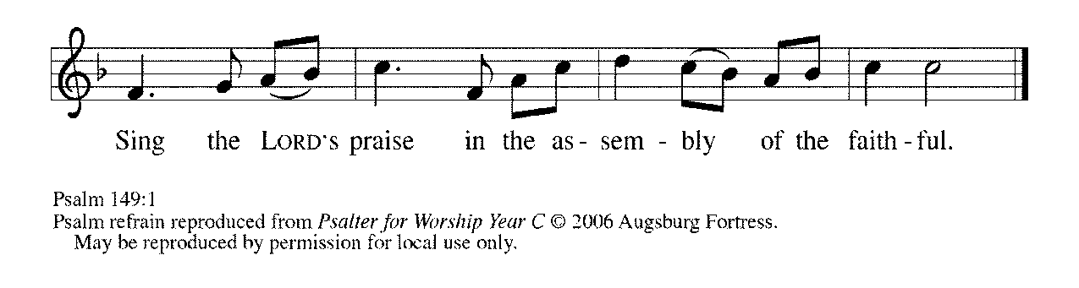
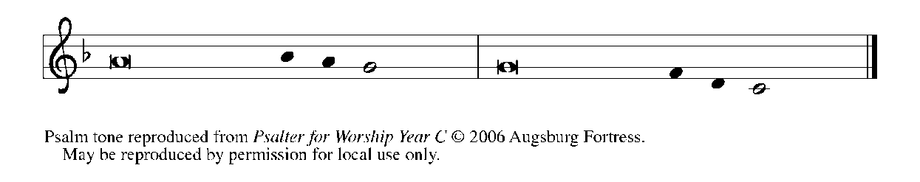

¹Hallelujah! Sing to the LORD | a new song,
God's praise in the assembly | of the faithful.

²Let Israel rejoice | in their maker;
let the children of Zion be joyful | in their ruler.

³Let them praise their maker's | name with dancing;
let them sing praise with tambou- | rine and harp.

⁴For the LORD takes pleasure | in the people
and adorns the | poor with victory. REFRAIN
⁵Let the faithful re- | joice in triumph;
let them sing for joy | on their beds.

⁶Let the praises of God be | in their throat
and a two-edged sword | in their hand,

⁷to wreak vengeance | on the nations
and punishment | on the peoples,

⁸to bind their | kings in chains
and their nobles with | links of iron,

⁹to inflict on them the judg- | ment decreed;
this is glory for all God's faithful ones. | Hallelujah! REFRAIN

SECOND READING Ephesians 1: 11-23

After giving thanks for the faith of the Ephesians, Paul prays that they might also see the power of God who has now enthroned Jesus as head of the church, which is His body.

¹¹In Christ we have also obtained an inheritance, having been destined according to the purpose of Him Who accomplishes all things according to His counsel and will, ¹²so that we, who were the first to set our hope on Christ, might live for the praise of His glory. ¹³In Him you also, when you had heard the word of truth, the gospel of your salvation, and had believed in Him, were marked with the seal of the promised Holy Spirit; ¹⁴this is the pledge of our inheritance toward redemption as God's own people, to the praise of His glory.
¹⁵I have heard of your faith in the Lord Jesus and your love toward all the saints, and for this reason ¹⁶I do not cease to give thanks for you as I remember you in my prayers. ¹⁷I pray that the God of our Lord Jesus Christ, the Father of glory, may give you a spirit of wisdom and revelation as you come to know Him, ¹⁸so that, with the eyes of your heart enlightened, you may know what is the hope to which He has called you, what are the riches of His glorious inheritance among the saints, ¹⁹and what is the immeasurable greatness of His power for us who believe, according to the working of His great power.
²⁰God put this power to work in Christ when He raised Him from the dead and seated him at his right hand in the heavenly places, ²¹far above all rule and authority and power and dominion, and above every name that is named, not only in this age but also in the age to come. ²²And He has put all things under His feet and has made Him the head over all things for the church, ^{23\}which is His body, the fullness of Him Who fills all in all.

The Word of the Lord.

Thanks be to God.

As you are able please rise

THE VERSE

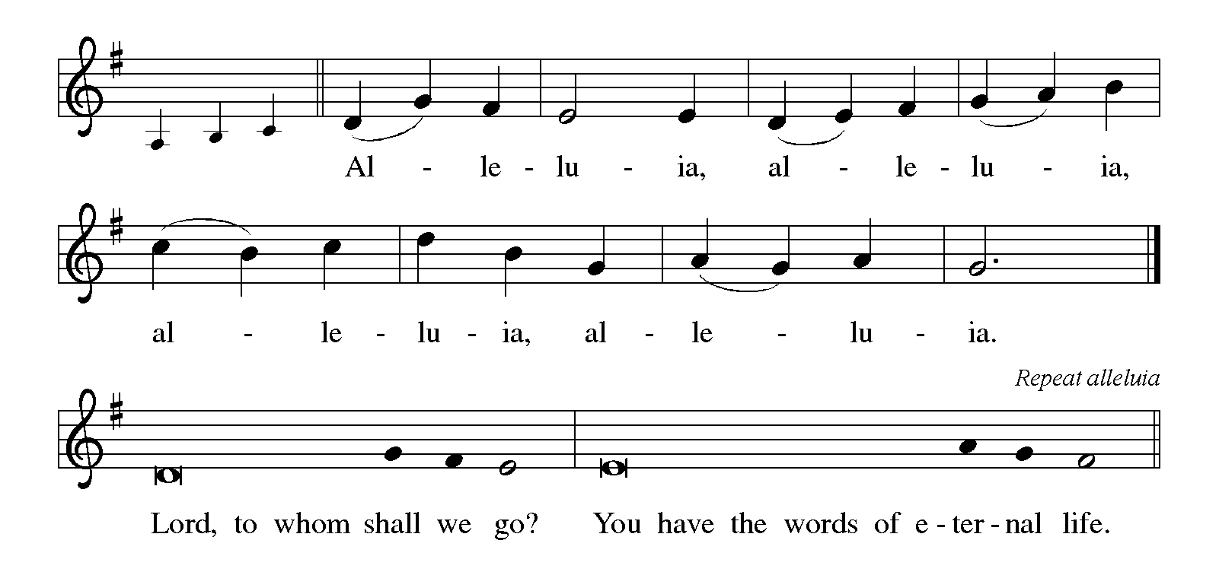

THE HOLY GOSPEL Luke 6: 17-31

Luke’s rendition of Jesus’ beatitudes pronounces blessings and warnings as they suggest that God’s standards and values may be quite different from those with which we are most familiar.

P: The Holy Gospel according to St. Luke, the sixth chapter.

C: Glory to You, O Lord!

¹⁷Jesus came down with them and stood on a level place, with a great crowd of His disciples and a great multitude of people from all Judea, Jerusalem, and the coast of Tyre and Sidon. ¹⁸They had come to hear Him and to be healed of their diseases; and those who were troubled with unclean spirits were cured. ¹⁹And all in the crowd were trying to touch Him, for power came out from Him and healed all of them.
²⁰Then Jesus looked up at His disciples and said:
"Blessed are you who are poor,
for yours is the kingdom of God.
²¹"Blessed are you who are hungry now,
for you will be filled.
"Blessed are you who weep now,
for you will laugh.
²²"Blessed are you when people hate you, and when they exclude you, revile you, and defame you on account of the Son of Man. ²³Rejoice in that day and leap for joy, for surely your reward is great in heaven; for that is what their ancestors did to the prophets.
²⁴"But woe to you who are rich,
for you have received your consolation.
²⁵"Woe to you who are full now,
for you will be hungry.
"Woe to you who are laughing now,
for you will mourn and weep.
²⁶"Woe to you when all speak well of you, for that is what their ancestors did to the false prophets.
²⁷"But I say to you that listen, Love your enemies, do good to those who hate you, ²⁸bless those who curse you, pray for those who abuse you. ²⁹If anyone strikes you on the cheek, offer the other also; and from anyone who takes away your coat do not withhold even your shirt. ³⁰Give to everyone who begs from you; and if anyone takes away your goods, do not ask for them again. ³¹Do to others as you would have them do to you."

P: The Gospel of the Lord.

C: Praise to You, O Christ!

The assembly is seated

THE SERMON

Silence for reflection follows the sermon

As you are able please rise

THE HYMN OF THE DAY (see p. 7) For All the Saints

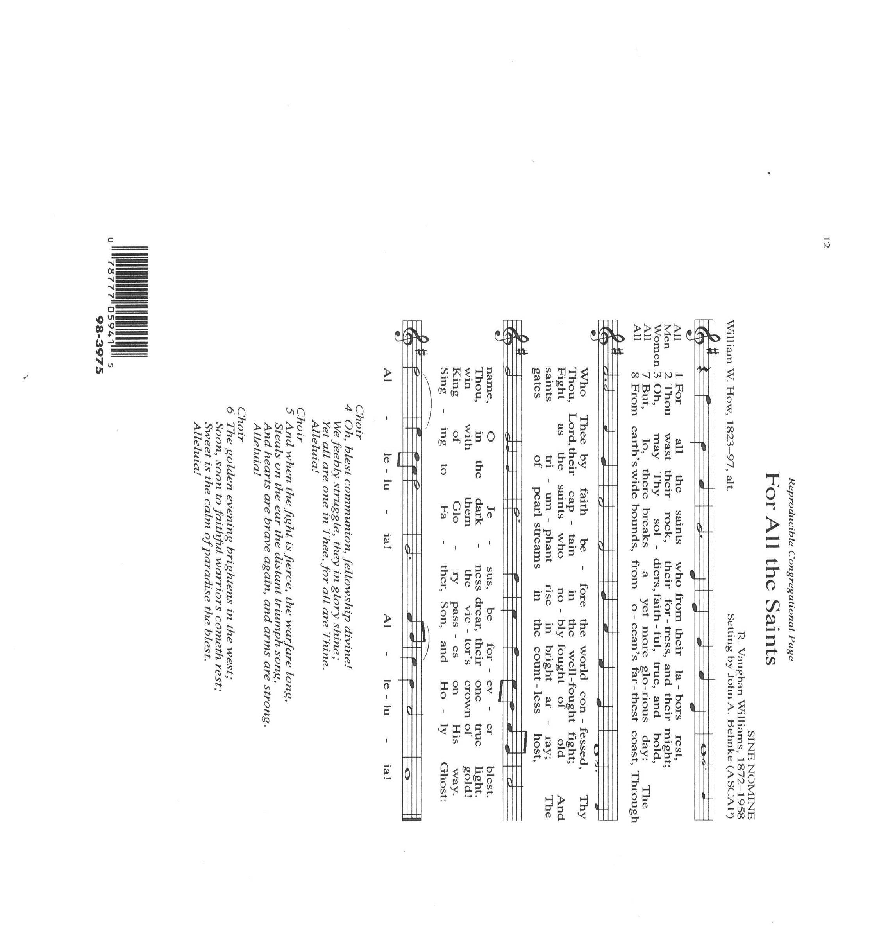

THE NICENE CREED

A: God has made us His people through our Baptism into Christ. Living together in trust
and hope, we confess our faith.

C: We believe in one God,
the Father, the Almighty,
maker of heaven and earth,
of all that is, seen and unseen.
We believe in one Lord, Jesus Christ,
the only Son of God,
eternally begotten of the Father,
God from God, Light from Light,
true God from true God,
begotten, not made,
of one Being with the Father.
Through Him all things were made.
For us and for our salvation
He came down from heaven;
by the power of the Holy Spirit
He became incarnate from the virgin Mary, and was made man.
For our sake He was crucified under Pontius Pilate;
He suffered death and was buried.
On the third day He rose again
in accordance with the Scriptures;
He ascended into heaven
and is seated at the right hand of the Father.
He will come again in glory to judge the living and the dead,
and His kingdom will have no end.

We believe in the Holy Spirit, the Lord, the giver of life,
Who proceeds from the Father and the Son.
With the Father and the Son He is worshiped and glorified.
He has spoken through the prophets.
We believe in one holy catholic and apostolic Church.
We acknowledge one Baptism for the forgiveness of sins.
We look for the resurrection of the dead,
and the life of the world to come. Amen

THE PRAYER OF THE CHURCH

A: One in communion with all the saints of every time and place, let us offer our prayers
to God for our needs and to the praise of God’s glory.

A: That the Church may be strengthened in its faith in the Lord Jesus and love for all the
saints, let us pray to the Lord:

C: Lord, have mercy.

A: That God would put the immeasurable greatness of His power to work for peace and
just living among the nations of the earth, especially in Ukraine, Sudan, Peru,
Madagascar, and Gaza, let us pray to the Lord:

C: Lord, have mercy.

A: That the victims of natural disasters, especially the people of Jamacia, Cuba, Haiti, and
the Bahamas from Hurricane Melissa might receive quick and helpful aid and
assistance along with endurance, strength, and hope as they rebuild their homes,
communities, and lives, let us pray to the Lord:

C: Lord, have mercy.

A: That our elected leaders and the leaders of all nations will govern with wisdom and
compassion, especially for the neediest and weakest among us, let us pray to the Lord:

C: Lord, have mercy.

A: That God will enlighten the eyes of the hearts of those in this congregation so that we
may faithfully and joyfully use our spiritual gifts in service to others, let us pray to the
Lord:

C: Lord, have mercy.

A: That the poor will be blessed with the Kingdom of God, the hungry will be filled, and
the sick healed, especially: Larry Litchford; Joyce Stark; Major Payne; David
Weiss; Fred Weiss; Shirley Freels; Jackie Gaines; Martha Schroeder; John
Bennitt; Joan Seifert; Allen Sydow; Lucas Bradshaw; and Shirley Shikany Long
so that the faithful may rejoice in triumph, let us pray to the Lord:

C: Lord, have mercy.

A: That those celebrating birthdays, especially Allen Sydow, may be filled with grace this
day and every day and grow in grace in the days ahead, let us pray to the Lord:

C: Lord, have mercy.

A: That with all the saints who have gone before us into death, especially: Wayne
Simerlein; Donna Collins; Bob Pheanis; Norman Carlson, Jr.; Russell Fischer;
Charles Ponder, Sr.; David Meyer; Venia Wendt; and Kenneth Hanft, Sr.; and
those saints who have this year emerged from the waters of Baptism: Leona Harper
Stahl; and Beckett Reed Fratgillo and all the faithful, we may be brought before the
throne of the Lamb in glory, let us pray to the Lord:

C: Lord, have mercy.

P: Holy God, mighty God, immortal God, adored by angels and praised by the saints,
receive the prayers of Your holy Church, and grant them in accordance with Your
gracious will, for the sake of Jesus Christ our Lord.

C: Amen.

MEAL
OFFERING

VOLUNTARY Down in the Valley to Pray St. Paul Senior Choir
(Arr. J. Althouse)

As you are able please rise

THE OFFERTORY
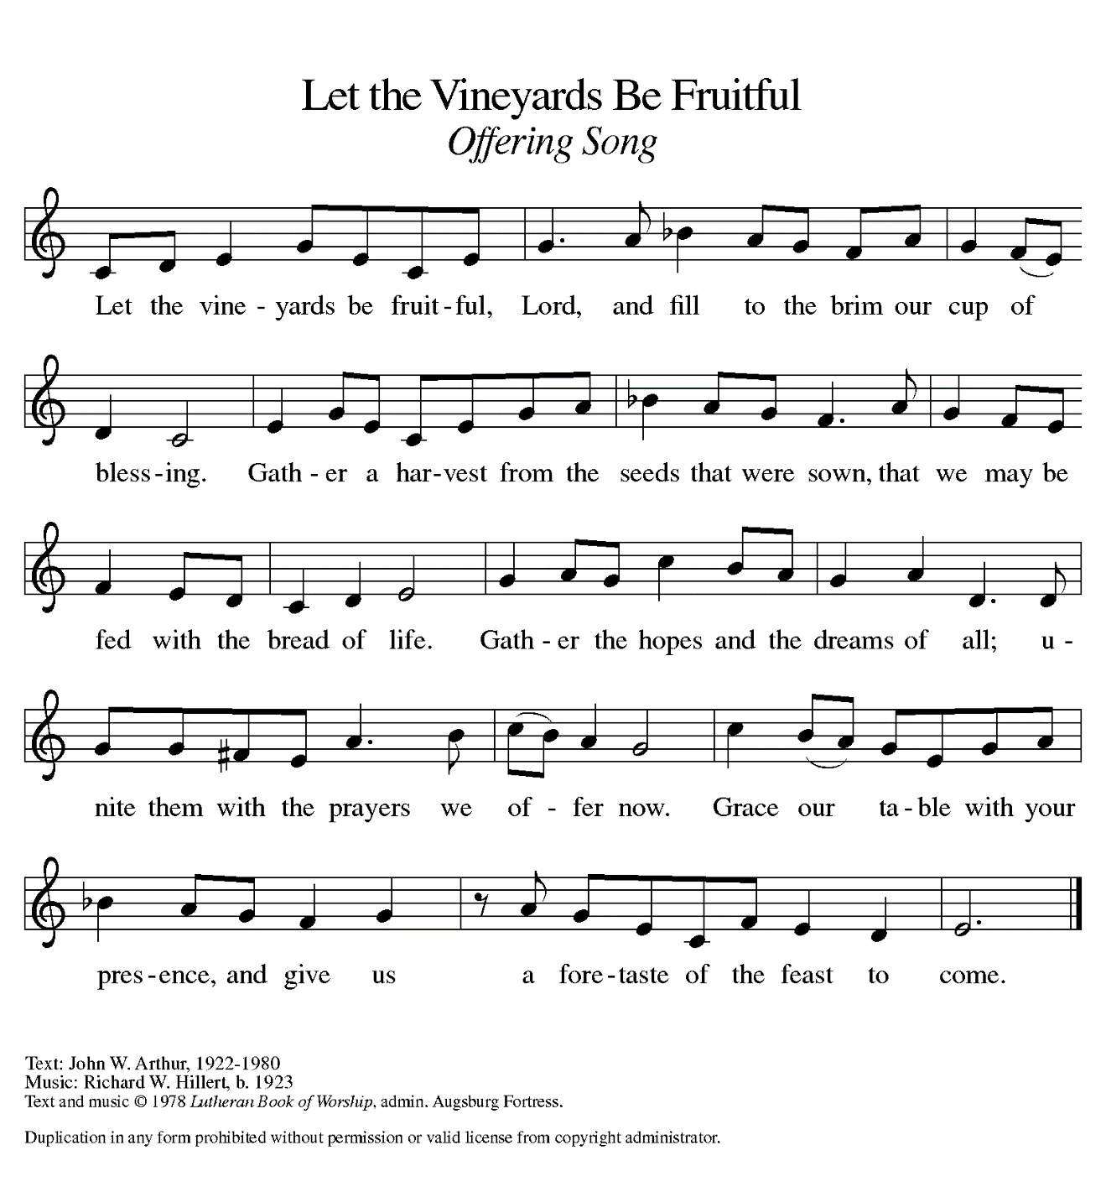
THE OFFERTORY PRAYER

A: Let us pray. Holy and mighty God,

C: We give You thanks for the triumph of Christ in the lives of His saints. Receive
all we offer You this Day, and help us, like them, to run our course with faith,
that we may come to Your eternal Kingdom. We ask this in the name of Jesus
the Lord. Amen.

THE GREAT THANKSGIVING

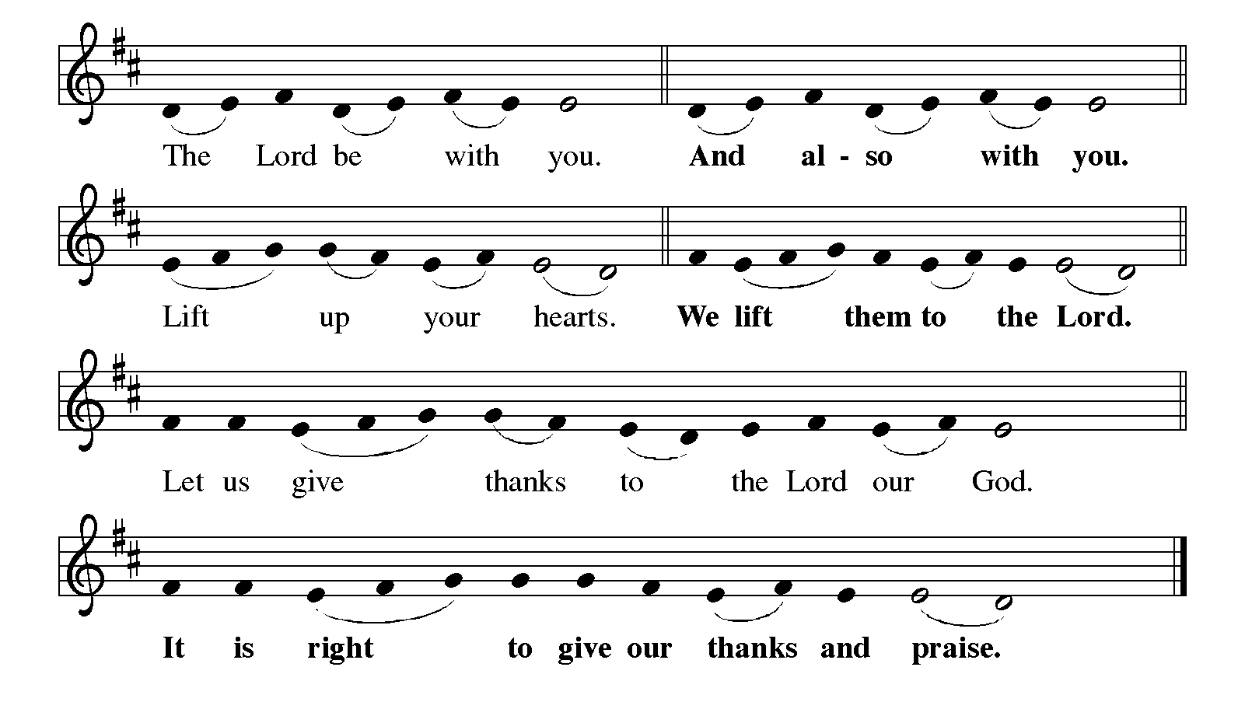

P: It is indeed right, our duty and our joy … join their unending hymn:

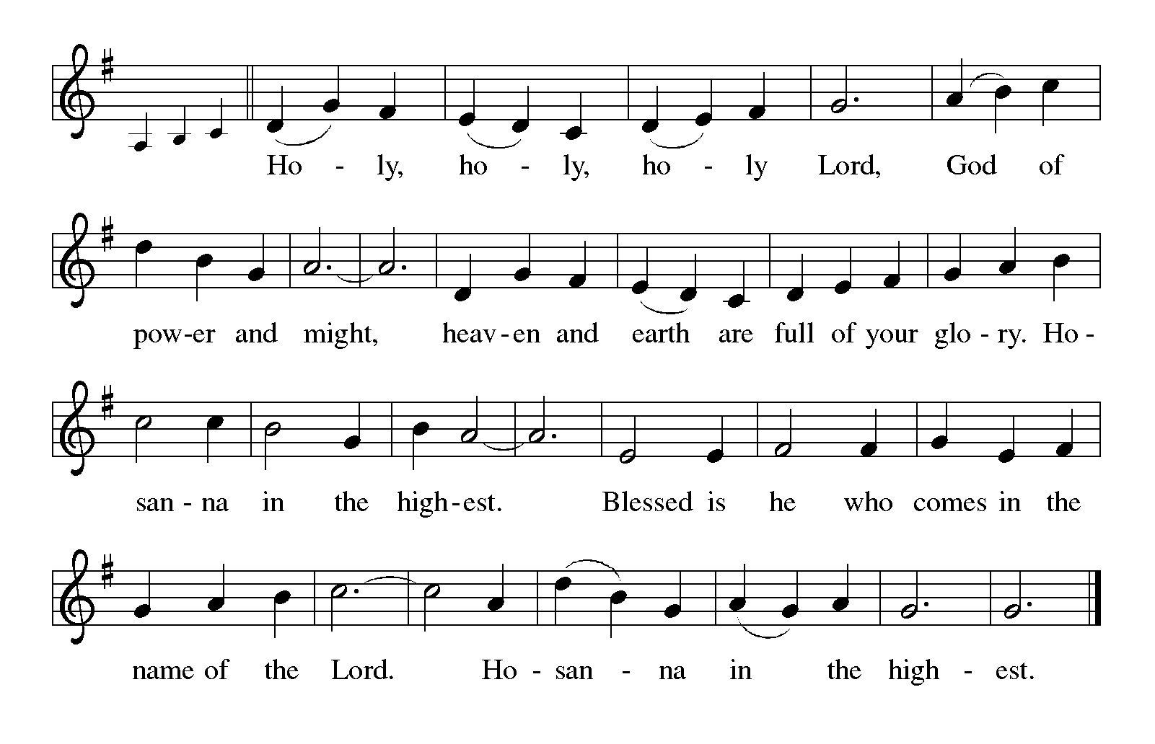
P: Creating and redeeming God, in Adam, Abraham, and Moses, in Deborah, Esther
and Mary, You have chosen not simply to direct the course of events but to
be in relationship with us and to entrust Your children with the embodiment
and exercise of Your will.
In the dying and rising Christ You give us not just a Savior but an example, and in
every generation You call people to imitate the pattern of His life and death
and so to witness to Your glory.
You call us not to be heroes who go it alone but saints whose every breath depends
on others and on You.
Transforming God, in this gathering You take the fruit of the vine and human hands
and make them a blessing for Your people now and forever.
As our earthly bodies decay and die, and resemble Your Son’s body taken down from
the cross, send Your Spirit and remake us into the image of Your Son’s
resurrected Body, that our scars may be signs of Your glory and our hearts
may be one with Yours.
Make this bread and cup holy that they may be for us the Body and Blood of Your
Son Jesus Christ,
Who in the night ... “Do this for the remembrance of Me.”
As often as we eat ... we proclaim the Lord’s death until He comes.
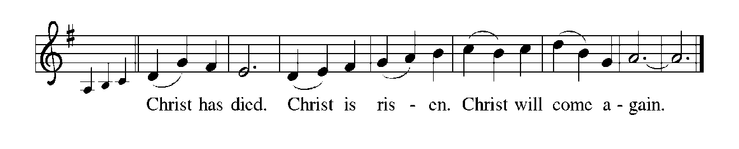P: Resurrecting God, bless those who mourn, that they may be comforted.
Bless the poor, that they may inherit the Kingdom of God.
Bless the hungry that they may be filled.
Visit those who face death amid persecution and violence, that they may know the
gladness and rejoicing of Your Kingdom.
Be close to any who end their days in agony and isolation, that they may enter the
joy of their reward.
Where Your children feel all is lost, meet them in their fear, touch them in their
loneliness, and raise them by Your mercy,
So that on the Last Day, when You bring a new heaven and a new earth they may
discover You as an infinite circle whose center is everywhere and whose
circumference is nowhere, and be changed from glory into glory,
With and by You, one God: Father, Son, and Holy Spirit.
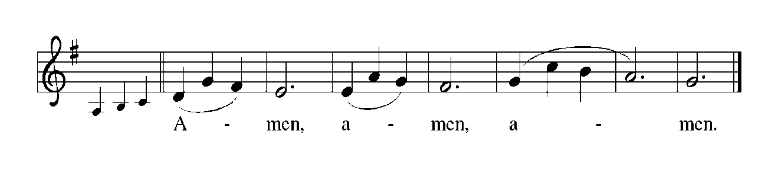
THE LORD’S PRAYER

P: Because through Baptism we are saints of God, called according to God’s purpose, let our lives be shaped by the prayer Jesus taught us:

C: Our Father in heaven, hallowed be Your name. Your Kingdom come. Your will
be done on earth as it is in heaven. Give us this day our daily bread, and forgive
us our sins as we forgive those who sin against us. Save us from the time of trial
and deliver us from evil. For the Kingdom, the power, and the glory are Yours,
now and forever. Amen.

The assembly is seated

THE DISTRIBUTION

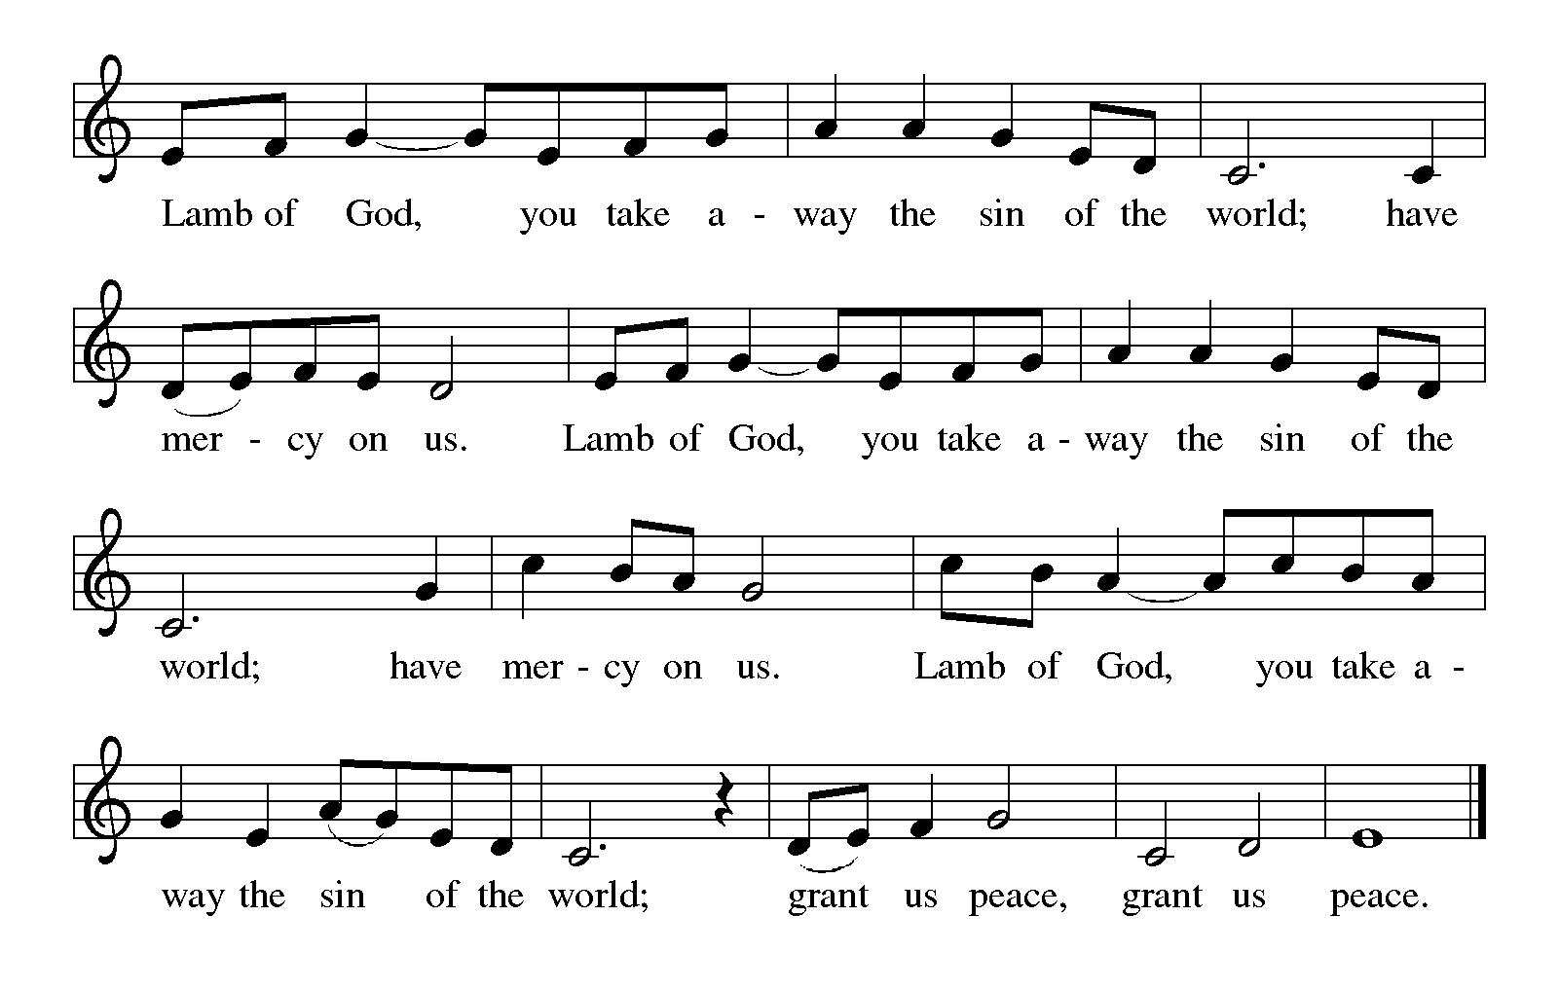
HYMN DURING DISTRIBUTION 423 Shall We Gather at the River
ELW 638 Blessed Assurance
ELW 482 I Come with Joy
ELW 774 What a Fellowship
As you are able please rise

THE POST-COMMUNION BLESSING

P: The Body and Blood of our Lord Jesus Christ strengthen you and keep you in His grace.

C: Amen.

THE POST-COMMUNION PRAYER

A: Let us pray. Sovereign God, in this Meal You give us a foretaste of the great Feast to come. Keep us faithful to You, that we, with all Your saints, may at length celebrate
the marriage Feast of the Lamb, Jesus Christ our Lord.

C: Amen.
SENDING

THE BENEDICTION

P: Almighty God: Father, Son, and Holy Spirit bless you now and forever.

C: Amen.

THE SENDING SONG Oh, When the Saints Go Marching In
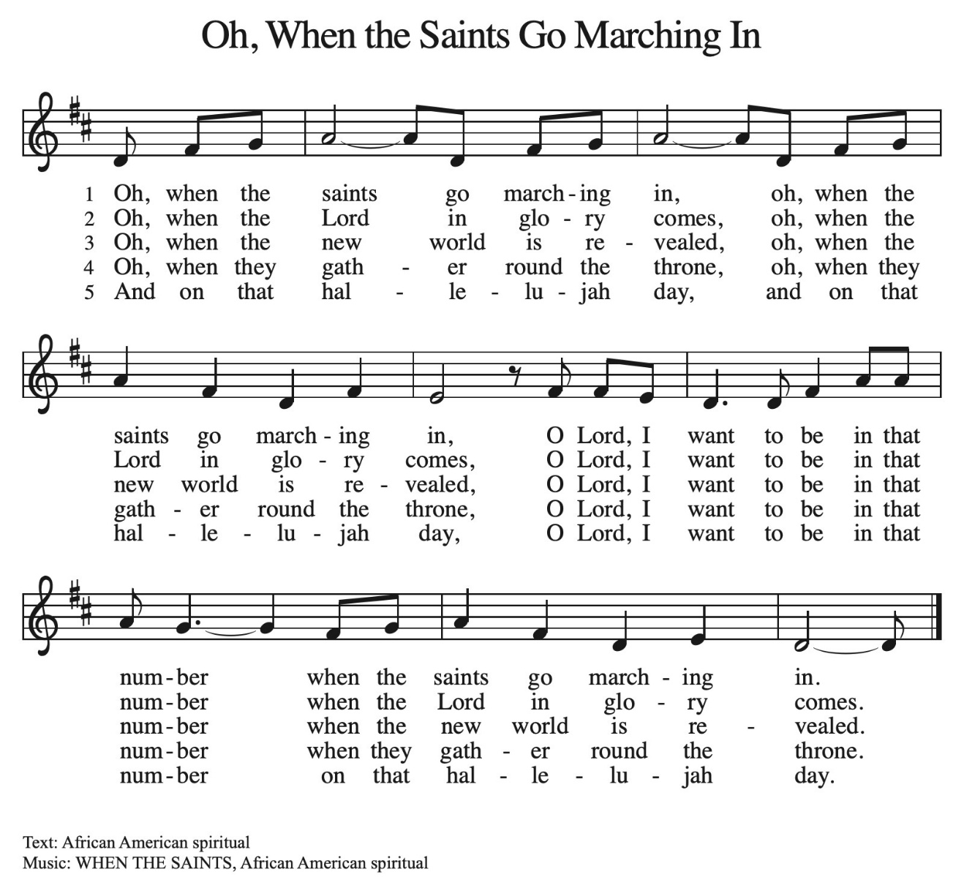THE DISMISSAL

A: Surrounded by so great a cloud of witnesses, let us go forth to love and serve the Lord.

C: Thanks be to God!

POSTLUDE
To God Alone Be Glory

The Meditations are from Sundays and Seasons. Copyright Augsburg Fortress, 1999.

The Eucharistic Prayer is adapted from Eucharistic Prayers. Samuel Wells and Abigail
Kocher. (Grand Rapids: Eerdmann’s Publishing Company, 2016) 316-17.

ANNOUNCEMENTS

Please remember to mail your offering to the Church Office at 818 Franklin Street, Michigan City, IN 46360. Another alternative is to give on-line through Tithe.ly. Please see your closure letter for information on how to set up a Tithe.ly account.

St. Paul Members are reminded to have a loved one contact the office if you are hospitalized. Many times, the Pastor doesn’t know someone is in the hospital. If you call and leave a message, please tell us at which hospital the patient is located.

BIRTHDAYS: Allen Sydow(11/6)

PRAYER CONCERNS: Bev Coburn; Barry Anderson; John Bennitt; Judy Gustum; Larry Litchford; Sarah McNabb; Jeanie Boatman Shepple; Debbie Martin; Mark Tannehill; Kathy Stein; Jan Paholski; Laura Dovey; Grace Romine; Roger and Margaret Miller; Bill Hazelgrove; Kerry Steinborn; Robert Bernth; Craig Hunt; Al Levenhagen;
Carl Wipperman; Major Payne.

OFFICE HOURS: Libby will be in the office on Mondays, Wednesdays, and Fridays; volunteers will cover Tuesdays and Thursdays.

Monday & Wednesday 8:00 a.m. – 5 p.m.
Tuesday & Thursday 9:00 a.m. – 12:00 p.m.
Friday 8:00 a.m. – 12:00 p.m.

If you are listening to the worship broadcast on the radio and would like to watch the Sunday morning service live stream follow these steps:

(1) If you have You Tube available on your TV, search for
St. Paul Lutheran Church Michigan City, IN.

(2) The direct link on the computer is https://
www.youtube.com/channel/UC5AIPNaKr3QN50984jGOa1g.

(3) This link is also on the main page of the church’s website in
the church section and will continue to be posted weekly on the St.
Paul Facebook page.

And it will always be available on the radio broadcast Sunday mornings at 11:00 a.m.
on WEFM (95.9), and on the local cable access station #99 for the previous week’s
service on Sundays at 4:00 p.m. and the current service on Wednesdays at 7:00 p.m.
and Fridays at 8:30 p.m.

To send e-mail to the church office, please use the following addresses:

Pastor Mark Reshan: seniorpastor@stpaulmichigancity.com

Church Office Secretary (Libby Pollock): churchsecretary@stpaulmichigancity.com

Church Treasurer (Karen Fleming): finance@stpaulmichigancity.com

2025 Church Council:

Mark Reshan - Pastor

Janet Bakken – President

Donna Knoll – Vice President

Judy Hunt – Secretary

Karen Fleming – Treasurer

Members: Paul Brooks, Diane Egilske, Sue Koziel, Judy Mutchler, Jim Schraidt, Trish Sprague

Worship Attendance:
Saturday , October 25, 2025 @ 4:00 p.m. 25
Sunday, October 26, 2025 @ 9:00 a.m. 61
TOTAL 86

Copies of the minutes from the August 28, 2025 and the September 25, 2025 Church Council meetings are on the back table in the upper Narthex. They were approved by the council via email.

The Good News Newsletter: If you have an article or anything you want included in The Good News please send it to the following e-mail address: splcgoodnews@gmail.com. Pastor Pamela Thiede will be using this e-mail address to assemble The Good News each month. The deadline for getting information to Pastor Pamela will be the 20th of each month.

Sunday’s lessons are Job 19: 23-27a; Psalm 17: 1-9; 2 Thessalonians 2: 1-5, 13-17; and Luke 20: 27-38 for those of you who like to study them in advance.

ACTIVITIES, EVENTS & MEETINGS
November 2025

Saturday, November 1, 2025 @ 4:00 p.m. 21 Pent ALL SAINTS Worship

Sunday, November 2, 2025 @ 9:00 a.m. 21 Pent ALL SAINTS DAY Worship
Sanctuary/with coffee after/St. Paul Room
Tuesday, November 4, 2025 @ 10:00 a.m. Altar Guild/Green Room
Wednesday, November 5, 2025 @ 9:15 a.m. Bible Study/Luther House
@ 10:00 a.m. God’s Purls/St. Paul Room
@ 4:30 p.m. Choir Rehearsal/Sanctuary
Thursday, November 6, 2025 FAITH CIRCLE/Green Room
Saturday, November 8, 2025 @ 4:00 p.m. 22 Pent Worship Service/Sanctuary

Sunday, November 9, 2025 @ 9:00 a.m. 22 Pent Worship Service/Sanctuary
Immediately following: FALL CONGREGATIONAL MEETING/St. Paul
Room with POTLUCK luncheon to follow/St. Paul Room
Monday, November 10, 2025 @ 1:00 p.m. HOPE CIRCLE/Green Room
Tuesday, November 11, 2025 @ 7:00 p.m. Estuary/Luther House
Wednesday, November 12, 2025 @ 9:15 a.m. Bible Study/Luther House
@ 10:00 a.m. God’s Purls/St. Paul Room
@ 11:00 a.m. – 9:00 p.m. GIVE BACK @ SWINGBELLY’S
@ 3:30 p.m. Worship & Music Mtg./Luther House
@ 4:30 p.m. Choir Rehearsal/Sanctuary
Thursday, November 13, 2025 @ 4:00 p.m. 150th Anniv. Mtg./Luther House
Saturday, November 15, 2025 @ 4:00 p.m. 23 Pent Worship Service/Sanctuary

Sunday, November 16, 2025 @ 9:00 a.m. 23 Pent Worship Service/Sanctuary with coffee after/ St. Paul Room with coffee after/St. Paul Room
Monday, November 17, 2025 @ 2:00 p.m. Finance Comm. Mtg./Luther House
@ 3:00 p.m. Executive Board Meeting/Luther House
Wednesday, November 19, 2025 @ 4:30 p.m. Choir Rehearsal/Sanctuary
Thursday, November 20, 2025 @ 3:00 p.m. Church Council Mtg./Luther House
Saturday, November 22, 2025 @ 4:00 p.m. CHRIST THE KING Worship Service/ Sanctuary

Sunday, November 23, 2025 @ 9:00 a.m. CHRIST THE KING Worship Sanctuary
with coffee after/St. Paul Room
Wednesday, November 26, 2025 @10:00 a.m. God’s Purls/St. Paul Room

SAVE THE DATE!
On Sunday, November 9th, our regular fall congregational meeting will be held in the St. Paul Room following the Sunday morning worship service with a true POTLUCK luncheon to follow. The primary item on the agenda will be the election of officers and council members. There will also be a financial report. We need not only your presence at the meeting but your willingness to step in and fill those seats. Please consider how you might be able to serve. We have many gifted members whose presence in leadership roles would greatly enrich our congregation. You might be one of them. Agree to serve.

2025 Financial Stewardship

Weekly Church Operating Needs (x 2 weeks)
October 18-19, 2025; and October 25-26, 2025: $ 12, 671.50

General Fund (including General Memorials): $ 6,245.00

Overage/Shortage: — $ 6,426.50

Restricted Income (not including Memorials)
Supports IK Synod & Church wide Ministries: $ 1554.00

Ministries in our Community/Congregation: $ 560.00

Capital Fund: $ 235.00

Thank$ for $haring
Thanks to all who participate in the Give Back opportunities! We earned $250 at our Give Back On October 2, 2025 at Galveston. Our next Give Back will be at Swingbelly’s on Wednesday, November 12, 2025 from 11am—9 pm. Here are two coupons—one for you and one for a friend.

