December, 2023
MARK: MY WORDS

Thank you. The main newsletter article for the December edition in every congregation that I have served has had to do with the season of Advent: its history, meaning, and purpose. In almost every other congregation that I have served, there has been pressure to short-change Advent and let the celebration of Christmas creep in over it.
I realized that has never happened in my time here. For that I am deeply grateful. Advent is one of my favorite seasons of the church year, and sometimes it has been a real battle to allow it to keep its observance and integrity. This willingness to engage in its primary posture of waiting is all the more impressive given the relentless and ever-increasing demands of our culture that Christmas be celebrated earlier and earlier each year.
In the past several years, I have noticed small exhibits of Christmas trees and decorations in some of the “big box” stores already in July. Normally, retailers will try to hold off on expanding those displays until after Halloween since that is the second-largest source of holiday revenue to them each year. But no longer. By early October, Christmas is in full swing in most stores. “Black Friday” sales—which used to be held only on the day after Thanksgiving—now are offered both online and in stores in early November!
From an economic standpoint, such a push is understandable. Many businesses, especially smaller operations depend on these sales to keep them in the “black” for the year. Emotionally, many people find comfort in the warm sounds and sights of Christmas during the time of fall when darkness envelopes us sooner each day and weather can turn cold and damp. Radio stations now try to outdo one another with starting their “all Christmas, all the time” playlist also in early November.
We in the Church are not necessarily better at waiting than the culture around us; but as God’s people, we have centuries of practice in patiently holding to God’s promises even when their fulfillment seems unbearably delayed. We can bear the darkness because we believe that the Light that entered it with us and for us in Jesus is stronger than the shadows that bring fear, worry, and despair.
That perseverance in faith and hope makes our celebration of the Word becoming flesh all the more joyful. There is a “payoff” to our waiting: in Jesus, God has joined us in the darkness; and to paraphrase Lutheran scholar Gordon Lathrop, “now we have a chance.”
So, we prepare for another Advent. We wait. We hope. We pray, “Come, Lord Jesus, both now and in The End.” It is a powerful time together. Thank you.

ADVENT/CHRISTMAS WORSHIP

The calendar does us no favors this year with regard to the end of Advent and the beginning of our Twelve Days of Christmas celebration. The Fourth Saturday of Advent falls on December 23, the Fourth Sunday on the morning of December 24, and Christmas Day on Monday the 25th. That is four worship services in about 40 hours. It will be a busy, tiring, and challenging stretch. Here is what the days and times of our liturgies will look like:

Saturday, December 23 Holy Communion, 4:00 p.m.
The Fourth Saturday of Advent

Sunday, December 24 Holy Communion, 9:00 a.m.
The Fourth Sunday of Advent

Sunday, December 24 Holy Communion 6:00 p.m.
Christmas Eve

Monday, December 25 Holy Communion 9:00 a.m.
Christmas Day Please note the time change

Saturday, December 30 Holy Communion/Lessons and Carols
The First Saturday after Christmas 4:00 p.m.

Sunday, December 31 Holy Communion/Lessons and Carols
The First Sunday after Christmas 9:00 a.m.

On the First Saturday and Sunday after Christmas, we will again offer a Service of Lessons and Carols with some traditional Scripture readings for the season interspersed with some beloved Christmas carols. There will be no homily on that day.
As highlighted above. please be aware of the change of time for our Christmas Day liturgy. For a good number of years, the service has been held at 10:00 a.m.; but the Worship Committee decided to move it back to 9:00 a.m. to be consistent with our normal morning worship time.
Avail yourself of all these opportunities to complete our preparation for Jesus’ advent among us and the joyous observance of His birth. We are the poorer for your absence. Help make our joy complete.

SENIOR COMMUNION
It has long been a tradition to hold a “Quiet/Senior Communion” service in Advent and Lent. Originally intended as a special service for those who were homebound or in nursing or assisted living facilities to attend worship, in recent years it has expanded to include all (not just “seniors”) who wish to gather for a meaningful spoken service and good food and fellowship afterward.
We were not sure if we would be able to hold our Advent service this year since we now do not have an organist. However, Maggie Martin graciously agreed to play for us as long as we were able to accommodate her schedule. She owns her own business in Michigan and normally has a regular client appointment on Wednesday morning when our service is usually held. After some discussion we discovered that if we moved the time of our service back one hour and she postponed her client meeting for 45 minutes that she could play and we could hold the service.
Therefore, this years’ service will take place on Wednesday, December 20, at 9:00 a.m. instead of 10:00 a.m. as in the past. This will allow Maggie time to play and get back to her business in time for her meeting. Traditionally, the Altar Guild has prepared a delicious lunch of homemade sandwiches, chips, Darlene Baker’s famous pickles , and desserts. Since 10:00 a.m. seems a little early to eat lunch this year we will serve homemade muffins, coffee cakes, and some light desserts.
That gathering after the service is always a warm time of fellowship for those who attend, and we are thankful that we will still be able to provide an opportunity for worshipers to experience that fellowship. An invitation letter will go out in early December, but all are welcome. Mark the date and new time on your calendar, and we hope to see you on the 20th.

TIME AWAY
I will be taking some time off in the week between Christmas Day and New Year’s Eve/Day to recharge for the season of Epiphany and then the busiest time of year as we enter Lent. As always, I am available by phone (630-450-1894) if there is a pastoral emergency.
ORGANIST/CHOIR DIRECTOR/HAND BELLS
As you know, Pastor Fischer resigned his position about a month ago. That left us again without an organist and choir director. Maggie Martin once more came to the rescue by agreeing to play the piano for us as often as her schedule will allow. On the days when she is unavailable, the Praise Band has agreed to provide the music for the service.
Led by Joan Seifert and Dan McNabb’s resolve to have the choir sing for Advent and Christmas, they have set up a practice schedule and music for each of the Sundays from now through Christmas. They will sing an anthem during the Offering and lead the congregation in the singing of the Psalm antiphon and Psalm tone.
The bell choir also would like to continue playing. As of this writing, we are trying to work out the logistics of the location of the bell tables and the choir seating. We hope that we will be able to resolve this issue so that they may continue to contribute their wonderful music that we have missed for so long.
God has richly blessed us with the dedication and commitment of these musicians. Thank them when you see them. We look forward to the deep enrichment they bring to these holy Days and Nights.

Christmas Poinsettias

Time to place your order! Yes, it’s time to start thinking about purchasing a Christmas Poinsettia from St. Paul’s Church. Each plant will be in a 7.5-inch pot with 4-11 blooms. You will have a choice in color between red, white, or pink. If you do not specify a color, red will be chosen. Each plant will cost $15.00 and can be put ‘In Memory or Honor of a Loved One.’
Please place your order through the Church Office by calling 219-874-7293; or place your information on an envelope with cash or a check made out to the church and place it in the offering plate. All checks should be made out to St. Paul Church. Orders must be placed by Monday, December 11. The final count is turned in that day!
All plants will be available to take home after the Christmas Eve Service.

CHRISTMAS DECORATIONS
We are blessed to have volunteers who are willing year after year to organize and put up beautiful decorations for our celebration of Advent and The Twelve Days of Christmas. Normally, we list those generous and hard workers after the decorations have come down but this year it seemed good to honor them beforehand so that when you see them you might thank them for all their faithful work. Many of them have been doing the same jobs for a long time, and we are so grateful to them for their selfless service at a time of year when everyone is busy and weary.

Christmas Tree Bob and Karen Kiser; Larry and Judy
Litchford; Wayne and Suzann Dolson; Kyle
Petter; Casey, Kelly and Brad Neulieb
Poinsettia plants Sue Koziel

Large wooden cross Janet Bakken; Sue Koziel; Karen Steinborn

Garland (outer narthex and Communion railings) Karen Steinborn; Sue Koziel

Window treatments (nave and outside) Mary Knaup

Upper narthex nativity scene and creche Pastor Mark Kloess; Jary Tannehill; Stacie
Crozier

It is easy to assume that these decorations will always be there at the right time and in the right way. We forget how much time and effort it takes to get them out of storage, put them up, clean up afterward, and then take them down after The Epiphany and return them to storage. When you see these good folks, please be effusive in your thanks for their work and the blessing we all receive from the decorated worship space.

MONTHLY MISSIONS UPDATES
December Local Monthly Mission – December’s local mission is available a little early due to the holidays. An Angel Tree has been placed in the narthex with angel tags. Each tag is for a gift for a child within our community who is in need and otherwise may not receive a gift for Christmas this year. If you wish to participate, please take a tag and shop for the item listed. Attach the tag to the gift and return it under the tree UNWRAPPED by December 10. If you’d like to contribute but cannot do the shopping yourself, please let Paul or Lora Brooks know; they would be happy to shop for you. Thanks for your help in bringing joy this Christmas season to the kids within our community!

OCTOBER, 2023, SUMMARY OF ACTIONS
- Pastor plans on meeting with Pastor Ericka of First Presbyterian and Pastor Nancy of First United Methodist Church to discuss the possibility of joint ministries after the first of the year.
- Donna Knoll proposed making a food pantry box.
- The Nominating Committee presented a ballot. It was approved by Council and will be presented at the fall congregational meeting.
- The December monthly mission will be an Angel Tree.
Please note that copies of Council meetings are placed in the Narthex after approval at the monthly meetings.

Look, what WE did in October!
Thank you to everyone who donated to Arise and Shine Food Outreach for the October mission. We collected quite a bit of food and donated it during their outreach here at our church. We were also able to donate $250. Thank you for your support to help feed the hungry in our community!
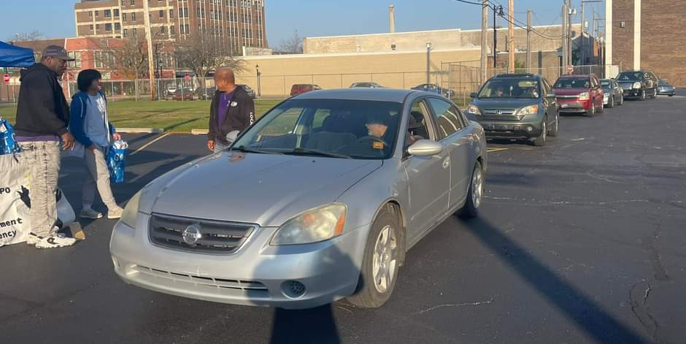
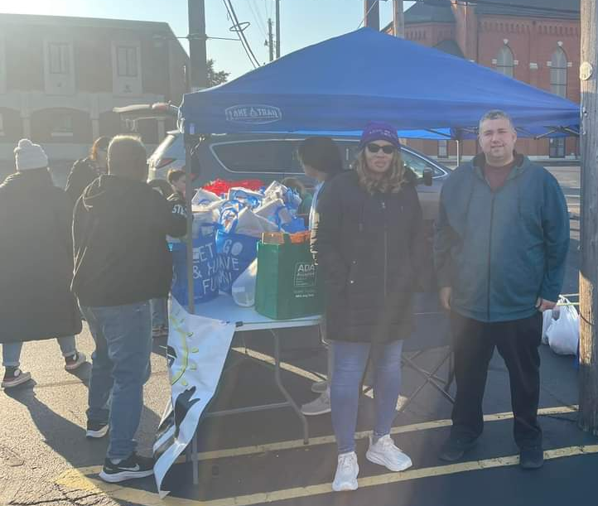

ARCHIVE NEWS

Merry Christmastime.
With this Holy Season upon us, the display on the glass case outside the Archive Room has been changed to reflect the season of Christmas. It is difficult to believe it is here already! Fall went by quickly.
There are some very old photos on display of Christmas seasons past on top of the display case. You will also find some bulletins there. If you take the bulletins into the St Paul Room to read, please return them to the top of the case when you are finished. Even though the bulletins “only” go back fifty years or so, they are interesting to look at and read.
The photos displayed were selected to give an overall feel for the Christmases past,here at St. Paul. Some of the 100+ year old photos show our altar with a LOT of adornment.
Also on display for you to view is a teen level (or so) reader written in German script. The cover is colorful with a Christmas scene of the Nativity.
And lastly, although not on the glass display case, feel free to go into the Archive Room itself for more Christmas Season bulletins. In the metal file cabinets farthest away from the door, bottom drawer, are a big collection in manilla folders that are all labeled, thanks to the hard work years ago of Bob Murray
Once again, a thank you goes out to the kind people that identified more photos that were lying about. This is so helpful and much appreciated. They have been put in the box on the antique table with the other pictures that have identification on them.
Merry Christmas to you and your loved ones!

December Birthdays

2 Paul Brooks 13 Douglas Kienitz
Amy Maesch 14 Karen Steinborn
Stephen Hapke 15 James Summers
3 John VanGemeren 17 Carol Radke
4 Mark Reshan 20 Stephanie Serrano
6 Dawn Pagels 22 Virgil Miller
Donna Ottersen 26 Barb fulkerson
8 Janelle Robinson 27 William Hackett
Judith Gleason 28 Benjamin Robbins
9 Pamela Thiede 29 Sherry Payne
12 Pamela Henderson

Long-Term Prayer List

Laura Dovey Marla Furness Dolores Hackett
Jess Kalvaitis Christine Kiser Pastor Al Lorentzen
Bethany Manning Christian Martinez Shane Nevels
Jan Paholski Kay Peglow Mark Tannehill
Kathy Thielman Margie Torres Venia Wendt

IN LOVING OF MY HUSBAND, LEE TIMM
General Fund from Sally Timm

IN MEMORY OF ALAN B. DOLSON
General Fund from Wayne & Suzann Dolson

IN MEMORY OF KEN WILSON
General Fund from Wayne & Suzann Dolson

Monday 8:00 a.m. – 5 p.m.
Tuesday 9:00 a.m. – 12:00 noon
Wednesday 8:00 a.m. – 5 p.m.
Thursday 9:00 a.m. – 12 noon
Friday 8:00 a.m. – 12 noon

St. Paul Lutheran Church Staff
Pastor Rev. Mark Reshan
Secretary Libby Pollock
Accompanists Jary Tannehill, Mark Tannehill, Jacob Tannehill
Custodian Mark Kloess

Thank$ for $haring
This month,we will see you at Holly’s on Tuesday, December 12! Here are two coupons: one for you and one for a friend.

