THE RESURRECTION OF OUR LORD
April 17, 2022

Finally, the faith and witness of the women consisted of three elements: the discovery of the empty tomb, the word of the two messengers, and their remembrance of the words of Jesus. Often the third factor is overlooked, but it is very important in the Gospel and is confirmed in our experience.
After the resurrection, disciples remembered and understood. The two at Emmaus experienced Christ in the breaking of the bread and then remembered what Jesus had said on the road. Faith does not usually move from promise to fulfillment but from fulfillment to promise. Remembering is often the activating of the power of recognition.
For this reason alone it is important that the preacher and teacher share with the listeners the story of Jesus and of the church. Such recitals may not strike fire at the time or be heard as matters of burning relevance; however, the time will come when the congregation will remember and it will make all the difference.

Fred Craddock

The women receive a word that runs counter to what they know to be true. "Why do you look for the living among the dead? He is not here, but has risen" (24:5). One might be tempted to linger over the description of these angelic messengers, but they are not the point. The focus in this section is on the message, not the messengers (24:4-7). What is most striking is that the women encounter the resurrection through this message. They are told that Jesus has risen, but they do not see the risen Jesus himself. What they have is a word, a message.
This brings the Easter experience uncomfortably close, because this is precisely what we have--the word of resurrection. One would think God would work differently. It would seem so much easier to have the women come to the tomb and watch Jesus walk out into the light of a new day. And it would seem much easier for Jesus simply to appear in dazzling glory to us, who gather on an Easter morning generations later. And this is precisely where our situation is like that of the women on the first Easter: we are all given a message of resurrection, which flies in the face of what we know to be true.
The only logical response to such a message is unbelief. Experience teaches that death wins. The Easter message says that Jesus lives. When such contradictory claims collide, it only makes sense to continue affirming what we already know. This is what Luke reports in the next section (24:8-11). The women bring the message of resurrection to the others, and they respond as thinking people regularly respond: they thought that the message was "an idle tale, and they did not believe them" (24:11).
Unbelief does not mean that people believe nothing. Rather, it means that they believe something else. People say "I don't believe it" because there is something else that they believe more strongly. Yet here is where the Easter message begins its work, by challenging our certainties. Experience teaches that death wins and that even the strongest succumb to it. Experience teaches that life is what you make it, so get what you can while you can because it will be over soon enough. And the Easter message says, "Really? How can you be so sure?" Death is real, but it is not final. In Jesus, life gets the last word.

Craig Koester

In the Name of Jesus
INTRODUCTION
"This is the day that the LORD has made; let us rejoice and be glad in it." God has indeed raised from the dead the one who was put to death "by hanging him on a tree." Alleluia! God allows Jesus to appear "to us who were chosen by God as witnesses" in holy baptism and invites us to eat and drink at the table of the risen Christ. Alleluia!
GATHERING

PRESERVICE MUSIC The Robe by Wes King The Praise Band

PRELUDE Festive Trumpet Tune David German

THE EASTER ACCLAMATION

P: Christ is risen! Alleluia!

C: (Shouted) Christ is risen indeed! Alleluia!

ANNOUNCEMENTS

As you are able please rise

AN EASTER LITANY

P: Rejoice, heavenly choirs of angels.

C: Rejoice, all creation around God’s throne.

P: Jesus Christ, our King, is risen!

C: Sound the trumpet of salvation.

P: Rejoice, O earth, in shining splendor,

C: Radiant in the brightness of Your King.

P: Christ has conquered! Glory fills you!

C: Darkness vanishes forever.

P: On this Day the Lord has acted.

C: We will rejoice and be glad in it. (Psalm 118:24)

THE PROCESSIONAL HYMN 365 Jesus Christ is Risen Today

The congregation faces the cross as it enters the assembly

THE GREETING

P: Christ is risen! Alleluia!

C: He is risen indeed! Alleluia!

P: The grace of our Lord Jesus Christ, the love of God, and the communion of the Holy
Spirit be with you all.
C: And also with you.

THE KYRIE
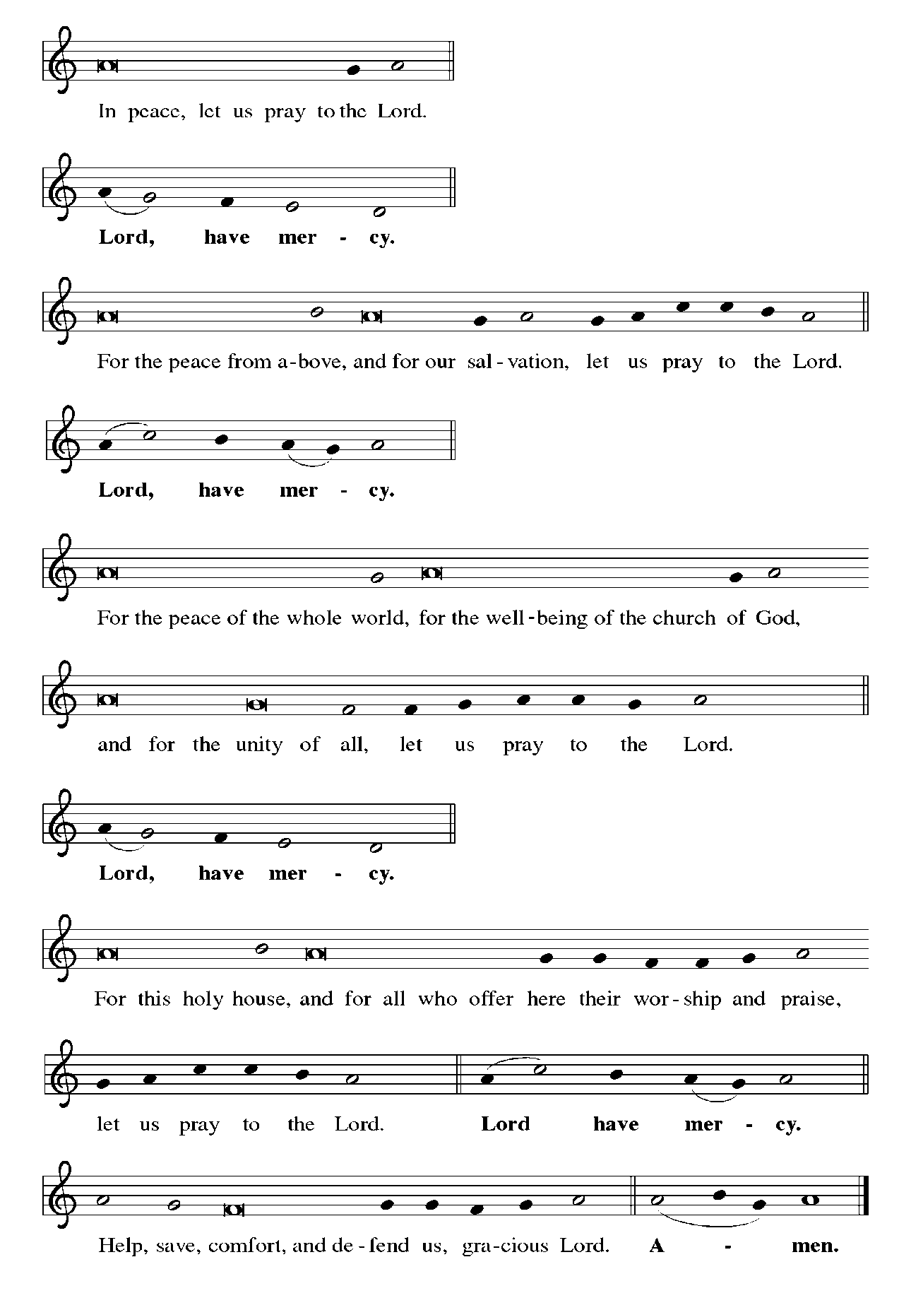

THE HYMN OF PRAISE

C—All
1—Women/children
2—Men

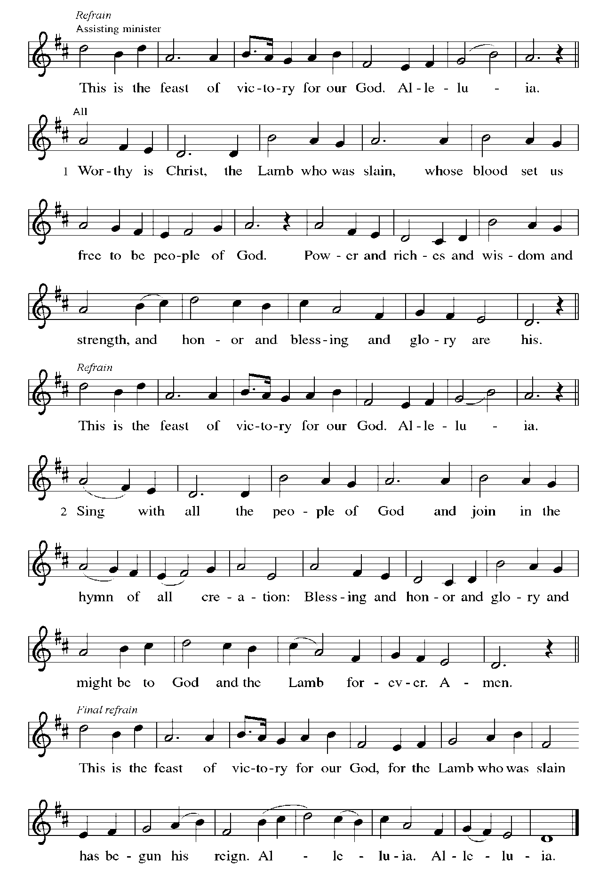

THE PRAYER OF THE DAY

P: The Lord be with you.

C: And also with you.

P: Let us pray. God of mercy, we no longer look for Jesus among the dead, for He is alive
and has become the Lord of life. Increase in our minds and hearts the risen life we
share with Christ, and help us to grow as Your people toward the fullness of eternal life
with You, through Jesus Christ, our Savior and Lord, Who lives and reigns with You
and the Holy Spirit, one God, now and forever.

C: Amen.

The assembly is seated
WORD

THE FIRST READING Acts 10:38-43

Peter's sermon, delivered at the home of Cornelius, a Roman army officer, is a summary of the essential message of Christianity: Everyone who believes in Jesus, whose life, death, and resurrection fulfilled the words of the prophets, receives forgiveness of sins through his name.

³⁴Then Peter began to speak to them: "I truly understand that God shows no partiality, ³⁵but in every nation anyone who fears Him and does what is right is acceptable to Him.
³⁶"You know the message He sent to the people of Israel, preaching peace by Jesus Christ--He is Lord of all. ³⁷That message spread throughout Judea, beginning in Galilee after the baptism that John announced: ³⁸how God anointed Jesus of Nazareth with the Holy Spirit and with power; how He went about doing good and healing all who were oppressed by the devil, for God was with Him.
³⁹We are witnesses to all that He did both in Judea and in Jerusalem. They put Him to death by hanging Him on a tree; ⁴⁰but God raised Him on the third day and allowed Him to appear, ⁴¹not to all the people but to us who were chosen by God as witnesses, and who ate and drank with Him after He rose from the dead.
⁴²"He commanded us to preach to the people and to testify that He is the one ordained by God as judge of the living and the dead. ⁴³All the prophets testify about Him that everyone who believes in Him receives forgiveness of sins through His name."

The Word of the Lord.

Thanks be to God.

THE PSALM: Psalm 118:1-2, 14-24 Antiphon by Bradley Ellingboe

Choir sings refrain first, followed immediately by the congregation
and as indicated

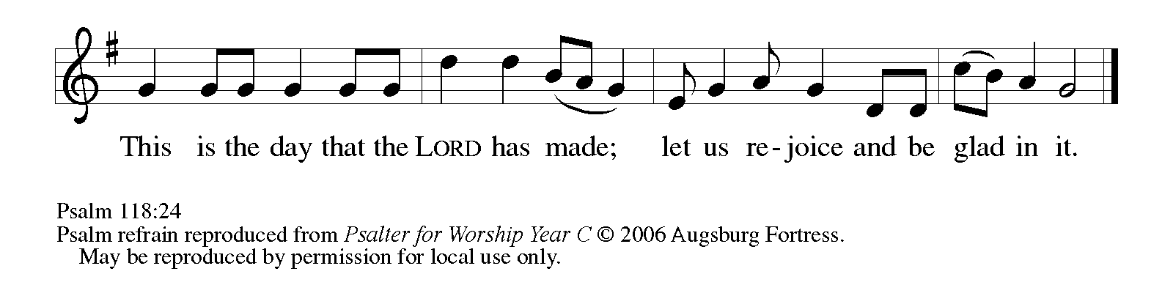

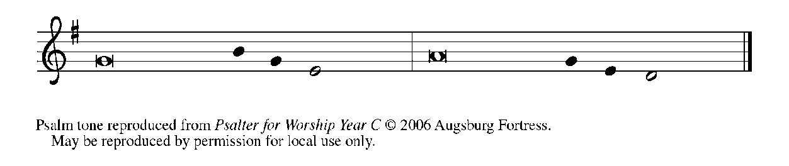

¹Give thanks to the LORD, for the | LORD is good;
God's mercy en- | dures forever.

²Let Israel | now declare,
"God's mercy en- | dures forever."

¹⁴The LORD is my strength | and my song,
and has become | my salvation.

¹⁵Shouts of rejoicing and salvation echo in the tents | of the righteous:
"The right hand of the | LORD acts valiantly!

¹⁶The right hand of the LORD | is exalted!
The right hand of the | LORD acts valiantly!"

¹⁷I shall not | die, but live,
and declare the works | of the LORD. REFRAIN

¹⁸The LORD indeed pun- | ished me sorely,
but did not hand me o- | ver to death.

¹⁹Open for me the | gates of righteousness;
I will enter them and give thanks | to the LORD.

²⁰"This is the gate | of the LORD;
here the righ- | teous may enter."

²¹I give thanks to You, for You have | answered me
and You have become | my salvation. REFRAIN

²²The stone that the build- | ers rejected
has become the chief | cornerstone.

²³By the LORD has | this been done;
it is marvelous | in our eyes.
²⁴This is the day that the | LORD has made;
let us rejoice and be | glad in it. REFRAIN

SECOND READING 1 Corinthians 15:19-26

Paul describes the consequences of the resurrection, including the promise of new life in Christ in a world that has known only death since Adam, the destruction of the forces of evil, and the establishment of God's victorious rule over all.

¹⁹If for this life only we have hoped in Christ, we are of all people most to be pitied. ²⁰But in fact Christ has been raised from the dead, the first fruits of those who have died. ²¹For since death came through a human being, the resurrection of the dead has also come through a human being; ²²for as all die in Adam, so all will be made alive in Christ.
²³But each in his own order: Christ the first fruits, then at His coming those who belong to Christ. ²⁴Then comes the end, when He hands over the kingdom to God the Father, after He has destroyed every ruler and every authority and power. ²⁵For He must reign until He has put all His enemies under His feet. ²⁶The last enemy to be destroyed is death.

The Word of the Lord.

Thanks be to God.

As you are able please rise

THE VERSE
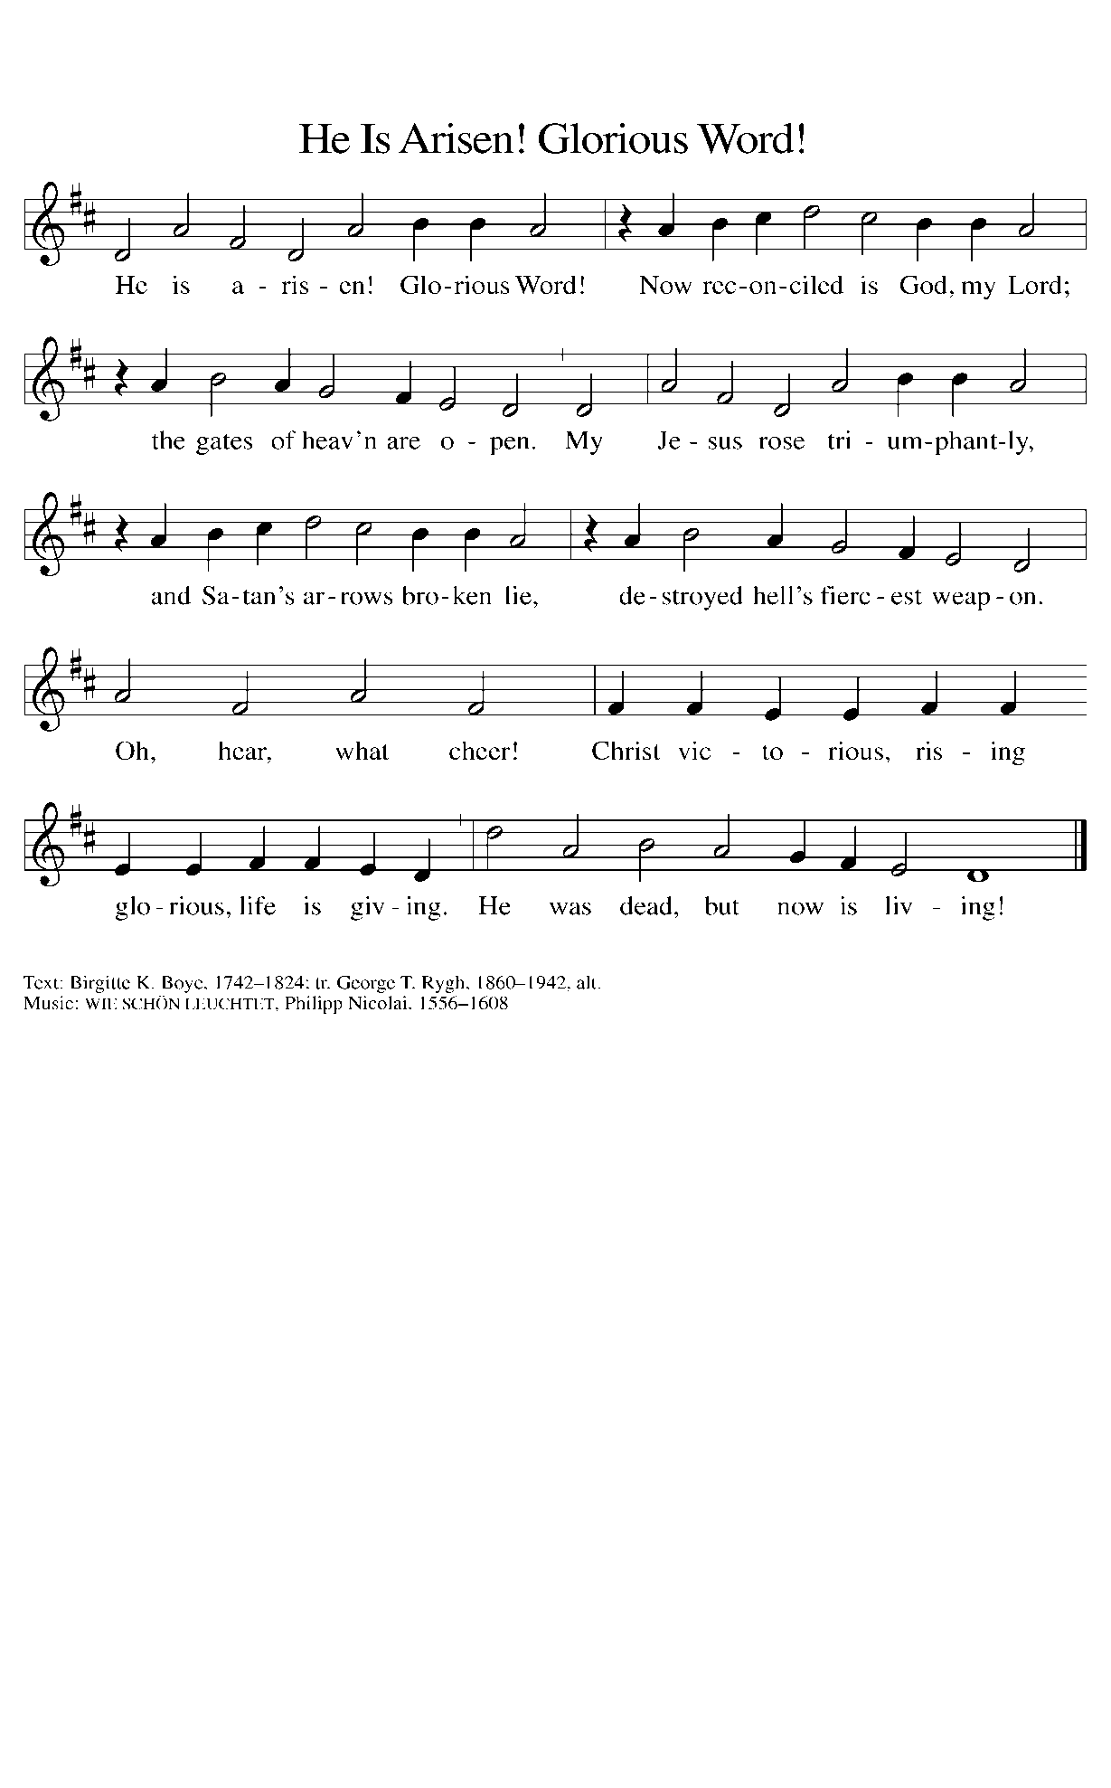
THE HOLY GOSPEL Luke 24:1-12

The women who followed Jesus take the lead in proclaiming the resurrection.

P: The Holy Gospel according to St. Luke, the twenty-fourth chapter.

C: Glory to You, O Lord!

¹But on the first day of the week, at early dawn, they came to the tomb, taking the spices that they had prepared. ²They found the stone rolled away from the tomb, ³but when they went in, they did not find the body. ⁴While they were perplexed about this, suddenly two men in dazzling clothes stood beside them.
⁵The women were terrified and bowed their faces to the ground, but the men said to them, "Why do you look for the living among the dead? He is not here, but has risen. ⁶Remember how He told you, while He was still in Galilee, ⁷that the Son of Man must be handed over to sinners, and be crucified, and on the third day rise again."
⁸Then they remembered His words, ⁹and returning from the tomb, they told all this to the eleven and to all the rest. ¹⁰Now it was Mary Magdalene, Joanna, Mary the mother of James, and the other women with them who told this to the apostles. ¹¹But these words seemed to them an idle tale, and they did not believe them.
¹²But Peter got up and ran to the tomb; stooping and looking in, he saw the linen cloths by themselves; then he went home, amazed at what had happened.

P: The Gospel of the Lord.

C: Praise to You, O Christ!

The assembly is seated

THE SERMON
Silence for reflection follows the sermon

As you are able please rise

THE HYMN OF THE DAY 367 Now All the Vault of Heaven Resounds

THE NICENE CREED

A: God has made us His people through our Baptism into Christ. Living together in trust
and hope, we confess our faith.

C: We believe in one God,
the Father, the Almighty,
maker of heaven and earth,
of all that is, seen and unseen.

We believe in one Lord, Jesus Christ,
the only Son of God,
eternally begotten of the Father,
God from God, Light from Light,
true God from true God,
begotten, not made,
of one Being with the Father.
Through Him all things were made.
For us and for our salvation
He came down from heaven;
by the power of the Holy Spirit
He became incarnate from the virgin Mary, and was made man.
For our sake He was crucified under Pontius Pilate;
He suffered death and was buried.
On the third day He rose again
in accordance with the Scriptures;
He ascended into heaven
and is seated at the right hand of the Father.
He will come again in glory to judge the living and the dead,
and His kingdom will have no end.

We believe in the Holy Spirit, the Lord, the giver of life,
Who proceeds from the Father and the Son.
With the Father and the Son He is worshiped and glorified.
He has spoken through the prophets.
We believe in one holy catholic and apostolic Church.
We acknowledge one Baptism for the forgiveness of sins.
We look for the resurrection of the dead,
and the life of the world to come. Amen

THE PRAYER OF THE CHURCH

A: In the light of Christ’s resurrection, let us pray for the Church, the world, and all who
long for the grace of new life, that the whole creation may know the benefits of Christ’s
Easter victory.

A: That the Church may faithfully and fearlessly bear witness to Christ as the Lord of the
living and the dead, for Christ is risen:

C: He is risen indeed!

A: That Christ’s victory over death would vanquish all powers of evil and oppression and
bring peace and reconciliation to our troubled and broken world, especially in Ukraine,
for Christ is risen:

C: He is risen indeed!

A: That in the power of the Holy Spirit this congregation may discover new ways to do
good and bring Christ’s healing to the hurting and the lost, for Christ is risen:

C: He is risen indeed!

A: That those who have trouble believing the Good News may be granted faith and hope
by the Spirit of the living Christ, for Christ is risen:

C: He is risen indeed!

A: That the sick, especially . . . might know the strength and compassion of the Lord, for
Christ is risen:

C: He is risen indeed!

A: That those celebrating birthdays, especially Jean Kleinschmidt; and anniversaries,
especially Tim and Stacie Crozier might know Your love this Day and every day and
be filled with Your love and grace in all the days ahead, for Christ is risen:

C: He is risen indeed!

A: That with Mary Magdalene, Joanna, Mary the mother of James, the disciples, and all
the saints we may come at last to see and worship You in glory: Lord, in Your mercy,

C: Hear our prayer.

P: Hear our prayers, O God, on behalf of those for whom we pray, and give us peace and
joy in this time of resurrection and new life, for the sake of Your Son, Jesus Christ, our
risen and living Lord.

C: Amen.

MEAL

THE OFFERING

CHOIR Resurrection Victory Lloyd Larson

As you are able please rise

THE OFFERTORY
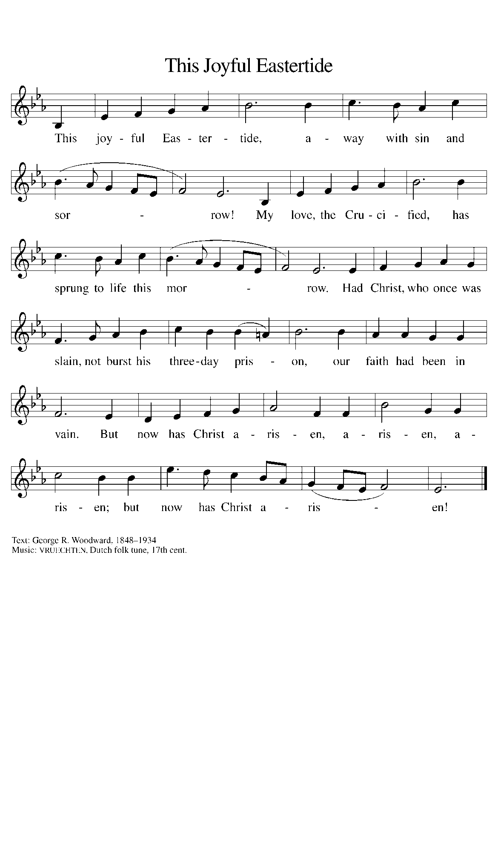
THE OFFERTORY PRAYER

A: Let us pray. Living Lord Jesus Christ,

C: On this Day of resurrection we offer You these simple gifts, signs of Your grace
and love. Be known to us in the breaking of the bread, and nourish us with the
cup of salvation, for You are Lord, now and forever. Amen.

THE GREAT THANKSGIVING

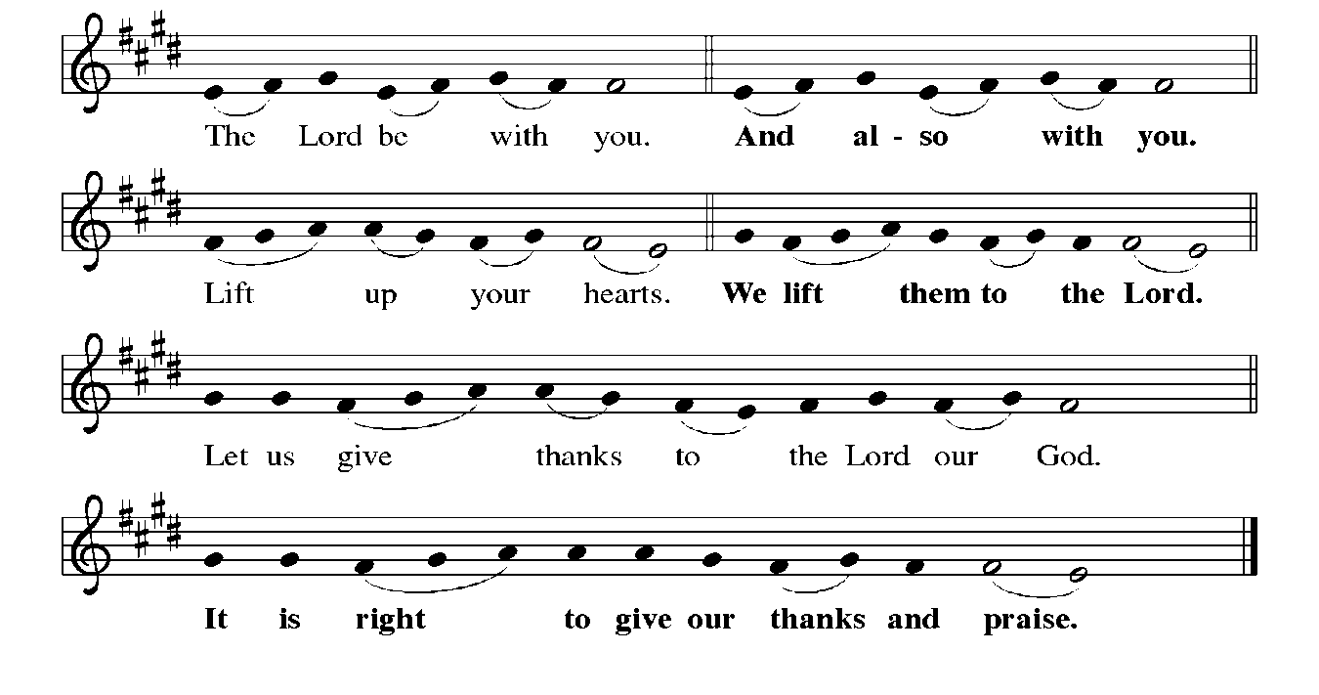

P: It is indeed right, our duty, and our joy … join their unending hymn:

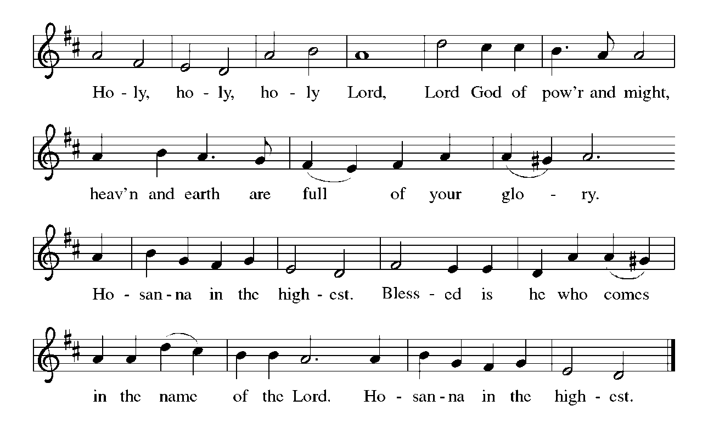

P: Holy God, our strength, our song, and our salvation, we bless and praise You.
On this Day You have acted; we will rejoice and be glad in it.
You are holy, O God, in Your irresistible will for life: in creation, in all its
intricate beauty; in Israel’s rescue from bondage, exile, and faithlessness;
and in her prophets’ promise of the death of death and a new creation.
In fulfillment of those promises, You sent Your Son, Jesus Christ.
He is the first fruits of resurrection, in Whom all will be made alive.
In the night ... “Do this for the remembrance of Me.”
As often as we eat ... we proclaim the Lord’s death until He comes.
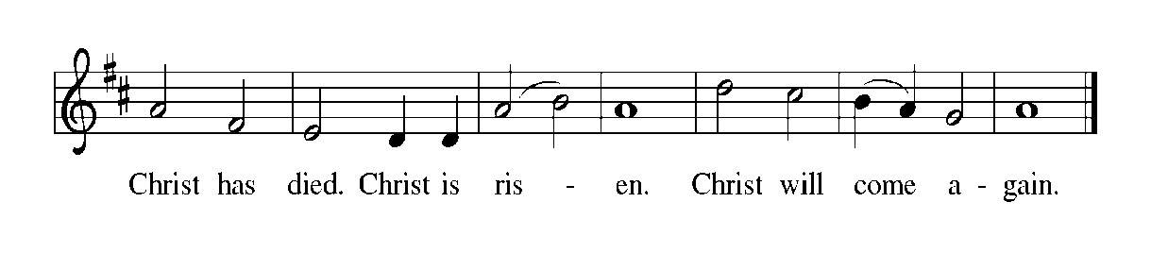
P: With this bread and cup we remember the life our Lord offered for us.
Anointed with Your Spirit, He did good, fed the hungry, and healed the sick.
Put to death on the cross, You raised Him to defeat the last enemy of death.
Now He reigns until He returns to share with us Your final Feast of victory.
Send now Your Holy Spirit on us and these gifts of bread and wine, that we
and all who share the Lord’s Body and Blood
May, with the women, bear faithful witness to His rising, until the hope of memory
becomes the joy of reality, and we, and all for whom He rose share in Your
everlasting glory.
To You, O God: Father, Son, and Holy Spirit, be all honor and glory, in Your holy
Church, in heaven and on earth, now and forever.
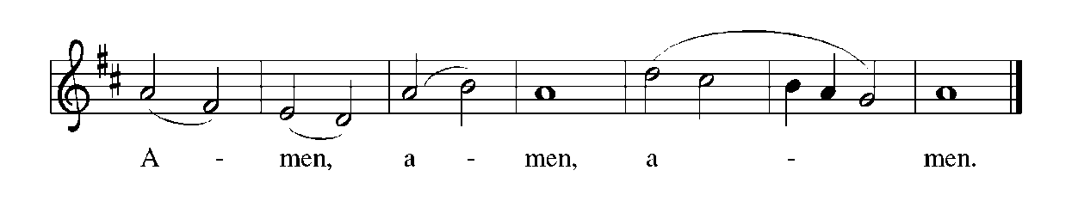

THE LORD’S PRAYER

P: Risen from the dead, Jesus lives to intercede for us and join us as He taught us to
pray:

C: Our Father, Who art in heaven, hallowed be Thy Name. Thy Kingdom come, Thy
will be done on earth as it is in heaven. Give us this day our daily bread, and
forgive us our trespasses as we forgive those who trespass against us. And lead us
not into temptation, but deliver us from evil. For Thine is the Kingdom, and the
power, and the glory, forever and ever. Amen.

INVITATION TO THE MEAL

P: Alleluia! Christ the Lamb of God has been sacrificed. Therefore, let us celebrate His
Feast with joy. Blessed are those who are called to the Supper of the Lamb. God’s
holy gifts for God’s holy people. Come, for all is now ready.

The assembly is seated

THE DISTRIBUTION
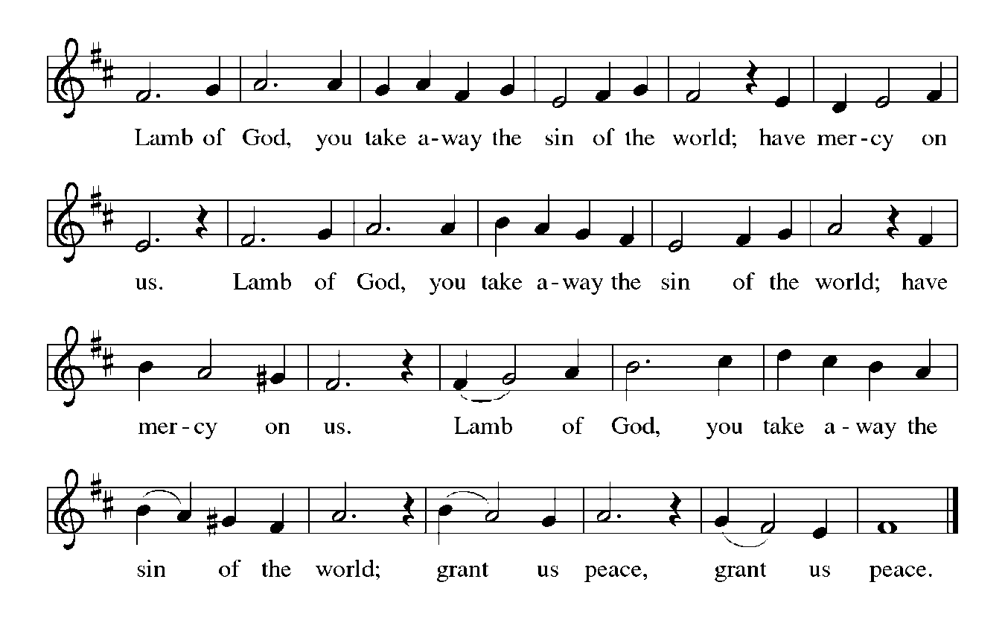HYMN DURING DISTRIBUTION 385 Good Christian Friends, Rejoice and Sing!
NSB 10 Beautiful Saviour (All My Days)
531 The Trumpets Sound, the Angels Sing
NSB 23 Come and See
NSB 64 Majesty

As you are able please rise

THE POST COMMUNION BLESSING

P: The Body and Blood of our Lord Jesus Christ strengthen you and keep you in His
grace.

C: Amen.

THE POST-COMMUNION PRAYER

A: Let us pray. Glorious Lord of life, at this Table we have tasted Your promised future
in which there will be no more death or pain. Strengthen us to be Your risen Body in
the world, that Your praise and glory may resound in all creation; through Jesus Christ
our Lord.

C: Amen.
SENDING

THE BENEDICTION

P: May God the Father Who raised Christ from the dead open to you the gate of everlasting
life.

C: Amen.

P: May God the Son Who burst from the grave give you joy as you celebrate His
resurrection.

C: Amen.

P: May God the Holy Spirit Who brought you to birth in Baptism fill you with strength
and peace.

C: Amen.

P: Almighty God: Father, Son and Holy Spirit bless you now and forever.

C: Amen.

RECESSIONAL HYMN 369 Christ the Lord is Risen Today; Alleluia

The congregation faces the cross as it leaves the assembly

THE DISMISSAL

A: Alleluia! Christ is risen!

C: He is risen indeed! Alleluia!

A: Go in the peace of Christ, alleluia!

C: Thanks be to God! Alleluia!

POSTLUDE Allegro Maestoso e Vivace Felix Mendelssohn
To God Alone Be Glory

The Meditations are from Interpretation. A Bible Commentary for Teaching and
Preaching. Fred Craddock. (Louisville: John Knox Press, 1990) 282-83; and
Working Preaching Online. Copyright 2022 Luther Seminary.

The Greeting, Peace, Prayers, and Dismissal are adapted from Sundays and Seasons.
Copyright 2000 Augsburg Fortress.

MEMORIALS IN SPRING FLOWERS FOR EASTER 2022

Maxine Powell in loving memory of husband Clint Powell and daughter Connie Hollis

Judy Mutchler in honor of daughter Cheryl
Mike & Amy Maesch

Jason & Carey Howard in loving memory of mother Christine Leslie and father John Foldenauer

Mike & Donna Knoll in memory of loved ones

Richard Cains in memory of wife Suzanne Cains

Don & Beth Thompson in loving memory of mother Suzanne Cains and parents
Palmer & Ruth Thompson

Beth & Don Thompson in honor of father Richard Cains

Janet Bakken in memory of loved ones and in honor of family and friends

Sandy Robbins in memory of husband Henry “Sonny” Robbins

Tim & Stacie Crozier

Trish Sprague in memory of loved ones

Chip & Audrey Claussen in memory of all loved ones

Beverly Johnson in loving memory of husband Ron Johnson

Bob & Karen Kiser in memory of loved ones

Carol Radke in memory of loved ones

David & Amy Haring in memory of mother Suzanne Cains

Emma & Abby Haring in memory of grandmother Suzanne Cains

Steve & Lauretta Hapke in memory of loved ones

Carol & Fred Weiss in memory of son Donald Weiss

Rich & Karen Fleming in honor and memory of people of Ukraine

Mary Knaup in memory of husband Dennis Knaup

Marjory & Mike Bockover in memory of loved ones

Susan Koziel in memory of my husband and in honor of my children and grandchildren

Richard & Kathy Thielman in loving memory of Don & Des Thielman, Lori Hall,
and Norman & Marcella O’Donnell

Susan Bagby in memory of parents Raymond & Hazel Reiter

Melinda Nagle in memory of parents Randy & Lois Miller

Pamela & Richard Henderson in memory of mother Suzanne Cains, in memory of brother Gary Henderson, and in honor of Madeline and Audrey Henderson

Diane Gielow in memory of loved ones

Libby Pollock in loving memory of husband John and daughter Jenise

Charles and Jana Thomas in memory of Otto Meyer family, in memory of Allie Thomas family, in memory of Stanley Redmon, and in memory of Steve Doster

Virginia Murray in memory of husband Robert Murray

IMMANUEL LUTHERAN CHURCH is sponsoring the
Alzheimer’s Association
1237 E. Coolspring Ave.
Michigan City, IN 46360
Tuesday, April 19th, at 5:30 p.m.

Call 800-272-3900 to register or visit www.alz.org/crf
Light snacks provided by Trail Creek Place

Learn about:
Landscape of Alzheimer’s and Dementia Science

Risk Factors for Alzheimer’s and all other dementia

Highlights in Early Detection and Diagnosis

Latest Advances in Clinical Trials, Treatments and
Lifestyle Interventions

ANNOUNCEMENTS

Please remember to mail your offering to the Church Office at 818 Franklin Street, Michigan City, IN 46360. Another alternative is to give on-line through Tithe.ly. Please see your closure letter for information on how to set up a Tithe.ly account.

St. Paul Members are reminded to have a loved one contact the office if you are hospitalized. Many times, the Pastor doesn’t know someone is in the hospital. If you call and leave a message, please tell us which hospital the patient is at.

Next Sunday’s lessons are Acts 5: 27-32; Psalm 118: 14-29 or Psalm 150; Revelations 1: 4-8; John 20: 19-31 for those of you who like to study them in advance.

Birthdays: Jean Kleinschmidt (4/23)

Anniversary: Tim and Stacie Crozier (4/22)

PRAYER CONCERNS: Audrey Beyer, Ryan Krueger, Donna Bostater, Maxine
Powell, Jim Tomscheck, Ken Mulder, Roger Milzarek, Eloise Ponder, Mark & Jary Tannehill and Leonard Cross.

If you requested someone’s name to be on the prayer list and are aware that they need continued imminent prayer then contact the church office and let us know.
Otherwise we will gradually transfer names to the long-term list.

OFFICE HOURS: Libby will be in the office on Mondays, Wednesdays, and Fridays; volunteers will cover Tuesdays and Thursdays.

Monday & Wednesday 8:00 a.m. – 5 p.m.
Tuesday & Thursday 9:00 a.m. – 12:00 p.m.
Friday 8:00 a.m. – 12:00 p.m.

If you are listening to the worship broadcast on the radio and would like to watch the Sunday morning service live stream follow these steps:

(1) If you have You.Tube available on your TV, search for
St. Paul Lutheran Church Michigan City, IN.

(2) The direct link on the computer is
https://www.youtube.com/channel/UC5AIPNaKr3QN50984jGOa1g.

(3) This link is also on the main page of the church’s website in the church section and will continue to be posted weekly on the St. Paul Facebook page.

And it will always be available on the radio broadcast Sunday mornings at 11:00 a.m. on WEFM (95.9), and on the local cable access station #99 for the previous week’s service on Sundays at 4:00 p.m. and the current service on Wednesdays at 7:00 p.m. and Fridays at 8:30 p.m.

To send e-mail to the church office, please use the following addresses:

Pastor Mark Reshan: seniorpastor@stpaulmichigancity.com

Church Office Secretary (Libby Pollock): churchsecretary@stpaulmichigancity.com

Church Treasurer (Karen Fleming) and Bookkeeper (Billie Atchinson):
finance@stpaulmichigancity.com.

The Good News Newsletter: If you have an article or anything you want included in The Good News please send it to the following e-mail address: splcgoodnews@gmail.com. Pastor Pamela Thiede will be using this e-mail address to assemble The Good News each month. The deadline for getting information to Pastor Pamela will be the 20th of each month.

WORSHIP ATTENDANCE for April 4, 2022
6:30 p.m. 23

WORSHIP ATTENDANCE for April 9 and 10, 2022
4:00 p.m. 29
9:00 a.m. 78
Total = 107

The Community Soup Kitchen serving out of First United Methodist is in need of volunteers. Sunday through Tuesday is always need, as is occasionally Wednesdays and Thursdays. Hours are 9:30 a.m. to 1:15 p.m. and it is not necessary to stay the entire time. There is also a need for volunteers to be available to help pick up deliveries from the Food Bank when they arrive. If you are able to help please contact their church office at 872-7200.

THANK YOU SO MUCH! A big shout out to our very own Altar Guild who prepared and served a lovely luncheon following the Senior Communion this week on the
morning of Maundy Thursday. There was a good time had by all with the fellowship of
friends and family we haven’t been able to worship with in quite a long while.

Thank$ for $haring
Thanks to all who attended the Galveston give-back in February. We raised $210 at that event. We’d also like to thank all those folks that were at Swingbelly’s for their give-back in March. We raised $150.00 at that event.

This month, we will see you again at Galveston! We’re giving you two coupons so you can invite a friend and give them their own coupon. Remember, the coupon is required for the Give-Back bucks.

