

February, 2023

**MARK: MY WORDS**

“Remember that you are dust, and to dust you shall return.” With those ominous words reminding us of our mortality, ashes are spread on our foreheads, not just in any shape, but in the sign of the cross. And in that moment, we are drawn again into the Forty Days of Lent. But, more importantly, we are returned to the promises of our Baptism to sustain us in these Days of repentance, renewal, and rebirth.

In the words of Jesus to the Samaritan woman at the well in John 4 (the Gospel reading for 3 Lent), Baptism washes us with “living” water. Water, of course, is the perfect earthly element for Baptism. In Romans 6, Paul declares that “all of us who have been baptized into Christ Jesus were baptized into his death? Therefore, we have been buried with him by baptism into death, so that, just as Christ was raised from the dead by the glory of the Father, so we too might walk in newness of life.” (vv. 3b-4).

In Baptism, our old, sinful self is drown in the healing water flowing from the side of Jesus on the cross; and we are joined to His resurrection life. That is, water both kills and makes alive according to Martin Luther. We have tragically witnessed that firsthand in these last weeks with massive storms and flooding in the Philippines and especially in northern California.

Our readings in this Lent call to mind those life-giving waters that refresh us in those times when we are dry, parched, and empty. In the words of an essay from our worship resource *Sundays and Seasons:*

Ash Wednesday and Lent 1 set the stage (for the many metaphorical aspects of the healing waters of Baptism) as Jesus is called out into the wilderness. The central baptism theme of rebirth is illustrated in the story of Nicodemus (Lent 2) and again in the stories of Lazarus and Ezekiel and the dry bones (Lent 5).

The cleansing and healing properties of water are explored in Psalm 51 (Ash Wednesday) and again in the story of the man born blind who washes in the pool (Lent 4). Thirst is quenched by water in a dry place with Moses striking the rock in the desert and the woman who meets Jesus at the well (Lent 3).

Why do we use water in Baptism? Besides its cleansing power, it is also all around us. It is a constant reminder of the promises made at the font. Again, Luther urged us that whenever we were around water--to bathe or wash dishes or water plants and gardens--to remember that we are baptized and, therefore, beloved daughters and sons of God. Lent is the time of the church year when we are especially cognizant of that powerful assurance.

So we “remember that we are dust,” but we also “remember” that we have been “marked with the cross of Christ and sealed with the Holy Spirit forever” (from the Baptismal liturgy).

May God grant us a holy and life-renewing Lent.



As we have done in the past, we will offer two worship services on Ash Wednesday: one at 10:00 a.m. and the other at 7:00 p.m. Both will include The Imposition of Ashes and Holy Communion. We hope you will begin your Lenten observance by joining us at one of these liturgies.



Once again, we will offer a mid-week Wednesday worship service during the five weeks of Lent; and we will again use Marty Haugen’s “Holden Evening Prayer” as the musical setting. I have not yet selected the theme for the services but will publicize that shortly. However, there will be a change in the worship time for the liturgies.

For the past several years, these services have been held at 6:30 p.m. followed by choir rehearsal at 7:00. It was decided this year to move both of those up by 30 minutes, **so the Evening Prayer will be held at 6:00 p.m. and choir rehearsal at 6:30 p.m.** Please make a note of the change on your calendar.



**FUNERAL TIMES**

As you know (and hopefully have heard), we have a wonderful new organist and choir director, Dr. Vernon Carey. He and his husband, Avril, are living in South Bend across the street from Memorial Hospital; and Vernon is teaching music education at a South Bend school. It is about a 45-minute drive from his home/school to church.

For some years, when we have had funerals at church during the week, the service has been scheduled at 11:00 a.m., with visitation often either at 9:00 or 10:00 a.m. Vernon has about a two-hour block of time off each morning from 10:05 (our time) to just before 12:30 (our time). If we keep the time of funerals at 11:00, there is no way that he will be able to drive here from South Bend, play for the service, and then make it back to school in time to begin his afternoon classes.

He has some time that he is able to take off, and is willing to keep some mornings in reserve in case of funerals and then go in to school after lunch. That will mean that the funeral services would need to begin at 10:00 instead of 11:00. If we want music for the services, we don’t have a choice. Naturally, we will also need to coordinate this with the funeral homes. Thank you for your understanding as we modify our practice.



**AUDIO/VISUAL CONVERSION**

Warren Schacht has generously offered to convert audio tapes and cassettes to CD’s and VHS tapes to DVDs at no charge! He is currently converting our church audio tapes/cassettes and has extended the offer to anyone who is interested in updating their material. You may call him directly at 219-448-1444 or email him at [w.schacht230@comcast.net](mailto:w.schacht230@comcast.net). Thank you, Warren!

**WORSHIP CLOSURE INFORMATION**

Hopefully, we will not have to cancel worship services as we did on Christmas Eve/Day because of weather; but in case that need arises; this is a good reminder of how to get that information:

* An email will be sent to those on the church email list
* You may tune to WEFM 95.9 for an announcement during their broadcast
* The church and school Facebook page ([St Paul Lutheran Church & School - Michigan City, IN | Facebook](https://www.facebook.com/stpaulmichigancity)) will post an announcement
* You may dial the church office number (219-874-7293) and when the automated menu begins press the # button for a recorded announcement

We will make every effort to insure that everyone is informed as quickly as possible should such an action be taken by the Church Council.

**Saying Good-bye and Thank You to John and Lori on January 1, 2023 . . .**

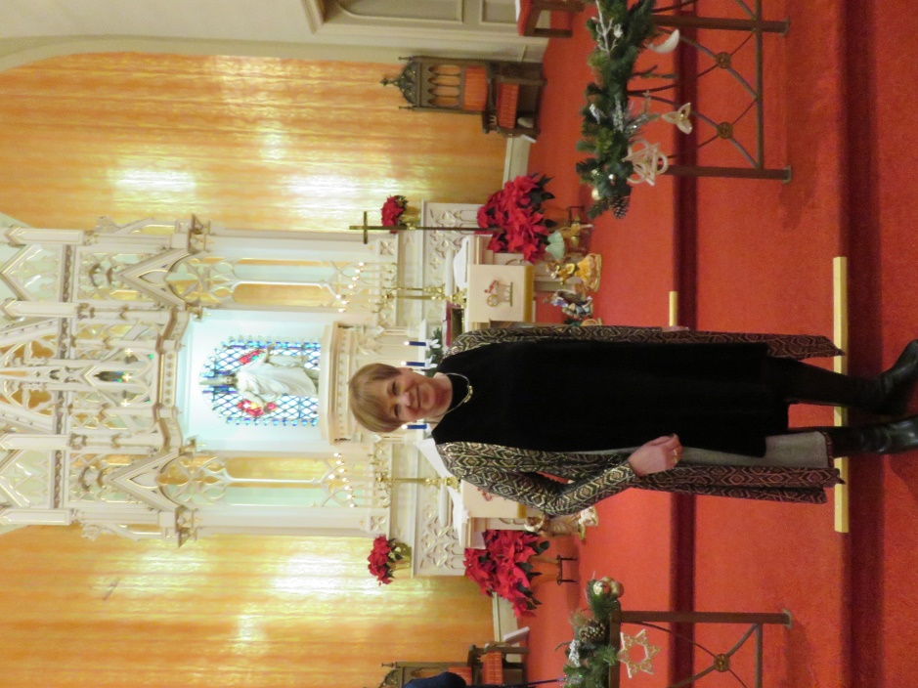

**THE COMMEMORATION OF MARTIN LUTHER**

February 10 is the Commemoration of Martin Luther on the church calendar. This article was included in last year’s February newsletter, but it seemed important enough to include it again this year. Many Lutherans are unaware of details of Luther’s life; and since we, as a church body, take our name from him, it is always good to re-acquaint ourselves with that knowledge.

Throughout the church year, we remember and give thanks for the lives, witness, and examples of many of the heroines and heroes of the faith. February brings us an especially important one for us who share a Lutheran heritage and history.

On February 18, 1546, Martin Luther died at the age of 62 in his hometown of Eisleben, Germany. He had long suffered from poor health due to a variety of illnesses and conditions: [Ménière's disease](https://en.wikipedia.org/wiki/M%C3%A9ni%C3%A8re%27s_disease), [vertigo](https://en.wikipedia.org/wiki/Vertigo), fainting, [tinnitus](https://en.wikipedia.org/wiki/Tinnitus), a [cataract](https://en.wikipedia.org/wiki/Cataract) in one eye, [kidney and bladder stones](https://en.wikipedia.org/wiki/Kidney_stone_disease), [arthritis](https://en.wikipedia.org/wiki/Arthritis), an ear infection that ruptured an ear drum, and [angina](https://en.wikipedia.org/wiki/Angina).

As one would expect, as his condition worsened, so did his mood, his writings, and sermons. It was during this time that he wrote some of his most hateful and incendiary comments about the Jewish people of Germany and Europe. Those are some of the most shameful aspects of his legacy; and over the last several decades, Lutherans worldwide have recognized the harm that they brought and repented of his vitriol to those against whom his writings were used as justification for oppression and violence.

Like all of us, Luther was a complex person. He is regularly included in the group of those who had some of the greatest influence on historical developments of his time but also one whose failings, shortcomings, and sins are as great as his accomplishments. In his own words, he, with the rest of us, are “saints and sinners” at the same time and always in need of the gracious and merciful compassion and forgiveness God grants in Christ that he so powerfully articulated and championed throughout his life and ministry.

His famous last words are, “We are all beggars. It is true.” Perhaps that better sums up his theology and teaching better than the dozens of volumes of his sermons and teachings that we possess. That belief fits particularly well in the Lenten season in which this commemoration falls. May God grant us, with Luther, the humility, the will, the faith, and the hope to “beg” God for His mercy and receive it always with joy, trust, and thanksgiving.



All 2022 Yearly donation statements have been either emailed for members with emails listed or printed and placed in envelopes in their hanging folders in the church narthex. Please pick up your report on your next visit to church. If you can't visit church and would like it mailed, please contact Karen Fleming in the church office (219-874-7293), and she will mail it to you. We are attempting to save postage by placing them in the hanging folders for those attending church and without email.

Please check your donation statement for any errors; and if you have any questions, please contact our Treasurer, Karen Fleming. She isn't in the office everyday but will get back to you to answer any questions concerning your donation statement.

Thank you all for your continued financial support of OUR St. Paul Lutheran Church. We are the Church.



**IN HONOR OF JOHN REMMEL**

**General Fund** from Warren & Karen Schacht

**IN MEMORY OF FRANK FROEHLKE**

**General Fund** from Gregory & Virginia Orlowski

**IN MEMORY OF LYLE PETERS**

**General Fund** from Bob & Karen Kiser, Dawn Fitzhugh

**IN MEMORY OF VALERIE WALTZ**

**General Fund** from Bob & Karen Kiser, Beverly Johnson

**IN MEMORY OF GEORGE OTTERSEN**

**General Fund** from Beverly Johnson, Maxine Powell

**IN MEMORY OF CLINT’S BIRTHDAY on January 18**

**General Fund** from Maxine Powell





**February Birthdays February Anniversaries**

1 Jary Tannehill 20 Tim & Laura Mellen

2 Heather Hazel 21 Charles & Sherry Payne

4 Barbara Tanner

5 Richard Cains

7 Susan Koziel

Martha Schroeder

9 Janet McMahon

10 Emma Haring

Janet Priebe-Protas

12 Susan Green

13 Jacob England

14 Wayne Dolson

15 Dena Slisher

16 Barbara Bass

17 Dale Prybylla

19 Kimberly Summers

22 Amelia Moore

Kelly Neulieb

Aaron Petri

23 Katherine Summa

24 Molly Robbins

25 David Murray

26 Kayla Bergquist

Chloe Fisher

Karen Schacht

27 Chip Claussen

Suzann Dolson

28 Bernhard Neitzel

**Long-Term Prayer List**

Audrey Beyer Irene Bohnstadt Donna Bostater

Laura Dovey Marla Furness Ed Gustum

Dolores Hackett Jess Kalvaitis Christine Kiser

Ryan Krueger Pastor Al Lorentzen Bethany Manning

Christian Martinez Shane Nevels Jan Paholski

Kay Peglow Kathy Thielman Jean Thomas

Margie Torres Venia Wendt



Monday 8:00 a.m. – 5 p.m.

Tuesday 9:00 a.m. – 12:00 noon

Wednesday 8:00 a.m. – 5 p.m.

Thursday 9:00 a.m. – 12 noon

Friday 8:00 a.m. – 12 noon

**St. Paul Lutheran Church & School Staff**

Pastor Mark Reshan

Organist/Choir Director Dr. Vernon Carey

Accompanists Jary Tannehill, Mark Tannehill, Jacob Tannehill

Custodian Mark Kloess

School Principal Tracey McCay

School Office Coordinator Christina Woodard

School Custodian Tara Soto-Garcia



**Do You Shop on Amazon?**

**St. Paul Lutheran Church is on Amazon Smile.** 0.5% of all eligible purchases will be returned to St. Paul. Help us spread the word! Link your Amazon account through the following link—https://smile.amazon.com/ch/52-1239301. When prompted, sign into your account to make sure you are choosing St. Paul for Amazon Smile. There’s no extra charge to your purchases.

Thank$ for $haring

Thanks to all who attended the giveback at Holly’s in January. The church received $298! from that evening.

This month,we will see you at Galveston on Thursday, February 16! Here are two coupons: one for you and one for a friend.

