

January, 2022

**MARK: MY WORDS**

“Happy New Year” is how the world marks the beginning of this month. Behind those words there is often a sense of relief that the worries, cares, and concerns of the previous year are behind us. There is, however briefly, a feeling of anticipation and hope of better things to come.

Yet our experience is that often there is little “new” that accompanies the change in the calendar year. Those worries, cares, and concerns don’t magically disappear. In some cases they only intensify and worsen.

The Church enters the New Year differently. January 1 is the festival of The Name of Jesus. It marks the tradition in Judaism that on the eighth day after birth all males are circumcised and formally named. “Jesus” is the English translation of the Hebrew name, *Yeshua,* or ‘Joshua.’ His name means, ‘God saves.’

In the Scriptures, “salvation” isn’t limited to ‘forgiving our sins so that when we die we can go to heaven.’ The root of the word gets at the idea of ‘health of mind, body, and spirit; wholeness and well-being in our lives and in our relationships with one another and the world around us.’ It is the basis of the familiar toast, “*Salu!*” ‘To your good health!’

As we hear each week in our Gospel readings, Jesus *does* what His name means. He “saves” the sick and hungry and poor and outcast and grieving and dying by restoring them to health and wholeness and to their families, friends, and community. And the Good News that we proclaim is that work did not end with His death on the cross.

God raised Him back to life so that such restoring and healing and renewing might continue now through those of us who are Jesus’ presence, hands, feet, arms, voice, and body in and for the world. Therefore, we face whatever is new—the day, the month, the year—with the confidence that, even if things are not better than before, Jesus is in every moment working for those of us who bear His Name through Baptism for our good and through us for the good of others.

There could be no more promising way to begin a New Year.



**PREPARING FOR THE SEASON OF EPIPHANY**

Epiphany is an often-overlooked season of the church year. Squeezed between the joy and celebration of Christmas and the solemnity of Lent leading into Holy Week it can easily become a bland, “filler” time of the year. But this year, it is a full eight weeks, so there will be ample time to hear and interact with its promise that Jesus the Light has come into the world to shatter its darkness and bathe all creation in His glorious illumination.

Our ELCA worship resource, *Sundays and Seasons,* offers some helpful suggestions on how to observe this important time. They are introduced by a wonderful essay providing background on the season and its themes and goals. Here is an extended quote from the essay:

“Epiphany commemorates the arrival of the magi who came from afar to pay homage to the Christ child. Yet, the Christ child is born to us every day and our Epiphany is continuous. The time after Epiphany is a perfect opportunity to receive new insights about ourselves and the God we serve…”

“…The Sundays after Epiphany give us time to unpack the full meaning of the gift we have received at Christmas. What begins in mystery starts to be revealed in signs and wonders until the light reaches every human being. The light does not overwhelm or crush the darkness; it helps us perceive what we could not see before. It pulls back the veil of our fear and the limits of our understanding such that we perceive the living God in our midst, and ourselves as God’s children. We are “born again,” baptized into Jesus Christ, and called like those first disciples to follow in the way of the cross.

It may be tempting to take a deep sigh of relief after a marathon of services during Advent and Christmas, but the time after Epiphany need not signify a “return to normal,” even if these are days of “ordinary time.” While most people will have put away their decorations by this point, these Sundays actually build on the momentum of Christmas: the living God is in our midst!

What does this new reality mean for our lives, the world, and those in need—all the things we pray for each Sunday? The stories we hear during this time are anything but normal. Jesus inaugurates his public ministry using the revolutionary language of Isaiah: “The Spirit of the Lord is upon me, because he has anointed me to bring good news to the poor. He has sent me to proclaim release to the captives and recovery of sight to the blind, to let the oppressed go free, to proclaim the year of the Lord’s favor” (Luke 4:18-19)…”

These weeks and this season come at the time of year when the darkness around us is the deepest and we yearn the greatest for an end to its shadows. Yet our final hope is in the magnificent poetry of the first chapter of John, heard on Christmas morning, that propels us into the days of Epiphany: “the Light shines in the darkness, and the darkness did not overcome it.” Amen. Shine on *us,* Lord Jesus!

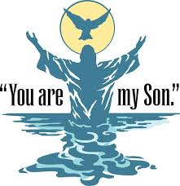

**THEOPHANY**

The Epiphany of Our Lord is one of the major feast days of the calendar. It always falls on January 6, which this year is a Thursday. It would be too early to move its observance back to January 1-2; and if we move it ahead to January 8-9, then we miss a vital minor festival, The Baptism of Our Lord.

The solution, as we have done in the past, is to combine these two festivals into one known as The Theophany of Our Lord. The word “theophany” means, “the revealing of God.” Both through the visit of the magi and the voice from heaven at the Jordan following Jesus’ Baptism, He is shown to be the Son of God for all people, not just for the chosen ones of Israel.

The observance of The Baptism of Our Lord is always a wonderful opportunity for us to remember and explore the meaning of Baptism in our lives. This will be an extra special celebration of these two powerful festivals of the church year that will deepen our understanding of both.



Please accept our great gratitude to all who sent our family Christmas cards and notes. Your prayerful support and wishes of joy and peace in these Days greatly increased our celebration of Christmas. We are ever thankful for our continued partnership in this Gospel ministry.

The Reshan Family

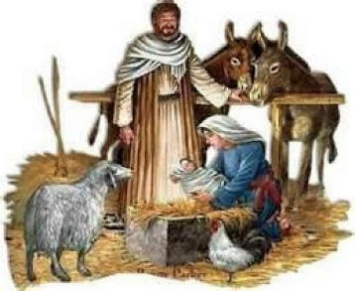 **ADVENT/CHRISTMAS DECORATIONS** 

Once again, we would like to recognize and thank those who so selflessly gave of their time and energy to put up the beautiful decorations that adorned our worship space during Advent and Christmas. As always please make sure that you offer your deep thanks for all their hard work.

Christmas Tree Bob and Karen Kiser; Bill Seedorf; Larry

and Judy Litchford; Wayne and Suzann Dolson; Casey and Brad Neulieb

Advent Log Virginia Murray

Poinsettia plants Virginia Murray; Sue Koziel

Large wooden cross Janet Bakken; Sue Koziel; Karen Steinborn

Garland (outer narthex and Communion railings) Karen Steinborn; Sue Koziel

Window treatments (nave and outside) Mary Knaup

Upper narthex nativity scene and creche Pastor Mark Kloess; Jary Tannehill; Stacie

Crozier

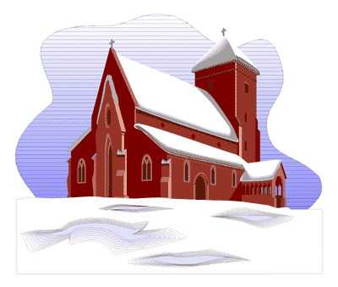

**SNOW EMERGENCY LIST**

This is a reminder of where to turn to learn if worship has been canceled because of inclement weather conditions. There are three ways to learn about the status of the service.

* Tune in to WEFM-95.9 FM to listen for a list of churches who have called off worship.
* Turn to our church and school Facebook page for updated announcements: <https://www.facebook.com/stpaulmichigancity/>.
* Call the church office number (874-7293) and press the “#” key; you will hear a recording about our “open/closed” status.



***&*** ***School Board***

It has been our custom to install our Church Council and School Board on the first Sunday in January, highlighting our newly elected members on both. They were chosen at the November congregational meeting and approved by consensus. Here are the Council members for 2022:

(* indicates a newly elected member):

President Judy Mutchler

Vice-President Paul Brooks

Treasurer Karen Fleming

Secretary Carey Howard

*Fred Hart

*Diane Waltz

*Wayne Dolson

*Susan Bagby

Shirley McCarty

Jim Schraidt

Janet Bakken

Susan Koziel

School Board: Melinda Nagle

Judy Hunt

Pastor Pamela Thiede

Principal Tracey McCay

*Sarah McNabb

We want to offer our deep gratitude to those who have completed their service on Church Council: Bob Kiser; David Pfeiffer; and Donna Bostater.

When you have opportunity, please thank these outgoing Council members and keep our new Council and School Board members daily in your prayers as we strive to lead our church and school communities in these challenging days.

**CHURCH MUSICIANS**

It has also been traditional for us to recognize and install our church musicians on the Second Sunday in January so we will gladly celebrate their great contributions to our worship life on that Day.



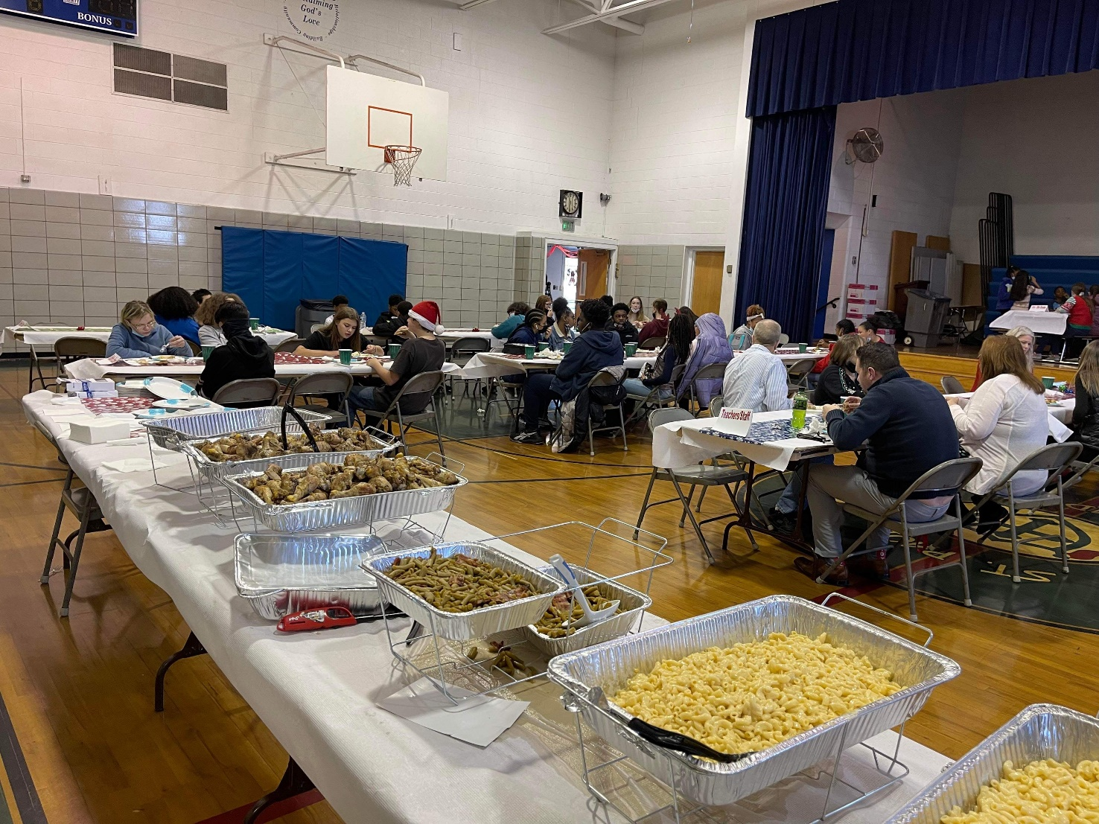

On Thursday, December 16, St. Paul Lutheran School enjoyed a Christmas banquet provided by Judy and Craig Hunt. The menu included grilled chicken legs (thanks, Craig, for all that time at the grill), green beans, macaroni and cheese, mashed potatoes, and Christmas cookies. All the classes had lunch together in the gym, seated by classes; and it truly felt like a family meal. There was enough food left over that each school family received a “take-out box” to take home.

Thanks, also, goes to the basketball team who set up the gym for the meal after their practice on Wednesday, and to the upper grades who cleaned up the gym, including putting away all the tables and chairs, following the meal.

During December, the school classes collected food and clothing to be distributed to agencies serving those in need in our community as well as pet supplies and toys for the Humane Society. All together, our school collected over 1,000 items total! First place for most items collected (and a free breakfast on Friday) went to Second Grade. Seventh Grade came in second.

Great job, students!



We are pleased to announce that St. Paul Lutheran Church has been awarded a $750 I-K Synod Future Church Fund Technology Grant toward audio improvements at church and updated hearing assistance devices. These grants are funded by individuals and congregations through the I-K Synod and beyond who shared gifts with the I-K Synod Future Church Fund in 2020 and 2021.

The note from Rev. Nancy Nyland, our Synod’s Director for Evangelical Mission, notifying us of the grant award, included the following:

Bishop Bill and the rest of the Synod staff give thanks for St. Paul Lutheran and their partnership with the IK Synod. We are grateful for your on-going mission and ministry, especially in the continuing covid-tide. Certainly, many people are being blessed through your congregation.

Thanks be to God for generous people across the IK Synod and beyond who have donated to the IK Synod Future Church Fund. Their generosity has blessed many, including your congregation.

Prayers that the Holy Spirit will stir anew in your congregation as you continue to share Christ’s love within and beyond your community.



**God’s Purls**

The knitting and crocheting group will resume their weekly meetings beginning Wednesday, January 5, 2022, at 10:00 a.m. until noon. The first meeting will be an organizational meeting to confirm the day of the week, time, etc. We will still be able to knit or crochet at that meeting.

Approximately $300 was spent from the Betty Lubke gift to provide yarn for church and community projects, so it should be an exciting and productive year for the group.

We will meet in the St. Paul Room and follow COVID guidelines, i.e., distancing and masking. Everyone is welcome.

   

**Thank you to all who donated poinsettias to beautify our sanctuary at Christmas:**

Jim & Bernadette Krueger in honor of Ryan Krueger and Anna Raul; and in memory of Ed & Mary Losiniecki and Jan & Robert Krueger

Mary Knaup in memory of Victor Herbert, Kathryn Herbert, and Dennis Knaup

Richard & Karen Fleming in memory of their mothers, Mary Knapp & Norma Fleming

Beverly Johnson in honor of family

Paul & Lora Brooks in memory of Dan Reef and Maggie Brooks

Diane Gielow in memory of loved ones

Melinda Nagle in memory of her parents, Randall & Lois Miller, and in honor of her new grandson, Miles Andres

Pastor Pamela Thiede in memory of her parents, Rynold & Evelyn Thiede

Richard Thielman in loving memory of Lori Hall, Norman & Marcella O’Donnell, and Donald & Desolyn Thielman

Nancy Mauman and family in loving memory of her husband, John Mauman; her parents, Dorothy & Wally Liebig; and loved ones

Richard & Pamela Henderson in memory of mother, Suzanne Cains; father, Gary Henderson; and in honor of daughters, Madeline & Audrey

Mike & Marge Bockover in memory of loved ones

Susan Koziel in memory of loved ones and in honor of her children and grandchildren

Don & Beth Thompson in memory of Palmer & Ruth Thompson, Suzanne Cains, and loved ones; and in honor of Richard Cains

Gail Leffew in memory of Paul Leffew

Sandy Robbins in memory of Sonny (Henry) Robbins

Bob & Karen Kiser in memory of loved ones

Maxine Powell in memory of Clint Powell and Connie Hollis

Virginia Murray in memory of loved ones

Carol & Fred Weiss in memory of their son, Donald, and Fred’s sister, Suzanne Cains

Janet Bakken in memory of loved ones and in honor of family and friends

Susan Bagby in memory of her parents, Raymond & Hazel Reiter

Brenda Biggs in memory of her mother, Sue Biggs

Bill & Carol Geleske in memory of Clarence & Leone Lange and Robert & Shirley Lange Timm

Tim & Laura Mellen

Larry & Judy Litchford in honor of all those in the military and all police officers

Chip & Audrey Claussen in memory of parents, Ollie & Josephine Olson; brother, Richard Olson; and parents Edward & Solveig Claussen

Jason & Carey Howard in memory of dad, John Foldenauer and mom, Christine Leslie

The family of Richard Cains in loving memory of wife, mother, and grandmother, Suzanne Cains

Carol Radke in memory of Al Radke



**January Birthdays January Anniversaries**

2 Christopher Michaels 1 Carol & Kenneth Hanft, Sr.

5 Laura Mellen 7 Terry & Linda Wolter

6 Mary Peters 12 Bradford & Kelly Neulieb

JoAnn Kring 14 Richard & Donna Collins

Fred LaBorn 15 Jeffrey & Marla Furness

Louise Muckway

David Schacht

Christian Siebert

7 Mackenzie O’Donnell

9 Susan Bagby

10 Debbie Martin

Jackson Schafer

Donald Thompson

11 Stacie Summers

12 James Burdett Have you noticed the string of

13 Kimberly Sydow blue lights inside the entrance

14 Jessica Avila of the church? They represent

15 Vicki Bergquist St. Paul’s donation to and

18 Micha Howard support of the Boys and Girls

Mark Tannehill Club of LaPorte County.

19 Amy Haring There is a similar string of

Vicki Shelton lights at the school.

23 Jackson Frever

25 Wayne Simerlein

26 Stacie Crozier

27 Anthony Hendricks

28 Elaine Bogart

Eloise Ponder



**IN MEMORY OF RUTH LUBS**

**Capital Improvement Fund** by Wayne & Suzann Dolson

**General Fund** by Janet Bakken, Maxine Powell, Pastor Pamela Thiede, Virginia Murray,

Bob & Karen Kiser, Lyle & Mary Peters, Donna Ottersen, Dan & Sarah McNabb, Joan Seifert,

Jana & Charlie Thomas, Charles & Carol Thomas, Ivye Benson & Verne Lee, Dawn Fitzhugh, Paul & Eileen Domrow, Deb & Randy Koepke, Melinda Nagle, Dave & Nancy Squires,

Scott & Cathy Daley, Kay Peglow & family, Matthew & Janice Dager, Tim & Stacie Crozier, Sharon Hutchcraft & Sheryl Lubke, Barbara Djuvik, Marla Tiebert, Judy Kaczmarek,

Christian & Darlene Terrell, Raynold & Sandy Durre, David & Beverly Lubs

**IN MEMORY OF NORMAN & DOROTHY KRIESEL**

**General Fund** by their granddaughters, Terri & Kristi Milzarek

**IN MEMORY OF ALLEN KRING**

**General Fund** by Terri & Kristi Milzarek; JoAnn Kring and Cindy, Sis, and Steve

**IN MEMORY OF AL RADKE**

**General Fund** by Carol Radke

**IN MEMORY OF SUE BIGGS**

**General Fund** by her husband, Roland Biggs; her children, Brenda Biggs & James Lamm and Brian & Leslie Biggs; her grandchildren, Brad & Kelly Biggs, Brittany & Jeff Intagliata, Zachary Biggs; Rev. Lawrence & Karen Shoberg

**IN MEMORY OF PRISCILLA LADWIG**

**Katie’s Purse** by Kay Peglow & family, Carol Radke

**WELCA** by Jill Keiser & family

**IN MEMORY OF JOYCE MANNING**

**General Fund** by Betty Yourist; William Manning, Jr.; William & Pamela Shrader



**Long-Term Prayer List**

Robert Atwood Sherry Brotsky Laura Eilers-Straight

Jim Gleason Dolores Hackett Terry Hygema

Jess Kalvaitis Christine Kiser Ryan Krueger

Tom & Larry Leuth Ken Mulder Duane Ormsby

George Ottersen Jean Thomas Linda Utley

Chris Weninger



Monday 8:00 a.m. – 5 p.m.

Tuesday 9:00 a.m. – 12:00 noon

Wednesday 8:00 a.m. – 5 p.m.

Thursday 9:00 a.m. – 12 noon

Friday 8:00 a.m. – 12 noon

**St. Paul Lutheran Church & School Staff**

Pastor Mark Reshan

Organist John Remmel

Accompanists Jary Tannehill, Mark Tannehill, Jacob Tannehill

Choir Director Lori Zylstra

Office Secretary Libby Pollock

Custodian Mark Kloess

School Principal Tracey McCay

School Office Coordinator Lisa Heddens

School Custodian Kevin Winkler



**Do You Shop on Amazon?**

**St. Paul Lutheran Church is on Amazon Smile.** 0.5% of all eligible purchases will be returned to St. Paul. Help us spread the word! Link your Amazon account through the following link—https://smile.amazon.com/ch/52-1239301. When prompted, sign into your account to make sure you are choosing St. Paul for Amazon Smile. There’s no extra charge to your purchases.

Thank$ for $haring

Thanks to all who participated in Facebook’s Day of Giving. We received $4,220.00 through your generosity; $715.00 of that was matching funds from Facebook.

Last month we received $158.00 from our Give-Back night at Holly’s. Thanks to all who participated.

This month,we will see you at Galveston! We’re giving you two coupons so you can invite a friend and give them their own coupon. Remember, the coupon is required for the Give-Back bucks.

