January, 2024
MARK: MY WORDS

Epiphany is the “quiet season” of the church year. It lacks the urgency of Advent’s call to “prepare the way of the Lord” and the joyful celebration of the Twelve Days of Christmas. It does not summon us to the searching self-examination of Lent and does not carry the emotional heft of the Three Great Days of Maundy Thursday, Good Friday, and Holy Saturday.
While its festivals of The Epiphany of Our Lord and The Baptism of Our Lord are vitally important to the Church’s life and proclamation, it does not equal Easter’s central good news of the faith that Jesus is alive forever from death. While its color is green like the long season of Pentecost, its call to mission is not as clear as that time of the Spirit. Even its duration is uncertain: depending on the date of Easter it can be as short as five weeks or as long as nine (including The Transfiguration).
So, what is the theme of these weeks? A helpful essay from our ELCA worship resource Sundays and Seasons offers good insight:

Year B gives us the Gospel of Mark as our primary text. In the time after Epiphany, we see the usual bookends of Jesus’ baptism on one end and the transfiguration on the other. These two events mirror each other, the voice of God declaring that this Jesus is God’s beloved son. In the Gospel of Mark, this voice speaks to Jesus in secret at his baptism, with only Jesus (and the reader) hearing the voice from heaven. At the transfiguration, the voice speaks only to Peter, James, and John, after which Jesus instructs them to tell no one until after he has risen from the dead. The “messianic secret” is a primary theme in Mark’s gospel, a theme confusing to many readers and worshipers who wonder why Jesus would prevent demons and disciples alike from speaking such a world-altering truth. Is Jesus’ identity as the Son of God not central to the gospel message? …
…A primary theme throughout this season is calling. God calls Samuel, Jonah, and a prophet to follow Moses. Jesus calls Nathanael, Philip, Simon Peter, Andrew, James, John, and Peter’s mother-in-law (in the Greek, it seems Peter’s mother-in-law gets up and performs a service like that of a deacon rather than that of a waitress). Beginning with remembering our own baptism as we commemorate Jesus’ baptism, we are promised that God is calling us, too. In the passages from 1 Corinthians, we hear Paul’s exhortations to early believers to think of their bodies as temples of the Holy Spirit, to set aside personal concerns in favor of the concerns of others, to exercise their freedoms with humility and in deference to weaker siblings, and to practice a radical empathy that forgoes individual “rights” in favor of solidarity with the plight of others. These exhortations can be taken as our baptismal calling to join the likes of the prophets and apostles in revealing God’s love to the world.
This year, Epiphany runs for seven weeks including The Transfiguration. There will be ample time for us to hear of our calling by God through Baptism to “reveal God’s love to the world.” It may not be as well-known or loved as some other seasons of the church year, but its mission and God’s work through it are no less important.

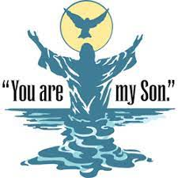
THE EPIPHANY/BAPTISM OF OUR LORD
Once again this year the calendar plays havoc with our observance of two of the important festivals of the church year. The Epiphany of Our Lord, one of the six major feast days (along with Christmas, Easter, the Ascension, Trinity, and Pentecost) falls on Saturday, January 6, this year. Then the church calendar places the observance of The Baptism of Our Lord, a minor festival, on the next day, Sunday, the 7th.
Rather than skip one of these important days, we will combine them as we have done numerous times before and celebrate The Theophany (literally, ‘the manifestation or revealing of God’) on both the 6th and the 7th. There is a long tradition of this solution, particularly in the Orthodox Church, which has celebrated these Days together for centuries.

MUSIC UPDATE
What a difference a year makes. Last January, we were celebrating the completion of the ministries of John Remmel and Lori Zylstra as organist and choir director, respectively. We were thrilled at the beginning of Vernon Carey’s time among us and had discussed plans for special concerts and musical events under his direction.
Then came his heart-breaking and untimely death on Easter morning, and we were back to searching for a replacement. Pastor Tom Fischer seemed to be just what we needed, but his sudden resignation after only a few months left us again without a permanent musician. In the interim periods organist John Carrington and Dan McNabb and pianist Maggie Martin have provided outstanding and inspiring leadership of our singing. Now we are faced for the third time in a year with finding a dedicated staff member.
The situation is not encouraging. Church musicians are few and far between. Dr. Joseph Bognar, chair of the Music Department at Valparaiso University, told me that this is the first time in his thirty years at the University where there are no organ majors and no students that he thought would be interested or qualified for our position.
We have friends who are searching with us and for us and there is a possible lead from a university that I will pursue. In the meantime, we hope that Maggie will be able to continue to play when she is available. Lori Zylstra is graciously helping with the choir during the month of January while her choir at Christ Lutheran in Hammond is on break.
Please keep us in your prayers as we seek yet again for a staff musician. St. Paul has a long and rich history and legacy of outstanding music, and it is our hope and desire to continue that wonderful tradition.

Please accept our great gratitude to all who sent our family Christmas cards and notes. Your prayerful support and wishes of joy and peace in these Days greatly increased our celebration of Christmas. We are ever thankful for our continued partnership in this Gospel ministry.

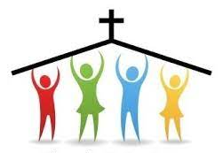
CHURCH COUNCIL
It has been our custom to install our Church Council on the first Sunday in January. However, since the first Sunday will be a full service celebrating The Theophany of Our Lord (see above) and the second Sunday involves the Healing Rite, we will move the installation to the third Sunday, January 21. The Council members were nominated at the November congregational meeting and approved by consensus. Here are the Council members for 2024:

(* indicates a newly elected member):

President Janet Bakken
Vice-President Fred Hart
Treasurer Karen Fleming
Secretary Donna Knoll
*Paul Brooks
Judy Mutchler
Wayne Dolson
Susan Bagby
Bob Kiser
*Diane Egilske
Judy Hunt
Lynne Nevels

We are deeply grateful for their willingness to serve us in this vital leadership position. Please remember them in your prayers, asking for God’s wisdom and guidance as they help us face the challenges we face as a congregation.
We want to thank those who have completed their service: Sue Koziel, Carey Howard, and Diane Waltz.

SNOW EMERGENCY LIST
This is a reminder of where to turn to learn if worship has been canceled because of inclement weather conditions. There are three ways to learn about the status of the service.
- First, you may tune in to WEFM-95.9 FM to listen for a list of churches who have called off worship.
- Second, you may also turn to our church Facebook page: https://www.facebook.com/stpaulmichigancity/ for updated announcements.
- Third, you may call the church office number (219-874-7293) and press the “#” key. You will hear a recording about our “open/closed” status.

MONTHLY MISSIONS UPDATES
January Monthly Mission: January's monthly mission will be for our local YMCA. Our YMCA provides our community with many programs to help youth development, health and well-being, education, and community cohesion. The YMCA offers preschool, school's day out camp, swim lessons, various sport camps, free family events, fitness classes, and so much more. Their scholarship program allows everyone to be a part of the Y! If you would like to support this mission, please place your donation in the offering plate marked for the YMCA. Thank you!

November and December Mission Updates: Thank you for your donations to the La Porte County Deserving Children Charity and our world Mission in the Middle East in the month of November. We collected several toiletry items and $315.

Also, thank you for your support of the Angel Tree in December. We collected lots of toys for our community's kids and were able to donate $117. Your support of these missions each month helps make a positive impact on our community!

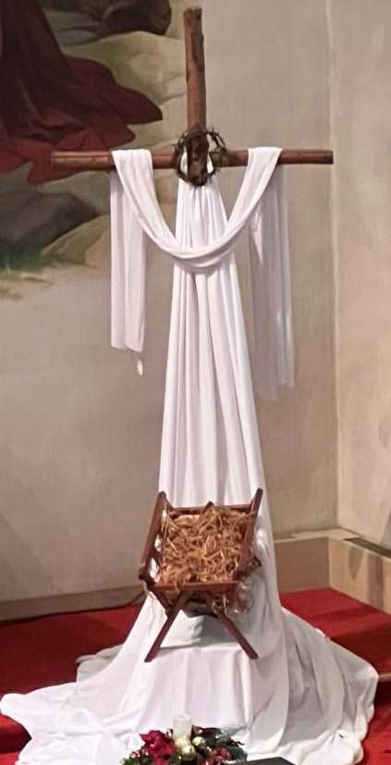
CHRISTMAS DECORATIONS
Thanks to all who worked to help us beautify our building and sanctuary this Advent/Christmas season: Bob and Karen Kiser; Larry and Judy Litchford; Wayne and Suzann Dolson; Kyle Petter; Casey, Kelly and Brad Neulieb; Sue Koziel; Janet Bakken; Karen Steinborn;
Mary Knaup; Pastor Mark Kloess; Jary Tannehill; and Stacie Crozier.

NOVEMBER, 2023, SUMMARY OF ACTIONS
- Pastor is planning to receive new members.
- Senior Communion has been scheduled for December 20 at 9 a.m.
- A suggestion was made to speak with a grant writer in order to obtain funds for a new playground.
- The architectural tour will take place November 26. Ninety people have signed up to tour St. Paul as well as other churches in Michigan City.
- Donna Knoll offered to assist Paul Brooks with the St. Paul Facebook page to add daily devotions and other thoughts.
Please note that copies of Council meetings are placed in the Narthex after approval at the monthly meetings.

IN LOVING MEMORY OF GRANDPARENTS, NORMAN & DOROTHY KRIESEL; DEAR FRIEND ALLENKRING; AND FATHER & GRANDFATHER, ROGER MILZAREK
General Fund from Terry & Kristi Milzarek

IN MEMORY OF HUSBAND, ROGER MILZAREK
General Fund from Norma Milzarek

IN MEMORY OF OUR PARENTS AND SIBLINGS
General Fund from Tim & Laura Mellen

IN MEMORY OF OUR ALLEN KRING
General Fund from JoAnn Kring

POINSETTIA MEMORIALS 2023
In memory of my husband, Ron Johnson from Beverly Johnson
In memory of my husband, Lee Timm from Sally Timm
In memory of my husband, Sonny (Henry) Robbins from Sandy Robbins
In memory of Don Reef, Elmo Elliot from Lora Brooks
In memory of Roger Milzarek from Norma Milzarek
In memory of loved ones from Sherry Payne
In memory of loved ones from Virginia Murray
In memory of loved ones from Chip & Audrey Claussen
In loving memory of Mother, Joyce Peters Manning, and Father, Bill Manning, from Bethany Manning
In memory of my husband, Joseph; and my parents, Roger & Lucille Storey from Sue Koziel
In honor of loved ones from Mike & Marge Bockover
In memory of Maxine & Clinton Powell from Rev. Ralph & Gayle Kuespert
In memory of loved ones from David & Nancy Squires
In memory of Irving & Pearl Carlson from Ivye Benson & Verne Lee
In memory of loved ones from Jim & Bernadette Krueger
In memory of Carol and Donald Weiss from Fred Weiss
In memory of Ronald Johnson from his daughters, the Johnson Women
In memory of our parents, Clarence Crozier & Patsy Crozier Humbers; and Harry Fisch & Lucille Fisch from Tim and Stacie Crozier
In memory of Paul Leffew from Gail Leffew

January Birthdays January Anniversaries

5 Laura Mellen 1 Kenneth & Carol Hanft, Sr.
6 Fred LaBorn 3 Daniel & Andrea Ottersen
JoAnn Kring 12 Bradford & Kelly Neulieb
9 Susan Bagby 14 Richard & Donna Collins
10 Donald Thompson 15 Jeffrey & Marla Furness
Debbie Martin
David Zummak
11 Stacie Summers
12 James Burdett
18 Mark Tannehill
25 Wayne Simerlein
26 Stacie Crozier
28 Elaine Bogart

Long-Term Prayer List

Julie Brooks Laura Dovey Marla Furness
Sue Granacki Jim Gleason Dolores Hackett
Jayla Jacobi Jess Kalvaitis Christine Kiser
Kay Kleinschmidt Pastor Al Lorentzen Bethany Manning
Christian Martinez Kim Mitchell Virginia Murray
Shane Nevels Jan Paholski Kay Peglow
Barbara Reichert Joan Seifert Jary Tannehill
Mark Tannehill Kathy Thielman Jana Thomas
Margie Torres Venia Wendt Janice White
Brian Wiseman

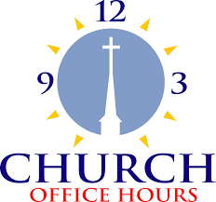
Monday 8:00 a.m. – 5 p.m.
Tuesday 9:00 a.m. – 12:00 noon
Wednesday 8:00 a.m. – 5 p.m.
Thursday 9:00 a.m. – 12 noon
Friday 8:00 a.m. – 12 noon

St. Paul Lutheran Church Staff
Pastor Rev. Mark Reshan
Secretary Libby Pollock
Accompanists Jary Tannehill, Mark Tannehill, Jacob Tannehill
Custodian Mark Kloess

Thank$ for $haring
Thank you to all who participated in our monthly Give Backs. In November, we raised $185 at Galveston. Last month, we raised $240 at Holly’s.
This month,we will see you at Leeds Public House on Wednesday, January 17! Here are two coupons: one for you and one for a friend.

