

July, 2021

**MARK: MY WORDS**

The first step has been accomplished. We have returned to in-person worship on a weekly basis. Singing and speaking responses are allowed and encouraged. Communion is offered at each service now with both bread and wine again. The choir has returned, and the band is accompanying and leading our music. At the spring congregational meeting on June 13, we met in the St. Paul Room for the first time in 16 + months and had refreshments. As of this writing, the Church Council will be taking up the issue of whether to continue to require masks when we meet.

For all of that, we give thanks and praise to God. Many of those were major steps in our efforts to return to “normal” congregational life. And after all the stress and worry and fear that we have been through during the pandemic, it would be understandable and natural for us to desire some time to “settle in” and just enjoy these blessings we have received.

That will easily happen. Summertime in most congregations, including ours, is usually a “down time” when not much outside of weekly worship takes place. People are gone on vacation, committees take time off from meeting, and everyone recharges, both from the busyness of the previous months and in preparation for resuming activities and ministries in the fall.

But as I have been writing and saying in sermons these last months, we need now to move forward. It is not enough for us simply to be back together. As this season of Pentecost, the time of ‘the mission of the Church,’ reminds us, God is always calling us beyond our walls, beyond ourselves, beyond what is safe and comfortable to be about His work in the community and world around us.

Before we can do that, however, there are two questions that I believe we need to answer. First, what *is* that work? We know the situation. Our school remains the primary way in which we reach out to our neighborhood and community to care for children and families who are not part of our congregation. That remains no small work. Many of the children who attend the school are here because they have fallen behind in the public schools and need more individual attention or have been harassed or bullied and need a safe place in which to learn and grow and thrive.

But with our work with men and women’s homeless shelter now done and our continued hiatus from the community soup kitchen ministry (see below), we are left without any other clear objects of ministry. That will take some deliberate meeting, praying, discerning, and working to establish.

From such work arises the second question: once we identify to what we believe God is calling us to do in and for those around us, do we have the will for that work? That is, are members of the congregation willing to offer their time and gifts for such ministry? You recall that five or six years ago we went through a thorough, two-year process of strategic planning. We identified three major areas of ministry to which we believed God was summoning us. And while some of those “planks” of the plan were at least attempted to be implemented, much of what we did remains gathering dust on the pages of our document.

Those two questions need to be addressed by our Council. In the next months, we will take them up and report back to you. In the meantime, search your heart. What time and effort and energy are *you* able to offer whatever ministries on which we decide? Without a sense of movement and mission, we will grow stale and stagnate.

Neither God nor we want that for us.

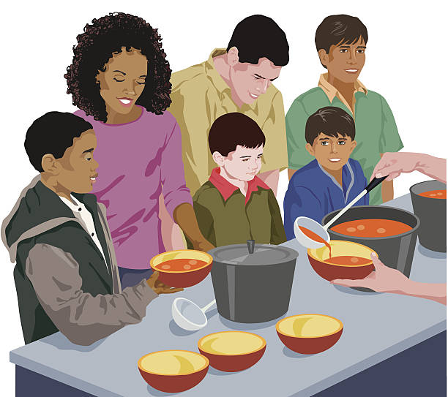

**SOUP KITCHEN UPDATE**

In mid-June I met with Erik Tannehill, Pastor Nancy Nichols of First United Methodist Church, and one of their soup kitchen volunteers. Pastor Kilbourne-Parkinson of First Presbyterian was unable to attend. We discussed the current situation of the ministry and what the future might hold, particularly whether there was a role for St. Paul to participate once again.

To summarize: because they are currently serving a good number of guests who are not vaccinated and those who do not want to wear a mask, it was felt that the current arrangement of working mostly out of First United should remain in place for the foreseeable future. I believe that First Presbyterian is serving meals one or two days a week. First United Methodist has found a way of working around the people who have resisted the shots/masks and did not think that it was fair to ask another congregation to do the same at this time.

As far as future plans, there was no firm decision. Erik reaffirmed that he is willing to try and re-start the program at St. Paul, but the concern is whether there would be enough teams of volunteers to make it run. You may recall that when we shut down in spring of 2019 there was only one regular team staffed by members of St. Paul. Other teams were volunteers from the community, many of whom, he said, have moved on to other opportunities for service.

So for now the program will remain at First United. It was agreed that we would meet again mid-summer to assess where it stood and whether we would try and bring it back to us. An update will be reported following that meeting.



**ORDINATION RECEPTION**

As published in last month’s edition, the congregation of Christ Lutheran in Hammond is planning a reception to honor Pastor Dale Zylstra’s ordination to the ministry of Word and Sacrament. It will be held on **Sunday, July 11 from 1:00-3:00 pm.** at Andorra Banquets, 1112 US 41, Schererville. Price is $25 for adults; $15 for children under 12. A cash bar will be available. Checks should be made to: Christ Lutheran Church and should accompany reservations. Their mailing address is: 7051 Indianapolis Blvd., Hammond, 46324. There is probably still time to make reservations if you are interested in attending and have not yet done so.

We are in the process of finalizing a date and time for our congregation to celebrate his ordination and will announce that information when it is set.



**BLOOD DRIVE**

We are again sponsoring a blood drive with the Red Cross on **Tuesday, July 27. from 1:30-6:00 p.m.** in the St. Paul Room. Please register on their website [www.redcross.org](http://www.redcross.org) or by calling their 800 number (800-733-2767). Your donation helps many in need. Please consider participating in this blood drive. We will be following all of the Covid-19 guidelines that are in place at that time.



**FOURTH OF JULY**

Since the Fourth falls on a Sunday this year, there will be no closure of the church office around its date. The office will be open on Friday, the 2nd, from 8:00-noon and on Monday, the 5th, from 8:00-5:00 as usual.



**GOD’S PURLS**

The members of the knitting and crocheting group decided at their last meeting to cancel our weekly meetings until the fall. Notice will be given later in the summer as to when our next meeting will be held.

We knit and crochet prayer shawls, prayer squares, lap robes, scarves, hats, mittens, etc. These items are given to shut-ins through the St. Paul Sunshine Basket Ministry, the school children at our school and public schools, and the homeless.

Yarn and other supplies can be provided through a gift in memory of Betty Lubke. We ask that any people who knit or crochet keep God’s Purls in mind and continue this ministry at home during the summer months.

See you in the fall!!!



**SYNOD ASSEMBLY 2021**

I would like to thank the Church Council for allowing me to be the female voting member at the 2021 Synod Assembly representing St. Paul Lutheran Church.  As with everything in the last 14 months, meetings are on some virtual platform.  I have only had to be part of this experience a few times, so I am definitely not comfortable with it.  However, I was able to join the three platforms that the Synod used.  Not being familiar with how things go virtually, I was a bit frustrated at the dead space between speakers, I was uncomfortable joining the written conversation, but I was comfortable with the voting. My overall take away was that the Indiana- Kentucky Synod (IK Synod), sometimes referred to as the IK Mission Territory, is identifying what has worked to keep God’s word alive during the pandemic and building on that to move the church forward, no talk about going back to how it used to be.  A lot has changed in our Covid- 19 world and WE ARE CALLED to move the Church forward.

The 2021 Assembly was an experience for me, but I hope that the 2022 Synod Assembly will be an in-person experience.



**WE’RE LOOKING FOR A FEW GOOD TEACHERS**

St. Paul Lutheran School is looking for some teachers for the upcoming school year. Two positions are for the 5th through 8th grades. We need one teacher for math and religion and another teacher to cover science, health, and computers. We are also looking for a part-time teacher who will teach art in all grades. If you know of a good teacher who could fill any of these positions, please encourage them to send their resume to our School Board President, Judy Hunt, at [judyhunt103@yahoo.com](mailto:judyhunt103@yahoo.com).



Some folks have been asking about the Luther Rose on the ends of our pews and what it means.

Here is how Luther himself explained its meaning:

*First, there is a black cross in a heart that remains its natural color. This is to remind me that it is faith in the Crucified One that saves us. Anyone who believes from the heart will be justified (Romans 10:10). . . . The heart should stand in the middle of a white rose. This is to show that faith gives joy, comfort, and peace—it puts the believer into a white, joyous rose. Faith does not give peace and joy like the world gives (John 14:27). This is why the rose must be white, not red. White is the color of the spirits and angels (cf. Matthew 28:3; John 20:12). This rose should stand in a sky-blue field, symbolizing that a joyful spirit and faith is a beginning of heavenly, future joy, which begins now, but is grasped in hope, not yet fully revealed. Around the field of blue is a golden ring to symbolize that blessedness in heaven lasts forever and has no end. Heavenly blessedness is exquisite, beyond all joy and better than any possessions, just as gold is the most valuable and precious metal.*

(From: Letter from Martin Luther to Lazarus Spengler, July 8, 1530 [WA Br 5:445]; tr. P. T. McCain)

**DO NOT DELAY**

**Volunteer today!**



**LaPorte County**

Together we can deliver

**IMMEDIATE NEEDS:** Substitute drivers needed in Michigan City

and LaPorte locations

**Mondays:** Michigan City Route 10

**Wednesdays:** LaPorte ROLLING MEADOWS route

LaPorte Route 4

**Thursdays:** LaPorte Route 2

Pick up meals in LaPorte at 620 Boston Street at 11:00 a.m.

Pick up meals in Michigan City at 301 E. Eighth Street at 11:00 a.m.

***RSVP*** program available for volunteers over 55 years old,

up to 100 miles rembursed monthly

It takes a community to care for its own. A commitment of **ONE** hour a week can make a difference! All you would need to be a LaPorte County Meals on Wheels volunteer is a desire to make the world better. Meals on Wheels not only provides a nutritious hot meal to the homebound but also provides a reassuring “check in” on those who live alone. Monday through Friday meal deliver is totally dependent on voluntters to help keep this community program alive and vital. Volunteers are needed for Michigan City, LaPorte, Westville, and South County routes.

Contact Meals on Wheels at 219-872-9117 or 219-369-6453

[www.laportecountymealsonwheels.org](http://www.laportecountymealsonwheels.org)

[lpcomow@laportecountymealsonwheels.org](mailto:lpcomow@laportecountymealsonwheels.org)



**July Birthdays July Anniversaries**

2 Edward Werner 1 Chip & Audrey Claussen

3 Christian Scheuchner Wayne & Milenda Simerlein

4 Amy Petri 3 David & Nancy Squires

6 David Squires 9 Dan & Sarah McNabb

Donna Sutor 17 Allen & JoAnne Sydow

8 Al Green 18 Mike & Amy Maesch

Diane Waltz 21 Mark & Judy Reshan

10 Elizabeth Thompson 28 Charles & Jana Thomas, Sr.

11 Warren Schacht

12 Norma Milzarek

13 Warren Glanz

14 Craig Hunt

15 Kyle Neulieb

18 Al Lorentzen

20 Bev Johnson

Nicholas Neulieb

Kathleen Pliske

21 Allen Sydow

23 Irene Bohnstadt

24 Zachary Petri

25 Bernadette Krueger

28 Grace Romine

29 Charles Thomas II



St. Paul Church will be holding a raffle on August 7, 2021. First prize will be a $500 gift card from Meijer; second prize will be a $400 Amazon gift card; and third prize will be a $250 gift card from Meijer.   Meijer graciously donated both Meijer gift cards.  Raffle tickets will cost $10.00 for a chance to win any one of these prizes. In the near future, church members will be asked to take some raffle tickets and sell them to family, friends, neighbors, and co-workers to help us have a successful fundraiser. Watch for more information.



**IN MEMORY OF CAROL MARTY ON HER BIRTHDAY**

**Capital Improvement Fund** by Gene Marty

**IN MEMORY OF MY BROTHER, ALLEN KRING,**

**ON HIS JUNE 11TH BIRTHDAY**

**General Fund** by Susan & Al Green

**IN MEMORY OF MARY LOSINIECKI**

**General Fund** by Phil & Sue Smithmeyer

**IN HONOR OF PASTOR DALE ZYLSTRA’S ORDINATION**

**General Fund** by Maxine Powell

**IN HONOR OF OUR MOTHER, BEV JOHNSON**

**General Fund** by The Johnson Women



**It is time to look alive!**

To that end, the Church Council has approved the idea of participating in the Uptown Taste of Michigan City.  On First Friday, August 6, and for the boat parade on Saturday, August 7, we will be charging a fee to park in our parking lot.  We also plan to sell popcorn and some other food items. Volunteers will be needed to make this work, so we are counting on everyone to help.  
Watch the church bulletin and listen for announcements as this idea takes shape and comes alive.



**Do You Shop on Amazon?**

**St. Paul Lutheran Church is on Amazon Smile.** 0.5% of all eligible purchases will be returned to St. Paul. Help us spread the word! Link your Amazon account through the following link—https://smile.amazon.com/ch/52-1239301. When prompted, sign into your account to make sure you are choosing St. Paul for Amazon Smile. There’s no extra charge to your purchases.

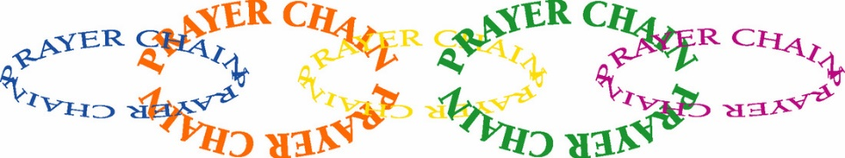

**PRAYER CHAIN**

The members of the Prayer Chain at St. Paul have made a commitment to pray for any and all who request their prayers. Let us pray for you! To activate the Prayer Chain, contact one of the members on the list below and tell her of your need. You may give as much informtion as you wish. Your request will be kept in strict confidence.

Prayer request forms are also available in the pew racks during worship. These forms include prayer categories such as Healing, Comfort, Guidance, etc. Simply fill out the form (please include the date of your request) and place it in the offering plate or hand it to a deacon. The form will be forwarded to a Prayer Chain member. When using the e-mail addresses, please note “Prayer Chain Request” on the subject line. If the subject line is not filled in, the e-mail will not be opened

**Vivian Zellers** 872-8780 [vteach2006@sbcglobal.net](mailto:vteach2006@sbcglobal.net)

**Carrie Ziesmer** 872-6541 [carrie124@comcast.net](mailto:carrie124@comcast.net)



**Long-Term Prayer List**

Robert Atwood Sherry Brotsky Laura Eilers-Straight

Jim Gleason Andy Hipskind Terry Hygema

Jess Kalvaitis Ryan Krueger Tom & Larry Leuth

Duane Ormsby Jean Thomas Linda Utley

Chris Weninger

**OFFICE HOURS**

Monday 8:00 a.m. – 5 p.m.

Tuesday 9:00 a.m. – 12:00 noon

Wednesday 8:00 a.m. – 5 p.m.

Thursday 9:00 a.m. – 12 noon

Friday 8:00 a.m. – 12 noon

**St. Paul Lutheran Church & School Staff**

Pastor Mark Reshan

Organist John Remmel

Accompanists Jary Tannehill, Mark Tannehill, Jacob Tannehill

Choir Director Lori Zylstra

Office Secretary Libby Pollock

Custodian Mark Kloess

School Principal Christy Smith

School Office Secretary Tracey McCay

Thank$ for $haring

The Galveston Give-Back in May raised $185. Thank you for participating in this event.

This month,we will see you at Holly’s! Remember to cut out this coupon, because it is required for the Give-Back bucks.

