**THE FOURTH SUNDAY AFTER PENTECOST**

**June 20, 2021**

Why therefore are you troubled, O you of little faith? If you have known me to have power on the land, why do you not believe that I have power also upon the sea? If you believe me to be God, the Creator of all things, why do you not also believe that the things which I have made are subject to my power? Why do you doubt, O you of little faith?

Now rising up he commands, and there comes a great calm. He commands the winds and the sea as their Lord, and, for the first time, in the presence of the disciples, so that hearing him command them they would be confirmed in their faith. Upon a sea tossed about and swollen by a great wind, and a great tempest, there comes a great calm. It was befitting that he that is mighty should do great things. And so, girt with mighty power, he shakes the sea to its depth: and again, showing the splendor of his might, he commands that there shall arise a great calm, so that the apostles, who had feared exceedingly, being now delivered might rejoice.

By means of all these happenings the Lord gave us a figure and image of his teaching, so that we might be patient in the face of every storm and persecution; that we may be steadfast; that we betray not our faith. And if all this world should boil up as the sea, and rise in fury against us, though on every side there should rage the winds and the whirlpools of the demons ... yet, be not afraid; be not troubled; do not tremble; do not yield.

For as many as are in the little ship of faith are sailing with the Lord; as many as are in the bark of holy church will voyage with the Lord across this wave-tossed life; though the Lord himself may sleep in holy quiet, he is but watching your patience and endurance, looking forward to the repentance and to the conversion of those who have sinned.

**Origen**

**Second century**

***✠ In the Name of Jesus✠***

**✠ GATHERING ✠**

**INTRODUCTION**

Now is the acceptable time; now is the day of salvation! Now we are in the storm, the boat almost swamped; but Jesus is here now, and when we call him he will calm the storm. Even the wind and waves listen to him as they would to their creator. We also listen to him and are called to believe in the power of God's word in him, a power greater than all that we fear.

**Onesimos Nesib, translator, evangelist, died 1931**

*Onesimos was born in Ethiopia. Captured and taken as a slave to Eritrea, he was there freed by Swedish missionaries. He translated the Bible into his native Oromo and returned to preach there.*

**PRELUDE**  *Rejoice, Ye Pure in Heart Arranged by* John Innes

**ANNOUNCEMENTS**

*As you are able please rise*

**CONFESSION AND ABSOLUTION**

P: In the name of the Father and of ✠the Son and of the Holy Spirit.

C: **Amen.**

P: “At any acceptable time I have listened to you,

C: **and on a day of salvation I have helped you.”**

P: “See, now is the acceptable time; see, now is the day of salvation.” (2 Corinthians 6:2).

Confident that God will again listen to our supplications, let us confess our sins against

God and one another, that on this “day of salvation” we may again know the help of

God’s mercy.

*Silence for self-examination and reflection is kept*

P: Most merciful God,

C: **We confess that we have sinned against You and one another in thought, word,**

**and deed. We are guilty of not trusting You to guide and protect us. When the**

**“storms of life” threaten to “swamp” us we are fearful and anxious. (Mark 4:38)**

**We do not believe that You notice or care that we are being overwhelmed. We**

**ask for Your forgiveness that often we “still have no faith.” (4:40) Help us to see**

**that each day is a “time of salvation,” (2 Corinthians 6:2) that we may respond to**

**Your gracious help with joy, trust, and hope.**

P: “Let (all those whom the LORD has redeemed) give thanks to the LORD for His mercy,

and the wonders He does for His children.” (Psalm 107:31) God’s mercy is abundant

this Day, for He rescues you still: as a called and ordained minister of the Church of

Christ, and by His authority, I therefore declare to you the entire forgiveness of all your

sins, in the name of the Father and of ✠ the Son and of the Holy Spirit.

C: **Amen.**

**THE GATHERING HYMN 756** *Eternal Father, Strong to Save*  page 11

**THE GREETING AND PRAYER OF THE DAY**

P: The grace of our Lord Jesus Christ, the love of God, and the communion of the Holy

Spirit be with you all.

C: **And also with you.**

P: Let us pray. O God of creation, eternal majesty, You preside over land and sea, sunshine

and storm. By Your strength pilot us, by Your power preserve us, by Your wisdom

instruct us, and by Your hand protect us, through Jesus Christ, our Savior and Lord.

C: **Amen.**

*The assembly is seated*

**✠ WORD ✠**

**FIRST READING Job 38:1-11**

*Confronted with great suffering, Job attempts to prove his innocence to God. God speaks from the whirlwind, and speaks of the power of the sea and its waves. A series of ironical*

*questions shows that Job, as a finite human, is incapable of judging the Creator.*

The LORD answered Job out of the whirlwind:

2 "Who is this that darkens counsel by words without knowledge?

3Gird up your loins like a man,

I will question you, and you shall declare to me.

4 "Where were you when I laid the foundation of the earth?

Tell me, if you have understanding.

5Who determined its measurements--surely you know!

Or who stretched the line upon it?

6On what were its bases sunk,

or who laid its cornerstone

7when the morning stars sang together

and all the heavenly beings shouted for joy?

8 "Or who shut in the sea with doors

when it burst out from the womb?--

9when I made the clouds its garment,

and thick darkness its swaddling band,

10and prescribed bounds for it,

and set bars and doors,

11and said, 'Thus far shall you come, and no farther,

and here shall your proud waves be stopped'?"

A: The Word of the Lord.

C: **Thanks be to God.**

**THE PSALM: Psalm 107:1-3, 23-32** Read responsively

1Give thanks to the LORD, for the LORD is good,

     for God's mercy endures forever.

**2Let the redeemed of the LORD proclaim**

**that God redeemed them from the hand of the foe,**

3gathering them in from the lands;

     from the east and from the west, from the north and from the south.

**23Some went down to the sea in ships,**

**plying their trade in deep waters.**

24They beheld the works of the LORD,

     God's wonderful works in the deep.

**25Then God spoke, and a stormy wind arose,**

**which tossed high the waves of the sea.**

26They mounted up to the heavens and descended to the depths;

     their souls melted away in their peril.

**27They staggered and reeled like drunkards,**

**and all their skill was of no avail.**

28Then in their trouble they cried to the LORD,

     and You delivered them from their distress.

**29You stilled the storm to a whisper**

**and silenced the waves of the sea.**

30Then were they glad when| it grew calm,

     when You guided them to the harbor they desired.

**31Let them give thanks to You, LORD, for Your steadfast love**

**and Your wonderful works for all people.**

32Let them exalt You in the assembly of the people;

     in the council of the elders, let them sing hallelujah!

**SECOND READING 2 Corinthians 6:1-13**

*Paul writes of the great hardships and calamities that he has faced, yet he is able to rejoice because what appears to be loss is great gain.*

As we work together with Him, we urge you also not to accept the grace of God in vain. 2For He says,

"At an acceptable time I have listened to you,

and on a day of salvation I have helped you."

See, now is the acceptable time; see, now is the day of salvation! 3We are putting no obstacle in anyone's way, so that no fault may be found with our ministry, 4but as servants of God we have commended ourselves in every way: through great endurance, in afflictions, hardships, calamities, 5beatings, imprisonments, riots, labors, sleepless nights, hunger; 6by purity, knowledge, patience, kindness, holiness of spirit, genuine love, 7truthful speech, and the power of God; with the weapons of righteousness for the right hand and for the left; 8in honor and dishonor, in ill repute and good repute.

We are treated as impostors, and yet are true; 9as unknown, and yet are well known; as dying, and see--we are alive; as punished, and yet not killed; 10as sorrowful, yet always rejoicing; as poor, yet making many rich; as having nothing, and yet possessing everything.

11We have spoken frankly to you Corinthians; our heart is wide open to you. 12There is no restriction in our affections, but only in yours. 13In return--I speak as to children--open wide your hearts also.

A: The Word of the Lord.

C: **Thanks be to God.**

*As you are able to please rise*

**THE VERSE (Sung twice) page 5**

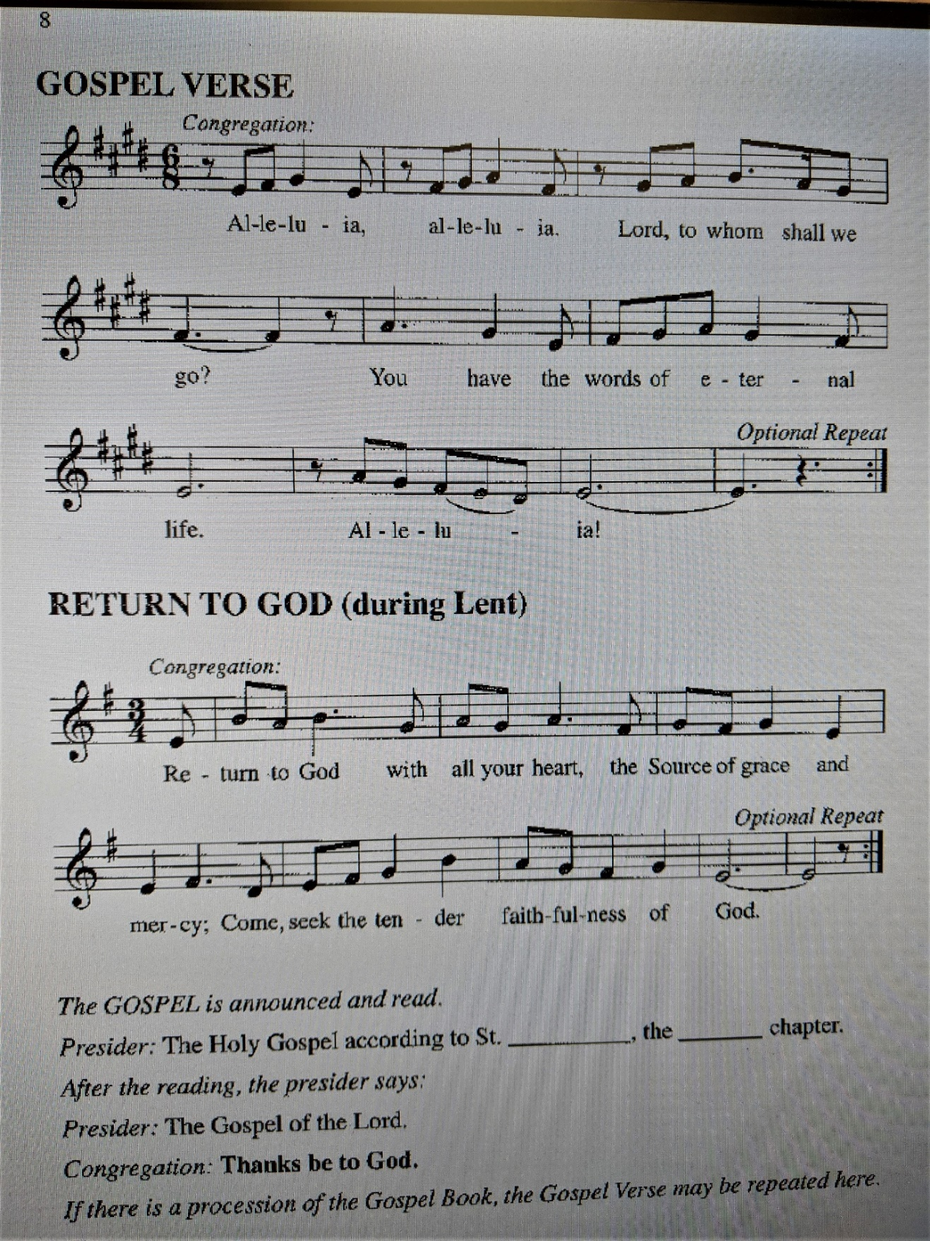

**THE HOLY GOSPEL Mark 4:35-41**

*Jesus' calming of the storm on the sea reveals his power over evil, because the sea represents evil and chaos. The boat on the sea is a symbol of the church, and invites us to trust God amid life's turbulence.*

P: The Holy Gospel according to St. Mark, the fourth chapter.

C: **Glory to You, O Lord!**

When evening had come, Jesus said to the disciples, "Let us go across to the other side." 36And leaving the crowd behind, they took Him with them in the boat, just as He was. Other boats were with Him.

37A great windstorm arose, and the waves beat into the boat, so that the boat was already being swamped. 38But He was in the stern, asleep on the cushion; and they woke Him up and said to him, "Teacher, do You not care that we are perishing?"

39He woke up and rebuked the wind, and said to the sea, "Peace! Be still!" Then the wind ceased, and there was a dead calm. 40He said to them, "Why are you afraid? Have you still no faith?" 41And they were filled with great awe and said to one another, "Who then is this, that even the wind and the sea obey Him?"

P: The Gospel of the Lord.

C: **Praise to You, O Christ!**

*The assembly is seated*

**THE SERMON**

*Silence for reflection is kept following the sermon*

*As you are able to please rise*

**THE HYMN OF THE DAY 773** *Precious Lord, Take My Hand*  page 12

**THE APOSTLES’ CREED**

P: God has made us His people through our Baptism into Christ. Living together in trust

and hope, we confess our faith.

C: **I believe in God, the Father almighty,**

**creator of heaven and earth.**

**I believe in Jesus Christ, His only Son, our Lord.**

**He was conceived by the power of the Holy Spirit**

**and born of the virgin Mary.**

**He suffered under Pontius Pilate,**

**was crucified, died, and was buried.**

**He descended into hell.**

**On the third day He rose again.**

**He ascended into heaven,**

**and is seated at the right hand of the Father.**

**He will come again to judge the living and the dead.**

**I believe in the Holy Spirit,**

**the holy catholic church,**

**the communion of saints,**

**the forgiveness of sins,**

**the resurrection of the body,**

**and the life everlasting. Amen.**

**THE PRAYER OF THE CHURCH**

A: As we find ourselves in a storm-tossed world, let us gather our concerns and intercede

for the Church, the world, and all those in need.

A: For patience and strength to weather the squalls that wake us to God’s presence, let us

pray to the Lord:

C: **Lord, have mercy.**

A: For peace and calm in Nigeria, Nicaragua; between Palestinians and Israelis; and all

places of turmoil, and violence, let us pray to the Lord:

C: **Lord, have mercy.**

A: For the compassion and hospitality to make this congregation a haven of help and hope

to those swamped by the storms of life, let us pray to the Lord:

C: **Lord, have mercy.**

A: For all fathers and those who give fatherly care, that they may be strengthened to nurture

and guide children with wisdom, gentleness, compassion, and grace: let us pray to the

Lord:

C: **Lord, have mercy.**

A: For those who are anxious or depressed, sick or suffering, especially **…** may know the

peace and stillness of Christ, let us pray to the Lord:

C: **Lord, have mercy.**

A: For those celebrating birthdays, especially **Beverly Coburn; Diane Gielow; Lou Ann**

**Shebel; and Muriel Jacobi;**  and anniversaries, especially **Lee and Sally Timm;**

**George and Donna Ottersen; and Bill and Pam Hackett** that they may be filled with

grace this day and every day and grow in grace in the days ahead, let us pray to the

Lord:

C: **Lord, have mercy.**

A: For those who have gone before us in the faith and are at rest in Christ, especially

**Onesimus Nesib,** whom we commemorate this Day, we give thanks. That we may

remain firm in faith in Jesus until the Day when all storms are stilled, all tears and

wiped away, and death and sorrow are no more, let us pray to the Lord:

C: **Lord, have mercy.**

P: Compassionate God, we thank You for being with us through the fury and calm of our

life’s voyage, for revealing Your care to us, and for drawing us to Your new life. Hear

our prayers for the sake of Your Son, Jesus Christ our Lord.

C: **Amen.**

**✠ MEAL ✠**

**THE PEACE**

P: The peace of the Lord be with you always.

C: **And also with you.**

*The assembly is seated*

**THE VOLUNTARY** *Faith of Our Fathers Arranged by* Smith and Hustad

*As you are able please rise*

**THE OFFERTORY PRAYER**

A: Let us pray. Eternal God,

C: **Our hearts are wide open to You in thanksgiving for all Your abundant mercies.**

**Receive these gifts we bring, and by this holy Sacrament, strengthen our little**

**faith. We ask this in the name of Jesus the Lord. Amen.**

**THE GREAT THANKSGIVING**

P: The Lord be with you.

C: **And also with you.**

P: Lift up your hearts.

C: **We lift them to the Lord.**

P: Let us give thanks to the Lord our God.

C: **It is right to give Him thanks and praise.**

P: Holy God, Lord of earth and seas, we bless and praise You.

From chaos and darkness You created life and light.

You made Israel Your own to bring Your blessings of life to all the world.

You redeemed them from the hands of their foes, and sent prophets to renew

Your covenant of life and hope

Faithful God, in Christ You speak to us amid the storm of our fear and dwell with us

when our faith is weak.

You are with us even when we lament our peril and doubt our destiny.

Come upon Your Church today in the power of Your Spirit that Your people may be

reborn as children of hope and courage and endurance.

Send that same Spirit upon this bread and cup, that we may find in them the joy of Your

presence and they may be for us the Body and Blood of Your Son, Jesus Christ,

Who … “Do this for the remembrance of Me.”

As often as we eat ... we proclaim the Lord’s death until He comes.

C: **Christ has died. Christ is risen. Christ will come again.**

P: Sustaining God, inspire all whom You call to serve you to realize that now is the day

of salvation.

Infuse Your Church with purity, knowledge, patience, kindness, holiness of spirit,

and genuine love.

When Your disciples face afflictions, hardships, calamities, imprisonments, and

hunger, make them possessors of all things in You

Until that Day when dishonor and distrust and death are no more, and Your Spirit

fills Your creation with the glory of Your risen Son, eternal Father,

now and forever.

C: **Amen!**

**THE LORD’S PRAYER**

P: Because in Christ we have received the Spirit of adoption, as daughters and sons of God

we dare to pray:

C: **Our Father in heaven, hallowed be Your name. Your Kingdom come. Your will**

**be done on earth as it is in heaven. Give us this day our daily bread, and forgive**

**us our sins as we forgive those who sin against us. Save us from the time of trial**

**and deliver us from evil. For the Kingdom, the power, and the glory are Yours,**

**now and forever. Amen.**

**INVITATION TO THE MEAL**

P: This is the Lamb of God Who takes away the sin of the world. Blessed are those who

are called to the Supper of the Lamb. God’s holy gifts for God’s holy people. Come,

for all is now ready.

*The assembly is seated*

**DISTRIBUTION “Lamb of God”**

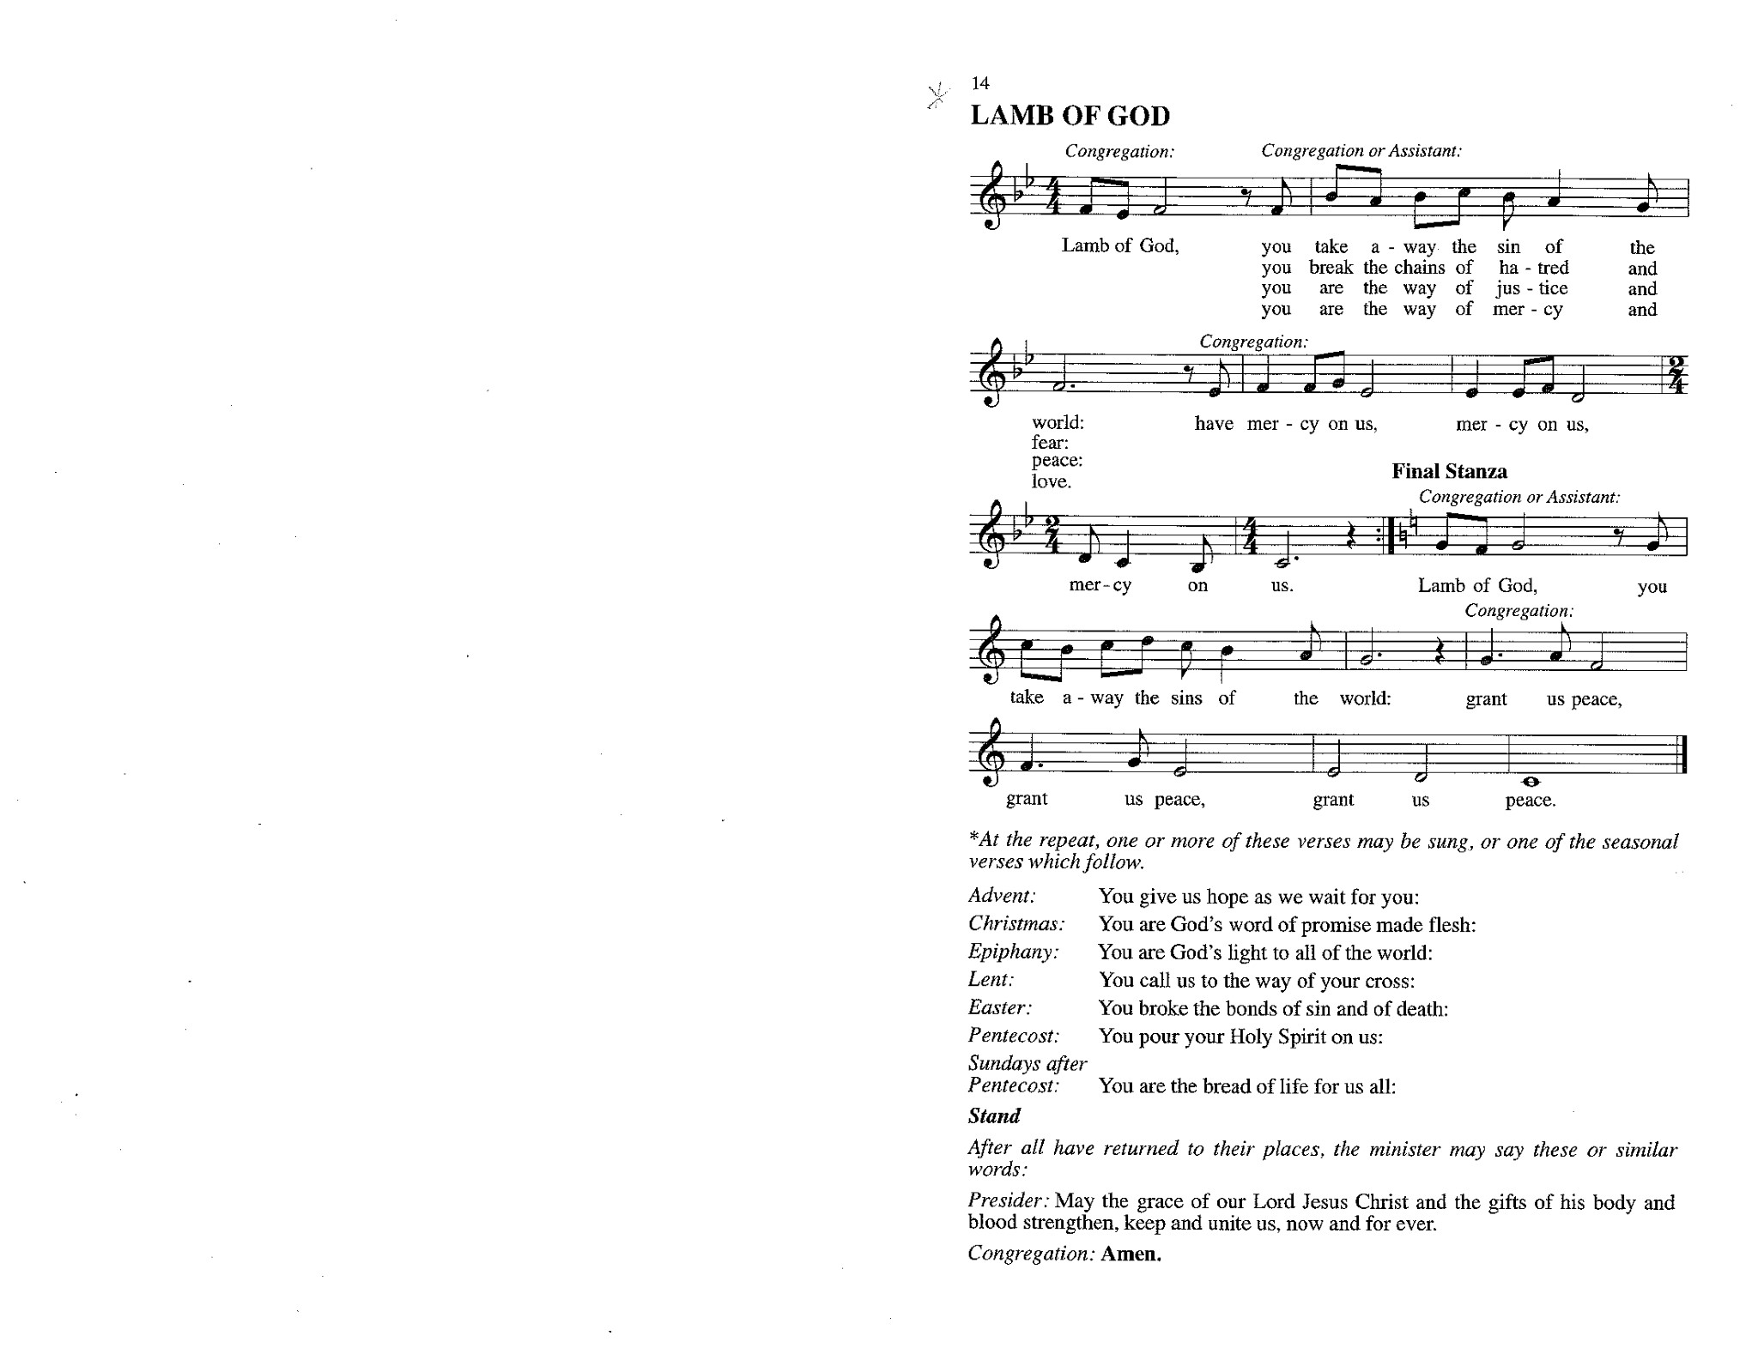

**HYMN DURING DISTRIBUTION 767** *Lord, Take My Hand and Lead Me* page 13

*As you are able please rise*

**THE POST-COMMUNION BLESSING**

P: The Body and Blood of our Lord Jesus Christ strengthen you and keep you in His grace.

C: **Amen.**

**THE POST-COMMUNION PRAYER**

A: Let us pray. Almighty God, guide and protect Your people who share in this sacred

Mystery. Grant us patience in adversity, strengthen our trust in You, and keep us

always n Your love. Grant this through Christ our Lord.

C: **Amen.**

**✠ SENDING ✠**

**THE BENEDICTION**

P: Almighty God: Father, Son, ✠ and Holy Spirit bless you now and forever.

C: **Amen.**

**THE SENDING SONG 763** *My Life Flows On in Endless Song*  page14

**THE DISMISSAL**

P: Go in peace to bear Christ’s love to the world.

C: **Thanks be to God!**

**POSTLUDE**  *To God Be the Glory Arranged by* Albin Whitworth

**✠ To God Alone Be Glory ✠**

The Meditation is from *Richer Fare for the People.* Gail Ramshaw, ed. (New York:

Pueblo Publishing Company, 1990) 116.

The musical setting of the liturgy, “Now the Feast and Celebration” by Marty Haugen, is

used by permission of GIA Publishers, Inc. OneLicense.net License #A-702836.

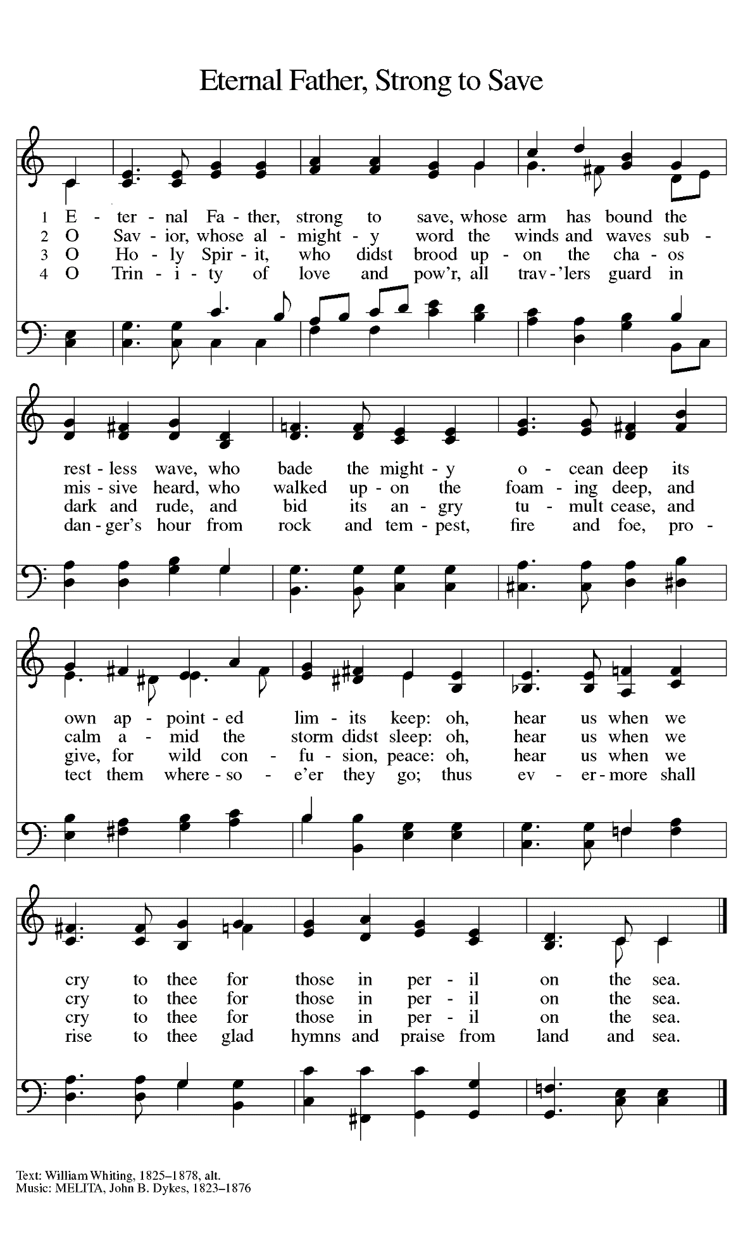

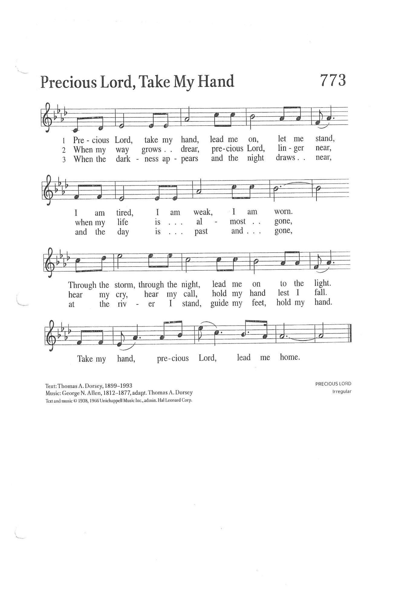

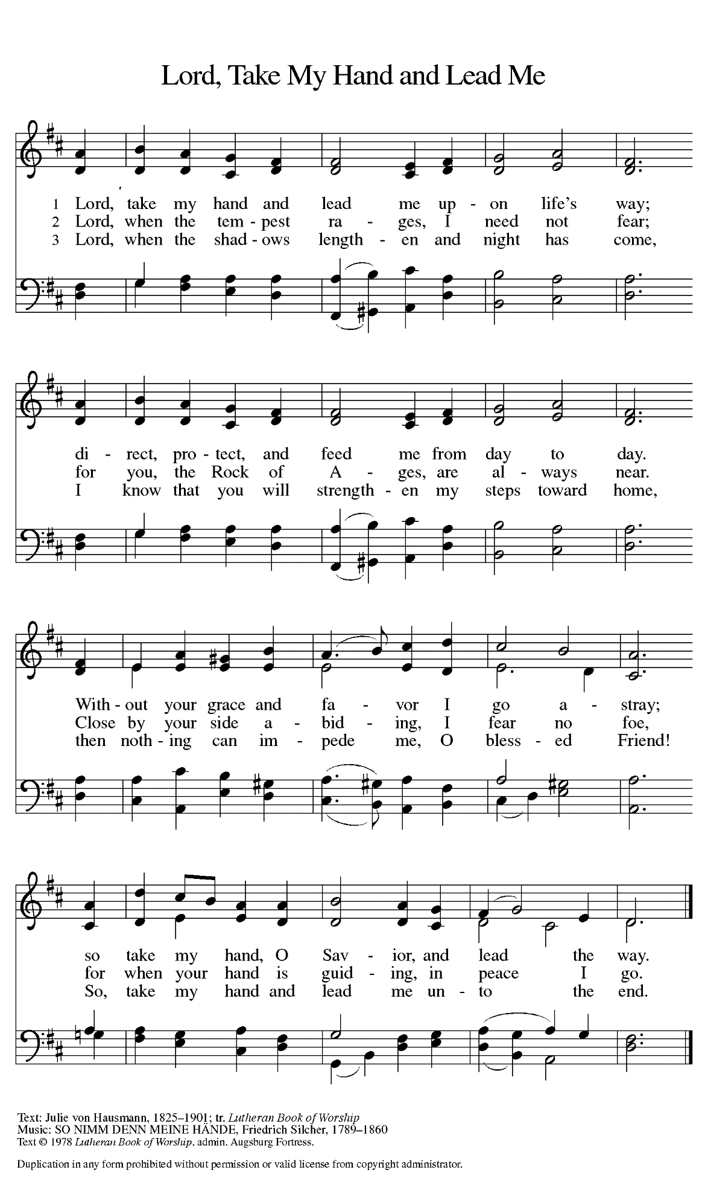

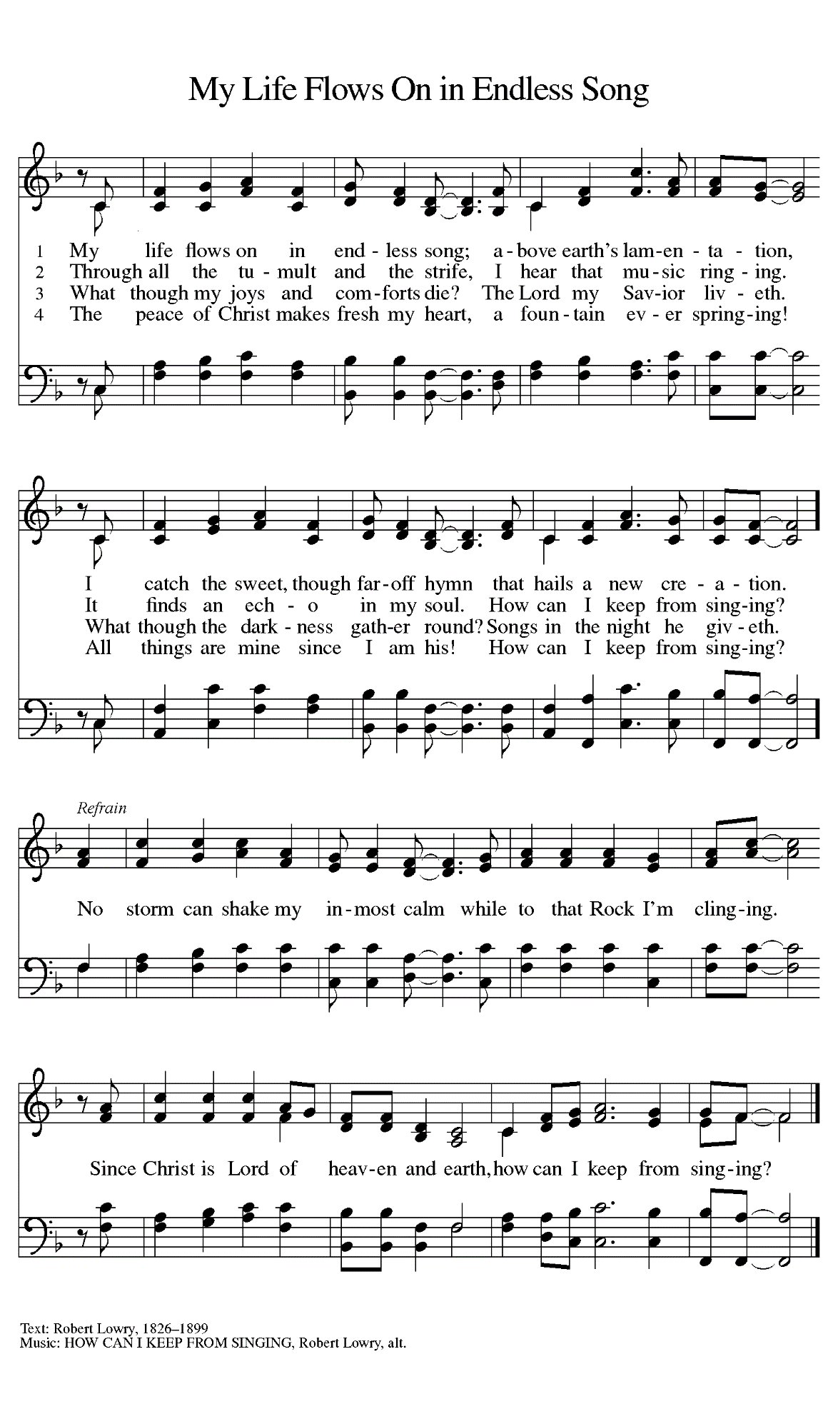

**ANNOUNCEMENTS**

**Please remember to mail your offering to the Church Office** at 818 Franklin Street, Michigan City, IN 46360**.** Another alternative is to give on-line through Tithe.ly. Please see your closure letter for information on how to set up a Tithe.ly account.

**St. Paul Members are reminded to have** a loved one contact the office if you are hospitalized. Many times, the Pastor doesn’t know someone is in the hospital. If you call and leave a message, please tell us which hospital the patient is at.

**Next Sunday’s lessons are Lamentations 3: 22-33; Psalm 30; II Corinthians 8: 7-15; Mark 5: 21-43** for those of you who like to study them in advance.

**Birthdays: Beverly Coburn (6/21); Diane Gielow (6/24); Lou Ann Shebel (6/ 24); and Muriel Jacobi (6/25)**

**Anniversaries: Sally & Lee Timm (6/21); George & Donna Ottersen (6/22); and William & Pamela Hackett (6/23)**

**PRAYER CONCERNS:** Kathy Thielman, Audrey Beyer, George Ottersen, Charles Thomas Sr, Joyce and Bethany Manning, Marla Furness, Christine Kiser, Delores Hackett, Kay Peglow, Lee Timm, Ryan Krueger, Donna Bostater, Diane Gielow, Jeff Jensen, Maxine Powell, Linda Utley, Jim Gleason, Jess Kalvaitis, Gail Leffew, Pastor Al Lorentzen, Jan Paholski, Laura Dovey, Heidi Happel, Gene Marty, Grant Houk, Shane Nevels, Don Smales, Elaine Gehring, Irene Bohnstadt, Joan Coughlin and Deb Prybylla.

**If you requested someone’s name to be on the prayer list and are aware that they need continued imminent prayer then contact the church office and let us know.** Otherwise we will gradually transfer names to the long-term list.

**OFFICE HOURS:** Libby will be in the office on Mondays, Wednesdays, and Fridays; volunteers will cover Tuesdays and Thursdays.

Monday & Wednesday 8:00 a.m. – 5 p.m.

Tuesday & Thursday 9:00 a.m. – 12:00 p.m.

Friday 8:00 a.m. – 12:00 p.m.

**If you are listening to the worship broadcast on the radio and would like to watch it live stream but you aren’t on Facebook,** follow these four steps:

1) Go to your search engine (Google, Bing, etc.).

2) Search for St. Paul Lutheran Church & School, Michigan City, Indiana

3) Click on the option for St. Paul Lutheran Church & School—Home/Facebook

4) Click on “Videos” in the menu on the left side of the screen.

That should take you to the former videos and there should be one with a little red box that says “LIVE.’ Click on that video to enlarge it.

We will continue to live stream/broadcast the Sunday morning service on our Facebook page, and it will always be available on the radio broadcast Sunday mornings at 11:00 a.m. on WEFM (95.9), and on the local cable access station #99 for the previous week’s service on Sundays at 4:00 p.m. and the current service on Wednesdays at 7:00 p.m. and Fridays at 8:30 p.m.

**To send e-mail to the church office**, please use the following addresses:

 Pastor Mark Reshan: [seniorpastor@stpaulmichigancity.com](mailto:seniorpastor@stpaulmichigancity.com)

 Church Office Secretary (Libby Pollock): [churchsecretary@stpaulmichigancity.com](mailto:churchsecretary@stpaulmichigancity.com)

 Church Treasurer (Karen Fleming) and Bookkeeper (Billie Atchinson):

[finance@stpaulmichigancity.com](mailto:finance@stpaulmichigancity.com).

**The Good News Newsletter**: If you have an article or anything you want included in **The Good News** please send it to the following e-mail address: splcgoodnews@gmail.com. Pastor Pamela Thiede will be using this e-mail address to assemble **The Good News** each month. The deadline for getting information to Pastor Pamela will be the 20th of each month.

**While we have been worshiping remotely** we emailed copies of the bulletin to those who requested them and sent hard copies to those without access to computers. Now that we are back in-person we will continue to mail the hard copies to those who requested them but not to those on the email list. If you have been receiving them by email and would like that to continue please call the office and we will be happy to resume that service to you.

**OUR NEW WEBSITE** is now up and running. Take a look and see the changes and updates that have been made. And when you have a minute send us a message and let us know what you think! The new address for the website is:

stpaulmichigancity.com.

**ST. PAUL NEEDS YOUR HELP!** People willing to serve their Lord on a weekend, when worship services are held. The work is light and easy with magnificent rewards. For more information call Virginia Murray, Altar Guild President at 872-9063. Or, Bob Kiser, Deacon Chairman at 872-8157.

**2021 Financial Stewardship**

Weekly Church Operating Needs (x 2 weeks): $13,692.30

June 5 and 6, and June 12 and 13, 2021

General Fund (including General Memorials): $10,709.00

Overage/Shortage: --$2,983.30

Restricted Income (not including Memorials)

Supports IK Synod & Church wide Ministries: $329.00

Ministries in our Community/Congregation: $ 10.00

Capital Fund: $ 735.00

General Fund: $ 30.00

Capital Fund: $500.00

Honorariums (General Fund): $150.00

**WORSHIP ATTENDANCE for June 12 and 13, 2021**

**4:00 p.m. 23**

**9:00 a.m. 55**

**Total = 78**

**An ordination celebration** in honor of Pastor Dale Zylstra will be given by his congregation of Christ Lutheran in Hammond on **Sunday, July 11 from 1:00-3:00 pm.** at Andorra Banquets, 1112 US 41, Shererville. Price is $25 for adults; $15 for children under 12. A cash bar will be available. Checks should be made to: Christ Lutheran Church and should accompany reservations. Their mailing address is: 7051 Indianapolis Blvd., Hammond, 46324. We are in the process of finalizing a date and time for our congregation to celebrate his ordination.

**And Finally:** If you have an activity or event or recognition you would like to have

included in our weekly bulletins please contact Libby in the Church office by email or by telephone no later than noon on Mondays. Thank you and God bless!