

June, 2021

**MARK: MY WORDS**

I don’t want to sound like a broken record, but now what?? This is being written two days after the CDC dramatically revised their guidelines regarding the wearing of masks and social distancing for those who have been fully vaccinated. After over fourteen months of extreme caution, this sudden relaxation of protocols for being in public came almost as a shock.

For our purposes at St. Paul, it seemed to validate the Council’s decision to move forward with a return to in-person worship. We will still be careful: as with everywhere else, based upon the honor system, we will not require those who are fully vaccinated to wear a mask in worship if they so choose. We will still have abundant amounts of hand sanitizer available and will socially distance those who are not yet vaccinated and wearing a mask.

We will allow *light* singing at this point and work to minimize the spread of aerosol droplets that it produces. We won’t yet share The Peace with hugs or handshakes and will ease into the resumption of coffee hour and other social activities. While we rejoice in being able to once again gather with sisters and brothers in Christ to offer our praise and thanks to God, that cannot be *all* that we do.

That is especially driven home by the time of the church year in which this occurs. When this edition of the newsletter is received, we will be at the beginning of the longest season of the year—the time of Pentecost—in which the mission of the Church takes center stage. We remember the coming of the Spirit and plead for its presence and power among *us* for *our* mission and ministry to this neighborhood and community.

Yet *what* that involves is unclear. Two of our former means of service have moved on. The men and women’s homeless shelters have found a beautiful new home. The Sunday Soup Kitchen has been running out of First United Methodist and First Presbyterian for over a year. Whether it will return to St. Paul is still under discussion.

Our school remains our one way of outreach to the community; but with only several children from member families attending and the vast majority of students unconnected to our congregation in any way, it is difficult to embrace its ministry as our own. Most of our members have no contact with or even awareness of what is taking place across our parking lot.

So, again, the question: now what?? From conversations with people over these months, it sometimes seems as though they are more anxious to come back to socialize with their friends than they are to worship as the way in which we are guided, strengthened, and emboldened to bear witness to what God has done and continues to do through the Crucified and Risen Jesus.

While fellowship is a vital part of our community life, it is not the primary work to which we are called. Our task “now” is to discern what that work is and how we will go about faithfully carrying it out. The first step is to gather and discuss and decide upon the proposed budget for the church and school in this new fiscal year that begins July 1 (see below).

What resources are we allocating for our mission? What, besides money, will enable us to fulfill our call? What have we learned—if anything—during these months that we can continue to do for the care and benefit of our community? These and other important questions will have to be part of an ongoing discussion among our Council and one another in the months to come.

As terrible and defeating and frightening as the pandemic has been, it has presented us with the opportunity to re-think and re-form our ministry. If we do not undertake that work, we will simply be a social club that will not last long. So, in this season of the Spirit, we will pray and work and struggle under the Spirit’s wisdom and guidance as to how in new ways God is making us into Easter and Pentecost people.

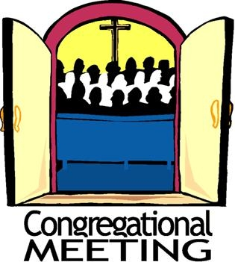

As we have been announcing we have scheduled our spring congregational meeting for **Sunday, June 13, at 10:00 a.m.** in the St. Paul Room following our worship service. The agenda for that meeting is the discussion of and vote on the proposed 2021-22 budget for the church and school. Both our budget team and School Board have worked very hard to put together a way to utilize our resources in a way that will make us a viable presence of Christ in our community. As always, we need your wisdom and input and vote to adapt/adopt that foundation of our ministries.

The Council will arrange tables and chairs so that we are still wisely but comfortably distanced. We may even be able to offer refreshments as part of our meeting. **Please** mark your calendars and plan to be with us so that once again, united in our purpose, we may offer ourselves in service to those among whom God has placed us.

**The Budget (Condensed)**

**St. Paul Lutheran Church**

**July, 2021 – June, 2022**

**Income**

Capital Improvement $ 18,000.00

Total Endowment Funds 40,000.00

Total Regular Giving 280,000.00

Restricted Income 13,000.00

**Total Income** $369,000.00

**Expenses**

Altar Supplies $ 700.00

Archive Expenses 500.00

Total Capital Improvements 52,000.00

Total Christian Education 500.00

Church Office 63,050.00

Total Contract Services 9,720.00

Council Expenses 2,640.00

FICA 2,700.00

Evangelism and Special Events 500.00

Ministry Expenses 2,345.00

Property and Maintenance Expenses 41,500.00

Senior Pastor Expenses 140,030.64

Stewardship Team 1,000.00

Technology Expenses 5,539.50

Worship and Music 341,300.00

**Total Expenses** $367,025.14

**St. Paul Lutheran School**

**July, 2021 – June, 2022**

School Operating Expenses $120,390.00

Total Salary Expense 439,073.68

**Total Expenses $559,463.68**

Projected School Enrollment of 103 students

Tuition Cost per student $5,600.00 x 103 **$576,800.00**



**SCHOOL GRADUATION**

Our school graduation will take place on **Saturday, June 5 at 10:00 a.m.** in our nave. While we are limiting attendance to parents and family members, we encourage you to remember these eighth graders as they approach this important educational milestone. Our graduates are:

Sarie Bond

TaeShaun Eckwood-McCormick

Avery Engstrom

Kylie Hernandez

Tyrone Hicks

Christopher Jackson

Lillian (Lilly) Matheney

Amariah Pryor

Jordan Staples

Sarah Sutor

Ashton Tompkins

Anthony Underwood

Congratulations to them for working through such enormous obstacles in these last two years. May God continue to bless their educational journey and life of faith.



A gift from Maxine Powell has been given to the Altar Guild to renew the sacristy.  We were able to purchase flooring, paint for the woodwork and outside of cabinets, a new steamer, and other needed items to make our work easier.  Maxine gave this gift in memory and in honor of all the women who have served on Altar Guild for the past forty years.  She commented, “I loved every minute.” Thank you, Maxine!



**MUSIC RETURNS**

We received the happy news that, now singing will be allowed in our worship services, the Choir is planning on re-gathering and Lori Zylstra will return as Choir Director. We are still working out the specifics of rehearsals and when they would sing that would work around her commitment to being with and supporting Dale in his ministry at Christ in Hammond. It looks as though they will be singing once or twice a month, depending on her schedule and what time of the church year it is.

We are also thankful that the Praise Band will be returning to lead us in worship during our Sunday morning liturgies. They have been anxious to play again, and we look forward to their contribution to our thanks and praise to God.

**ORDINATION CELEBRATION**

Pastor Dale Zylstra has invited any member of St. Paul to a long-delayed celebration of his ordination by his congregation of Christ Lutheran in Hammond. Here is the information for the event:





**God’s Purls**

It’s exciting to be back to church! Along with that comes the opportunity to be able to resume other activities as well. The knitting and crocheting group will resume meeting on Thursday, June 3, 2021, from 10:00 a.m. to noon in the St. Paul Room. We will continue to meet every Thursday. Hopefully, we can continue to enjoy lunch the first Thursday of every month.

We knit and crochet prayer shawls, prayer squares, lap robes, scarves, hats, mittens, etc. These items are given to shut-ins through the St. Paul Sunshine Basket Ministry, the school children at our school and public schools, and the homeless.

Yarn and other supplies can be provided through a gift we received in memory of Betty Lubke. If you have not been part of this group and enjoy knitting, crocheting, or any other sewing or craft project, please consider coming out to enjoy some fellowship. We look forward to meeting again.



**New Website**

St. Paul Lutheran Church and School has a new, updated website. Check it out at stpaulmichigancity.com.



**We Have Questions . . . Do You Have Answers?**

Early last year we asked if anyone knew the provenance of this beautiful tapestry. We were wondering who may have made it and/or who might have donated it to St. Paul. This piece of art has since been framed (Thank you, Pastor Kloess!) and is hanging on the east wall of the St. Paul Room. If you have any information on the source of this tapestry, please let us know.

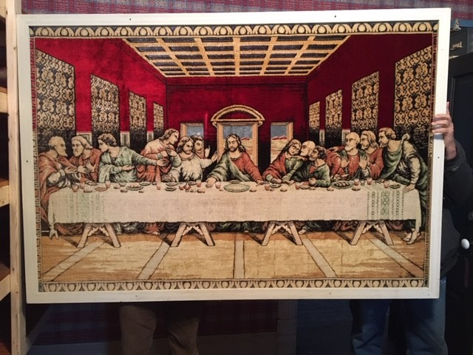

ALSO . . . it seems that we have lost track of the school cornerstone from 1958 or 1959. If you know where it might be hiding, please contact Bob Kiser (219-617-0959).



**IN MEMORY OF MARY LOSINIECKI**

**Altar Guild** by Bill & Pam Hackett

**General Fund** by Maxine Powell, Jim & Bernadette Krueger

**IN MEMORY OF ALLEN KRING**

**Capital Improvement Fund** by Wayne & Suzann Dolson

**General Fund** by Altar Guild, Virginia Murray, Richard & Karen Fleming,

Craig & Pamela Dwight, Dennis & Merry Kuhn, Betty Yourist, Keg Peglow,

Sharon Hutchcraft & Sheryl Lubke, Robert & Judith Caddo, Lyle & Mary Peters,

Joyce Manning, Dawn Fitzhugh, Jerry & Diane Land, Gloria Hardaway, Allen & Jo Ann Sydow,

Ted & Mary Nowatzke, Isidro & Nereida Hernandez, Joe & Mary Haro and family,

Roger & Norma Milcarek, Orrito Foundation Dentistry, PC; Bruce Smith, DDS;

Edward & Judith Schuchow, Linda Biederstadt, James Dressel, Cheryl & Kenneth Jesse,

Horizon Bank, and Susan & Al Green

**Radio Broadcast** by Jana & Charles Thomas, Sr.

**IN MEMORY OF MOM, CHARLOTTE (JANEZ) KRUEGER ON HER BIRTHDAY AND ON MOTHER’S DAY**

**Quilt Fund** by Bernadette Krueger



**Do You Shop on Amazon?**

**St. Paul Lutheran Church is now on Amazon Smile.** 0.5% of all eligible purchases will be returned to St. Paul. Help us spread the word! Link your Amazon account through the following link—https://smile.amazon.com/ch/52-1239301. When prompted, sign into your account to make sure you are choosing St. Paul for Amazon Smile. There’s no extra charge to your purchases.



**June Birthdays June Anniversaries**

2 Bethany Manning 6 Michael & Marjory Bockover

5 Edward Gustum Eloise & Charles Ponder, Sr.

7 Donna Bostater 10 Lyle & Mary Peters

Nancy Johnson 12 David & Donna Sutor

Vivian Zellers 13 Tom & Amy Petri

8 Richard Cains 15 Jim & Judy Gleason

9 Lynne Nevels Doug & Pam Kienitz

11 Larry Litchford 21 Lee & Sally Timm

12 Leigh Coburn 22 George & Donna Ottersen

14 Janet Bakken 23 William & Pamela Hackett

Ivye Benson 29 Ed & Judy Gustum

15 Jacob Ziesmer Al & Clara Lorentzen

16 Jacob Hazel

Jeffrey Hazel

20 Jim Schraidt

Allen Sydow Our apologies and a belated Happy

21 Beverly Coburn Birthday to Emma Robbins who

Clara Lorentzen celebrated on May 26 but was

23 Alex Scheuchner inadvertently omitted last month.

24 Dawn Fitzhugh

Diane Gielow

Lou Ann Shebel

25 Muriel Jacobi

26 Helen Hill-Weaver

Daniel Reshan

Jacob Reshan

27 Helen Albertson

Jacob Payne

Cynthia Scheuchner

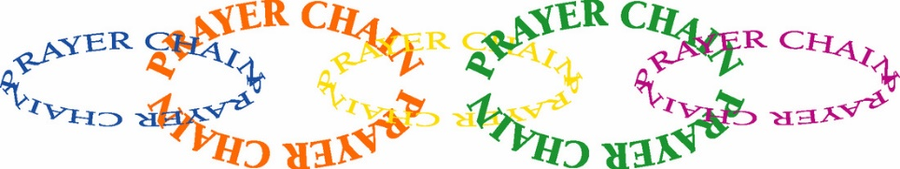

**PRAYER CHAIN**

The members of the Prayer Chain at St. Paul have made a commitment to pray for any and all who request their prayers. Let us pray for you! To activate the Prayer Chain, contact one of the members on the list below and tell her of your need. You may give as much informtion as you wish. Your request will be kept in strict confidence.

Prayer request forms are also available in the pew racks during worship. These forms include prayer categories such as Healing, Comfort, Guidance, etc. Simply fill out the form (please include the date of your request) and place it in the offering plate or hand it to a deacon. The form will be forwarded to a Prayer Chain member. When using the e-mail addresses, please note “Prayer Chain Request” on the subject line. If the subject line is not filled in, the e-mail will not be opened

**Vivian Zellers** 872-8780 [vteach2006@sbcglobal.net](mailto:vteach2006@sbcglobal.net)

**Carrie Ziesmer** 872-6541 [carrie124@comcast.net](mailto:carrie124@comcast.net)



**Long-Term Prayer List**

Robert Atwood Sherry Brotsky Laura Eilers-Straight

Jim Gleason Andy Hipskind Terry Hygema

Jess Kalvaitis Ryan Krueger Tom & Larry Leuth

Duane Ormsby Jean Thomas Linda Utley

Chris Weninger

**OFFICE HOURS**

Monday 8:00 a.m. – 5 p.m.

Tuesday 9:00 a.m. – 12:00 noon

Wednesday 8:00 a.m. – 5 p.m.

Thursday 9:00 a.m. – 12 noon

Friday 8:00 a.m. – 12 noon

**St. Paul Lutheran Church & School Staff**

Pastor Mark Reshan

Organist John Remmel

Accompanists Jary Tannehill, Mark Tannehill, Jacob Tannehill

Choir Director Lori Zylstra

Office Secretary Libby Pollock

Custodian Mark Kloess

School Principal Christy Smith

School Office Secretary Tracey McCay

Thank$ for $haring

The Holly’s Give-Back in April raised $94. Thank you for participating in either or both of these events.

This month,we will see you at Hacienda! Remember to cut out this coupon, because it is required for the Give-Back bucks.

