

November, 2021

**MARK: MY WORDS**

The end is *finally* in sight. The seemingly endless season of Saturdays and Sundays after Pentecost, begun in June, come to their completion in this month. After five weeks of Jesus’ teaching on “the Bread of Life” and over twenty weeks of green paraments, we are ready for something different. Happily, that is the very theme of the new season of the church year into which we will now enter.

Advent begins and ushers in a new church year on the last Saturday and Sunday of the month, November 27 and 28. We move into Year C of the three-year lectionary, or cycle of Scripture readings, anchored around the Gospel of Luke. The transition from this year’s Gospel, Mark, to Luke is significant.

Whereas Mark’s Greek (and English translation) is rough and sometimes brusque, Luke’s Greek is the most eloquent of the Gospel authors and much more flowing than Mark. In Mark, stories were often pared down to their barest; and for the first half of the Gospel narrative, Jesus was constantly on the move. In Luke, the pace throughout is much less frantic; and many of his famous stories and parables are filled with rich and evocative details.

Because of Paul’s reference to Luke as “the physician” (Colossians 4:14), scholars have noted an emphasis and heightened awareness in this Gospel to Jesus’ acts of healing for the sick, the possessed, and even the dying and dead. Given our continued struggle with COVID and its variants, that assurance of God’s continued ministry of restoration is especially welcome.

As mentioned above, Advent is about preparing for the Lord’s coming: both at The End of all things and as an infant in Bethlehem. As a seasonal essay in the worship resource *Sundays and Seasons* published by Augsburg Fortress notes:

The season of Advent is about waiting for the coming of the Lord. We wait for Christ’s arrival that happened two thousand years ago and for the arrival that is yet to occur. We journey toward Bethlehem in the comforting but challenging reality of the “already” and the “not yet.” We travel with holy anticipation to meet the newborn king in the manger.

The mood or tone of Advent is one of longing. As the body of Christ, we carry different longings. What were the deep longings stirring in the hearts of the original hearers of Luke’s gospel? What did they expect from the promised Messiah? A conquering king? A mighty warrior? An avenger? The season of Advent unfolds against the backdrop of deliverance from oppression.

Yet even today, oppression persists and the long-awaited deliverance tarries, especially for people who live on the margins of society. The preacher is encouraged to remember the people who are struggling during the holiday season and cannot wait one more minute for Jesus. Lean heavily into the “already.” After all, Advent is about hope for today; and Jesus is with us in the liminal time between the already and the not yet.

As the days become shorter in this season and darkness swallows more of our days, “hope” is a precious gift for which we all long. The shadows of worry and fear, grief and sickness, and uncertainty of what lies ahead can weigh us down. Once again from the essay:

“Jesus is near when we are joyful and when are spirits are crushed. Jesus, our Savior, comes to us every time a community of faith gathers. Jesus comes to strengthen our hearts, comfort our souls, and equip us for the journey. Jesus is near. Jesus is here!”

May that unshakeable promise fill us with hope and joy this Advent, and may our journey through the darkness be faithful and fruitful.

 **FESTIVAL DAYS** 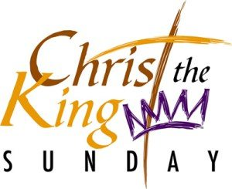

We begin and end this month with important Feast days of the church year. On the first weekend we commemorate All Saints Day. Originally intended to remember and give thanks for the lives of those martyred for their confession of and faith in Jesus, by the fourth century it was expanded to include all the baptized faithful.

We mark the Day both by solemnly calling the names of those who have died in the Lord from the congregation during the past year and also holding up those who have entered the Body of Christ through Baptism. In this way, we look to the past for our encouragement and inspiration even as we renew the promise we made to the newly baptized to support and nurture them in the ways and teachings of the Lord.

The current church year ends with the festival of Christ the King. Instituted by Pope Pius XIX in 1925, this Day was meant to counteract what he saw as the rampant materialism and idolatrous coveting of wealth and power that was so prominent during “The Roaring Twenties” as the world recovered from the devastation of World War I.

Both serve as a fitting conclusion to our current church year and propel us forward into a new one uplifted and encouraged by their powerful promises.

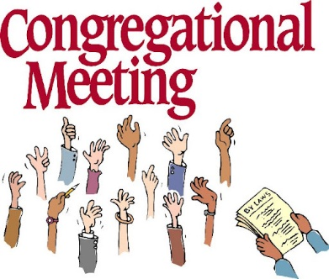

On **Sunday, November 14, at 10:00 a.m.,** our regular fall congregational meeting will be held in the St. Paul Room following worship. The primary agenda item will be the election of new Church Council and School Board members. Going off Council is the entire executive team: **President Paul Brooks; Vice-President Janet Bakken; Treasurer Karen Fleming; and Secretary Sue Koziel.** In addition, Council members **David Pfeiffer, Carey Howard, Bob Kiser, and Donna Bostater** have completed their service.

The School Board member who has finished her term is **Judy Hunt.**  We are profoundly grateful for all their faithful and dedicated service. Their leadership has enriched our school and church community during these extraordinarily difficult times. They have been a rich blessing to us all.

The Nominating Committee, consisting of **Janet Bakken, Judy Mutchler, Dave Pfeiffer, Carey Howard, and Bob Kiser,** has been working extremely hard over these last months to secure candidates for all these important positions. Thank you to them for their difficult work. Please plan to attend and cast your vote for those who have agreed to be placed on the ballot so that we might have a seamless transition on both Church Council and School Board and continue to move forward in our ministry to our students, their families, and our community.

As you can see, we have a monumental task ahead of us filling all of those vacant positions. We need not only your presence at the meeting but your willingness to step in and fill those slots. We cannot have the same handful of people doing all the work all the time. We have many gifted members whose presence in leadership roles would greatly enrich us. Agree to serve. We need you.

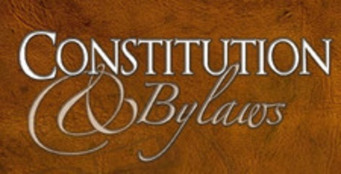Another important matter we will vote on is our updated Constitution and Bylaws. These were sent by e-mail and U.S. Postal Service (to those who receive the newsletter by snail mail) prior to October 14.

As Pastor Rudy Mueller, retired Assistant to the Bishop, frequently said, a congregation’s Constitution is its mission statement. Much of the Constitution is mandated by the ELCA Model Constitution for Congregations. The Constitution Task Force has carefully reviewed the entire document and presents to you this updated Constitution with the Bylaws integrated into the document for your affirmation. Although the mandated portions are already in force, it takes two positive votes to institute the entire document. The first vote is at this meeting on November 14; the second vote will be at the spring Annual Meeting.



**President – Judy Mutchler** has been a member of St. Paul Lutheran Church since 1994. She has served as Communion Assistant and as a member of the Counting Committee for fifteen years. She is presently a member of Altar Guild and has served as Church Council Secretary and is a Council member. She assisted in our Sunday School program and has scheduled lectors and greeters. She recently served on the Constitution Committee and budget team and is a member of the finance team. She enjoys knitting and has organized St. Paul’s knitting group called God’s Purls.

**Vice-President – Paul Brooks** has been the Council President the last two years. Prior to that, he was Vice-President for two years. Paul currently schedules the give back nights, manages the website and Facebook, and helps Mike Bockover with the video recordings. In his spare time, Paul enjoys short walks on the beach.

**Secretary – Carey Howard** is a lifelong Michigan City resident and has been a member of St. Paul Lutheran Church for 15 years. She and her husband, Jason, were married at St. Paul in 2006 and have three children. Adam is a sophomore at Ball State University, Brooklynn is 11, and Micha is 8. Carey has served on the Church Council the past two years. She would like to serve as secretary. She is devoted to helping our church prosper and enjoys being involved.

**Treasurer** – The nominating committee was unable to find a candidate for this position.

***Church Council (2 year term)***

**Janet Bakken** is currently as Vice-President and served as President for two years before this. Jan is the only member left on the Stewardship team. She has scheduled communion assistants, schedules office volunteers, and schedules St. Paul’s Wednesday Meals on Wheels teams. As needed Jan serves as Property Coordinator. She presently serves on the Budget team, finance team, and Constitution Committee and is the Council liaison to the School Board. Jan attends Bible study and is a 2010 graduate of Diakonia, a program built on service.

**Fred Hart** previously served on the Church Council. He takes care of filling our pop machine and is always willing to lend a hand. Fred regularly attends the Saturday evening service.

**Susan Storey Koziel** was baptized at St. Paul in 1958, attended St. Paul School, graduated and was confirmed in 1972. She attended Kana Lutheran College in Blair, Nebraska, where she met her husband, Joseph. Sue was a 5th grade teacher in New Carlisle from 1998 – 2016. She retired after her husband’s death to pursue other interests. She had previously been Sunday School Superintendent and then became a member of the Altar Guild, the Praise Band, and the Church Council as Secretary and serves as Assisting Minister.

**Diane Waltz** is a lifetime member of St. Paul Church. Her three children and seven grandchildren were baptized and attended St. Paul Sunday School and Church. In the past Diane has enjoyed several different Bible studies, served at funeral lunches, was in the quilting group, participated in the community after school program for our school and neighborhood students, and has worked in the soup kitchen. She is a member of Harmony Circle. Diane wants to take a roll in working discussion of the congregation as a Council member.

***Church Council (1 year term)***

**Susan Bagby** has been at St. Paul Church since she was six years old. She attended Sunday School and sang in the Youth Choir. She has been a member of the Senior Choir for over 50 years. Susan has been on the Counting Committee since 2008 and is a member of the Archives Committee. Susan is also a member of Fellowship Club, WELCA Harmony Circle, and attends Pastor’s Wednesday morning Bible study.

**Wayne Dolson** has been a member of St. Paul Lutheran Church since 1963. He has served on Church Council, School Board, Worship & Music team, Finance team, has been a deacon and sung in the Choir.



Daylight Savings Time ends at 2 a.m. on Sunday, November 7.

Remember to turn your clocks back before going to bed on Saturday.



The church office will be closed on Thursday, November 25, in honor of Thanksgiving. It will reopen for its usual Friday schedule on the 26th from 8:00 a.m.-12:00 p.m.

The Community Soup Kitchen, currently housed at First United Methodist Church, needs your help. Erik Tannehill and others need help by those who can volunteer at least one day a week from 9 a.m. to 12 noon. The work involved is preparing the food, putting it in single-serving containers, and handing them out at the door. Those who have been helping several days a week for the last two years are burning out and need relief. Please consider helping in this important, vital ministry of our downtown churches.



**ST. PAUL ON YOU.TUBE**

Paul Brooks has set up a You.Tube account for St. Paul. If you have You.Tube available on your TV, search for **St. Paul Lutheran Church Michigan City, IN.** The direct link on the computer is <https://www.youtube.com/channel/UC5AIPNaKr3QN50984jGOa1g>. The link is also on the main page of our website. This will potentially help us reach a larger audience and gives us an alternative to Facebook (with which we have been having difficulty). Paul also plans to post the link weekly on the St. Paul Facebook page. If you can’t be with us in church, join us on You.Tube.

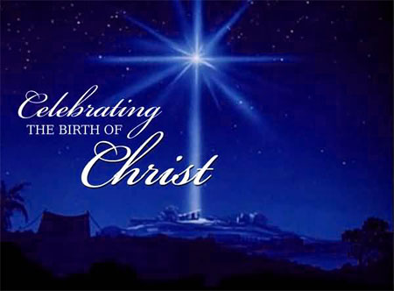

It is not too early to post information about our end-of-Advent and Christmas Eve/Day and following worship services. We will include them in the December newsletter as well, but it might be helpful to mark your calendars now for these special liturgies.

**Saturday, December 18** Fourth Saturday in Advent 4:00 p.m.

**Sunday, December 19** Fourth Sunday in Advent 9:00 a.m.

**Friday, December 24** Christmas Eve 6:00 p.m.

**Saturday, December 25** Christmas Day 10:00 a.m.

**(No 4:00 p.m. worship)**

**Sunday, December 26** The First Sunday of Christmas 9:00 a.m.



**CHRISTMAS POINSETTIAS**

It’s time to start thinking about purchasing a Christmas Poinsettia. Each plant will be in a 6½-inch pot with 3 – 6 blooms. Each plant will cost $6.50 and can be given “in memory of” or “in honor of” a loved one. Please place your order through the church office (219-874-7293); or place your information on an envelope with cash or a check made out to St. Paul Lutheran Church, and place it in the offering plate. You are welcome to take your plant(s) home after the Christmas Eve, Christmas Day, or Sunday (December 26) service. **Orders must be placed by Monday, December 13.** The final count will be turned in that day.



**November Birthdays November Anniversaries**

1 Rian Wiseman 1 Warren & Kathryn Glanz

2 James Gleason 23 Bob & Karen Kiser

Mary Jo Moncheski 26 Fred & Carol Weiss

3 Gary Larson 20 Dave & Sue Pfeiffer

Sarah Sutor

6 Allen Sydow

7 Judy Hunt

9 Fred Hart

10 Darin Devereaux

11 Kaylee Richardson

Tristan Schnick

Jeffrey Timmrick

12 Collin Fisher

14 Hillary Frever

15 Drey Devereaux

17 Ryan Scheuchner

Susan Tomsheck

Noah Van Gemeren

19 Nicole Miller

20 Scott Bartels

Elizabeth Gesse

Haley Gesse

22 Laura Summa

23 Darlene Baker

Jeffrey Dettman

JoAnn Sydow

24 Carrie Ziesmer

25 Marla Furness

26 Gaby Cains

Dave Pfeiffer

Mark Robbins



**IN MEMORY OF RON JOHNSON**

**General Fund** by Beverly Johnson

**IN MEMORY OF CONNIE HOLLIS ON HER OCTOBER 11 BIRTHDAY**

**Katie’s Fund** by Maxine Powell



**Do You Shop on Amazon?**

**St. Paul Lutheran Church is on Amazon Smile.** 0.5% of all eligible purchases will be returned to St. Paul. Help us spread the word! Link your Amazon account through the following link—https://smile.amazon.com/ch/52-1239301. When prompted, sign into your account to make sure you are choosing St. Paul for Amazon Smile. There’s no extra charge to your purchases.



**Long-Term Prayer List**

Robert Atwood Sherry Brotsky Laura Eilers-Straight

Jim Gleason Terry Hygema Jess Kalvaitis

Christine Kiser Ryan Krueger Tom & Larry Leuth

Ken Mulder Duane Ormsby George Ottersen

Jean Thomas Linda Utley Chris Weninger

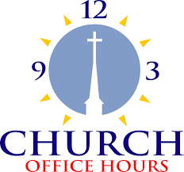

Monday 8:00 a.m. – 5 p.m.

Tuesday 9:00 a.m. – 12:00 noon

Wednesday 8:00 a.m. – 5 p.m.

Thursday 9:00 a.m. – 12 noon

Friday 8:00 a.m. – 12 noon

**St. Paul Lutheran Church & School Staff**

Pastor Mark Reshan

Organist John Remmel

Accompanists Jary Tannehill, Mark Tannehill, Jacob Tannehill

Choir Director Lori Zylstra

Office Secretary Libby Pollock

Custodian Mark Kloess

School Principal Tracey McCay

School Office Coordinator Lisa Heddens

Thank$ for $haring

Thank you for participating in the Holly’s Give-Back Night last month. The church raised $125.00.

This month,we will see you at Galveston! We’re giving you two coupons so you can invite a friend and give them their own coupon. Remember, the coupon is required for the Give-Back bucks.

