

November, 2022

**MARK: MY WORDS**

*Finally.* After over twenty weeks of (mostly) green paraments, challenging and sometimes head-scratching parables, and few festival days to break up the season, the time of Pentecost, begun in June is drawing to its close. With the end of this year of St. Luke, Year C in the three-year lectionary cycle, we begin Year A, the year of St. Matthew’s Gospel.

Advent begins and ushers in a new church year on the last Saturday and Sunday of the month, November 27 and 28. Advent is one of the most powerful and yet often-overlooked seasons of the church year. Much of that has to do with the enormous pressure of the culture around us to start celebrating Christmas as early as possible.

It seems as though stores don’t even wait for Halloween any longer before bringing out their Christmas decorations. I actually saw a display of artificial trees in a “big box” store last July! Online retailers begin numerous “Black Friday” sales long before the traditional day after Thanksgiving events.

Advent is overlooked or brushed aside precisely *because* of its call and theme. The readings of the season summon us to watch and *wait* for the coming of Jesus, first at the end of history and then as an Infant in Bethlehem. But, clearly, we neither want to nor are patient enough to wait. Everything must be immediate. We want our internet speeds to be ever faster, our access to information ever quicker, our news stories ever fresher.

Because the days grow shorter and darker, Advent also asks us to sit with and face the darkness of our world, our lives, and our hearts. In the words of a seasonal essay in the worship resource *Sundays and Seasons* published by Augsburg Fortress:

Advent is a season of waking up. Even as the days grow darker, we are awoken to the light of truth about our lives, the world, and, ultimately, God. But no one really likes being woken from sleep, real or metaphorical. No one likes being pulled from a cozy blanket to a crowded commute, from dreams to reality, from what’s comfortable and “always has been” to what’s actually happening right now. It’s why when we have pivotal, perhaps painful moments in our lives in which we become aware of something previously hidden, or about which we shed the veil of denial, we refer to them as “wake-up calls.”

Yet it is never God’s intent to hurt us by rousing us from sleep. It is not to punish us for our past mistakes, to expose our inner failings to the world, or to add to the already deep well of shame that so many of us carry. It is for our good that God comes to reveal that which was hidden, breaking into our world as human flesh and blood. And it is for our good that, through our baptism, we are able to “put on the Lord Jesus Christ” (Romans 13:14—from the Second Reading on the First Sunday in Advent). The divine image is revealed in you, and in every friend and stranger. God knows, loves, and takes delight in each of us…

…This season is a time for us to awaken to this new reality: at any moment, and at every moment, Christ lives among and within us, helping us rub the sleep out of our eyes, and revealing a different way.

May that unshakeable promise fill us with hope and joy this Advent and may our journey through the darkness be faithful and fruitful.

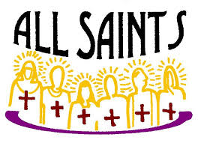**

We begin and end this month with important feast days of the church year. On the first weekend, we commemorate All Saints Day. Originally intended to remember and give thanks for the lives of those martyred for their confession of and faith in Jesus, by the fourth century it was expanded to include all the baptized faithful.

We mark the day both by solemnly calling the names of those who have died in the Lord from the congregation during the past year and also holding up those who have entered the Body of Chris through Baptism. In this way we look to the past for our encouragement and inspiration even as we renew the promise we made to the newly baptized to support and nurture them in the ways and teachings of the Lord.

The current church year ends with the festival of Christ the King. Instituted by Pope Pius XIX in 1925, this day was meant to counteract what he saw as the rampant materialism and idolatrous coveting of wealth and power that was so prominent during “The Roaring Twenties” as the world recovered from the devastation of World War I. Such longing remains powerfully entrenched in both our national and global society. Thus, the need to proclaim that amid all the turmoil, violence, and fear Jesus rules His good creation is an especially important promise to proclaim.

Both days serve as a fitting conclusion to our current church year and propel us forward into a new one uplifted and encouraged by their powerful promises.

**&** 

On **Sunday, November 13, at 10:00 a.m.** our regular fall congregational meeting will be held in the St. Paul Room following worship. The primary agenda item will be the election of new Church Council and School Board members. Going off of Council is the entire executive team: **President Judy Mutchler; Vice-President Janet Bakken; Treasurer Karen Fleming; and Secretary Carey Howard.** In addition, Council members **Shirley McCarty and Jim Schraidt** have completed their service. **Wayne Dolson and Susan Bagby** are completing one-year terms but are eligible to run again. School Board members who have finished their terms are: **Judy Hunt and Pastor Pamela Thiede.** Pastor Pamela may run for a second term. We are profoundly grateful for all their faithful and dedicated service. Their leadership has enriched our school and church community and have been a rich blessing to us all.

The Nominating Committee, consisting of **Janet Bakken and the four Council members going off,** has been working extremely hard over these last months to secure candidates for all these important positions. Thank you to them for their difficult work. Please plan to attend and cast your vote for those who have agreed to be placed on the ballot so that we might have a seamless transition on both Council and School Board and continue to move forward in our ministry to our students, their families, and our community.

Following the meeting, we will have a potluck meal. You are invited to bring your favorite dish to share. As always, we have a challenging task ahead of us filling our vacant positions. We need not only your presence at the meeting, but your willingness to step in and fill those slots. We cannot have the same handful of people doing all the work all the time. We have many gifted members whose presence in leadership roles would greatly enrich us. Agree to serve. We need you.

Slate of Candidates

President: Judy Mutchler

Vice-President: Janet Bakken

Secretary: Carey Howard

Treasurer: Karen Fleming

Church Council Members: Susan Bagby

Wayne Dolson

Judy Hunt

Donna Knoll

School Board: Beverly Johnson

Pastor Pamela Thiede

Nominations will be open from the floor.



We hope you have your calendar marked for Sunday, November 13, when we will hold our fall congregational meeting at 10 a.m. in the St. Paul Room. We need a quorum of voting members. Several important agenda items will be under consideration. The first is the election of Church Council and School Board members. The Nominating Committee has worked very hard to secure candidates for all the openings. As always, nominations from the floor will also be received.

We will also hear from the Property Evaluation Team regarding fnidings for the use of the school building should the school close. Related to that, we will hear an update on the current financial situation of the school. As of this writing, it appears that even with the anticipated voucher payment from the state at the end of October, there will still be approximately $109,000 shortfall between now and the next voucher payment at the end of March.

At the May congregational meeting, there was discussion of accepting a $100,000 donation from the Gruenke Foundation to help cover any shortfall in school revenue. There was no official vote on that proposal at that time. We will call for a vote on whether to accept that money. There will be a report on the current enrollment at the school and its prospects for the remainder of the school year.

These are all critical issues for whch we need your wisdom and input. Make plans to be with us and let your voice be heard. Following the meeting we will enjoy good food at our potluck and even better fellowship.



Blessing Mix

Bugles: shaped like a cornucopia or Horn of Plenty, a symbol of our nation’s abundance.

Pretzels: arms folded in prayer, a freedom sought by those who founded our country.

Candy corn: Sacrifices of the pilgrims’ first winter; food was so scarce that settlers survived on just a few kernels of corn a day.

Nuts or seeds: Promise of a future harvest, one we will reap only if seeds are planted and tended with diligence.

Dried fruits: Harvest gifts of our bountiful land.

M & M’s: Memories of those who came before us to guide us to a blessed future.

Hershey’s Kiss: The love of family and friends that sweetens our lives.

**THANK YOU, JOHN!**

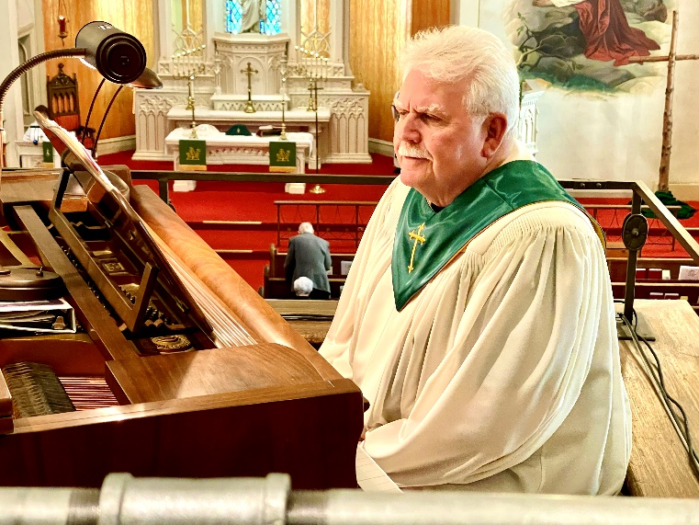

On Saturday, October 15, and Sunday, October 16, we were privileged to honor and recognize our organist, John Remmel, for his thirty years of service to St. Paul. We gave thanks for the many ways he has carried out his music ministry, always with great good humor, faithfulness, and deep humility.

My closing thoughts were of how all of this was done by John without ever calling attention to himself. Everything that he did--playing for worship services, funerals, weddings, and special services; accompanying the choir; arranging for special musicians; maintaining the organ and pianos; and serving on the Worship and Music Committee--were all for the purpose of glorifying God and equipping us, God’s People, to leave worship with joy and hope to carry out our ministry in and for the world each week.

“Thank you” seems so inadequate, but we thank God for John’s presence and work among us; and with the Lord we say, “Well done, good and faithful servant!”

**ORGANIST SEARCH UPDATE**

As mentioned in last month’s newsletter, our organist, John Remmel, has informed us that he will be retiring after worship on Christmas Day. We have formed a search committee for his replacement that consists of Pastor Reshan, Judy Mutchler, Sue Koziel, Susan Bagby, and Fred Hart.

A job description was drawn up and approved by the Church Council. It has been sent to a number of resources for organists: Valparaiso University Music Department; Notre Dame University Program of Sacred Music; and the local American Guild of Organists chapters for Northwest Indiana and Ft. Wayne. Thus far we have received no inquiries. We are looking into the possibility of contracting with a long-term interim until we can find a permanent replacement.

We will keep the congregation informed as to the progress of our search.



I have received some cards and notes for “Pastor Appreciation Month.” Thank you to those who so kindly expressed your support. I am blessed and strengthened by your care.

Pastor Reshan

The church office will be closed on Thursday, November 24, in honor of Thanksgiving. It will reopen for the usual Friday schedule on the 25th from 8:00 a.m.-12:00 p.m.

**CHRISTMAS WORSHIP SCHEDULE**

It is not too early to post information about our end-of-Advent and Christmas Eve/Day and following worship services. We will include them in the December newsletter as well, but it might be helpful to mark your calendars now for these special liturgies.

**Saturday, December 17** Fourth Saturday in Advent 4:00 p.m.

**Sunday, December 18** Fourth Sunday in Advent 9:00 a.m.

**Saturday, December 24** Christmas Eve 6:00 p.m.

**(No 4:00 p.m. worship)**

**Sunday, December 25** Christmas Day 9:00 a.m.

**(Please note time change from previous years)**

**Sunday, January 1** The First Sunday after Christmas 9:00 a.m.



**VOLLEYBALL**

Did you know our St. Paul Lutheran School Girl Volleyball Team is undefeated in its first seven outings this season? Come out to the school gym and cheer these girls on to the end of their season.

Wednesday, October 26 vs, Renaissance 5:00 p.m. at Armory

Thursday, October 27 vs. Discoery 5:00 p.m. Home

Thursday, November 3 vs. St. Stans 4:00 p.m. Home

Their tournament starts the week of November 7.



Our Student Council has been busy organizing many activities including the sale of Fannie Mae candy bars.  Each bar costs $2, and come in a variety of chocolaty goodness. They will be available in the school office, the church office, and at all school events.  The candy will be on sale up until the week of Thanksgiving.

Our Harvest Dance on October 28 will kick off our Thanksgiving food drive.  The fee to get into the dance includes a non-perishable food item.  Our classes will compete to collect the most food items.  These will be donated local shelters.

I would like to invite anyone interested in volunteering at the school--whether it be to read to students, work one on one with little ones, or to help teachers--to please stop by anytime.

Tracey McCay

Principal

St. Paul School

On Sunday, October 23, St. Paul honored our teacher Don Thompson for his 41 years of remarkable service to our church and school community.  Don teaches social studies, religion, and gym in the Middle School as well as serving as Athletic Director. He was recognized during the worship service; and we continued to honor him during the coffee hour following the service.

In addition, Jacob Hazel and Abby Haring read their Statements of Faith in preparation for their Affirmation of Baptism (Confirmation) on Reformation Sunday, October 30.

Every table in the St. Paul Room was filled with members and family who wished Don, Abby, and Jacob best wishes on these wonderful achievements.  We wish all three our very best in their future endeavors.

**ARCHIVE ROOM NEWS**

The Archive Committee was started in 1975 in order to be in place by 1976, St. Paul’s 100th anniversary celebration, but the Archive Room at St. Paul has information in it dating back to 1876, the year our congregation came to be.

Many interesting facts and figures have been gathered from these records. Interested in seeing more? The bottom drawer in the middle of the stack of file cabinets has a wealth of information for you to browse. Feel free to sit at the table and look at some of the interesting stories, etc.

Some statistics:

* The church purchased the corner lot at our current location for $2,500.00 in 1876. (in today’s dollars $52,887.00). The church itself cost $25,417.00 to build (in today’s dollars $703,531.00). St. Paul had to take out a loan for $5,000.00 at 10% interest (in today’s dollar $138,398.00).
* Our first Pastor, Pastor Emil Hardrat was in place at St. John’s Church for 3 years before moving to St. Paul. His salary was $55.00 per month and free house rent (in today’s dollars $1,522.00 per month).
* In the early years of our church, the pews were rented out. Those in the front 7 rows could be rented by “competent men” for $35.00 per year (in today’s dollars $1,016.00!). Take pride when you sit in those front rows! By 1891, young people that were newly married were asked to rent a pew for their own use or be dismissed. Wow!
* In 1886, St. Paul decided to buy a house and lot next door for use as a parsonage at the price of $2,200.00 (in today’s dollars $63,880.00).
* 1886 brought an increase to the janitor’s wages. He was paid $225.00 per year with the understanding that he must pay a boy to pump the organ (in today’s dollars the janitor’s wages would be $9,696.00).
* By 1924, the church needed a new roof. Relaid *asbestos* shingles cost $2,200.00 (in today’s dollars $38,103.00).
* And last statistic but not the least is from 1930: the treasurer for benevolence funds reported that $4,384.00 was collected from the congregation (in today’s dollars $76,877.00).

The Archive Room is NOT all about statistics! Stop by today and see for yourself.



**IN MEMORY OF RON JOHNSON**

**General Fund** from Beverly Johnson

**IN MEMORY OF PETER ONATE, JR.**

**General Fund** from Venia Wendt and Cynthia Clark

**IN MEMORY OF CAROL WEISS**

**General Fund** from Colleen & Thomas Nieman

**IN HONOR OF THE BIRTHDAYS OF DAUGHTER CONNIE**

**AND GRANDDAUGHTER AMY**

**Capital Improvement Fund** from Maxine Powell

**IN HONOR OF BOB KISER’S 80TH BIRTHDAY**

**General Fund** from Kay Peglow & family

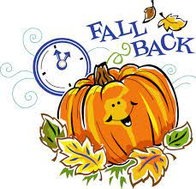

Turn your clocks back next Saturday evening, November 5!



**November Birthdays November Anniversaries**

1 Rian Wiseman 1 Warren & Kathryn Glanz

2 James Gleason 23 Bob & Karen Kiser

Mary Jo Moncheski 26 David & Sue Pfeiffer

5 Gary Larson

Sarah Sutor Last month we missed Lee Timm’s

6 Allen Sydow birthday on October 29. Happy

7 Judy Hunt belated birthday, Tim!

9 Fred Hart

10 Darin Devereaux

11 Kaylee Richardson

Tristan Schnick

Jeffrey Timmrick

12 Collin Fisher

14 Hillary Frever

15 Drey Devereaux

17 Ryan Scheuchner

Susan Tomsheck

Noah VanGemeren

19 Nicole Miller

20 Scott Bartels

Elizabeth Gesse

Haley Gesse

22 Lauren Summa

23 Darlene Baker

Jeffrey Dettman

JoAnne Sydow

25 Marla Furness

26 Gaby Cains

Dave Pfeiffer

Mark Robbins

**Long-Term Prayer List**

Robert Atwood Audrey Beyer Irene Bohnstadt

Donna Bostater Shari Brotsky Laura Dovey

Laura Eilers-Straight Marta Furness Diane Gielow

Jim Gleason Ed Gustum Dolores Hackett

Heidi Happel Terry Hygema Jess Kalvaitis

Christine Kiser Ryan Krueger Tom & Larry Leuth

Pastor Al Lorentzen Bethany Manning Christian Martinez

Laura Moore Shane Nevels Duane Ormsby

George Ottersen Jan Paholski Kay Peglow

Cameron Rackard Wally & Betty Ratliff Annette Scroggin

Ryan Sirk Erik Tannehill Jary Tannehill

Kathy Thielman Jean Thomas Lee Timm

Venia Wendt

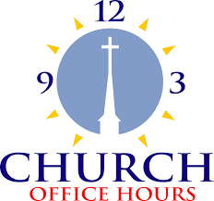

Monday 8:00 a.m. – 5 p.m.

Tuesday 9:00 a.m. – 12:00 noon

Wednesday 8:00 a.m. – 5 p.m.

Thursday 9:00 a.m. – 12 noon

Friday 8:00 a.m. – 12 noon

**St. Paul Lutheran Church & School Staff**

Pastor Mark Reshan

Organist John Remmel

Accompanists Jary Tannehill, Mark Tannehill, Jacob Tannehill

Choir Director Lori Zylstra

Office Secretary Libby Pollock

Custodian Mark Kloess

School Principal Tracey McCay

School Office Coordinator Christina Woodard

School Custodian Tara Soto-Garcia



**Do You Shop on Amazon?**

**St. Paul Lutheran Church is on Amazon Smile.** 0.5% of all eligible purchases will be returned to St. Paul. Help us spread the word! Link your Amazon account through the following link—https://smile.amazon.com/ch/52-1239301. When prompted, sign into your account to make sure you are choosing St. Paul for Amazon Smile. There’s no extra charge to your purchases.

Thank$ for $haring

Thanks to all who attended the giveback at Hacienda. The church received $171.00 from that evening.

This month,we will see you at Holly’s! We’re giving you two coupons so you can invite a friend and give them their own coupon. Remember, the coupon is required for the Give-Back bucks.

