November, 2023
MARK: MY WORDS

November is one of the most important months of the church year. It begins with the commemoration of All Saints. Originally established as a church festival to honor the martyrs of the faith, by the fourth century it was expanded to include all the baptized on a day of thanksgiving to honor their example for those who followed them in discipleship.
We mark the day at St. Paul both by solemnly calling the names of those who have died in the Lord from the congregation during the past year and also holding up those who have entered the Body of Christ from the waters of Baptism. In this way, we both look to the past for our encouragement and inspiration even as we renew the promise we made at their Baptism to support and nurture the newly washed in the ways and teachings of the Lord.
November is also the month in which the current church year comes to its completion, capped off by the Feast of Christ the King on the last Saturday/Sunday after Pentecost. Instituted by Pope Pius XI in 1925, this day was meant to counteract what he saw as the rampant materialism and idolatrous coveting of wealth and power so prominent during “The Roaring Twenties” as the world recovered from the devastation of World War I.
Following this festival day is the beginning of the new church year on the First Saturday/Sunday in Advent, which falls on the first weekend of December this year. This begins a new series of lectionary readings for the church year, alternating between the Gospels of Matthew (Year A, which we will finish); Mark (Year B, into which we will enter); and Luke (Year C). All three years, especially the year of Mark are supplemented by abundant readings from the Gospel of John so that throughout the three years witness from all four Gospel accounts are heard.
And we need the powerful witness of these “Gospel-ers,” these authors and editors who compiled the stories about Jesus to bring hope and strength and encouragement to the communities of faith to which they belonged. While it is true that throughout history the world has seemed on the verge of collapse, the times in which we live are especially fraught with troubles and fears.
There are two major wars in Ukraine and now between Israel and Hamas; political divisions and gridlock in Congress; devastating natural disasters and the effects of climate change; increasing drug abuse and the crime that accompanies it; the loss of civility and reasonableness in public discourse; and new and ever-more deadly sicknesses and diseases against which to fight. We live in frightening times when often it seems as though chaos reigns and no one is in control.
But in the midst of all the anxiety and uncertainty, the promises of November’s days rings true perhaps more deeply than ever. Surely our ancestors in the faith faced their own struggles with sickness, disease, and death. There were times through the centuries when the Church faced challenges they were not sure could be overcome.
But they did, through the goodness and guidance and faithfulness of “Christ the King,” Who, as we confess each week in the Creed, continues to “sit at the right hand of the Father” to rule His universe with mercy and grace. For ourselves and our world, the confession that Jesus yet reigns needs to be proclaimed with power and conviction.
Through our witness in person, by the testimony of our broadcasts on radio and television and the internet, may God grant us the strength and courage in the face of doubt and cynicism and fear to be faithful and fruitful in our confession in word and action.

ADVENT/CHRISTMAS

There will be more details in next month’s newsletter; but it is worth pointing out now that the way the calendar falls this year, the end of Advent and our Christmas celebrations will make for a very busy few days.
Our Advent celebration begins on Saturday, December 2, and Sunday, December 3. The season will lead us through the four weeks with 4 Advent falling on Saturday, December 23, and Sunday the 24th, which of course, is also Christmas Eve. That means there will be two worship services that weekend; and then on Sunday evening, we will celebrate Christmas Eve with Christmas Day falling on Monday morning.
Much planning will be needed as will many volunteers. Watch for more information about this hectic stretch in next month’s newsletter.

Thank you to Pastor Mark Kloess for designing the new masthead for the Good News.
THE YEAR OF ST. MARK

With the new church year, we move into cycle B of the three-year lectionary. The primary Gospel for this year is Mark, although because it is so short it is often supplemented by readings from John.
Perhaps it is because of its relative brevity compared to the other Gospel narratives but there is an urgency found here not as fully present in Matthew, Luke, and John. One of Mark’s favorite words is, “immediately.” In the first eight chapters Jesus is a whirlwind of action. He is constantly in motion, teaching, healing, casting out unclean spirits and demons and storming the gates of evil.
Mark’s Greek is rough and coarse in some places. His writing does not have the elegance of John or the refinement of Luke. It is commonly held that Mark was the first Gospel account to be written after oral reports about Jesus had circulated for several decades after His death and rising. The date usually associated with its publication is around 70 A.D. right about the time Rome destroyed Jerusalem and the temple.
There is much material from Mark that is common to Matthew and Luke. Conventional wisdom holds that the authors/editors of those Gospels had a copy of Mark before them as they compiled their account of Jesus’ life. With the destruction of the Temple Rome continued a systematic persecution of Christians. If Mark was composed around 70 A.D. then its readers were among those being harassed for their faith in Jesus.
But some scholars pose an alternative setting. What if Mark was not the first but the last to be written? What if instead of being persecuted Mark’s readers are falling away because of their comfortableness with the faith? In this setting there is no persecution and no threat. The danger is that his readers have become apathetic and lethargic and need to be shaken, hence the rough language, the breathless pace, and a Jesus Who sometimes acts more than speaks.
In that case Mark would be much more addressed to the Church in our time and setting than to a group being persecuted. However it is interpreted, this Gospel grabs its hearers by the lapels and will not let go. It should be a bracing and even unsettling year with St. Mark.

MONTHLY MISSIONS UPDATES
Lutheran World Relief Kits Update - Several volunteers came together and packed 106 health kits and 96 school kits for our Lutheran World Relief Kit mission! (See pictures on the next two pages.) The kits will be delivered to Christ Lutheran in Valpo at the end of October. From there, they will be shipped to one of LWR’s warehouses in Minnesota or Maryland. The warehouses ship the kits all over the world to people who have experienced disaster. In 2022, over 94,000 health kits and 90,000 school kits were shipped to 12 countries, including Ukraine, Poland, Syria, Lebanon, and South Sudan. We were also able to donate around $100 to Lutheran World Relief. Thank you to everyone who helped assemble and pack our 200+ kits; your help and support for this mission is greatly appreciated!

September Monthly Mission – Maui Fires Update: We collected $450 for ELCA Lutheran Disaster Response donated specifically towards the Maui wildfires. Thank you to everyone who supported this mission to provide help to those in Maui affected by the fires.

November Local Monthly Mission – We will be collecting toiletry items such as body wash, deodorant, shampoo, conditioner, tampons, and pads for LaPorte Deserving Children. A box will be in the Narthex for these items. This organization services kids, mainly pre-k to 6th grade, but sometimes older children as well. They work all year to raise funds and collect items to support their LaPorte County Deserving Children Shopping Tour. The shopping tour takes place on two nights, one in Michigan City and one in LaPorte. Chaperones sign up to take deserving children shopping for necessities such as shoes, clothes, and coats. The kids get a free meal provided by McDonald’s, meet Santa, and receive a stocking and backpack full of goodies, such as books, stuffed animals, hats, gloves, toothbrushes, toothpaste, and combs. The kids are selected from the area schools by their guidance counselors. To sign up to chaperone this year, visit www.laportecountyrealtors.com/deserving-children-charity and scroll down to the section regarding chaperones. You can choose to shop with the kids or for the kids this year. Paul and Lora Brooks have chaperoned for several years and would be happy to answer any questions about the experience!

November World-wide Monthly Mission – Due to the escalating conflict in Gaza and Israel, a severe humanitarian crisis is quickly unfolding. For November, we would like to not only support a local mission, but also provide help to those in the Holy Land. We will be collecting monetary donations for ELCA’s Lutheran Disaster Response, specifically for the Middle East Crisis. Please place your donation in the offering plate marked “Middle East Crisis.” Checks can be made payable to St. Paul. Thank you for your support!

₊ 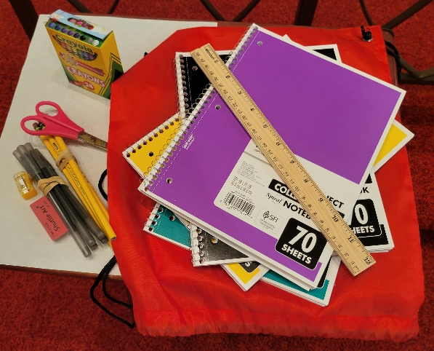
=
The kits were assembled by . . .

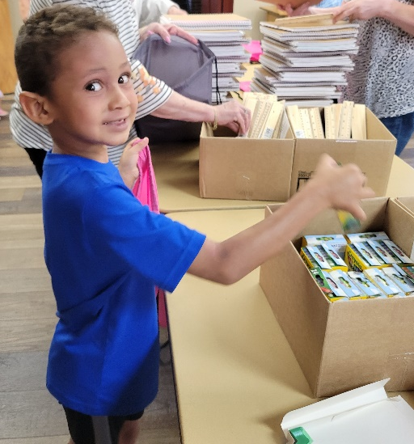
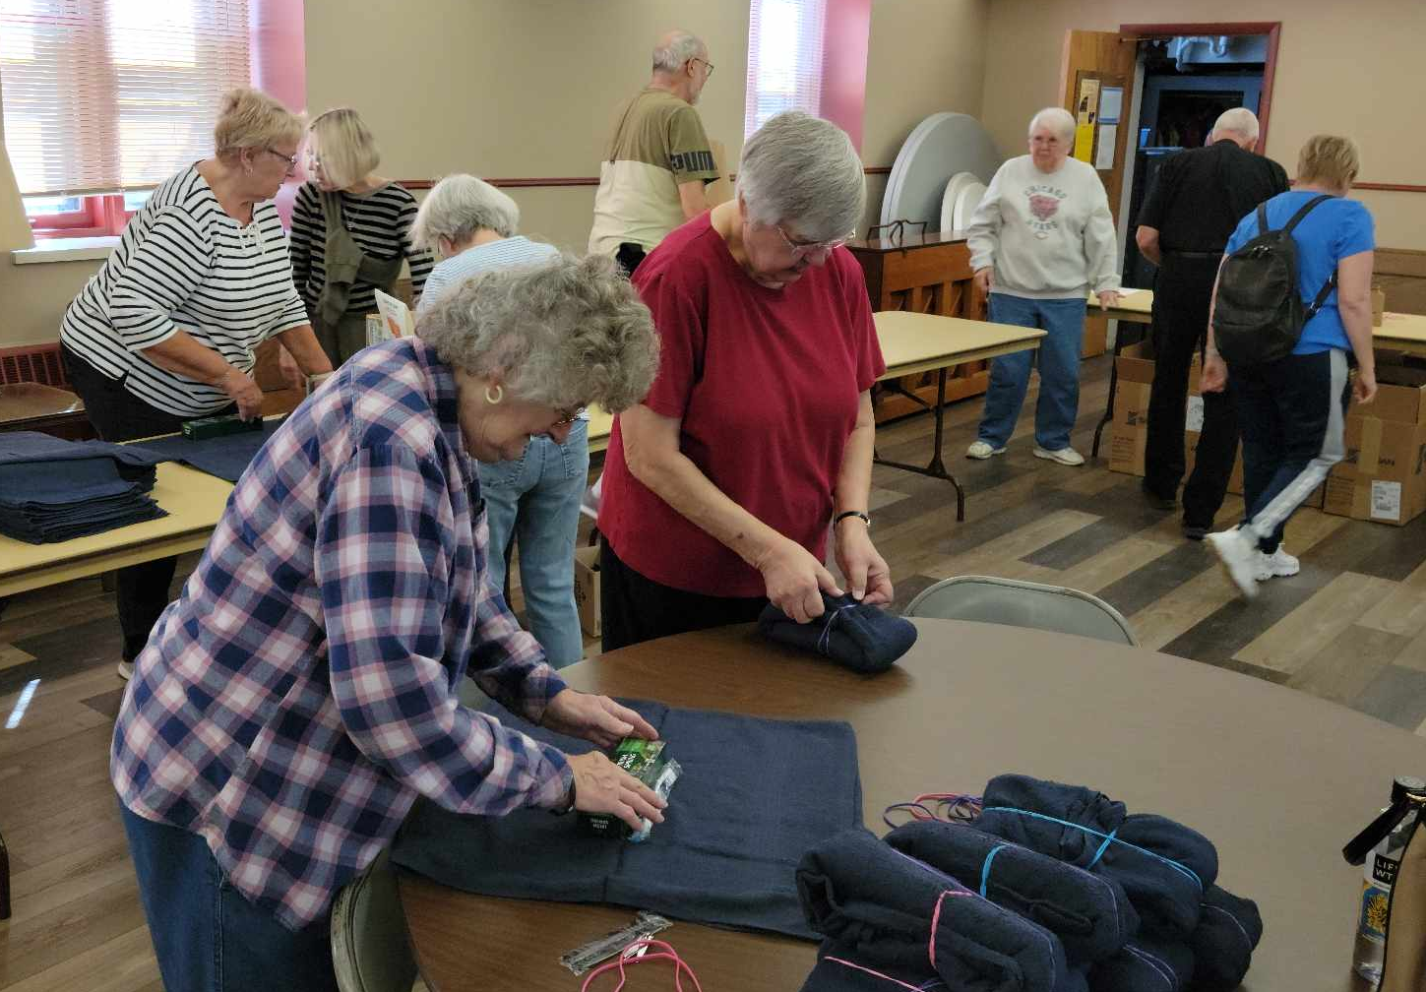
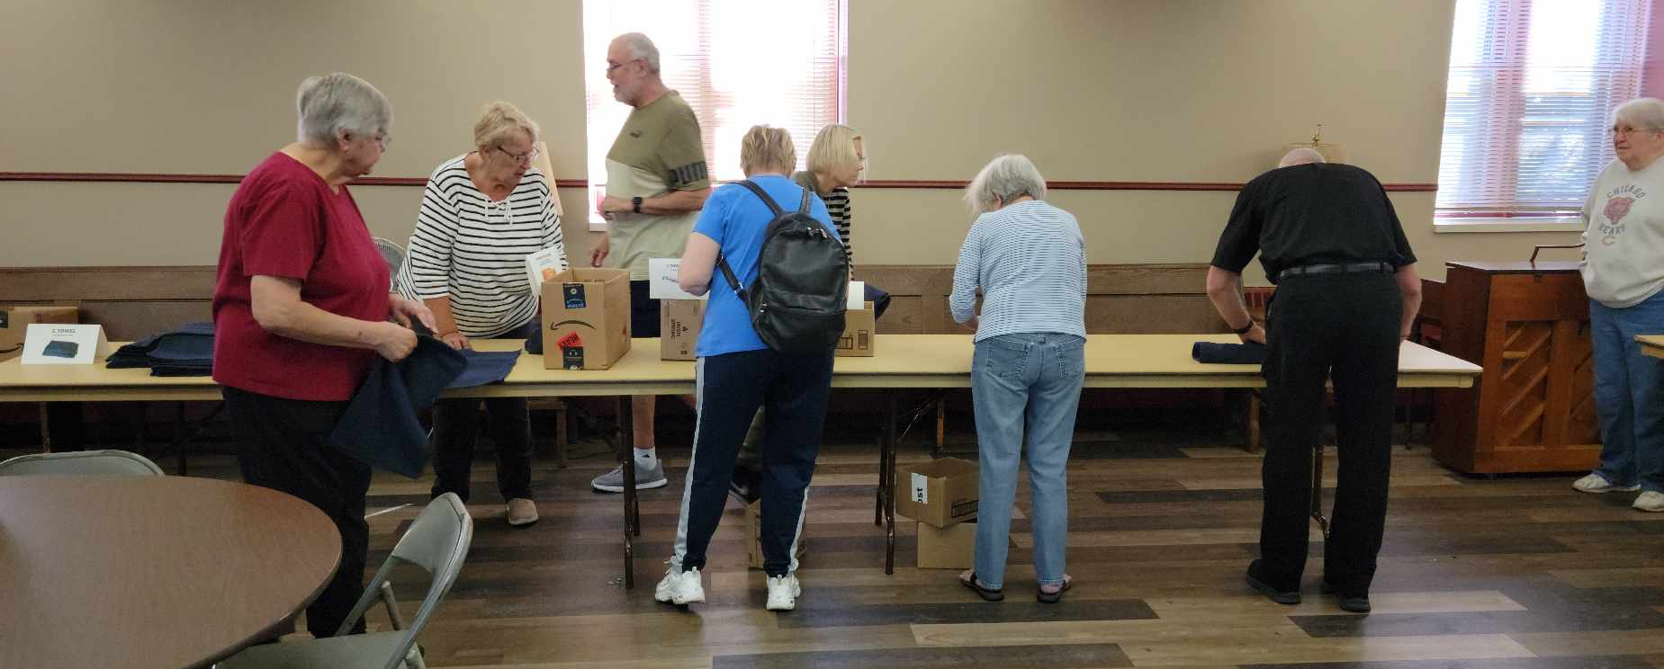
ARCHIVE NEWS

There is a great new tool in the Archive Room! Actually, it’s not in the Archive Room but possibly in the palm of your hand…your phone! How does your phone tie in with the Archive Room? If it is like many, it has an app (application) named Google Translate. If you have an iPhone, there is most likely a similar app.
So much of the Archive Room is old papers, Bibles, ledgers, minutes, etc., that are written in German. With Google Translate, those German papers are no longer a mystery. Very cool!
An old ledger written in the German language was dug out and experimented on. Using this app on the camera mode (no need to take a photo though), you can see what our forefathers wrote! It translates from German script, a few words here or there. Better yet, if the German is printed, you get a clear translation of every word! Even if a book is written in the ornate German script, you can see through your phone (or your friend’s) what the sentences have to say.
The book experimented with was in cursive so just words here and there were picked up: Women’s Club Meetings, Women’s Association, 1925 to 1938, sending flowers to funerals and ill, doing laundry for the hospital??, sick people, wash dishes, choir of Chicago, illnesses, cemetery flowers, fallen soldiers, etc. It also made clear the meetings started and ended with Pastor’s prayers, but the group was composed of all women. There is mention of women in Blair’s Addition, Canada, Eastport, and other communities. The minutes may have been written in German; but according to those German minutes, they were read aloud in English as well. If all these women were of St. Paul, this is a big group! If you would like to view this book, it is on the table in the Archive Room in an archival plastic pouch.
Please try it!
In other news, a thank you goes out to the Wednesday Morning Bible Study. They were able to identify all but two of the people in the big 8x10 photos. The remaining 2 remain on the glass case if you want a try at figuring out who they are.
Have a Happy Thanksgiving!

Christmas Poinsettias

Time to place your order! Yes, it’s time to start thinking about purchasing a Christmas Poinsettia from St. Paul’s Church. Each plant will be in a 7.5-inch pot with 4-11 blooms. You will have a choice in color between red, white, or pink. If you do not specify a color, red will be chosen. Each plant will cost $15.00 and can be put ‘In Memory or Honor of a Loved One.’
Please place your order through the Church Office by calling 219-874-7293; or place your information on an envelope with cash or a check made out to the church and place it in the offering plate. All checks should be made out to St. Paul Church. Orders must be placed by Monday, December 11. The final count is turned in that day!
All plants will be available to take home after the Christmas Eve Service.

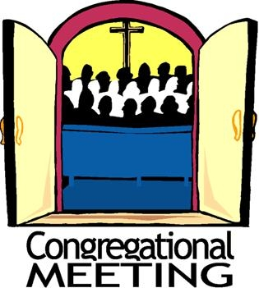

On Sunday, November 12, at 10:00 a.m. we will hold our annual Fall Congregational meeting in the St. Paul Room. The primary agenda will be the election of new Church Council members. There will also be a vote to officially close the Gruenke School Account so that the remaining funds may be dispersed to the congregation and one or more Lutheran higher education institutions as required by the charter of the fund. There will be a brief report from the Property Evaluation Team on the status of the sale of the school building.
As always, we need your wisdom and input for these important decisions. Following the meeting, there will be a potluck dinner. The Council will provide the main dishes and attendees are asked to provide a favorite side dish. Join us for important decision-making, good food, and fellowship.

SEPTEMBER, 2023, SUMMARY OF ACTIONS
· All accounts have been closed regarding the school.
· Discussions continue with Pastor Erika and Pastor Nancy regarding combining ministries.
· Fall Congregational meeting set for Sunday, November 12, 10:00 a.m. with potluck luncheon to follow.
· A vote will be taken at the congregational meeting to close the Gruenke Fund.
· Facilities Use Requirements were approved.
· Monthly Mission Schedule was reviewed.

Please note that copies of Council meetings are placed in the Narthex after approval at the monthly meetings.

November 12 Radio Schedule

Because the Indianapolis Colts football game on November 12 will be played in Germany, WEFM will be broadcasting it live from 8:30 a.m. to about 11:30 a.m. that Sunday. Therefore, St. Paul’s worship service will be broadcast beginning about 11:30 a.m. on that date. The regular broadcast schedule will resume on November 19.

November Birthdays November Anniversaries

2 James Gleason 1 Warren & Kathryn Glanz
5 Sarah Sutor 23 Bob & Karen Kiser
6 Allen Sydow 26 Dave & Sue Pfeiffer
Susan Levenhagen
7 Judy Hunt
8 Brittany Struebing
9 Fred Hart
Kari Hendricks
11 Jeffrey Timmrick
Kaylee Richardson
12 Collin Fisher
17 Susan Tomsheck
Ryan Scheuchner
Noah VanGemeren
20 Scott Bartels
23 JoAnn Sydow
Darlene Baker
24 Carrie Ziesmer
25 Marla Furness
26 Mark Robbins
Dave Pfeiffer
Gaby Cains
30 Rhys Fratgillo

God of life,
You make amazing things happen every day.
Bless the seeds that sprout and the babies that are born.
Bless the people who try new things,
like school or jobs or plans or projects.
Teach us all to see and celebrate all the beginnings around us.
Amen.

Long-Term Prayer List

Laura Dovey Marla Furness Dolores Hackett
Jess Kalvaitis Christine Kiser Pastor Al Lorentzen
Bethany Manning Christian Martinez Shane Nevels
Jan Paholski Kay Peglow Mark Tannehill
Kathy Thielman Margie Torres Venia Wendt

IN HONOR OF WARREN & KAREN SCHACHT
General Fund from Donna Otttersen

IN MEMORY OF ED GUSTUM
General Fund from Sharon & Kenneth Larson

IN MEMORY OF AUDREY BEYER
General Fund from Payton McCoy, Andrew & Patricia Smith and Amy Smith

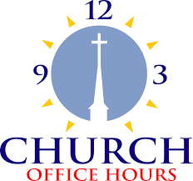
Monday 8:00 a.m. – 5 p.m.
Tuesday 9:00 a.m. – 12:00 noon
Wednesday 8:00 a.m. – 5 p.m.
Thursday 9:00 a.m. – 12 noon
Friday 8:00 a.m. – 12 noon

St. Paul Lutheran Church Staff
Pastor Rev. Mark Reshan
Secretary Libby Pollock
Accompanists Jary Tannehill, Mark Tannehill, Jacob Tannehill
Custodian Mark Kloess

Thank$ for $haring
Thank you all for your participation in our give-back opportunities. In August, we raised $225 from Carlsons. In September, our Galveston give-back raised $325 for the church. In October, The Holly’s give back raised $297.
This month,we will see you again at Galveston on Thursday, November 9! Here are two coupons: one for you and one for a friend.

