

October, 2022

**MARK: MY WORDS**

For Lutherans, the month of October always brings to mind the Reformation. That event, after all, is the “ground zero” of our history as a confessing movement within the Church catholic and Body of Christ. At the heart of that heritage is the promise Luther re-discovered from the Scriptures that, in the end, God is always faithful to His merciful acceptance of us in Jesus even when we are faithless.

This month, that faithfulness is especially embodied for us in the lives and service of two of our most beloved members. Thirty years ago our organist, John Remmel, came to St. Paul to serve as the assistant organist under Elvira Precious. His duties also included serving as Senior Choir Director, Bell Choir Director, and Director of the Music Program. When she died in Lent of 2000, he finished out the season and then was selected by the search committee to serve as her permanent replacement as senior organist. He kept the other duties as well until Dennis Kienitz was hired in 2001 to serve as Senior Choir Director.

For the last 22 years, he has “faithfully” played for worship services, weddings, funeral, school chapel services, special liturgies, and as accompanist for the choir. He has helped the congregation learn new musical settings of the liturgy and remember favorite arrangements.

All of this has been done with great good humor, patient flexibility, and a deep commitment to worship that communicates depth of spirituality and an integrity to our Lutheran tradition. We have been so blessed by his ministry among us. In thanksgiving for that service we will honor him during the worship services on **Saturday, October 15, and Sunday, October 16.** After each service there will be some light refreshments served in the upper narthex and an opportunity to thank him. We hope that you will make a special effort to be with us on those days and offer your congratulations for his “faithful” music-making.

The other model of such “faithfulness” is our eighth grade homeroom teacher, Don Thompson. We actually missed his fortieth anniversary at the school last year, so we are taking the opportunity now to honor his long and distinguished ministry among us. For many of those years, he has taught history and geography and served as athletic director and coach of virtually every sport the school has offered. A number of his basketball players went on to highly successful high school and college careers, building on the strong foundation that he established with them in their time at St. Paul.

He has also served as commencement speaker for the eighth grade graduation services for many of the classes over the years. In the time that I have been here, it has been the tradition for the students to choose their speaker; and “Mr. T” has been their overwhelming choice again and again. Clearly, they form a deep connection with him during their time at the school; and they look to him to send them into the next phase of their educational journey with his trademark good humor and practical wisdom.

Many hundreds of students and their families have been touched and enriched by Don’s ministry to them. Amid all the changes the school has undergone over the past four decades, the one constant has been his commitment to them and his quiet witness to Christ both in and outside of the classroom. We will recognize and honor Don at our worship service on October 23 and then also with a coffee hour in his honor afterward.

God has richly blessed our church and school communities through John and Don. I hope that you will make sure to join us in our recognition of their “faithful” ministry and to offer your thanks for their work. God’s grace is always incarnated, and it has been powerfully so in them for many years. And for that, we offer God our thanks and praise.



**AFFIRMATION OF BAPTISM**

On Sunday, October 30 (Reformation Sunday), we will be honored to have our two confirmands from last year, Abby Haring and Jacob Hazel, publicly affirm their Baptism. We met two days a week during the 2020-2021 school year to study the essentials of the faith as put forward in Martin Luther’s *Small Catechism.*

Traditionally, the confirmands have prepared a Statement of Faith that articulates in their own words what they learned during their study and what their Baptismal covenant with God means to them. They have read those Statements the Sunday before following the worship service in front of family and friends in the St. Paul Room.

That would place the reading on Sunday, October 23, which is also the day on which we would like to honor Don Thompson for his years of service in our school. Abby happens to be Don’s niece, and so it seems appropriate to combine those two events.

Please remember Abby and Jacob in your prayers as they prepare their Statements and to affirm their faith during our remembrance of the Reformation.

**WEDDING**

On Saturday, October 1, Zach Petri, son of Tom and Amy, and Katie Schoof will join themselves together as husband and wife in Christ. Please remember them in your prayers as they begin this new life together.



**SPECIAL THANKS**

Some years ago, we discovered it was more economical for the congregation to lease a car for me for my home, hospital, nursing home visits, and other responsibilities than to pay a stipend based upon mileage. Through the help of former member Roger Miller and then Tim Crozier, we were able to secure wonderful and reliable vehicles.

The lease on the current car was up in October. Because of the insanely high prices for new and used cars, Tim helped us determine that it would be to our advantage to purchase the car rather than lease a new one. The lease prices now are running about twice as much as the cost of the three-year old car.

With approval from the Church Council, we set about completing that transaction. In the fine print of the contract there were charges totaling about $1,300 on which we had not counted. Tim was able to negotiate with the Bosak GMC-Chevy dealership at which he works here in Michigan City and get those charges waived. We are so grateful for his help and expertise!

Tim has been voted the #1 car salesperson in Michigan City for the last several years. If you are looking for a new or used car, he is the guy to see. But hurry; he plans on retiring within the next few months (if the dealership lets him go ☺).

Thank you, Tim, for all your help in these last years in providing safe and dependable transportation for me and my ministry.

**BAPTISMS**

A baptism was held on August 28, 2022.  Leah Ann Brooks, daughter of Paul and Lora Brooks, and Camren Brooks, Paul and Lora’s nephew, were baptized at the 9:00 a.m. service.  We welcome the Brooks children into our church family and look forward to seeing them in church and at future activities.  A reception sponsored by the Altar Guild was held following the service.

On Sunday, September 18, 2022, the St. Paul Congregation welcomed Harlow Rae Fratgillo as our newest member.  Harlow is also the daughter of Rhys and Krysten Fratgillo and the granddaughter of Lynn and Bill Wilson.  We congratulate Harlow and her family and look forward to having her as a new member.



**GOD’S PURLS**

The knitting and crocheting group meets every Wednesday at 10:00 a.m. until noon.  If you enjoy knitting or crocheting or any other sewing project you may be working on, you are invited to come out Wednesday mornings in the St. Paul Room.  The group makes prayer shawls, lap robes, scarves, mittens, hats, and slippers to be distributed to shut-ins and those in need of a little warmth during the cold winter days.  We recently brought over 22 hats and mittens for the children at St. Paul School.  Thanks to a generous donation, yarn was purchased to be used for our projects.  Please consider joining God’s Purls.  All are welcome.

**ARCHIVE ROOM NEWS**

Did you know the Archive Room also has a treasure trove of information about our St. Paul Lutheran School?

The school was opened in 1876 with classes meeting in the church basement. By 1886, the two teachers each had over 100 students to instruct. A third teacher was called when school attendance reached 264 students in 1891. The first school building was built in the late 1800s.

There are no attendance records for the early years, but we do have attendance records for some of the years the school has been open. An Alumni Association was established in 1994; some of their minutes are also in the Archive Room. Some of the old textbooks are in the Archive Room while others and some of the old school desks are in the basement of Luther House.

PS: If anyone has a list of St. Paul Lutheran School alumni, please drop it off in the school or church office. The School Board and school office would like to have that information.

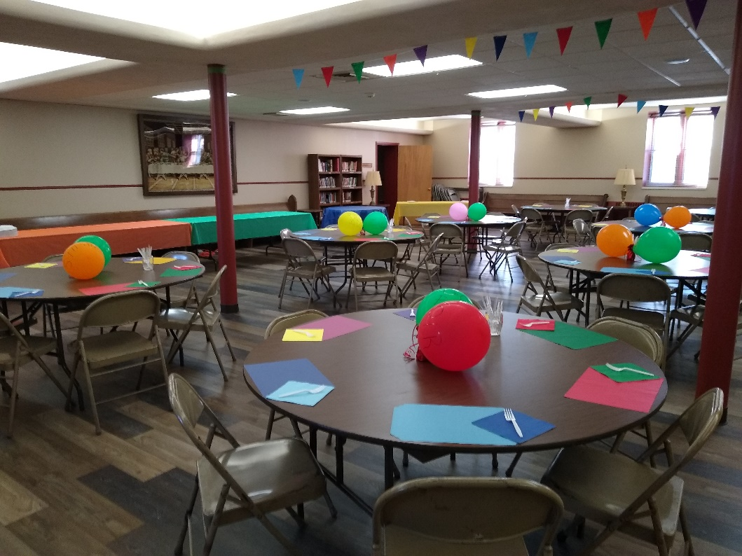**RALLY DAY CELEBRATION**

St. Paul celebrated Rally Day by having a potluck dinner on Saturday, September 10, after the evening service.  The St. Paul Room was decorated with colorful balloons, flags, and table settings.

Forty people attended; and the food, as usual, was delicious.  Hot dogs were cooked on the barbeque by Chef Rich Fleming.

And we were happy to have in attendance the youngest member of St. Paul.

After the dinner, Pastor Reshan encouraged our congregation to think about ideas concerning participation in any synod-related strategic planning or revisit our own plan from seven years ago.  Virginia Murray asked those present to consider attending ongoing activities at St. Paul:   Bible Study, Altar Guild, WELCA, God’s Purls (knitting and crocheting), Meals on Wheels, Soup Kitchen, Funeral Luncheons, Choir, Praise Band, Deacons, and Church Council.



Thanks to all who enjoyed the chicken, pork chops, and potatoes from our school’s Port-a-Pit fundraiser. With your help, we raised $1,000!

For all of you who love Butter Braids, have we got a treat for you! St. Paul Lutheran School is selling butter braids in October with delivery before Thanksgiving. School Board members will be available in the narthex to take your orders on the weekends of October 15-16 and 22-23, or you can contact the school office for an order form.



**IN MEMORY OF CAROL WEISS**

**Capital Improvement Fund** from Fred Weiss (for church organ maintenance), Mary Knaup, Bob & Karen Kiser, Wayne & Suzann Dolson, Maxine Powell, Richard & Kathy Thielman,

Mary Ann Reitmeir

**General Fund** from Virginia Murray; Pamela Janisch; Don & Beth Thompson; Michael Sass;

Chip & Audrey Claussen; Ray & Judy Reagor; Donna & Mike Knoll; Richard G. Cains;

Pamela & Richard Henderson; Dave & Nancy Squires; Katie & Byron Johnson; Grace Romine;

Paul Fischer & Dannie Chandler; the Seifert family: Joan, Tim, Jeff, Teresa, & Jackie;

Eugene & Carol Tylisz; Tom & Nan Fischer; Sherry Ann Demaire; David & Amy Haring;

Jana & Charlie Thomas; Tim & Stacie; Carol Radke; Martha Schroeder & Thomas;

Jeffrey Timmrick; Beth & Norman Smith and Mark & Mary Fischer; Mr. & Mrs. Thomas King;

Janet Bakken; James & Sandra Galinowski; Karen & Warren Schacht; Betty Yourist;

Diane Gielow; Diane Fischer; Mike & Marjory Bockover

**IN MEMORY OF NORMAN EGILSKE**

**Capital Improvement Fund** from Wayne & Suzann Dolson, Maxine Powell, Kathy Lowder

**General Fund** from Linda Depaul, Donna Martens, Don & Beth Thompson, Janice White



**October Birthdays October Anniversaries**

1 Derek Devereaux 4 James & Susan Thomsheck

Jacocb Tannehill 9 James & Sandra Galinowski

2 Lauren Hahn 20 Craig & Judy Hunt

Maria Ruminski 21 Warren & Karen Schacht

Amy VanGemeren 24 James & Kimberly Summers

4 Natalie Kendricks

Dennis Wahl

5 Cynthia Payeur

7 Dan McNabb

Milenda Simerlein

8 Susan Callahan

9 Judith Gustum

Jayden O’Donnell

Carol Thomas

11 Laura Childers

Heidi Ponder

12 George Martin

16 Kurt Smith

19 Karen Jarrell

Evan Prast

24 Kenneth Hanft, Sr.

25 Judith Mutchler

26 Bob Kiser

28 Sandra Sobecki

29 Karen Schacht

31 Kenneth Wilson

**Long-Term Prayer List**

Robert Atwood Audrey Beyer Irene Bohnstadt

Donna Bostater Shari Brotsky Laura Dovey

Laura Eilers-Straight Marta Furness Diane Gielow

Jim Gleason Ed Gustum Dolores Hackett

Heidi Happel Terry Hygema Jess Kalvaitis

Christine Kiser Ryan Krueger Tom & Larry Leuth

Pastor Al Lorentzen Bethany Manning Christian Martinez

Laura Moore Shane Nevels Duane Ormsby

George Ottersen Jan Paholski Kay Peglow

Cameron Rackard Wally & Betty Ratliff Annette Scroggin

Ryan Sirk Erik Tannehill Jary Tannehill

Kathy Thielman Jean Thomas Lee Timm

Venia Wendt

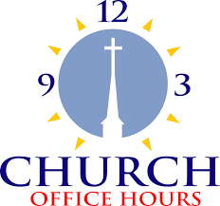

Monday 8:00 a.m. – 5 p.m.

Tuesday 9:00 a.m. – 12:00 noon

Wednesday 8:00 a.m. – 5 p.m.

Thursday 9:00 a.m. – 12 noon

Friday 8:00 a.m. – 12 noon

**St. Paul Lutheran Church & School Staff**

Pastor Mark Reshan

Organist John Remmel

Accompanists Jary Tannehill, Mark Tannehill, Jacob Tannehill

Choir Director Lori Zylstra

Office Secretary Libby Pollock

Custodian Mark Kloess

School Principal Tracey McCay

School Office Coordinator Lisa Heddens

School Custodian



**Do You Shop on Amazon?**

**St. Paul Lutheran Church is on Amazon Smile.** 0.5% of all eligible purchases will be returned to St. Paul. Help us spread the word! Link your Amazon account through the following link—https://smile.amazon.com/ch/52-1239301. When prompted, sign into your account to make sure you are choosing St. Paul for Amazon Smile. There’s no extra charge to your purchases.

Thank$ for $haring

This month,we will see you at Galveston! We’re giving you two coupons so you can invite a friend and give them their own coupon. Remember, the coupon is required for the Give-Back bucks.

