

September, 2021

**MARK: MY WORDS**

“One of the most difficult challenges of dealing with the pandemic is that out of necessity everything is so fluid. Every day brings changes in plans or projects due to an increase in positive cases, restrictions by government or church leaders, or new recommendations by medical experts and personnel.”

That was the opening paragraph to the front-page article from last year’s September newsletter. Twelve months later, we find ourselves in much the same position. As of this writing, just several weeks ago, LaPorte County and those surrounding us were in the “blue” level of COVID infections. Because of the lightning-quick spread of the Delta variant of the virus, within days we went from “blue” to “yellow” to “orange” where we now stand.

That forced us to return to mandating the wearing of masks during worship; to make contingency plans in case the level goes to “red;” and, today, the news that the White House is going to recommend a third booster shot eight months after their second one for those fully vaccinated. This lack of progress and movement forward and freedom from anxiety can leave us frustrated, discouraged, and fearful.

It also casts a shadow over our own hopes and plans to plot a new direction for our congregation about which I have been writing and speaking over these last months. The Council will still move forward with consideration of the options offered by the synod and ELCA, but the threat of having to curtail worship and other activities may prevent the full realization of those plans in the months to come.

September offers two minor church festivals on the calendar that bring comfort and encouragement and strength in the face of such challenges. September 14 is observed as Holy Cross Day. The Gospel reading for that Day is John 3:13-17, which of course includes the famous “Gospel in a nutshell” in Martin Luther’s words of “For God so loved the world …”

Jesus begins this section of His response to Nicodemus’s question of how one can be “born from above” by saying, “No one has ascended into heaven except the One Who has descended *from* heaven, the Son of Man.” In these words is the assurance that when we are faced with pandemics, disease, sickness, anxiety, worry, fear, grief, and all the other assaults of sin and evil that we do not face them alone. God is not detached and removed from them or us far-off in heaven. In Jesus, He “descends” into our very suffering and death to join us in them.

He comes, Jesus goes on to say, “so that whoever believes (in this Son of Man) may not perish but may have eternal life.” In John’s Gospel, the phrase “eternal life” does not refer to “going to heaven” when we die, but rather to entering into a relationship with Jesus and His Father through their Spirit that *already now* places them in Their life and love and care.

Thus, in the strength of that relationship, we may face whatever tries to disrupt that life with the confidence and hope that Father, Son, and Spirit will bring us through and bless us with the power of their own life and love that has defeated every threat to them.

One of the ways that they keep us in their care is celebrated on the second festival Day of St. Michael and All Angels on September 29. In the Old Testament, the archangel Michael was the heavenly protector of God’s chosen people of Israel. He has since been honored as now the guardian of all of God’s people, fighting against the devil and his angels in the famous battle scenes in the book of Revelation.

On this Day, we remember that God sends His holy messengers who actively seek our good against all the evil that would try to separate us from Him. In a reading from Ephesians that we heard on 13 Pentecost, Paul asserts that “our struggle is not against enemies of flesh and blood, but against the rulers, against the authorities, against the cosmic powers of this present darkness, against the spiritual forces of evil in the heavenly places.”

Pandemics, wars, famines, earthquakes, hurricanes, drought, wildfires, and other disasters are all part of the “labor pains” (to use another phrase of Paul from Romans 8) as we await the final defeat of suffering and death and the birth of the promised new creation where they will be no more. In this and all times of intense suffering, God’s holy angels surround and support us, strengthening us as we seek to continue to bear witness to what God has done and is doing in Jesus for all this suffering world.

May these two Days infuse all our days with God’s own courage and hope.



Traditionally, the second Sunday in September is “Rally Day,” which marks the beginning of Sunday School and other congregational programs that were dormant over the summer. Last year, we did not celebrate this unofficial day because of the pandemic. This year, it will again be very low-key, partly because virus conditions may affect our in-person worship plans by that time and also because right now we have no Sunday School-aged children to resume that educational ministry. There will be a few ministries starting up again (see below) but once again our Rally Day will be rather quiet.



**BIBLE STUDY**

Our Wednesday morning Bible study of the text for the coming week has not taken place for almost 18 months. We will attempt to gather again beginning **Wednesday, September 15, at 10:00 a.m.** in the Luther House. Or, if we are at the point where we need to keep further distance, we will meet in the St. Paul Room. Join us for an in-depth review of the week’s lessons that will enhance the liturgy and sermon and your growth in the Word.



**INSTALLATION OF MUSICIANS**

With the return of the Choir under the direction of Lori Zylstra this summer, we will again look forward to formally installing them and the members of the New Song Praise Band on **September 19.** This is always a wonderful opportunity to recognize the rich ways our musicians lead our worship and praise and to thank them for their many hours of practice and sacrifice in order to do so.

**BENEFIT FOR ERIK TANNEHILL**

On Saturday, September 25, from 10:00 a.m.-2:00 p.m., together with the members of First Presbyterian Church and First United Methodist Church, we will hold a benefit for our own Erik Tannehill. Erik continues to oversee the Soup Kitchen ministry, currently operating out of First United Methodist. Because of some health issues and a recent hospitalization, his own income stream from his catering business and the operation of his Melt Restaurant in La Porte has been interrupted.

We would like to raise some money to help him and his family, so this benefit has been put together. It will be held in the parking lot of First United Methodist and will include a car show, entertainment from the Hoosier Star program, and the sale of food and refreshments. Sloppy Joes will be provided by The Stadium Inn, we will sell hot dogs and chips, and there will be other food selections and desserts for sale.

Parking will be held in our lot since First United Methodist’s will be filled with the car show. As we did for the Taste of Michigan City and the Boat Parade and races, we will charge $5 for parking with the proceeds going to the fund for Erik.

Volunteers are needed for our parking; help with preparing and selling the food items; and setting up and taking down tables, chairs, and other equipment. To help, contact the church office.





As mentioned in a recent worship service, this has been a challenging summer for our school. Three teachers needed to be replaced. Many interviews took place, and several positions were filled with excellent candidates. Also, our former principal abruptly resigned four days before the first day of school.

The School Board, consisting of Chair Judy Hunt, Pastor Pamela Thiede, Melinda Nagle, Jan Bakken, and Pastor Reshan, have worked hard to fill the vacancies and try to ensure a smooth beginning to the new school year. We welcome Janelle Eckroad teaching middle school language arts and Jamie Paull as fifth grade teacher. We continue to seek qualified candidates for one opening.

We have hired Tracey McCay as our new principal. Tracey has been the Office Coordinator for the school for the past eight years; and she is well familiar with the parents, staff, students, and operation of the school. Before coming to St. Paul, she was a teacher at St. Stan’s. We are confident that she will lead the school into a full and rich year of instruction and growth for our students. We have hired Allison Wilson to replace Tracey as Office Coordinator. Please continue to pray for all our school staff, families, and children as we begin this vital ministry of the congregation once again.

Finally, as our Kindergarten teacher, Alexa Allison, was cleaning out her room at the end of last school year, she found a card her class had made for the congregation. It reads: “With gratitude for your love and support during a very difficult year! We hope your summer has been happy and healthy. Prayers for a heart-felt year ahead!”



**WEEKEND AWAY**

As many of you know our sons Dan and Jacob are now seniors at New Prairie High School (they were in kindergarten when I came to St. Paul!). We are starting the process of contacting and visiting colleges and universities they might be interested in attending next year and arranging for visits to the campuses.

The first will take place on the weekend of September 11-12. Dan will be taking the ACT exam in the morning and then we will leave for Cleveland to visit and tour the campus of Case Western Reserve University on Sunday afternoon. We will return home late on Sunday, and I will be back for worship on the weekend of the 18th and 19th.



**OFFICE CLOSURE**

The church office will be closed on Monday, September 6, in honor of Labor Day. It will re-open on Tuesday, the 7th, at 9:00 a.m.



**IT’S THAT TIME AGAIN**

It is time for each of us to consider what we can do for St. Paul Lutheran Church and St. Paul Lutheran School. It is time to remind ourselves that things don’t just happen; it all takes leadership. We are not all called to be leaders; but some of us are, and we need to step forward and lead.

Our annual fall election is coming up; and we need to elect a President, Vice President, Secretary, and Treasurer. (The people in these positions have served for two terms and cannot run for the same office again). There are four 2-year Church Council seats and one seat for a 1-year term that need to be filled. We also need four people to serve a 1-year term on the Nominating Committee. The School Board has two 2-year positions open.

If you feel called to serve St. Paul in any of these positions, it would be very helpful if you would contact Janet Bakken, Vice President at (219) 873-9015 or

[grandmajan06@sbcglobal.net](mailto:grandmajan06@sbcglobal.net).



**UPDATE FROM THE SPRING CONGREGATIONAL MEETING**

A committee of five people (Jim Schraidt, Karen Fleming, Judy Mutchler, Pastor Pamela Thiede, and Janet Bakken) have been meeting every other week to work on a new church constitution. Members of the congregation realized that our constitution needs some updating that can’t be done to our present constitution, so we have started the process of drafting a new constitution. Once the committee has the new document ready. it will have to be voted on at two congregational meetings and then approved by the Synod Council. You can see that we are very early in the process…but we have begun.



**ST. PAUL IS ALIVE!**

Friday, August 6, and Saturday, August 7, just kept growing. It started with an idea to charge for parking in our lot during the Michigan City Boat Parade. Then we got an unexpected contribution of $750 in gift cards from Meijer, and the raffle came to life. The idea of selling popcorn came next. It would be the weekend of First Friday and Taste of Michigan City: we can sell hot dogs, chips, walking tacos, soda, and water. Let the coordinating and planning begin!

A **BIG** thank you shout out to those who made it happen: Barb and Mike Fulkerson, Bob and Karen Kiser, Richard and Karen Fleming, Larry and Judy Litchford, Wayne and Susann Dolson, Dave and Nancy Squires, Kelly and Brad Neulieb, Paul and Lora Brooks, Virginia Murray, Lee Coburn, Ivye Benson, Jean Kleinschmidt, Craig Hunt. Amy VanGemeren, Susie Dolson, Pastor Mark Kloess, and Janet Bakken. Job well done.

Together the raffle, parking, and food sales raised $3,800 which was designated for a new hearing amplifying system and the remainder to the 150th Anniversary fund that we are building for our 150th Anniversary in 5 years.

We are evaluating this year’s event and planning for next year. One thing we can be sure of is that we will need more volunteers!

(Pictures on the next page . . . )

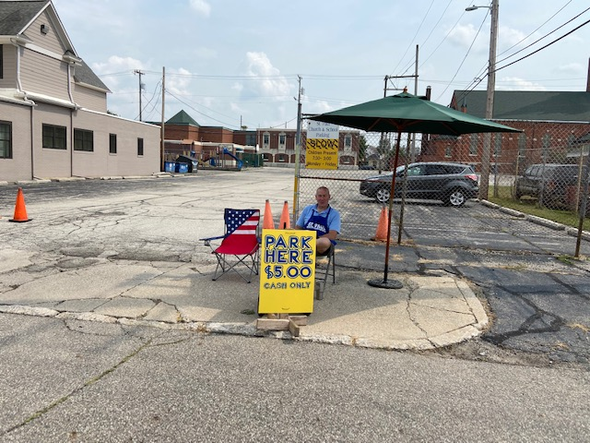

Helena Albertson offfers this opportunity to be Comfort Keeper. If you are retired,looking for a few shifts here and there to help someone seeking in-home, non medical care; a college student, looking for a flexible schedule with short shifts between classes; or anyone in between looking for a meaningful part-time enterprise, perhaps you could help Comfort Keepers provided needed services to a neighbor.



**September Birthdays**

1 Benjamin Crozier 27 Katherine Crozier

Brien Ruminski 28 Philip Koss

2 Judy Litchford 30 Joyce Manning

Larry Miller Denita Newenhouse

Lori Zylstra

5 Sarah Payne

Brett Schacht **September Anniversaries**

6 Ryan Ruminski 6 Paul & Lora Brooks

Ryley Ruminski 14 Allen & Kimberly Sydow

7 Joan Coughlin 15 Richard & Pamela Henderson

Verne Kee 19 Donald & Elizabeth Thompson

8 Joan Seifert30Robert & Carrie Ziesmer

9 Chloe Cloutier

Mary Knaup

Jayme Orlowski

10 Nan Larson

11 Trish Sprague

13 Karen Morlan

Kalen Sprague

14 Robert Pheanis

15 Richard Collins

James Krueger

16 Clay Payne

17 Matthew Keith

Hannah Tannehill

19 Julie Edinger

Kay Peglow

20 Violet Fane

Samantha Hendricks

Laurie O’Hara

Daniel Ottersen

22 Sue Pfeiffer

Helen Wiese

23 Martin Tannehill

25 Cole Ponder

26 Fred Weiss



**IN MEMORY OF JOHN STIBBE ON HIS BIRTHDAY (August 22)**

**General Fund** by his daughters, Kay Peglow, Pat Jones, Pam Sullivan, and Linda Strohacker

**IN MEMORY OF SUZANNE CAINS**

**General Fund** by Fred & Carol Weiss

**Crusader Fund for Girls Volleyball and Basketball uniforms** by Virginia Murray,

Kristen Jasicki, David P. Jocelyn, Pamela Henderson, Don & Beth Thompson, Pamela Janisch,

Michael & Donna Knoll, Mark & Mary Fischer, Beth & Norman Smith, Steve & Darlene Baker, Wayne & Susann Dolson, Thomas & Nan Fischer, Diane Fisher, David Bornfleth, Mary Knaup, Phyllis & Wally Sacks, Janice Lubiniecki, Gregory & Virginia Orlowski, the Finney Family, James & Jennifer Gebbink, Dale & Denice Moss-Osos, David & Amy Haring,

Michael & Marjory Bockover

**IN HONOR OF PASTOR DALE ZYLSTRA’S ORDINATION**

**General Fund** by James & Sandra Galinowski

**HOLY CROSS DAY**

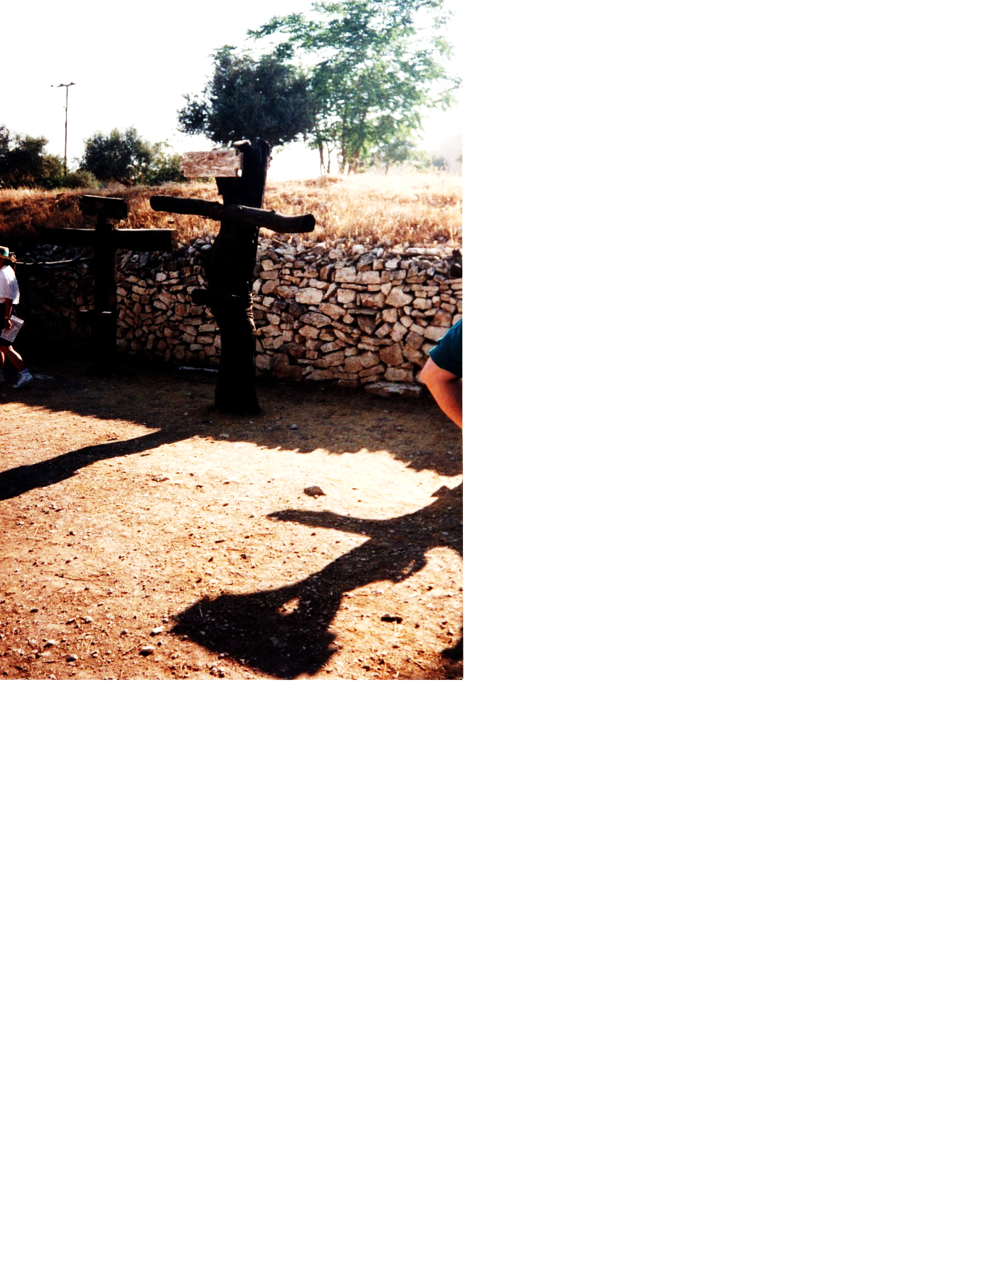In the summer of 1995, just before I began seminary, my dad (Rynold Thiede) and I took a trip to Israel and Egypt. One of my favorite places was Tantur, a Biblical Scripture garden just outside of Bethlehem. After lots of research, the people at Tantur have recreated many aspects of first century life. In honor of Holy Cross Day, I share with you my pictures of some examples of crosses that would have been used in the time when Jesus was crucified. (The girl in the picture on the right is Tuesday, a 10-year-old in our tour group.)



**Do You Shop on Amazon?**

**St. Paul Lutheran Church is on Amazon Smile.** 0.5% of all eligible purchases will be returned to St. Paul. Help us spread the word! Link your Amazon account through the following link—https://smile.amazon.com/ch/52-1239301. When prompted, sign into your account to make sure you are choosing St. Paul for Amazon Smile. There’s no extra charge to your purchases.

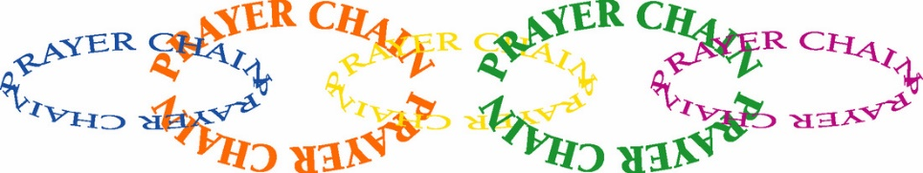

**PRAYER CHAIN**

The members of the Prayer Chain at St. Paul have made a commitment to pray for any and all who request their prayers. Let us pray for you! To activate the Prayer Chain, contact one of the members on the list below and tell her of your need. You may give as much informtion as you wish. Your request will be kept in strict confidence.

Prayer request forms are also available in the pew racks during worship. These forms include prayer categories such as Healing, Comfort, Guidance, etc. Simply fill out the form (please include the date of your request) and place it in the offering plate or hand it to a deacon. The form will be forwarded to a Prayer Chain member. When using the e-mail addresses, please note “Prayer Chain Request” on the subject line. If the subject line is not filled in, the e-mail will not be opened

**Vivian Zellers** 872-8780 [vteach2006@sbcglobal.net](mailto:vteach2006@sbcglobal.net)

**Carrie Ziesmer** 872-6541 [carrie124@comcast.net](mailto:carrie124@comcast.net)



**Long-Term Prayer List**

Robert Atwood Sherry Brotsky Laura Eilers-Straight

Jim Gleason Andy Hipskind Terry Hygema

Jess Kalvaitis Ryan Krueger Tom & Larry Leuth

Ken Mulder Duane Ormsby Jean Thomas

Linda Utley Chris Weninger

**OFFICE HOURS**

Monday 8:00 a.m. – 5 p.m.

Tuesday 9:00 a.m. – 12:00 noon

Wednesday 8:00 a.m. – 5 p.m.

Thursday 9:00 a.m. – 12 noon

Friday 8:00 a.m. – 12 noon

**St. Paul Lutheran Church & School Staff**

Pastor Mark Reshan

Organist John Remmel

Accompanists Jary Tannehill, Mark Tannehill, Jacob Tannehill

Choir Director Lori Zylstra

Office Secretary Libby Pollock

Custodian Mark Kloess

School Principal Tracey McCay

School Office Secretary Allison Wilson

Thank$ for $haring

This month,we will see you at Hacienda! We’re giving you two coupons so you can invite a friend and give them their own coupon. Remember, the coupon is required for the Give-Back bucks.

