September, 2024

**MARK: MY WORDS**

This month there is another happy confluence of a festival of the church year and the calendar. The last Sunday of the month is the 29th, which is the day commemorating St. Michael and All Angels. According to my files, it appears that we last observed this day five years ago; so it is about time to celebrate it again.

Angels remain big business in our culture. Check the shelves or websites for any retail store or outlet, and you will find a dizzying array of angel figurines, statues, posters, jewelry, T-shirts, hoodies, and various other items. Prices range from under $10 to well over $100 depending on the media you are seeking.

They are inevitably portrayed with wings (the passage from Isaiah 6 is the only Scripture passage about angels of which I am aware that mentions this); Caucasian ethnicity; bright, beaming faces; and a halo around their heads. Their appearance is often meant to provide a calming, soothing appearance.

This is not to say that such descriptions are inaccurate. But in many other instances in the Scriptures angels are portrayed as fierce warriors and servants of God who battle the forces of evil and protect God’s people against, in Luther’s phrase, “the wiles of the devil.” Their appearance is many times anything *but* calming and soothing.

In the aforementioned story from Isaiah 6, when the prophet sees the angels flying around the Temple shouting, “Holy, holy, holy is the Lord God of Hosts!” he experiences the very foundations of the Temple shaking. In the accounts of the Resurrection in the Gospels when the women come to the tomb and find it empty. the appearance of the angel(s) to tell them that Jesus has been raised causes them to fall on their faces in terror. In Matthew’s account, when the angel descends from heaven on Easter morning and rolls back the stone from the entrance to the tomb, the Roman soldiers guarding it “became as dead men.”

Perhaps most famously, in the visions of the Book of Revelation, angels variously open the Seven Scrolls that bring devastation upon the earth and do battle with Satan and his angels leading up to the final victory over evil and death by Jesus, the Lamb at the center of the throne of God. In the Scriptures, angels are not cute, cuddly, curly-haired cherubs but part of God’s heavenly army that carry out His purposes and sometimes make known His will to humans (e.g., Gabriel’s annunciation to Mary that she will be the mother of Jesus).

It is those mighty messengers that this day commemorates and gives thanks to God. On this day, we will join our voices with theirs in the unceasing praise with which the heavenly hosts worship and honor their and our Lord.

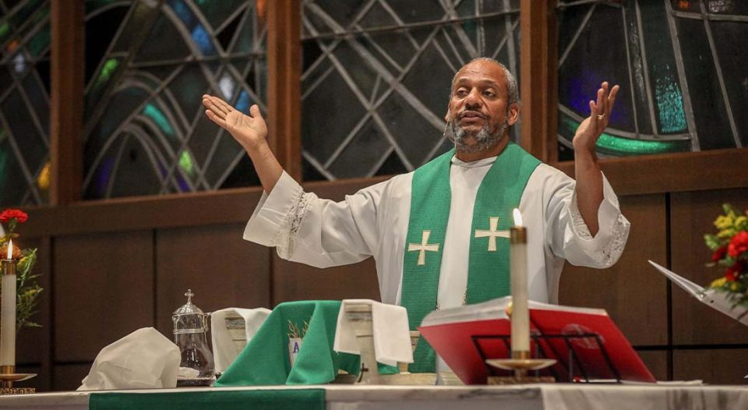

**MEET OUR NEW BISHOP**

As reported following the Synod Assembly in June, Pastor Timothy Graham from Messiah Lutheran Church in Fort Wayne was elected the new bishop of the Indiana-Kentucky Synod. One of our sister congregations in the area recently published a wonderful introduction to Bishop-Elect Graham. It is included here to help you learn more about him and his family. Please include Bishop-Elect Graham and his family in your prayers as he prepares to begin this new ministry.

“After graduating from Wartburg Theological Seminary in 2007, I received a dual call. The first and primary call was as a redevelopment pastor to Grace Lutheran Church/Light of the Cross (LOTC) in Fort Wayne—the same church my father was called to in 1976—and the second call was to Messiah Lutheran Church as an Associate Pastor.

“We built some meaningful community at LOTC. However, sadly, we celebrated the holy closure of LOTC at the end of 2009.

“In March, 2010, Messiah called me to serve full-time as the Youth and Family Pastor. In 2014, I was called as the Interim Senior Pastor, and then in May, 2015, I was unanimously called to Messiah as the Senior Pastor.

“**Some highlights from 17 years at Messiah include:**

* an amazing staff and church leadership that fully supported me
* several international, domestic, and local mission trips with our youth and one international trip with a couples’ group
* the restructuring of our governance to an “Accountability Model”
* transitioned preschool to childcare with infant care
* a $2.3 million Capital and Building Renovation campaign without any debt
* a new culture focusing on hospitality to the stranger where “Everyone means anyone, and anyone means everyone”

“I was adopted in Iowa as an infant, and named Timothy Mark Graham by my father and mother, the late Rev. Vernon Graham and Ellen Graham, while they were at Wartburg Theological Seminary. I have three sisters, Dawn (Tom) Starks, Kristina Alderdice (deceased, 2016), and Melissa (Stacy) Curry and several nieces and nephews.

“My wife Meme (Michelle) and I met in high school and were married in January, 1992. We have four adult children—Sashelle Rose and her fiancé Alex Knight; Timothy Graham, Jr.; Larraine Graham and husband (Cody) Williamson; and Robert Graham—and they all reside in Fort Wayne. We also have seven grandchildren—Jaylen, Maleyah, Michelle, Noelle, Elias, Graham, and Greyson.

“Meme and I love traveling, especially to beaches! Our favorite place is the Dominican Republic, and Hilton Head Island is a close second! I also enjoy watching movies (big Marvel fan), smoking BBQ, and reading thriller mystery novels. And I love an array of music. My favorite artists include Luther Vandross, Elvis Presley, Marvin Gaye, and Christopher Cross.

Rev. Tim Graham

Bishop, IN-KY Synod

**THE WEISS AWARD**

As many of you know, for 19 years Fred Weiss worked every weekend when we hosted the men’s homeless shelter in the St. Paul Room. He *never* missed a shift! He was a quiet, compassionate, wise, humble, and caring presence for those struggling with all the factors that led to their poverty and lack of housing.

When the shelter was moved to its permanent location at the renovated Sacred Heart church building on Eighth, Street Fred ended his volunteering; but his amazing commitment was not forgotten. When the Nest Shelter held its annual awards and recognition dinner on July 30, he was the first recipient of the deservedly named “Weiss Award” that will from now on recognize a volunteer who has demonstrated the same care, compassion, and commitment to the shelter’s guests as did Fred. As Director Harry Holtkamp stated, “Fred’s service has become our gold standard, a shining example that inspires staff and volunteers alike with his compassion, consistency, and advocacy for the shelter’s cause in the community. He’s left an indelible mark on our shelter community; and this award, known henceforth as The Weiss Award, will serve as a lasting tribute to his legacy and inspire future generation of volunteers to follow in his footsteps.”

Congratulations, Fred! Thank you for your faithful service to Jesus present in those homeless men, and for inspiring us in our discipleship.



**MUSICIAN UPDATE**

Once again, unfortunately, there is no progress to report on our search for an organist/choir director. We thought that perhaps we had a good lead on a candidate in mid-August. Pastor Pamela forwarded to me an email from an Episcopal priest in Valparaiso that contained the name and phone number of a musician who was looking for a position.

I immediately texted him to briefly describe for what we were looking, our worship schedule, and some information about the organ. He quickly responded very enthusiastically and asked me to send pictures of the organ to him. I did, and I later spoke to him on the phone and learned a little about his background and current situation.

He seemed very excited about interviewing and asked that we set up a time only two days later. He even asked about presenting a recital before taking the job. I slowed him down and told him that we needed to talk with him first. I called a few extra people and asked them to attend the interview along with our Search Committee members Susan Bagby, Sue Koziel, and Judy Mutchler. They all agreed, and we were very much looking forward to meeting him and hearing him play.

The morning of the interview he texted me to say that he had to turn back and go home because of a situation with his wife. I told him I was sorry that she was experiencing some difficulty and said that we would be in touch to reschedule the interview.

I did not hear back from him either that day nor the following day. I tried calling the next two days but got his voicemail. I asked him to call me back both times, but I never did hear from him. I have no idea what happened or why he suddenly withdrew after his great initial excitement about the position.

So, we continue to be blessed by Maggie, the Praise Band, and Dr. George Karst when Maggie is unavailable on Saturdays. We will patiently await other possibilities for candidates to interview. As always, we are thankful for your patience and understanding.



**INSTALLATION OF MUSICIANS**

September is traditionally the time we formally install our musicians and give thanks for their ministry to us. Although right now things are a bit unsettled with regard to the health of Mark Tannehill, our praise band drummer, and how many will be in choir and how often they will be able to sing, we will install them on Sunday, September 15. We always look forward to being able to publicly recognize their commitment to our worship leadership and showing our appreciation for their great faithfulness.



On Sunday, September 1, we will joyfully receive the following persons into membership in our community of faith: **Tay Klare, Pam Soule, Jim Albano, and Mike Knoll.** Tay lives in the Rittenhouse Villas and is a neighbor and friend of Donna Ottersen. Pam recently moved here from Pennsylvania and was a member of a Lutheran congregation there. Jim is the husband of Melanie and father of Tyler, who joined several months ago. Mike is the husband of life-long member, former church secretary, and current Council secretary Donna.

All regularly attend worship and participate in the life of the congregation. We are thankful for their interest in becoming members and know they will greatly enrich our life and mission together. There will be a reception honoring them during coffee hour following the service on September 1. In the meantime, please welcome them into our fellowship.

**OFFICE CLOSURE**

The office will be closed on **Monday, September 2,** for Labor Day. It will reopen on Tuesday, September 3, at 9:00 a.m.



Our Wednesday morning Bible study will resume on September 18 at 9:00 a.m. in the Luther House conference room. We usually look at the texts for the coming week to provide background information that will enrich the hearing and digesting of the Word. No special understanding or expertise in the Scriptures is required. Bring your Bible and join us.



Last week I received an email from David Weiss, son of Fred. He related that an issue concerning him and an ELCA congregation in St. Paul has arisen because Gov. Tim Walz is a member. David has preached and taught there many times over the years. Once Vice-President Kamala Harris named Walz as her running mate, far-right religious extremists have targeted St. Paul on various social media platforms because of their support of LGBT+ persons. David has been an outspoken advocate for them as well.

The pastor and congregation have taken steps to try to prevent any disturbances that may arise. So far there have been no active threats against them. They have had to hire security personnel to be at their worship; and they have contacted the local FBI office, who has promised to keep an eye on things.

Regardless of one’s political preference, such intolerance and hatred is inexcusable, especially from those who claim to be fellow-Christians. David is rightly concerned, as surely is Fred. Please remember them, Pastor Rome, and the people of Pilgrim in your prayers that they may remain safe and faithful to their witness to Jesus and the Gospel.



**IN MEMORY OF MARY & DYLAN LUSTICK**

**General Fund** from Nic McMillon



**SEPTEMBER MONTHLY MISSION**

Our September monthly mission is the Christian Appalachian Project.  This organization was started by a Catholic priest assigned to pastor a large portion of east-central Kentucky.  Through his outreach, he witnessed tremendous poverty in Appalachia.  With the help of others, he provided food, clothing, and other essentials to neighbors in need.  His small outreach grew into the Christian Appalachian Project in 1964. They now serve more than one million people a year in all 13 states of the Appalachian region.  In this region, the poverty rate is 28%, food insecurity is 19.7%, and 46% of homes are severely deteriorating.  They rely on donations, 88.5% of which go directly to families in need, providing food, clothing, home repair, elderly services, and other essentials.  Please consider helping our neighbors in Appalachia by donating to this month’s mission! Checks can be made out to St. Paul and marked for the Christian Appalachian Project and placed in the offering plate. Noisy coin contributions will also go to the mission of the month.



**SALVATION ARMY FOOD BANK CART**

Have you noticed the decorated grocery cart in the southwest corner of the upper  narthex?  It has a large, cute hippopotamus asking you to ‘Fill Me Up!’ on its side.  This cart is the collection spot for any shelf-stable food item you would like to donate to the Salvation Army Food Pantry.

A few years ago Sarah McNabb was inspired by a summertime Bible Study and thought St. Paul could this!  She sought and received permission to collect food inside the church to donate to the Salvation Army Food Pantry.  To make it easy for everyone, she knew a grocery cart would not only serve as a reminder, but also eliminate some heavy lifting.  St. Paul people responded generously by donating food to the cart for the locally hungry that are served by the Salvation Army Food Pantry.

Even though Sarah (and Dan) McNabb have recently relocated to Indianapolis, her care-taking duties of the grocery cart have been accepted by the Hope Circle.  They will take full responsibility to transfer items to the Salvation Army Food Pantry for distribution to the locally hungry.  The Hope Circle is confident the people of St. Paul will continue to support the Salvation Army Food Pantry and help fill up the cart, even as they support the new St. Paul Little Free Food Pantry.

**ST. PAUL LUTHERAN CHURCH’S**



This pantry aims to provide food, hygiene products, and other miscellaneous essentials that may be otherwise unattainable to members of our community. The pantry box is on the northwest corner of the church building next to the sidewalk.

  

Non-perishable food Paper plates Oral hygiene products

Shelf-stable & microwavable Toilet paper Shampoo & conditioner

items Tissues Body wash & soap

Cooking essentials Laundry soap Feminine products

Cereal & snacks Dish soap Deodorant

Baby food & formula Cleaning products Lotion

Juice Sponges First Aid kits

**Give what you can—place unexpired food, hygiene, or other essential items inside the pantry.**

**Take what you need—you determine your need. All items are available, no questions asked.**

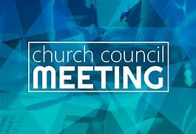

**AUGUST COUNCIL HIGHLIGHTS**

* The parking lot entrance and sidewalk were repaired by the city, but a small section still needs to be filled in by the city.
* We are waiting for a redesigned plan by the playground company to help lower the cost.
* The Council approved the purchase of three news doors to replace the rusted doors on both sides of the St. Paul Room as well as the boiler room.
* The Michigan City Fire Department requested a donation for educational materials. the Council approved a $105 donation.
* The Council approved a motion to place the interest income from the investment of the sale proceeds from the school building in the General Fund.

Full copies of the approved minutes are available in the church narthex.

The Council will begin considering local 501C organizations who will benefit from the half of the school sale money that was set aside.  If you have a local 501C organization that you would like for the Council to consider, we need that suggestion in writing.  You can email it to  
church[secretary@stpaulmichigancity.com](mailto:secretary@stpaulmichigancity.com) or send it by U.S. mail.  The Council will not consider any suggestions that are not in writing.

Janet Bakken

Council President



Baker, Ken & Ruth Peglow, Kay

2002 Andrew Avenue, Unit 4 c/o Samaritan Water Valley Sr. Living

LaPorte, IN 46350 Resort

Email: [krbake288@gmail.com](mailto:krbake288@gmail.com) 1831 Compassion Court, #205

Ken’s phone: (239) 788-7599 Windsor, CO 80550

Ruth’s phone: (239) 770-5743 Stacy’s Phone: (303) 915-2916

Baker, Steve Sunde, Diane

507 Birch Tree Lane Phone: (219) 210-3047

Michigan City, IN 46360

White, Janice

Cobrun, Leigh & Beverly 1522 Ardendale Avenue

Winter address 1/1-5/1 Michigan City, IN 46360

1916 N.W. Federal Highway, Apt. 3406 Phone: (219) 879-8094

Stuart, FL 34994

LaBorn, Fred & Judy

Email: [djlaborn@yahoo.com](mailto:djlaborn@yahoo.com)

Logan, Marsha

209 Raven Drive

Michigan City, IN 46360

Email: [grannylogan209@gmail.com](mailto:grannylogan209@gmail.com)

Cell Phone: (219) 871-9921

McNabb, Dan & Sarah

Phone: (317) 589-8206



**September Birthdays September Anniversaries**

1 Benjamin Crozier 4 Michael & Becky Greenlaw

2 Judy Litchford 6 Paul & Lora Brooks

5 Sarah Payne 12 Ronwyn & Chris Jones

7 Verne Lee 15 Al & Susan Green

8 Joan Seifert Richard & Pamela henderson

9 Mary Knaup 19 Donald & Elizabeth Thompson

10 Nan Larson

11 Trish Sprague

12 Kalen Sprague

14 Robert Pheanis

15 Richard Collins

James Krueger

16 Clay Payne

17 Hanna Tannehill

19 Kay Peglow

20 Daniel Ottersen

Laurie O’Hara

21 Ronwyn Jones

22 Helen Wiese

Sue Pfeiffer

23 Martin Tannehill

26 Fred Weiss

27 Katherine Crozier

28 Donna Knoll

**Long-Term Prayer List**

Laura Dovey Russ Fischer Marla Furness

Jess Kalvaitis Marsha Kenney Christine Kiser

Bethany Manning Cathy Martin Christian Martinez

Shirley McCarty Shane Nevels Jan Paholski

Kay Peglow Joan Siefert Kathy Stein

Jary Tannehill Mark Tannehill Kathy Thielman

Jana Thomas Venia Wendt Brian Wiseman

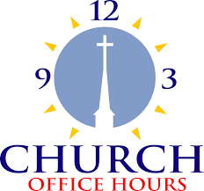

Monday 8:00 a.m. – 5 p.m.

Tuesday 9:00 a.m. – 12:00 noon

Wednesday 8:00 a.m. – 5 p.m.

Thursday 9:00 a.m. – 12 noon

Friday 8:00 a.m. – 12 noon

**St. Paul Lutheran Church Staff**

Pastor Rev. Mark Reshan

Secretary Libby Pollock

Accompanists Jary Tannehill, Mark Tannehill, Jacob Tannehill

Custodian Mark Kloess

Thank$ for $haring

This month, we will see you at Galveston on Thursday, September 12! Here are two coupons: one for you and one for a friend.

