THE THIRD SUNDAY AFTER PENTECOST
June 14, 2026

How vividly I remember meeting with a group of elementary school children in our church, discussing this very text, Jesus’ calling of The Twelve. I pointed out to them how these disciples turned out to be very ordinary people. Peter was impetuous and short-sighted. He was constantly making mistakes. Judas later betrayed Jesus. When the going got rough, they all forsook Jesus and fled into the darkness.
“What does that tell you about Jesus, from the people he chose?” I asked the group.
They sat there in numbed silence for some time. Then one of the young boys responded: “I suppose it shows us that Jesus was a lousy judge of character.”
Indeed! At yet there may also be a helpful message here. Jesus chooses those to help him who are ordinary, weak, prone to failure and to misunderstanding. Herein is our hope.

William Willimon

Today the readings point to the mystery of holiness as a mystery of life-giving and love-sharing power. Such power begins and ends with life and love shared. This mystery is one the disciples of Christ are invited into, for he gives over his power to heal, to enlighten, and to love. That ideal of Christ’s power, the power to care, to share, and to heal, has not been the power that humans have used through history.
Power over others rather than power for others has been more typical, from personal relationships to those of more global proportions. Today we are called to receive again the power that is given to all disciples. This day we are called to be co-creators with Christ of a world where Christ’s power continues to heal, to affirm, to encourage, to empower others. In giving his gift of reconciliation, we receive more of that gift, for Christ’s table assures those who believe that they shall share his power to proclaim and manifest God’s kingdom.

Shawn Madigan, CSJ

In the Name of Jesus

INTRODUCTION

In today's gospel reading, Jesus speaks of the church's mission with images drawn from daily life. The harvest is already plentiful, he says, but laborers are needed for work in the fields of daily life.
What are we to do? We are to do what the liturgy invites us to do: let our conversation be shaped by the good news, extend Christ's peace wherever we find ourselves, and share our bread with the hungry.

Basil the Great, Bishop of Caesarea, died 379; Gregory, Bishop of Nyssa, died around 385; Gregory of Nazianzus, Bishop of Constantinople, died around 389; Macrina, teacher, died around 379

The Cappadocian fathers, as the three men in this group are known, explored the mystery of the Holy Trinity. Basil's monastic rule forms the basis for Eastern monastic life. Gregory of Nazianzus defended orthodox Christianity in Constantinople. Gregory of Nyssa, Basil's younger brother, wrote on the spiritual life. Macrina, older sister of Basil and Gregory of Nyssa, was the leader of a community dedicated to asceticism, meditation, and prayer.

GATHERING

PRE-SERVICE MUSIC Eagle’s Wings New Song Praise Band
(Reuben Morgan)

ANNOUNCEMENTS

As you are able please rise

CONFESSION AND ABSOLUTION

P: In the name of the Father and of the Son and of the Holy Spirit.

C: Amen.

P: “Enter (God’s) gates with thanksgiving, go into His courts with praise, give thanks to Him and
call upon His name.” (Psalm 100: 3) As God’s people, “the sheep of His pasture,” (Psalm 100:
2), we may approach the Lord to confess our sins, confident of His mercy and “compassion.”
(Matthew 9: 36)

Silence for self-examination and reflection is kept

P: Most merciful God,

C: We confess that we have sinned against You in thought, word, and deed, and are in need
of Your forgiveness. We have not “obeyed Your voice.” (Exodus 19: 3) We have failed
to serve as a “priestly kingdom” and to live as a “holy nation.” (19: 6) We have not
“endured” in our sufferings nor “hoped” in our adversities. We have failed to be faithful
workers in Your harvest. (Matthew 9: 35) For these and all our sins, O God, have mercy
on us. Forgive us, strengthen us, and “pour Your Holy Spirit into our hearts” (Romans
5: 5), that with courage and joy we may “do everything that You have spoken.” (Exodus
19: 8)

P: “Since we are justified by faith, we have peace with God through our Lord Jesus Christ “
(Romans 5: 1) Though we are “still sinners,” (5: 8), we have “access to this grace in which we
stand” through our Lord Jesus Christ. God “proves His love for you” this day in this Word: as
a called and ordained minister of the Church of Christ, and by His authority, I declare to you
the entire forgiveness of all your sins, in the name of the Father and of the Son and of the
Holy Spirit.

C: Amen.

GATHERING SONG NSB 43 He Has Made Me Glad

THE GREETING AND PRAYER OF THE DAY

P: The grace of our Lord Jesus Christ, the love of God, and the communion of the Holy Spirit be
with you all.
C: And also with you.

P: Let us pray. God of compassion, You have opened the way to us and brought us to Yourself.
Pour Your love into our hearts, that, overflowing with joy, we may freely share the blessings
of Your realm and faithfully proclaim the Good News of Your Son, Jesus Christ, our Savior
and Lord.

C: Amen.

The assembly is seated

WORD

FIRST READING Exodus 19: 2-8a

Upon their arrival at Mount Sinai following the great deliverance at the Reed (Red) Sea, Israel hears the marvelous story of what God has done for them. Because God has delivered them, Israel is called to live in a relationship with God--to live as a priestly people through whom God will work for all.

[The Israelites] had journeyed from Rephidim, entered the wilderness of Sinai, and camped in the wilderness; Israel camped there in front of the mountain. ³Then Moses went up to God; the LORD called to him from the mountain, saying, "Thus you shall say to the house of Jacob, and tell the Israelites: ⁴You have seen what I did to the Egyptians, and how I bore you on eagles' wings and brought you to myself. ⁵Now therefore, if you obey my voice and keep my covenant, you shall be my treasured possession out of all the peoples. Indeed, the whole earth is mine, ⁶but you shall be for me a priestly kingdom and a holy nation. These are the words that you shall speak to the Israelites."
⁷So Moses came, summoned the elders of the people, and set before them all these words that the LORD had commanded him. ⁸The people all answered as one: "Everything that the LORD has spoken we will do."

A: The Word of the Lord.

C: Thanks be to God.

PSALM: Psalm 100 Antiphon by Linda Cable Shute

Choir sings refrain first, followed immediately by the congregation
and as indicated

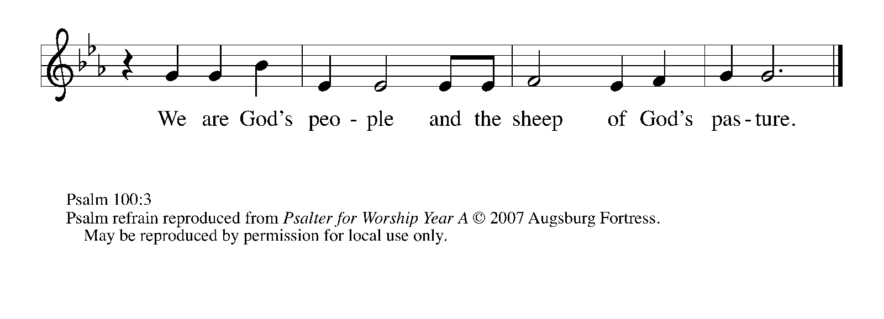

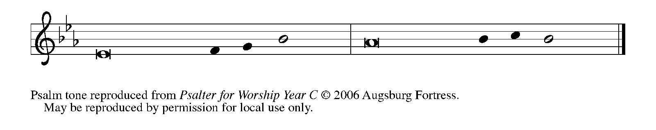

¹Make a joyful noise to the Lord, | all you lands!
²Serve the Lord with gladness; come into God’s presence | with a song.
³Know that the Lord is God, our maker to Whom | we belong;
we are God’s people and the sheep | of God’s pasture. REFRAIN
⁴Enter the gates of the Lord with thanksgiving and the | courts with praise;
give thanks and bless God’s | holy name.
⁵Good indeed is the Lord, Whose steadfast love is | everlasting,
Whose faithfulness endures from | age to age. REFRAIN

SECOND READING Romans 5: 1-8

For Paul, living in God's grace means experiencing peace with God and hope that does not disappoint. The love of God, evident in Christ's death for the undeserving, has been poured into our hearts and sustains us in our troubles.

Since we are justified by faith, we have peace with God through our Lord Jesus Christ, ²through whom we have obtained access to this grace in which we stand; and we boast in our hope of sharing the glory of God. ³And not only that, but we also boast in our sufferings, knowing that suffering produces endurance, ⁴and endurance produces character, and character produces hope, ⁵and hope
does not disappoint us, because God's love has been poured into our hearts through the Holy Spirit that has been given to us.
⁶For while we were still weak, at the right time Christ died for the ungodly. ⁷Indeed, rarely will anyone die for a righteous person--though perhaps for a good person someone might actually dare to die. ⁸But God proves his love for us in that while we still were sinners Christ died for us.

A: The Word of the Lord.

C: Thanks be to God.

As you are able please rise

THE VERSE (Sung twice) (see p. 5)

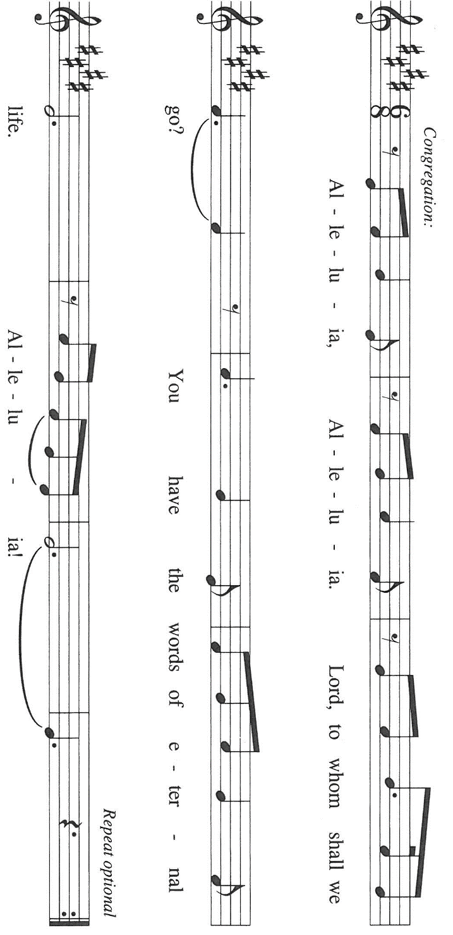

THE HOLY GOSPEL Matthew 9: 35--10: 8

According to Matthew's gospel, the mission of Jesus' followers is to continue the mission of Jesus himself. Here, he instructs his first disciples as to how they might proclaim the gospel through their words and deeds.

P: The Holy Gospel according to St. Matthew, the ninth chapter.

C: Glory to You, O Lord!

Jesus went about all the cities and villages, teaching in their synagogues, and proclaiming the good news of the kingdom, and curing every disease and every sickness. ³⁶When He saw the crowds, He had compassion for them, because they were harassed and helpless, like sheep without a shepherd. ³⁷Then He said to His disciples, "The harvest is plentiful, but the laborers are few; ³⁸therefore ask the Lord of the harvest to send out laborers into His harvest."
^{10:1}Then Jesus summoned His twelve disciples and gave them authority over unclean spirits, to cast them out, and to cure every disease and every sickness. ²These are the names of the twelve apostles: first, Simon, also known as Peter, and his brother Andrew; James son of Zebedee, and his brother John; ³Philip and Bartholomew; Thomas and Matthew the tax collector; James son of Alphaeus, and Thaddaeus; ⁴Simon the Cananaean, and Judas Iscariot, the one who betrayed Him.
⁵These twelve Jesus sent out with the following instructions: "Go nowhere among the Gentiles, and enter no town of the Samaritans, ⁶but go rather to the lost sheep of the house of Israel. ⁷As you go, proclaim the good news, 'The kingdom of heaven has come near.' ⁸Cure the sick, raise the dead, cleanse the lepers, cast out demons. You received without payment; give without payment.

P: The Gospel of the Lord.

C: Praise to You, O Christ!

The assembly is seated

THE SERMON
Silence for reflection follows the sermon

As you are able please rise

THE HYMN OF THE DAY 722 O Christ, Your Heart, Compassionate
(Stanza 2—women; Stanza 3—men)

THE APOSTLES’ CREED

A: God has made us His people through our Baptism into Christ. Living together in trust and hope, we confess our faith.

I believe in God, the Father almighty,
creator of heaven and earth.
I believe in Jesus Christ, His only Son, our Lord.
He was conceived by the power of the Holy Spirit
and born of the virgin Mary.
He suffered under Pontius Pilate,
was crucified, died, and was buried.
He descended into hell.
On the third day He rose again.
He ascended into heaven,
and is seated at the right hand of the Father.
He will come again to judge the living and the dead.

I believe in the Holy Spirit,
the holy catholic Church,
the communion of saints,
the forgiveness of sins,
the resurrection of the body,
and the life everlasting. Amen.

THE PRAYER OF THE CHURCH

A: God has called us to be priests for all people, offering to God the world’s concerns.
Let us pray then for the whole people of God in Christ Jesus, and for all people ac-
cording to their needs.

A: For power for those who preach, wisdom for those who teach, and blessing for
those who heal, that the compassion of Christ might be revealed by the Church to
all who are like sheep without a shepherd: Lord of the harvest,

C: Let Your Kingdom come.

A: For the Spirit’s continued guidance and presence in efforts to bring peace in
Ukraine, Iran, Lebanon, Israel, and the Middle East, and the resolve to end poverty
and hunger in Africa and other places of need: Lord of the harvest,

C: Let Your Kingdom come.

A: For this assembly, that God might bring to the harassed and helpless fruits of joy,
hope, and peace through our work in His fields this week: Lord of the harvest,

C: Let Your Kingdom come.

A: For Maggie Louise Brooks, born to Paul and Lora this week, that she may be kept in
health and safety, and with the support, love and care of this community of faith may
grow to the full life in Christ You intend for her: Lord of the harvest,

C: Let Your Kingdom come.

A: For those who suffer, especially: Jon Samuelson; Pastor Dale Zylstra; Mark
Tannehill; Verne Lee; Major Payne; Jean Warner; Marvin Dirks; Jan Paholski
and Laura Dovey that they may know the power of Jesus to help in every need:
Lord of the harvest,

C: Let Your Kingdom come.

A: For those celebrating anniversaries, especially Doug and Pam Kienitz, that they may
be filled with grace this day and every day and grow in grace in the days ahead:
Lord of the harvest,

C: Let Your Kingdom come.

A: For us and all disciples of Jesus, that following the path of all the faithful, we may
one Day enter God’s gates with thanksgiving and His courts with praise: Lord of the
harvest,

C: Let Your Kingdom come.

P: O God, grant us grace to trust Your promises, that our lives may bear fruit to the glory of Your name, through Your Son, Jesus Christ our Lord.

C: Amen.
MEAL

THE PEACE

P: The peace of the Lord be with you always.

C: And also with you.

The assembly is seated
THE OFFERING

THE VOLUNTARY Here I Am St. Paul Senior Choir
(T. Long & Allen Pote; arr. J. Schrader)
As you are able please rise

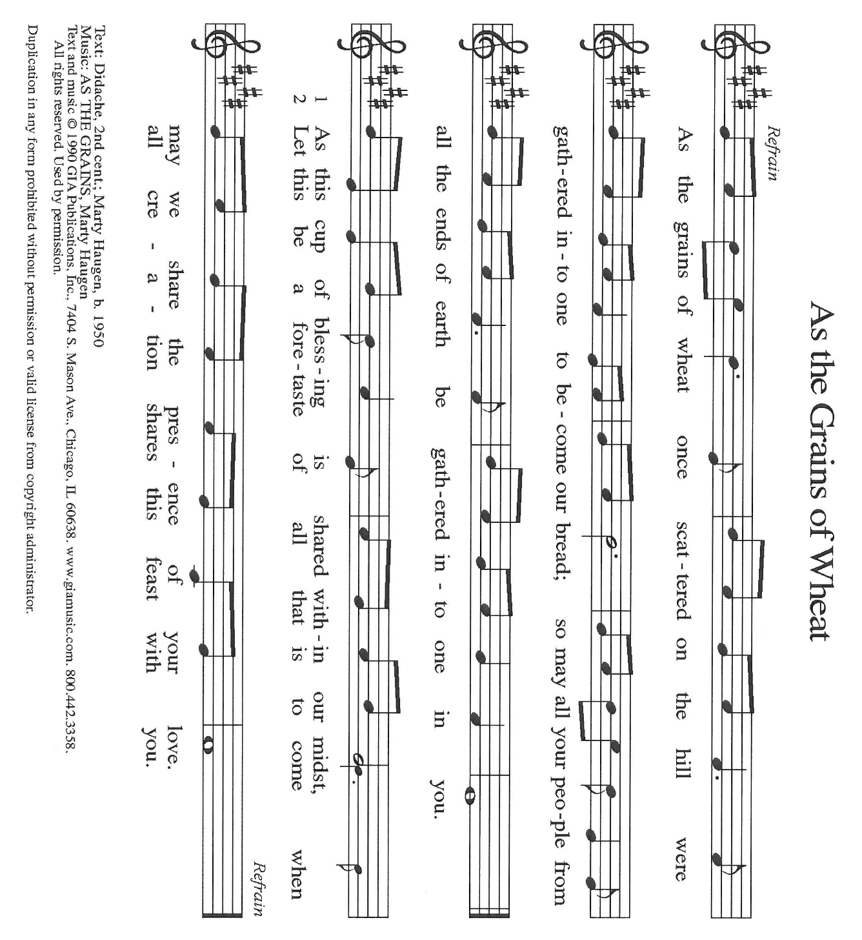
THE PRESENTATION OF GIFTS As the Grains of Wheat

THE OFFERTORY PRAYER

A: Let us pray. God of steadfast love,

C: As Your holy company of priests we offer You the sacrifice of our lives. Use them to
proclaim Your Kingdom’s presence. By this holy Sacrament grant us access to Your
great grace, and pour Your love into our hearts through Your Holy Spirit. We ask this
in the name of Jesus the Lord. Amen.

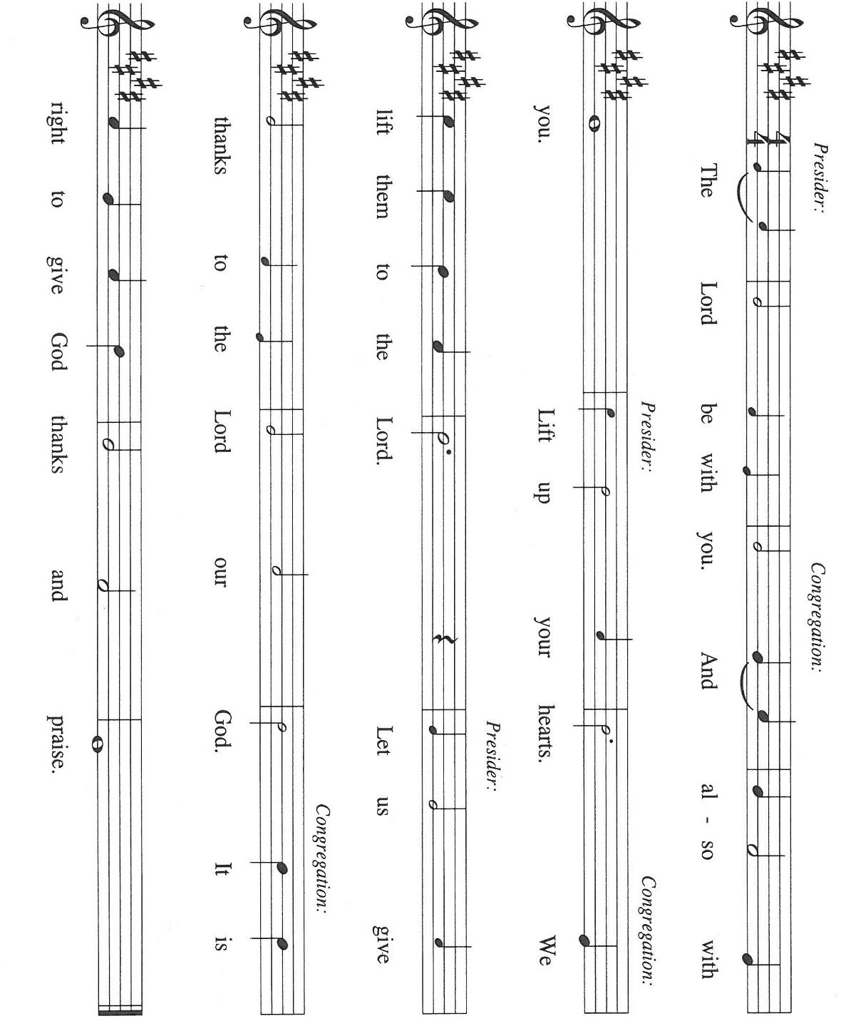
THE GREAT THANKSGIVING

P: It is our duty and delight … join their unending hymn:

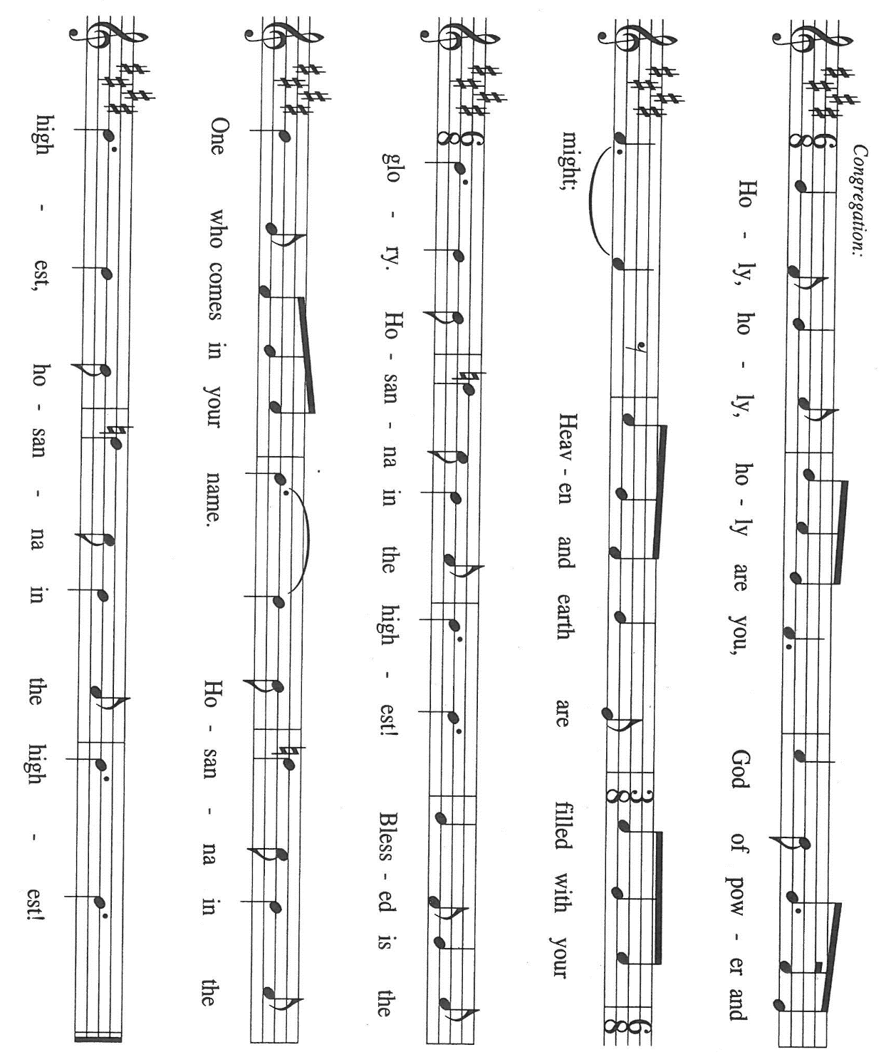

P: Trinity of grace and love, we thank and praise You, for You resolved before the foundation of
the world to open Your dance of delight to include even us.
While we were yet sinners, Christ not only came but died at our hands.
In the glory of His resurrection He called ones like us to be His apostles and spread the
Good News of His mercy to all the world.
Come among Your people today, that in the sharing of this bread and wine we may be made
bearers of Your covenant of grace.
Send Your Holy Spirit on the bread we break and the cup we bless that they may be for us
the Body and Blood of Your Son, Jesus Christ our Lord.
In the night ... “Do this for the remembrance of Me.”
As often as we eat this bread ... we proclaim the Lord’s death until He comes.

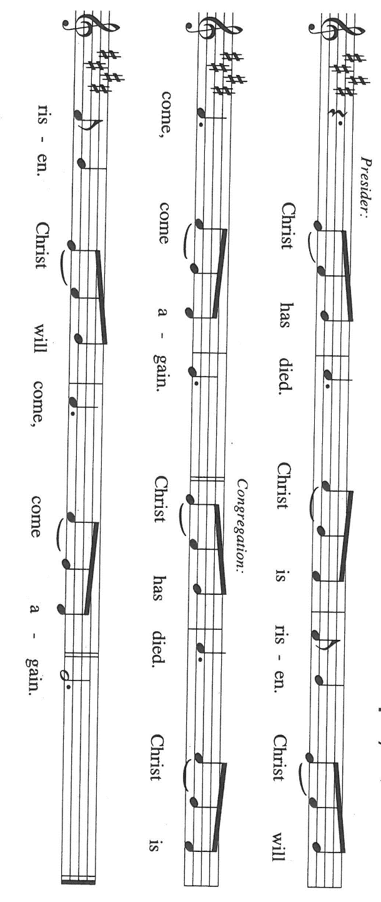

P: Sustaining God, as Your servant Paul and his Lord Christ before him suffered and endured,
strengthen Your Church and hasten Your Kingdom through the witness of Your
people under persecution.
When Your children are oppressed, give them courage to endure.
When they find strength to endure, produce in them character to reflect Your truth.
When they develop character, reveal in them hope of Your deliverance.
When they grow in hope, do not disappoint them, but roll down justice like a never-
failing stream, until that Day when a new heaven and a new earth engulf the
longings of Your aching people.
To You, O God: Father, Son, and Holy Spirit, be all honor and glory, in Your
holy Church, in heaven and on earth, now and forever.

C: Amen!

THE LORD’S PRAYER

P: Seeking first the Kingdom of God and its righteousness, with trust in God’s daily care for us,
we now pray:

C: Our Father, Who art in heaven, hallowed by Thy name.
Thy Kingdom come, Thy will be done on earth as it is in heaven.
Give us this day our daily bread, and forgive us our trespasses as we forgive those
who trespass against us.
And lead us not into temptation, but deliver us from evil.
For Thine is the Kingdom, and the power, and the glory, forever and ever. Amen.

INVITATION TO THE MEAL

P: Behold the Teacher Who gathers us as disciples to teach us the mysteries of God’s Kingdom.
Blessed are those who are called to the Supper of the Lamb. God’s holy gifts, for God’s holy
people. Come, for all is now ready.

The assembly is seated

THE DISTRIBUTION Lamb of God

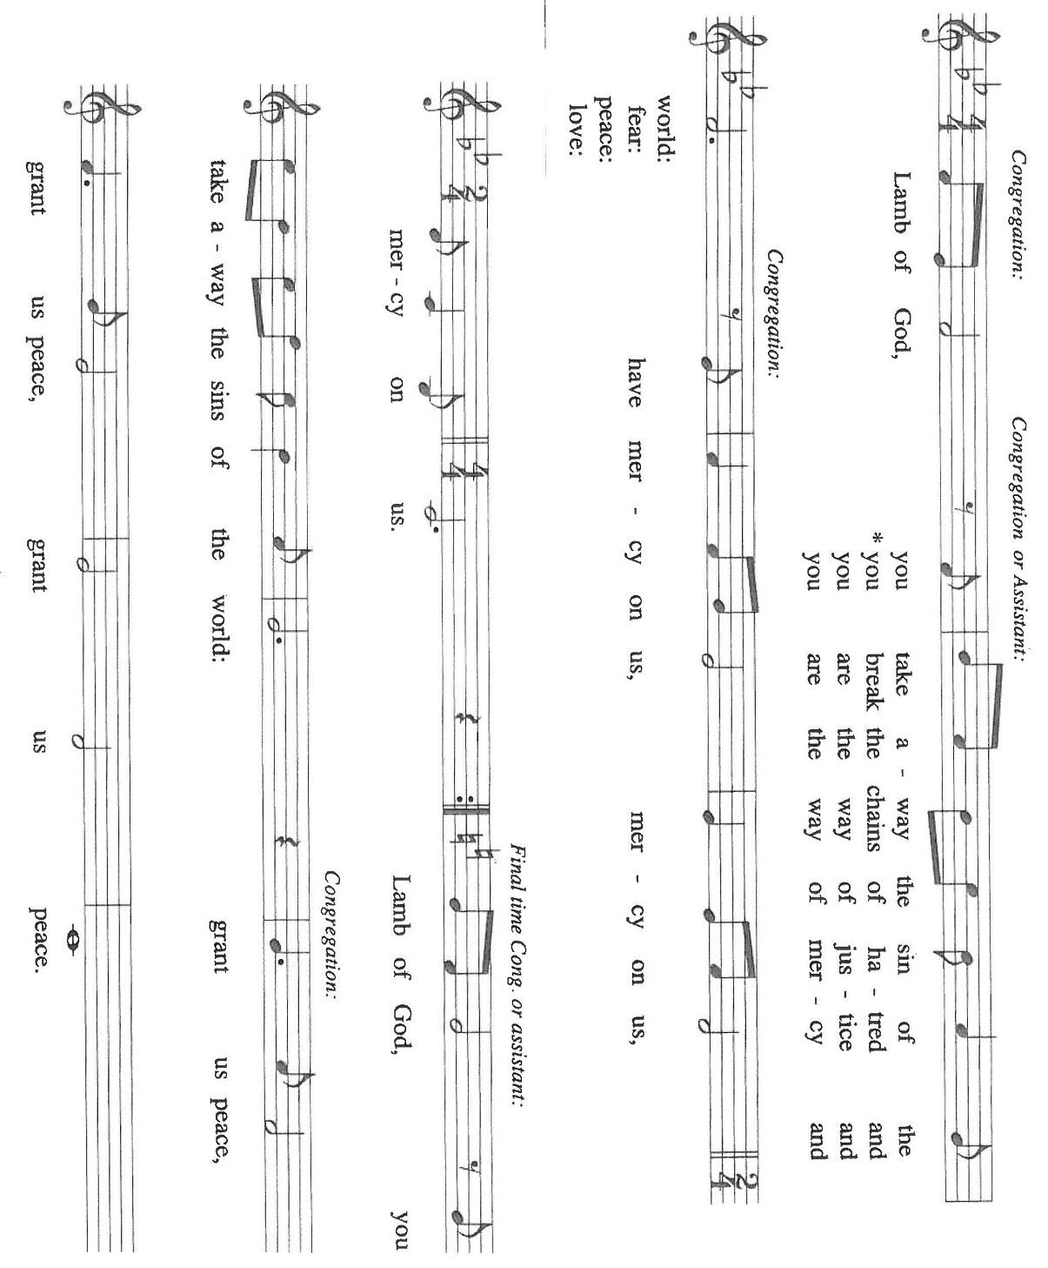
Those wishing to receive the Laying on of Hands, Anointing with Oil, and Prayer for Healing
may go to Pastor at the side aisle

HYMN DURING DISTRIBUTION 663 Spread, O Spread, Almighty Word

NSB 6 Amazing Love

NSB 48 I Am the Bread of Life (Talbot)

NSB 86 The Power of Your Love

ELW 482 I Come with Joy

As you are able please rise

THE POST-COMMUNION BLESSING

P: The Body and Blood of our Lord Jesus Christ strengthen you and keep you in His grace.

C: Amen.

THE POST-COMMUNION PRAYER

A: Let us pray. Lord Jesus, in the strength of this Holy Sacrament send us out into Your harvest.
To the harassed and helpless, to the lost and hurting, make us faithful laborers of Your love
and compassion. Until we gather again at Your Table, may our every word and action
proclaim the Good News that Your Kingdom is near. You are the Lord forevermore.

C: Amen.

SENDING

THE BENEDICTION

P: Almighty God: Father, Son, and Holy Spirit bless you now and forever.

C: Amen.

THE SENDING SONG 547 Sent Forth By God’s Blessing

THE DISMISSAL

A: Go forth with God’s blessing to love and serve the Lord.

C: Thanks be to God!

POSTLUDE

To God Alone Be Glory

The Meditation is from Pulpit Resources. William Willimon, ed. Vol. 27, No. 2. (Inver Heights,
MN: Logos Productions, 1999). 50.

The Prayers, Introduction to the Lord’s Prayer, and Invitation to the Meal are adapted from
Prayers for Sundays and Seasons. Year A. Peter J. Scagnelli. (Chicago: Liturgy Training Publications, 1998) 90-91.

The Eucharistic Prayer is from Eucharistic Prayer. Samuel Wells and Abigail Kocher. (Grand
Rapids: Wm. Eerdmann Publishing Company, 2016) 185-86.

ANNOUNCEMENTS

Please remember to mail your offering to the Church Office at 818 Franklin Street, Michigan City, IN 46360. Another alternative is to give on-line through Tithe.ly. Please see your closure letter for information on how to set up a Tithe.ly account.

St. Paul Members are reminded to have a loved one contact the office if you are hospitalized. Many times, the Pastor doesn’t know someone is in the hospital. If you call and leave a message, please tell us at which hospital the patient is located.

ANNIVERSARIES: Douglas & Pamela Kientz (6/15)

PRAYER CONCERNS: Debbie Martin; Mark Tannehill; Kathy Stein; Jan Paholski; Laura Dovey; Bill Hazelgrove; Al Levenhagen; Carl Wipperman; Major Payne.

OFFICE HOURS: Libby will be in the office on Mondays, Wednesdays, and Fridays; volunteers will cover Tuesdays and Thursdays.

Monday & Wednesday 8:00 a.m. – 5 p.m.
Tuesday & Thursday 9:00 a.m. – 12:00 p.m.
Friday 8:00 a.m. – 12:00 p.m.

If you are listening to the worship broadcast on the radio and would like to watch the Sunday morning service live stream follow these steps:

(1) If you have You Tube available on your TV, search for
St. Paul Lutheran Church Michigan City, IN.

(2) The direct link on the computer is https://
www.youtube.com/channel/UC5AIPNaKr3QN50984jGOa1g

(3) This link is also on the main page of the church’s website in
the church section and will continue to be posted weekly on the St.
Paul Facebook page.

And it will always be available on the radio broadcast Sunday mornings at 11:00 a.m.
on WEFM (95.9), and on the local cable access station #99 for the previous week’s
service on Sundays at 4:00 p.m. and the current service on Wednesdays at 7:00 p.m.
and Fridays at 8:30 p.m.

To send e-mail to the church office, please use the following addresses:

Pastor Mark Reshan: seniorpastor@stpaulmichigancity.com

Church Office Secretary (Libby Pollock): churchsecretary@stpaulmichigancity.com

Church Treasurer (Karen Fleming): finance@stpaulmichigancity.com

2026 Church Council:

Pastor - Mark Reshan

President - Donna Knoll

Vice President - Jan Bakken

Secretary - Judy Hunt

Treasurer - Karen Fleming

Members: Sue Koziel; Jim Schraidt; Trish Sprague; Bob Kiser; Barry Anderson; and
Pam Soule

Worship Attendance:

Saturday, June 6, 2026 @ 4:00 p.m. 23

Sunday, June 7, 2026 @ 9:00 a.m. 68

TOTAL 89

Copies of the minutes from the April 23, 2026 and May 21, 2026 Church Council meetings are on the back table in the upper Narthex. They were approved by the council via email.

The Good News Newsletter: If you have an article or anything you want included in The Good News please send it to the following e-mail address: splcgoodnews@gmail.com. Pastor Pamela Thiede will be using this e-mail address to assemble The Good News each month. The deadline for getting information to Pastor Pamela will be the 20th of each month.

Next week’s lessons are Jeremiah 20: 7-13; Psalm 69: 7-10 [11-15] 16-18; Romans 6: 1b-11; Matthew 10: 24-39 for those of you who like to study them in advance.

ACTIVITIES, EVENTS & MEETINGS
JUNE 2026

Sunday, June 7, 2026 @ 9:00 a.m. 2 Pentecost Worship Service/Sanctuary with
coffee after

Monday, June 8, 2026 @ 1:00 p.m. Hope Circle/Green Room

Tuesday, June 9, 2026 11:00 a.m.-10:00 p.m. GIVE BACK at Holly’s Restaurant & Pub

Wednesday, June 10, 2026 @ 10:00 a.m. God’s Purls
@ 3:30 p.m. Worship & Music Mtg./Luther House
@ 4:30 p.m. Choir Rehearsal/Sanctuary

Saturday, June 13, 2026 @ 4:00 p.m. 3 Pentecost Worship Service/Sanctuary

Sunday, June 14, 2026 @ 9:00 a.m. 3 Pentecost Worship Service/Sanctuary with coffee after

Wednesday, June 17, 2026 @ 10:00 God’s Purls

Saturday, June 20, 2026 at 4:00 p.m. 4 Pentecost Worship Service/Sanctuary

Sunday, June 21, 2026 @ 9:00 a.m. 4 Pentecost Worship Service/Sanctuary with coffee after

Monday, June 22, 2026 @ 2:00 p.m. Finance Committee Mtg./Luther House

@ 3:00 p.m. Executive Board Mtg/Luther House

Wednesday, June 24, 2026 @ 10:00 a.m. God’s Purls
@ 4:30 p.m. Choir Rehearsal/Sanctuary

Thursday, June 25, 2026 @ 3:00 p.m. Church Council Meeting/St. Paul Room

Saturday, June 27, 2026 @ 4:00 p.m. 5 Pentecost Worship Service/Sanctuary

Sunday, June 28, 2026 @ 9:00 a.m. 5 Pentecost Worship Service/Sanctuary with coffee after

2026 Financial Stewardship

Weekly Church Operating Needs (x 2 weeks)
May 30-31 & June 6-7, 2026: $ 10,501.82

General Fund (including General Memorials): $ 7,846.00

Overage/Shortage: — $ 2,655.82

Restricted Income (not including Memorials)
Supports IK Synod & Church wide Ministries: $ 475.00

Ministries in our Community/Congregation: $ 135.00

Capital Fund: $ 177.00

MEMORIALS
General Fund $ 25.00

JUNE MONTHLY MISSION

The Service League of Michigan City is a no-profit organization of volunteers that loans medical equipment and provides supplemental adult incontinence supplies to the residents of LaPorte County. Equipment loans are for three months and most items can be borrowed for free. As a non-profit, they maintain their services through the generosity of community donations, competitive grants, memorials and member support. The Service League receives no government funds. To help their generous mission, we will be collecting both monetary donations as well as the following items:

Disposable gloves
Disposable Gauze rolls, dressing pads and surgical tape
Disposable pull up and tab adult briefs (opened and unopened packages)

Please make checks payable to St. Paul and mark for Service League and place in the offering. Noisy Coin for the month of June will also go to support the Service League. Items can be placed in the bin in the outer Narthex. Thank you for your generosity each month! Lora

THANK YOU!

The Maintenance Department would like to thank Pastor Mark Kloess, Tim Crozier, and Rich Fleming for helping fix the mortar and gutters on the boiler room wall along the alley way. Bob Kiser

