
January, 2026
MARK: MY WORDS

It is a milestone that few congregations reach. This year, 2026, marks the 150th anniversary of St. Paul. For a century and a half, to paraphrase the writer to the Hebrews, “in many and various ways God has spoken to His people” in this place and through us to our neighborhood and larger community. It is a remarkable achievement, an astounding gift of God that He might have a continual presence and voice through World Wars, Depressions, recessions, countless political and social changes, pandemics, and scientific and technological developments and advancements that would have been unimaginable to our forebears who first gathered for worship.
These long and many years have been marked by tremendous sacrifice on the part of members and parents, pastors, teachers, deaconesses, and a myriad number of volunteers who have embodied and enacted God’s mercy in rich, faithful, and fruitful ways.
We have been planning this year-long celebration for almost three years. An extraordinarily dedicated committee consisting of Virginia Murray, Sue Koziel, Paul and Lora Brooks, Pastor Reshan, and Jan Bakken have been meeting to develop a series of events that would lift up the last 50 years of our history. The first 100 years were covered in the great Centennial celebration in 1976. We saw no need to replicate what had been done then.
Much of this edition of the newsletter will be given over to listing and describing what the committee has planned for the year so that the congregation might be aware of what is coming and look forward to the events with joy and anticipation. This list is not meant to be exhaustive but rather to highlight some of the wonderful events and activities we have planned.
In order that the activities do not get lost in a long and detailed article, each major celebration will have its own heading. There are three major occasions on and for which special plans have been made.

ANNIVERSARY WORSHIP SERVICE

The first and most important event is a worship service to be held on Sunday, March 15, one day after the congregation first gathered for worship in 1876. We are honored to have Bishop Timothy Graham of the Indiana-Kentucky Synod as our guest preacher that day. We will also invite former pastors and interns to be our guests. The theme for the Day, as well as for the entire year, is a line from our anniversary hymn, “Serving You Whom We Proclaim.” The hymn was written some years ago specifically for the anniversary of a congregation. It is sung to the tune of Cwm Rhondda (familiar with God of Grace and God of Glory and Guide Me Ever, Great Redeemer) .
On this day, we will reflect upon both what Gospel fruits God has enabled St. Paul to produce over the years as well as look at what our mission and ministry might look like moving forward. There will be NO Saturday worship on March 14. The committee’s goal is to get as many people as possible into the nave to increase our singing, fellowship, and joy at being together.

ANNIVERSARY BANQUET

Immediately following the worship service, there will be a banquet in the St. Paul Room catered by Country Kitchen Caterers of La Porte. We have used them before frequently; their service has been outstanding and their food delicious. We investigated renting other venues, but the cost for the space and the catering was prohibitive. Because it will be held in our fellowship hall, it is vital to know that seating will be limited to 120 persons. Reservations will begin to be received on February 1. Order forms will be printed in the bulletin, newsletter, and available in the narthex for people to fill out and place in the offering plate. We will also share the information and forms on Facebook and our St. Paul website for anyone out of town who wishes to attend. This is first-come, first-served. Once we reach the 120 person limit, no more reservations will be accepted.
It is also important to know that there will be no charge for tickets to the meal. The Anniversary Fund that has been established to cover costs for our events will pay the fees for the meal. All that members need to do is fill out the form in a timely manner and come to enjoy great food and fellowship.

ARCHIVES

On March 15 and throughout the year, the Archives Room will be open for those who wish to examine many of our historical records and pictures. Laura Mellen has done an outstanding job organizing files, documents, pictures, and memorabilia for easy viewing and remembering. We will also have a special display on some tables in and around the St. Paul Room on that day.

ANNIVERSARY BANNER

Pastor Mark Kloess, who has so graciously allowed us to use his artwork for bulletin covers for many years, has designed a special anniversary logo that will appear on a number of media, including a new banner created by Jary Tannehill. It will make its first appearance at the March 15 liturgy and then throughout the rest of the year.

ANNIVERSARY T-SHIRTS AND TOTE BAGS

Anniversary committee member Lora Brooks has arranged for T-shirts and tote bags to bear the logo that will go on sale as keepsakes of the year. Shirts will be royal blue (the anniversary color) with white print and white with royal blue print. The cost will be $12 per shirt and $8 for a tote bag. Children and adult sizes will be available.
Order forms will be printed in the bulletin and available in the narthex for people to fill out and place in the offering plate, and they will be shared on Facebook for anyone out of town wishing to purchase a shirt. Shirts will be ordered after purchases are made; no extra shirts will be ordered.

ANNIVERSARY BOOKLET

A commemorative booklet is being prepared for publication recapping the work and ministry of a number of groups, organizations, and ministries of the congregation. It will be printed by The Beacher and, hopefully, will be available by the March worship service. Some of the topics will include Luther League, choir, Fellowship Club, the development of our contemporary service, the Fish Fry, St. Paul and COVID, the men and women’s homeless shelter ministry, our video streaming of worship, and many more articles.

ICE CREAM SOCIAL

The second major event of the year will take place in mid-July when we will host an ice cream social following worship in the St. Paul Room. The goodies will be provided by Bubbles Ice Cream Shop of Michigan City. Nothing tastes better in the midst of summer heat and humidity than a heaping bowl of great-tasting ice cream!

HYMN FESTIVAL

The third and final event of the year will take place on Sunday, October 25, when we celebrate Reformation Day. It will be held at 3:00 p.m. and will be led by Dr. Steven Wente, Professor Emeritus of Organ and Church Music at Concordia University-Chicago. Steve has played for us a number of times. and we have always been uplifted and inspired by his musical gifts.
We will sing hymns celebrating Reformation Day, All Saints, and Christ the King. We will have a mass choir consisting of members from Maggie Martin’s community choir, the Harbor Country Singers, and those from our own choir. There will also be a brass quintet with two trumpets, a trombone, a French horn, and a tuba to accompany the hymns. Afterwards there will be a reception in the St. Paul Room.

As you can see, there will be much going on in the new year to remember and give thanks to God for the amazing ministry with which He has blessed us over the last 150 years. Specific details about each event will be forthcoming, but this overview will hopefully fill you with anticipation and joy for what promises to be a great and exciting celebration.



A PERSONAL NOTE

Please accept our great gratitude to all who sent our family Christmas cards and notes. Your prayerful support and wishes of joy and peace in these days greatly increased our celebration of Christmas. We are ever thankful for our continued partnership in this Gospel ministry.


THE SEASON OF EPIPHANY

Epiphany is the “quiet season” of the church year. It lacks the urgency of Advent’s call to “prepare the way of the Lord” and the joyful celebration of the Twelve Days of Christmas. It does not summon us to the searching self-examination of Lent nor does it not carry the emotional heft of the Three Great Days of Maundy Thursday, Good Friday, and Holy Saturday.
While its festivals of The Epiphany of Our Lord and The Baptism of Our Lord are vitally important to the Church’s life and proclamation, it does not equal Easter’s central good news of the faith that Jesus is alive forever from death. Also, while its color is green like the long season following Pentecost, its call to mission is not as clear as that time of the Spirit. Even its duration is uncertain: depending on the date of Easter, it can be as short as five weeks or as long as nine (including The Transfiguration).
A helpful essay from our ELCA worship resource Sundays and Seasons offers good insight into what a theme for this year’s Epiphany season might be:

One interesting trajectory for the season is to consider 1 Corinthians as a guide for revealing the hope and possibility of church life. Paul addresses the church as those who are “sanctified” (1:2) and “not lacking any gift” (1:7) while, at the same time, naming their challenges of division and theological confusion. The early chapters unfold over the weeks, bringing revelatory glimpses that capture true wisdom.
The message of the cross, the church’s ongoing dying and rising, is foolish and a sign of failure to many; but to the baptized, transfigured by grace, Christ is the power and wisdom of God. It is not the wise, the ones all put-together, that serve as witnesses to the work of God. It is the tender ones, the ones pressed to the edges, the very people the world does not embrace, whom God has chosen to be witnesses of glory. Jesus’ Sermon on the Mount is heard on the fourth and fifth Sundays after Epiphany to highlight and deepen this beautiful word.
This year Epiphany runs for six weeks including The Transfiguration. It may not be as well-known or loved as some other seasons of the church year, but its mission and God’s work through it are no less important.



THE EPIPHANY/BAPTISM OF OUR LORD

This January allows us to celebrate two of the most important festivals of the church year on their own instead of combining them as we did last year. The Epiphany of Our Lord, one of the six major feast days (along with Christmas, Easter, the Ascension, Trinity, and Pentecost) falls on Tuesday, January 6, this year. That makes it easy for us to move our observance to the previous Saturday, January 3, and Sunday, January 4.
I will not be here on Sunday, January 4. My son Dan is flying from O’Hare to Phoenix to attend the national convention of The American Astronomical Society as part of the summer internship program in astronomy he completed at the University of Wyoming. Our good friend Dr. Fred Niedner from Valparaiso University will fill in for me. I will be here on Saturday January 3, to celebrate the festival.
The following weekend (Saturday the 10th and Sunday the 11th), we will focus on the minor festival of The Baptism of Our Lord on. Each of these days have a long and rich tradition in the Church’s worship, and it will be good to be able to give each their proper due.


SNOW EMERGENCY LIST

This is a reminder of where to turn to learn if worship has been canceled because of inclement weather conditions. There are two ways to learn about the status of the service.
First, you may turn to our church Facebook page for updated announcements: https://www.facebook.com/stpaulmichigancity/. Perhaps most quickly and easily, you may call the church office number (219-874-7293) and press the “#” key and you will hear a recording about our “open/closed” status. Messages will be posted by noon on Saturday.

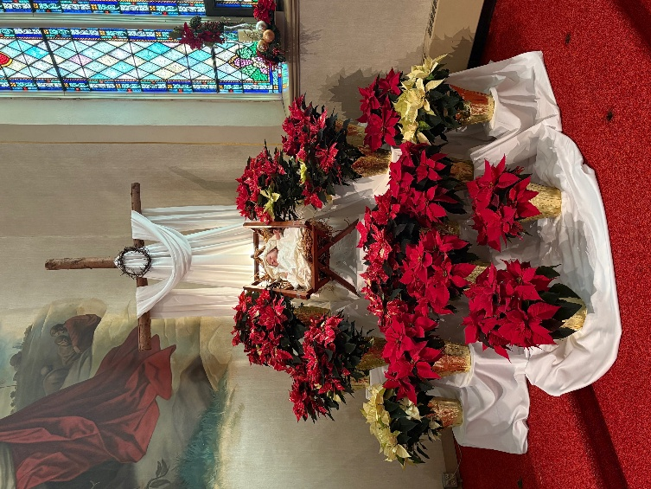

CHRISTMAS DECORATIONS

Thank you again to all of our faithful volunteers for their hard and excellent work in preparing, setting up, and taking down the many decorations that beautify our worship space and building for the Twelve Days of Christmas. As always, when you see them, please express your gratitude for their ministry among us and for us as well as the blessing we all receive from the decorated worship space.

Advent Log Bernadette Krueger, Sandy Galinowski,
Karen Peters

Christmas Tree Bob and Karen Kiser, John VanGemeren,
Kelly and Brad Neulieb, Tim Crozier,
Wayne & Suzann Dolxon

Poinsettia plants Sue Koziel, Karen Steinborn,
Pastor Mark Kloess

Large wooden cross Janet Bakken, Sue Koziel, Karen Steinborn

Garland (outer narthex and Communion railings) Karen Steinborn; Sue Koziel; Julie Brooks

Window treatments (nave and outside) Sue Koziel, Karen Steinborn; Julie Brooks

Outside lights and wreaths Tina Zimmerman-Putnam
and Serviscape crew

Upper narthex nativity scene and creche Pastor Mark Kloess; Jary Tannehill;
Stacie Crozier

Pew candles and candelabras on back altar Al and Sue Green

It is easy to assume these decorations will always be there at the right time and in the right way. We forget how much time and effort it takes to get them out of storage, put them up, clean up afterward, and then take them down after Epiphany and return them to storage.


Would you like to celebrate St. Paul’s 150th anniversary with a special t-shirt or tote bag? We have just what you are looking for!
White T-Shirt Blue T-Shirt
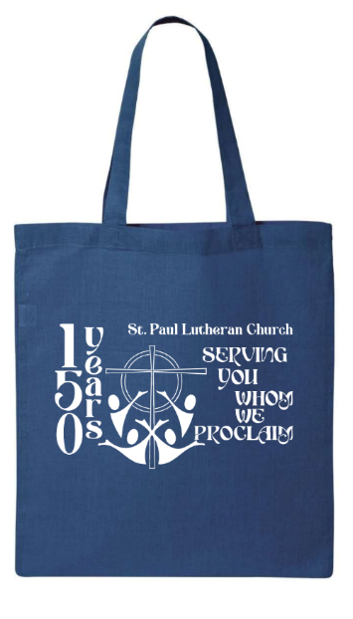



These items, declaring “St. Paul Designs can be viewed on a
Lutheran Church 150 years poster in the Narthex. If you
Serving You Whom We Proclaim have questions or need additional
can be yours when you order them sizes, please contact Lora Brooks
using the order form available in at 260-701-1586.
the narthex. T-Shirts are $12;
Tote bags are $8. (Editor’s Note: I apologize, but
Orders are due by February 1. I could not copy the order form
into the newsletter.)

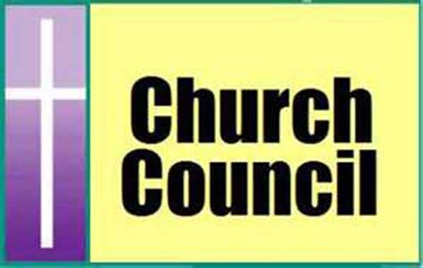

It has been our custom to install our Church Council on the first Sunday in January. However, since I will not be here and the second Sunday of the month is already a longer service because of The Laying on of Hands healing rite, we will wait until the third Sunday, January 18, to welcome our Council. They were chosen at the November congregational meeting and approved by consensus. Here are the council members for 2025 (* indicates a newly elected member).

President Donna Knoll
Vice-President Janet Bakken
Treasurer Karen Fleming
Secretary Judy Hunt

*Bob Kiser
*Barry Anderson
*Pam Soule
Sue Koziel
Trish Sprague
Jim Schrait
We are deeply grateful for their willingness to serve us in this vital leadership position. Please remember them in your prayers, asking for God’s wisdom and guidance as they help us face the challenges we face as a congregation.
We want to thank those who have completed their service: Diane Egilske; Paul Brooks; and Judy Mutchler.

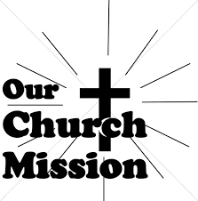
MONTHLY MISSION: LaPORTE COUNTY MEALS ON WHEELS

We have many dedicated Meals on Wheels volunteers within our church family! Their unwavering dedication not only ensures people in our community receive safe nutritious meals; but the delivery also provides a wellness check, ensuring their safety and well-being. Meals on Wheels has a current need to replace their essential food delivery cases. Black (cold) cases can be sponsored for just $200, and Blue (hot) cases can be sponsored for $500. Every contribution helps ensure their clients receive meals each day. Case sponsorship includes sponsor's name on the case, recognizing their support and commitment for years to come. Based on the total amount received, we will sponsor as many cases as possible in honor of our St. Paul Volunteers and Congregation. Please make checks payable to St. Paul and place in the offering. The noisy coin offering in January will also go towards the monthly mission. Thank you for your unwavering and continuous support of Meals on Wheels!
SALVATION ARMY BELL “RINGERS”

On December Saturday 6, 2025, St. Paul helped the Salvation Army in their Red Kettle Campaign from 10 a.m. to 7 p.m. Those who participated are shown below. We want to offer our sincere “Thank You” to each of them for donating an hour of their time during a very busy time of year. If you are wondering why some of the people are holding up a sign that reads “ding-dong,” it is because Al’s asked that no bells be rung inside. It is too close to their cash registers to have bells rung constantly.

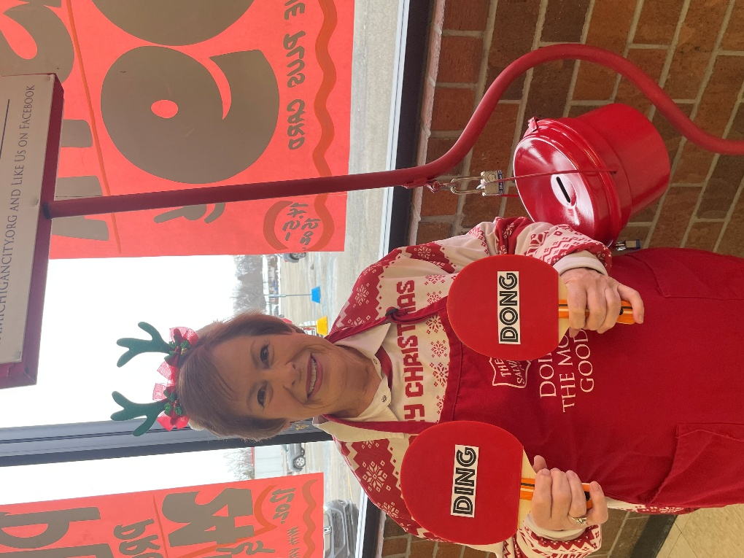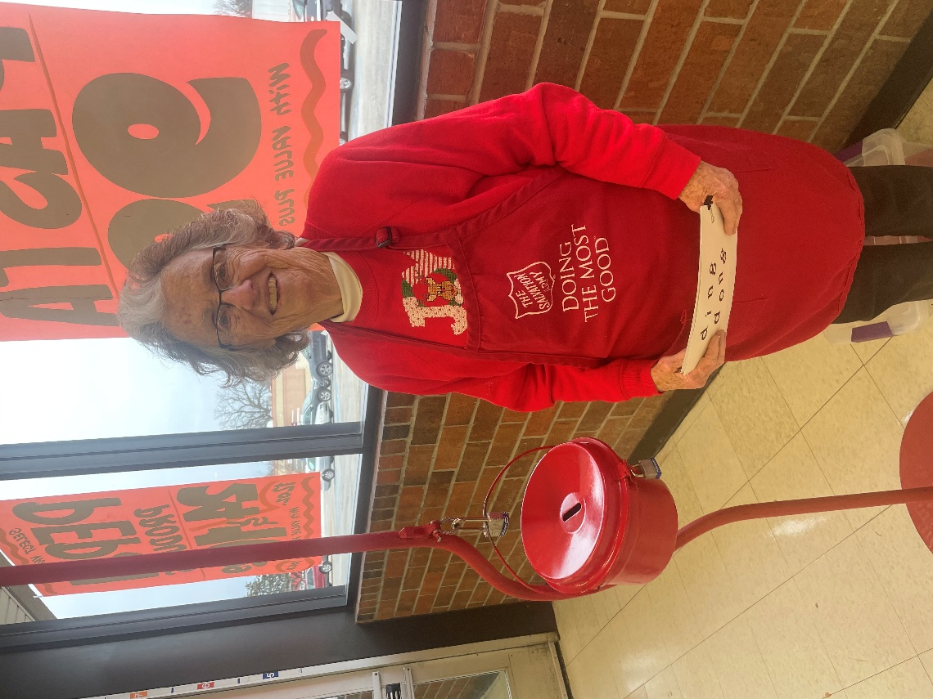
Mary Knaup Jean Kleinschmidt

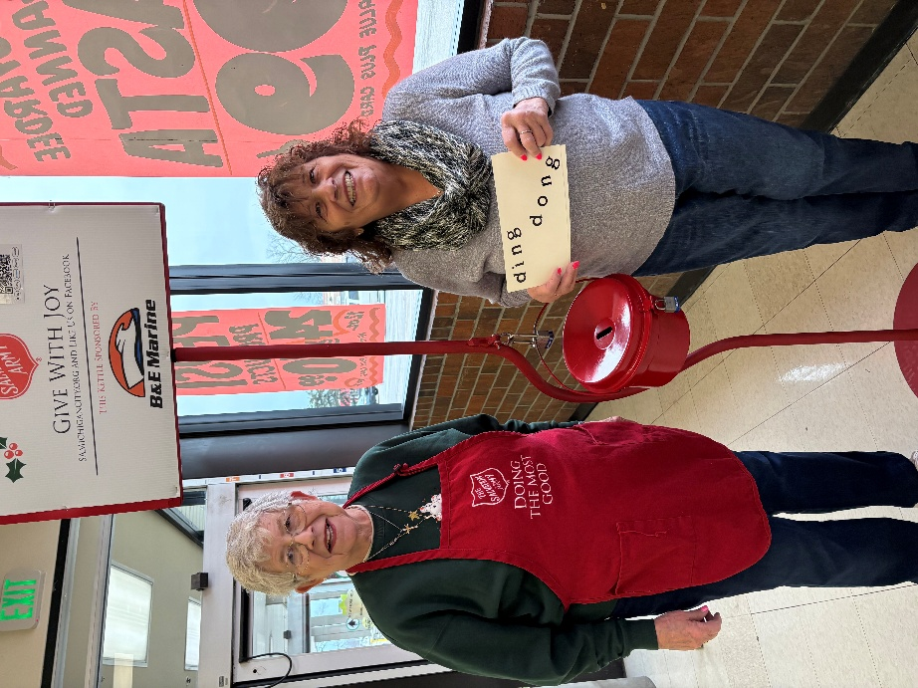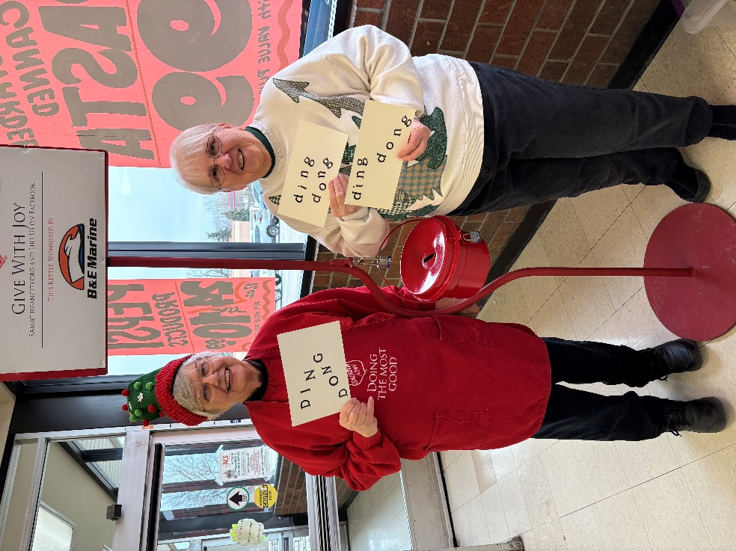
Diane Egilske & Kathy Becker Virginia Murray & Janet Bakken

More Bell Ringers:
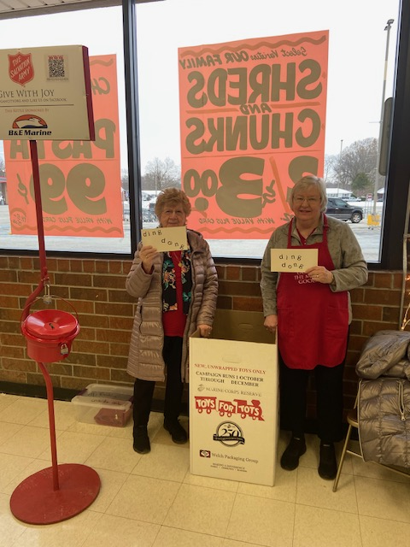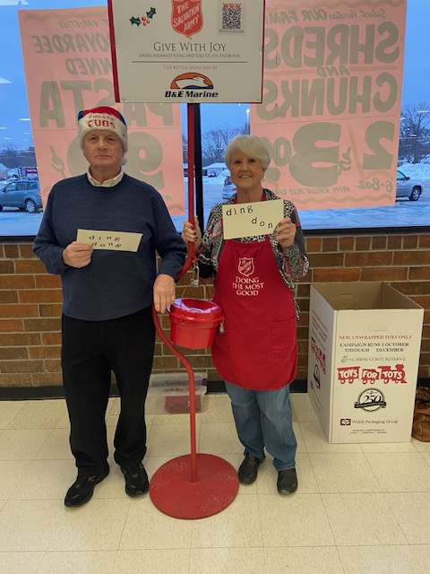
Gail Leffew & Elizabeth Lasater Rich & Karen Fleming

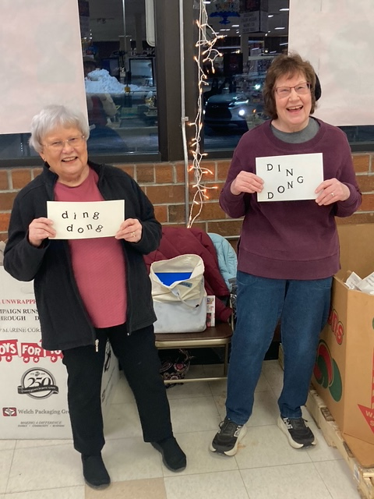
Diane Waltz & Susan Bagby Sandy Galinowski & Bernadette Krueger

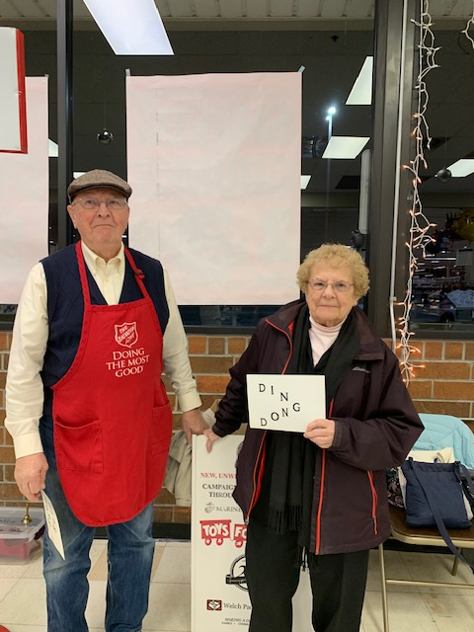
Bob & Karen Kiser


TO THE MUSICIANS WHO HAVE BLESSED OUR WORSHIP IN THE PAST YEAR

Piano/Organ Maggie Martin, Dr. George Karst, John Carington

Trumpet Nate Miller

Bell Choir Judy Hunt, Judy Mutchler, Karen Fleming, Kelly Neulieb,
Trish Sprague

Choir Stacie Crozier, Susan Bagby, Carolyn Cooney, Mary Knaup,
Virginia Murray, Sue Koziel, David Jocelyn, Doug Kienitz

New Song Praise Band Jary Tannehill, Peggy Wolf, Stacie Crozier, Sue Koziel,
Carlie Marks, Jacob Tannehill, Mark Tannehill



IN MEMORY OF CHERYL DETTMAN
General Fund from Bob & Karen Kiser

IN MEMORY OF LARRY LITCHFORD
General Fund from Brad & Kelly Neulieb

IN MEMORY OF LEONARD & DOROTHY HILL’S BIRTHDAYS
General Fund from Helen Hill-Weaver

IN MEMORY OF ROGER MILZAREK
General Fund from Norma Milzarek

IN MEMORY OF WAYNE A. SIMERLEIN
General Fund from Nicj & Sue Novakovich, Lori MacMillan, Suzannea Baker


CHRISTMAS POINSETTIAS
In loving memory of loved ones from Virginia Murray
In memory of my parents, Dorothy & Wally Liebig, from Nancy Mauman and fmaily
In memory of John Mauman from Nancy Mauman; Rom, Gail, and Conrad Mauman; and Megan, T.J., Nick and Michael Pruzin
In honor of family from Bev Johnson
In memory of loved ones from Tim & Stacie Crozier
In memory of Henry “Sonny” Robbins from Sandy Robbins
In memory of husband Norman Egilske and cousisn Janice White from Diane Egilske
In memory of Lawrence & Norma Wolgast, Elizabeth Hapke, and David Hapke and in honor of Norma Hapke from Stephen & Lauretta Hapke
In memory of our father Ronald Johnson with love from the Johnson Women
With love and remembrance of my parents Bill & Joyce Manning on Christmas from Beth Manning
In memory of my husband Joseph Koziel and my parents Roger & Lucille Story from Sue Koziel
In honor and memory of loved ones from Kelly Neulieb
In memory of loved ones from Chip & Audrey Claussen
In memory of my son Don and my wife Carol from Fred Weiss


January Birthdays January Anniversaries
5 Laura Mellen 3 Daniel & Andrea Ottersen
6 Fred LaBorn 12 Bradford & Kelly Neulieb
JoAnn Kring 15 Jeffrey & Marla Furness
9 Susan Bagby
10 Donald Thompson
Debbie Martin
Donald Zummak
11 Stacie Summers
12 James Burdett
18 Mark Tannehill
19 Amy Haring
26 Stacie Crozier
28 Elaine Bogart
Eloise Ponder



Long-Term Prayer List

Barry Anderson John Bennitt Robert Bernth
Lucas Bradshaw Laura Dovey Shirley Freels
Jess Kalvaitis Christine Kiser Bethany Manning
Debbie Martin Shirley McCarty Sarah McNabb
Jan Paholski Grace Romine Martha Schroeder
Jeanie Boatman Shepple Joyce Stark Kathy Stein
Mark Tannehill Kevin Thiede Kathy Thielman
David Weiss Fred Weiss Brian Wiseman



Monday 8:00 a.m. – 5 p.m.
Tuesday 9:00 a.m. – 12:00 noon
Wednesday 8:00 a.m. – 5 p.m.
Thursday 9:00 a.m. – 12 noon
Friday 8:00 a.m. – 12 noon

St. Paul Lutheran Church Staff
Pastor Rev. Mark Reshan
Secretary Libby Pollock
Accompanists Jary Tannehill, Mark Tannehill, Jacob Tannehill
Custodian Mark Kloess

Thank$ for $haring
Last month’s Give-back at Holly’s raised $162. Thank you to all who participated.

This month, are going to Five Guys on Wednesday, January 7. Here are two coupons—one for you and one for a friend.
