August, 2025

**MARK: MY WORDS**

I did not check my files thoroughly, but I believe that I wrote about this topic some years ago. A recent experience justifies mentioning it again. It has to do with how to proceed when a family member or loved one dies, and the family would like me and the congregation to be involved in the funeral or memorial service.

If you have been in that situation, you know how many decisions must be made and to how many details attention must be paid, often within just a few days. Deep grief and loss, and perhaps a sense of shock, further complicates the process. If the deceased had not discussed their wishes with the family. that makes things all the more difficult.

After contacting whatever funeral home has been chosen. the next, **important** step is to call me directly (630-450-1894) or the church office. This is necessary for several reasons. First, if it is desired that the funeral take place at church, we must check the calendar to make sure there are no other events going on at that time. Generally during the week there are few times when the worship space is being used. Funerals or memorial services always have precedence, but it is good to make sure that the space is available.

Second, and this is what prompted this article, it is obviously necessary, and a matter of common courtesy, to see if **I** am able to preside at the service. That is one of the first questions the funeral director will ask the family when they meet to make arrangements, but it should not be assumed that I can clear my calendar of all other commitments.

Again, I will do everything possible to make sure that I am available when the family wishes to have the service; but, (contrary to what some may think 😊) I do have family responsibilities and a life outside of the congregation. Sometimes those commitments cannot easily, or at all, be changed on short notice. Such a scheduling conflict adds even more stress to the family and also to me.

In addition, often there is a request to have a funeral luncheon after the service in the St. Paul Room. We have an incredibly dedicated team of women who faithfully and selflessly offer their time to host those meals. Virginia Murray is the head of that group, and she also needs to be consulted before any decisions are made about going forward with the luncheon.

Comforting the bereaved and celebrating the promise of The Resurrection when death occurs is one of the most important ministries the Church offers. We want to be present and walk with the grieving in their time of sadness and loss. Honoring these simple steps of contacting the office and me before making any final decisions will make such a ministry possible. Thank you for your cooperation in fulfilling that goal.

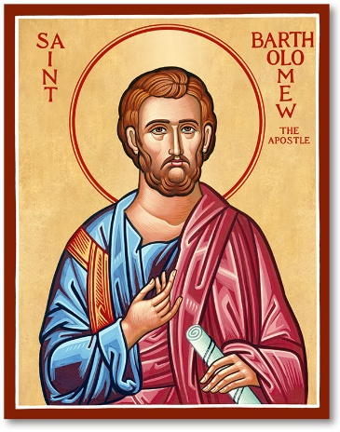

**A FESTIVAL COMMEMORATION**

As you are aware, the season of Pentecost takes up a major portion of the church year. Depending on the date of Easter, it usually begins in late April or early May and runs until the latter half of November when the church year ends with the Day of Christ the King. For example, this year that Day falls on the 24th Sunday after Pentecost. So many weeks of the season spread over so many months can seem numbingly monotonous.

So, whenever there is a chance to celebrate a festival day or commemoration of one of the heroes or heroines of the faith, it is good to observe it. Unfortunately, August only contains two minor festival Days: Mary, Mother of Our Lord, on August 15, and Bartholomew, Apostle, on August 24.

We celebrated the Day of Mary last year, so I would like to observe the Day of Bartholomew this year since it falls on a Sunday. After checking my notes and files, I do not believe that I have ever commemorated him before, so it will be interesting to see how a service and homily will play out. Adding to the challenge, there is little in the Gospels about him and not much more in early church history or tradition. Some deep digging with be necessary!

Regardless of the lack of information about him, Bartholomew was one of the apostles who enabled the witness of Jesus to spread beyond Palestine, as Jesus commanded the apostles to do (Acts 1:8). And if for nothing else, that is a good reason to remember and give thanks for his life and ministry.

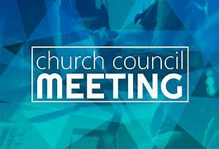

**JULY COUNCIL HIGHLIGHTS**

The Church Council did not meet in July.



**BACK TO SCHOOL TRIP**

Once again I will be taking my son Dan back to Cleveland for the beginning of his fall semester in his senior year. Classes begin on Monday, August 25. While I do not yet have the specific dates of our trip, we will be going sometime during the week of August 18. As in the past, I will be gone two days and will be sure to return in time to lead worship on Saturday, the 23rd, and Sunday the 24th.

Jacob does not begin his classes until after Labor Day on September 4 but will not require us to help him return to his apartment. We are excited for them as they enter their final year of college and look forward to another stellar year for them as they prepare for graduation and entering the job market.

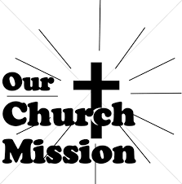

**MONTHLY MISSION: MICHIGAN CITY AREA SCHOOLS**

It's back to school time already! Let's help our area kids start the year out on a good note! We will be collecting money to support different projects in various elementary schools in Michigan City through Donors Choose. Donors Choose provides a list of teacher-led classroom projects that need funding. Flexible seating, music education, and classroom supplies are some of the options we can provide to our elementary schools. Please consider donating to help fund our local teachers' classroom projects! Checks can be written to St. Paul and can be marked for MCAS and placed in the offering plate. The noisy coin offering will also support the mission of the month. To see a full list of projects, visit [www.donorschoose.org](http://www.donorschoose.org/) and search for Michigan City.

**NEW PARAMENTS**

In the June *Good News,* we announced the gift of a set of new green paraments in memory of Maxine Powell from The Rev. Ralph and Gayle Kuespert, Maxine’s son-in-law and daughter. The paraments were received and dedicated during our worship services on June 28 and 29. Below are pictures of the new paraments. For an explanation of the symbols on the paraments, see your June newsletter. (If you threw out your June newsletter and want another one, email Pastor Pamela at [splcgoodnews@gmail.com](mailto:splcgoodnews@gmail.com); she will email you another copy of the newsletter.) Here are some pictures of the new paraments.



**IN MEMORY OF JOYCE NEULIEB**

**General Fund** from Wayne & Suzann Dolson

**Long-Term Prayer List**

Laura Dovey Jess Kalvaitis Christine Kiser

Larry Litchford Bethany Manning Debbie Martin

Shirley McCarty Sarah McNabb Jan Paholski

Carol Radke Grace Romine Danielle Schnell

Martha Schroeder Jeanie Boatman Shepple Joyce Stark

Kathy Stein Mark Tannehill Kathy Thielman

David Weiss Brian Wiseman

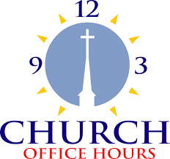

Monday 8:00 a.m. – 5 p.m.

Tuesday 9:00 a.m. – 12:00 noon

Wednesday 8:00 a.m. – 5 p.m.

Thursday 9:00 a.m. – 12 noon

Friday 8:00 a.m. – 12 noon



**August Birthdays**

1 Susan Dolson 14 James Tomsheck

2 Terri Bartels 15 Diane Egilski

3 Robin Cross Diane Dirks

4 Sandra Robins Frankie Thomas III

Jim Galinowski 16 Jaimee Pryzbylinski

David Haring 19 Shirley McCarty

Hannah Payne 20 Nancy Squires

5 Richard Thielman 21 Barbara Djuvik

6 Robert Ziesmer 23 Brenda Biggs

Mike Bockover 28 Reese Robbins

8 Lynn Wilson 30 Michael Maesch

Thomas Ottersen

Jason Schacht

9 Carol Hanft **August Anniversaries**

Brooklyn Howard

10 Stacey Richardson 3 John & Amy VanGemeren

11 Karen Peters5 Virgil & Patricia Miller

Deborah Reagor 9 Richard & Karen Fleming, Jr.

12 Anna Kreighbaum 10 David & Amy Haring

Beckly Greenlaw

**St. Paul Lutheran Church Staff**

Pastor Rev. Mark Reshan

Secretary Libby Pollock

Accompanists Jary Tannehill, Mark Tannehill, Jacob Tannehill

Custodian Mark Kloess

Thank$ for $haring

This month, are going to Panera on Wednesday, August 6.  Bring this page to Panera with you.

