**THE SECOND SUNDAY IN LENT**

**March 16, 2025**

If you have ever loved someone you could not protect, then you understand the depth of Jesus’ lament. All you can do is open your arms. You cannot make anyone walk into them. Meanwhile, this is the most vulnerable posture in the world --wings spread, breast exposed -- but if you mean what you say, then this is how you stand.

Given the number of animals available, it is curious that Jesus chooses a hen. Where is the biblical precedent for that? What about the mighty eagle of Exodus, or Hosea’s stealthy leopard? What about the proud lion of Judah, mowing down his enemies with a roar? Compared to any of those, a mother hen does not inspire much confidence. No wonder some of the chicks decided to go with the fox.

But a hen is what Jesus chooses, which -- if you think about it --is pretty typical of him. He is always turning things upside down, so that children and peasants wind up on top while kings and scholars land on the bottom. He is always wrecking our expectations of how things should turn out by giving prizes to losers and paying the last first. So of course he chooses a chicken, which is about as far from a fox as you can get. That way the options become very clear: you can live by licking your chops or you can die protecting the chicks.

Jesus won’t be king of the jungle in this or any other story. What he will be is a mother hen, who stands between the chicks and those who mean to do them harm. She has no fangs, no claws, no rippling muscles. All she has is her willingness to shield her babies with her own body. If the fox wants them, he will have to kill her first.

Which he does, as it turns out. He slides up on her one night in the yard while all the babies are asleep. When her cry wakens them, they scatter. She dies the next day where both foxes and chickens can see her -- wings spread, breast exposed -- without a single chick beneath her feathers. It breaks her heart, but it does not change a thing. If you mean what you say, then this is how you stand.

**Barbara Brown Taylor**

**✠ *In the Name of Jesus*✠**

**INTRODUCTION**

*An ancient Byzantine prayer bids us to receive Lent with gladness, a welcome invitation as we prepare to renew our baptismal vows at Easter. To walk grudgingly through Lent with Jesus is to miss the opportunity to be surprised by joy, the joy of realizing that the risen Lord is with us, faithful to His promises.*

**Patrick, bishop, missionary to Ireland, died 461**

*A native of Britain, Patrick was kidnapped by pirates at age sixteen and sold into slavery in Ireland. After a few years, he escaped, returned home, and entered the ministry. Returning to Ireland, he successfully served as a bishop and missionary there.*

**✠ GATHERING ✠**

**PRELUDE**

**ANNOUNCEMENTS**

*As you are able please rise*

**CONFESSION AND ABSOLUTION**

P: In the name of the Father, and of the **✠** Son, and of the Holy Spirit.

**C: Amen.**

P: Our help is in the name of the Lord:

**C: Who made heaven and earth.**

P: I said, I will confess my transgressions to the Lord.

**C: Then You forgave me the guilt of my sin.**

P: Let us pray for the forgiveness of our sin.

*Silence for self-examination and reflection is kept*

P: Our impatience when Your promises seem unfulfilled; our discouragement when the

future seems closed, and our lack of trust, we confess to You, O Lord:

**C: Lord, have mercy.**

P: Our failure to imitate the life of Christ; our minds set on earthly things; and our concern

with physical needs, we confess to You, O Lord:

**C: Lord, have mercy.**

P: Our failure to stay the course of discipleship; our choosing to follow another way; and

our unwillingness to be gathered under Your wings, we confess to You, O Lord:

**C: Lord, have mercy.**

P: Almighty God have mercy on you, forgive you all your sins, and strengthen you in all

goodness.

**C: Amen.**

**GATHERING HYMN 831 *The God of Abraham Praise***(Stanzas 1-4, 8)

**THE GREETING**

P: The grace of our Lord Jesus Christ, the love of God, and the communion of the Holy

Spirit be with you all.

**C: And also with you.**

**THE KYRIE**

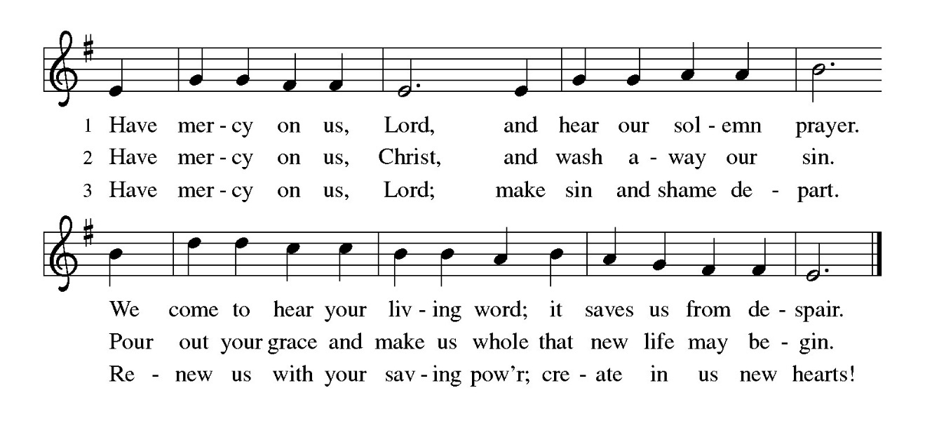

**THE PRAYER OF THE DAY**

P: The Lord be with you.

**C: And also with you.**

P: Let us pray. God of the covenant, in the mystery of the cross You promise everlasting

life to the world. Gather all peoples into Your arms, and shelter us with Your mercy,

that we may rejoice in the life we share in Your Son, Jesus Christ, our Savior and Lord,

Who lives and reigns with You and the Holy Spirit, one God, now and forever.

**C: Amen.**

*The assembly is seated*

**✠** **WORD ✠**

**FIRST READING Genesis 15: 1-12, 17-18**

*God promises a childless and doubting Abram that he will have a son, that his descendants will be as numerous as the stars, and that the land will be their inheritance. Abram's trust in God's promise, sealed with a covenant-making ritual, is reckoned to him as righteousness.*

1After these things the word of the Lord came to Abram in a vision, "Do not be afraid, Abram, I am Your shield; your reward shall be very great." 2But Abram said, "O Lord God, what will You give me, for I continue childless, and the heir of my house is Eliezer of Damascus?" 3And Abram said, "You have given me no offspring, and so a slave born in my house is to be my heir." 4But the word of the Lord came to him, "This man shall not be your heir; no one but your very own issue shall be your heir." 5He brought him outside and said, "Look toward heaven and count the stars, if you are able to count them." Then He said to him, "So shall your descendants be." 6And he believed the Lord; and the Lord reckoned it to him as righteousness.

7Then He said to him, "I am the Lord who brought you from Ur of the Chaldeans, to give you this land to possess." 8But he said, "O Lord God, how am I to know that I shall possess it?" 9He said to him, "Bring me a heifer three years old, a female goat three years old, a ram three years old, a turtledove, and a young pigeon." 10He brought him all these and cut them in two, laying each half over against the other; but he did not cut the birds in two. 11And when birds of prey came down on the carcasses, Abram drove them away. 12As the sun was going down, a deep sleep fell upon Abram, and a deep and terrifying darkness descended upon him.

17When the sun had gone down and it was dark, a smoking fire pot and a flaming torch passed between these pieces. 18On that day the Lord made a covenant with Abram, saying, "To your descendants I give this land, from the river of Egypt to the great river, the river Euphrates."

The Word of the Lord.

**Thanks be to God.**

**THE PSALM: Psalm 27** Antiphon by Bradley Ellingboe

Choir sings refrain first, followed immediately by the congregation

and as indicated

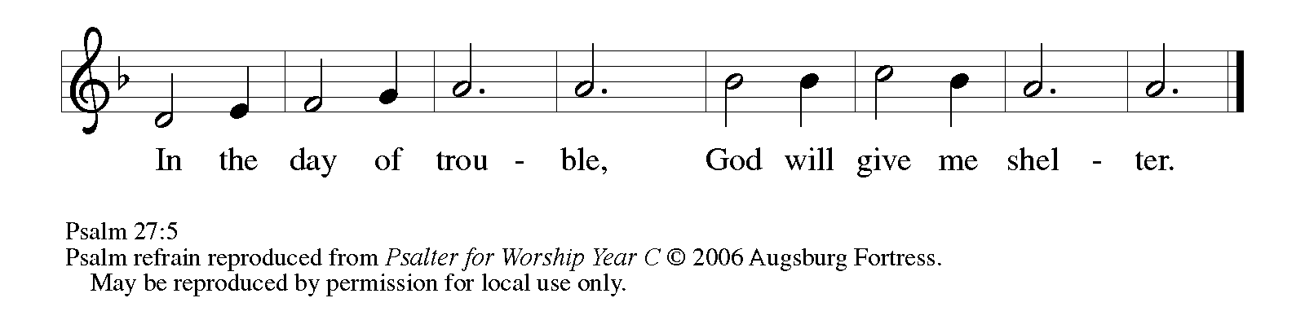

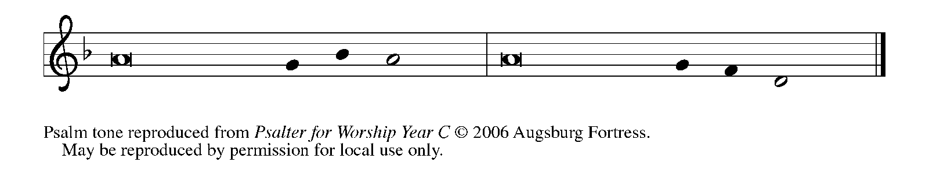

1The LORD is my light and my salvation; whom then | shall I fear?

     The LORD is the stronghold of my life; of whom shall I | be afraid?

**2When evildoers close in against me to de- | vour my flesh,**

**they, my foes and my enemies, will stum- | ble and fall.**

3Though an army encamp against me, my heart | will not fear.

     Though war rise up against me, my trust will | not be shaken.

**4One thing I ask of the LORD; one | thing I seek;**

**that I may dwell in the house of the LORD all the days of my life; to gaze upon the beauty of the LORD and to seek God | in the temple.   REFRAIN**

5For in the day of trouble God will | give me shelter,

     hide me in the hidden places of the sanctuary, and raise me high up- | on a rock.

**6Even now my head is lifted up above my enemies | who surround me.**

**Therefore I will offer sacrifice in the sanctuary, sacrifices of rejoicing; I will sing and make music | to the LORD.**

7Hear my voice, O LORD, | when I call;

     have mercy on me and | answer me.

**8My heart speaks your message— | "Seek My face."**

**Your face, O LORD, | I will seek.   REFRAIN**

9Hide not Your face from me, turn not away from Your ser- | vant in anger.

     Cast me not away—You have been my helper; forsake me not, O God of | my salvation.

**10Though my father and my moth- | er forsake me,**

**the LORD will | take me in.**

11Teach me Your | way, O LORD;

     lead me on a level path, because of | my oppressors.

**12Subject me not to the will | of my foes,**

**for they rise up against me, false witnesses | breathing violence.**

13This I believe—that I will see the goodness | of the LORD

     in the land | of the living!

**14Wait for the LORD | and be strong.**

**Take heart and wait | for the LORD!   REFRAIN**

**SECOND READING Philippians 3: 17--4:1**

*Although Paul's devotion to Christ has caused him to be persecuted, he does not regret the course he has taken. Writing from prison, he expresses confidence in a glorious future and encourages other Christians to follow in his footsteps.*

17Brothers and sisters, join in imitating me, and observe those who live according to the example you have in us. 18For many live as enemies of the cross of Christ; I have often told you of them, and now I tell you even with tears. 19Their end is destruction; their god is the belly; and their glory is in their shame; their minds are set on earthly things. 20But our citizenship is in heaven, and it is from there that we are expecting a Savior, the Lord Jesus Christ. 21He will transform the body of our humiliation that it may be conformed to the body of His glory, by the power that also enables Him to make all things subject to Himself.

4:1Therefore, my brothers and sisters, whom I love and long for, my joy and crown, stand firm in the Lord in this way, my beloved.

The Word of the Lord.

**Thanks be to God.**

*As you are able please rise*

**THE VERSE**

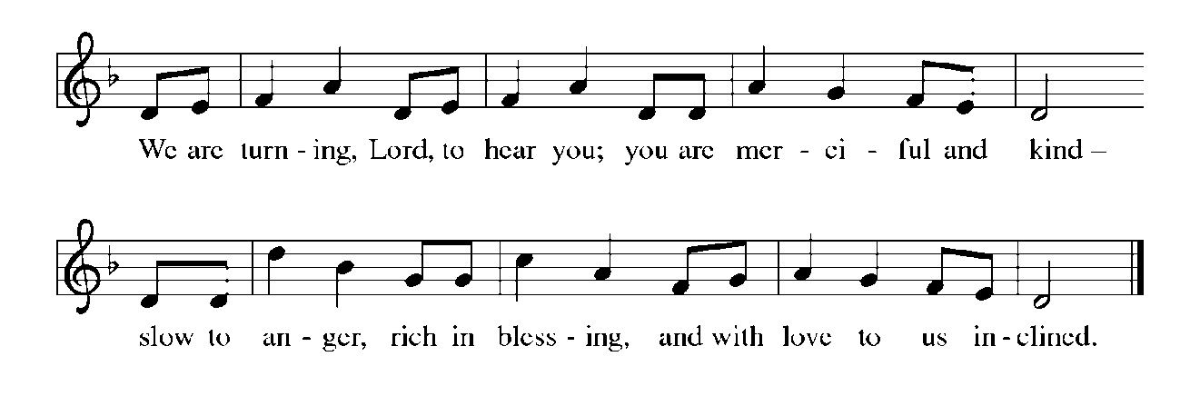

**THE HOLY GOSPEL Luke 13: 31-35**

*Jesus likens the tyrant Herod to a murderous fox. He speaks of himself as a mother hen who would sacrifice her own life to shield her children from danger.*

P: The Holy Gospel according to St. Luke, the thirteenth chapter.

**C: Glory to You, O Lord!**

31At that very hour some Pharisees came and said to Jesus, "Get away from here, for Herod wants to kill you." 32He said to them, "Go and tell that fox for me, 'Listen, I am casting out demons and performing cures today and tomorrow, and on the third day I finish My work. 33Yet today, tomorrow, and the next day I must be on My way, because it is impossible for a prophet to be killed outside of Jerusalem.'

34"Jerusalem, Jerusalem, the city that kills the prophets and stones those who are sent to it! How often have I desired to gather your children together as a hen gathers her brood under her wings, and you were not willing! 35See, your house is left to you. And I tell you, you will not see Me until the time comes when you say, 'Blessed is the One Who comes in the name of the Lord.' "

P: The Gospel of the Lord.

**C: Praise to You, O Christ!**

*The assembly is seated*

**THE SERMON**

*Silence for reflection follows the sermon*

*As you are able please rise*

**THE HYMN OF THE DAY NSB 86 *The Power of Love***

**THE NICENE CREED**

A: God has made us His people through our Baptism into Christ. Living together in trust

and hope, we confess our faith.

**C: We believe in one God,**

**the Father, the Almighty,**

**maker of heaven and earth,**

**of all that is, seen and unseen.**

**We believe in one Lord, Jesus Christ,**

**the only Son of God,**

**eternally begotten of the Father,**

**God from God, Light from Light,**

**true God from true God,**

**begotten, not made,**

**of one Being with the Father.**

**Through Him all things were made.**

**For us and for our salvation**

**He came down from heaven;**

**by the power of the Holy Spirit**

**He became incarnate from the virgin Mary, and was made man.**

**For our sake He was crucified under Pontius Pilate;**

**He suffered death and was buried.**

**On the third day He rose again**

**in accordance with the Scriptures;**

**He ascended into heaven**

**and is seated at the right hand of the Father.**

**He will come again in glory to judge the living and the dead,**

**and His kingdom will have no end.**

**We believe in the Holy Spirit, the Lord, the giver of life,**

**Who proceeds from the Father and the Son.**

**With the Father and the Son He is worshiped and glorified.**

**He has spoken through the prophets.**

**We believe in one holy catholic and apostolic Church.**

**We acknowledge one Baptism for the forgiveness of sins.**

**We look for the resurrection of the dead,**

**and the life of the world to come. Amen**

**THE PRAYER OF THE CHURCH**

A: As we journey toward the Easter Feast, let us turn to God Who is gracious and merciful,

slow to anger, and abounding in steadfast love.

A: That in this Lent the Church may be daily conformed to the mind and life of Christ, let

us pray to the Lord:

**C: Lord, have mercy.**

A: That we may earnestly seek and eagerly accept Christ’s embrace and nurture, let us

pray to the Lord:

**C: Lord, have mercy.**

A: That those preparing for Baptism may in faith grasp the truth of God’s Word and hold

it fast, let us pray to the Lord:

**C: Lord, have mercy.**

A: That those who live in our neighborhoods and communities, especially those plagued

by gang violence, shootings, and drug-related crime may be delivered from fear to live

in safety and peace, let us pray to the Lord:

**C: Lord, have mercy.**

A: That those who suffer in body or mind, especially: **Russ Fischer; Fred Weiss;**

**MacKenzie O’Donnell; Sarah McNabb; Larry Litchford; Christine Kiser;**

**Martha Schroeder; Debbie Martin; and Jess Kalvaitis** may know the strength and

healing of God’s life, let us pray to the Lord:

**C: Lord, have mercy.**

A: That those celebrating anniversaries, especially: **Wayne and Suzann Dolson** that they

may be filled with grace this day and every day and grow in grace in the days ahead,

let us pray to the Lord:

**C: Lord, have mercy.**

A: That with all the faithful departed, especially **Patrick, Bishop, missionary to Ireland,**

whom we commemorate this Daywe may at last find a home in the heavenly Jerusalem,

let us pray to the Lord:

**C: Lord, have mercy.**

P: Come to our aid, Lord God, and grant by Your grace, that we may walk in the footsteps

of the crucified Lord and so come with Him to the glory You have promised. We ask

this through Christ our Lord.

**C: Amen.**

**✠ MEAL ✠**

**THE PEACE**

P: Through Christ we have been reconciled to God, Who has given us the ministry of

reconciliation. Let us be reconciled with one another.

The peace of the Lord be with you always.

**C: And also with you.**

*The assembly is seated*

**THE OFFERING**

**THE VOLUNTARY*****Abide With Me*** **St. Paul Senior Choir**

**(**Arr. M Ijames)

*As you are able please rise*

**THE PRESENTATION OF THE GIFTS (see p. 10)**

*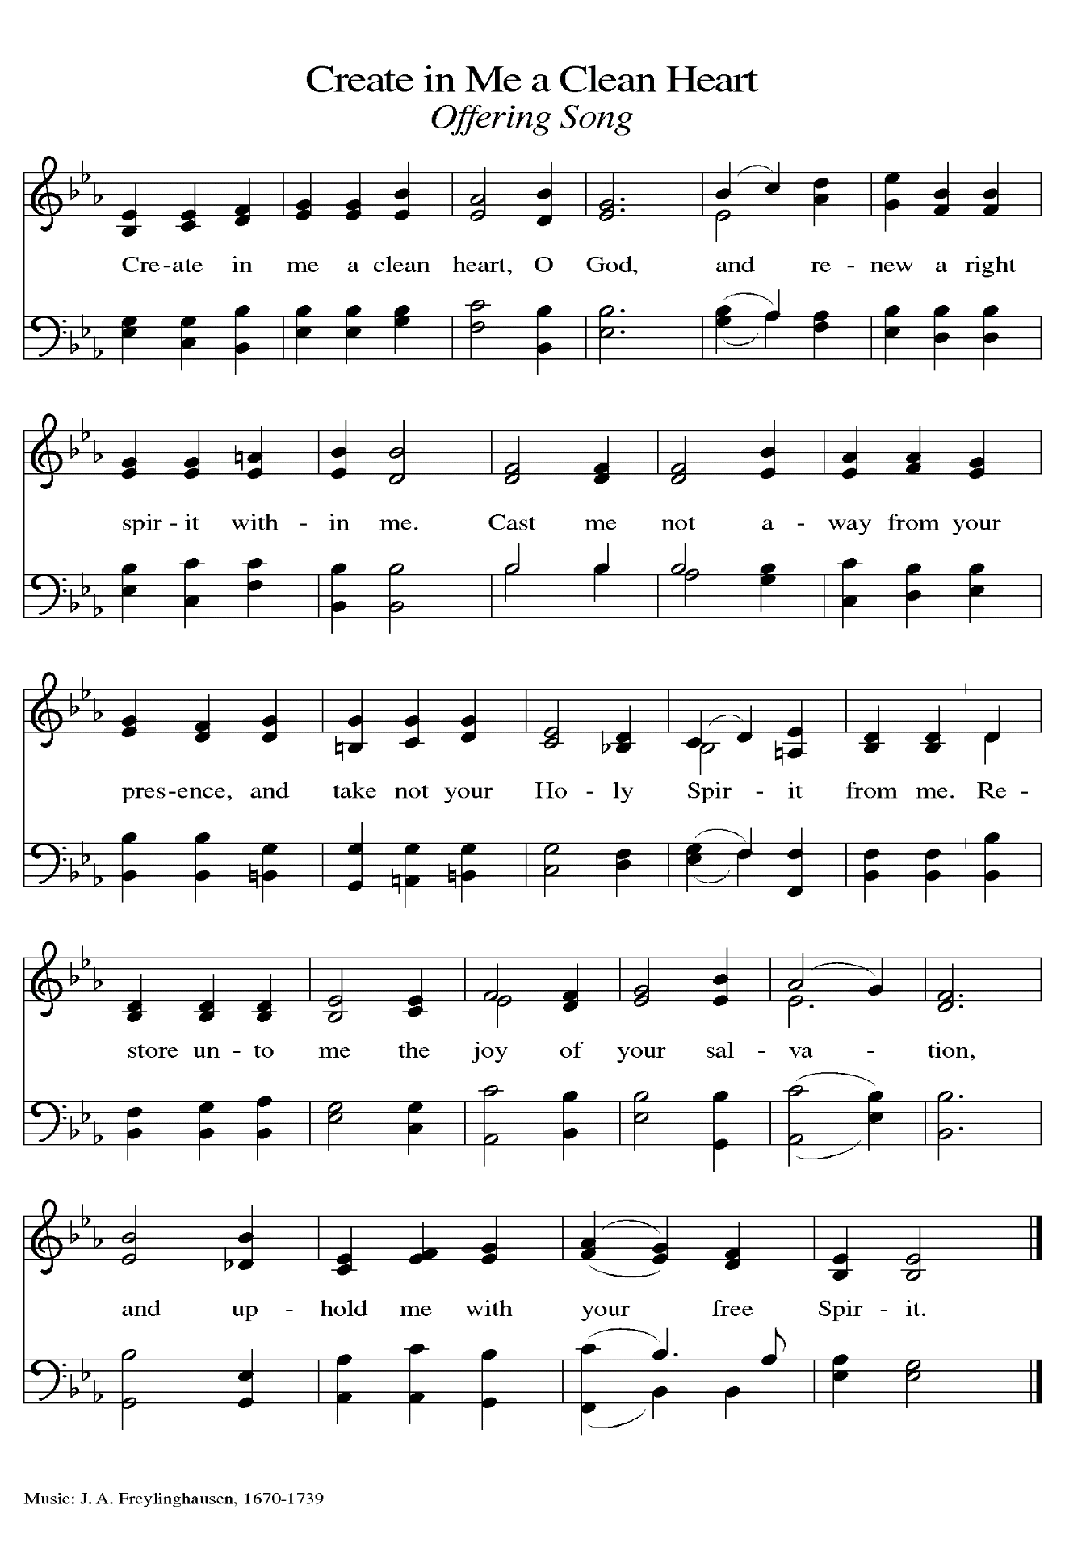***THE OFFERTORY PRAYER**

A: Let us pray. God of promise,

**C: Receive these offerings we bring of Your bounty, and make them holy in Your**

**service. May this Eucharist we share fill us with the life of Christ, and enable us**

**to stand firm in His way of suffering love for the world. We ask this in the name**

**of Jesus the Lord. Amen.**

**THE GREAT THANKSGIVING**

P: The Lord be with you.

**C: And also with you.**

P: Lift up your hearts.

**C: We lift them up to the Lord.**

P: Let us give thanks to the Lord our God.

**C: It is right to give Him thanks and praise.**

P: It is indeed right, our duty, and our joy …join their unending hymn:

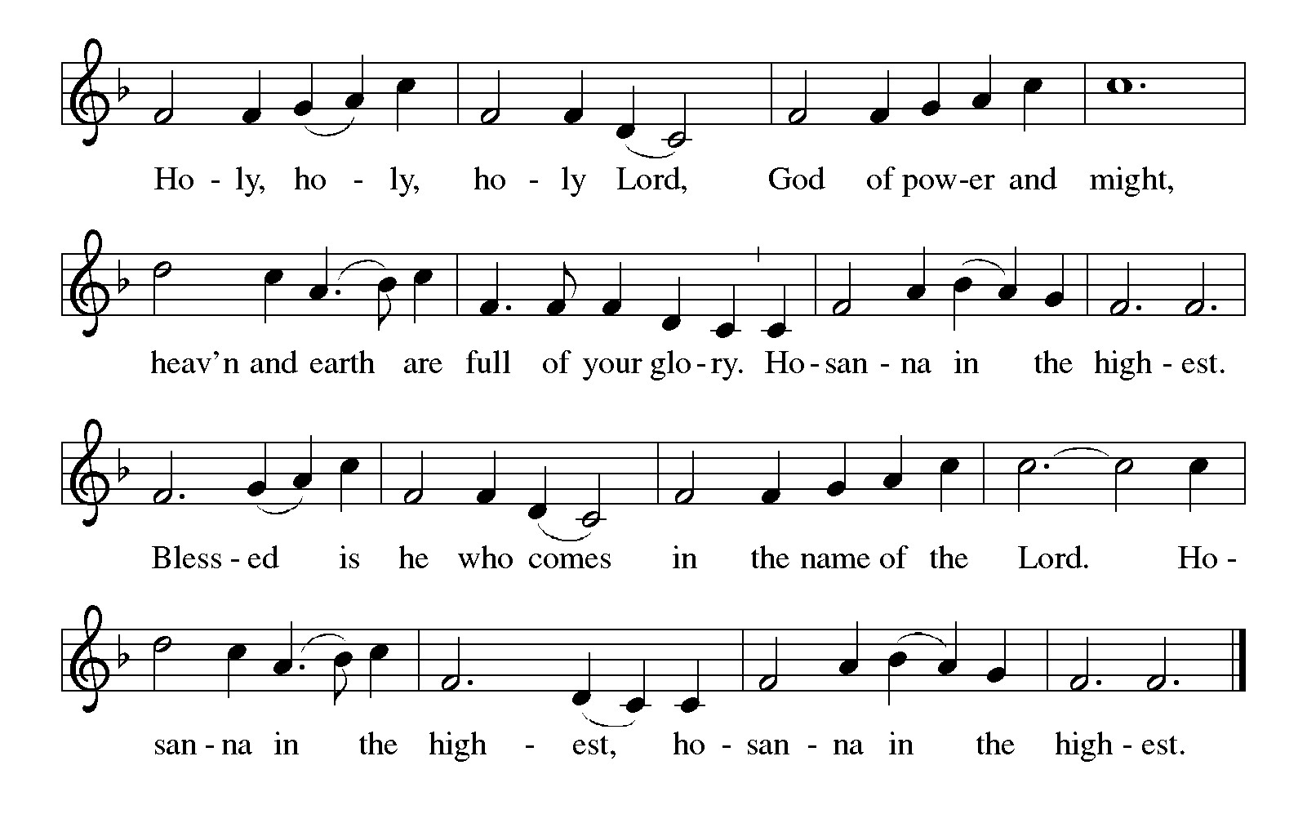

P: Maternal God, You long to gather Your children as a mother hen gathers her brood

under her wings.

You have made the descendants of Abraham as many as the stars in the sky and the

sands in the desert; and in Your great mercy You have made us, too,

children of Your blessed unbreakable covenant.

In Jesus You came among us in grace and truth; in His death we showed the depth of

of departure from Your ways; in His resurrection You demonstrate that

nothing is impossible with you.

God of our salvation, You have made us a people for Your own possession, and we

become Yours as You become ours in the sharing of this Meal of bread and

cup.

Send down Your Holy Spirit, that these tokens of earthly sustenance and heavenly joy

may be for us the Body and Blood of Your Son Jesus Christ,

Who, in the night ... “Do this for the remembrance of Me.”

As often as we eat ... we proclaim the Lord’s death until He comes.

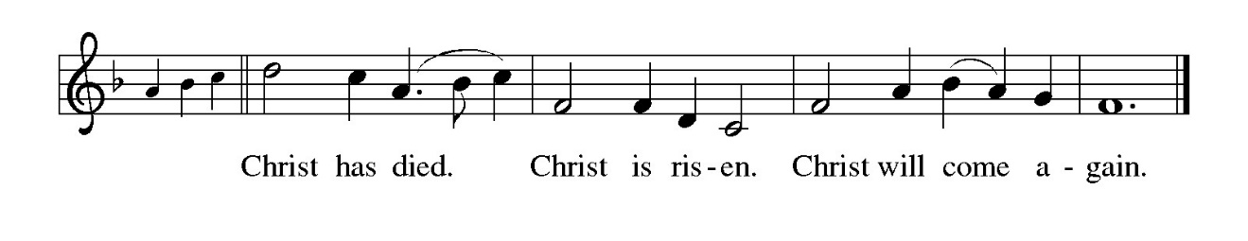

P: God our stronghold, as we walk this Lenten journey through the wilderness with You,

make this Food eternal enough to feed us through times of uncertainty

and fear.

Soften in us the impulse of greed, that, as we share the Bread of Life, we may

continue to understand the word, “enough.”

Shape our hearts to long for that Day when You gather Your children to Yourself,

and inspire us to make all who are created in Your image our companions

at this and other tables,

Until the Day when all our hungers are satisfied and every friendship is fulfilled

in the company of Your Holy Trinity,

Through Whom, and with Whom, and in Whom all honor and glory are Yours,

now and forever.

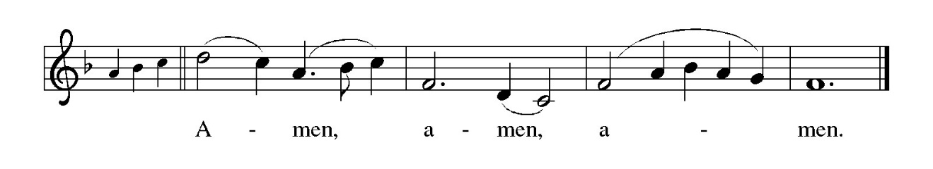

**THE LORD’S PRAYER**

P: Baptized into Christ’s death that we might share in the resurrection, let us pray for the

fulfillment of the mystery as Jesus taught us:

**C: Our Father in heaven, hallowed be Your name.**

**Your Kingdom come, Your will be done on earth as in heaven.**

**Give us today our daily bread, and forgive us our sins, as we forgive**

**those who sin against us.**

**Save us from the time of trial, and deliver us from evil.**

**For the Kingdom, the power, and the glory are Yours, now and forever.**

**Amen.**

**INVITATION TO THE MEAL**

P: Behold the Servant of God, obedient unto death on a cross, highly exalted as Lord of

glory. Blessed are those who are called to the banquet of the Lamb. God’s holy gifts

for God’s holy people. Come, for all is now ready.

*The assembly is seated*

**THE DISTRIBUTION**

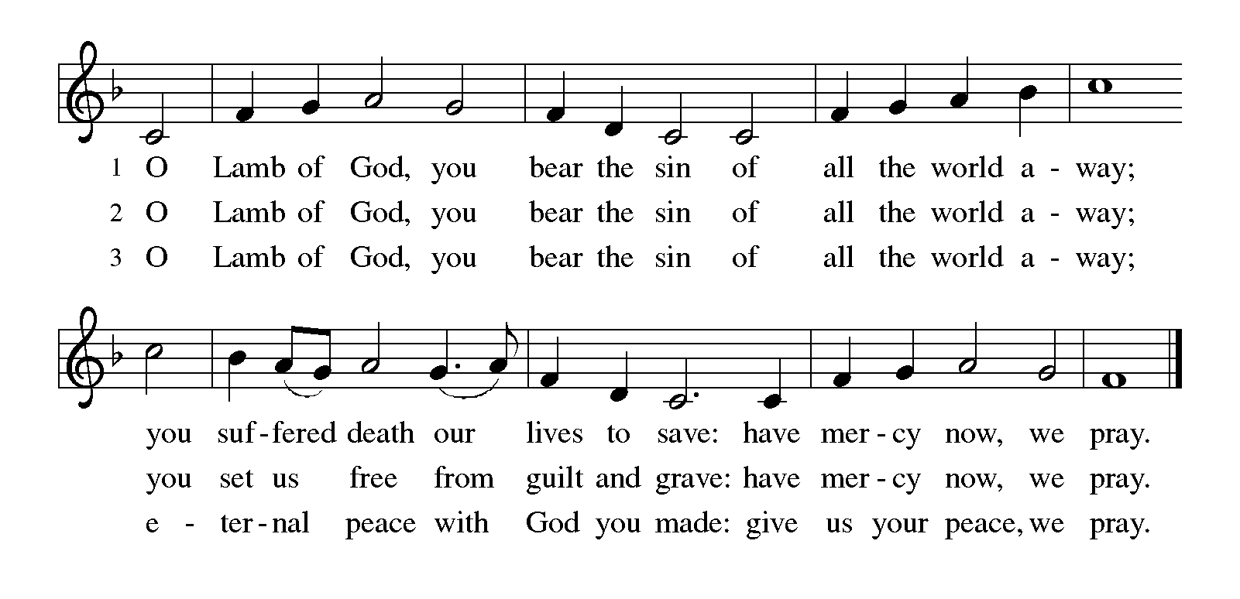

**HYMN DURING DISTRIBUTION 613 *Thy Holy Wings***

**ELW 838 *Beautiful Savior***

**ELW 472 *Eat This Bread***

**NSB 6 *Amazing Love***

*As you are able please rise*

**THE POST COMMUNION BLESSING**

P: The Body and Blood of our Lord Jesus Christ strengthen you and keep you in His

grace.

**C: Amen.**

**THE POST-COMMUNION PRAYER**

A: Let us pray. Lord Jesus Christ, Your Body and Blood is the substance and assurance of

the life You gave for our sin. Having received Your gifts, keep us on the path to the

new life You promise through cross and resurrection. We bless You now and forever.

**C: Amen.**

**✠ SENDING ✠**

**THE BENEDICTION**

P: Jesus took the form of a servant and was obedient to death, even death on a cross. May

you follow His example and share in the resurrection.

**C: Amen.**

P: Almighty God: Father, Son, **✠** and Holy Spirit bless you now and forever.

**C: Amen.**

**SENDING SONG NSB 26 *Cry of My Heart***

**THE DISMISSAL**

A: Reconciled to God through Christ, let us go out into the world in peace.

**C: Thanks be to God!**

**THE POSTLUDE**

***✠ To God Alone Be Glory✠***

The Meditation is from *The Christian Century.* February 25, 1986. p. 201.

**ANNOUNCEMENTS**

**Please remember to mail your offering to the Church Office** at 818 Franklin Street, Michigan City, IN 46360**.** Another alternative is to give on-line through Tithe.ly. Please see your closure letter for information on how to set up a Tithe.ly account.

**St. Paul Members are reminded to have** a loved one contact the office if you are hospitalized. Many times, the Pastor doesn’t know someone is in the hospital. If you call and leave a message, please tell us which hospital the patient is at.

**Anniversaries: Wayne & Suzann Dolson (3/23)**

**PRAYER CONCERNS:** Pope Francis, Larry Litchford, Sarah McNabb, Carol Radke, Jeanie Boatman Shepple, Nolan Wilson, Debbie Martin, Mark Tannehill, Brian Wiseman, Kathy Stein, Danielle Schnell, Jan Paholski, Laura Dovey, and Grace

Romine.

**OFFICE HOURS:** Libby will be in the office on Mondays, Wednesdays, and Fridays; volunteers will cover Tuesdays and Thursdays.

Monday & Wednesday 8:00 a.m. – 5 p.m.

Tuesday & Thursday 9:00 a.m. – 12:00 p.m.

Friday 8:00 a.m. – 12:00 p.m.

**If you are listening to the worship broadcast on the radio and would like to watch the Sunday morning service live stream follow these steps:**

(1) If you have You Tube available on your TV, search for

**St. Paul Lutheran Church Michigan City, IN.**

(2) The direct link on the computer is

https://www.youtube.com/channel/UC5AIPNaKr3QN50984jGOa1g.

   (3) This link is also on the main page of the church’s website in

the church section and will continue to be posted weekly on the St.

Paul Facebook page.

And it will always be available on the radio broadcast Sunday mornings at 11:00 a.m.

on WEFM (95.9), and on the local cable access station #99 for the previous week’s

service on Sundays at 4:00 p.m. and the current service on Wednesdays at 7:00 p.m.

and Fridays at 8:30 p.m.

**Next Sunday’s lessons are Isaiah 55: 1-9; Psalm 63: 1-8; I Corinthians 10: 1-13; Luke 13: 1-9** for those of you who like to study them in advance.

**To send e-mail to the church office**, please use the following addresses:

Pastor Mark Reshan: seniorpastor@stpaulmichigancity.com

Church Office Secretary (Libby Pollock): churchsecretary@stpaulmichigancity.com

Church Treasurer (Karen Fleming): finance@stpaulmichigancity.com

**The Good News Newsletter**: If you have an article or anything you want included in **The Good News** please send it to the following e-mail address: splcgoodnews@gmail.com. Pastor Pamela Thiede will be using this e-mail address to assemble **The Good News** each month. The deadline for getting information to Pastor Pamela will be the 20th of each month.

**Worship Attendance:**

**Wednesday, March 5, 2025 @ 10:00 a.m. 39**

**Wednesday, March 5, 2025 @ 7:00 p.m. 43**

**Saturday , March 8, 2025 @ 4:00 p.m. 28**

**Sunday, March 9, 2025 @ 9:00 a.m. 59**

**TOTAL 169**

**Copies of the minutes from the January 23, 2025 and February 27, 2025 Church Council meetings are on the back table in the upper Narthex. They were approved by the council via email.**

**FYI:**

In response to the ever rising costs for postage we will be putting your copy

of the “Good News” in your hanging file folder in the narthex each month

from now on. Those of you who are unable to attend services on a regular

basis may still receive your copies through your email address or in the

U.S. mail. If you normally receive your copy of the newsletter via your

email address anyway, nothing will change for you. Thank you so much for

your understanding and cooperation!

**MISSION OF THE MONTH FOR MARCH 2025:**

We will be supporting The Social and Learning Institute as our Mission of the Month for March. The Institute has been serving LaPorte County since 1976 by helping individuals with developmental disabilities expand their minds, learn important life skills and recognize their worth through a structured balance of socialization and learning activities. If you would like to make a monetary donation, please make checks out to St. Paul and mark it for the March mission and place in the offering plate. Noisy coin offering will also go to support the monthly mission. The Institute also has an Amazon wish list of classroom supplies. When ordering from the wish list, select Abby Hinsch LaPorte, IN as the shipping address and items will be delivered directly to the Institute. If you prefer to shop in person, items can be placed in the bin in the Narthex.

**Wishlist URL (also available on our Facebook page; note: the last 3 characters are zero f zero):** [**https://shorturl.at/xg0f0**](https://shorturl.at/xg0f0)

**Items needed:**

**Personal Care:** Facial tissues w/ lotion, 2-ply toilet paper, band aids, first aid kits

**Cleaning**: Sweeper wet mopping pad refills, Lysol disinfectant spray or wipes, 30 gallon and kitchen sized drawstring trash bags, nitrile gloves

**Games/Toys:** Magnatiles, board games, stress balls or squishy toys, Montessori learning toys, sensory toys

**Classroom:** Colored cardstock, construction paper, crayons, Elmer’s liquid glue or glue sticks, retractable permanent markers, Post-it pop up notes, bulletin board supplies (paper, boarders, letters, mounting tape)

**ACTIVITIES, EVENTS & MEETINGS**

**MARCH 2025**

**Saturday,** March 8, 2025 @ 4:00 p.m. 1st Lent Worship Service

**Sunday,** March 9, 2025 @ 9:00 a.m. 1st Lent Worship Service

**Monday,** March 10, 2025 @ 1:00 p.m. Hope Circle/Green Room

**Tuesday,** March 11, 2025 **@ 11:00 a.m. – close GIVE BACK at Holly’s Restaurant & Pub**

@ 7:00 p.m. Estuary/Luther House

**Wednesday,** March 12, 2025 @ 9:15 a.m. Bible Study/Luther House

@ 10:00 a.m. God’s Purls/St. Paul Room

@ 4:30 p.m. Choir Rehearsal/Sanctuary

@6:00 p.m. **Lenten Service**

**Saturday,** March 15, 2025 @ 4:00 p.m. 2nd Lent Worship Service

**Sunday,** March 16, 2025 @ 9:00 a.m. 2nd Lent Worship Service

**Wednesday,** March 19, 2025 @ 9:15 a.m. Bible Study/Luther House

@ 10:00 a.m. God’s Purls/St. Paul Room

@ 4:30 p.m. Choir Rehearsal/Sanctuary

@ 6:00 p.m. **Lenten Service**

**Saturday,** March 22, 2025 @ 4:00 p.m. 3rd Lent Worship Service

**Sunday,** March 23, 2025 @ 9:00 a.m. 3rd Lent Worship Service

**Monday,** March 24, 2025 @ 2:00 p.m. Finance Committee Mtg./Luther House

@ 3:00 p.m. Executive Board Committee Mtg./Luther House

**Wednesday,** March 26, 2025 @ 9:15 a.m. Bible Study/Luther House

@ 10:00 a.m. God’s Purls/St. Paul Room

@ 4:30 p.m. Choir Rehearsal/Sanctuary

@6:00 p.m. **Lenten Service**

**Thursday,** March 27, 2025 @ 5:30 p.m. Church Council Mtg./Luther House

**Saturday,** March 29, 2025 @ 4:00 p.m. 4th Lent Worship Service

**Sunday,** March 30, 2025 @ 9:00 a.m. 4th Lent Worship Service

**Easter Plants**

A variety of spring plants will be available to order for decorating St. Paul’s Church on Easter Morning! The varieties available will be Lily, Daffodil, Hyacinth, Tulip, Hydrangea, Florist Mum, and Hanging Fern Basket. Orders must be placed by Monday, March 31st.

The varieties and color available are Lily, Daffodil, Hyacinth in purple, pink, or white. Tulips in yellow, red, white, or pink. Florist Mum (Daisy like form) in pink, white, or yellow. Hydrangeas in pink or purple/blue, and the 10” Hanging Fern Basket.

Cost per plant is as follows:

Lily - $10.00

Daffodil - $9.00

Hyacinth - $9.00 (purple, pink, or white)

Tulip - $9.00 (yellow, red, white, or pink)

Florist Mum - $11.00 (pink, white, or yellow)

Hydrangea - $15.00 (pink or purple/blue)

Hanging Fern - $15.00

Please specify your choice of plant and your choice of color when applicable.

Orders MUST be placed by Monday morning, March31st.

Your order may be placed ‘In Memory or Honor of a Loved One’. Please call the Church Office, 219-874-7293, or place your order in an envelope and title it ‘EasterPlants’ for ordering.

REMEMBER, you must specify what type of plant and color, if applicable!! All checks should be made out to St. Paul Church.

Please plan on picking up your plant after the Easter Morning Service by 11:00 a.m..