**THE TRANSFIGURATION OF OUR LORD**

**The Last Sunday after the Epiphany**

**March 2, 2025**

“ ...One thing is clear: Jesus and his disciples have an experience of God (on the mountain). Its meaning for Jesus and for them is different, but the only actor in the event is God. Jesus is not acting but is being acted on. The God of Moses and Elijah affirms them in their unity with Jesus but asserts the finality of Jesus.

The God who could rescue the Son from suffering confirms for Jesus the way of the cross. This God also tells the disciples, who will soon face conditions that seem to derail if not bring to an end their hope in Jesus that those very painful conditions do not lie *across* the way but *on* the way to the completion of God’s purpose.

This is a mountaintop experience but not the kind about which persons write glowingly of sunrises, soft breezes, warm friends, music, and quiet time. On this mountain the subject is death, and the frightening presence of God reduces those present to silence. In due time, after the resurrection, they will remember, understand, and not feel heavy. In fact, they will tell is broadly as good news.”

**Fred Craddock**

There are many people today who are seeking God, a lot of them in bizarre ways. Your local “spiritual supply store” offers crystals, cards, boards, powders and various other gadgets for the expressed purpose of cosmic convergence of your coming in contact with God. The greatest search in our time and for all time is the search for God.

However, Christian people proclaim that God cannot be found, but rather has found us in Jesus the Christ. Jesus is Emmanuel, God with us. All of heaven breaks loose for us in the weekly assembly, but we miss it if we are sleeping. As we awake to God’s presence, let us not lock it away in booths of our own security and salvation.

Instead of snoozing, let us be dazzled, opening our hearts to God’s presence, a source of courage, power and might that will motivate us to go out into the world and point others to God’s most brilliant light.

**Karen M. Ward**

**✠ *In the Name of Jesus* ✠**

**INTRODUCTION**

*The Transfiguration of Our Lord concludes the Epiphany season. In these weeks the ministry of Jesus--his words and actions--has been the focus of the Sunday readings. On this day the church stands with the disciples before the transfigured Christ, who will soon invite us on the journey to Jerusalem.*

**✠ GATHERING ✠**

**PRE-SERVICE MUSIC *The Mountain of the Lord* New Song Praise Band**

**(Andy Parks)**

**ANNOUNCEMENTS**

*As you are able please rise*

**THE GATHERING SONG (see page 3) *Come to the Mountain***

**THE GREETING**

P: Arise; shine; for your light has come. The grace of our Lord Jesus Christ, the love of

God, and the communion of the Holy Spirit be with you all.

**C: And also with you.**

**THE HYMN OF PRAISE (see page 4)**

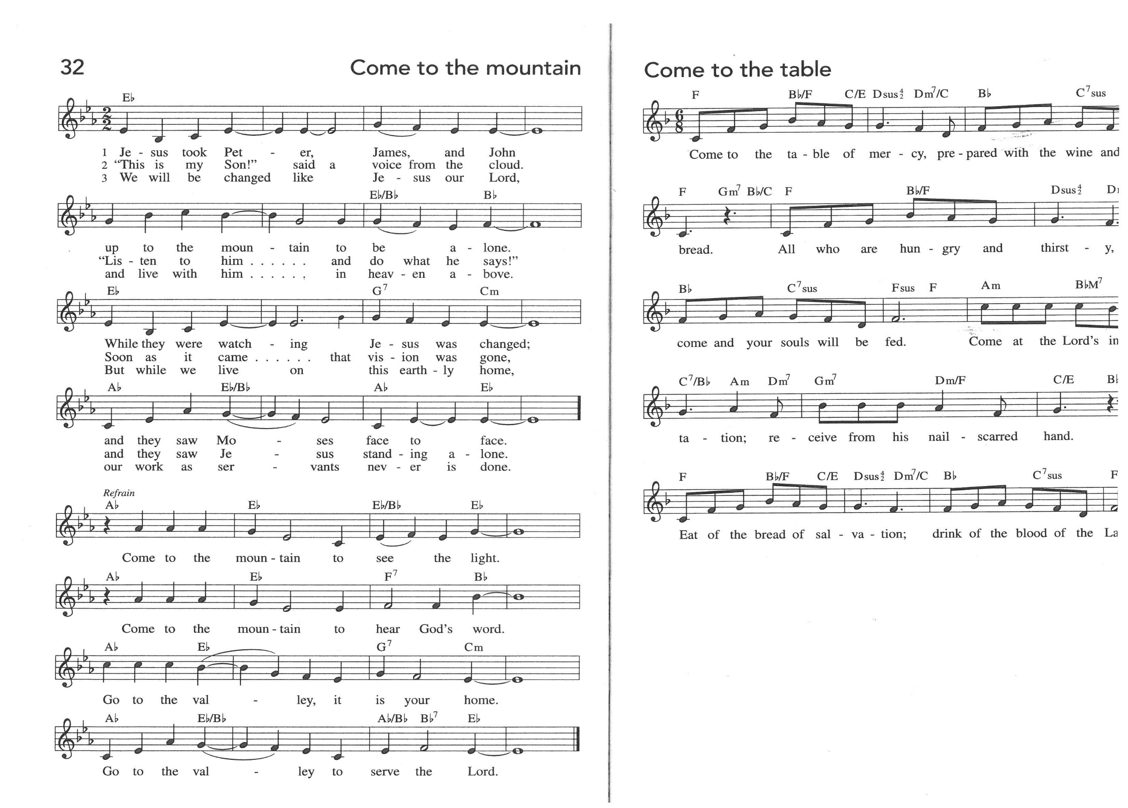

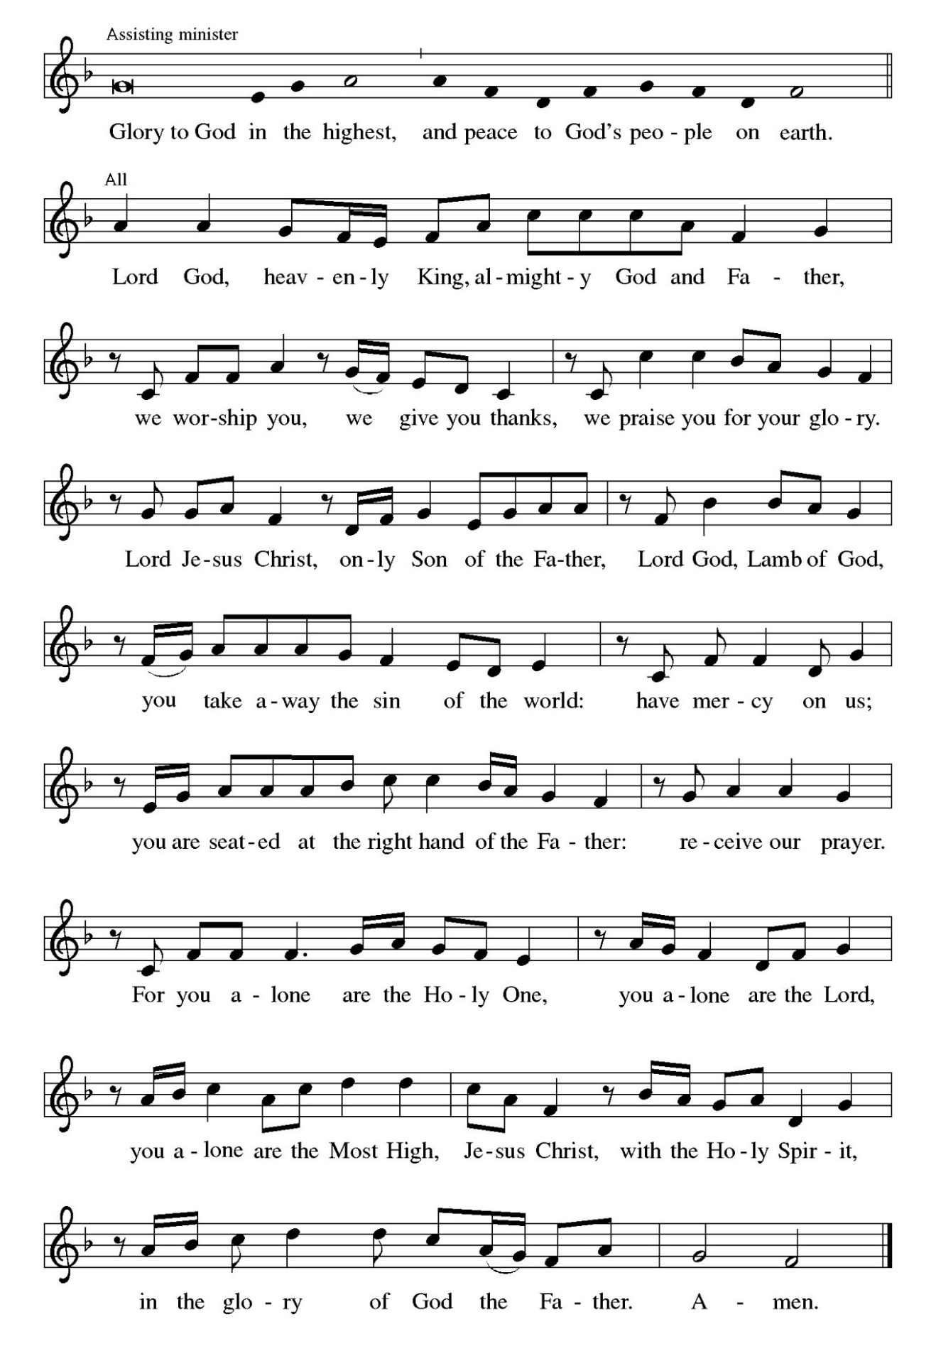

**THE PRAYER OF THE DAY**

P: The Lord be with you.

**C: And also with you.**

P: Let us pray. Holy God, mighty and immortal, You are beyond our knowing, yet we see

Your glory in the face of Jesus Christ. Transform us into the likeness of Your Son, Who

renewed our humanity so that we may share in His divinity, Jesus Christ our Lord, Who

lives and reigns with You and the Holy Spirit, one God, now and forever.

**C: Amen.**

*The assembly is seated*

**✠ WORD ✠**

**FIRST READING Exodus 34: 29-35**

*Following his reception of the Ten Commandments on Mt. Sinai, Moses' shining face reflected the glory of God. It also caused the Israelites to be afraid. Moses decides to wear a veil that masks the radiance of God's glory but allows direct communication with the people.*

29Moses came down from Mount Sinai. As he came down from the mountain with the two tablets of the covenant in his hand, Moses did not know that the skin of his face shone because he had been talking with God. 30When Aaron and all the Israelites saw Moses, the skin of his face was shining, and they were afraid to come near him. 31But Moses called to them; and Aaron and all the leaders of the congregation returned to him, and Moses spoke with them.

32Afterward all the Israelites came near, and he gave them in commandment all that the Lord had spoken with him on Mount Sinai. 33When Moses had finished speaking with them, he put a veil on his face; 34but whenever Moses went in before the Lord to speak with Him, he would take the veil off, until he came out; and when he came out, and told the Israelites what he had been commanded, 35the Israelites would see the face of Moses, that the skin of his face was shining; and Moses would put the veil on his face again, until he went in to speak with Him.

The Word of the Lord.

**Thanks be to God.**

**THE PSALM: Psalm 99** Antiphon by Martin A. Seltz

Refrain is sung first by the choir and then repeated immediately by the congregation

and as indicated

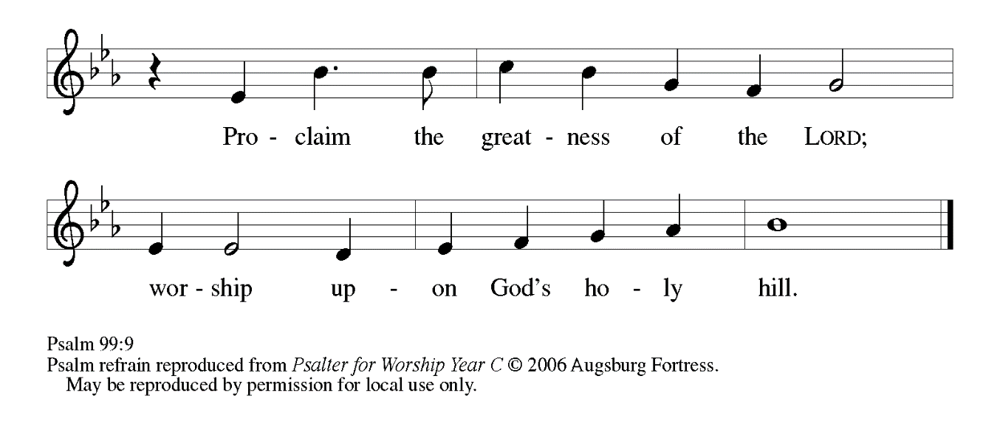

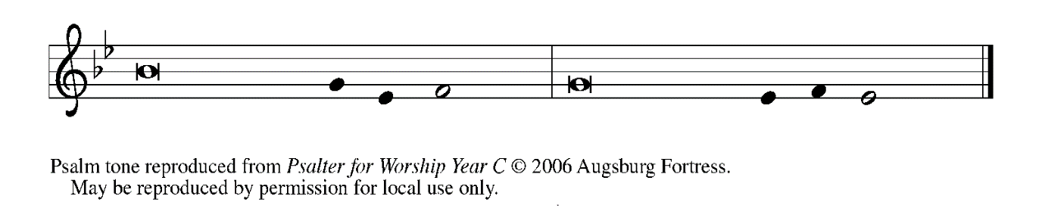

1The Lord is king; let the | people tremble.  
  The Lord is enthroned upon the cherubim; let | the earth shake.

 2**The Lord, | great in Zion,**  
  **is high a- | bove all peoples.**

 3Let them confess God’s name, which is | great and awesome;  
  God is the | Holy One.

 4**O mighty king, lover of justice, You have es- | tablished equity;**  
  **You have executed justice and righteous- | ness in Jacob. REFRAIN**

 5Proclaim the greatness of the Lord and fall down be- | fore God’s footstool;  
  God is the | Holy One.

 6**Moses and Aaron among Your priests, and Samuel among those who call upon Your | name, O Lord,**  
  **they called upon You, and You | answered them,**

 7You spoke to them out of the pil- | lar of cloud;  
  they kept Your testimonies and the decree | that You gave them.

 8**O Lord our God, You answered | them indeed;**  
  **You were a God Who forgave them, yet punished them for their | evil deeds.**

 9Proclaim the greatness of the Lord and worship upon God’s | holy hill;  
  for the Lord our God is the | Holy One.  **REFRAIN**

**SECOND READING 2 Corinthians 3: 12--4:2**

*In his debates with the Corinthians, Paul contrasts the glory of Moses with the glory of Christ. The Israelites could not see Moses' face because of the veil. But in Christ we see the unveiled glory of God and are transformed into his likeness.*

12Since, then, we have such a hope, we act with great boldness, 13not like Moses, who put a veil over his face to keep the people of Israel from gazing at the end of the glory that was being set aside. 14But their minds were hardened. Indeed, to this very day, when they hear the reading of the old covenant, that same veil is still there, since only in Christ is it set aside. 15Indeed, to this very day whenever Moses is read, a veil lies over their minds; 16but when one turns to the Lord, the veil is removed. 17Now the Lord is the Spirit, and where the Spirit of the Lord is, there is freedom. 18And all of us, with unveiled faces, seeing the glory of the Lord as though reflected in a mirror, are being transformed into the same image from one degree of glory to another; for this comes from the Lord, the Spirit.

4:1Therefore, since it is by God's mercy that we are engaged in this ministry, we do not lose heart. 2We have renounced the shameful things that one hides; we refuse to practice cunning or to falsify God's word; but by the open statement of the truth we commend ourselves to the conscience of everyone in the sight of God.

The Word of the Lord.

**Thanks be to God.**

*As you are able please rise*

**THE VERSE**

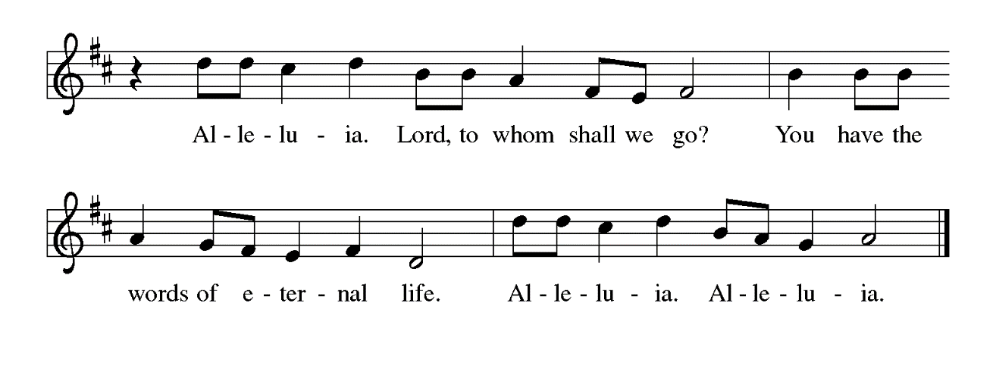

**THE HOLY GOSPEL Luke 9: 28-43**

*Today's reading offers a remarkable conclusion to the Epiphany season and turns us toward Lent. The transfiguration of Jesus is itself a great epiphany, or manifestation. But in the very midst of this event is talk of what will happen in Jerusalem, where Jesus must suffer and die.*

P: The Holy Gospel according to St. Luke, the ninth chapter.

**C: Glory to You, O Lord!**

28Now about eight days after these sayings Jesus took with Him Peter and John and James, and went up on the mountain to pray. 29And while He was praying, the appearance of His face changed, and His clothes became dazzling white. 30Suddenly they saw two men, Moses and Elijah, talking to Him. 31They appeared in glory and were speaking of His departure, which He was about to accomplish at Jerusalem.

32Now Peter and his companions were weighed down with sleep; but since they had stayed awake, they saw His glory and the two men who stood with Him. 33Just as they were leaving Him, Peter said to Jesus, "Master, it is good for us to be here; let us make three dwellings, one for You, one for Moses, and one for Elijah"--not knowing what he said. 34While he was saying this, a cloud came and overshadowed them; and they were terrified as they entered the cloud.

35Then from the cloud came a voice that said, "This is My Son, my Chosen; listen to Him!" 36When the voice had spoken, Jesus was found alone. And they kept silent and in those days told no one any of the things they had seen.

37On the next day, when they had come down from the mountain, a great crowd met Him. 38Just then a man from the crowd shouted, “Teacher, I beg you to look at my son; he is my only child. 39Suddenly a spirit seizes him, and all at once he shrieks. It convulses him until he foams at the mouth; it mauls him and will scarcely leave him. 40I begged Your disciples to cast it out, but they could not.”

41Jesus answered, “You faithless and perverse generation, how much longer must I be with you and bear with you? Bring your son here.” 42While he was coming, the demon dashed him to the ground in convulsions. But Jesus rebuked the unclean spirit, healed the boy, and gave him back to his father. 43aAnd all were astounded at the greatness of God.

P: The Gospel of the Lord.

**C: Glory to You, O Christ!**

*The assembly is seated*

**THE SERMON**

*Silence for reflection follows the sermon*

*As you are able please rise*

**THE HYMN OF THE DAY (see page 9) *You, Lord, Are Both Lamb and Shepherd***

Stanza 2—Men; Stanza 3--Women

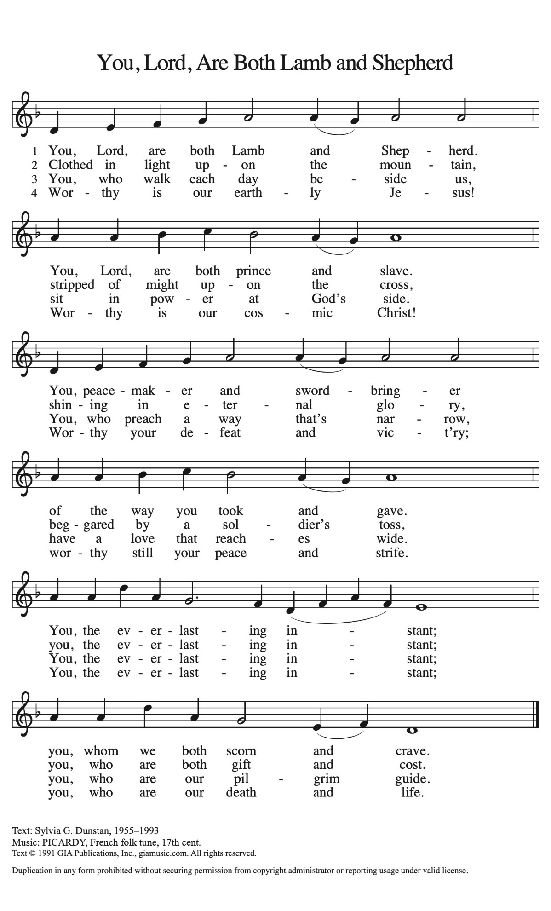

**THE NICENE CREED**

A: God has made us His people through our Baptism into Christ. Living together in trust

and hope, we confess our faith.

**C: We believe in one God,**

**the Father, the Almighty,**

**maker of heaven and earth,**

**of all that is, seen and unseen.**

**We believe in one Lord, Jesus Christ,**

**the only Son of God,**

**eternally begotten of the Father,**

**God from God, Light from Light,**

**true God from true God,**

**begotten, not made,**

**of one Being with the Father.**

**Through Him all things were made.**

**For us and for our salvation**

**He came down from heaven;**

**by the power of the Holy Spirit**

**He became incarnate from the virgin Mary, and was made man.**

**For our sake He was crucified under Pontius Pilate;**

**He suffered death and was buried.**

**On the third day He rose again**

**in accordance with the Scriptures;**

**He ascended into heaven**

**and is seated at the right hand of the Father.**

**He will come again in glory to judge the living and the dead,**

**and His kingdom will have no end.**

**We believe in the Holy Spirit, the Lord, the giver of life,**

**Who proceeds from the Father and the Son.**

**With the Father and the Son He is worshiped and glorified.**

**He has spoken through the prophets.**

**We believe in one holy catholic and apostolic Church.**

**We acknowledge one Baptism for the forgiveness of sins.**

**We look for the resurrection of the dead,**

**and the life of the world to come. Amen**

**THE PRAYER OF THE CHURCH**

A: Formed by the Word and promise of God, let us pray that the merciful glory of God

may drive away all darkness, and that God’s providence lead all people from death into

life.

A: That the Church may faithfully and powerfully reflect the glory of life in Christ, we

pray:

**C: Shine in our hearts, O Lord.**

A: That peoples of the world and their leaders might be drawn by the Light of Christ into

the paths of peace, we pray:

**C: Shine in our hearts, O Lord.**

A: That the ministries of this congregation might shine the face of Christ to those we are

granted to serve, we pray:

**C: Shine in our hearts, O Lord.**

A: That the weak may be strengthened by Your love, the ignorant enlightened by Your

knowledge, and the sick, especially: **MacKenzie O’Donnell; Fred Weiss; Joyce**

**Stark; Diane Sunde; Martha Schroeder; and Debbie Martin** might be made whole

by the light of Your life, we pray:

**C: Shine in our hearts, O Lord.**

A: That those celebrating birthdays, especially **Gail Leffew and Ken Baker** may be filled

with grace this day and every day and grow in grace in the days ahead, we pray:

**C: Shine in our hearts, O Lord.**

A: That, joining with Your whole Church and all the faithful who waited for You, with

Moses and Elijah, Peter, James, and John, we may at last share in Your splendor and

behold Your glory face to face, we pray:

**C: Shine in our hearts, O Lord.**

P: Before You, O God, are all our prayers and our needs. You are our Light and our Life,

our mercy and hope and our ever-dawning day. Hear us now through Your Son, Jesus

Christ our Lord.

**C: Amen.**

**✠ MEAL ✠**

**THE PEACE**

P: The peace of the Lord be with you always.

**C: And also with you.**

*The assembly is seated*

**THE OFFERING**

**THE VOLUNTARY *What Is This Light?* St. Paul Senior Choir**

**(L. Shackley)**

*As you are able please rise*

**THE PRESENTATION OF THE GIFTS**



**THE OFFFERTORY PRAYER**

A: Let us pray. God of light,

**C: Engaged in Your ministry, we bring You these offerings of our time, our**

**possessions, and ourselves. Receive them for the sake of Your Son, and use them**

**for faithful service until You bring us to the radiant glory we see in the**

**transfigured face of Your Son, Jesus Christ our Lord. Amen.**

**THE GREAT THANKSGIVING**

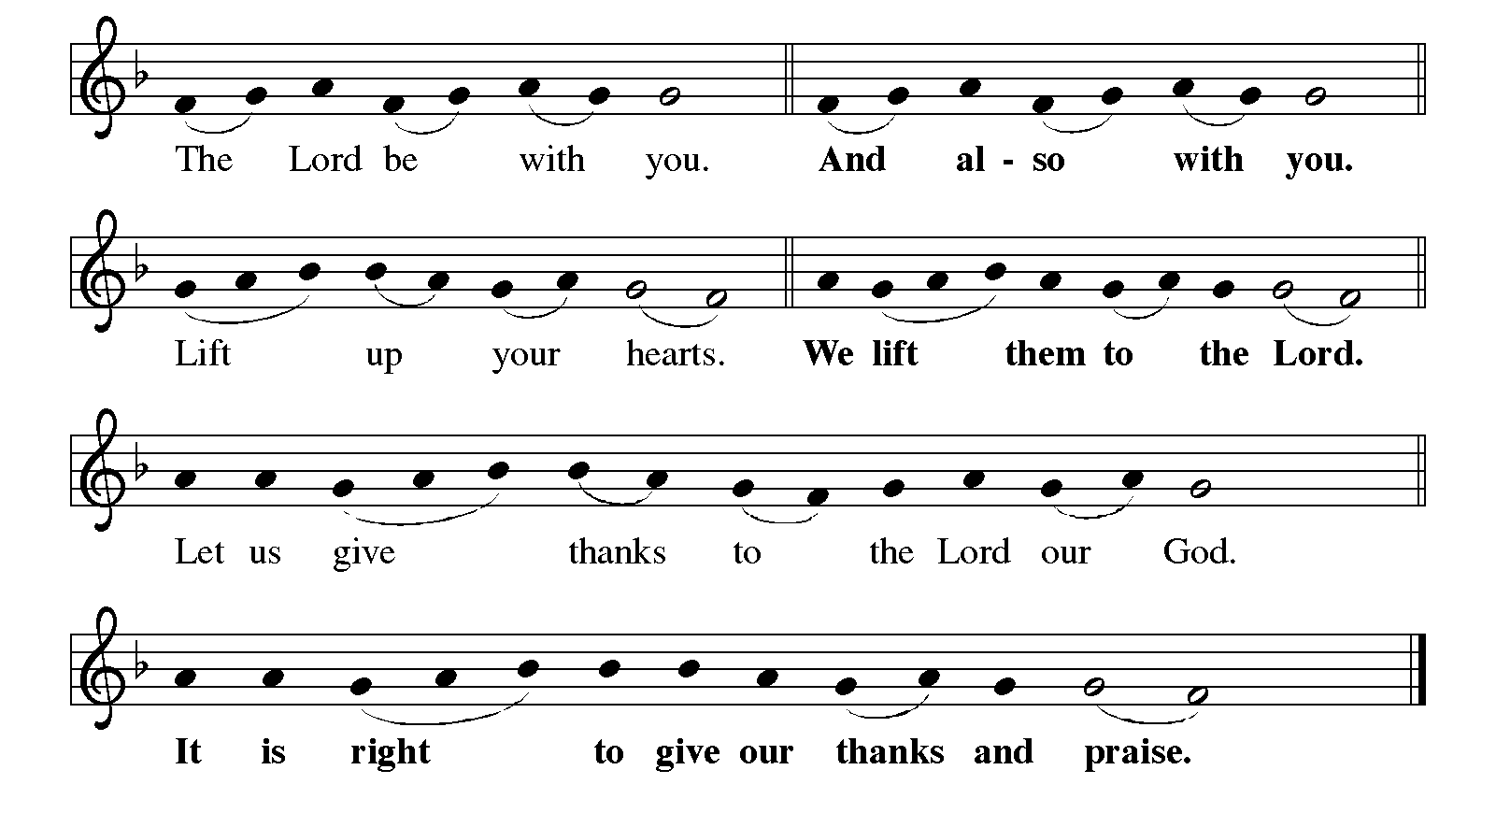 P: It is indeed right, our duty and our joy … and join their unending hymn:

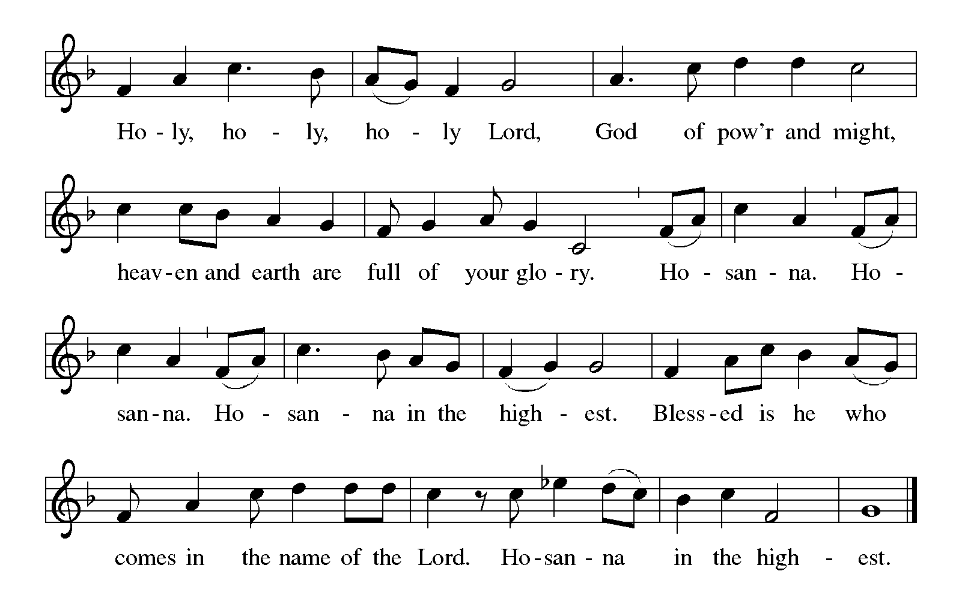

P: Creating and liberating God, You called Your people into covenant with You and

sealed Your trust with Moses on the mountain.

You called Your people back to that covenant through Your prophets and spoke in

a still small voice to Elijah on a mountain.

Then, in Your Son Jesus, on a mountain You stood between the Law and the

Prophets and revealed the radiance of Your Gospel.

On Calvary’s hill Your Son redeemed us by the blood of Your new covenant,

and on the mountain in the Galilee He ascended to Your right hand on

high.

Dazzling God, You set up Your tent and make Your dwelling among us.

Abide with us now through the power of Your Holy Spirit, that Your people may

become a temple of Your presence, and these gifts of bread and wine

may be for us the Body and Blood of Your Son Jesus Christ,

Who, in the night ... “Do this for the remembrance of Me.”

As often as we eat ... we proclaim the Lord’s death until He comes.

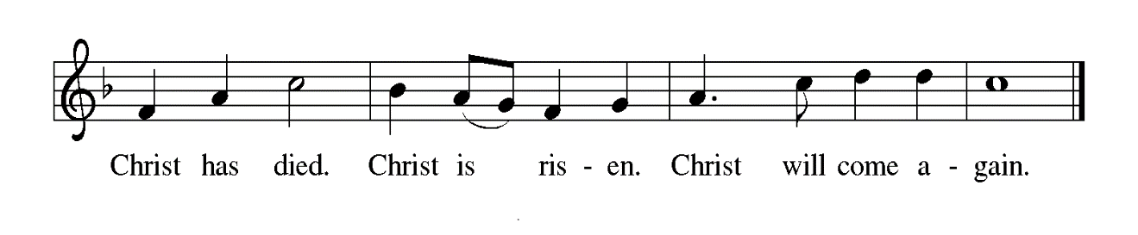

P: Transfiguring God, it is good for us to be here.

Through this holy sacrament make us Your daughters and sons, and be close to

all children who have no one to share Your love and mercy with them.

Make us Your beloved, and visit all who have no one to call them beloved.

Give us grace to listen to Your voice, and bring to Your heart any who have

no one to listen to them.

Surround us with Your prophetic company and take us up into the whirlwind of

Your glory, until the Day comes when the waters of the Jordan are parted

and the heavens are opened and the chariots bring us home to You,

Ever one God: Father, **✠** Son, and Holy Spirit.

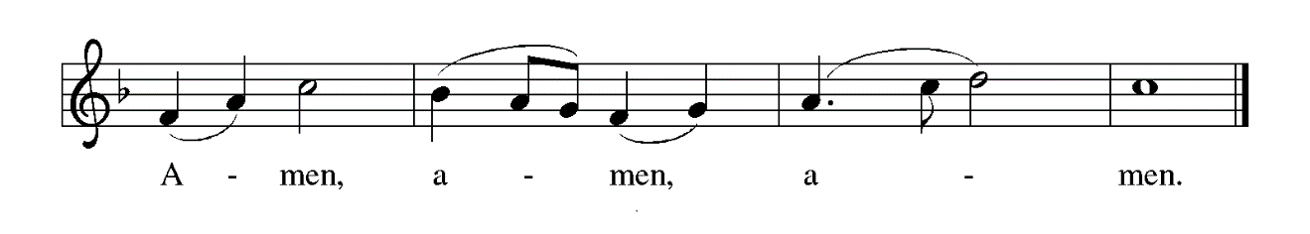

**THE LORD’S PRAYER**

P: Because in Christ we have received the Spirit of adoption, as daughters and sons of God

we dare to pray:

**C: Our Father in heaven, hallowed be Your name.**

**Your Kingdom come, Your will be done on earth as in heaven.**

**Give us today our daily bread, and forgive us our sins, as we forgive**

**those who sin against us.**

**Save us from the time of trial, and deliver us from evil.**

**For the Kingdom, the power, and the glory are Yours, now and forever.**

**Amen.**

**INVITATION TO THE MEAL**

P: Behold the true Light of the world, the Beloved of God, anointed by the Spirit. Blessed

are those who are called to the Supper of the Lamb. God’s holy gifts for God’s holy

people. Come, for all is now ready.

*The assembly is seated*

**THE DISTRIBUTION**

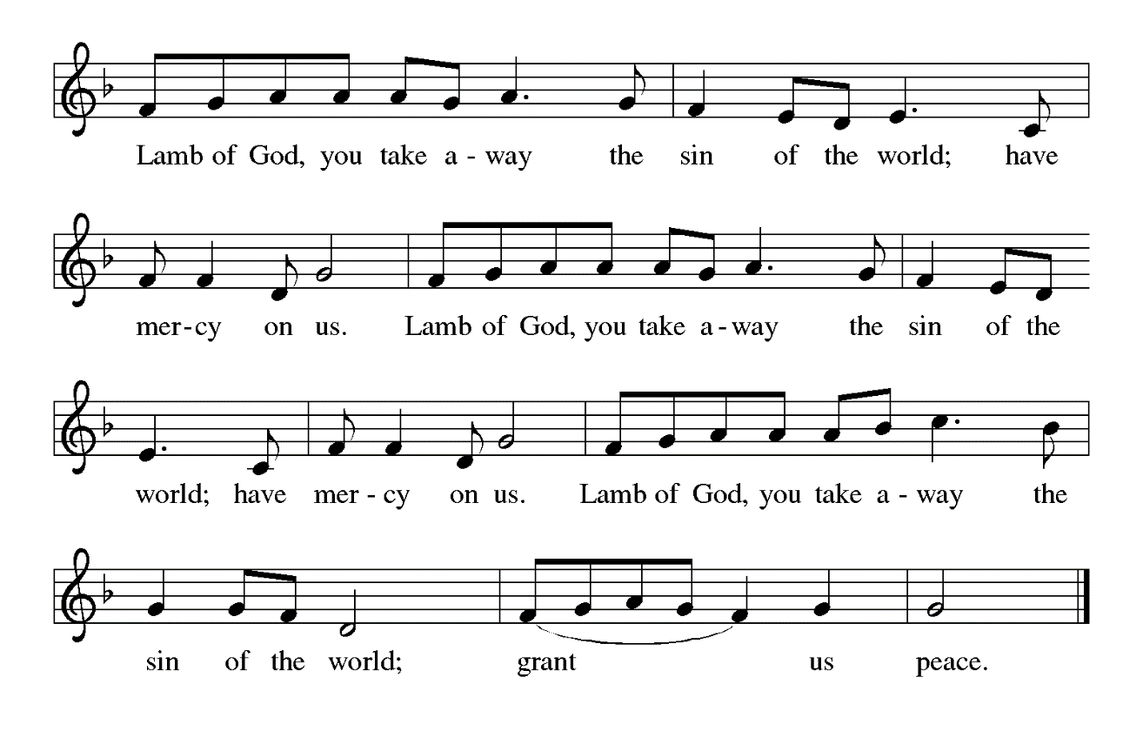

**HYMN DURING DISTRIBUTION 315 *How Good, Lord, to Be Here!***

**NSB 10 *Beautiful Savior (All My Days)***

**NSB 23 *Come and See***

**ELW 671 *Shine, Jesus, Shine***

*As you are able please rise*

**THE POST COMMUNION BLESSING**

P: The Body and Blood of our Lord Jesus Christ strengthen you and keep you in His

grace.

**C: Amen.**

**THE POST-COMMUNION PRAYER**

A: Let us pray. Holy God, we see Your glory in the face of Jesus Christ. May we who are

partakers of His Table reflect His life in word and deed, that all the world may know

His power to change and save. Grant this through Christ our Lord.

**C: Amen.**

**✠ SENDING ✠**

**THE BENEDICTION**

P: The Lord bless you and keep you. The Lord make His face shine on you and be gracious

to you. The Lord look upon you with favor + and give you peace.

**C: Amen.**

P: We are an Easter people.

**C: And Alleluia is our song.**

P: Alleluia! Alleluia!

**C: Alleluia! Alleluia!**

P: The author of Ecclesiastes writes:

For everything there is a season, and a time for every matter under heaven.

A: A time to be born and a time to die.

**C: A time to plant and a time to pluck up what is planted.**

A: A time to break down and a time to build up.

**C: A time to weep and a time to laugh.**

A: A time to mourn and a time to dance.

**C: A time to keep silence and a time to speak.**

P: As a sign of our repentance, we now say Farewell to the Alleluia until our rejoicing at

the resurrection of our Lord.

**THE SENDING HYMN 318 *Alleluia, Song of Gladness***

A: How good it is for us to be here.

**C: Amen! Alleluia!**

A: And we have seen the glory of the Lord.

**C: And we are all being transformed from one degree of glory to another.**

A: It is by God’s mercy that we are engaged in this ministry, so go in peace and courage

to love and serve the Lord. Alleluia, alleluia!

**C: Thanks be to God! Alleluia! Alleluia!**

**POSTLUDE**

**✠ *To God Alone Be Glory* ✠**

The Meditations are from *Luke. A Commentary for Preaching and Teaching.* Fred B.

Craddock. (Nashville: John Knox Publishing, 1990) 134-35; and *Sundays and*

*Seasons Online.* Copyright 2022 Augsburg Fortress.

The “Farewell to Alleluia” rite is used by permission from the Indiana-Kentucky Synod

*Sanctus* Newsletter, February 2010.

**ANNOUNCEMENTS**

**Please remember to mail your offering to the Church Office** at 818 Franklin Street, Michigan City, IN 46360**.** Another alternative is to give on-line through Tithe.ly. Please see your closure letter for information on how to set up a Tithe.ly account.

**St. Paul Members are reminded to have** a loved one contact the office if you are hospitalized. Many times, the Pastor doesn’t know someone is in the hospital. If you call and leave a message, please tell us which hospital the patient is at.

**Birthdays: Ken Baker (3/4); Gail Leffew (3/6)**

**PRAYER CONCERNS:** Jeanie Boatman Shepple, Nolan Wilson, Debbie Martin, Mark Tannehill, Brian Wiseman, Kathy Stein, Danielle Schnell, Jan Paholski, Laura Dovey, and Grace Romine.

**OFFICE HOURS:** Libby will be in the office on Mondays, Wednesdays, and Fridays; volunteers will cover Tuesdays and Thursdays.

Monday & Wednesday 8:00 a.m. – 5 p.m.

Tuesday & Thursday 9:00 a.m. – 12:00 p.m.

Friday 8:00 a.m. – 12:00 p.m.

**If you are listening to the worship broadcast on the radio and would like to watch the Sunday morning service live stream follow these steps:**

(1) If you have You Tube available on your TV, search for

**St. Paul Lutheran Church Michigan City, IN.**

(2) The direct link on the computer is

https://www.youtube.com/channel/UC5AIPNaKr3QN50984jGOa1g.

   (3) This link is also on the main page of the church’s website in

the church section and will continue to be posted weekly on the St.

Paul Facebook page.

And it will always be available on the radio broadcast Sunday mornings at 11:00 a.m.

on WEFM (95.9), and on the local cable access station #99 for the previous week’s

service on Sundays at 4:00 p.m. and the current service on Wednesdays at 7:00 p.m.

and Fridays at 8:30 p.m.

**Next Sunday’s lessons are Deuteronomy 26: 1-11; Psalm 91: 1-2, 9-16; Romans 10:**

**8b-13; Luke 4: 1-13** for those of you who like to study them in advance.

**To send e-mail to the church office**, please use the following addresses:

Pastor Mark Reshan: seniorpastor@stpaulmichigancity.com

Church Office Secretary (Libby Pollock): churchsecretary@stpaulmichigancity.com

Church Treasurer (Karen Fleming): finance@stpaulmichigancity.com

**The Good News Newsletter**: If you have an article or anything you want included in **The Good News** please send it to the following e-mail address: splcgoodnews@gmail.com. Pastor Pamela Thiede will be using this e-mail address to assemble **The Good News** each month. The deadline for getting information to Pastor Pamela will be the 20th of each month.

**Worship Attendance:**

**Saturday , February 22, 2025 @ 4:00 p.m. 24**

**Sunday, February 23, 2025 @ 9:00 a.m. 66**

**TOTAL 90**

**Copies of the minutes from the January 23, 2025 Church Council meeting are on the back table in the upper Narthex. They were approved by the council via email. There were no Council meetings in the months of November or December, 2024.**

**WINTER BIRTHDAYS:**

Did you observe a birthday during December ’24, January ’25 or February ‘25? If so, come join us during the Coffee Hour on today, March 2nd, 2025. We will be celebrating all the people who turned 1 year older during that time. All you need to do is come down to the St. Paul Room after the 9am service today and we will celebrate you!

**FYI:**

In response to the ever rising costs for postage we will be putting your copy

of the “Good News” in your hanging file folder in the narthex each month

from now on. Those of you who are unable to attend services on a regular

basis may still receive your copies through your email address or in the

U.S. mail. If you normally receive your copy of the newsletter via your

email address anyway, nothing will change for you. Thank you so much for

your understanding and cooperation!

**MISSION OF THE MONTH FOR MARCH 2025:**

We will be supporting The Social and Learning Institute as our Mission of the Month for March. The Institute has been serving LaPorte County since 1976 by helping individuals with developmental disabilities expand their minds, learn important life skills and recognize their worth through a structured balance of socialization and learning activities. If you would like to make a monetary donation, please make checks out to St. Paul and mark it for the March mission and place in the offering plate. Noisy coin offering will also go to support the monthly mission. The Institute also has an Amazon wish list of classroom supplies. When ordering from the wish list, select Abby Hinsch LaPorte, IN as the shipping address and items will be delivered directly to the Institute. If you prefer to shop in person, items can be placed in the bin in the Narthex.

**Wishlist URL (also available on our Facebook page; note: the last 3 characters are zero f zero):** [**https://shorturl.at/xg0f0**](https://shorturl.at/xg0f0)

**Items needed:**

**Personal Care:** Facial tissues w/ lotion, 2-ply toilet paper, band aids, first aid kits

**Cleaning**: Sweeper wet mopping pad refills, Lysol disinfectant spray or wipes, 30 gallon and kitchen sized drawstring trash bags, nitrile gloves

**Games/Toys:** Magnatiles, board games, stress balls or squishy toys, Montessori learning toys, sensory toys

**Classroom:** Colored cardstock, construction paper, crayons, Elmer’s liquid glue or glue sticks, retractable permanent markers, Post-it pop up notes, bulletin board supplies (paper, boarders, letters, mounting tape)

**ACTIVITIES, EVENTS & MEETINGS**

**MARCH 2025**

**Saturday,** March 1, 2025 @ 4:00 p.m. **Transfiguration** Worship Service

**Sunday,** March 2, 2025 @ 9:00 a.m. **Transfiguration** Worship Service

@ 10:00 a.m. Winter Birthdays at Coffee Hour/St. Paul Room

**Wednesday,** March 5, 2025 @ **10:00 a.m.** **ASH WEDNESDAY** Worship Service

@ 5:30 p.m. Choir Rehearsal/Sanctuary

@**7:00 p.m. ASH WEDNESDAY** Worship Service

**Thursday,** March 6, 2025 Faith Circle/Green Room

**Saturday,** March 8, 2025 @ 4:00 p.m. 1st Lent Worship Service

**Sunday,** March 9, 2025 @ 9:00 a.m. 1st Lent Worship Service

**Monday,** March 10, 2025 @ 1:00 p.m. Hope Circle/Green Room

**Tuesday,** March 11, 2025 **@ 11:00 a.m. – close GIVE BACK at Holly’s Restaurant & Pub**

@ 7:00 p.m. Estuary/Luther House

**Wednesday,** March 12, 2025 @ 9:15 a.m. Bible Study/Luther House

@ 10:00 a.m. God’s Purls/St. Paul Room

@ 4:30 p.m. Choir Rehearsal/Sanctuary

@6:00 p.m. **Lenten Service**

**Saturday,** March 15, 2025 @ 4:00 p.m. 2nd Lent Worship Service

**Sunday,** March 16, 2025 @ 9:00 a.m. 2nd Lent Worship Service

**Wednesday,** March 19, 2025 @ 9:15 a.m. Bible Study/Luther House

@ 10:00 a.m. God’s Purls/St. Paul Room

@ 4:30 p.m. Choir Rehearsal/Sanctuary

@ 6:00 p.m. **Lenten Service**

**Saturday,** March 22, 2025 @ 4:00 p.m. 3rd Lent Worship Service

**Sunday,** March 23, 2025 @ 9:00 a.m. 3rd Lent Worship Service

**Monday,** March 24, 2025 @ 2:00 p.m. Finance Committee Mtg./Luther House

@ 3:00 p.m. Executive Board Committee Mtg./Luther House

**Wednesday,** March 26, 2025 @ 9:15 a.m. Bible Study/Luther House

@ 10:00 a.m. God’s Purls/St. Paul Room

@ 4:30 p.m. Choir Rehearsal/Sanctuary

@6:00 p.m. **Lenten Service**

**Thursday,** March 27, 2025 @ 5:30 p.m. Church Council Mtg./Luther House

**Saturday,** March 29, 2025 @ 4:00 p.m. 4th Lent Worship Service

**Sunday,** March 30, 2025 @ 9:00 a.m. 4th Lent Worship Service

Thank$ for $haring

Thank you for all who participate in our Give Back days! On January 7, 2025 we met at Holly’s and we earned $235. Our next Give Back is coming up on Tuesday, March 11 at Holly’s.  Here are two coupons: one for you and one for a friend.

