THE EPIPHANY OF OUR LORD
January 4, 2026

In choosing to be born for us, God chose to be known by us. He therefore reveals himself in this way, in order that this great sacrament of his love may not be an occasion for us of great misunderstanding.
Today the magi find, crying in a manger, the one they have followed as he shone in the sky. Today the magi see clearly, in swaddling clothes, the one they have long awaited as he lay hidden among the stars.
Today the magi gaze in deep wonder at what they see: heaven on earth, earth in heaven, humanity in God, God in humanity, one whom the whole universe cannot contain now enclosed in a tiny body. As they look, they believe and do not questions, as they symbolic gifts bear witness: incense for God, gold for a king, myrrh for one who is to die ...

Peter Chrysologus, fifth century

Matthew's account is a dramatic presentation of the truth that is spoken in the reading from Ephesians: that the Gentiles are "heirs with us, members of the same body," and partakers of the promise in Christ Jesus. Traditionally, the Gentiles were excluded from the promise to Israel through Abraham. Thus they were thought to be alienated from God. Matthew's magi represent the Gentiles—they come from the East and they receive a revelation from nature—and they are portrayed as the first to pay homage to the king of the Jews. The impenetrable wall between Jew and Gentile has been overcome. God's salvation is for all the world. Epiphany is a celebration of the unfathomable gift of the birth of Jesus—and of the new possibilities that exist for the human race because of this gift of God to us.

Kathleen Cannon, O.P.

The star is seen by the magi; where Herod is, it is not seen; it is seen again where Christ is, and it shows the magi the way. Therefore this star is the way, and the way is Christ: for in the mystery of the incarnation, Christ is a star. For He himself is the bright and morning star. He shows us himself therefore by his own light.

Ambrose
Fourth century

In the Name of Jesus

INTRODUCTION

Epiphany means "manifestation." On this day we celebrate the revelation of Christ to the Gentiles—that is, to all nations. Some Christian traditions celebrate three great epiphanies on this day: the magi's adoration of the Christ child, Jesus' baptism in the Jordan River, and his first miracle, in which he changes water into wine. The word and sacraments are for us the great epiphany of God's grace and mercy. We go forth to witness to the light that shines brightly in our midst.

GATHERING

PRE-SERVICE MUSIC Mourning Into Dancing New Song Praise Band

ANNOUNCEMENTS

As you are able please rise

AN EPIPHANY DIALOGUE

P: We give thanks on this holy day, adorned with epiphanies: for the star that led the magi to the
manger,

C: that the nations may see the light of Christ;

P: for the water turned to wine at Cana’s wedding,

C: that the people taste the goodness of the Lord;

P: for the baptism of our Lord Jesus Christ in the Jordan,

C: that the Christ would save us all.

P: This is the day that the Lord has made,

C: we will rejoice and be glad in it. Alleluia.

THE GATHERING SONG 671 Shine, Jesus, Shine
THE GREETING

P: To the Church of God in this place, to those who are called to be saints, to all those who call
upon the name of our Lord Jesus Christ:

The grace of our Lord Jesus Christ, the love of God, and the communion of the Holy Spirit be
with you all.

C: And also with you.

THE KYRIE (see p. 3)
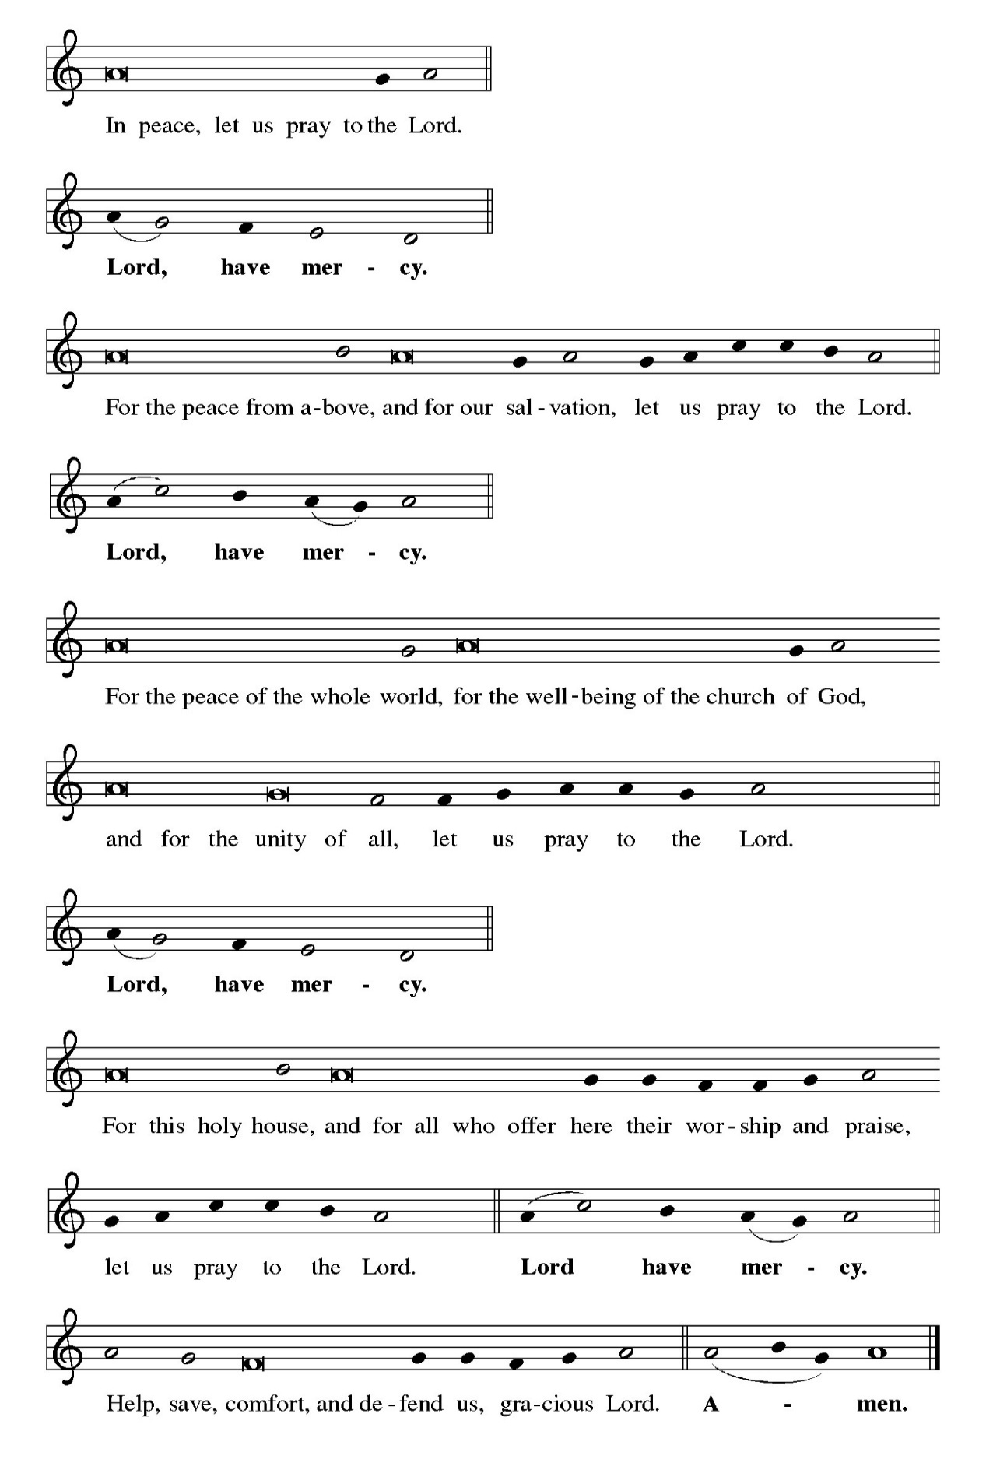
THE HYMN OF PRAISE (see p. 5)
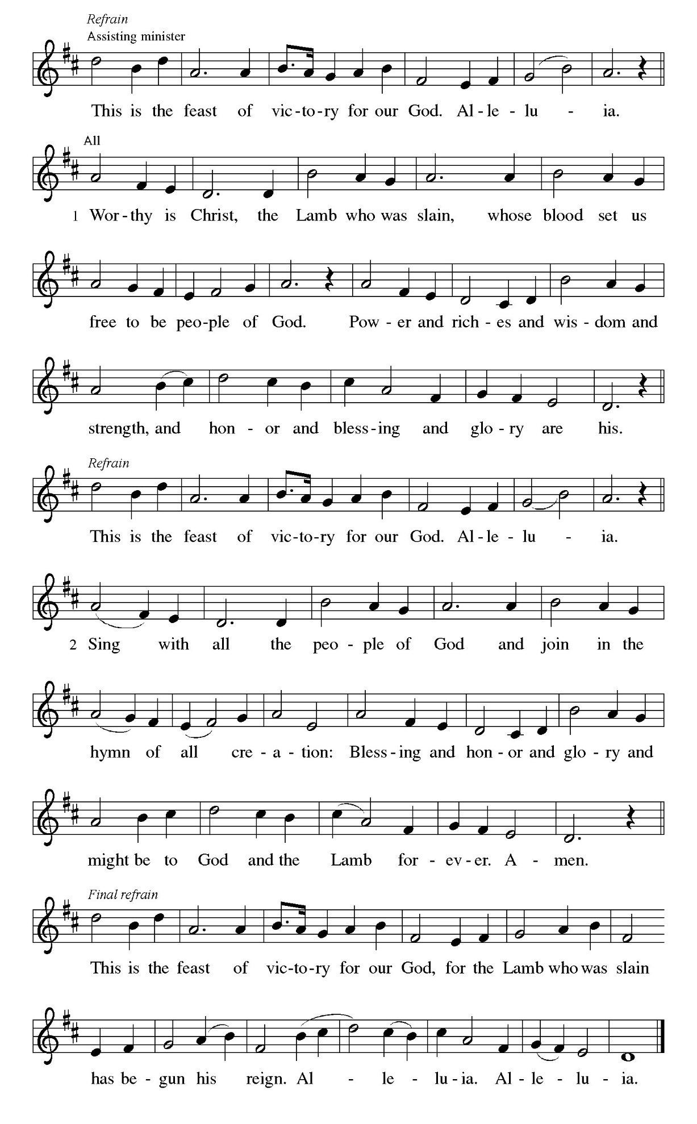
THE PRAYER OF THE DAY

P: The Lord be with you.

C: And also with you.

P: Let us pray. Everlasting God, the radiance of all the faithful people, You brought the nations
to the brightness of Your rising. Fill the world with Your glory, and show Yourself to all the
world through Him Who is the true Light and the bright Morning Star, Your Son, Jesus Christ,
our Savior and Lord, Who lives and reigns with You and the Holy Spirit, one God, now and
forever.

C: Amen.

The assembly is seated

WORD

FIRST READING Isaiah 60: 1-6

¹Arise, shine; for your light has come,
and the glory of the LORD has risen upon you.
²For darkness shall cover the earth,
and thick darkness the peoples;
but the LORD will arise upon you,
and His glory will appear over you.
³Nations shall come to your light,
and kings to the brightness of your dawn.
⁴Lift up your eyes and look around;
they all gather together, they come to you;
your sons shall come from far away,
and your daughters shall be carried on their nurses' arms.
⁵Then you shall see and be radiant;
your heart shall thrill and rejoice,
because the abundance of the sea shall be brought to you,
the wealth of the nations shall come to you.
⁶A multitude of camels shall cover you,
the young camels of Midian and Ephah;
all those from Sheba shall come.
They shall bring gold and frankincense,
and shall proclaim the praise of the LORD.

The Word of the Lord.

Thanks be to God.

THE PSALM: Psalm 72: 1-7, 10-14 Antiphon by Robert Hobby

Choir sings refrain first, followed immediately by the congregation
and as indicated
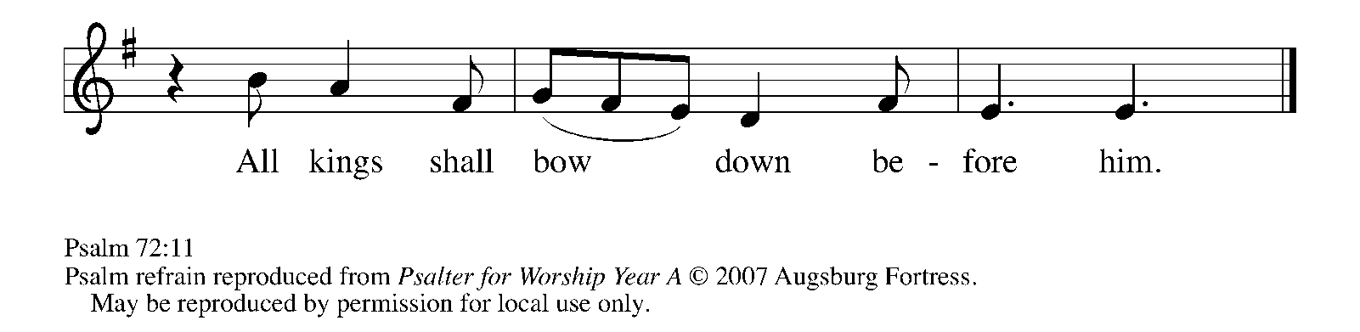
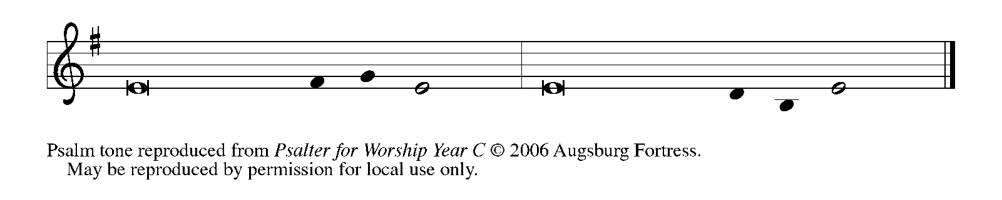

¹Give the king Your jus- | tice, O God,
and Your righteousness to | the king's son;

²that he may rule Your | people righteously
and the | poor with justice;

³that the mountains may bring prosperity | to the people,
and the | hills, in righteousness.

⁴Let him defend the needy a- | mong the people,
rescue the poor, and crush | the oppressor. REFRAIN

⁵May he live as long as the sun and | moon endure,
from one generation | to another.

⁶Let him come down like rain upon | the mown field,
like showers that wa- | ter the earth.

⁷In his time may the | righteous flourish;
and let there be an abundance of peace till the moon shall | be no more.

¹⁰May the kings of Tarshish and of the | isles pay tribute,
and the kings of Sheba and Seba | offer gifts. REFRAIN

¹¹May all kings bow | down before him,
and all the nations | do him service.

¹²For the king delivers the poor who cry out | in distress,
the oppressed, and those who | have no helper.

¹³He has compassion on the low- | ly and poor,
and preserves the lives | of the needy.

¹⁴From oppression and violence he re- | deems their lives,
and precious is their blood | in his sight. REFRAIN

SECOND READING Ephesians 3: 1-12

Though it had been hidden for years, Paul now reveals the secret that has shaped his apostolic witness: in Jesus Christ, God's salvation extends beyond the Jews to include all people. The light of Christ shines upon Jew and Gentile alike.

¹This is the reason that I Paul am a prisoner for Christ Jesus for the sake of you Gentiles--²for surely you have already heard of the commission of God's grace that was given me for you, ³and how the mystery was made known to me by revelation, as I wrote above in a few words, ⁴a reading of which will enable you to perceive my understanding of the mystery of Christ.
⁵In former generations this mystery was not made known to humankind, as it has now been revealed to His holy apostles and prophets by the Spirit: ⁶that is, the Gentiles have become fellow heirs, members of the same Body, and sharers in the promise in Christ Jesus through the gospel.
⁷Of this gospel I have become a servant according to the gift of God's grace that was given me by the working of His power. ⁸Although I am the very least of all the saints, this grace was given to me to bring to the Gentiles the news of the boundless riches of Christ, ⁹and to make everyone see what is the plan of the mystery hidden for ages in God who created all things; ¹⁰so that through the church the wisdom of God in its rich variety might now be made known to the rulers and authorities in the heavenly places.
¹¹This was in accordance with the eternal purpose that He has carried out in Christ Jesus our Lord, ¹²in Whom we have access to God in boldness and confidence through faith in Him.

The Word of the Lord.

Thanks be to God.

As you are able please rise

THE VERSE 301 Stanza 6 Bright and Glorious is the Sky

As a star, God’s holy Word
Leads us to our King and Lord;
Brightly from its sacred pages
Shall this Light throughout the ages
Shine upon our path of life,
Shine upon our path of life.

THE HOLY GOSPEL Matthew 2: 1-12

The rich symbolism of this story--the magi, a star in the east, Herod's plots--announces the prophetic hope for an epiphany or revelation that God has entered into our history as one of us.

P: The Holy Gospel according to St. Matthew, the second chapter.

C: Glory to You, O Lord!

In the time of King Herod, after Jesus was born in Bethlehem of Judea, wise men from the East came to Jerusalem, ²asking, "Where is the child who has been born king of the Judeans? For we observed His star at its rising, and have come to pay Him homage." ³When King Herod heard this, he was frightened, and all Jerusalem with him; ⁴and calling together all the chief priests and scribes of the people, he inquired of them where the Messiah was to be born. ⁵They told him, "In Bethlehem of Judea; for so it has been written by the prophet:
⁶'And you, Bethlehem, in the land of Judah,
are by no means least among the rulers of Judah;
for from you shall come a ruler
who is to shepherd My people Israel.' "
⁷Then Herod secretly called for the wise men and learned from them the exact time when the star had appeared. ⁸Then he sent them to Bethlehem, saying, "Go and search diligently for the child; and when you have found Him, bring me word so that I may also go and pay him homage."
⁹When they had heard the king, they set out; and there, ahead of them, went the star that they had seen at its rising, until it stopped over the place where the child was. ¹⁰When they saw that the star had stopped, they were overwhelmed with joy.
¹¹On entering the house, they saw the child with Mary His mother; and they knelt down and paid Him homage. Then, opening their treasure chests, they offered Him gifts of gold, frankincense, and myrrh. ¹²And having been warned in a dream not to return to Herod, they left for their own country by another road.

P: The Gospel of the Lord.

C: Praise to You, O Christ!

The assembly is seated

THE SERMON The Rev. Dr. Frederick Niedner, Jr.

Silence for reflection follows the sermon

As you are able please rise

THE HYMN OF THE DAY 303 Brightest and Best of the Stars of the Morning

Stanza 2—Women; Stanza 4—Men

THE NICENE CREED

A: God has made us His people through our Baptism into Christ. Living together in trust and
hope, we confess our faith.

We believe in one God,
the Father, the Almighty,
maker of heaven and earth,
of all that is, seen and unseen.

We believe in one Lord, Jesus Christ,
the only Son of God,
eternally begotten of the Father,
God from God, Light from Light,
true God from true God,
begotten, not made,
of one Being with the Father.
Through Him all things were made.
For us and for our salvation
He came down from heaven;
by the power of the Holy Spirit
He became incarnate from the virgin Mary, and was made man.
For our sake He was crucified under Pontius Pilate;
He suffered death and was buried.
On the third day He rose again
in accordance with the Scriptures;
He ascended into heaven
and is seated at the right hand of the Father.
He will come again in glory to judge the living and the dead,
and His kingdom will have no end.

We believe in the Holy Spirit, the Lord, the giver of life,
Who proceeds from the Father and the Son.
With the Father and the Son He is worshiped and glorified.
He has spoken through the prophets.
We believe in one holy catholic and apostolic Church.
We acknowledge one Baptism for the forgiveness of sins.
We look for the resurrection of the dead,
and the life of the world to come. Amen

THE PRAYER OF THE CHURCH

A: God’s glory has been veiled in flesh. Our flesh has become a glorious epiphany. Let us
therefore present before the Lord of glory our gift of prayer for the Church, the world, and all
those in need.

A: For all who are on a journey to find the source of grace and forgiveness, that like the magi they
might be led to Christ, we pray:

C: Send forth Your light, O God.

A: For the mission of the Church, that like the holy star of Bethlehem, we might be a beacon of
hope, safety, and love for all who are seeking Your face, we pray:

C: Send forth Your light, O God.

A: For the dawning of the glory of God upon all dark places of hunger, disease, warfare,
oppression, and tyranny, we pray:

C: Send forth Your light, O God.

A: For this congregation, that we may continue to generously and faithfully lay the offerings of
our lives before the One born to save us, we pray:

C: Send forth Your light, O God.

A: For those who bear the burden of illness and long for healing, especially: Kevin Thiede;
Major Payne; Robert Bernth; Carl Wipperman; Chuck Payne; Martha Schroeder; Joyce
Stark; Jackie Gaines; David Weiss; Fred Weiss; Shirley Shikany Long; Shirley Freels;
John Bennitt; Catherine Lanigan; Debbie Martin; Christine Kiser; Tim Miller; and
Lucas Bradshaw that their health may be renewed, we pray:

C: Send forth Your light, O God.

A: That those celebrating birthdays, especially Susan Bagby; Fred Laborn; and JoAnn
Kring; and anniversaries, especially Dan and Andrea Ottersen may grow in
grace this day and every day, and may be filled with grace for the days ahead, we
pray:

C: Send forth Your light, O God.

A: In thanksgiving for all those who have borne Christ’s light, revealing His glory, and now rest
in God’s eternal peace, that we may follow their course until the day we stand with them as
one holy people, we pray:

C: Send forth Your light, O God.

P: O God of stars and journeys, You lead us day by day to the joyful vision of Your light. Move
us by the power of Your Word that we too might open our gifts for others and so receive in
our hearts the Child of Bethlehem. So may You be praised and adored through the same Jesus
Christ our Lord, in the Holy Spirit, this Day of Your Epiphany, now and forever.

C: Amen.

MEAL

THE PEACE

P: The peace of the Lord be with you always.

C: And also with you.
The assembly is seated

THE OFFERING

THE VOLUNTARY

As you are able please rise

THE PRESENTATION OF GIFTS 300 Stanzas 1, 3, 5 The First Noel
THE OFFERTORY PRAYER

A: Let us pray. God of mercy,

C: As the Magi offered gifts to the Christ Child, receive the treasures we offer to Your glory.
Through this Meal unite us as Your Body, that we may be a light to all nations; for the
sake of Him Who gave Himself for us, Jesus Christ our Lord. Amen.

THE GREAT THANKSGIVING

P: The Lord be with you.

C: And also with you.

P: Lift up your hearts.

C: We lift them up to the Lord.

P: Let us give thanks to the Lord our God.

C: It is right to give Him thanks and praise.

P: Holy One, the Beginning and the End, the Giver of life:
Blessed are You for the birth of creation.
Blessed are You in the darkness and in the light.
Blessed are You for Your promise to Your people.
Blessed are You in the prophets’ hopes and dreams.
Blessed are You for Mary’s openness to Your will.
Blessed are You for Your Son Jesus, the Word made flesh.

In the night ... “Do this for the remembrance of Me.”
As often as we eat ... we proclaim the Lord’s death until He comes.

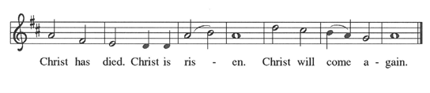
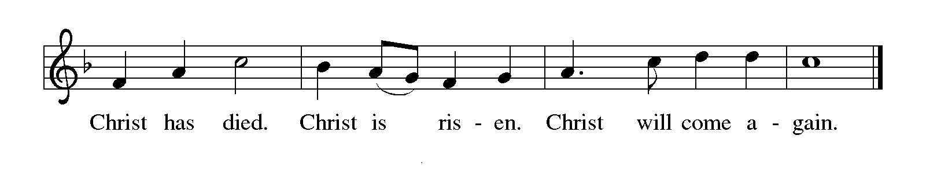

P: With this bread and cup we remember Your Word dwelling among us, full of grace and truth.
We remember our new birth in His death and resurrection.
We look with hope for His coming.

Holy God, we long for Your Spirit.
Come among us.
Bless this Meal.
May Your Word take flesh in us.
Awaken Your people.
Fill us with Your light.
Bring the gift of peace on earth.

All praise and glory are Yours, Holy One of Israel, Word of God incarnate, Power of the Most
High, one God, now and forever.
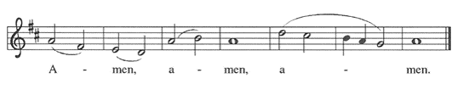
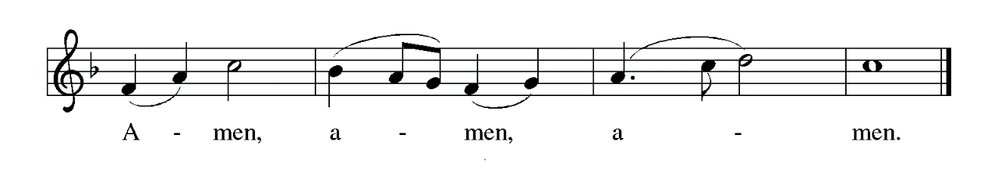
THE LORD’S PRAYER

P: Because in Christ we have received the Spirit of adoption, as daughters and sons of God, we
dare to pray:

C: Our Father in heaven, hallowed be Your name. Your Kingdom come. Your will be
done on earth as in heaven. Give us this day our daily bread, and forgive us our sins as
we forgive those who sin against us. Save us from the time of trial and deliver us from
evil, for the Kingdom, the power, and the glory are Yours, now and forever. Amen.

INVITATION TO THE MEAL

P: Behold the true Light of the world, the Beloved of God, anointed by the Spirit. Blessed are
those who are called to the Supper of the Lamb. God’s holy gifts for God’s holy people. Come,
for all is now ready.

The assembly is seated

THE DISTRIBUTION (see p. 14)

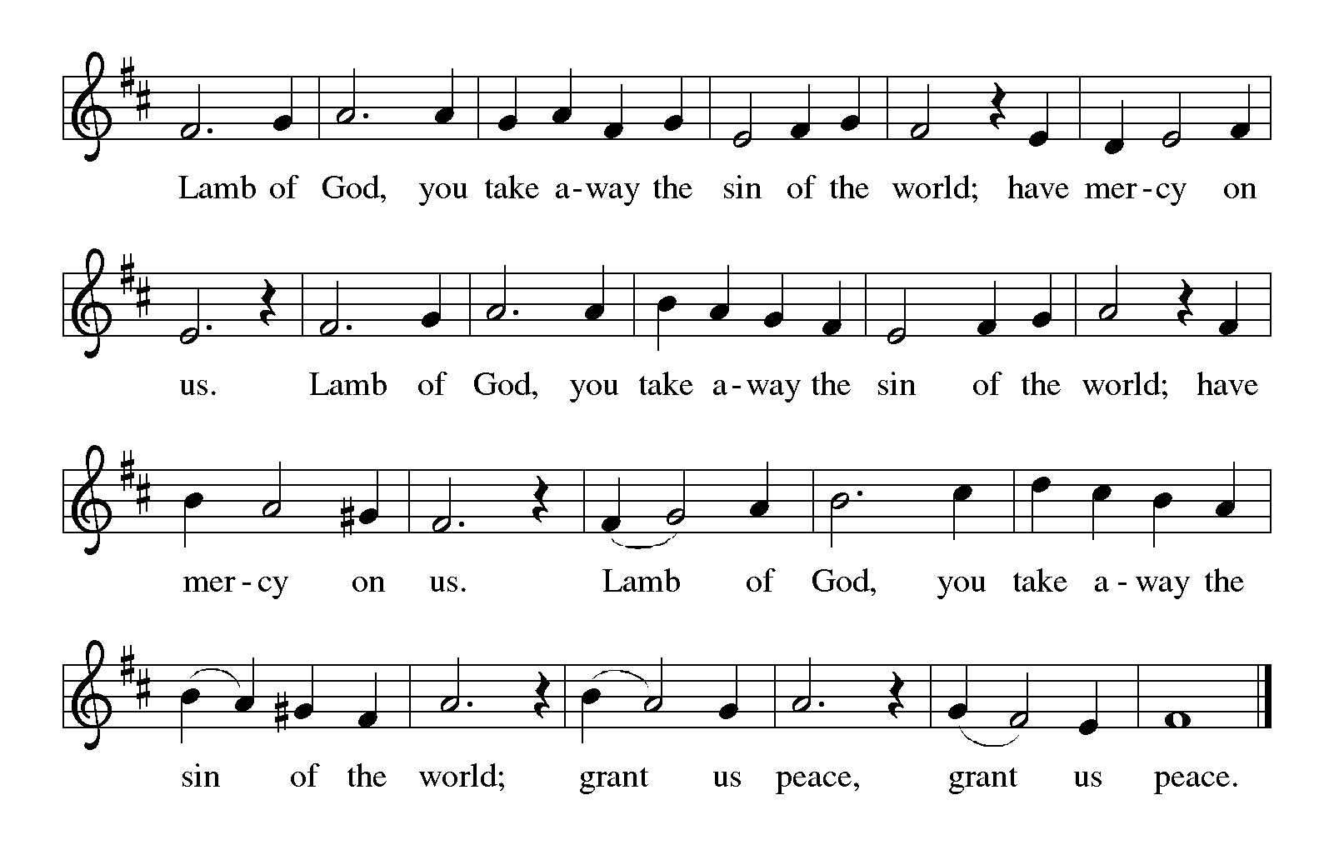
HYMN DURING DISTRIBUTION 815 I Want to Walk as a Child of the Light
ELW 295 Of The Father’s Love Begotten
ELW 294 In the Bleak Midwinter
ELW 510 Word of God, Come Down on Earth

THE POST-COMMUNION BLESSING
P: The Body and Blood of our Lord Jesus Christ strengthen you and keep you in His grace.
C: Amen.
THE POST-COMMUNION PRAYER

A: Let us pray. Gracious God, You look upon us in love and refresh us through the gifts of bread
and wine. Send us out, reflecting the light of Your grace, to tell the story of Jesus Christ, our
bright Morning Star.

C: Amen.

SENDING

THE BENEDICTION

P: Almighty God: Father, Son, and Holy Spirit bless you now and forever.

C: Amen.

SENDING SONG NSB 23 Come and See

THE DISMISSAL

A: You are servants of God; you are light to the nations.

Go in peace. Serve the Lord.

C: Thanks be to God!

POSTLUDE

To God Alone Be Glory

The Meditation is from Sundays and Seasons Online. Copyright Augsburg Fortress 2018.

The Prayers, Introduction to the Lord’s Prayer, and Invitation to the Meal are adapted from Prayers
for Sundays and Seasons. Year A. Peter J. Scagnelli. (Chicago: Liturgy Training Publications, 1998) 24-25.

The order of service, “We Too Have a Star to Guide Us” is from Sundays and Seasons. Year C.
2018 by permission of Augsburg Fortress.

The Eucharistic Prayer is adapted from Eucharistic Prayers. Samuel Wells and Abigail Kocher.
(Grand Rapids: Eerdmann’s Publishing Company, 2016) 74-75.

ANNOUNCEMENTS

Please remember to mail your offering to the Church Office at 818 Franklin Street, Michigan City, IN 46360. Another alternative is to give on-line through Tithe.ly. Please see your closure letter for information on how to set up a Tithe.ly account.

St. Paul Members are reminded to have a loved one contact the office if you are hospitalized. Many times, the Pastor doesn’t know someone is in the hospital. If you call and leave a message, please tell us at which hospital the patient is located.

BIRTHDAYS: JoAnn Kring (1/6); Fred LaBorn (1/6); Susan Bagby (1/9)
ANNIVERSARIES: Daniel & Andrea Ottersen (1/3)

PRAYER CONCERNS: Kevin Thiede; Robert Bernth; Barry Anderson; John Bennitt; Sarah McNabb; Debbie Martin; Mark Tannehill; Kathy Stein; Jan Paholski; Laura Dovey; Grace Romine; Bill Hazelgrove; Al Levenhagen; Carl Wipperman; Major Payne; Carol Hazelgrove; Allen Sydow; Elizabeth Sanders and Tim Miller.

OFFICE HOURS: Libby will be in the office on Mondays, Wednesdays, and Fridays; volunteers will cover Tuesdays and Thursdays.

Monday & Wednesday 8:00 a.m. – 5 p.m.
Tuesday & Thursday 9:00 a.m. – 12:00 p.m.
Friday 8:00 a.m. – 12:00 p.m.

If you are listening to the worship broadcast on the radio and would like to watch the Sunday morning service live stream follow these steps:

(1) If you have You Tube available on your TV, search for
St. Paul Lutheran Church Michigan City, IN.

(2) The direct link on the computer is https://
www.youtube.com/channel/UC5AIPNaKr3QN50984jGOa1g

(3) This link is also on the main page of the church’s website in
the church section and will continue to be posted weekly on the St.
Paul Facebook page.

And it will always be available on the radio broadcast Sunday mornings at 11:00 a.m.
on WEFM (95.9), and on the local cable access station #99 for the previous week’s
service on Sundays at 4:00 p.m. and the current service on Wednesdays at 7:00 p.m.
and Fridays at 8:30 p.m.

To send e-mail to the church office, please use the following addresses:

Pastor Mark Reshan: seniorpastor@stpaulmichigancity.com

Church Office Secretary (Libby Pollock): churchsecretary@stpaulmichigancity.com

Church Treasurer (Karen Fleming): finance@stpaulmichigancity.com

2026 Church Council:

Pastor – Mark Reshan

President – Donna Knoll

Vice President – Janet Bakken

Secretary – Judy Hunt

Treasurer – Karen Fleming

Members: Sue Koziel; Jim Schraidt; Trish Sprague; Bob Kiser; Barry Anderson; Pam Soule

Worship Attendance:

Wednesday, December 24, 2025 @6:00 p.m. 115

Thursday, December 25, 2025 @ 9:00 a.m. 40

Saturday, December 27, 2025 @ 4:00 p.m. 24
Sunday, December 28, 2025 @ 9:00 a.m. 56

TOTAL 235

Copies of the minutes from the December 18, 2025 Church Council meeting are on the back table in the upper Narthex. It was approved by the council via email.

The Good News Newsletter: If you have an article or anything you want included in The Good News please send it to the following e-mail address: splcgoodnews@gmail.com. Pastor Pamela Thiede will be using this e-mail address to assemble The Good News each month. The deadline for getting information to Pastor Pamela will be the 20th of each month.

Sunday’s lessons are Isaiah 42: 1-9; Psalm 29; Acts 10: 34-43; and
Matthew 3: 13-17 for those of you who like to study them in advance.

MISSION OF THE MONTH FOR JANUARY 2026
We have many dedicated Meals on Wheels volunteers within our church family. Their unwavering dedication not only ensures people in our community receive safe and nutritious meals, but the delivery also provides a wellness check, ensuring their safety and well-being. Meals on Wheels has a current need to replace their essential food delivery cases. Black (cold) cases can be sponsored for just $200, and Blue (hot) cases can be sponsored for $500. Every contribution helps ensure their clients receive meals each day. Case sponsorship includes sponsor’s name on the case, recognizing their support and commitment for years to come. Based on the total amount received, we will sponsor as many cases as possible in honor of our St. Paul Volunteers and Congregation. Please make checks payable to St. Paul and place in the offering. Noisy coin offering will also go towards the monthly mission. Thank you for your unwavering and continuous support of Meals on Wheels!

SNOW EMERGENCY LIST
This is a reminder of where to turn to learn if worship has been canceled because of inclement weather conditions. There are two ways to learn about the status of the service.
First, you may turn to our church and school Facebook page: https://www.facebook.com/stpaulmichigancity/ for updated announcements. Or, perhaps most quickly and easily, you may call the church office number (219-874-7293) and press the “#” key and you will hear a recording about our “open/closed” status.

HELP NEEDED FOR OUR LOCAL SALVATION ARMY
Due to the pause taken by all the programs sponsored by SNAP, our local Salvation Army has been swamped with people needing help. All of the items placed in the grocery store cart located on the upper southwest corner of the outer Narthex is taken to our Michigan City Salvation Army location. The cart has a large hippo asking you to help “fill ‘er up!” Whatever you can do to help is greatly appreciated.

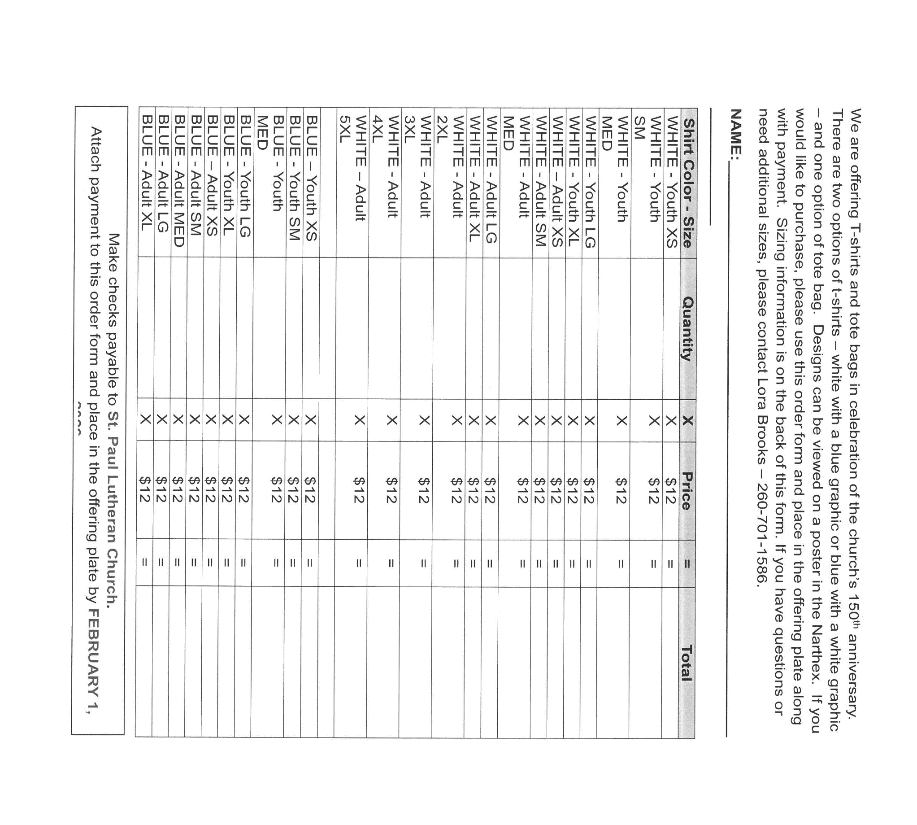

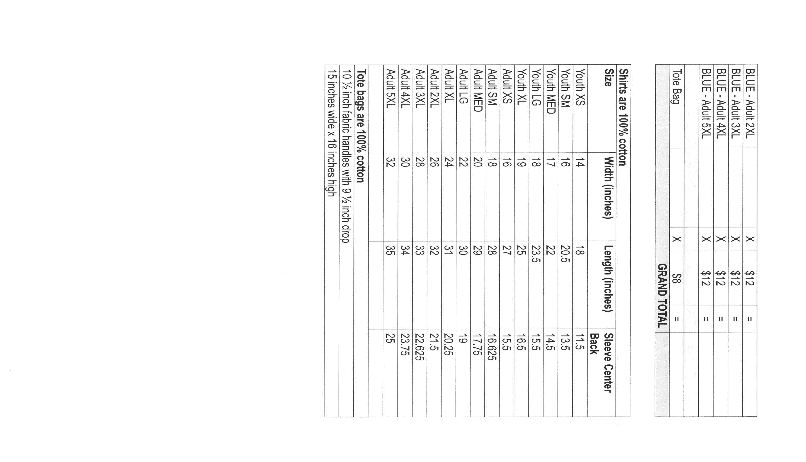

ACTIVITIES, EVENTS & MEETINGS
January 2026

Saturday, January 3, 2026 @ 4:00 p.m. Epiphany Worship Service/Sanctuary

Sunday, January 4, 2026 @ 9:00 a.m. Epiphany Worship Service/Sanctuary with
Coffee after/St. Paul Room
Wednesday, January 7, 2026 @ 9:15 a.m. Bible Study/Luther House
@ 10:00 a.m. God’s Purls/St. Paul Room
@ 10:00 a.m. – 10:00 p.m. GIVE BACK at 5 GUYS
@ 4:30 p.m. Choir Rehearsal/Sanctuary
Thursday, January 8, 2026 Faith Circle ?
Saturday, January 10, 2026 @ 4:00 p.m. Baptism of Our Lord Worship Service/

Sunday, January 11, 2026 @ 9:00 a.m. Baptism of our Lord Worship Service/ Sanctuary with Coffee after/St. Paul Room
Monday, January 12, 2026 @ 1:00 p.m. Hope Circle/Green Room
Wednesday, January 14, 2026 @ 9:15 a.m. Bible Study/Luther House
@10:00 a.m. God’s Purls/St. Paul Room
@3:30 p.m. Worship & Music Mtg./Luther House
@ 4:30 p.m. Choir Rehearsal/Sanctuary
Saturday, January 17, 2026 @ 4:00 p.m. 2 Epiphany Worship Service/Sanctuary

Sunday, January 18, 2026 @ 9:00 a.m. 2 Epiphany Worship Service/Sanctuary with Coffee after/St. Paul Room
Monday, January 19, 2026 @ 2:00 p.m. Finance Comm. Mtg./Luther House
@ 3:00 p.m. Executive Board Mtg./Lither House
Wednesday, January 21, 2026 @ 9:15 a.m. Bible Study/Luther House
@ 10:00 a.m. God’s Purls/St. Paul Room
@ 4:30 p.m. Choir Rehearsal
Thursday, January 22, 2026 @ 3:00 p.m. Church Council Mtg./St. Paul Room
Saturday, January 24, 2026 @ 4:00 p.m. 3 Epiphany Worship Service/Sanctuary

Sunday, January 25, 2026 @ 9:00 a.m. 3 Epiphany Worship Service/ Sanctuary with Coffee after/St. Paul Room
Wednesday, January 28, 2026 @ 9:15 a.m. Bible Study/Luther House
@10:00 a.m. God’s Purls/St. Paul Room
@ 4:30 p.m. Choir Rehearsal/Sanctuary
Saturday, January 31, 2026 @ 4:00 p.m. 4 Epiphany Worship Service/Sanctuary

Thank$ for $haring
Thank you to all who participate in our Give-Back opportunities each month where we earn $$ to add to our Mission of the Month donations from our congregation to those in our community who need our help!
In October we earned $250 from our Give Back at Galveston Steak House. And in November we earned $87 at Swingbelly’s. This month we went to Holly’s Restaurant & Pub on Tuesday, December 9, 2025 and we earned $162. On Wednesday, January 7, 2026 we’re going to meet at Five Guys for our GIVE BACK from 10am—10pm. Here are two coupons—one for you and one for a friend.

