
December, 2025
MARK: MY WORDS

We do not like to wait. Whether it is our impatience at the driver ahead of us not moving quickly enough when the light turns green, web pages are slow in loading on our phones or home computers, or having to stay on the line to speak to an actual person for customer service, we want things to be done quickly.
That is at least one of the reasons that Advent is probably among people’s least favorite seasons of the church year. Everything around us screams, “Christmas!” Black Friday sales occur earlier and earlier each year; light and trees and decorations go up well before Thanksgiving; radio stations play holiday music endlessly by the end of October. All condition us to want to get to December 25 as fast as possible.
In addition, the tone of the season remains somewhat somber. Many of us growing up recall that the color for Advent was purple, not the blue we use today. This linked these four weeks to the six weeks of Lent, the most penitential time of the church year. We were not ready to celebrate Christmas yet because we first needed to “prepare the royal highway,” in the words of a well-known Advent hymn, for Jesus to be born again into our hearts and lives.
In the rush of shopping and baking and wrapping and decorating, who has time for self-reflection and examination? Whether we want it or not, we get swept up into the frantic rhythm of the culture around us, filled with anxiety and fear that we will not get all of our preparations completed, or that the gifts we buy will not be sufficient or appreciated, or that the family gatherings will not live up to the perfection portrayed in the countless Hallmark Christmas movies that run on a loop.
But wait we must. In these days when we are plunged into darkness earlier than any other time of year, we are called to discern those shadows in our own hearts and lives in addition to the sin and evil that surrounds us in the world. That takes time and patience, habits and disciplines that we must learn anew each year.
To (again) quote from our good friend Fred Niedner, “In the darkest days of the calendar, when night has swallowed up day, it is appropriate to ponder the meaning of darkness in nature, in the events which cast a pall over the world and humankind, and in the shadow which is part of each of us. Hence, it is both a season of repentance, but also a season to pray, “Come quickly, Lord Jesus.” Healing and reconciliation can come from facing up to the darkness which is both around us and within us, and Advent offers the opportunity to work at that.
“He came. He comes. He will come again.” That is the framework around which these weeks are built. May God grant us a holy and faithful waiting, hoping, praying, and watching for the “advent” of the Lord Jesus now and in The End.


Saturday, December 20 Fourth Saturday in Advent 4:00 p.m.
Sunday, December 21 Fourth Sunday in Advent 9:00 a.m.

Wednesday, December 24 Christmas Eve 6:00 p.m.
Pre-service music @ 5:45 p.m.

Thursday, December 25 Christmas Day 9:00 a.m.

Saturday, December 27 The First Saturday after Christmas 4:00 p.m.
Sunday, December 28 The First Sunday after Christmas 9:00 a.m.


SENIOR COMMUNION

It has long been a tradition to hold a “Quiet/Senior Communion” service in Advent and Lent. Originally intended as a special service for those who were homebound or in nursing or assisted living facilities to attend worship, in recent years it has expanded to include all (not just “seniors”) who wish to gather for a meaningful spoken service and good food and fellowship afterward.
The service will be held on Wednesday, December 17, at 10:00 a.m. Following the service, the Altar Guild will provide their usual delicious luncheon in the St. Paul Room. That gathering after the service is always a warm time of fellowship for those who attend, and we are thankful that we will still be able to provide an opportunity for worshipers to experience that fellowship. An invitation letter will go out in early December, but all are welcome. Mark the date and time on your calendar; we hope to see you on the 17th.



I will be taking some time off between Christmas Day and New Year’s Day to recharge for the season of Epiphany and then the busiest time of year as we enter Lent. As always, I am available by phone (630-450-1894) if there is a pastoral emergency.


CHRISTMAS DECORATIONS

We are blessed to have volunteers who are willing to organize and put up the beautiful decorations year after year for our celebration of Advent and The Twelve Days of Christmas. Many of them have been doing the same jobs for a long time, and we are so grateful to them for their selfless service at a time of year when everyone is busy and weary.

Christmas Tree Bob and Karen Kiser;
Casey, Kelly and Brad Neulieb
Poinsettia plants Sue Koziel, Karen Steinborn

Large wooden cross Janet Bakken; Sue Koziel; Karen Steinborn

Garland (outer narthex and Communion railings) Karen Steinborn; Sue Koziel

Window treatments (nave and outside) Sue Koziel, Karen Steinborn

Outside lights and wreaths Tina Zimmerman-Putnam
and Serviscape crew

Upper narthex nativity scene and creche Pastor Mark Kloess; Jary Tannehill;
Stacie Crozier

It is easy to assume these decorations will always be there at the right time and in the right way. We forget how much time and effort it takes to get them out of storage, put them up, clean up afterward, and then take them down after The Epiphany and return them to storage. Normally we list those generous and hard workers after the decorations have come down; but this year it seemed good to honor them beforehand. When you see these good folks, please be effusive in your thanks for their work and the blessing we all receive from the decorated worship space.



Some time ago, we had volunteers to read the lessons at worship. When we had some trouble with scheduling, we decided to have the assisting minister read them; this can deprive a person from offering their gift to our worship service. After the first of the year, we will offer that opportunity to read once again. If you would like to participate, please call the church office; and we will make out a list for the upcoming liturgies. You will receive the readings well in advance so that you may practice and look them over before the service. Thank you for your willingness to serve.

On Reformation weekend and again on November 16 we were blessed to receive six new members into our community:

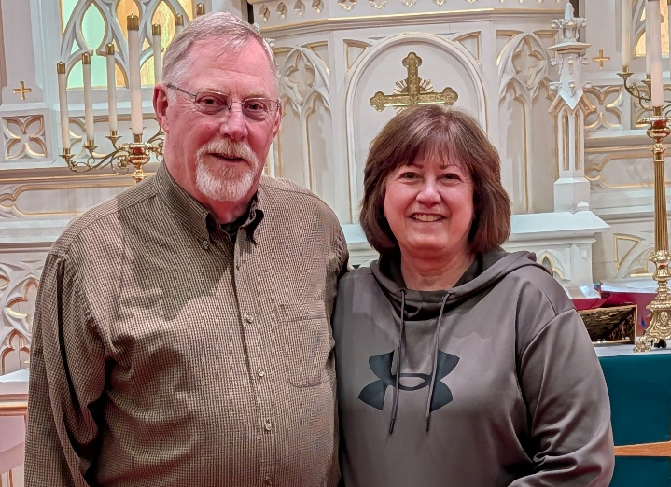
Marshall and Belinda Schnick, former members who returned after some time at Bethany Lutheran in La Porte.

Aydan Dettman, grandson of Dick and Cheryl Dettman, former members of St. Paul. We hope to include his picture next month.

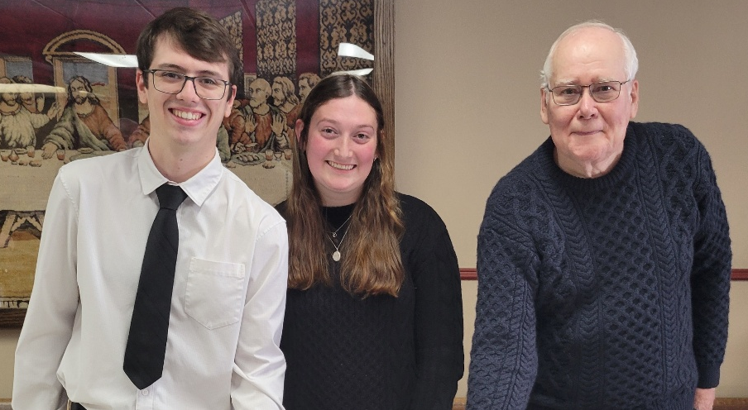
Left to right: Tyler Albano, son of Jim and Melanie, who joined last year; Jerzy Streiter, Tyler’s significant other; David Jocelyn, formerly a member of St. Andrews Episcopal Church in Michigan City

We officially welcomed them with a coffee hour reception on November 16. Please greet them warmly into our fellowship. We look forward to benefitting from their gifts and passions for our ministry.
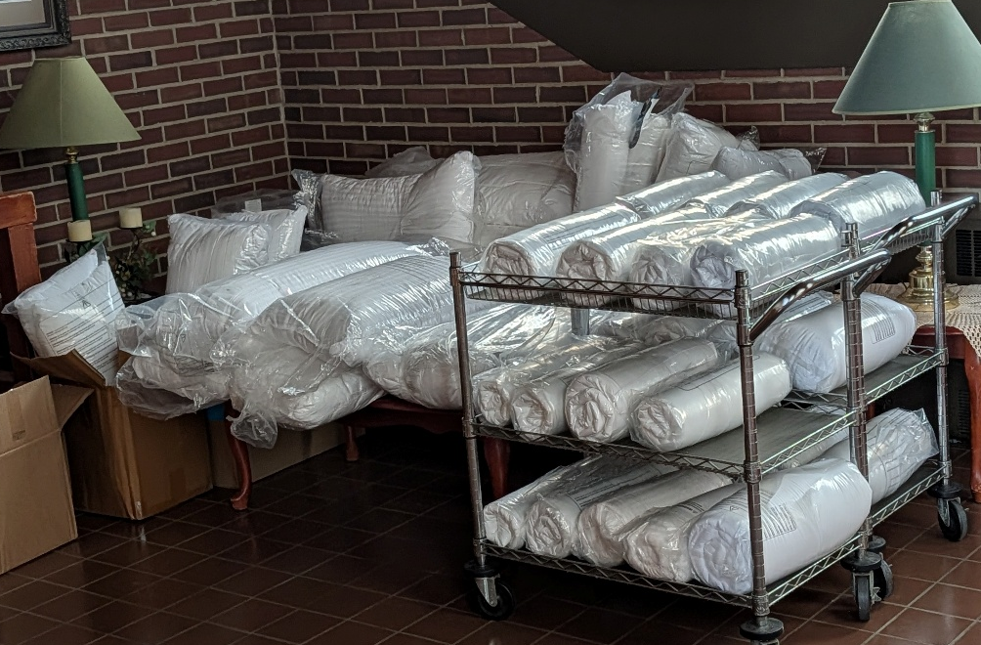

A WONDERFUL DONATION

Angela Cook and her husband, Francisco Chavez, have been attending regularly and have expressed interest in joining the congregation. She works at a warehouse that was going to throw out a large number of new pillows and blankets. She saw that we were collecting them for our November mission of the month, Nest Community, and was able to secure them to donate them to the shelter. They are pictured here in the lower narthex before being taken to Harry Holtkamp and his staff. What a generous and wonderful gift! Thank you, Angela, for your help in aiding the homeless in our community.


SNOW EMERGENCY LIST

This is a reminder of where to turn to learn if worship has been canceled because of inclement weather conditions. There are two ways to learn about the status of the service.
First, you may turn to our church Facebook page for updated announcements: https://www.facebook.com/stpaulmichigancity/. Perhaps most quickly and easily, you may call the church office number (219-874-7293) and press the “#” key and you will hear a recording about our “open/closed” status.


OFFICE CLOSURES

The church office will close at 12 noon on Wednesday, December 24 and December 31, for Christmas Eve and New Year's Eve. The office will also be closed all day on Thursday, December 25 and January 1, for Christmas and New Year’s Day. The office will reopen as normal on Friday, December 26 and January 2. Happy holidays, everyone!



IN MEMORY OF NORMAN CARLSON, JR.
General Fund from David Carlson

IN MEMORY OF LARRY LITCHFORD
General Fund from Bob & Karen Kiser
Meals on Wheels from John & Amy VanGemeren, Barbara Varrow


December Birthdays December Anniversary
2 Paul Brooks 27 Mark & Mandy Robbins
Amy Maesch
Stephen Hapke
3 John VanGemeren
4 Pastor Mark reshan
6 Dawn Pagels
Donna Ottersen
8 Janelle Robinson
Judith Gleason
9 Pastor Pamela Thiede
12 Pamela Henderson
13 Douglas Kienitz
14 Karen Steinborn
15 James Summers
17 Carol Radke
20 Stephanie Serrano
22 Virgil Miller
26 Barbara Fulkerson
27 William Hackett
28 Benjamin Robbins
29 Sherry Payne



Long-Term Prayer List

Barry Anderson John Bennitt Robert Bernth
Lucas Bradshaw Laura Dovey Shirley Freels
Jess Kalvaitis Christine Kiser Bethany Manning
Debbie Martin Shirley McCarty Sarah McNabb
Jan Paholski Grace Romine Martha Schroeder
Jeanie Boatman Shepple Joyce Stark Kathy Stein
Mark Tannehill Kevin Thiede Kathy Thielman
David Weiss Fred Weiss Brian Wiseman



Monday 8:00 a.m. – 5 p.m.
Tuesday 9:00 a.m. – 12:00 noon
Wednesday 8:00 a.m. – 5 p.m.
Thursday 9:00 a.m. – 12 noon
Friday 8:00 a.m. – 12 noon

St. Paul Lutheran Church Staff
Pastor Rev. Mark Reshan
Secretary Libby Pollock
Accompanists Jary Tannehill, Mark Tannehill, Jacob Tannehill
Custodian Mark Kloess

Thank$ for $haring
This month, are going to Holly’s on Tuesday, December 9. Here are two coupons—one for you and one for a friend.

