ALL SAINTS’ DAY
November 7, 2021

Though not specifically labelled as such, the raising of Lazarus is the climactic “sign” within Jesus’ ministry in John. In this Gospel, the astounding things Jesus does are not “miracles,” not simply places where the general patterns of the world swerve wildly. Instead, they are revelations, signs that point beyond the astounding event itself to something else. More precisely, they point to someone else.
They testify to Jesus as the Son to whom the Father has given life (John 5:25-26). This scene points to Jesus’ own glorification through his death and resurrection (12:23). There too we will find a tomb, a stone, grieving women, the linen wrappings and face cloth. This means that if we focus on Lazarus being brought back to life and perhaps even wrestle with why others whom we love were not similarly brought back, we have missed the point rather badly.
This text is also not simply about how Jesus will raise us on the last day. This was Martha’s confession, and (though true) it was not sufficient. Jesus calls Lazarus out, like the good shepherd who calls his sheep and gives them life (10:3, 27-28). This is what Jesus does for all those who believe in him. Jesus has the power to give life now, because Jesus is the presence of God’s life become flesh for us.
Jesus raising Lazarus does not negate the promise of the day that is coming when all those in the tombs will hear his voice and come out (John 5:28), but it is not primarily about that claim. What it reveals is that Jesus is the one in whom there is life (1:4), the one who even now calls us out of all the dark and binding places of death (5:25).
In grief, people do not only need or want to know that Jesus is powerful enough to raise the dead. After all, then why didn’t Jesus do more to help their own family member, or to stop the monstrous daily march of death through our world? But Jesus is life itself; Jesus himself is resurrection’s defeat of death. Jesus is the place where death ends and everlasting life begins.
Without denying the eschatological promise of resurrection and death’s final elimination, the life of Jesus breaks into our present and transforms it. What we need to hear is that on both sides of the grave there is life for us because Jesus has been sent to call our names. On both sides of the grave Jesus is life for us.
This is what All Saints Day is for: not just to remember those from long ago or those whose deaths are still painfully near, and not just to point ahead to that ultimate promise of resurrection, though both of these are certainly part of this day and to be affirmed. More centrally, however, this day is about what all God’s saints have known and experienced, that here and now there is no death or grief or fear so deep and dark that the voice of Jesus cannot reach into it, call us out, and bring life.

Brian Peterson
In the Name of Jesus
INTRODUCTION

Of all three years of the lectionary cycle, this year's All Saints readings have the most tears. Isaiah and Revelation look forward to the day when God will wipe away all tears; in John's gospel, Jesus weeps along with Mary and all the gathered mourners before he demonstrates his power over death. On All Saints Day we celebrate the victory won for all the faithful dead, but we grieve for our beloved dead as well, knowing that God honors our tears. We bring our grief to the table and find there a foretaste of Isaiah's feast to come.
All Saints Day
The custom of commemorating all of the saints of the church on a single day goes back at least to the third century. All Saints Day celebrates the baptized people of God, living and dead, who make up the body of Christ. On this day or the following Sunday, many congregations will remember the faithful who have died during the past year. We will also give thanks for those saints who in the last year have been raised up from the waters of Baptism.
GATHERING

PRELUDE Ye Watchers and Ye Holy Ones Robert A. Hobby

ANNOUNCEMENTS

As you are able please rise

GATHERING HYMN 424 Ye Watchers and Ye Holy Ones page 11

THE GREETING AND PRAYER OF THE DAY

P: The grace of our Lord Jesus Christ, the love of God, and the communion of the Holy
Spirit be with you all.

C: And also with you.

P: Let us pray. Almighty God, You have knit Your people together in one communion in
the mystical body of Your Son, Jesus Christ our Lord. Grant us grace to follow Your
blessed saints in lives of faith and commitment, and to know the inexpressible joys You
have prepared for those who love You, through Jesus Christ, our Savior and Lord, Who
lives and reigns with You and the Holy Spirit, one God, now and forever.

C: Amen.

The assembly is seated

WORD

FIRST READING Isaiah 25:6-9

Isaiah sees a vision of the end of days, when the Lord will gather all God’s people on God’s holy mountain and will prepare for them a rich feast. At this banquet the Lord will wipe the tears from all eyes. And there will be no more sorrow, for God will destroy death itself.

On this mountain the LORD of hosts will make for all peoples
a feast of rich food, a feast of well-aged wines,
of rich food filled with marrow, of well-aged wines strained clear.
⁷And He will destroy on this mountain
the shroud that is cast over all peoples,
the sheet that is spread over all nations;
He will swallow up death forever.
⁸Then the Lord GOD will wipe away the tears from all faces,
and the disgrace of His people He will take away from all the earth,
for the LORD has spoken.
⁹It will be said on that day,
Lo, this is our God; we have waited for Him, so that He might save us.
This is the LORD for whom we have waited;
let us be glad and rejoice in His salvation.

The Word of the Lord.

Thanks be to God.

THE PSALM: Psalm 24 Read responsively
The earth is the LORD's and all that is in it,
the world and all who dwell therein.

²For it is He Who founded it upon the seas
and made it firm upon the rivers of the deep.

³ "Who can ascend the hill of the LORD
and who can stand in His holy place?"

⁴"Those who have clean hands and a pure heart,
who have not pledged themselves to falsehood, nor sworn by what is a fraud.

⁵They shall receive a blessing from the LORD
and a just reward from the God of their salvation."

⁶Such is the generation of those who seek Him,
of those who seek Your face, O God of Jacob.

⁷Lift up your heads, O gates; lift them high, O everlasting doors;
and the King of glory shall come in.

⁸ "Who is this King of glory?"
"The LORD, strong and mighty, the LORD, mighty in battle."

⁹Lift up your heads, O gates; lift them high, O everlasting doors;
and the King of glory shall come in.

¹⁰"Who is He, this King of glory?"
"The LORD of hosts, He is the King of glory."

SECOND READING Revelation 21:1-6a

Here is a vision of the new heaven and new earth in which God resides fully with God’s people so that mourning, despair, and pain have been eradicated. These renewing words from the God who spans all of time are trustworthy and true.

I saw a new heaven and a new earth; for the first heaven and the first earth had passed away, and the sea was no more. ²And I saw the holy city, the new Jerusalem, coming down out of heaven from God, prepared as a bride adorned for her husband. ³And I heard a loud voice from the throne saying,

"See, the home of God is among mortals.
He will dwell with them as their God;
they will be His peoples,
and God Himself will be with them;
⁴He will wipe every tear from their eyes.
Death will be no more;
mourning and crying and pain will be no more,
for the first things have passed away."
⁵And the One Who was seated on the throne said, "See, I am making all things new." Also He said, "Write this, for these words are trustworthy and true." ^{6a}Then He said to me, "It is done! I am the Alpha and the Omega, the Beginning and the End."

The Word of the Lord.

Thanks be to God.

As you are able please rise

THE VERSE

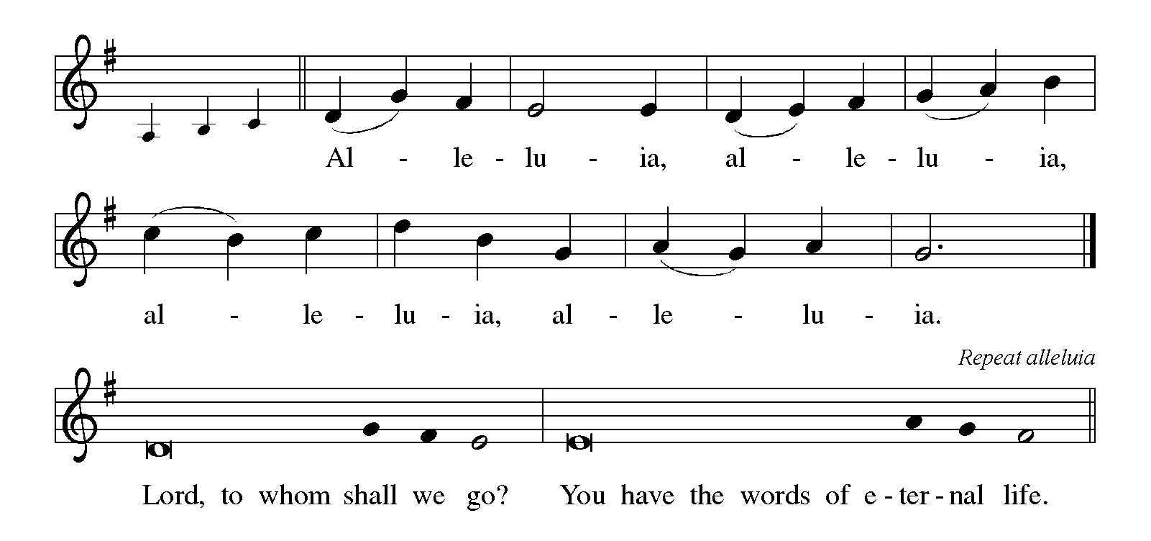

THE HOLY GOSPEL John 11:32-44

Through the raising of Lazarus, Jesus offers the world a vision of the life to come, when death and weeping will be no more.

P: The Holy Gospel according to St. John, the eleventh chapter.

C: Glory to You, O Lord!

When Mary came where Jesus was and saw Him, she knelt at His feet and said to Him, "Lord, if You had been here, my brother would not have died." ³³When Jesus saw her weeping, and the Judeans who came with her also weeping, He was greatly disturbed in spirit and deeply moved. ³⁴He said, "Where have you laid him?" They said to Him, "Lord, come and see." ³⁵Jesus began to weep. ³⁶So the Judeans said, "See how He loved him!" ³⁷But some of them said, "Could not He Who opened the eyes of the blind man have kept this man from dying?"
³⁸Then Jesus, again greatly disturbed, came to the tomb. It was a cave, and a stone was lying against it. ³⁹Jesus said, "Take away the stone." Martha, the sister of the dead man, said to Him, "Lord, already there is a stench because he has been dead four days." ⁴⁰Jesus said to her, "Did I not tell you that if you believed, you would see the glory of God?"
⁴¹So they took away the stone. And Jesus looked upward and said, "Father, I thank You for having heard Me. ⁴²I knew that You always hear Me, but I have said this for the sake of the crowd standing here, so that they may believe that You sent me."
⁴³When He had said this, He cried with a loud voice, "Lazarus, come out!" ⁴⁴The dead man came out, his hands and feet bound with strips of cloth, and his face wrapped in a cloth. Jesus said to them, "Unbind him, and let him go."

P: The Gospel of the Lord.

C: Praise to You, O Christ!

The assembly is seated

THE SERMON

Silence for reflection follows the sermon

As you are able please rise

THE HYMN OF THE DAY 427 For All Your Saints, O Lord page 12

THE NICENE CREED

A: God has made us His people through our Baptism into Christ. Living together in trust
and hope, we confess our faith.

C: We believe in one God,
the Father, the Almighty,
maker of heaven and earth,
of all that is, seen and unseen.

We believe in one Lord, Jesus Christ,
he only Son of God,
eternally begotten of the Father,
God from God, Light from Light,
true God from true God,
begotten, not made,
of one Being with the Father.
Through Him all things were made.
For us and for our salvation
He came down from heaven;
by the power of the Holy Spirit
He became incarnate from the virgin Mary, and was made man.
For our sake He was crucified under Pontius Pilate;
He suffered death and was buried.
On the third day He rose again
in accordance with the Scriptures;
He ascended into heaven
and is seated at the right hand of the Father.
He will come again in glory to judge the living and the dead,
and His kingdom will have no end.

We believe in the Holy Spirit, the Lord, the giver of life,
Who proceeds from the Father and the Son.
With the Father and the Son He is worshiped and glorified.
He has spoken through the prophets.
We believe in one holy catholic and apostolic Church.
We acknowledge one Baptism for the forgiveness of sins.
We look for the resurrection of the dead,
and the life of the world to come. Amen

THE PRAYER OF THE CHURCH

A: In communion with all the saints, let us pray to God Who is our resurrection, our life,
and our eternal home.

A: For the holy Church of God throughout the world, that God might confirm it in faith,
sustain it in hope, and deepen its witness to Christ, let us pray to the Lord:

C: Lord, hear our prayer.

A: For those 340 million Christians being persecuted because of their faith in Christ,
especially in North Korea; Afghanistan; Somalia; Libya; Pakistan; Eritrea; Yemen;
Iran; Nigeria; and India that God may lift their shroud of suffering and establish them
in peace and justice, let us pray to the Lord:

C: Lord, hear our prayer.

A: For our community of faith, that we may grow into and mirror the abundant generosity
of God in our care for one another, and especially the poor, the hungry, the lonely, and
the homeless, let us pray to the Lord:

C: Lord, hear our prayer.

A: For those who suffer in body or spirit, especially … that they may know the healing
power of God Who banishes crying and pain, let us pray to the Lord:

C: Lord, hear our prayer.

A: For those celebrating birthdays, especially Fred Hart that they may grow in grace this
day and be filled with grace in the days ahead, let us pray to the Lord:

C: Lord, hear our prayer.

A: For all the saints who have gone before us into death in this year: Pastor Norman
Ryding; Eugene F. Neulieb; Doris Jordan; Conrad Lubs; Eugene Prybylla; David
Prybylla; Richard K. Fischer; Bud Westphal; Robert Shebel; Violet Fane; Allen
Kring; Brian Schraidt; Phyllis Rapp; Philip Haney; Suzanne Cains; Marcia
Gielow; and Ryan Cross; and for the faithful yet to come, we give thanks to the Lord.
That with them we may be brought before the throne of the Lamb in glory, let us pray
to the Lord:

C: Lord, hear our prayer.

A: For the faithful of every time and place, let us give thanks to the Lord. That surrounded
by so great a cloud of witnesses, we may continue our journey to the new Jerusalem as
we seek the love of Christ in all things, let us pray to the Lord:

C: Lord, hear our prayer.

P: Your Reign, O God, endures forever, and in Christ we are free to be Your saints and
servants. Hear our prayers for the sake of Him Who died and rose again, Your Son,
Jesus Christ, Who lives with You and the Holy Spirit in the company of all Your saints
in light.

C: Amen.
MEAL

THE PEACE

P: The peace of the Lord be with you always.

C: And also with you.

The assembly is seated

THE VOLUNTARY Rock of Ages John A. Behnke

As you are able please rise

THE OFFERTORY PRAYER

A: Let us pray. Holy and mighty God,

C: We give You thanks for the triumph of Christ in the lives of His saints. Receive
all we offer You this Day, and help us, like them, to run our course with faith, until
we come to the new heaven and earth of Your everlasting Kingdom. We ask this
in the name of Jesus the Lord. Amen.

THE GREAT THANKSGIVING

P: The Lord be with you.

C: And also with you.

P: Lift up your hearts.

C: We lift them to the Lord.

P: Let us give thanks to the Lord our God.

C: It is right to give Him thanks and praise.

P: Blessed are You, holy God, Lord of Hosts, the Beginning and the End.
For You created the heavens and the earth and all creatures in them.
You raised up women and men to bear witness to Your light and love.
You chose Israel to be a beacon of hope to all the world.
Through her judges and poets, kings and prophets, You delivered them from
defeat, wiped their tears, and promised an end to death forever.
At the last, You made Your promise come true in Your Son, Jesus Christ.
He is the Resurrection and the life.
In the night ... “Do this for the remembrance of Me.”
As often as we eat ... we proclaim the Lord’s death until He comes.

C: Christ has died. Christ is risen. Christ will come again.

P: With this bread and cup we remember the life our Lord offered for us.
Making His home among us, He overcame loss and grief by healing the sick,
feeding the hungry, and resurrecting the dead.
He entered our death, that we might share His life. You raised Him as the
first-fruits of the dead, in Whom all will be made new.
He is coming to defeat death forever, and to host Your Feast of victory.
Send Your Spirit on us and these Your gifts of bread and wine, that we and
all who share the Lord’s Body and Blood
May go with Christ to comfort the weak and dying until all people dwell with God and
His saints in everlasting glory.
To You, O God: Father, Son, and Holy Spirit, be all honor and glory, in Your holy
Church, in heaven and on earth, now and forever.

C: Amen!

THE LORD’S PRAYER

P: Because God’s love has made us God’s beloved children, in the words Jesus taught us
we dare to pray:

C: Our Father, Who art in heaven, hallowed be Thy name. Thy Kingdom come, Thy
will be done, on earth as it is in heaven. Give us this day our daily bread, and
forgive us our trespasses as we forgive those who trespass against us. And lead us
not into temptation, but deliver us from evil. For Thine is the Kingdom, and the
power, and the glory forever and ever. Amen.

INVITATION TO THE MEAL

P: This is the Lamb of God Who takes away the sin of the world. Blessed are those who
are called to the Supper of the Lamb. God's holy gifts for God's holy people. Come,
for all is now ready.

The assembly is seated

THE DISTRIBUTION

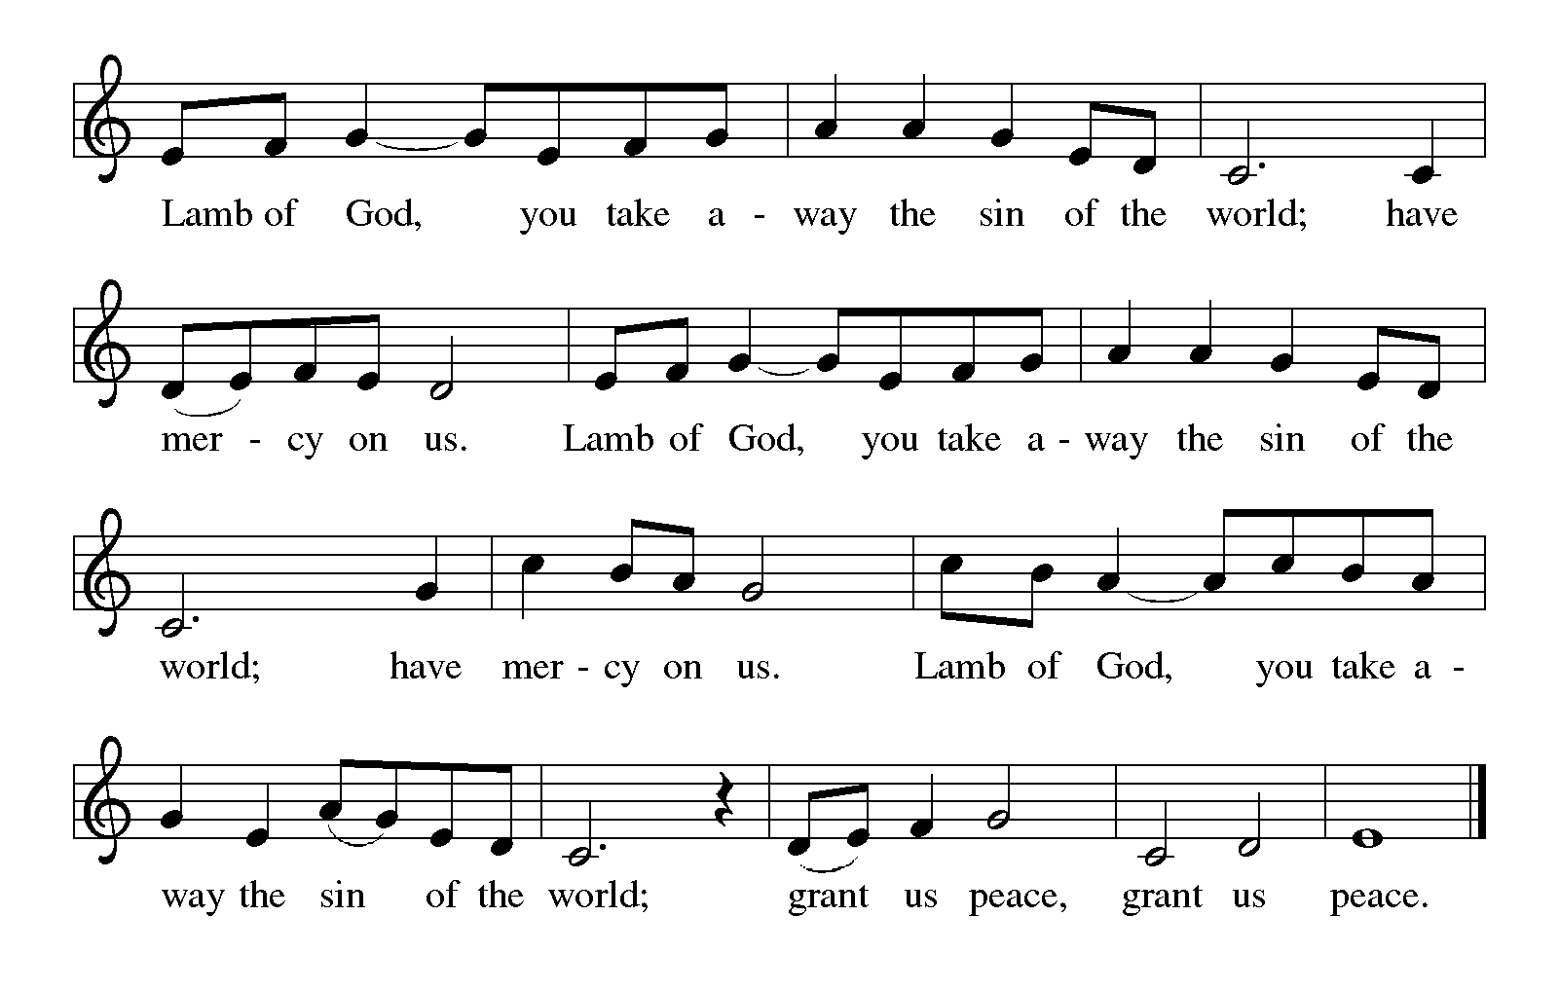
HYMNS DURING DISTRIBUTION 423 Shall We Gather at the River page 13
484 You Satisfy the Hungry Heart page 14

As you are able please rise

THE POST-COMMUNION BLESSING

P: The Body and Blood of our Lord Jesus Christ strengthen you and keep you in His grace.

C: Amen.

THE POST-COMMUNION PRAYER

A: Let us pray. God of the ages, in this holy Supper we have received the fruit of the vine
and the Bread of eternal life, the Body and Blood of Your Son. Strengthen us as we
await the harvest of everlasting life, where we will dwell with you and all the saints in
the peace of Your eternal home. Grant this through Christ our Lord.

C: Amen.
SENDING

THE BENEDICTION

P: Almighty God: Father, Son, and Holy Spirit, bless you now and forever.

C: Amen.

SENDING HYMN 414 Holy God, We Praise Your Name page 15

THE DISMISSAL

A: Go in peace to bear Christ's love to the world.

C: Thanks be to God!

POSTLUDE Holy God, We Praise Your Name Robert A. Hobby

To God Alone Be Glory

The Meditation is from Working Preacher Online. Copyright Luther Seminary, 2018.

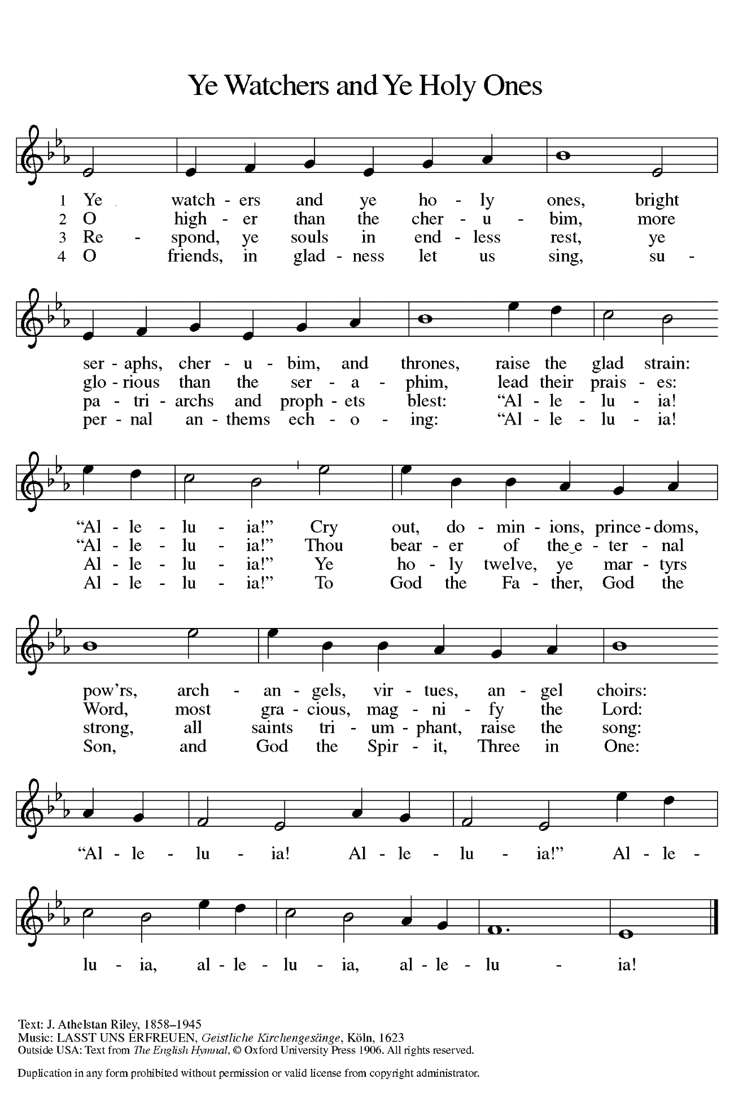
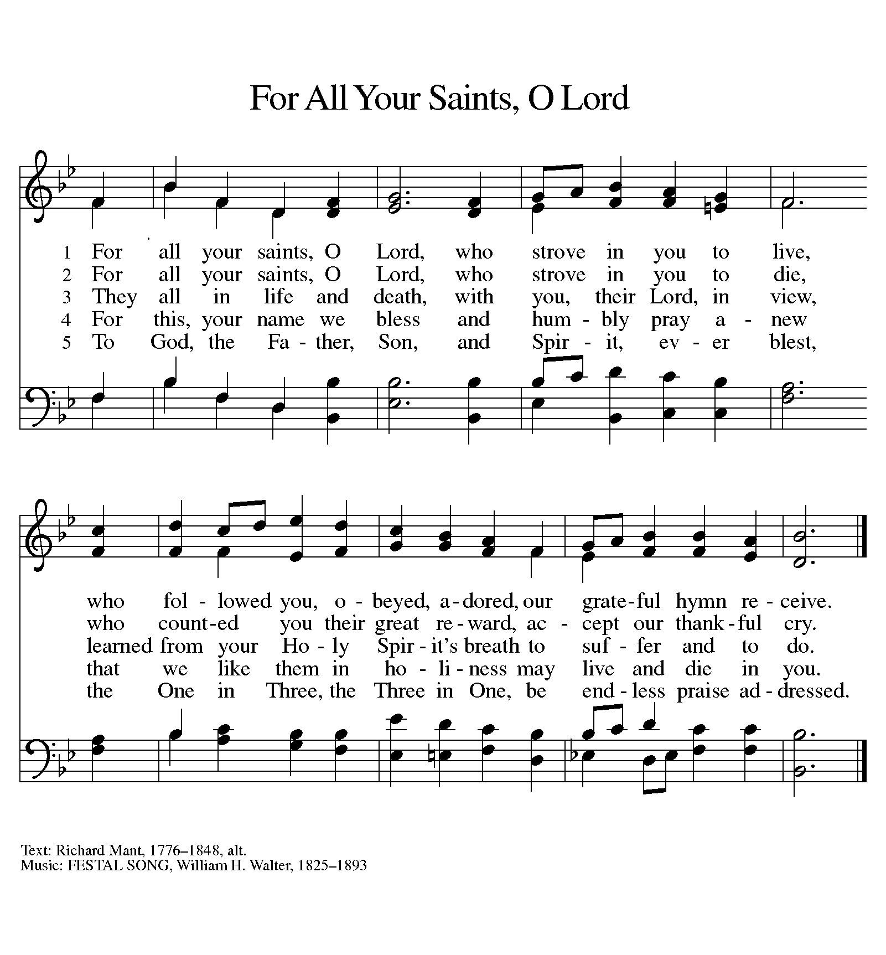

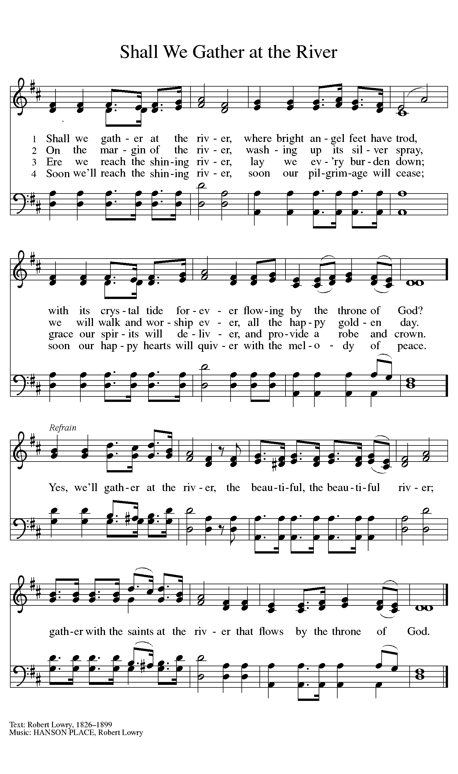
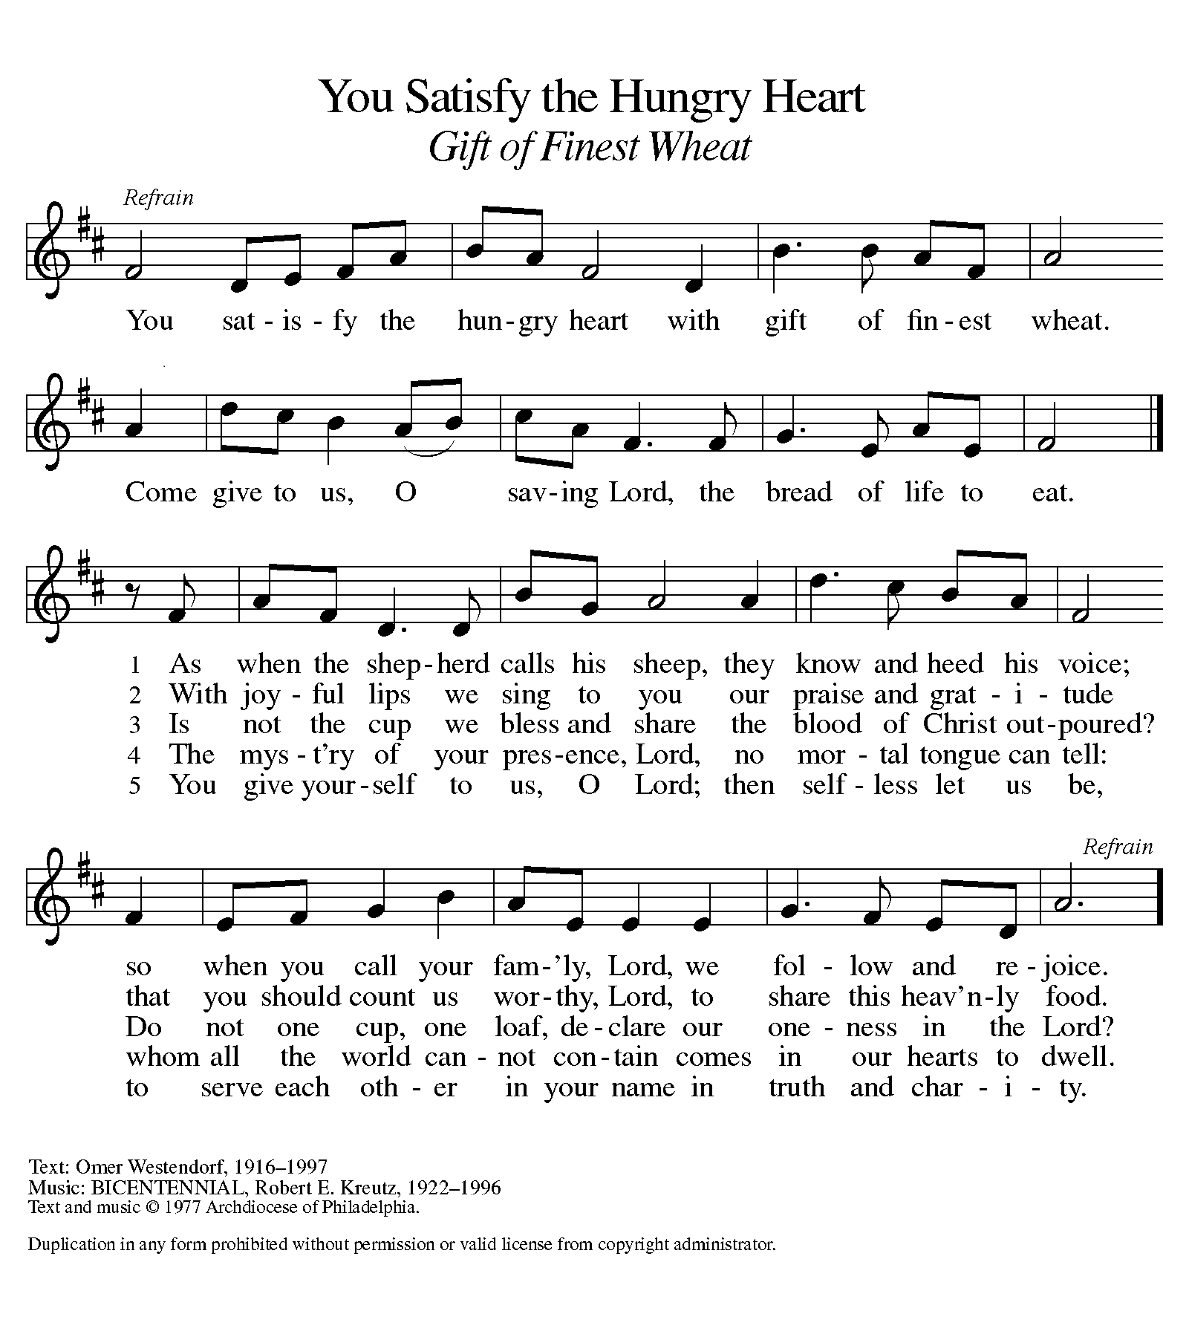

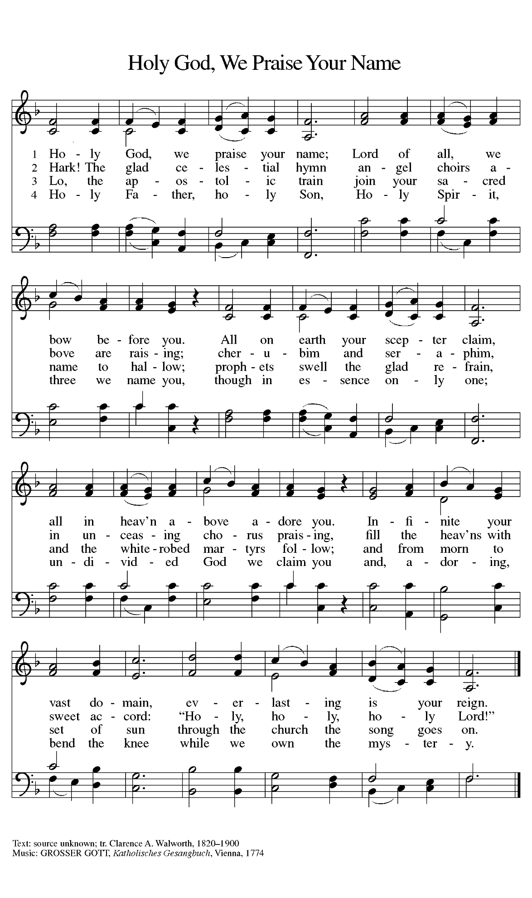
ANNOUNCEMENTS

Please remember to mail your offering to the Church Office at 818 Franklin Street, Michigan City, IN 46360. Another alternative is to give on-line through Tithe.ly. Please see your closure letter for information on how to set up a Tithe.ly account.

St. Paul Members are reminded to have a loved one contact the office if you are hospitalized. Many times, the Pastor doesn’t know someone is in the hospital. If you call and leave a message, please tell us which hospital the patient is at.

Next Sunday’s lessons are Daniel 12: 1-3; Psalm 16; Hebrews 10: 11-14 [15-18] 19-25; Mark 13: 1-8 for those of you who like to study them in advance.

BIRTHDAYS: Fred Hart (11/9)

PRAYER CONCERNS: Kathy Thielman, Audrey Beyer, Joyce and Bethany Manning, Marla Furness, Delores Hackett, Kay Peglow, Lee Timm, Ryan Krueger, Donna Bostater, Diane Gielow, Jeff Jensen, Maxine Powell, Jess Kalvaitis, Pastor Al Lorentzen, Jan Paholski, Laura Dovey, Heidi Happel, Shane Nevels, Irene Bohnstadt, Joan Coughlin, Jim Tomscheck, Wally & Betty Ratliff, Laura Moore, Cameron Rackard, Erik Tannehill, Ruth Lubs, Ed Gustum, Ken Mulder, Ashton Steele, Christian Martinez, Nancy Wisser, Ryan Sirk, Tyler Brown, Jary Tannehill, Susan McKinnon, Martha Schroeder and Jim Gleason.

If you requested someone’s name to be on the prayer list and are aware that they need continued imminent prayer then contact the church office and let us know. Otherwise we will gradually transfer names to the long-term list.

OFFICE HOURS: Libby will be in the office on Mondays, Wednesdays, and Fridays; volunteers will cover Tuesdays and Thursdays.

Monday & Wednesday 8:00 a.m. – 5 p.m.
Tuesday & Thursday 9:00 a.m. – 12:00 p.m.
Friday 8:00 a.m. – 12:00 p.m.

If you are listening to the worship broadcast on the radio and would like to watch the Sunday morning service live stream follow these steps:

- If you have You.Tube available on your TV, search for
St. Paul Lutheran Church Michigan City, IN.
- The direct link on the computer is
https://www.youtube.com/channel/UC5AIPNaKr3QN50984jGOa1g.
- This link is also on the main page of the church’s website in the church section and will continue to be posted weekly on the St. Paul Facebook page.

And it will always be available on the radio broadcast Sunday mornings at 11:00 a.m. on WEFM (95.9), and on the local cable access station #99 for the previous week’s service on Sundays at 4:00 p.m. and the current service on Wednesdays at 7:00 p.m. and Fridays at 8:30 p.m.

To send e-mail to the church office, please use the following addresses:

Pastor Mark Reshan: seniorpastor@stpaulmichigancity.com

Church Office Secretary (Libby Pollock): churchsecretary@stpaulmichigancity.com

Church Treasurer (Karen Fleming) and Bookkeeper (Billie Atchinson):
finance@stpaulmichigancity.com.

The Good News Newsletter: If you have an article or anything you want included in The Good News please send it to the following e-mail address: splcgoodnews@gmail.com. Pastor Pamela Thiede will be using this e-mail address to assemble The Good News each month. The deadline for getting information to Pastor Pamela will be the 20th of each month.

WORSHIP ATTENDANCE for October 30 and 31, 2021
4:00 p.m. 31
9:00 a.m. 52
Total = 83

The Community Soup Kitchen serving out of First United Methodist is in need of volunteers. Sunday through Tuesday is always need, as is occasionally Wednesdays and Thursdays. Hours are 9:30 a.m. to 1:15 p.m. and it is not necessary to stay the entire time. There is also a need for volunteers to be available to help pick up deliveries from the Food Bank when they arrive. If you are able to help please contact their church office at 872-7200.

MEETINGS & ACTIVITIES IN NOVEMBER

Worship Service: Saturday, November 6, 2021 at 4:00 pm

Worship Service: All Saints Sunday, November 7, 2021 at 9:00 am
Harmony Circle: Tuesday, November 9, 2021 at 9:30 am/Green Room
Wednesday Bible Study: Wednesday, November 10, 2021 at 9:45 am/Luther House
Worship & Music Committee: Wednesday, November 10, 2021 at 6:00 pm
Choir Rehearsal: Wednesday, November 10, 2021 at 7:00 pm
Give-back at Galveston: Thursday, November 11, 2021 from 4:00 pm – 10:00 pm
Worship Service: Saturday, November 13, 2021 at 4:00 pm

Worship Service: Sunday, November 14, 2021 at 9:00 am
Finance Committee: Monday, November 15, 2021 at 4:00 pm/St. Paul Room
Wednesday Bible Study: Wednesday, November 17, 2021 at 9:45 am/ Luther House
Worship Service: Saturday, November 20, 2021 at 4:00 pm

Worship Service: Sunday, November 21, 2021 at 9:00 am
Wednesday Bible Study: Wednesday November 24, 2021 at 9:45 am/Luther House
THANKSGIVING
Worship Service: Saturday, November 27, 2021 at 4:00 pm

Worship Service: Sunday, November 28, 2021 at 9:00 am

2021 Financial Stewardship
Weekly Church Operating Needs (x 2 weeks): $14,116.36
October 23 and 24, and October 30 and 31, 2021
General Fund (including General Memorials): $7,700.60
Overage/Shortage: --$6,415.76

Restricted Income (not including Memorials)
Supports IK Synod & Churchwide Ministries: $260.00
Ministries in our Community/Congregation: $ 10.00
Capital Fund: $450.00

Next Give-back is on Thursday, November 11, 2021 from 4:00 pm – 10:00 pm at
Galveston Steak House in Michigan City. Please come out and enjoy the fellowship! There will be extra coupons in the church office as well. Our previous take from Galveston was $250.00. Thank you for your participation and support!

