THE SEVENTH SUNDAY OF EASTER
Observed as The Ascension of Our Lord
May 12, 2024

“The next statement of the creed identifies Jesus as the one who “ascended into heaven, and is seated at the right hand of the Father.” Thereby, the creed reminds us that the friend of sinners is indeed at the reins of the universe. Far from being absent from them, he is where God is—in control of his world, and ruling it as a part of his love for the sinners he wills to befriend.
Like the statement about the descent to the netherworld, the confession of Jesus’ ascension makes no sense if it is taken as a cosmological or astronautical statement. The ascension was not like climbing up a ladder. Rather, it is imagery in the service of a profound theological truth: Jesus, who is the sinners’ friend, is not a pretender, a wishful thinker hoping that things will turn out for them in the end.
He is, in fact, in charge, and he is bringing about that good and gracious will of God which he spoke and lived.”

Frederick Niedner, Jr. and David Truemper
Keeping the Faith

The Ascension was a great and indescribable cause for joy, for in it the nature of humankind ascended, above the dignity of all the heavenly creatures, rising above the angelic order, above the sublimity of the archangels, until, received into the company of the eternal Father, it was made a sharer of the throne of God’s glory, to whose nature it was united in the Son. Therefore, the Ascension of Christ is our uplifting, for where the glory of Our Head shall go, there the hope of our body is called.
Let us then rejoice exceedingly with fitting joy, and let us be glad with devout thanksgiving. For on this day, not alone are we made sure heirs of paradise, but in Christ we have already reached the heights of heaven, and we have obtained more abundant gifts through the ineffable favor of Christ than we lost through the envy of the devil.

Leo
In the Name of Jesus

GATHERING

INTRODUCTION

In today’s readings the risen Christ ascends into heaven and his followers are assured that the Spirit will empower them to be witnesses throughout the earth. The disciples were told to not gaze up into heaven to look for Jesus (Acts 1: 11); we find his presence among us as we proclaim the word and share the Easter feast. We too long for the Spirit to enliven our faith and invigorate our mission.
PRE-SERVICE MUSIC Did You Hear the Mountains Tremble The Praise Band
(Martin Smith)

THE EASTER ACCLAMATION

P: Christ is risen and ascended! Alleluia!

C: He is risen and ascended indeed! Alleluia!

ANNOUNCEMENTS

As you are able please rise

THE GATHERING SONG NSB 70 Open Our Eyes

The congregation faces the cross as it enters

THE GREETING AND PRAYER OF THE DAY

P: Alleluia! Christ is risen!

C: Christ is risen indeed! Alleluia!

P: The grace of our Lord Jesus Christ, the love of God, and the communion of the Holy Spirit be
with you all.

C: And also with you.

P: Let us pray. Almighty God, Your blessed Son, our Savior Jesus Christ, ascended far above all
heavens that He might fill all things. Mercifully give us faith to trust that, as He promised, He
abides with us on earth to the end of time, Who lives and reigns with You and the Holy Spirit,
one God, now and forever.

C: Amen.

The assembly is seated

WORD

FIRST READING Acts 1: 1-11

Before he is lifted into heaven, Jesus promises that the missionary work of the disciples will spread out from Jerusalem to all the world. His words provide an outline of the book of Acts.

In the first book, Theophilus, I wrote about all that Jesus did and taught
from the beginning
²until the day when He was taken up to heaven, after giving instructions through
the Holy Spirit to the apostles whom He had chosen.
³After His suffering He presented Himself alive to them by many convincing
proofs, appearing to them during forty days and speaking about the
kingdom of God.
⁴While staying with them, He ordered them not to leave Jerusalem, but to wait
there for the promise of the Father. "This," He said, "is what you have
heard from Me;
⁵for John baptized with water, but you will be baptized with the Holy Spirit
not many days from now."
⁶So when they had come together, they asked Him, "Lord, is this the time when
You will restore the kingdom to Israel?"
⁷He replied, "It is not for you to know the times or periods that the Father has
set by His own authority.
⁸But you will receive power when the Holy Spirit has come upon you; and
you will be My witnesses in Jerusalem, in all Judea and Samaria, and
to the ends of the earth."
⁹When He had said this, as they were watching, He was lifted up, and a cloud took
Him out of their sight.
¹⁰While He was going and they were gazing up toward heaven, suddenly
two men in white robes stood by them.
¹¹They said, "Men of Galilee, why do you stand looking up toward heaven?
This Jesus, who has been taken up from you into heaven, will come in
the same way as you saw Him go into heaven."

The Word of the Lord.

Thanks be to God.

THE PSALM: Psalm 47 Read responsively

¹Clap your hands, all you peoples;
shout to God with a joyful sound.

²For the LORD Most High is to be feared:
a great King over all the earth,

³Who subdues the peoples under us,
and the nations under our feet;

⁴Who chooses our inheritance for us,
the pride of Jacob, whom God loves.

⁵God has gone up with a shout,
the LORD with the sound of the ram's horn.

⁶Sing praises to God, sing praises;
sing praises to our King, sing praises.

⁷For God is King of all the earth;
sing praises with a song.

⁸God reigns over the nations;
God is enthroned on high.

⁹The nobles of the peoples have gathered as the people of the God of Abraham.
The rulers of the earth belong to God, who is highly exalted.

SECOND READING Ephesians 1: 15-23

The risen and exalted Christ reigns over the entire universe. The author of Ephesians prays that we would be given the wisdom to comprehend this and display it through love toward others.

¹⁵I have heard of your faith in the Lord Jesus and your love toward all the saints,
and for this reason
¹⁶I do not cease to give thanks for you as I remember you in my prayers.
¹⁷I pray that the God of our Lord Jesus Christ, the Father of glory, may give
you a spirit of wisdom and revelation as you come to know Him,
¹⁸so that, with the eyes of your heart enlightened, you may know what is the
hope to which He has called you, what are the riches of His glorious
inheritance among the saints,
¹⁹and what is the immeasurable greatness of His power for us who believe,
according to the working of His great power.
²⁰God put this power to work in Christ when He raised Him from the dead and
seated Him at His right hand in the heavenly places,
²¹far above all rule and authority and power and dominion, and above every
name that is named, not only in this age but also in the age to come.
²²And He has put all things under His feet and has made Him the head over
all things for the church,
²³which is His body, the fullness of him who fills all in all.

The Word of the Lord.

Thanks be to God.

As you are able please rise

THE VERSE

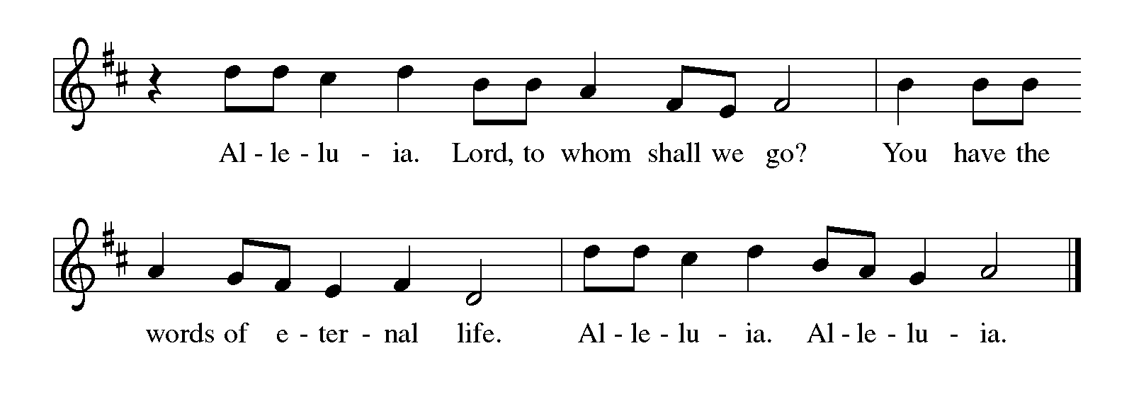
THE HOLY GOSPEL Luke 24: 44-53

On the day of his ascension, Jesus leaves his disciples with a commission, a blessing, and a promise of the Holy Spirit.

P: The Holy Gospel according to St. Luke, the twenty-fourth chapter.

C: Glory to You, O Lord!

⁴⁴Then He said to the disciples, "These are My words that I spoke to you while I was
still with you — that everything written about Me in the law of Moses,
the prophets, and the psalms must be fulfilled."
⁴⁵Then He opened their minds to understand the scriptures,
⁴⁶and He said to them, "Thus it is written, that the Messiah is to suffer and to rise
from the dead on the third day,
⁴⁷and that repentance and forgiveness of sins is to be proclaimed in
His name to all nations, beginning from Jerusalem.
⁴⁸You are witnesses of these things.
⁴⁹And see, I am sending upon you what My Father promised; so stay here in the
city until you have been clothed with power from on high."
⁵⁰Then He led them out as far as Bethany, and, lifting up His hands, He blessed them.
⁵¹While He was blessing them, He withdrew from them and was carried up into heaven.
⁵²And they worshiped Him, and returned to Jerusalem with great joy;
⁵³and they were continually in the temple blessing God.
P: The Gospel of the Lord.

C: Praise to You, O Christ!

The assembly is seated

THE SERMON

Silence for meditation follows the sermon

As you are able please rise

THE HYMN OF THE DAY 393 A Hymn of Glory Let Us Sing

THE NICENE CREED

A: God has made us His people through our Baptism into Christ. Living together in trust and
hope, we confess our faith.

We believe in one God,
the Father, the Almighty,
maker of heaven and earth,
of all that is, seen and unseen.

We believe in one Lord, Jesus Christ,
the only Son of God,
eternally begotten of the Father,
God from God, Light from Light,
true God from true God,
begotten, not made,
of one Being with the Father.
Through Him all things were made.
For us and for our salvation
He came down from heaven;
by the power of the Holy Spirit
He became incarnate from the virgin Mary, and was made man.
For our sake He was crucified under Pontius Pilate;
He suffered death and was buried.
On the third day He rose again
in accordance with the Scriptures;
He ascended into heaven
and is seated at the right hand of the Father.
He will come again in glory to judge the living and the dead,
and His kingdom will have no end.

We believe in the Holy Spirit, the Lord, the giver of life,
Who proceeds from the Father and the Son.
With the Father and the Son He is worshiped and glorified.
He has spoken through the prophets.
We believe in one holy catholic and apostolic Church.
We acknowledge one Baptism for the forgiveness of sins.
We look for the resurrection of the dead,
and the life of the world to come. Amen

THE PRAYER OF THE CHURCH

A: Our risen and ascended Lord offers up priestly intercessions before the throne of God. Let us
offer our prayers for the Church, the world, and all those who long for the grace of new life.

A: That the Church may faithfully witness to Jesus and repentance and forgiveness in His name,
we pray:

C: Hear us, risen Lord.

A: That the Jesus Who rules the world at the Father’s right hand might fill all leaders and nations
with wisdom, and all things with His Spirit of justice, reconciliation, and peace, we pray:

C: Hear us, risen Lord.

A: That we might be clothed with power from on high to be “taken up” into Jesus’ own love and
mission for the world, we pray:

C: Hear us, risen Lord.

A: That those in the healing professions: doctors, nurses, surgeons, therapists, aides, and
counselors might bring the immeasurable power of God’s healing love to the lonely, the
forgotten, the institutionalized, and the sick, especially: Cathy Martin; Venia Wendt; Russ
Fischer; Marsha Kenney; Debbie Martin; Kathy Stein; Leonard Cross; and Kay Peglow,
we pray:

C: Hear us, risen Lord.

A: That those celebrating birthdays, especially Pat Miller; and anniversaries, especially Fred
and Judy Laborn might be filled with grace this day and every day and grow in grace in the
days ahead, we pray:

C: Hear us, risen Lord.

A: That with all the saints we too might be received into the fullness of Christ’s everlasting rule
and glory, we pray:

C: Hear us, risen Lord.

P: Ascended Lord, You have not left us, but gone before us into the heavenly glory. Raise these
our prayers to heaven, and present them to God in union with Your eternal sacrifice, that we
may know Your divine love in this life and may be one with You in the life to come.

C: Amen.

MEAL

THE PEACE

P: The peace of the risen Lord be with you always.

C: And also with you.

The assembly is seated

THE OFFERING

THE VOLUNTARY Seek to Serve St. Paul Senior Choir
(Lloyd Pfautsch)

As you are able please rise

THE PRESENTATION OF THE GIFTS

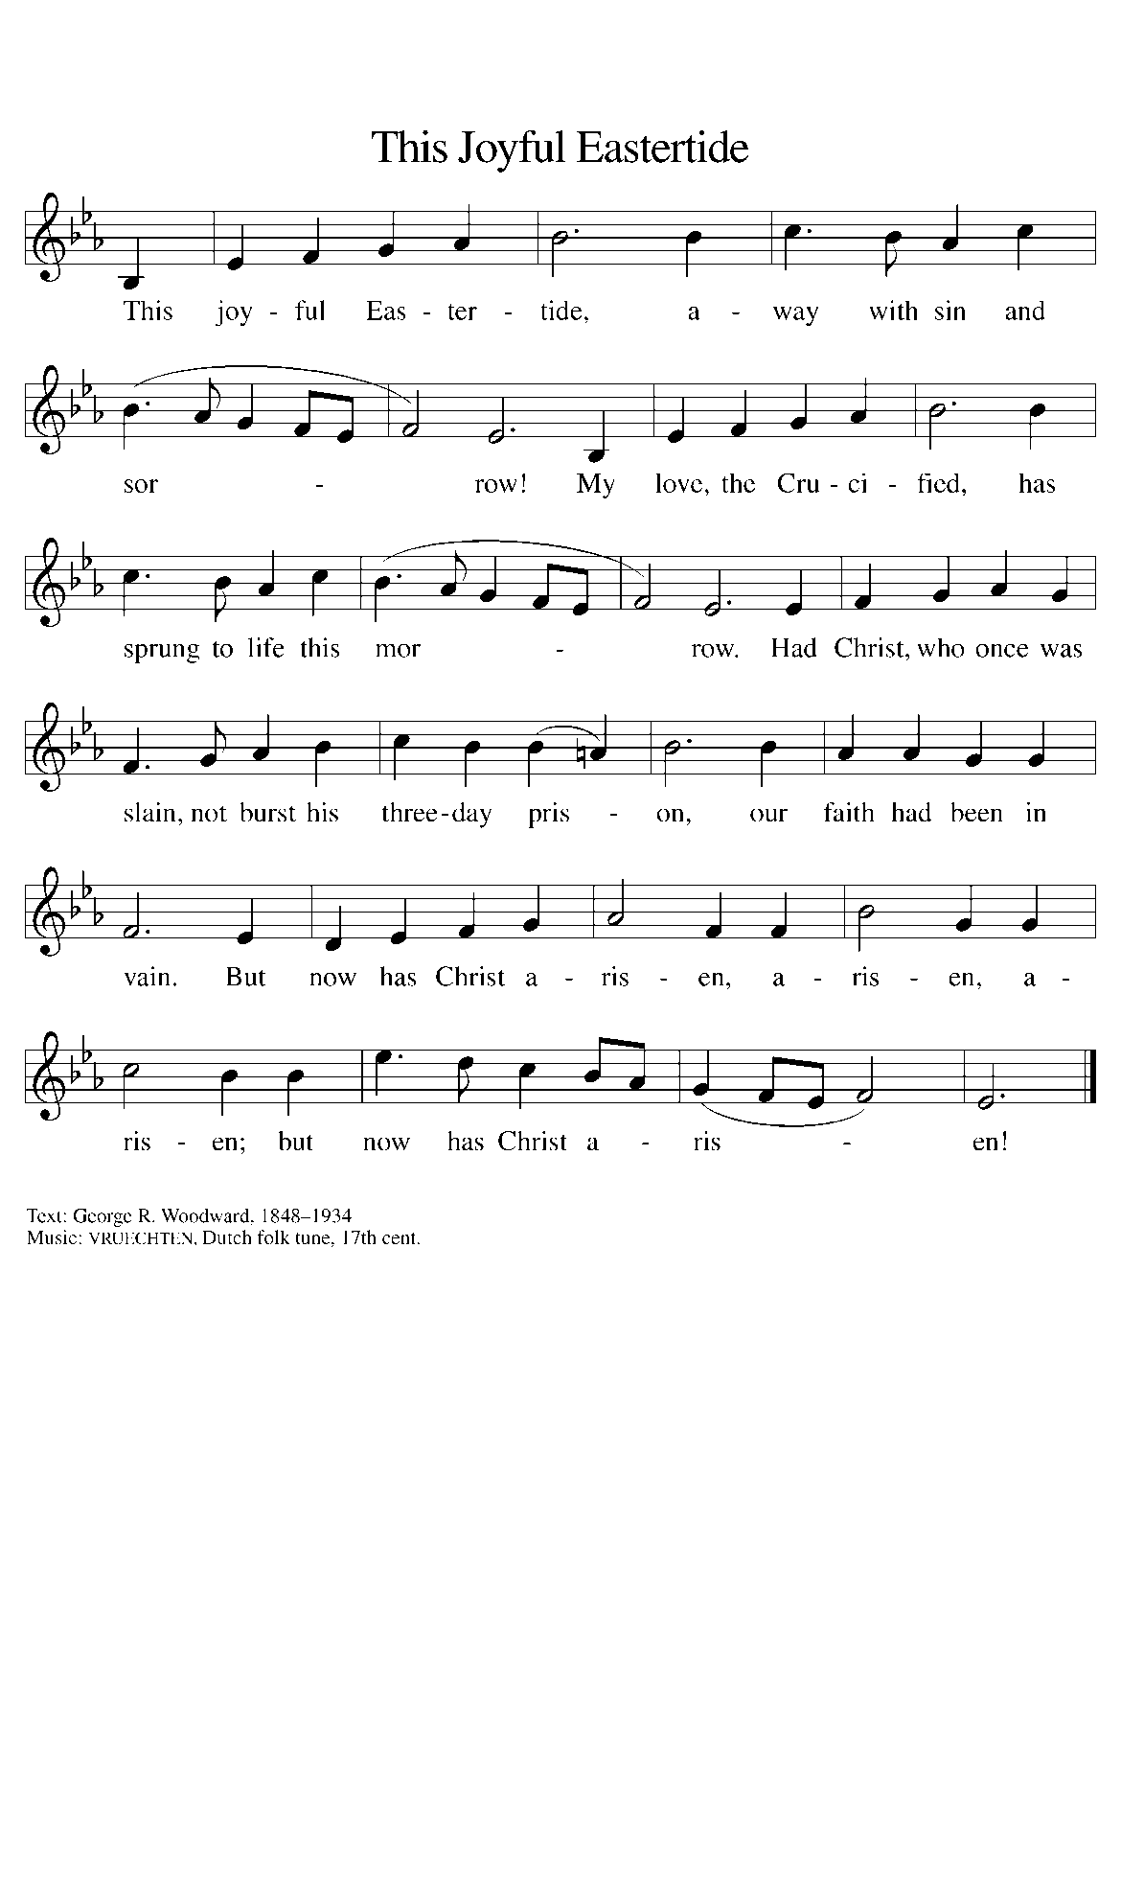
THE OFFERTORY PRAYER

A: Let us pray. Eternal God,

C: Our Savior Jesus Christ has promised to be with us until the end of time. Accept all we
offer You this day, and renew in us His risen and ascended life. We ask this in the name
of Jesus the Lord. Amen.

THE GREAT THANKSGIVING

P: The Lord be with you.

C: And also with you.

P: Lift up your hearts.

C: We lift them to the Lord.

P: Let us give thanks to the Lord our God.

C: It is right to give Him thanks and praise.

P: Holy God, You alone are holy.
You alone are God.
The universe declares Your praise:
Beyond the stars;
beneath the sea;
within each cell;
with every breath.

C: We praise You, O God.

P: Generations bless Your faithfulness;
Through the water;
by night and day;
across the wilderness;
out of exile;
into the future.

C: We bless You, O God.

P: We give You thanks for Your dear Son:
At the heart of human life;
near to those who suffer;
beside the sinner;
among the poor;
With us now.

C: We thank You, O God.

P: In the night ... “Do this for the remembrance of Me.”
As often as we eat ... we proclaim the Lord’s death until He comes.
Remembering His love for us on the way,
at the table,
and to the end,
we proclaim the mystery of faith:

C: Christ has died. Christ is risen. Christ will come again.

P: We pray for the gift of Your Spirit:
In our gathering;
within this Meal;
among Your people;
throughout the world.

Blessings, praise, and thanks to You,
Holy God,
through Christ Jesus,
by Your Spirit,
in Your Church,
without end.

C: Amen!

THE LORD’S PRAYER

P: Risen from the dead, Jesus lives to intercede for us and join us as He taught us to pray:

C: Our Father in heaven, hallowed be Your name.
Your Kingdom come, Your will be done on earth as in heaven.
Give us today our daily bread, and forgive us our sins, as we forgive
those who sin against us.
Save us from the time of trial, and deliver us from evil.
For the Kingdom, the power, and the glory are Yours, now and forever.
Amen.

INVITATION TO THE MEAL

P: Alleluia! Christ the Lamb of God has been sacrificed. Therefore, let us celebrate His Feast
with joy. Blessed are those who are called to the Supper of the Lamb. God’s holy gifts for
God’s holy people. Come, for all is now ready.

The assembly is seated

DISTRIBUTION
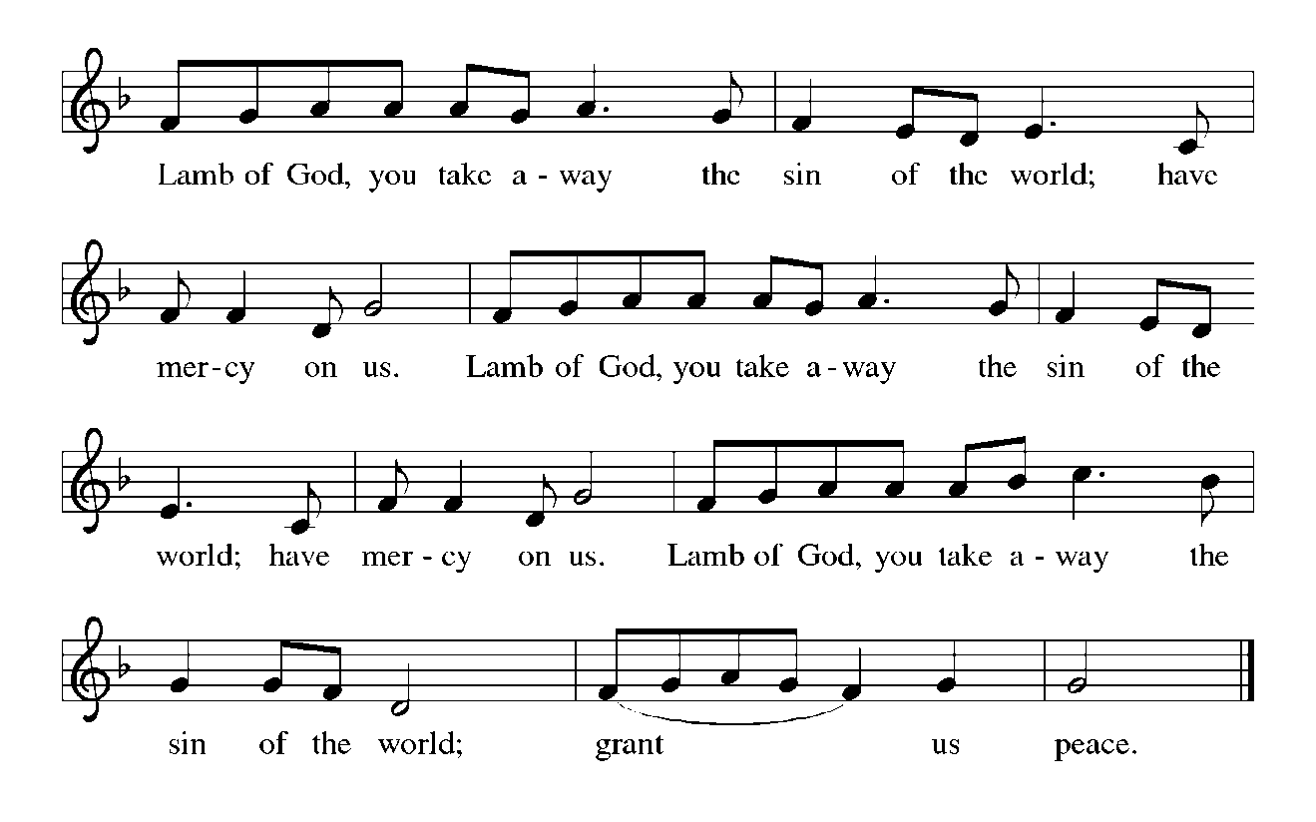
Those wishing to receive the Laying on of Hands, Anointing with Oil and Prayer for Healing
may come to Pastor at the side aisle

HYMN DURING DISTRIBUTION 434 Jesus Shall Reign
ELW 483 Here is Bread
ELW 481 Come to the Table
NSB 64 Majesty
As you are able please rise

THE POST-COMMUNION BLESSING

P: The Body and Blood of our Lord Jesus Christ strengthen you and keep you in His grace.

C: Amen.

THE POST-COMMUNION PRAYER

A: Let us pray. Heavenly Father, in the Eucharist we celebrate the Ascension of Your Son into
glory. May the gifts of His Body and Blood help us to rise with Him to the joys of heaven,
where He lives and reigns with You and the Holy Spirit, one God, now and forever.

C: Amen.

SENDING

THE BENEDICTION

P: May God the Father Who raised Christ from the dead open to you the gate of everlasting life.

C: Amen.

P: May God the Son Who burst from the grave give you joy as you celebrate His resurrection.

C: Amen.

P: May God the Holy Spirit Who brought you to birth in Baptism fill you with strength and peace.

C: Amen.

P: Almighty God: Father, Son, and Holy Spirit bless you now and forever.

C: Amen.

THE SENDING HYMN 838 Beautiful Savior

THE DISMISSAL

A: Alleluia! Christ is risen!

C: He is risen indeed! Alleluia!

A: Go in the peace of Christ, alleluia!

C: Thanks be to God! Alleluia!

POSTLUDE

To God Alone Be Glory

The Meditation is from Keeping the Faith. A Guide to the Christian Faith. David Truemper and
Frederick Niedner, Jr. (Valparaiso University, Department of Theology, 1980). 67.

The Greeting, Peace, Offertory, Post-Communion Prayers, and Dismissal are from Sundays and
Seasons. Copyright 2000 Augsburg Fortress.

The Prayers are adapted from Prayers for Sundays and Seasons. Year B. Peter Scagnelli.
(Chicago: Liturgy Training Publications, 1996, 72-73.

ANNOUNCEMENTS

Please remember to mail your offering to the Church Office at 818 Franklin Street, Michigan City, IN 46360. Another alternative is to give on-line through Tithe.ly. Please see your closure letter for information on how to set up a Tithe.ly account.

St. Paul Members are reminded to have a loved one contact the office if you are hospitalized. Many times, the Pastor doesn’t know someone is in the hospital. If you call and leave a message, please tell us which hospital the patient is at.

Birthdays: Patricia Miller (5/16)
Anniversaries: Fred & Judy LaBorn (5/19)

PRAYER CONCERNS: Jim Tomsheck, Marsha Kenney, Grace Romine, Debbie Martin, Sue Koziel, Jana Thomas, Margie Torres, Jayla Jacobi, Ronwynn Jones, Chris Jones, Mark Tannehill, Joan Seifert, Virginia Murray, Brian Wiseman, Jary Tannehill, Sue Granacki, Kathy Stein, Karen Peters and Pastor Charlie Streitelmeier.

OFFICE HOURS: Libby will be in the office on Mondays, Wednesdays,
and Fridays; volunteers will cover Tuesdays and Thursdays.

Monday & Wednesday 8:00 a.m. – 5 p.m.
Tuesday & Thursday 9:00 a.m. – 12:00 p.m.
Friday 8:00 a.m. – 12:00 p.m.

If you are listening to the worship broadcast on the radio and would like to watch the Sunday morning service live stream follow these steps:

(1) If you have You Tube available on your TV, search for
St. Paul Lutheran Church Michigan City, IN.

(2) The direct link on the computer is
https://www.youtube.com/channel/UC5AIPNaKr3QN50984jGOa1g.

(3) This link is also on the main page of the church’s website in
the church section and will continue to be posted weekly on the St.
Paul Facebook page.

And it will always be available on the radio broadcast Sunday mornings at 11:00 a.m.
on WEFM (95.9), and on the local cable access station #99 for the previous week’s
service on Sundays at 4:00 p.m. and the current service on Wednesdays at 7:00 p.m.
and Fridays at 8:30 p.m.

There will be no broadcast or streaming of the Sunday, May 12 service. Both Mike Bockover and Paul Brooks will be out of town that weekend. This also means that the service will not be available on the local cable access channel or on the normal radio broadcast on WEFM. Broadcasting and taping will resume on Sunday the 19th.

The approved and signed minutes of the February 22 and March 21, 2024 Church Council Meetings are on the table at the back of the church in the Narthex. Please take a copy with you as you go.

To send e-mail to the church office, please use the following addresses:

Pastor Mark Reshan: seniorpastor@stpaulmichigancity.com

Church Office Secretary (Libby Pollock): churchsecretary@stpaulmichigancity.com

Church Treasurer (Karen Fleming): finance@stpaulmichigancity.com

The Good News Newsletter: If you have an article or anything you want included in The Good News please send it to the following e-mail address: splcgoodnews@gmail.com. Pastor Pamela Thiede will be using this e-mail address to assemble The Good News each month. The deadline for getting information to Pastor Pamela will be the 20th of each month.

Worship Attendance:
Saturday, May 4, 2024 @ 4:00 p.m. 37
Sunday, May 5, 2024 @ 9:00 a.m. 63
TOTAL 100

IT’S TIME FOR A NEW DIRECTORY

As I get closer to the end of my first draft I find that some of the numbers I’ve called to check in with folks have been disconnected. If you know of anyone in the directory that has a new phone number or address please let me know by sending me an email or call the church office in the next couple weeks and let me know. I look forward to hearing from you as soon as you’re able.

Libby Pollock
Church Secretary

Our annual spring congregational meeting will take place on Sunday, May 19 at 10:00 in the St. Paul Room. There will be two main agenda items: the proposed budget for the 2024-2025 fiscal year; and a report on the sale of the school building.

POTLUCK DINNER

Following the congregational meeting on May 19, we will hold a traditional potluck meal. The Council will not be providing the main course this time, so whatever entrees, salads, sides, and desserts we have will come from those who attend. No need to sign up for anything; simply bring a favorite dish to share and enjoy good food and better fellowship following the meeting.

The Mission of the Month for May
May’s mission of the month is Dolly Parton’s Imagination Library of
LaPorte County. Dolly Parton’s Imagination Library is dedicated to inspiring a love of reading by gifting books each month to children from birth to age five, free of charge, through funding shared by Dolly and local community partners in the United States, Canada, United Kingdom, Australia and Republic of Ireland. Any child within LaPorte County who is under the age of 5 can sign up. Some of the books Leah has received are “The Little Engine That Could,” “Llama Llama Red Pajama,” “The Very Hungry Caterpillar’s First Summer,” and her favorite, “Goodnight Gorilla.” Please consider helping to foster a love of reading in young kids in our community by donating to the Imagination Library. Checks can be made out to the church and marked for the Imagination Library and placed in the offering plate. Thank you so much!

ACTIVITIES, EVENTS & MEETINGS
MAY 2024

Saturday, May 11, 2024 @ 4:00 p.m. Ascension Worship Service

Sunday, May 12, 2024 @ 9:00 a.m. Ascension Worship Service

Monday, May 13, 2024 @ Noon Choir Rehearsal

@1:00 p.m. Hope Circle/Green Room

@ 1:00 p.m. Worship & Music Committee Mtg./Luther House

Tuesday, May 14, 2024 @ 7:00 p.m. Estuary/Luther House

Wednesday, May 15, 2024 @ 9:15 a.m. Bible Study/Luther House

@10:00 a.m. God’s Purls/St. Paul Room

Saturday, May 18, 2024 @ 4:00 p.m. Vigil and Day of Pentecost Worship Service

Sunday, May 19, 2024 @ 9:00 a.m. Vigil and Day of Pentecost Worship Service

@ 10:00 a.m. Congregational Spring Meeting & Potluck in
St. Paul Room
Monday, May 20, 2024 @ 2:00 p.m. Finance Committee Mtg./Luther House

@3:00 p.m. Executive Board Mtg/Luther House

Wednesday, May 22, 2024 @ 9:15 a.m. Bible Study/Luther House

@10:00 a.m. God’s Purls/St. Paul Room

@5:30 p.m. Church Council Mtg./St. Paul Room

Thursday, May 23, 2024 @ 4:00-10:00 p.m. GIVE-BACK at Galveston Steakhouse

Saturday, May 25, 2024 @ 4:00 p.m. Holy Trinity Worship Service

Sunday, May 26, 2024 @ 9:00 a.m. Holy Trinity Worship Service

Monday, May 27, 2024 OFFICE IS CLOSED FOR MEMORIAL DAY

Wednesday, May 29, 2024 @10:00 a.m. God’s Purls/St. Paul Room

Thank$ for $haring

Thank you to all who participated in the Give-Back at Leed’s Public House on April 10, 2024. The church received $200.00 as a result of the event. This month, we will see you again at Galveston on Thursday, May 23! Here are two coupons: one for you and one for a friend.

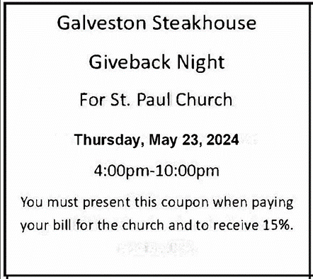

Coming Soon:

We invite you to join us for a lakeshore cruise on the Emita II on Tuesday, June 4. The cost is $35 per person with $10 of that going to the church (no coupon required). Children up to age three are free. The link for making a reservation is:

https://tinyurl.com/mtk3ach6
Please use this link for any communication instead of the longer one previously provided. They have to book via the site (they’re not able to book over the phone). If you have any issues with using a credit card online, you are invited to pay Paul Brooks in person and he will take care of it for you. (please include a few extra dollars for fees)
For now, the day is blocked out on their main page, so the above link is the only way to book a reservation for this particular cruise. The cruise will be made public two to three weeks prior to the cruise date, so the earlier you make your reservation, the better.

