THE THIRD SUNDAY IN LENT
March 8, 2026

John’s gospel says the Samaritan woman was invited to take all the water she needed. The early centuries of the church, and now we again, have seen in the Samaritan woman an image of us all. We all search in the wrong place for refreshment, lugging home water which gives out or goes bad; we continuously need more water; we are always somewhat thirsty, dirty or raw.
We thought to find water there, down at the stream, and were surprised to find it here, directly before us. Turning around—the word is conversion—we find a water source we had not even imagined. Baptism, says the church, is this water source, this fountain of God, this conversation with Christ, this gift of self-knowledge, this sense of mission, this true religious rite, this conversion of life.

Gail Ramshaw

Jesus met the Samaritan woman at Jacob’s well.
The One who covers the earth with clouds asks water of her.
Oh, what a wonder!
The One who suspended the earth on the waters asks for water!

Byzantine Vespers

I am the vessel.
The draught is God’s.
And God is the thirsty one.

Dag Hammarskjold

In the Name of Jesus

INTRODUCTION

In today's gospel the Samaritan woman asks Jesus for water, an image of our thirst for God. Jesus offers living water, a sign of God's grace flowing from the waters of baptism. The early church used this gospel and those of the next two Sundays to deepen baptismal reflection during the final days of preparation before baptism at Easter. As we journey to the resurrection feast, Christ comes among us in word, bath, and meal—offering us the life-giving water of God's mercy and forgiveness.

Perpetua and Felicity and companions, martyrs at Carthage, died 202

Vibia Perpetua, a noblewoman, and Felicity, an enslaved woman, were catechumens at Carthage, northern Africa. They, with four other catechumens, had defied the Roman emperor who had forbidden conversions to Christianity, and were put to death in the amphitheater.

GATHERING

PRE-SERVICE MUSIC Down in the River to Pray New Song Praise Band
(Public Domain)

ANNOUNCEMENTS

As you are able please rise

CONFESSION AND ABSOLUTION

P: In the name of the Father and of the Son and of the Holy Spirit.

C: Amen.

P: “Since we are justified by faith, we have peace with God through our Lord Jesus Christ,
through Whom we have obtained access to this grace in which we stand ...” (Romans
5: 1) God comes this Day to make peace for us through the grace of His Word of
forgiveness. Let us therefore confess our sins with “the hope that does not disappoint
us” (Romans 5: 5) of God’s unfailing love.

Silence for self-examination and reflection is kept

P: Most merciful God,

C: We confess that we are sinners in need of Your forgiveness. We have put You to
the test with our complaining and quarreling. (Exodus 17: 2) We have been weak
in faith and hope. (Romans 5: 4-5) We are thirsty for the true and living water
only You can give, but we draw from “wells” that do not satisfy. (John 4: 15)
Return us, O God, to the refreshing streams of our Baptism. Wash our fears and
failures from us, and cause Your eternal life to gush up in us, that we may live
renewed, forgiven, and free.

P: “God proves His love for us in that while we were yet sinners Christ died for us.”
(Romans 5: 8) Almighty God have mercy on you, forgive you all your sins through
our Lord Jesus Christ, strengthen you in all goodness, and by the power of the Holy
Spirit keep you in everlasting life.

C: Amen.

GATHERING SONG NSB 58 I Will Call Upon the Lord
THE GREETING

P: The grace of our Lord Jesus Christ, the love of God, and the communion of the Holy
Spirit be with you all.

C: And also with you.

THE KYRIE

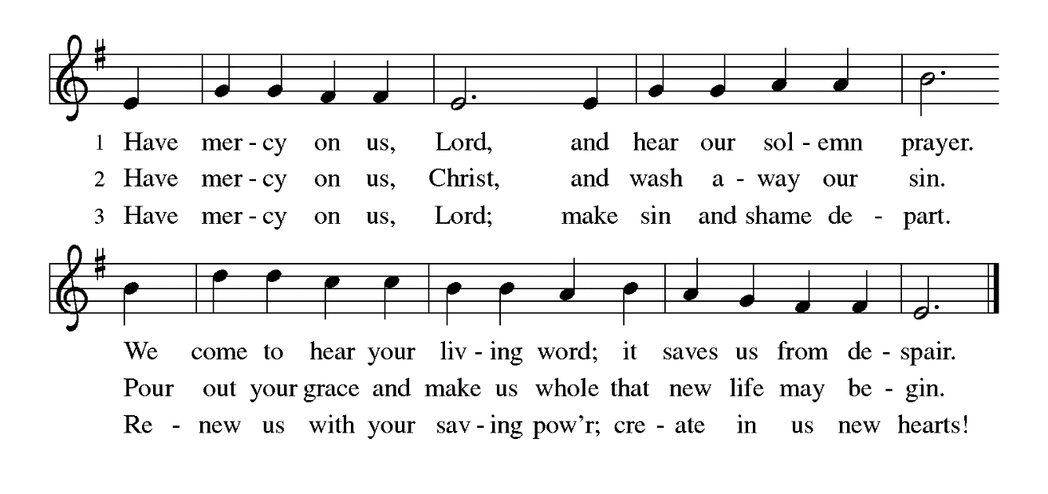

THE PRAYER OF THE DAY

P: The Lord be with you.

C: And also with you.

P: Let us pray. Merciful God, the Fountain of living water, You quench our thirst and
wash away our sin. Give us this water always. Bring us to drink from the well that
flows with the beauty of Your truth, through Your Son, Jesus Christ, our Savior and
Lord, Who lives and reigns with You and the Holy Spirit, one God, now and forever.

C: Amen.

The assembly is seated

WORD

FIRST READING Exodus 17: 1-7

Today's reading is one of several that tell of experiences during the wilderness wandering. In this case, the people complain because they have a legitimate need and God responds by providing for them. Later in their wanderings, when the people complain because of their wants, God responds with anger.

From the wilderness of Sin the whole congregation of the Israelites journeyed by stages, as the LORD commanded. They camped at Rephidim, but there was no water for the people to drink. ²The people quarreled with Moses, and said, "Give us water to drink." Moses said to them, "Why do you quarrel with me? Why do you test the LORD?"
³But the people thirsted there for water; and the people complained against Moses and said, "Why did you bring us out of Egypt, to kill us and our children and livestock with thirst?" ⁴So Moses cried out to the LORD, "What shall I do with this people? They are almost ready to stone me." ⁵The LORD said to Moses, "Go on ahead of the people, and take some of the elders of Israel with you; take in your hand the staff with which you struck the Nile, and go.
⁶I will be standing there in front of you on the rock at Horeb. Strike the rock, and water will come out of it, so that the people may drink." Moses did so, in the sight of the elders of Israel. ⁷He called the place Massah and Meribah, because the Israelites quarreled and tested the LORD, saying, "Is the LORD among us or not?"

The Word of the Lord.

Thanks be to God.

THE PSALM: Psalm 95 Antiphon by May Schwarz
Choir sings refrain first, followed immediately by the congregation
and as indicated

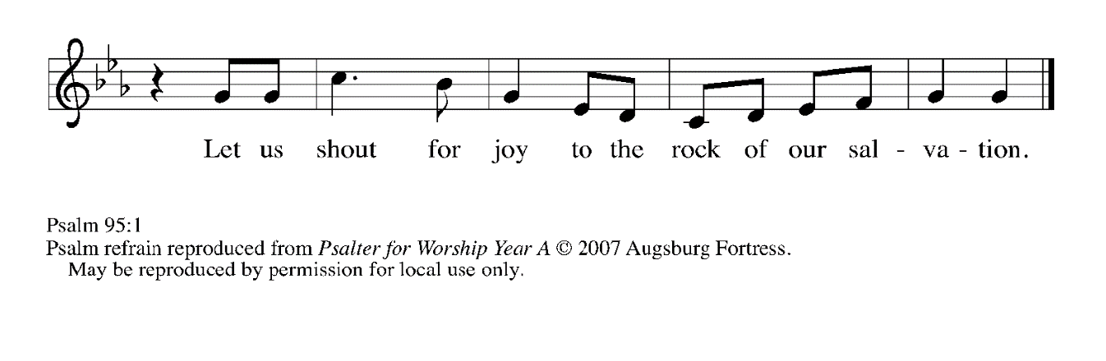
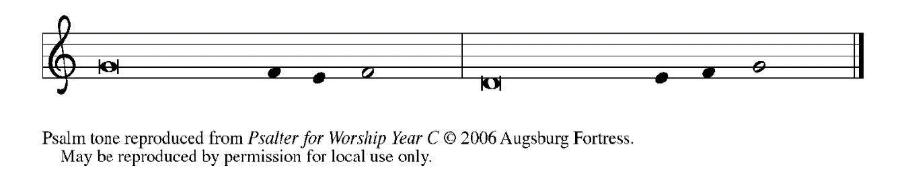

¹Come, let us sing | to the LORD;
let us shout for joy to the rock of | our salvation.

²Let us come before God's presence | with thanksgiving
and raise a loud shout to the | LORD with psalms.

³For You, LORD, | are a great God,
and a great ruler a- | bove all gods.

⁴In Your hand are the caverns | of the earth;
the heights of the hills are | also Yours.

⁵The sea is Yours, | for You made it,
and Your hands have molded | the dry land.

⁶Come, let us worship | and bow down,
let us kneel before the | LORD our maker. REFRAIN

⁷For the LORD is our God, and we are the people of God's pasture
and the sheep | of God's hand.
Oh, that today you would | hear God's voice!

⁸"Harden | not your hearts,
as at Meribah, as on that day at Massah | in the desert.
⁹There your ancestors | tested Me,
they put Me to the test, though they had | seen My works.

¹⁰Forty years I loathed that gener- | ation, saying,
'The heart of this people goes astray; they do not | know My ways.'

¹¹Indeed I swore | in My anger,
'They shall never come | to My rest.'" REFRAIN

SECOND READING Romans 5: 1-11

Through Jesus' death on the cross, sinners have been put right with God through faith. But being made right with God produces results--ultimately, sure hope for the future produced by God's Spirit.

Since we are justified by faith, we have peace with God through our Lord Jesus Christ, ²through Whom we have obtained access to this grace in which we stand; and we boast in our hope of sharing the glory of God. ³And not only that, but we also boast in our sufferings, knowing that suffering produces endurance, ⁴and endurance produces character, and character produces hope, ⁵and hope does not disappoint us, because God's love has been poured into our hearts through the Holy Spirit that has been given to us.
⁶For while we were still weak, at the right time Christ died for the ungodly. ⁷Indeed, rarely will anyone die for a righteous person--though perhaps for a good person someone might actually dare to die. ⁸But God proves His love for us in that while we still were sinners Christ died for us.
⁹Much more surely then, now that we have been justified by His blood, will we be saved through Him from the wrath of God. ¹⁰For if while we were enemies, we were reconciled to God through the death of His Son, much more surely, having been reconciled, will we be saved by His life. ¹¹But more than that, we even boast in God through our Lord Jesus Christ, through Whom we have now received reconciliation.

The Word of the Lord.

Thanks be to God.

As you are able please rise

THE VERSE

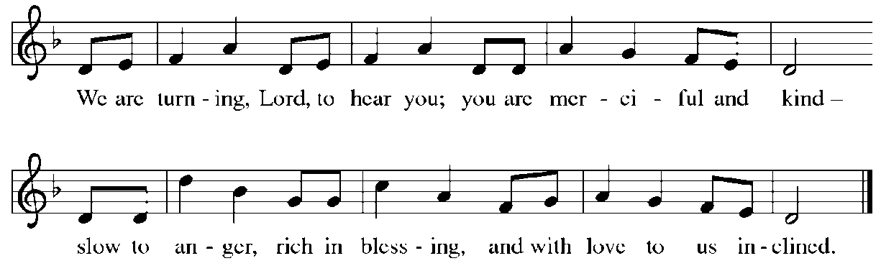

THE HOLY GOSPEL John 4: 5-42

In the culture of Jesus' time, Judeans tended to avoid dealings with Samaritans, and men did not converse with women in public. When Jesus crosses these boundaries to speak with a Samaritan woman, He makes Himself known as the agent of God Who knows all.

P: The Holy Gospel according to St. John, the fourth chapter.

C: Glory to You, O Lord!

[Jesus] came to a Samaritan city called Sychar, near the plot of ground that Jacob had given to his son Joseph. ⁶Jacob's well was there, and Jesus, tired out by His journey, was sitting by the well. It was about noon.
⁷A Samaritan woman came to draw water, and Jesus said to her, "Give me a drink." ⁸(His disciples had gone to the city to buy food.) ⁹The Samaritan woman said to Him, "How is it that you, a Judean, ask a drink of me, a woman of Samaria?" (Judeans do not share things in common with Samaritans.)
¹⁰Jesus answered her, "If you knew the gift of God, and Who it is that is saying to you, 'Give me a drink,' you would have asked Him, and He would have given you living water." ¹¹The woman said to Him, "Sir, you have no bucket, and the well is deep. Where do you get that living water? ¹²Are you greater than our ancestor Jacob, who gave us the well, and with his sons and his flocks drank from it?"
¹³Jesus said to her, "Everyone who drinks of this water will be thirsty again, ¹⁴but those who drink of the water that I will give them will never be thirsty. The water that I will give will become in them a spring of water gushing up to eternal life." ¹⁵The woman said to Him, "Sir, give me this water, so that I may never be thirsty or have to keep coming here to draw water."
¹⁶Jesus said to her, "Go, call your husband, and come back." ¹⁷The woman answered Him, "I have no husband." Jesus said to her, "You are right in saying, 'I have no husband'; ¹⁸for you have had five husbands, and the one you have now is not your husband. What you have said is true!"
¹⁹The woman said to Him, "Sir, I see that you are a prophet. ²⁰Our ancestors worshiped on this mountain, but you say that the place where people must worship is in Jerusalem." ²¹Jesus said to her, "Woman, believe Me, the hour is coming when you will worship the Father neither on this mountain nor in Jerusalem. ²²You worship what you do not know; we worship what we know, for salvation is from the Judeans.
²³But the hour is coming, and is now here, when the true worshipers will worship the Father in spirit and truth, for the Father seeks such as these to worship Him. ²⁴God is spirit, and those who worship Him must worship in spirit and truth." ²⁵The woman said to Him, "I know that Messiah is coming" (who is called Christ). "When He comes, He will proclaim all things to us." ²⁶Jesus said to her, "I am He, the One Who is speaking to you."
²⁷Just then His disciples came. They were astonished that He was speaking with a woman, but no one said, "What do you want?" or, "Why are You speaking with her?" ²⁸Then the woman left her water jar and went back to the city. She said to the people, ²⁹"Come and see a man Who told me everything I have ever done! He cannot be the Messiah, can he?" ³⁰They left the city and were on their way to Him.
³¹Meanwhile the disciples were urging Him, "Rabbi, eat something." ³²But He said to them, "I have food to eat that you do not know about." ³³So the disciples said to one another, "Surely no one has brought Him something to eat?" ³⁴Jesus said to them, "My food is to do the will of Him Who sent Me and to complete His work. ³⁵Do you not say, 'Four months more, then comes the harvest'? But I tell you, look around you, and see how the fields are ripe for harvesting.
³⁶The reaper is already receiving wages and is gathering fruit for eternal life, so that sower and reaper may rejoice together. ³⁷For here the saying holds true, 'One sows and another reaps.' ³⁸I sent you to reap that for which you did not labor. Others have labored, and you have entered into their labor."
³⁹Many Samaritans from that city believed in him because of the woman's testimony, "He told me everything I have ever done." ⁴⁰So when the Samaritans came to Him, they asked Him to stay with them; and He stayed there two days. ⁴¹And many more believed because of His word. ⁴²They said to the woman, "It is no longer because of what you said that we believe, for we have heard for ourselves, and we know that this is truly the Savior of the world."

P: The Gospel of the Lord.

C: Praise to You, O Christ!

The assembly is seated

THE SERMON

Silence for reflection follows the sermon

As you are able please rise

THE HYMN OF THE DAY Before the Waters Nourished Earth
(Stanza 2 - women; Stanza 3 – men)
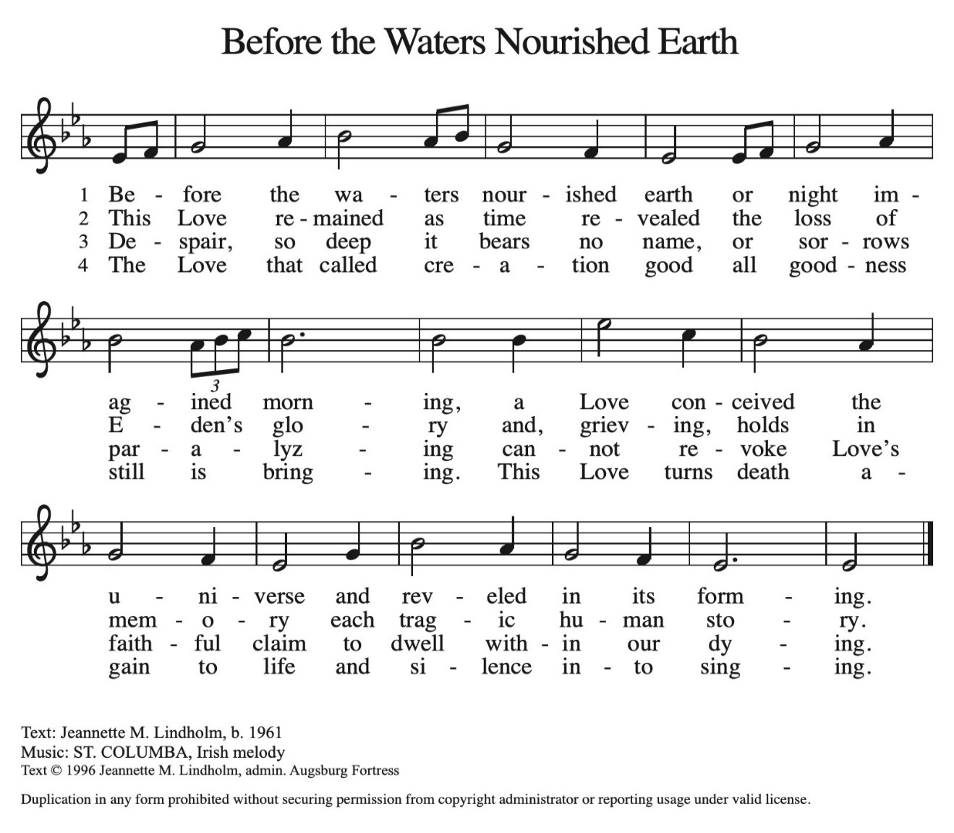
THE NICENE CREED
A: God has made us His people through our Baptism into Christ. Living together in trust
and hope, we confess our faith.

We believe in one God,
the Father, the Almighty,
maker of heaven and earth,
of all that is, seen and unseen.

We believe in one Lord, Jesus Christ,
the only Son of God,
eternally begotten of the Father,
God from God, Light from Light,
true God from true God,
begotten, not made,
of one Being with the Father.
Through Him all things were made.
For us and for our salvation
He came down from heaven;
by the power of the Holy Spirit
He became incarnate from the virgin Mary, and was made man.
For our sake He was crucified under Pontius Pilate;
He suffered death and was buried.
On the third day He rose again
in accordance with the Scriptures;
He ascended into heaven
and is seated at the right hand of the Father.
He will come again in glory to judge the living and the dead,
and His kingdom will have no end.

We believe in the Holy Spirit, the Lord, the giver of life,
Who proceeds from the Father and the Son.
With the Father and the Son He is worshiped and glorified.
He has spoken through the prophets.
We believe in one holy catholic and apostolic Church.
We acknowledge one Baptism for the forgiveness of sins.
We look for the resurrection of the dead,
and the life of the world to come. Amen

THE PRAYER OF THE CHURCH

A: Let us pray to God, Whose love has been poured into our hearts through the Holy Spirit
that has been given to us, for the Church, the world, and all those who thirst for Jesus,
the Living Water.

A: That in the wilderness of the world the Church may be the rock of God, providing the
waters of life to all who thirst, let us pray to the Lord:

C: Lord, have mercy.

A: That those preparing for Baptism might grow in faith, love, and obedience to the will
of God, let us pray to the Lord:

C: Lord, have mercy.

A: That the millions facing famine and starvation in North Korea, Somolia, Kenya,
Tanzania, Ethiopia, and other countries in East Africa might find relief, help, and hope
from humanitarian agencies and the generosity of the world community, let us pray to
the Lord:

C: Lord, have mercy.

A: That this assembly might be refreshed this Day by the living water of our Baptism to
faithfully work in God’s harvest, let us pray to the Lord:

C: Lord, have mercy.

A: That those who thirst for the grace only Christ can give, the hungry for God’s goodness,
and the sick, especially: Bill Homan; Tim Miller; Rob Steinborn; David Jocelyn;
Ed Lotts; Elizabeth Saunders; Kathy Stein; Major Payne; Martha Schroeder;
Jackie Gaines; Carl Wipperman; Shirley Shikany Long; John Bennitt and Debbie
Martin might be quenched, filled, and healed, let us pray to the Lord:

C: Lord, have mercy.

A: That those celebrating birthdays, especially Jean Warner; and anniversaries,
especially Mike and Barb Fulkerson might grow in grace this day and every day and
be filled with grace for the days ahead, let us pray to the Lord:

C: Lord, have mercy.

A: That with the baptized who have gone before us, especially Perpetua and Felicity and
companions, martyrs, whom we commemorate this Day we might live and worship
in Spirit and truth until we see God face-to-face, let us pray to the Lord:

C: Lord, have mercy.

P: Pour Your love into our hearts, O God of peace. Give us joy in our suffering, endurance
in trials, character in times of weakness, and hope in adversity. So may we live in You:
Father, Son, and Holy Spirit, one God, forever and ever.

C: Amen.

MEAL

THE PEACE

P: Through Christ we have been reconciled to God, Who has given us the ministry of
reconciliation. Let us be reconciled with one another.

The peace of the Lord be with you always.

C: And also with you.

The assembly is seated

THE OFFERING

THE VOLUNTARY Living Water St. Paul Senior Choir
(Emily Crocker)

As you are able please rise

THE OFFERTORY (see p. 11) Create in Me a Clean Heart
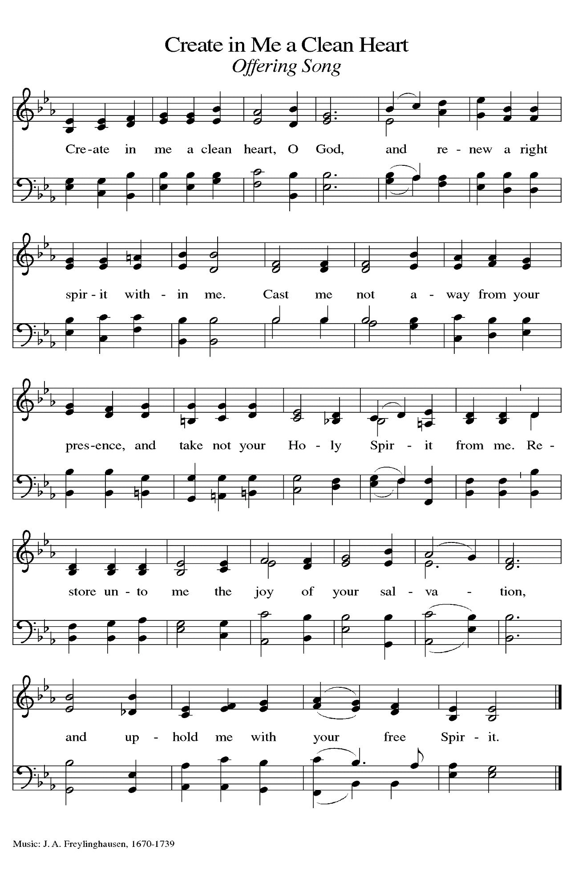
THE OFFERTORY PRAYER

A: Let us pray. God of mercy,

C: You are the Rock of our salvation. With these gifts we bow our hearts and lives
to You in praise and thanksgiving. Receive all we offer You, and bring us now to
the Living Water, Jesus Christ our Lord. Amen.

THE GREAT THANKSGIVING

P: The Lord be with you.

C: And also with you.

P: Lift up your hearts.

C: We lift them up to the Lord.

P: Let us give thanks to the Lord our God.

C: It is right to give Him thanks and praise.

P: It is indeed right, our duty, and our joy … join their unending hymn:

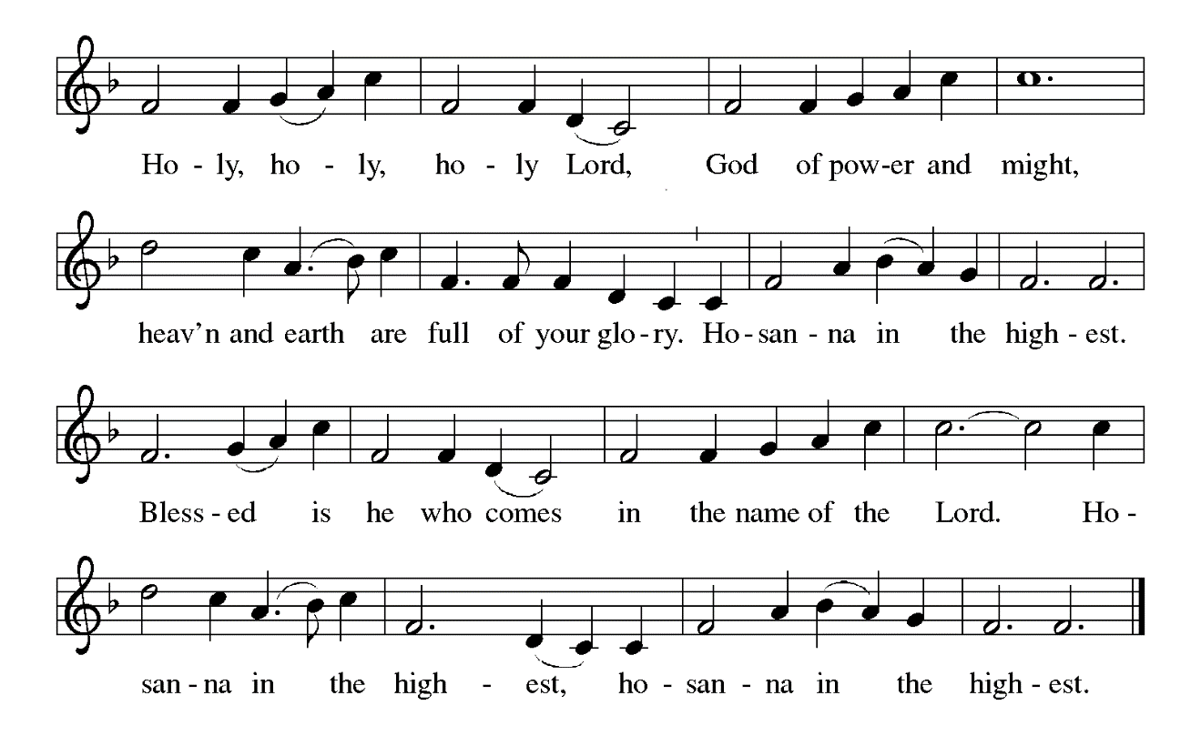

P: Living God, You created all things out of nothing; You called a people out of the desert;
You sent Your Son to us when we were hard-hearted and far from Your grace;
and You send Your Holy Spirit to us today despite our foolishness and forget-
fullness.
Through Your servant Moses You drew water out of the rock, and in Your Son Jesus
You brought living water that we might never be thirsty again.
Out of Your Son’s pierced side on the cross flowed water and blood, and in the glory
of His resurrection we are baptize into wondrous forgiveness and everlasting
life with You.

Overflowing God, in You we discover that all our striving and thirsting are truly a
Striving and thirsting for You, and in all our desert wanderings we find that only
You can satisfy.
Come among us in the power of Your Holy Spirit, that Your people may taste Your
living water,
And that these gifts of bread and wine may become for us the Body and Blood of Your
Son Jesus Christ,
Who, in the night … “Do this for the remembrance of Me.”
As often as we eat ... we proclaim the Lord’s death until He comes.

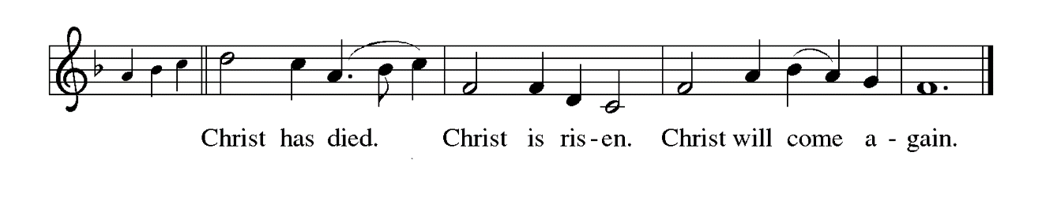

P: Cleansing God, bring the healing power of Your living water to visit with all who labor
with disease today.
Pour the refreshment of Your living water to invigorate all who are weary.
Send the momentum of Your living water to roll down justice like a never-failing
stream.
Make us, Your Church, a fountain of Your living water, until the Day when hunger and
thirst are no more,
And we live Your life abundant with the communion of saints, and You are all in all,
In the presence and companionship of Your Holy Trinity,
Father, Son, and Holy Spirit, ever one God.



THE LORD’S PRAYER

P: While we were still sinners, Christ died for us, that, with confidence in God’s love for
us, we might dare to pray:

C: Our Father, Who art in heaven, hallowed be Thy Name. Thy Kingdom come, Thy
will be done on earth as it is in heaven. Give us this day our daily bread, and
forgive us our trespasses as we forgive those who trespass against us. And lead us
not into temptation but deliver us from evil. For Thine is the Kingdom, and the
power, and the glory, forever and ever. Amen.

INVITATION TO THE MEAL

P: Behold our Savior Christ Jesus, Who abolished death and brought life through the
Gospel. Blessed are those called to the Banquet of the Lamb. God’s holy gifts for
God’s holy people. Come, for all is now ready.

The assembly is seated

THE DISTRIBUTION O Lamb of God

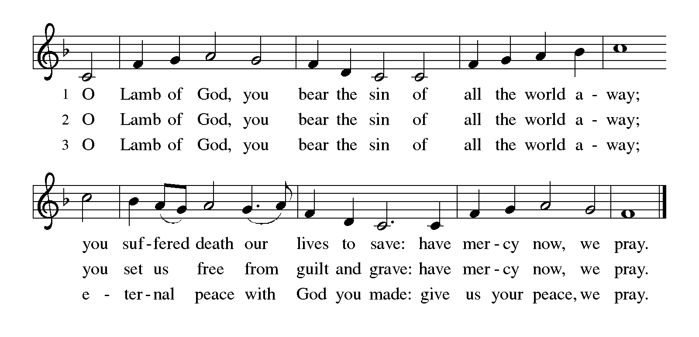

Those wishing to receive the Laying on of Hands, Anointing with Oil and Prayer for Healing may go to Pastor at the side aisle

HYMN DURING DISTRIBUTION 611 I Heard the Voice of Jesus Say

ELW 623 Rock of Ages Cleft for Me

NSB 81 Spirit Song

NSB 75 Rock of My Salvation

NSB 50 I Exalt thee

As you are able please rise

THE POST-COMMUNION BLESSING

P: The Body and Blood of our Lord Jesus Christ strengthen you and keep you in His grace.

C: Amen.

THE POST-COMMUNION PRAYER

A: Let us pray. God of our pilgrimage, once again in this Meal You have poured Your
love into our hearts. Refresh and sustain us as we go forth on our journey. Grant us
the confidence to know that You are among us, leading us one day to share in Your
glory, through Your Son, Jesus Christ our Lord.

C: Amen.

SENDING
THE BENEDICTION

P: Jesus took the form of a servant and was obedient to death, even death on a cross. May
you follow His example and share in the resurrection.

C: Amen.

P: Almighty God: Father, Son, and Holy Spirit bless you now and forever.

C: Amen.

SENDING SONG 866 We Are Marching in the Light

THE DISMISSAL

A: Reconciled to God through Christ, let us go out into the world in peace.

C: Thanks be to God!

THE POSTLUDE

To God Alone Be Glory

The Meditation is from Sundays and Seasons Online. Copyright 2016 Augsburg Fortress.

The Greeting, Prayers, Peace, Offertory, Post-Communion, and Dismissal are adapted
from Sundays and Seasons. Copyright 2001 Augsburg Fortress.

The Eucharistic Prayer is adapted from With One Voice: Leader’s Edition. (Minneapolis:
Augsburg Fortress, 1995) 68.

The Prayers, Introduction to the Lord’s Prayer, and Invitation to the Meal are adapted from
Prayers for Sundays and Seasons. Year A. Peter J. Scagnelli. (Chicago: Liturgy Training Publications, 1998) 34-35.

THANK YOU FROM MEALS ON WHEELS TEAM
Dear St. Paul Church,
We were so very excited to receive your generous donation. It will allow us to get the new cooler bags we very much need. Your gift will assist us in saving hot, healthy meals to our clients and we couldn’t be more grateful. Thank You!
The Meals on Wheels Team
(note: we were able to donate $1,091 to Meals on Wheels in February)

ANNOUNCEMENTS

Please remember to mail your offering to the Church Office at 818 Franklin Street, Michigan City, IN 46360. Another alternative is to give on-line through Tithe.ly. Please see your closure letter for information on how to set up a Tithe.ly account.

St. Paul Members are reminded to have a loved one contact the office if you are hospitalized. Many times, the Pastor doesn’t know someone is in the hospital. If you call and leave a message, please tell us at which hospital the patient is located.

BIRTHDAYS: Jean Warner (3/14)

ANNIVERSARIES: Barbara & Mike Fulkerson (3/9)

PRAYER CONCERNS: John Bennitt; Debbie Martin; Mark Tannehill; Kathy Stein; Jan Paholski; Laura Dovey; Bill Hazelgrove; Al Levenhagen; Carl Wipperman; Major Payne; Elizabeth Saunders; and Tim Miller.

OFFICE HOURS: Libby will be in the office on Mondays, Wednesdays, and Fridays; volunteers will cover Tuesdays and Thursdays.

Monday & Wednesday 8:00 a.m. – 5 p.m.
Tuesday & Thursday 9:00 a.m. – 12:00 p.m.
Friday 8:00 a.m. – 12:00 p.m.

If you are listening to the worship broadcast on the radio and would like to watch the Sunday morning service live stream follow these steps:

(1) If you have You Tube available on your TV, search for
St. Paul Lutheran Church Michigan City, IN.

(2) The direct link on the computer is https://
www.youtube.com/channel/UC5AIPNaKr3QN50984jGOa1g

(3) This link is also on the main page of the church’s website in
the church section and will continue to be posted weekly on the St.
Paul Facebook page.

And it will always be available on the radio broadcast Sunday mornings at 11:00 a.m.
on WEFM (95.9), and on the local cable access station #99 for the previous week’s
service on Sundays at 4:00 p.m. and the current service on Wednesdays at 7:00 p.m.
and Fridays at 8:30 p.m.

To send e-mail to the church office, please use the following addresses:

Pastor Mark Reshan: seniorpastor@stpaulmichigancity.com

Church Office Secretary (Libby Pollock): churchsecretary@stpaulmichigancity.com

Church Treasurer (Karen Fleming): finance@stpaulmichigancity.com

2026 Church Council:

Pastor - Mark Reshan

President - Donna Knoll

Vice President - Jan Bakken

Secretary - Judy Hunt

Treasurer - Karen Fleming

Members: Sue Koziel; Jim Schraidt; Trish Sprague; Bob Kiser; Barry Anderson; and
Pam Soule

Worship Attendance:

Wednesday, February 25, 2026 @ 7:00 p.m. 28

Saturday, February 28, 2026 @ 4:00 p.m. 27

Sunday, March 1, 2026 @ 9:00 a.m. 67

TOTAL 122

Copies of the minutes from the December 18, 2025 Church Council meeting are on the back table in the upper Narthex. It was approved by the council via email.

The Good News Newsletter: If you have an article or anything you want included in The Good News please send it to the following e-mail address: splcgoodnews@gmail.com. Pastor Pamela Thiede will be using this e-mail address to assemble The Good News each month. The deadline for getting information to Pastor Pamela will be the 20th of each month.

Next week’s lessons are I Samuel 16: 1-13; Psalm 23; Ephesians 5: 8-14 and John 9:
1-41 for those of you who like to study them in advance.

SNOW EMERGENCY LIST

This is a reminder of where to turn to learn if worship has been canceled because of inclement weather conditions. There are two ways to learn about the status of the service.
First, you may turn to our church and school Facebook page: https://www.facebook.com/stpaulmichigancity/ for updated announcements. Or, perhaps most quickly and easily, you may call the church office number (219-874-7293) and press the “#” key and you will hear a recording about our “open/closed” status.

2026 Financial Stewardship

Weekly Church Operating Needs (x 2 weeks)
February 21-22 & February 28 & March 1, 2026 $ 12,141.00

General Fund (including General Memorials): $ 19,839.00

Overage/Shortage: + $ 7,698.00

Restricted Income (not including Memorials)
Supports IK Synod & Church wide Ministries: $ 445.00

Ministries in our Community/Congregation: $ 205.00

Capital Fund: $ 155.00

Memorials
General Fund: $ 480.00

MISSION OF THE MONTH for MARCH 2026:

7th & 8th Grade STEAM Learning Opportunities
Daisy Lee is an extraordinary 7th and 8th grade environmental science teacher in our community. Every year, along with a few other extraordinary people, Daisy takes 30-40 girls to Indianapolis in January for the Sycamore STEAM Conference for Girls. This allows the girls to get hands on experience in various STEAM careers. They learn how everything functions in a real cadaver arm, how to do different types of stitches in a pig’s foot with Dermatologists, drill into arm bones and secure metal rods with Orthopedic Surgeons, create nutrition plans with Nutritionists, dissect cow hearts with Cardiologists, dissect sheep brains with Neurologists, code robots with IT specialists, and so much more!

Daisy also has a trip in May where she takes 70 students (at $110 each) on a 3 day, two night trip to the Dunes learning Center in Chesterton. Students will engage in hands on investigations of local ecosystems in this STEM and service – themed program. Participants learn and practice research procedures used by professional scientists such as quadrant surveys and chemical water monitoring to gather and analyze data and participate in stewardship activities within the park. Biodiversity, ecosystems, sustainability and human impacts on the environment are explored through real conservation and natural resource management experiences. Activities include: Ecosystem Hike where students embark on a hike to learn about various ecosystems and research tools that scientists use to collect data. They will have the opportunity to practice using different tools. This hike gives students the information they need to create a research question they will apply in the field. Field investigations: Trail Groups will work together to collect data on their research questions out in the field. They will collect, record, and analyze the data to determine their findings. Field investigations Presentations: Trail Groups will be able to share their findings with their classmates, just as a scientist would share their research!

To help Daisy make these trips possible, please make checks payable to St. Paul and mark for Daisy Lee and place in the offering. Noisy coin for the month of March will also go to support Daisy’s trips. Thank you for your generosity each month!

EASTER PLANTS 2026

A variety of spring plants will be available to order for decorating St. Paul Church on Easter Morning! The varieties available will be Lily, Daffodil, Hyacinth, Tulip, Hydrangea and 10 inch Fern in hanging basket. Color choices and cost of plants are as follows:

Lily(white) $10.00
Daffodil (yellow) $9.00
Hyacinth (purple or pink) $9.00
Tulip (white, yellow, pink, or red) $9.00
Hydrangea (pink or purple/blue) $15.00
10 inch Hanging Fern Basket $15.00

Please specify your choice of plant and color when applicable.
Orders MUST be placed by Wednesday morning, March 25th.

Your order may be placed “In memory of or in honor of a Loved One.” Please call the church office at (219) 874-7293 to place your order. Or you can place your order in an envelope and title it ‘Easter Plants’ for ordering and place it in the offering. Remember you must specify what type of plant and what color, if applicable. All checks should be made out to St. Paul Church.

ACTIVITIES, EVENTS & MEETINGS
MARCH 2026

Saturday, March 7, 2026 @ 4:00 p.m. 3 Lent Worship Service/Sanctuary

Sunday, March 8, 2026 @ 9:00 a.m. 3 Lent Worship/Sanctuary with coffee after
Tuesday, March 10, 2026 from 11 a.m. – 10 p.m. GIVE BACK @ Holly’s Restau- rant & Pub
Wednesday, March 11, 2026 @ NO BIBLE STUDY TODAY
@ 10:00 a.m. God’s Purls
@ 4:00 p.m. Choir Rehearsal/Sanctuary
@ 5:00 P.M. Bell Choir Rehearsal
@ 6:00 p.m. Mid-week Lenten Service/Sanctuary
Saturday, March 14, 2026 NO WORSHIP SERVICE @ 4 p.m. TODAY

Sunday, March 15, 2026 @ 9:00 a.m. 4 Lent Worship/Sanctuary: celebrating
150 YEARS OF ST. PAUL LUTHERAN CHURCH with Banquet to follow
Wednesday, March 18, 2026 @ 9:15 a.m. Bible Study/Luther House
@ 10:00 a.m. God’s Purls/St. Paul Room
@ 4:30 p.m. Choir Rehearsal/Sanctuary
@6:00 p.m. Mid-week Lenten Service/Sanctuary
Saturday, March 21, 2026 @ 4:00 p.m. 5 Lent Worship Service/Sanctuary

Sunday, March 22, 2026 @ 9:00 a.m. 5 Lent Worship with Baptism/Sanctuary with coffee after
Monday, March 23, 2026 @ 2:00 p.m. Finance Meeting/Luther House
@3:00 p.m. Executive Board Meeting/Luther House
Wednesday, March 25, 2026 @ 9:15 a.m. Bible Study/Luther House
@10:00 a.m. God’s Purls/St. Paul Room
@4:30 p.m. Choir Rehearsal/Sanctuary
@6:00 p.m. Mid-week Lenten Service/ Sanctuary
Thursday, March 26, 2026 @ 3:00 p.m. Church Council Meeting/St. Paul Room
Saturday, March 28, 2026 @ 4:00 p.m. PASSION/PALM Saturday Worship/ Sanctuary

Thank$ for $haring
Thank you to all who participate in our Give-Back opportunities each month where we earn $$ to add to our Mission of the Month donations, from our congregation to those in our community who need our help! On Thursday, February 5th, we earned $200 from our Galveston Steak House GIVE BACK!
On Tuesday, March 10, 2026 we’re meeting at Holly’s Restaurant And Pub for our GIVE BACK from 11am—close. Here are two coupons—one for you and one for a friend.

