THE FIRST SUNDAY IN ADVENT
November 30. 2025

In a religious autobiography entitled Confessions, St. Augustine tells of hearing the singsong chant of a child intoning repeatedly, “Pick it up and read it.” Going back to Paul’s letters Augustine opened randomly to what we now designate as Romans 13: 13: “Put on the Lord Jesus Christ,” and this Romans passage is designated as our second Bible reading on this Advent Sunday.
As the days continue to darken earlier during this season, we are summoned to the light at the end of the Advent tunnel. That light is Christ: chiefly as he is to come in glory at the end, but also, prefigured, as that coming is, by his earthly coming as the Christ of Christmas. But for now, look for the coming one at an hour you do not expect him.

Gerald Sloyan

Face to face with our limits,
Blinking before the frightful
Stare of our frailty,
Promise rises
Like a posse of clever maids
Who do not fear the dark
Because their readiness
Lights the search.
Their oil
Becomes the measure of their love,
Their ability to wait—
An indication of their
Capacity to trust and take a chance.
Without the caution or predictability
Of knowing the day or hour,
They fall back on that only
Of which they can be sure:
Love precedes them,
Before it,
No door will ever close.

T.J. O’Gorman

In the Name of Jesus

INTRODUCTION

The new church year begins with a wake-up call: Christ is coming soon! In today's readings both Paul and Jesus challenge us to wake from sleep, for we know neither the day nor hour of the Lord's coming. Isaiah proclaims the day when God will gather all people on the holy mountain and there will be no more war or suffering. Though we vigilantly watch for the promised day of salvation, we wait for what we already have: Christ comes among us this day as the word and meal that strengthens our faith in the promises of God.

Andrew, Apostle

The first of the disciples to be called by Jesus, Andrew quickly began to bring others to the Savior, including Simon Peter. The Bible also shows him leading some Greeks to meet Jesus, and he brought forward the boy with five loaves and two fish, with which Jesus fed thousands.

GATHERING

PRELUDE

ANNOUNCEMENTS

As you are able please rise

CONFESSION AND ABSOLUTION

P: In the name of the Father and of the Son and of the Holy Spirit.

C: Amen.

P: “ ...you know what time it is, how it is the moment for you to wake from sleep ... let us then
lay aside the works of darkness and put on the armor of light; let us live honorably ... put on
the Lord Jesus Christ.” (Romans 13: 11, 13-14) Let us confess the ways in which we need to
“lay aside the works of darkness” that God may fill us with the bright light of Christ’s mercy
and forgiveness.

Silence for self-examination and reflection is kept

P: Most merciful God,

C: We confess that we have sinned against You in thought, word, and deed. We need to be
awakened to Your call to live honorably and justly (Isaiah 2: 3). We are guilty of
quarreling and jealousy (Romans 13: 13). We have sought to satisfy our own desires
instead of seeking Your will and way. We have lived unaware, unconcerned, and
unprepared for Your return (Matthew 24: 42-43). For the sake of Your Son, Jesus
Christ, have mercy on us. Scatter the darkness of our hearts. Fill them with Your love
and life. Make us ready for Your advent.

P: In your Baptism you have already “put on the Lord Jesus Christ” (Romans 13: 14). Therefore,
the light of God’s forgiveness is yours. Put aside the darkness, and rejoice in this Good News:
as a called and ordained minister of the Church of Christ, and by His authority, I declare to you
the entire forgiveness of all your sins, in the name of the Father and of the Son and of the
Holy Spirit.

C: Amen.

GATHERING HYMN 260 The King Shall Come

THE GREETING
P: In days to come, God’s holy mountain shall be raised above the hills; all nations shall stream
to it.

C: Come, let us go up to the house of our God (Psalm 122: 1).

P: The grace of our Lord Jesus Christ, the love of God, and the communion of the Holy Spirit be
with you all.

C: And also with you.

THE KYRIE

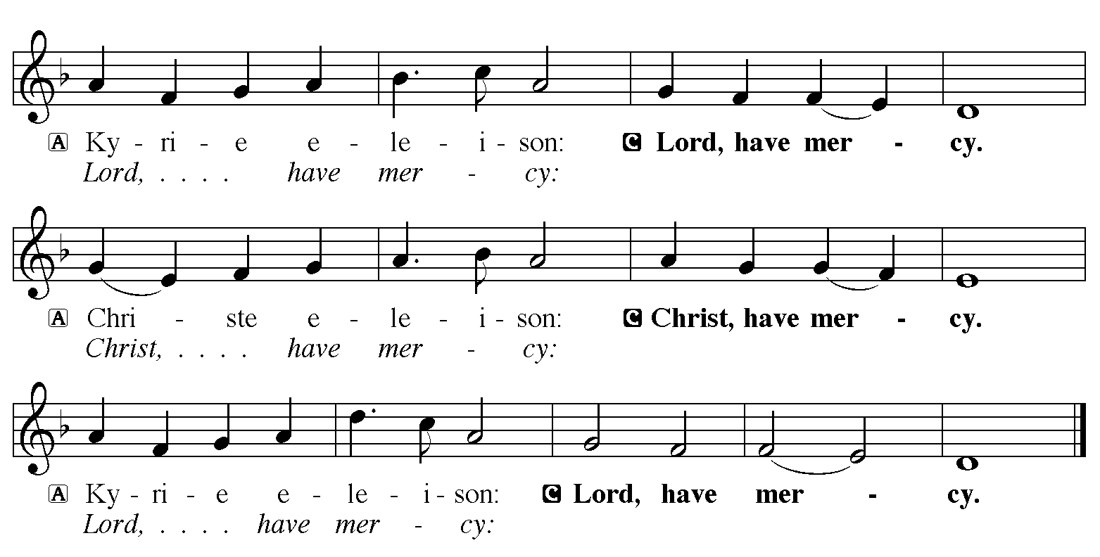

THE PRAYER OF THE DAY

P: The Lord be with you.

C: And also with you.

P: Let us pray. Stir up Your power, Lord Christ, and come. By Your merciful protection save us
from the threatening dangers of our sins, and enlighten our way in the way of Your salvation,
for You live and reign with the Father and the Holy Spirit, one God, now and forever.

C: Amen.

The assembly is seated

WORD

LIGHTING OF ADVENT LOG Christ, Be Our Light! St. Paul Senior Choir
(Joel Raney)
Stanza 1

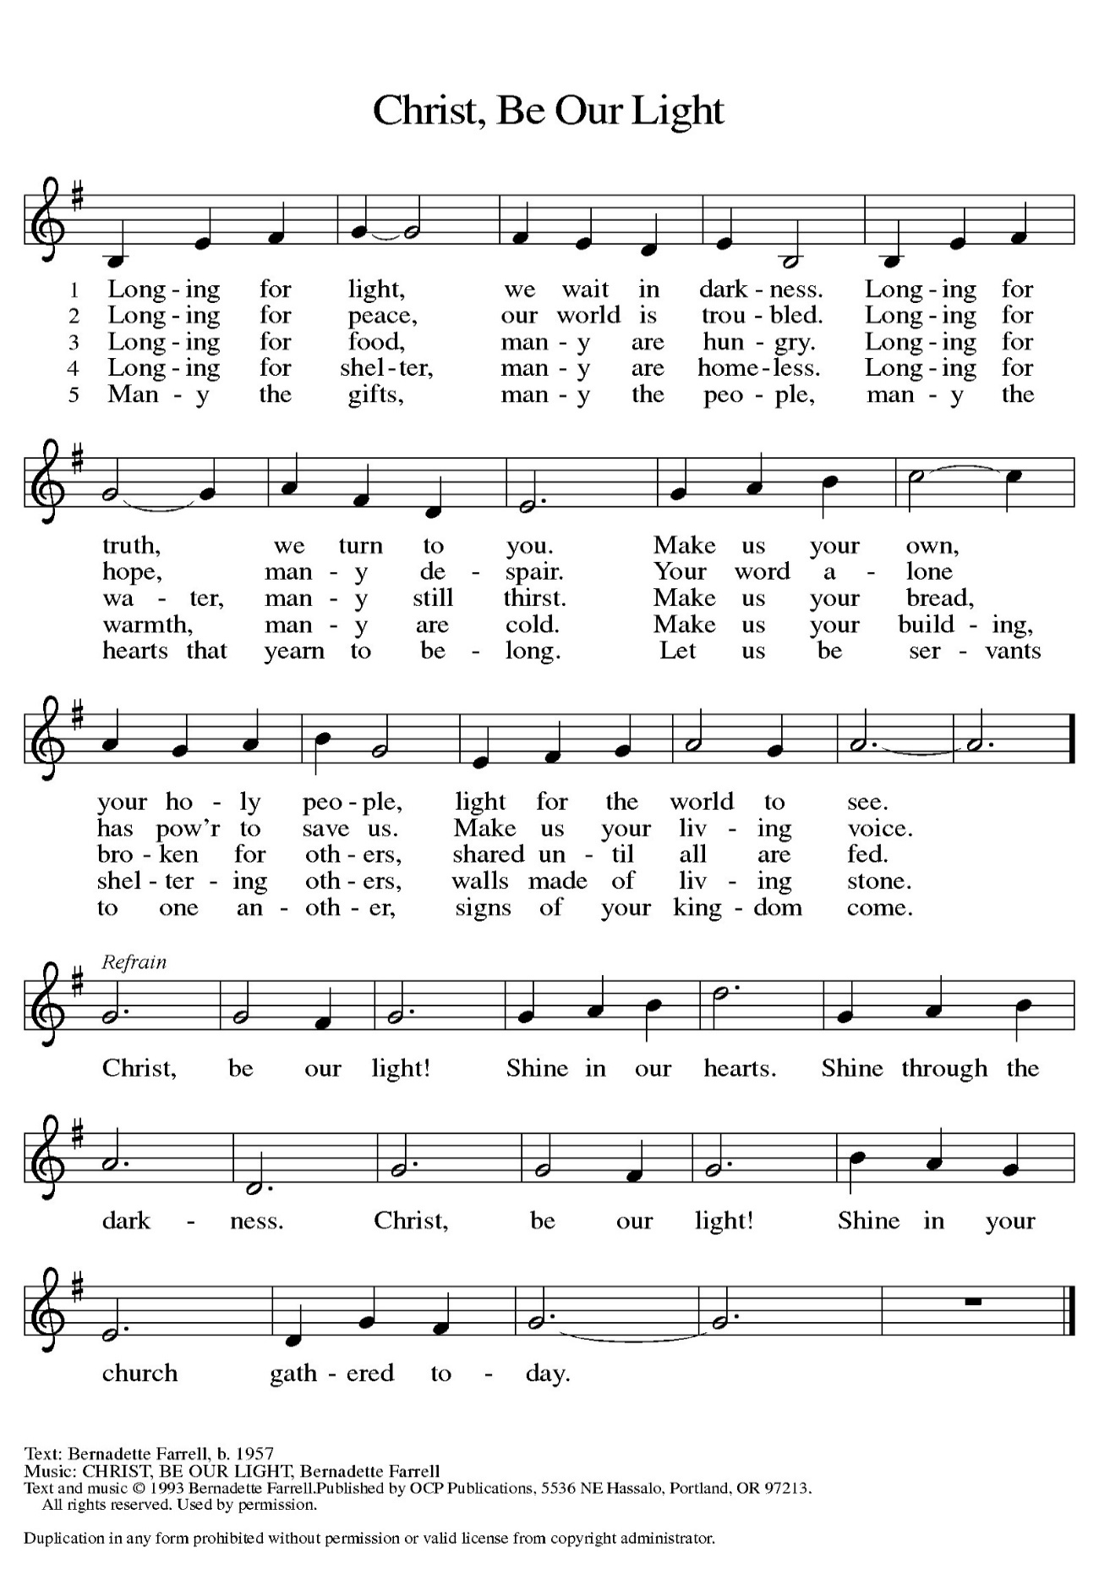

Hope for Those Who Wait

P: Advent is a time for the human heart to wait, while trusting in God’s eternal time.

C: How long, O Lord, how long?

P: For those waiting for answered prayer:

C: Grant Your steadfast patience.

P: For those waiting in the face of uncertainty:

C: Grant unshakeable confidence in Your sovereign provision.

P: For those waiting for justice and mercy to reign:

C: Grant a glimpse of Your glory in our wounded world.

P: For all of us waiting for God’s Kingdom to come:

C: Grant that we might have the peace of Christ as we wait, the love of Christ as we act, and
the grace of Christ as we speak.

(During the candle lighting)

P: This morning we light the first candle which reminds us that throughout history, God’s people
have spent time waiting, wandering, and wondering about the timing of God’s eternal plan.
Like the people of old, we long for God’s presence to illuminate the areas of life where we are
called to wait. This morning we echo the words of the Psalmist, “Wait for the Lord; be strong,
and let your hearts take courage; wait for the Lord!” (Psalm 27: 14)

(Repeat the refrain)

THE FIRST LESSON Isaiah 2: 1-5

The visionary message presented in this reading focuses on a future day when God establishes universal reign. At that time, the Lord will be recognized as God of all the earth. The prophet calls God's people to trust in the certainty of that reign even now.

The word that Isaiah son of Amoz saw concerning Judah and Jerusalem.
²In days to come
the mountain of the LORD's house
shall be established as the highest of the mountains,
and shall be raised above the hills;
all the nations shall stream to it.
³Many peoples shall come and say,
"Come, let us go up to the mountain of the LORD,
to the house of the God of Jacob;
that He may teach us His ways
and that we may walk in His paths."
For out of Zion shall go forth instruction,
and the word of the LORD from Jerusalem.
⁴He shall judge between the nations,
and shall arbitrate for many peoples;
they shall beat their swords into plowshares,
and their spears into pruning hooks;
nation shall not lift up sword against nation,
neither shall they learn war any more.
⁵O house of Jacob, come, let us walk in the light of the LORD!

The Word of the Lord.

Thanks be to God.

THE PSALM: Psalm 122 Antiphon by Robert Hobby
Choir sings refrain first, followed immediately by the congregation
and as indicated

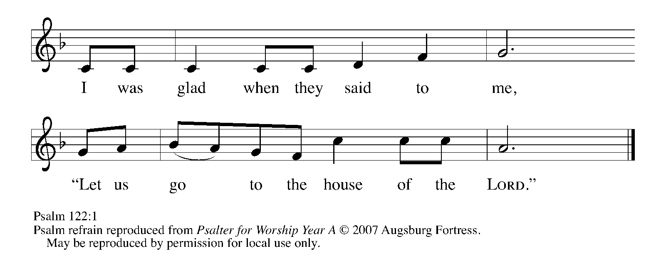

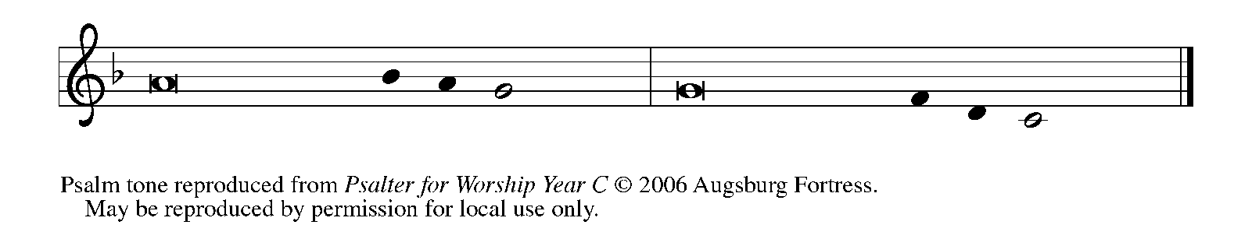

¹I was glad when they | said to me,
"Let us go to the house | of the LORD."

²Now our | feet are standing
within your gates, | O Jerusalem.

³Jerusalem is built | as a city
that is at unity | with itself;

⁴to which the tribes go up, the tribes | of the LORD,
the assembly of Israel, to praise the name | of the LORD. REFRAIN
⁵For there are the | thrones of judgment,
the thrones of the | house of David.

⁶Pray for the peace | of Jerusalem:
"May they pros- | per who love you.

⁷Peace be with- | in your walls
and quietness with- | in your towers.

⁸For the sake of my kindred | and companions,
I pray for | your prosperity.

⁹Because of the house of the | LORD our God,
I will seek to | do you good." REFRAIN

SECOND READING Romans 13: 11-14

Paul compares the advent of Christ to the coming of the dawn. We should anticipate his arrival and prepare for it as we would prepare to greet the new day.

Besides this, you know what time it is, how it is now the moment for you to wake from sleep. For salvation is nearer to us now than when we became believers; ¹²the night is far gone, the day is near. Let us then lay aside the works of darkness and put on the armor of light; ¹³let us live honorably as in the day, not in reveling and drunkenness, not in debauchery and licentiousness, not in quarreling and jealousy. ¹⁴Instead, put on the Lord Jesus Christ, and make no provision for the flesh, to gratify its desires.

The Word of the Lord.

Thanks be to God.

As you are able please rise

THE VERSE

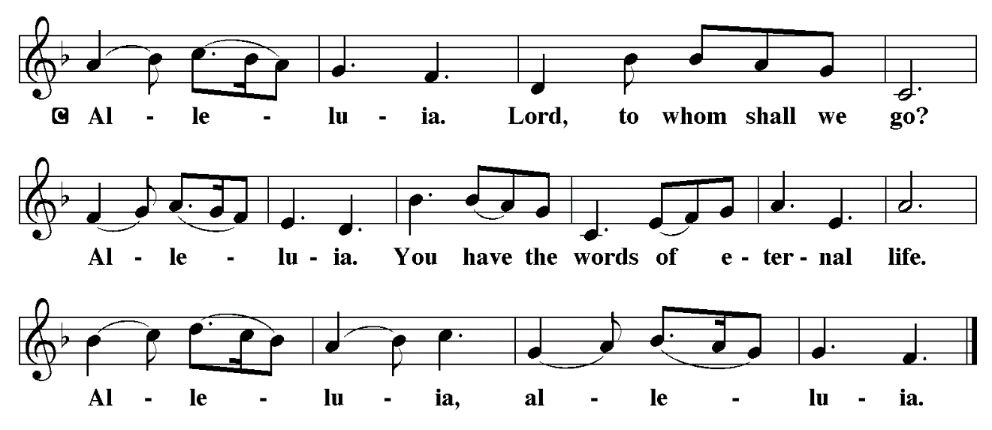

THE HOLY GOSPEL Matthew 24: 36-44

Jesus describes his second coming as a sudden unexpected event that will bring salvation or judgment upon people caught up in the usual affairs of daily life. Therefore, he urges people to be alert and expectant.

P: The Holy Gospel according to St. Matthew, the twenty-fourth chapter.

C: Glory to You, O Lord!

Jesus said to the disciples, "About that day and hour no one knows, neither the angels of heaven, nor the Son, but only the Father. ³⁷For as the days of Noah were, so will be the coming of the Son of Man. ³⁸For as in those days before the flood they were eating and drinking, marrying and giving in marriage, until the day Noah entered the ark, ³⁹and they knew nothing until the flood came and swept them all away, so too will be the coming of the Son of Man.
⁴⁰Then two will be in the field; one will be taken and one will be left. ⁴¹Two women will be grinding meal together; one will be taken and one will be left. ⁴²Keep awake therefore, for you do not know on what day your Lord is coming. ⁴³But understand this: if the owner of the house had known in what part of the night the thief was coming, he would have stayed awake and would not have let his house be broken into. ⁴⁴Therefore you also must be ready, for the Son of Man is coming at an unexpected hour."

P: The Gospel of the Lord.

C: Praise to You, O Christ!

The assembly is seated

THE SERMON

Silence for reflection follows the sermon

As you are able please rise

THE HYMN OF THE DAY 242 Awake, Awake and Greet the New Morn

THE NICENE CREED

A: God has made us His people through our Baptism into Christ. Living together in trust and
hope, we confess our faith.

We believe in one God,
the Father, the Almighty,
maker of heaven and earth,
of all that is, seen and unseen.

We believe in one Lord, Jesus Christ,
the only Son of God,
eternally begotten of the Father,
God from God, Light from Light,
true God from true God,
begotten, not made,
of one Being with the Father.
Through Him all things were made.
For us and for our salvation
He came down from heaven;
by the power of the Holy Spirit
He became incarnate from the virgin Mary, and was made man.
For our sake He was crucified under Pontius Pilate;
He suffered death and was buried.
On the third day He rose again
in accordance with the Scriptures;
He ascended into heaven
and is seated at the right hand of the Father.
He will come again in glory to judge the living and the dead,
and His kingdom will have no end.

We believe in the Holy Spirit, the Lord, the giver of life,
Who proceeds from the Father and the Son.
With the Father and the Son He is worshiped and glorified.
He has spoken through the prophets.
We believe in one holy catholic and apostolic Church.
We acknowledge one Baptism for the forgiveness of sins.
We look for the resurrection of the dead,
and the life of the world to come. Amen

THE PRAYER OF THE CHURCH

A: As the Day of the Lord Jesus draws near, we are called to be awake, alert, and watchful in
prayer.

A: Prepare the Church for Your advent, gracious God. Help us to grasp the urgency of the hour
in which we live, that we may be bold and courageous in our witness. O Giver of hope,

C: Hear our prayer.

A: Prepare the nations for Your advent, gracious God. Turn their weapons into instruments of
peace, so that they no longer learn war. O Giver of hope,

C: Hear our prayer.

A: Prepare this community for Your advent, gracious God. Teach us to live honorably, and to put
on Christ in all our speech and deeds. O Giver of hope,

C: Hear our prayer.

A: Prepare those who suffer for Your advent, gracious God. Encircle those who are ill, especially:
Major Payne; Robert Bernth; Carl Wipperman; Chuck Payne; Martha Schroeder; Joyce
Stark; Jackie Gaines; Debbie Martin; David Weiss; Fred Weiss; Shirley Shikany Long;
Shirley Freels; John Bennitt; Allen Sydow; and Lucas Bradshaw with peace and healing.
O Giver of hope,

C: Hear our prayer.

A: As the Day of the Lord draws near, keep us faithful that we may join the saints, especially
Andrew, Apostle whom we commemorate this Day in everlasting light. O Giver of hope,

C: Hear our prayer.

P: You have called us, O God, to be Your people and the instruments of Your presence in the
world. Grant us grace to discern Your will and the strength to do it, through Jesus Christ our
Lord.

C: Amen.

MEAL

THE PEACE

P: The peace of the Lord be with you always.

C: And also with you.

The assembly is seated

OFFERING

VOLUNTARY Bring Us Hope St. Paul Senior Choir
(R. Schram)

As you are able please rise

THE OFFERTORY (see p. 11) Let the Vineyards be Fruitful
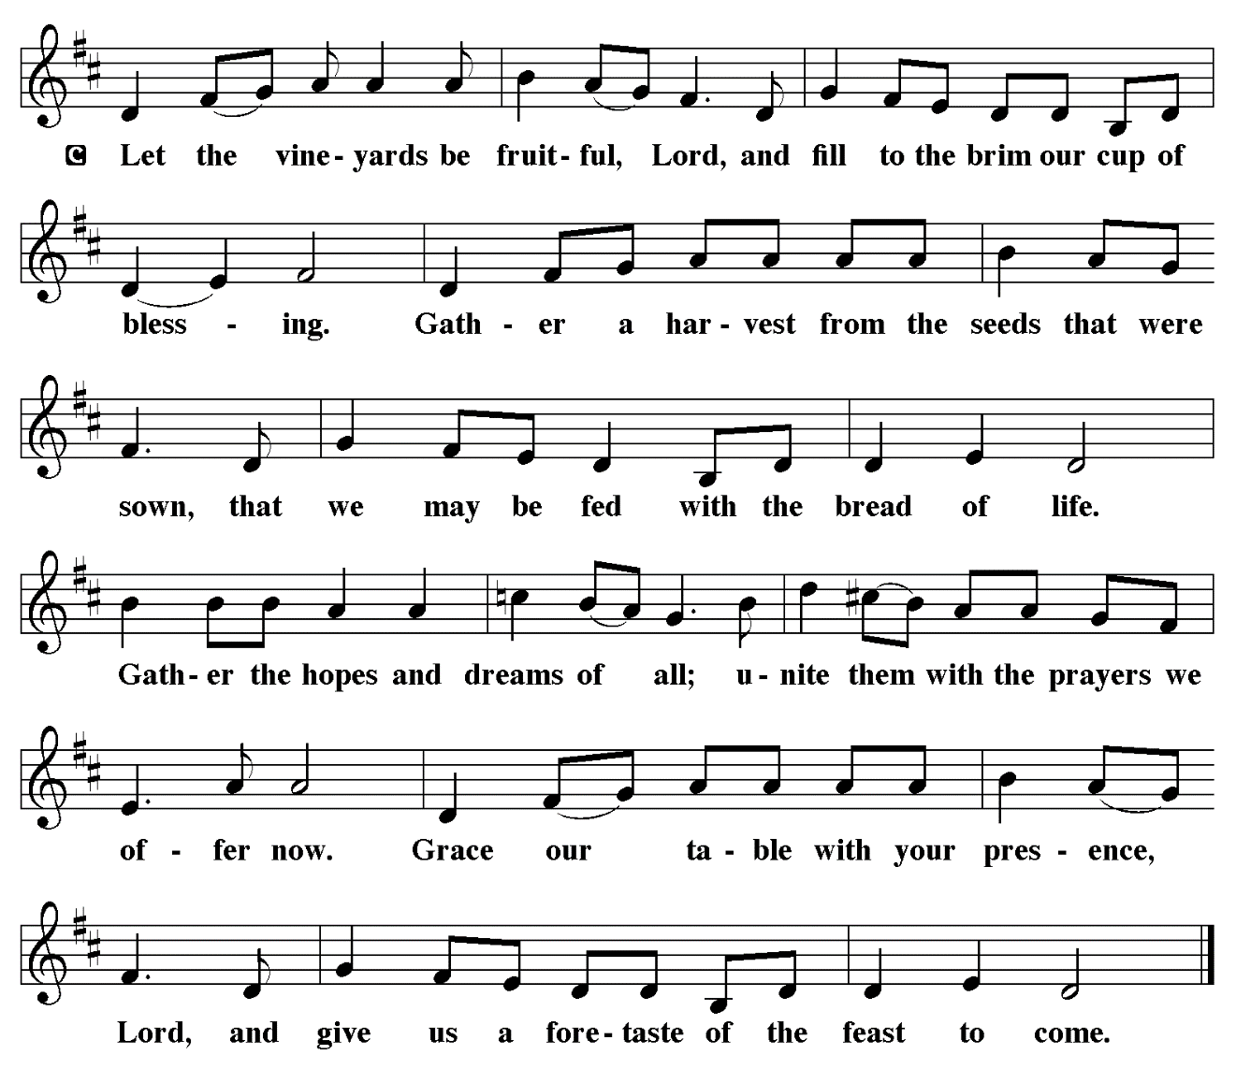

THE OFFERTORY PRAYER

A: Let us pray. God of love and power,

C: Your Word stirs within us the expectation of the coming of Your Son. Accept all we offer
You this Day, and by our eating and drinking, make us ready for the advent of Christ,
both now and in the age to come. We ask this in the name of Jesus the Lord. Amen.

THE GREAT THANKSGIVING

P: The Lord be with you.

C: And also with you.

P: Lift up your hearts.

C: We lift them up to the Lord.

P: Let us give thanks to the Lord our God.
C: It is right to give Him thanks and praise.

P: Covenant God, in the beginning You called Your creation good and flooded it with
beauty and bounty, with goodness and grace.
In the days of Noah You drowned Your creation to wash away sin and draw Your own
sons and daughters to Yourself.
Through Your covenant with Israel Your promises flowed to all nations, and in Jesus
Christ You drew us out of our waywardness into the relentless flood of Your
mercy.
His death was the drowning of our sin; His resurrection and ascension bless all nations
to stream toward You in glory.
Peacemaking God, in Christ You made an ending of the life of spears and swords, and
came to us with plowshares and pruning hooks, the tools of planting and
cultivating, that we might be fed.
In Him You showed us how to study war no more, how to lay down our swords and
shields, and how to feast with the Prince of Peace.
As You came to us to be our very food and drink, send Your Holy Spirit upon this bread
and cup, and make them be for us the Body and Blood of Your Son Jesus Christ;
Who, in the night ... “Do this for the remembrance of Me.”
As often as we eat ... we proclaim the Lord’s death until He comes.

C: Christ has died. Christ is risen. Christ will come again.

P: God of prophets and promises, as You turn swords into plowshares, take our sin and
reshape us for salvation.
Take our foolishness and bend us toward faith.
Take our hostility and refashion us for heaven in the crucible of Your love.
Stir Your Church with wakening hope, that soon and very soon we are going to see
our King.
Quicken our spirits with trust in that Day when we who have been blessed with such
hope will gather around Your throne with saints of every age, in praise and
thanksgiving to You,
One God: Father, Son, and Holy Spirit.

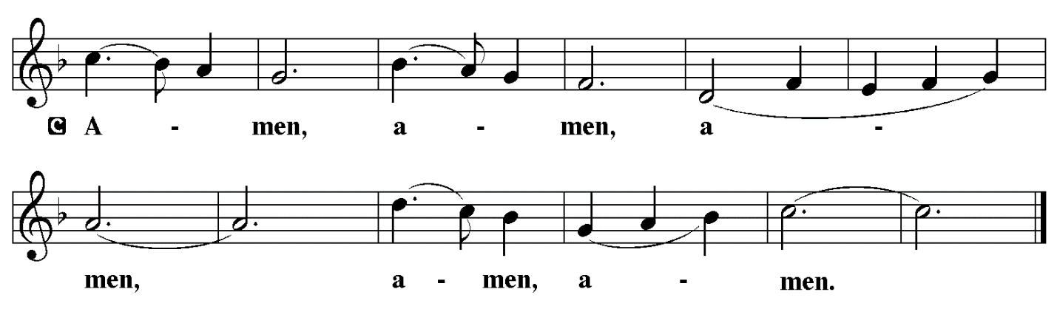

THE LORD’S PRAYER

P: Let us pray for the coming of God’s Reign as Jesus taught us:

C: Our Father, Who art in heaven, hallowed by Thy name.
Thy Kingdom come, Thy will be done on earth as it is in heaven.
Give us this day our daily bread, and forgive us our trespasses as we forgive those
who trespass against us.
And lead us not into temptation, but deliver us from evil.
For Thine is the Kingdom, and the power, and the glory, forever and ever. Amen.

INVITATION TO THE MEAL

P: Behold the Lord Whose advent we await, Who will come with glory on the Day of judgment.
Blessed are those who are called to the Supper of the Lamb. God’s holy gifts for God’s holy
people. Come, for all is now ready.

The assembly is seated

THE DISTRIBUTION

HYMN DURING DISTRIBUTION 244 Rejoice, Rejoice, Believers
ELW 243 Lost in the Night
ELW 250 Blessed Be the God of Israel
ELW 239 Hark, the Glad Sound

As you are able please rise

THE POST-COMMUNION BLESSING

P: The Body and Blood of our Lord Jesus Christ strengthen you and keep you in His grace.

C: Amen.

THE POST-COMMUNION PRAYER

A: Let us pray. Lord Jesus Christ, we recognize Your coming in this Sacrament. Teach us how
to keep awake and to watch for You through faithfulness, that Your advent may always make
us ready to stand before You with hope and joy. You are the Lord forevermore.

C: Amen.

SENDING
THE BENEDICTION

P: The Lord bless you and keep you. The Lord make His face shine on you and be gracious to
you. The Lord look upon you with favor and + give you peace.

C: Amen.

SENDING SONG 253 He Came Down

THE DISMISSAL

A: Go in peace. Walk in the light of the Lord.

C: Thanks be to God!

POSTLUDE

To God Alone Be Glory

The Meditations are from Sundays and Seasons. Year A. Copyright Augsburg Fortress 2016;
An Advent Sourcebook. T.J. O’Gorman, ed. (Chicago: Liturgy Training Publications,
1988) 33-4.

The Invitation to the Lord’s Prayer, the Prayers, and Holy Communion are from Prayers for
Sundays and Seasons. Year A. Peter J. Scagnelli. (Chicago: Liturgy Training Publications,
1998) 2-3.

The Rite for the Lighting of the Advent candle is from Sundays and Seasons. Year A. Copyright
Augsburg Fortress, 2014.

ANNOUNCEMENTS

Please remember to mail your offering to the Church Office at 818 Franklin Street, Michigan City, IN 46360. Another alternative is to give on-line through Tithe.ly. Please see your closure letter for information on how to set up a Tithe.ly account.

St. Paul Members are reminded to have a loved one contact the office if you are hospitalized. Many times, the Pastor doesn’t know someone is in the hospital. If you call and leave a message, please tell us at which hospital the patient is located.

BIRTHDAYS: Donna Ottersen (12/6); Judy Gleason (12/8)

PRAYER CONCERNS: Robert Bernth; Barry Anderson; John Bennitt; Sarah McNabb; Debbie Martin; Mark Tannehill; Kathy Stein; Jan Paholski; Laura Dovey; Grace Romine; Bill Hazelgrove; Al Levenhagen; Carl Wipperman; Major Payne; Carol Hazelgrove and Allen Sydow.

OFFICE HOURS: Libby will be in the office on Mondays, Wednesdays, and Fridays; volunteers will cover Tuesdays and Thursdays.

Monday & Wednesday 8:00 a.m. – 5 p.m.
Tuesday & Thursday 9:00 a.m. – 12:00 p.m.
Friday 8:00 a.m. – 12:00 p.m.

If you are listening to the worship broadcast on the radio and would like to watch the Sunday morning service live stream follow these steps:

(1) If you have You Tube available on your TV, search for
St. Paul Lutheran Church Michigan City, IN.

(2) The direct link on the computer is https://
www.youtube.com/channel/UC5AIPNaKr3QN50984jGOa1g.

(3) This link is also on the main page of the church’s website in
the church section and will continue to be posted weekly on the St.
Paul Facebook page.

And it will always be available on the radio broadcast Sunday mornings at 11:00 a.m.
on WEFM (95.9), and on the local cable access station #99 for the previous week’s
service on Sundays at 4:00 p.m. and the current service on Wednesdays at 7:00 p.m.
and Fridays at 8:30 p.m.

If you had a birthday in September, October or November we will be honoring your special day during the Coffee Hour after the Sunday service today November 30th. Not with cake and coffee but with Birthday Pie. You will want to come and enjoy a piece of pie with us.
To send e-mail to the church office, please use the following addresses:
Pastor Mark Reshan: seniorpastor@stpaulmichigancity.com
Church Office Secretary (Libby Pollock): churchsecretary@stpaulmichigancity.com
Church Treasurer (Karen Fleming): finance@stpaulmichigancity.com

2025 Church Council:

Mark Reshan - Pastor

Janet Bakken – President

Donna Knoll – Vice President

Judy Hunt – Secretary

Karen Fleming – Treasurer

Members: Paul Brooks, Diane Egilske, Sue Koziel, Judy Mutchler, Jim Schraidt, Trish Sprague

Worship Attendance:

Saturday, November 22, 2025 @ 4:00 p.m. 35

Sunday, November 23, 2025 @ 9:00 a.m. 55

TOTAL 90

Copies of the minutes from the October 23 2025 Church Council meeting are on the back table in the upper Narthex. It was approved by the council via email.

The Good News Newsletter: If you have an article or anything you want included in The Good News please send it to the following e-mail address: splcgoodnews@gmail.com. Pastor Pamela Thiede will be using this e-mail address to assemble The Good News each month. The deadline for getting information to Pastor Pamela will be the 20th of each month.

Sunday’s lessons are Isaiah 11: 1-10; Psalm 72: 1-7, 18-19; Romans 15: 4-13; and Matthew 3: 1-12 for those of you who like to study them in advance.

NOVEMBER MISSION OF THE MONTH

The Mission of the Month for November: Nest Community Shelter, located at the old Sacred Heart Church, is a nonprofit organization delivering temporary emergency shelter for the homeless men and women (including women with children) in our community. Nest provides not just shelter but food and other resources. Nest is always in need of the following items:

-Bedding - blankets, pillows, pillow cases

-Food items – sugar, breakfast cereal, coffee, coffee filters, creamer, non-perishable goods

-Dining – 8 oz. foam cups, 12 oz. foam bowls, 6” & 9” plates, plastic flatware, paper towels, paper napkins, plastic wrap, aluminum foil, gallon Ziploc bags, large serving gloves

-Kitchen – 55 gallon trash bags, dish soap

-Hygiene items – liquid hand soap, hand sanitizer, all purpose cleaner, feminine hygiene products, toilet paper

Donations of goods can be placed in the bin in the Narthex. Monetary donations can be marked for Nest and placed in the offering plate. Noisy coin offering will also go toward the mission of the month. Thank you for your help in providing for those in need in our community!

SNOW EMERGENCY LIST
This is a reminder of where to turn to learn if worship has been canceled because of inclement weather conditions. There are two ways to learn about the status of the service.
First, you may turn to our church and school Facebook page: https://www.facebook.com/stpaulmichigancity/ for updated announcements. Or, perhaps most quickly and easily, you may call the church office number (219-874-7293) and press the “#” key and you will hear a recording about our “open/closed” status.

December Mission of the Month – St. Paul Angel Tree

It’s beginning to look a lot like Christmas! We are starting our December mission a little early to ensure our gifts make it to their recipients by Christmas Day. A Mama’s Heart Ministry has provided us with names and wish lists of four children in our community who need assistance this Christmas. Please take a tag (or two) and shop for the item listed on the tag. Gifts can be returned wrapped or unwrapped, your preference. Please attach the angel tree tag to the gift. Toy tags have suggestions based on the child’s interests, but any age appropriate toy will do! Please return all gifts underneath the angel tree by Sunday, December 7th, to ensure everything can be delivered to the families by Christmas. Thank you for your generosity and Christmas spirit!

2025 Financial Stewardship

Weekly Church Operating Needs (x 2 weeks)
November 15-16, 2025; and November 22-23, 2025: $ 11, 070.00

General Fund (including General Memorials): $ 7,347.00

Overage/Shortage: — $ 3,723.00

Restricted Income (not including Memorials)
Supports IK Synod & Church wide Ministries: $ 130.00

Ministries in our Community/Congregation: $ 260.00

Capital Fund: $ 190.00

Memorials
General Fund: $ 35.00

Christmas Poinsettias

Time to place your order! Yes, it’s time to start thinking about purchasing a Christmas Poinsettia from St. Paul Church. Each plant will be a 7.5 inch pot with 4-11 blooms. You will have a choice in color between red, white, or ‘Jingle Bell’ which is a combination of red and white. If you do not specify a color, red will be chosen. Each plant will cost $15.00 and can be put “in memory of. . .” or “in honor of . . .” a loved one. Please place your order through the Church Office by calling (219) 874-7293; or place your information on an envelope with a check made out to the church, or cash, and place in offering plate.
All checks should be made out to St. Paul Church. All plants will be available to take home after the Christmas Eve Service. And all orders must be placed by Thursday, December 11th. The final count will be turned in that day!

HELP NEEDED FOR OUR LOCAL SALVATION ARMY

Due to the pause taken by all the programs sponsored by SNAP, our local Salvation Army has been swamped with people needing help. All of the items placed in the grocery store cart located on the upper southwest corner of the outer Narthex is taken to our Michigan City Salvation Army location. The cart has a large hippo asking you to help “fill ‘er up!” Whatever you can do to help is greatly appreciated.

ACTIVITIES, EVENTS & MEETINGS
December 2025

Sunday, November 30, 2025 @ 9:00 a.m. 1st Sunday in Advent Worship Service/ Sanctuary with Birthday Pie and coffee after service/St. Paul Room
Wednesday, December 3, 2025 @ 9:15 a.m. Bible Study/Luther House
@10:00 a.m. God’s Purls/St. Paul Room
@ 4:30 p.m. Choir Rehearsal/Sanctuary
Thursday, December 4, 2025 FAITH CIRCLE/Green Room
Saturday, December 6, 2025 @ 4:00 p.m. 2nd Saturday in Advent Worship Service

Sunday, December 7, 2025 @ 9:00 a.m. 2nd Sunday in Advent Worship Service/ Sanctuary with coffee after service/St. Paul Room
Tuesday, December 9, 2025 from 11:00 a.m. – Close GIVE-BACK @ HOLLY’S Restaurant & Pub
@ 7:00 P.M. Estuary/Luther House
Wednesday, December 10, 2025 @ 9:15 a.m. Bible Study/Luther House
@ 10:00 a.m. God’s Purls/St. Paul Room
@ 3:30 p.m. Worship & Music Mtg/Luther House
@ 4:30 p.m. Choir Rehearsal/Sanctuary
Thursday, December 11, 2025 @ 4:00 p.m. 150th Anniv. Comm. Mtg/Luther House
Saturday, December 13, 2025 @ 4:00 p.m. 3rd Saturday in Advent Worship Service

Sunday, December 14, 2025 @ 9:00 a.m. 3rd Sunday in Advent Worship Service/ Sanctuary with coffee after service/St. Paul Room
Monday, December 15, 2025 @ 2:00 p.m. Finance Committee Mtg/Luther House
@ 3:00 p.m. Executive Board Mtg/Luther House
Wednesday, December 17, 2025 @ 10:00 a.m. QUIET SR COMMUNION & LUNCHEON
@ 4:30 p.m. Choir Rehearsal/Sanctuary
Thursday, December 18, 2025 @ 3:00 p.m. and January 2026 Church Council Mtg/St. Paul Room
Saturday, December 20, 2025 @ 4:00 p.m. 4th Saturday in Advent Worship Service

Sunday, December 21, 2025 @ 9:00 a.m. 4th Sunday in Advent Worship
Service/Sanctuary with coffee after service/St. Paul Room
Wednesday, December 24, 2025 @ 5:45 p.m pre - service Music/Sanctuary
@ 6:00 p.m. Christmas Eve Worship Service/Sanctuary
Thursday, December 25, 2025 @ 9:00 a.m. Christmas Worship Service/Sanctuary
Saturday, December 27, 2025 @ 4:00 p.m. 1st Saturday After Christmas Worship Service

Sunday, December 28, 2025 @ 9:00 a.m. 1st Sunday After Christmas Worship
Service/Sanctuary with coffee after /St. Paul Room
Thank$ for $haring
Thank you to all who participate in our Give-Back opportunities each month where we earn $$ to add to our Mission of the Month donations from our congregation to those in our community who need our help!
This month we’re going to Holly’s Restaurant & Pub on Tuesday, December 9, 2025 from 11a.m.—close. Here are two coupons—one for you and one for a friend.

