THE SECOND SUNDAY AFTER PENTECOST
June 7, 2026

“The Lectionary combines the First Gospel’s account of Matthew’s call with the twin restorations of the woman with the flow of blood and the ruler’s daughter. Sandwiched between the Lectionary excerpts Jesus insists that old garments and old wineskins cannot withstand new cloth and new wineskins.
Both passages provide grist for reflection upon the nature of ministry–that of Jesus as well as that of the church. Jesus calls Matthew to follow him, yet Jesus follows Matthew and the sinners to the table. Meanwhile, the desperate ruler and the suffering woman prevail upon Jesus to win his touch. Jesus reaches out to the toll collector, but he finds himself apprehended by those seeking his healing touch.
So it may be with the church’s ministry: sometimes we go forth and identify ourselves with those on the margins; in other cases the needs of others draw the church beyond its comfortable boundaries. Like the Jesus of the First Gospel, the church needs to cultivate the art of following …”
“ … Mainline churches–mine no less than yours–wonder how to draw people in rather than how to engage human beings where they live. Rather than wait for people to come in, perhaps the church should follow our neighbors out into the world, responding to their needs as they emerge.”

Greg Carey

Jesus never tarries. Like foxes and birds, he is always on the move. The kingdom is a movement that requires him to go to those to whom he has been sent. That he must go to those in need indicates that the gospel is not and cannot be a set of beliefs. The gospel is this man, and this man must encounter actual men and women in order to call them into the community of the new age.
Evangelism is people meeting and coming to know people.

Stanley Hauerwas

In the Name of Jesus

INTRODUCTION

Though Jesus was a devout Jew who practiced his faith, he was criticized for eating with tax collectors and sinners—the religiously nonobservant. Jesus criticizes the self-righteous and reminds us that mercy is to be at the heart of our religious practices. God continues to be made known in those on the margins of society, like Matthew the tax collector and the hemorrhaging woman. As we gather each Lord’s day we receive the healing that makes us well and sends us forth to be signs of God’s mercy for the world.

GATHERING

PRELUDE

ANNOUNCEMENTS

CONFESSION AND ABSOLUTION

P: In the name of the Father and of the Son and of the Holy Spirit.

C: Amen.

P: “I will return to My place until they acknowledge their guilt and seek My face. In their distress
they will beg My favor.” (Hosea 5: 15) We come before the Lord this Day to “acknowledge
our guilt” that we may know God’s abundant mercy and favor.

Silence for meditation and self-examination is kept

P: Most merciful God,

C: We confess that we are sinners and are in need of Your forgiveness. Our love for You
and one another is “like the morning cloud, like the dew that goes away early.” (Hosea
6: 4) We have failed to offer You our thanksgiving (6: 14) and to honor You (6: 15) with
faithful hearts and lives. We have “wavered” in our trust in Your promises (Romans 4:
20). We have not “followed You” to where You call and lead us (Matthew 9: 9). For
these and all our sins, O Lord, forgive us for the sake of Your Son, Jesus Christ. Have
mercy on us (9: 13) that we in turn may bear Your mercy and blessings to others.

P: “Call upon Me in the day of trouble; I will deliver you.” (Psalm 50: 15). God hears our cries
for healing and reconciliation, and draws near to “deliver” us from fear, doubt, and unbelief.
For as a called and ordained minister of the Church of Christ, and by His authority, I therefore
declare to you the entire forgiveness of all your sins, in the name of the Father and of the
Son and of the Holy Spirit.

C: Amen.

GATHERING HYMN 858 Praise to the Lord, the Almighty

THE GREETING AND PRAYER OF THE DAY

P: The grace of our Lord Jesus Christ, the love of God, and the communion of the Holy Spirit be
with you all.

C: And also with you.

P: Let us pray. O God, You are the source of life and the ground of our being. By the power of
Your Spirit bring healing to this wounded world, and raise us to the new life of Your Son,
Jesus Christ, our Savior and Lord.

C: Amen.

The assembly is seated
WORD

FIRST READING Hosea 5: 15--6: 6

Because the people have trusted in military powers and not God, God decides to withdraw from the scene until Israel acknowledges its guilt and seeks God’s face. The response of the people does not acknowledge this guilt and is as fickle as fog or dew burned away quickly by the sun. God desires loyalty rather than words or meaningless deeds.

¹⁵I will return again to My place
until they acknowledge their guilt and seek My face.
In their distress they will beg My favor:
^{6:1}“Come, let us return to the Lord;
for it is He who has torn, and He will heal us;
He has struck down, and He will bind us up.
²After two days He will revive us;
on the third day He will raise us up,
that we may live before Him.
³Let us know, let us press on to know the Lord;
His appearing is as sure as the dawn;
He will come to us like the showers,
like the spring rains that water the earth.”
⁴What shall I do with you, O Ephraim?
What shall I do with you, O Judah?
Your love is like a morning cloud,
like the dew that goes away early.
⁵Therefore I have hewn them by the prophets,
I have killed them by the words of My mouth,
and My judgment goes forth as the light.
⁶For I desire steadfast love and not sacrifice,
the knowledge of God rather than burnt offerings.

The Word of the Lord.

Thanks be to God.

THE PSALM: Psalm 50: 7-15 Read responsively

⁷“Listen, My people, and I will speak: Israel, I will bear witness against you;
for I am God, your God.
⁸I do not accuse you because of your sacrifices;
your burnt offerings are always before me.
⁹I will not accept a calf from your stalls,
nor goats from your pens;

¹⁰for all the wild animals of the forest are Mine,
the cattle on a thousand hills.
¹¹I know every bird of the mountains,
and the creatures of the fields are mine.
¹²If I were hungry, I would not tell you,
for the whole world is Mine and all that is in it.
¹³Do you think I eat the flesh of bulls,
or drink the blood of goats?
¹⁴Offer to God a sacrifice of thanksgiving
and make good your vows to the Most High.
¹⁵Call upon Me in the day of trouble;
I will deliver you, and you shall honor Me.

SECOND READING Romans 4: 13-25

Paul presents Abraham as a living model of right relationships. For Abraham and for us, a right relationship with God involves trusting that God’s promises will be fulfilled because God makes the dead alive and calls into existence what otherwise does not exist.

¹³The promise that he would inherit the world did not come to Abraham or to his descendants through the law but through the righteousness of faith. ¹⁴If it is the adherents of the law who are to be the heirs, faith is null and the promise is void. ¹⁵For the law brings wrath; but where there is no law, neither is there violation.
¹⁶For this reason it depends on faith, in order that the promise may rest on grace and be guaranteed to all his descendants, not only to the adherents of the law but also to those who share the faith of Abraham (for he is the father of all of us, ¹⁷as it is written, “I have made you the father of many nations”)—in the presence of the God in Whom he believed, Who gives life to the dead and calls into existence the things that do not exist.
¹⁸Hoping against hope, he believed that he would become “the father of many nations,” according to what was said, “So numerous shall your descendants be.” ¹⁹He did not weaken in faith when he considered his own body, which was already as good as dead (for he was about a hundred years old), or when he considered the barrenness of Sarah’s womb. ²⁰No distrust made him waver concerning the promise of God, but he grew strong in his faith as he gave glory to God, ²¹being fully convinced that God was able to do what He had promised.
²²Therefore his faith “was reckoned to him as righteousness.” ²³Now the words, “it was reckoned to him,” were written not for his sake alone, ²⁴but for ours also. It will be reckoned to us who believe in Him Who raised Jesus our Lord from the dead, ²⁵Who was handed over to death for our trespasses and was raised for our justification.

The Word of the Lord.

Thanks be to God.

As you are able please rise

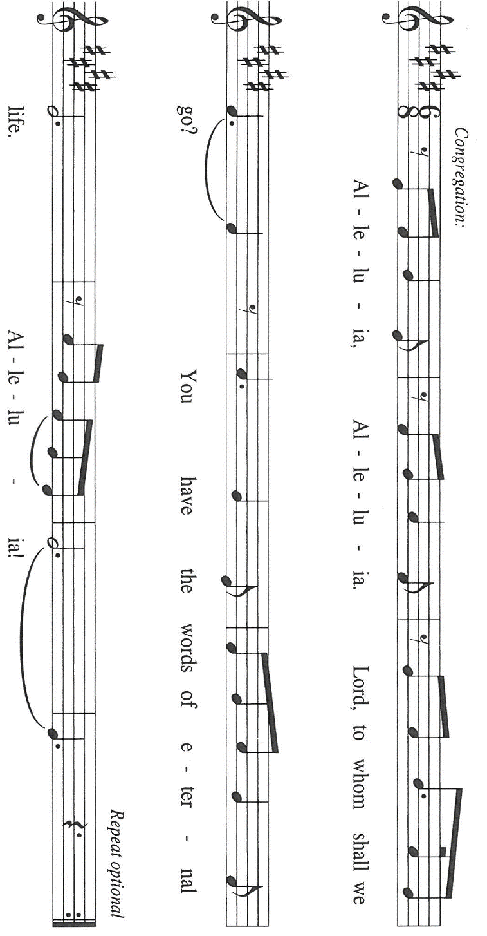
THE VERSE (Sung twice)

THE HOLY GOSPEL Matthew 9: 9-13, 18-26

Jesus demonstrates God’s mercy and power, accepting the unacceptable and curing the incurable. Even the dead receive new life.

P: The Holy Gospel according to St. Matthew, the ninth chapter.

C: Glory to You, O Lord!

⁹As Jesus was walking along, He saw a man called Matthew sitting at the tax booth; and He said to him, “Follow Me.” And he got up and followed Him.
¹⁰And as He sat at dinner in the house, many tax collectors and sinners came and were sitting with Him and His disciples. ¹¹When the Pharisees saw this, they said to His disciples, “Why does your teacher eat with tax collectors and sinners?” ¹²But when He heard this, He said, “Those who are well have no need of a physician, but those who are sick. ¹³Go and learn what this means, ‘I desire mercy, not sacrifice.’ For I have come to call not the righteous but sinners.”
¹⁸While He was saying these things to them, suddenly a leader of the synagogue came in and knelt before Him, saying, “My daughter has just died; but come and lay Your hand on her, and she will live.” ¹⁹And Jesus got up and followed him, with His disciples. ²⁰Then suddenly a woman who had been suffering from hemorrhages for twelve years came up behind Him and touched the fringe of his cloak, ²¹for she said to herself, “If I only touch His cloak, I will be made well.”
²²Jesus turned, and seeing her He said, “Take heart, daughter; your faith has made you well.” And instantly the woman was made well. ²³When Jesus came to the leader’s house and saw the flute players and the crowd making a commotion, ²⁴He said, “Go away; for the girl is not dead but sleeping.” And they laughed at Him. ²⁵But when the crowd had been put outside, He went in and took her by the hand, and the girl got up. ²⁶And the report of this spread throughout that district.

P: The Gospel of the Lord.

C: Praise to You, O Christ!

The assembly is seated

THE SERMON
Silence for reflection follows the sermon

As you are able please rise

THE HYMN OF THE DAY NSB 96 We Are an Offering

THE APOSTLES’ CREED

A: God has made us His people through our Baptism into Christ. Living together in trust and
hope, we confess our faith.

I believe in God, the Father almighty,
creator of heaven and earth.

I believe in Jesus Christ, His only Son, our Lord.
He was conceived by the power of the Holy Spirit
and born of the virgin Mary.
He suffered under Pontius Pilate,
was crucified, died, and was buried.
He descended into hell.
On the third day He rose again.
He ascended into heaven,
and is seated at the right hand of the Father.
He will come again to judge the living and the dead.

I believe in the Holy Spirit,
the holy catholic Church,
the communion of saints,
the forgiveness of sins,
the resurrection of the body,
and the life everlasting. Amen.

THE PRAYER OF THE CHURCH

A: Gathered together by the Holy Spirit, let us pray for the church and the needs of the world.
A: God of mercy, You call us to a life filled with acts of mercy. Ground us in following Christ,
that we might extend the mercy we receive. God of grace,

C: hear our prayer.

A: God of creation, all You have made is Yours. Revive lands in need of healing and make us
wise stewards of all You have given us to tend. God of grace,

C: hear our prayer.

A: God of the nations, You promise to deliver those who call on You. Bring an end to conflict in
all places of warfare, bigotry, and injustice in all their forms wherever they are found. God of
grace,

C: hear our prayer.

A: God of comfort, you provide for those in need. Bring an end to addiction. Comfort people as
they mourn. Provide tenderly for those in need, especially Martha Schroeder; Mark
Tannehill; Pastor Dale Zylstra, Verne Lee, and Major Payne. God of grace,

C: hear our prayer.

A: God of blessings, You send the Holy Spirit to provide varieties of gifts in the body of Christ.
Accompany those who travel this summer, make our gatherings joyous, and grant us a spirit
of hospitality and togetherness. God of grace,

C: hear our prayer.

A: God of joy, bless those celebrating birthdays, especially Leigh Coburn, Ivye Benson, and
Janet Bakken; and anniversaries, especially Daniel and Brittany Streubing; David and
Donna Sutor; and Tom and Amy Petri, that they may be filled with grace this day and every
day and grow in grace in the days ahead. God of grace,

C: Hear our prayer.

A: God of life, we give You thanks for saints whose lives revealed Your faithfulness, especially
Seattle, Chief of the Duwamish Confederacy, whom we commemorate this Day. May
remembering their faithfulness strengthen our own. God of grace,

C: hear our prayer.

P: Trusting You receive all our prayers, we commend our spoken and unspoken prayers to You,
O God, through Jesus our Savior.

C: Amen.

MEAL

THE PEACE

P: The peace of the Lord be with you always.
C: And also with you.

The assembly is seated

THE OFFERING

THE VOLUNTARY Come Expecting Jesus New Song Praise Band
(John Chisum & Nancy Gordon)

As you are able please rise

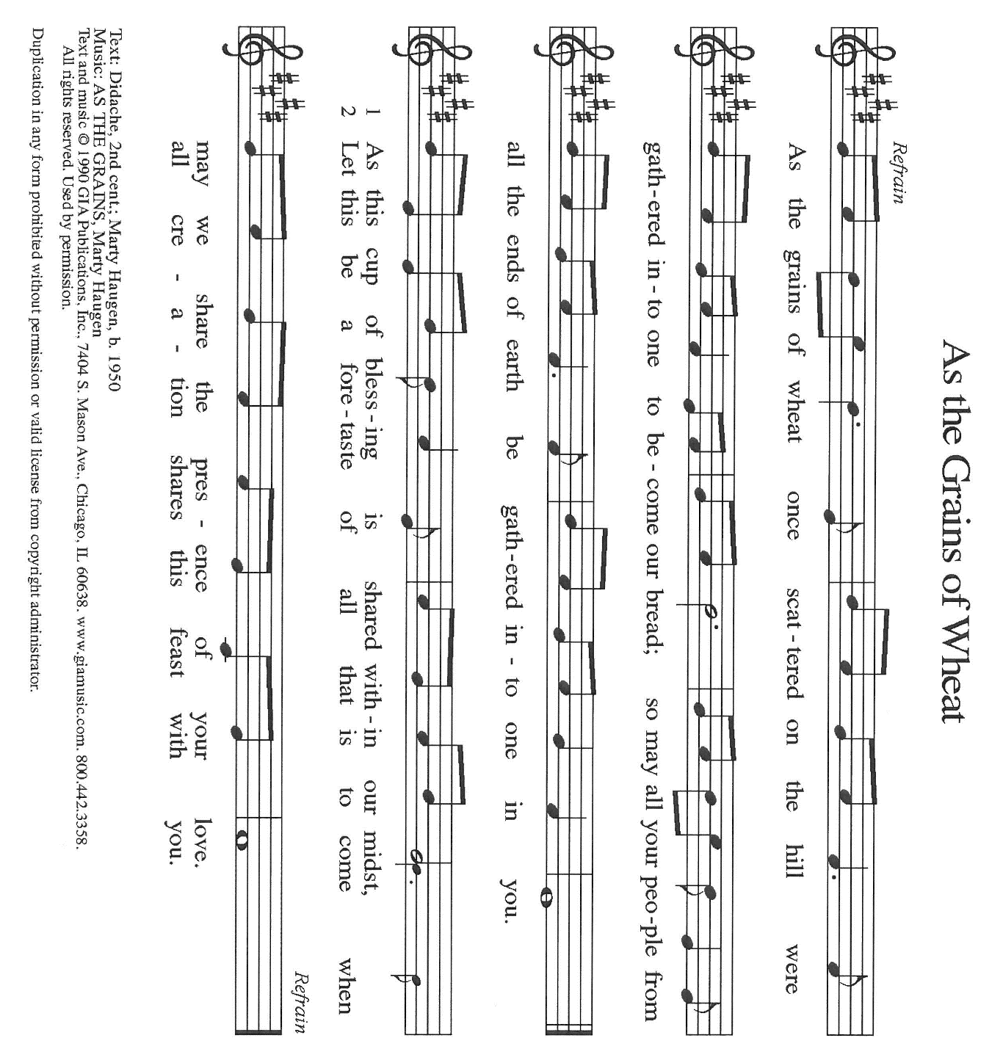
THE PRESENTATION OF GIFTS As the Grains of Wheat

THE OFFERTORY PRAYER

A: Let us pray. God of reconciliation and forgiveness,

C: The saving work of Christ has made our peace with You. May that work grow in us
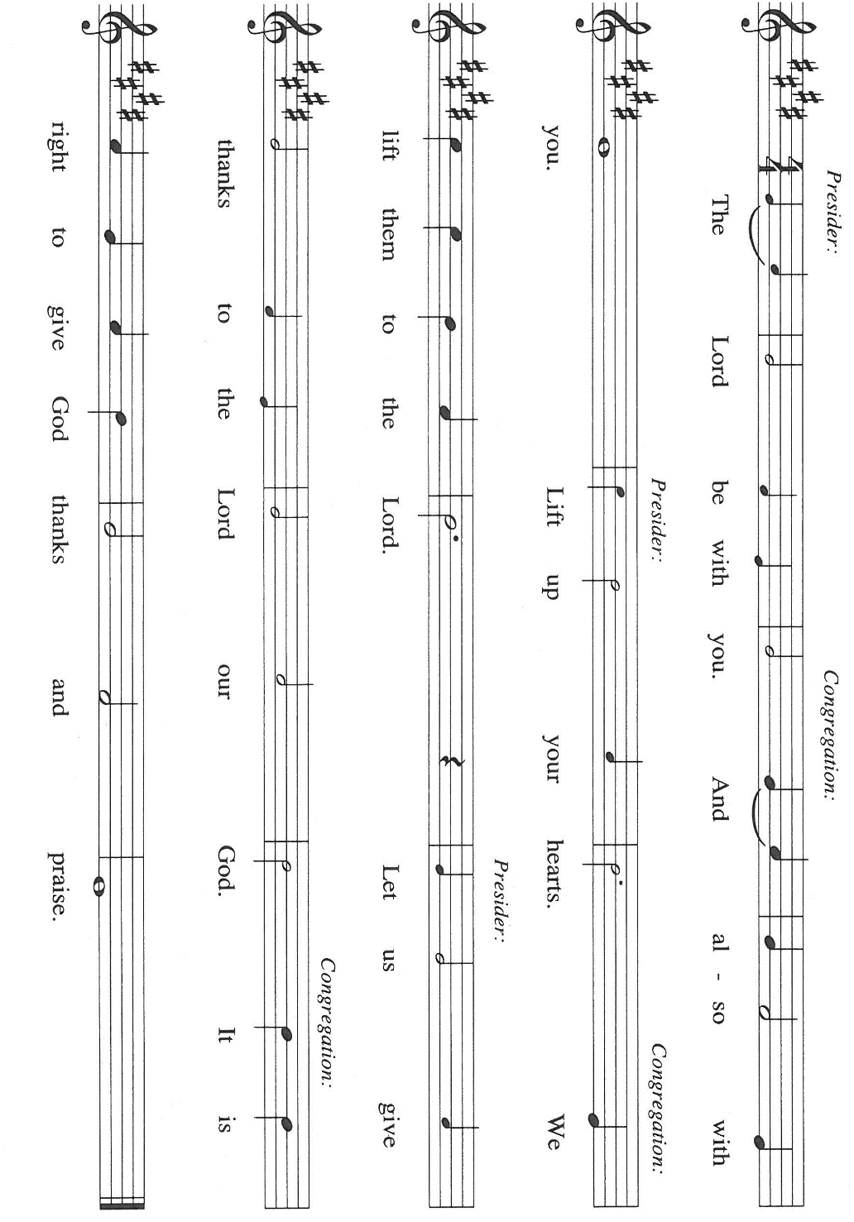
through all that we offer You this Day and through this Meal in which we are again made
one with You. We ask this in the name of Jesus the Lord. Amen.

THE GREAT THANKSGIVING

P: It is our duty and delight … join their unending hymn:

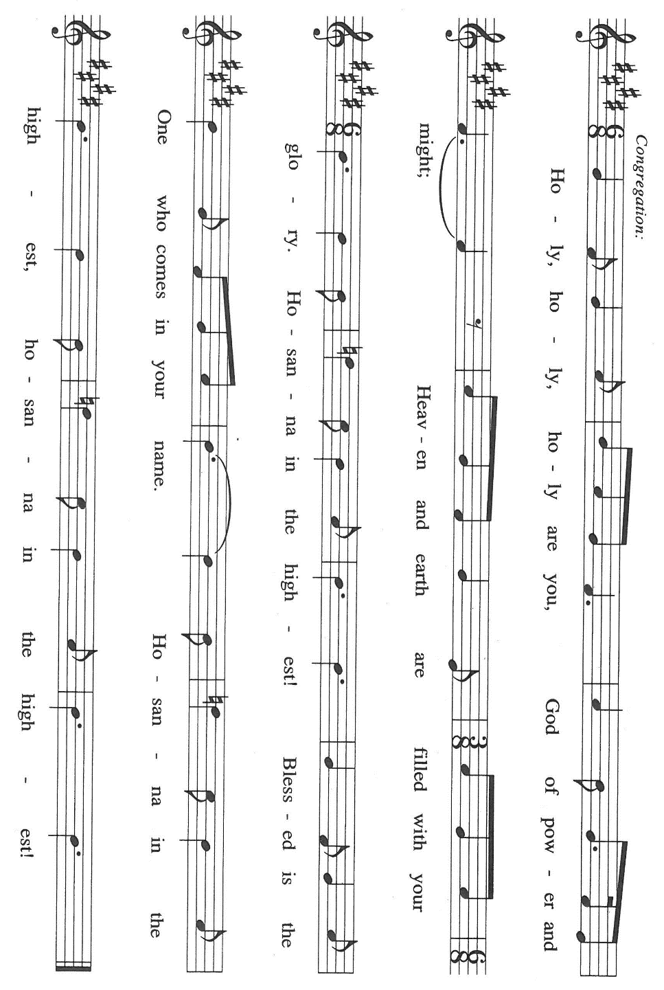

P: We lift our hearts and lives to You, Lord God, for You made creation out of nothing, and in
Abraham You called a people to be Your own.
You crafted a destiny for Your children from the barrenness of despair and the wilderness of
sin.
You made an everlasting covenant that bound You and humanity to be with one another
forever.
In Jesus You made a new covenant that embodied humankind’s full presence before You and
Your full presence before humankind.
Uniting God, You bind Yourself to us in Christ’s death, and You bind us to Yourself in
Christ’s resurrection.
In Him we are dead to sin and alive to You.
Send now Your Holy Spirit upon us and upon this Meal in His memory, that we might be a
ransomed, healed, restored, and forgiven people,
And that this bread and wine might be for us the Body and Blood of Your Son, Jesus Christ,
Who, in the night … “Do this for the remembrance of Me.”
As often as we eat …the Lord’s death until He comes.

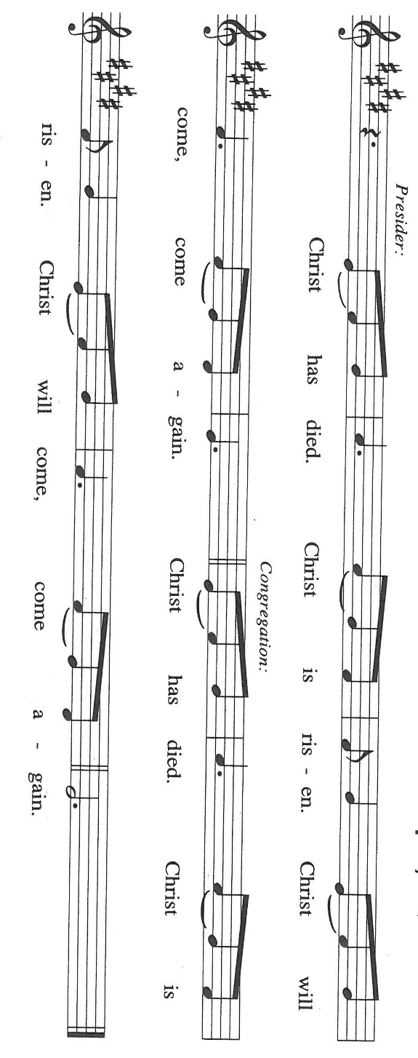

P: Jealous God, You want us for Yourself and You teach us to shape all our loves as ways of
loving You.
Give Your consolation to all who live without peace.
Dwell with those who find their households divided, and any who find it hard to love You and
cherish their family members too.
Restore Your Church may it may discover You on the way of the cross and find its life by
losing it for Your sake,
Until the Day when You are the joy of our desiring and we the joy of Yours, when every eye
shall behold You
And every tongue confess You as Lord, one and holy God: Father, Son, and Holy Spirit.

C: Amen!

THE LORD’S PRAYER

P: Seeking first the Kingdom of God and its righteousness, with trust in God’s daily care for us,
we now pray:

C: Our Father in heaven, hallowed be Your name.
Your Kingdom come, Your will be done on earth as in heaven.
Give us today our daily bread, and forgive us our sins, as we forgive
those who sin against us.
Save us from the time of trial, and deliver us from evil.
For the Kingdom, the power, and the glory are Yours, now and forever.
Amen.

INVITATION TO THE MEAL

P: Behold the Teacher Who gathers us as disciples to teach us the mysteries of God’s
Kingdom.Blessed are those who are called to the Supper of the Lamb. God’s holy gifts, for
God’s holy people. Come, for all is now ready.

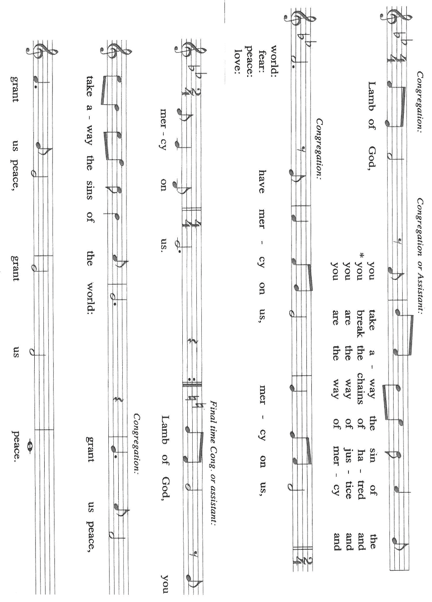
The assembly is seated

THE DISTRIBUTION Lamb of God

HYMN DURING DISTRIBUTION 722 O Christ, Your Heart Compassionate
NSB 30 Draw Me Close to You
ELW 556 Morning Has Broken
ELW 860 I’m So Glad Jesus Lifted Me
ELW 836 Joyful, Joyful We Adore Thee

As you are able please rise

THE POST-COMMUNION BLESSING

P: The Body and Blood of our Lord Jesus Christ strengthen you and keep you in His grace.

C: Amen.

THE POST-COMMUNION PRAYER

A: Let us pray. Holy and blessed God, as You give us the Body and Blood of Your Son, guide us
with Your Holy Spirit, that we may honor You not only with our lips but also in our lives.
Grant this through Christ our Lord.
C: Amen.
SENDING

THE BENEDICTION

P: Almighty God: Father, Son, and Holy Spirit bless you now and forever.

C: Amen.

THE SENDING HYMN 848 Give to Our God Immortal Praise

THE DISMISSAL

A: Go forth with God’s blessing to love and serve the Lord.

C: Thanks be to God!

POSTLUDE

To God Alone Be Glory

The Meditations are from Working Preacher Online. Copyright Luther Seminary 2023; and
Matthew Brazos Theological Commentary on the Bible. Stanley Hauwerwas. (Brazos
Press: Grand Rapids, MI, 2006). 103.

The Prayers are adapted from Sundays and Seasons Online. Copyright Augsburg Fortress Press,
023.

The Offertory and Post-Communion Prayers are adapted from The Book of Alternative Services of
The Anglican Church of Canada. (Anglican Book Centre: Toronto, 1985). 362-63.

ANNOUNCEMENTS

Please remember to mail your offering to the Church Office at 818 Franklin Street, Michigan City, IN 46360. Another alternative is to give on-line through Tithe.ly. Please see your closure letter for information on how to set up a Tithe.ly account.

St. Paul Members are reminded to have a loved one contact the office if you are hospitalized. Many times, the Pastor doesn’t know someone is in the hospital. If you call and leave a message, please tell us at which hospital the patient is located.

BIRTHDAYS: Leigh Coburn (6/12); Ivye Benson (6/14); Janet Bakken (6/14)

ANNIVERSARIES: Daniel & Brittany Struebing (6/8); David & Donna Sutor (6/12); Tom & Amy Petri (6/13)

PRAYER CONCERNS: Debbie Martin; Mark Tannehill; Kathy Stein; Jan Paholski; Laura Dovey; Bill Hazelgrove; Al Levenhagen; Carl Wipperman; Major Payne.

OFFICE HOURS: Libby will be in the office on Mondays, Wednesdays, and Fridays; volunteers will cover Tuesdays and Thursdays.

Monday & Wednesday 8:00 a.m. – 5 p.m.
Tuesday & Thursday 9:00 a.m. – 12:00 p.m.
Friday 8:00 a.m. – 12:00 p.m.

If you are listening to the worship broadcast on the radio and would like to watch the Sunday morning service live stream follow these steps:

(1) If you have You Tube available on your TV, search for
St. Paul Lutheran Church Michigan City, IN.

(2) The direct link on the computer is https://
www.youtube.com/channel/UC5AIPNaKr3QN50984jGOa1g

(3) This link is also on the main page of the church’s website in
the church section and will continue to be posted weekly on the St.
Paul Facebook page.

And it will always be available on the radio broadcast Sunday mornings at 11:00 a.m.
on WEFM (95.9), and on the local cable access station #99 for the previous week’s
service on Sundays at 4:00 p.m. and the current service on Wednesdays at 7:00 p.m.
and Fridays at 8:30 p.m.

To send e-mail to the church office, please use the following addresses:

Pastor Mark Reshan: seniorpastor@stpaulmichigancity.com

Church Office Secretary (Libby Pollock): churchsecretary@stpaulmichigancity.com

Church Treasurer (Karen Fleming): finance@stpaulmichigancity.com

2026 Church Council:

Pastor - Mark Reshan

President - Donna Knoll

Vice President - Jan Bakken

Secretary - Judy Hunt

Treasurer - Karen Fleming

Members: Sue Koziel; Jim Schraidt; Trish Sprague; Bob Kiser; Barry Anderson; and
Pam Soule

Worship Attendance:

Saturday, May30, 2026 @ 4:00 p.m. 31

Sunday, May 31, 2026 @ 9:00 a.m. 58

TOTAL 89

Copies of the minutes from the March 26, 2026 and April 23, 2026 Church Council meetings are on the back table in the upper Narthex. They were approved by the council via email.

The Good News Newsletter: If you have an article or anything you want included in The Good News please send it to the following e-mail address: splcgoodnews@gmail.com. Pastor Pamela Thiede will be using this e-mail address to assemble The Good News each month. The deadline for getting information to Pastor Pamela will be the 20th of each month.

Next week’s lessons are Exodus 19: 2-8d; Psalm 100; Romans 5: 1-8; Matthew 28: 16-20 for those of you who like to study them in advance.

JUNE MONTHLY MISSION

The Service League of Michigan City is a no-profit organization of volunteers that loans medical equipment and provides supplemental adult incontinence supplies to the residents of LaPorte County. Equipment loans are for three months and most items can be borrowed for free. As a non-profit, they maintain their services through the generosity of community donations, competitive grants, memorials and member support. The Service League receives no government funds. To help their generous mission, we will be collecting both monetary donations as well as the following items:

Disposable gloves
Disposable Gauze rolls, dressing pads and surgical tape
Disposable pull up and tab adult briefs (opened and unopened packages)

Please make checks payable to St. Paul and mark for Service League and place in the offering. Noisy Coin for the month of June will also go to support the Service League. Items can be placed in the bin in the outer Narthex. Thank you for your generosity each month! Lora

ACTIVITIES, EVENTS & MEETINGS
JUNE 2026

Wednesday, June 3, 2026 @ 10:00 a.m. God’s Purls
Thursday, June 4, 2026 Faith Circle
Saturday, June 6, 2026 @ 4:00 p.m. 2 Pentecost Worship Service/Sanctuary

Sunday, June 7, 2026 @ 9:00 a.m. 2 Pentecost Worship Service/Sanctuary with coffee after
Monday, June 8, 2026 @ 1:00 p.m. Hope Circle/Green Room
Tuesday, June 9, 2026 11:00 a.m.-10:00 p.m. GIVE BACK at Holly’s Restaurant & Pub
Wednesday, June 10, 2026 @ 10:00 a.m. God’s Purls
@ 4:30 p.m. Choir Rehearsal/Sanctuary
Saturday, June 13, 2026 @ 4:00 p.m. 3 Pentecost Worship Service/Sanctuary

Sunday, June 14, 2026 @ 9:00 a.m. 3 Pentecost Worship Service/Sanctuary with coffee after
Wednesday, June 17, 2026 @ 10:00 God’s Purls
Saturday, June 20, 2026 at 4:00 p.m. 4 Pentecost Worship Service/Sanctuary

Sunday, June 21, 2026 @ 9:00 a.m. 4 Pentecost Worship Service/Sanctuary with coffee after
Monday, June 22, 2026 @ 2:00 p.m. Finance Committee Mtg./Luther House
@ 3:00 p.m. Executive Board Mtg/Luther House
Wednesday, June 24, 2026 @ 10:00 a.m. God’s Purls
@ 4:30 p.m. Choir Rehearsal/Sanctuary
Thursday, June 25, 2026 @ 3:00 p.m. Church Council Meeting/St. Paul Room
Saturday, June 27, 2026 @ 4:00 p.m. 5 Pentecost Worship Service/Sanctuary

Sunday, June 28, 2026 @ 9:00 a.m. 5 Pentecost Worship Service/Sanctuary with coffee after

Thank$ for $haring
Thank you to all who participate in our Give-Back opportunities each month where we earn $$ to add to our Mission of the Month donations, from our congregation to those in our community who need our help! On Tuesday, June 9, 2026 from 11:00 a.m.—10:00 p.m. we’ll be meeting at Holly’s Restaurant for our GIVE BACK for June. Here are two coupons. One for you and one for a friend.

