**THE FIFTH SUNDAY OF EASTER**

**May 18, 2025**

Today’s word from Revelation is a large, expansive, cosmic, sweeping claim. Too much American popular religion tends to be miniaturized--just me and God, getting along as best we can.

For most of our lives, on most days, this is enough. We are concerned mostly about ourselves. When we think of God, we think of God’s work mostly for us as individuals. Me and Jesus. That little word “I” has a nasty habit of cropping up constantly in our Sunday speech.

But the Bible ends, as it begins, with God the Creator, with God’s large, cosmic work. Here is no detached, caring, and compassionate but mostly inactive God. Here is a God who moves, acts in ways that are sweeping and cosmic. We are promised, here at the end of Revelation, not just a little comfort in our troubled inner lives. We are promised nothing less than a new heaven and a new earth. There is a whole new city, come down from heaven. God shall tabernacle among us, and the kingdoms of this world shall become wholly owned by God almighty.

Thus, as the Bible’s story ends, we are summoned forth to a large, cosmic claim. Our religion gets more than personal.

Only this sort of God can help. We don’t need just to feel a bit better about ourselves. We need nothing less than a new heaven and a new earth. We need a God who not only cares but acts, moves, continues to work with the world, continues to create, continues to bring light out of darkness, form out of the void.

This is the God we get on this the Fifth Sunday of Easter. Only this sort of active, moving, creating God can ultimately help.

**William Willimon**

“The poignancy of Revelation 21:5-6 is that the new creation is framed by God’s direct speech, “See, I am making all things new.” God’s new creation must replace this deadly, torn, raped, angry, sick, evil, revengeful, hurtful, and painful world…”

“ …Christians are not called to escape into this new world but rather to partner with God in ways that will allow the power of God and the Lamb be experienced in this world. That is the reason why God comes down into the world to dwell with his people and that coming down is basically the New Jerusalem that comes out of heaven. In other words, Revelation does not rely on the notion of eternal life and John does not deny it either but what he believes is that this New Jerusalem begins in the present moment and every human being must experience its joy and goodness in the present moment. Thus, the dream of God that is also shared by Isaiah 65:17-25 and also presented in Revelation 21 is not an eternal world but must be realized in human history…”

“…The role of the church is clearly spelled out in this chapter because God’s plan for a new reality is not only done by God. Like in Genesis 12-22, God involved humanity in the person of Abraham and creation is still done in partnership with humanity. Thus, a new world order for authentic humanity will come about when human beings, particularly the church is involved in this new creation. In Genesis, humanity is the summit of God’s creation and therefore, God calls on believing humanity to be involved in making God’s dream come true in this world.”

**Israel Kamuzandu**

**✠ In the Name of Jesus ✠**

**✠ GATHERING ✠**

**INTRODUCTION**

Easter initiates a new day. It anticipates a new heaven and a new earth. The risen Lord is making all things new. In the mystery of holy baptism God has made new people of us. Today the Lord Jesus invites us to see everyone in a new light—through the lens of love.

**Erik, King of Sweden, martyr, died 1160**

*Erik is considered the patron saint of Sweden. As king of that nation, he tried to bring peace in the region, and to spread Christianity in Scandinavia. He was also known for his attempts to make fair laws and to protect those who were poor or sick.*

**PRE-SERVICE MUSIC Praise Adonai New Song Praise Band**

**(Paul Baloche)**

**THE EASTER ACCLAMATION**

P: Christ is risen! Alleluia!

**C: Christ is risen indeed! Alleluia!**

**ANNOUNCEMENTS**

*As you are able please rise*

**CONFESSION AND ABSOLUTION**

P: In the name of the Father and of **✠** the Son and of the Holy Spirit.

**C: Amen.**

P: God has given to all nations the repentance that leads to life. Let us come with repentant

hearts to the God Who makes all things new.

*Silence for self-examination and reflection is kept*

P: Most merciful God,

**C: We confess that we have sinned against You in thought, word and deed. Through**

**the blood of Christ, You have made all people clean, but we yet treat others as if**

**they are profane. (Acts 11: 9) We have not treated Your promises as “trustworthy**

**and true.” (Revelation 21: 5) We have failed to love one another as You have loved**

**us. (John 13: 34) We have not been Your faithful disciples. (13: 35) For the sake**

**of Your Son, Jesus Christ, breathe Your forgiving Spirit into us. Forgive us,**

**renew us, and set us free to love and serve others in Your name and to Your glory.**

P: “And the One Who was seated on the throne said, “See, I am making all things new.”

(Revelation 21: 5) From “beginning to end” (Revelation 21: 6) this is God’s Word for

you: as a called and ordained minister of the Church of Christ, and by His authority, I

therefore declare to you the entire forgiveness of all your sins, in the name of the Father

and of **✠** the Son and of the Holy Spirit.

**C: Amen.**

**GATHERING SONG NSB 44 *He is Exalted***

**THE GREETING AND PRAYER OF THE DAY**

P: Christ is risen! Alleluia!

**C: Christ is risen indeed! Alleluia!**

P: The grace of our Lord Jesus Christ, the love of God, and the communion of the Holy

Spirit be with you all.

**C: And also with you.**

P: Let us pray. O Lord God, You teach us that without love, our actions gain nothing.

Pour into our hearts Your most excellent gift of love, that, made alive by Your Spirit,

we may know goodness and peace, through Your Son, Jesus Christ, our Savior and

Lord, Who lives and reigns with You and the Holy Spirit, one God, now and forever.

**C: Amen.**

*The assembly is seated*

**✠ WORD ✠**

**FIRST READING**  **Acts 11: 1-18**

*In defense of his earlier baptism of pagan believers, Peter demonstrates to the members of the Jerusalem church that God's intention to save Gentiles as well as Jews is revealed in Jesus' own testimony. In this way the mission to the Gentiles* *was officially authorized.*

1Now the apostles and the believers who were in Judea heard that the Gentileshadalso accepted the word of God. 2So when Peter went up to Jerusalem, the circumcised believers criticized him, 3saying, "Why did you go to uncircumcised men and eat with them?" 4Then Peter began to explain it to them, step by step, saying, 5"I was in the city of Joppa praying, and in a trance I saw a vision. There was something like a large sheet coming down from heaven, being lowered by its four corners; and it came close to me. 6As I looked at it closely I saw four-footed animals, beasts of prey, reptiles, and birds of the air.

7I also heard a voice saying to me, 'Get up, Peter; kill and eat.' 8But I replied, 'By no means, Lord; for nothing profane or unclean has ever entered my mouth.' 9But a second time the voice answered from heaven, 'What God has made clean, you must not call profane.' 10This happened three times; then everything was pulled up again to heaven.

11"At that very moment three men, sent to me from Caesarea, arrived at the house where we were. 12The Spirit told me to go with them and not to make a distinction between them and us. These six brothers also accompanied me, and we entered the man's house. 13He told us how he had seen the angel standing in his house and saying, 'Send to Joppa and bring Simon, who is called Peter; 14he will give you a message by which you and your entire household will be saved.'

15And as I began to speak, the Holy Spirit fell upon them just as it had upon us at the beginning. 16And I remembered the word of the Lord, how He had said, 'John baptized with water, but you will be baptized with the Holy Spirit.' 17If then God gave them the same gift that He gave us when we believed in the Lord Jesus Christ, who was I that I could hinder God?" 18When they heard this, they were silenced. And they praised God, saying, "Then God has given even to the Gentiles the repentance that leads to life."

The Word of the Lord.

**Thanks be to God.**

**THE PSALM: Psalm 148** Antiphon by Carl Schalk

Choir sings refrain first, followed immediately by the congregation

and as indicated

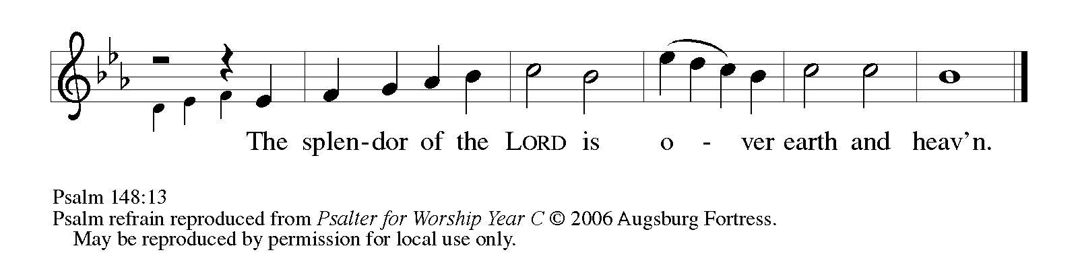

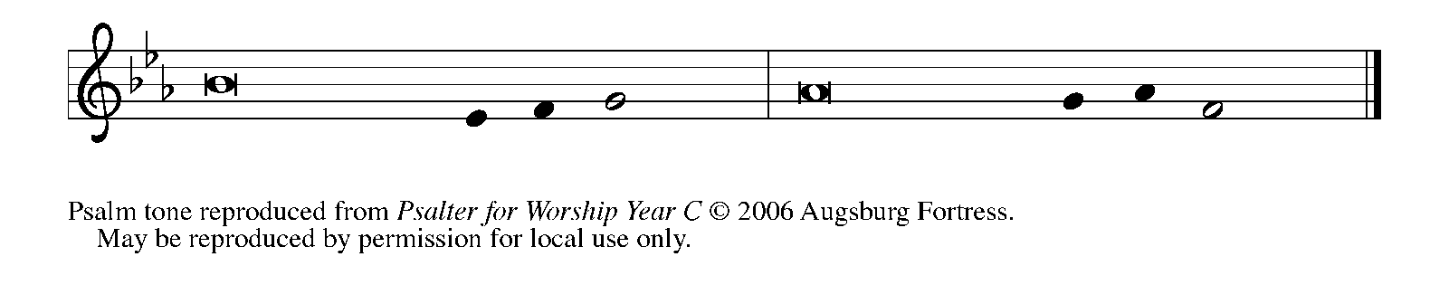

1Hallelujah! Praise the LORD | from the heavens;

     praise God | in the heights.

**2Praise the LORD, | all you angels;**

**sing praise, all you | hosts of heaven.**

3Praise the LORD, | sun and moon;

     sing praise, all you | shining stars.

**4Praise the LORD, heav- | en of heavens,**

**and you waters a- | bove the heavens.**

5Let them praise the name | of the LORD,

     Who commanded, and they | were created,

**6Who made them stand fast forev- | er and ever,**

**giving them a law that shall not | pass away.   REFRAIN**

7Praise the LORD | from the earth,

     you sea monsters | and all deeps;

**8fire and hail, | snow and fog,**

**tempestuous wind, do- | ing God's will;**

9mountains | and all hills,

     fruit trees | and all cedars;

**10wild beasts | and all cattle,**

**creeping things and | flying birds;**

11sovereigns of the earth | and all peoples,

     princes and all rulers | of the world;

**12young | men and maidens,**

**old and | young together.   REFRAIN**

13Let them praise the name | of the LORD,

     Whose name only is exalted, Whose splendor is over | earth and heaven.

**SECOND READING Revelation 21: 1-6**

*John's vision shows us that in the resurrection the new age has dawned; God dwells with us already. Yet we wait for the time when the tears that cloud our vision will be wiped away. Then we will see the new heaven, new earth, and new Jerusalem.*

1Then I saw a new heaven and a new earth; for the first heaven and the first earth had passed away, and the sea was no more. 2And I saw the holy city, the new Jerusalem, coming down out of heaven from God, prepared as a bride adorned for her husband. 3And I heard a loud voice from the throne saying,

"See, the home of God is among mortals.

He will dwell with them as their God;

they will be His peoples,

and God Himself will be with them;

4He will wipe every tear from their eyes.

Death will be no more;

mourning and crying and pain will be no more,

for the first things have passed away."

5And the One Who was seated on the throne said, "See, I am making all things new." Also He said, "Write this, for these words are trustworthy and true." 6Then He said to me, "It is done! I am the Alpha and the Omega, the beginning and the end. To the thirsty I will give water as a gift from the spring of the water of life."

The Word of the Lord.

**Thanks be to God.**

*As you are able please rise*

**THE VERSE**

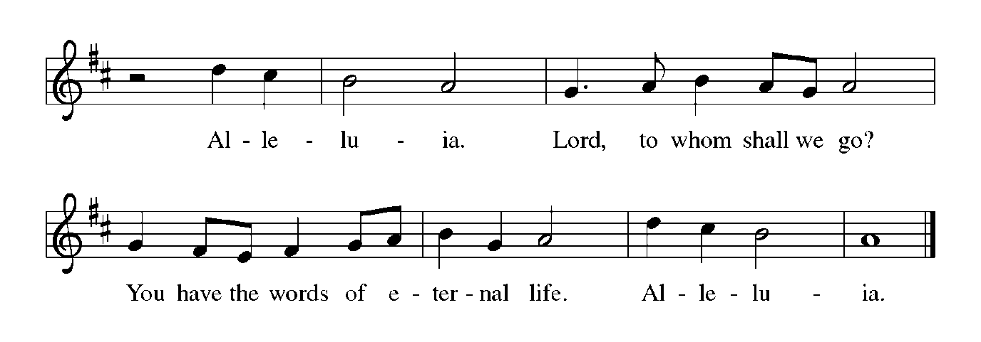

**THE HOLY GOSPEL John 13: 31-35**

*Three times Jesus says that his sheep are secure; no one will snatch them from Jesus' hand or the Father's hand. The sheep have eternal life and so shall never perish.*

P: The Holy Gospel according to St. John, the thirteenth chapter.

**C: Glory to You, O Lord!**

31When he had gone out, Jesus said, "Now the Son of Man has been glorified, and God has been glorified in Him. 32If God has been glorified in Him, God will also glorify Him in Himself and will glorify Him at once.

33Little children, I am with you only a little longer. You will look for me; and as I said to the Jews so now I say to you, 'Where I am going, you cannot come.' 34I give you a new commandment, that you love one another. Just as I have loved you, you also should love one another. 35By this everyone will know that you are My disciples, if you have love for one another."

P: The Gospel of the Lord.

**C: Praise to You, O Christ!**

*The assembly is seated*

**THE SERMON**

*Silence for reflection follows the sermon*

*As you are able please rise*

**THE HYMN OF THE DAY 826 *Thine the Amen***

Stanza 2—Women/children; Stanza 3--Men

**THE NICENE CREED**

A: God has made us His people through our Baptism into Christ. Living together in trust

and hope, we confess our faith.

**C: We believe in one God,**

**the Father, the Almighty,**

**maker of heaven and earth,**

**of all that is, seen and unseen.**

**We believe in one Lord, Jesus Christ,**

**the only Son of God,**

**eternally begotten of the Father,**

**God from God, Light from Light,**

**true God from true God,**

**begotten, not made,**

**of one Being with the Father.**

**Through Him all things were made.**

**For us and for our salvation**

**He came down from heaven;**

**by the power of the Holy Spirit**

**He became incarnate from the virgin Mary, and was made man.**

**For our sake He was crucified under Pontius Pilate;**

**He suffered death and was buried.**

**On the third day He rose again**

**in accordance with the Scriptures;**

**He ascended into heaven**

**and is seated at the right hand of the Father.**

**He will come again in glory to judge the living and the dead,**

**and His kingdom will have no end.**

**We believe in the Holy Spirit, the Lord, the giver of life,**

**Who proceeds from the Father and the Son.**

**With the Father and the Son He is worshiped and glorified.**

**He has spoken through the prophets.**

**We believe in one holy catholic and apostolic Church.**

**We acknowledge one Baptism for the forgiveness of sins.**

**We look for the resurrection of the dead,**

**and the life of the world to come. Amen**

**THE PRAYER OF THE CHURCH**

A: Gathered together in the name and power of our risen Lord, let us pray for the Church,

the world, and all who long for the grace of new life.

A: That the Church in every place might be open to the Spirit-driven mission of extending

the repentance that leads to life, let us pray to the Lord:

**C: Lord, hear our prayer.**

A: That all bishops, especially **Elizabeth and Timothy;** all pastors, especially **Mark,**

**Dale, Pamela, and Mark;** and all missionaries, might be given the wisdom and power

to proclaim the promise of the new heaven and earth to those who are still captive to

the old world of sin and death, let us pray to the Lord:

**C: Lord, hear our prayer.**

A: That as faithful stewards of God’s abundant blessings we may cheerfully share of our

gifts and resources in fruitful service to those we are called to serve in this community,

let us pray to the Lord:

**C: Lord, hear our prayer.**

A: That those in pain, illness, or suffering, especially: **Carol Radke; Fred Weiss; Joyce**

**Stark; Jan Paholski; Laura Dovey; Larry Litchford; Christine Kiser; Martha**

**Schroeder; Lucas Bradshaw; Nick Henrich; Carol Pauluhn; and Kathy Thielman**

might know the newness of God’s healing love, let us pray to the Lord:

**C: Lord, hear our prayer.**

A: That those celebrating birthdays, especially **Pat Miller; and Beverly Coburn;** and

anniversaries, especially **Fred and Judy LaBorn; and William and Pamela Hackett;**

may be filled with grace this day and every day and grow in grace in all the days ahead,

let us pray to the Lord:

**C: Lord, hear our prayer.**

A: That with all the faithful, especially **Matthias, Apostle** whom we commemorate this

Day we may find our home in the new Jerusalem in God’s new heaven and earth, let

us pray to the Lord:

**C: Lord, hear our prayer.**

P: Grant, eternal God, that we who are made one with Jesus Christ in the power of His

death and resurrection may show forth in our lives the love which proclaims us as His

disciples, that the world may believe in You and be saved, through Jesus Christ our

Lord.

**C: Amen.**

**✠ MEAL ✠**

**THE PEACE**

P: The peace of the risen Lord be with you always.

**C: And also with you.**

*The assembly is seated*

**OFFERING**

**THE VOLUNTARY** ***Love Grows Here*  St. Paul Senior Choir**

**(**D. Besig)

*As you are able please rise*

**THE OFFERTORY**

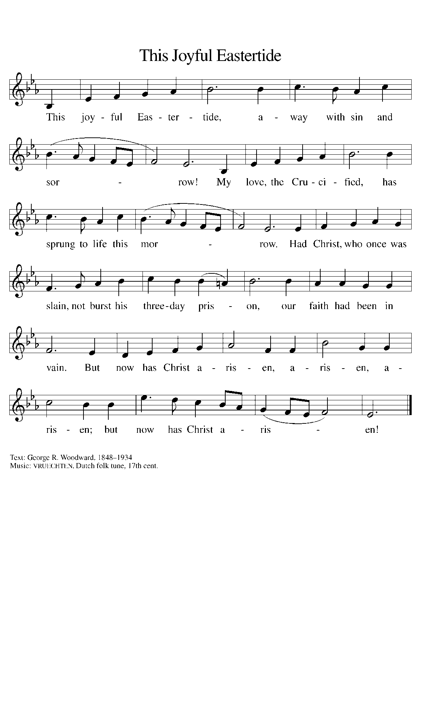

**THE OFFERTORY PRAYER**

A: Let us pray. God of glory,

**C: You call us to love one another as You have first loved us. Accept all we offer You this day as gifts of our devotion. By this Meal, fill us with the power of Your Spirit, and bring us at last to that eternal city of love and light, where Christ is King. We ask this in the name of Jesus the Lord. Amen.**

**THE GREAT THANKSGIVING**

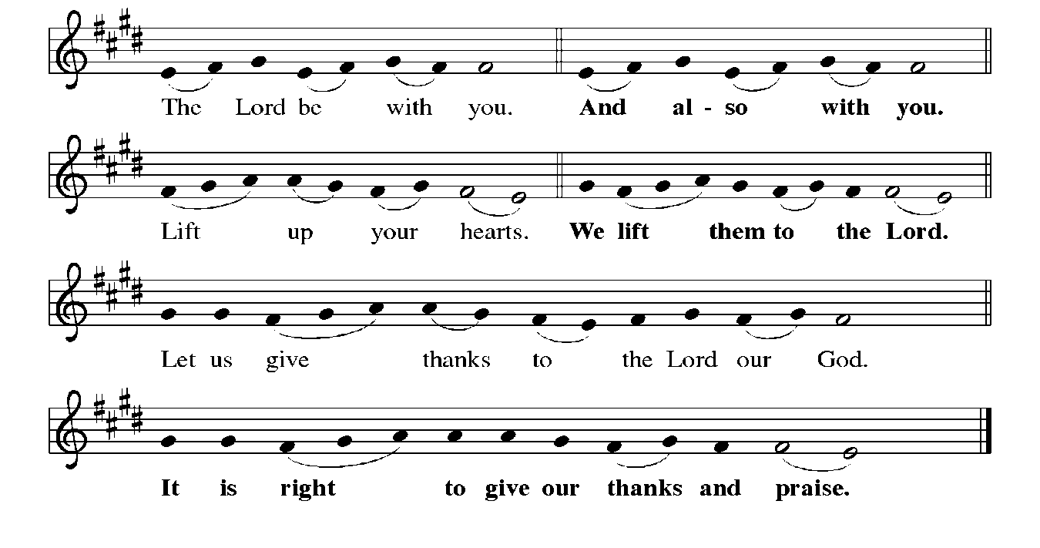

P: It is indeed right, our duty, and our joy … join their unending hymn:

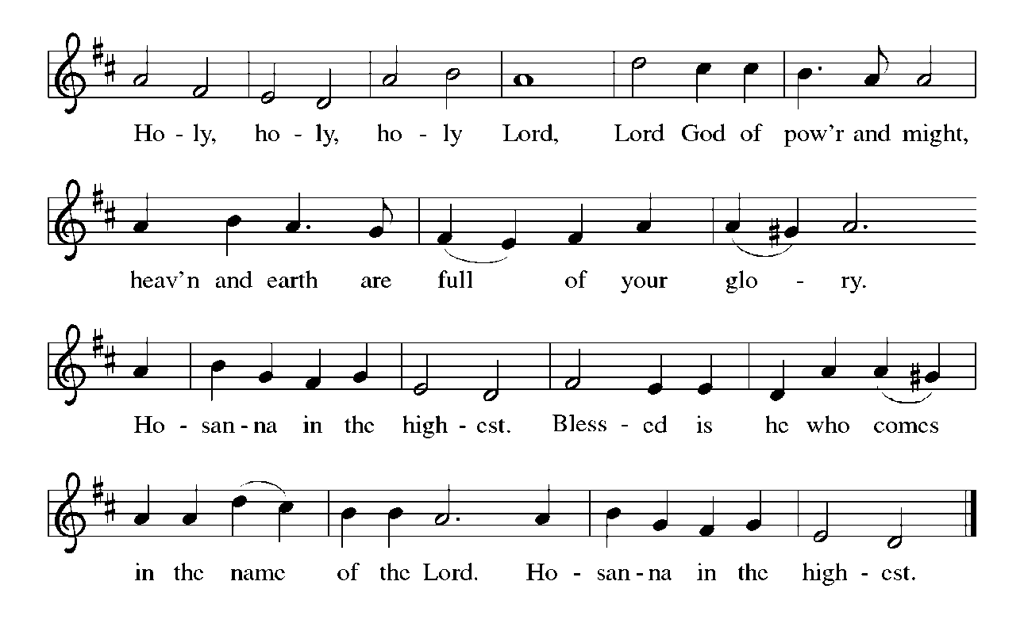

P: Creating God, You made the earth as a place of encounter.

Here You made a covenant with Your chosen people.

When Your children went astray You came among us in the form of Your Son,

showed Your glory, and in His passion suffered for our sin.

In Him You brought every aspect of creation to its purpose.

Your Son’s resurrection empowered His disciples, and Your Spirit’s fire enlivens

Your Church.

You promise us that when our story with You is complete You will inaugurate a new

heaven and a new earth where we shall enjoy life with Your forever.

Redeeming God, You have prepared a Banquet for us to share with You in Your

Kingdom.

Send now Your Holy Spirit, that we may taste that Banquet today, and this bread

broken and wine outpoured may be for us His Body and Blood;

Who, in the night ... “Do this for the remembrance of Me.”

As often as we eat ... we proclaim the Lord’s death until He comes.

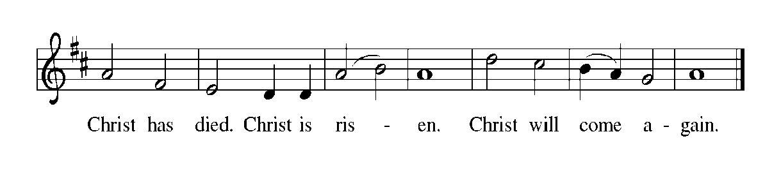

P: Transforming God, in Christ and in this holy Meal You show us the shape of love.

In broken bread show us the cost of Your love and inspire us to love like You.

In poured wine show us the constancy of Your love and form us to love as truly

as You love us.

Remake Your earth that it may breathe Your life.

Remake its people that they may resound with Your glory.

Remake Your Church that it may look like Your Son .

Wipe every tear from every eye; make death no more; and take away mourning and

crying and pain, that all may find justice in Your mercy and freedom in

Your service,

Until the beginning and ending of all things are one in You, and You are all in all:

One God, Father **✠** Son, and Holy Spirit.

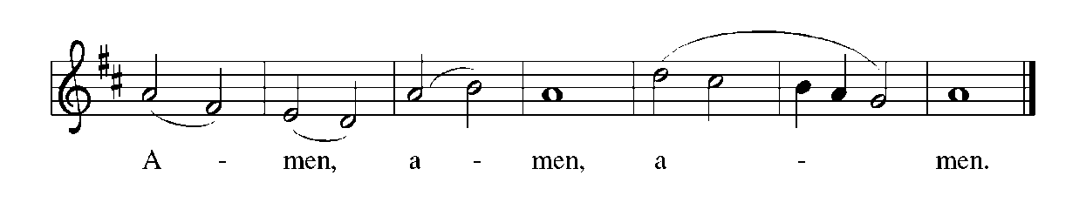

**THE LORD’S PRAYER**

P: Risen from the dead, Jesus lives to intercede for us and join us as He taught us to pray:

**C: Our Father in heaven, hallowed be Your name. Your Kingdom come. Your will**

**be done on earth as it is in heaven. Give us this day our daily bread, and forgive**

**us our sins as we forgive those who sin against us. Save us from the time of trial**

**and deliver us from evil. For the Kingdom, the power, and the glory are Yours,**

**now and forever. Amen.**

**INVITATION TO THE MEAL**

P: Alleluia! Christ the Lamb of God has been sacrificed. Therefore, let us celebrate His

Feast with joy. Blessed are those who are called to the Supper of the Lamb. God’s

holy gifts for God’s holy people. Come, for all is now ready.

*The assembly is seated*

**THE DISTRIBUTION**

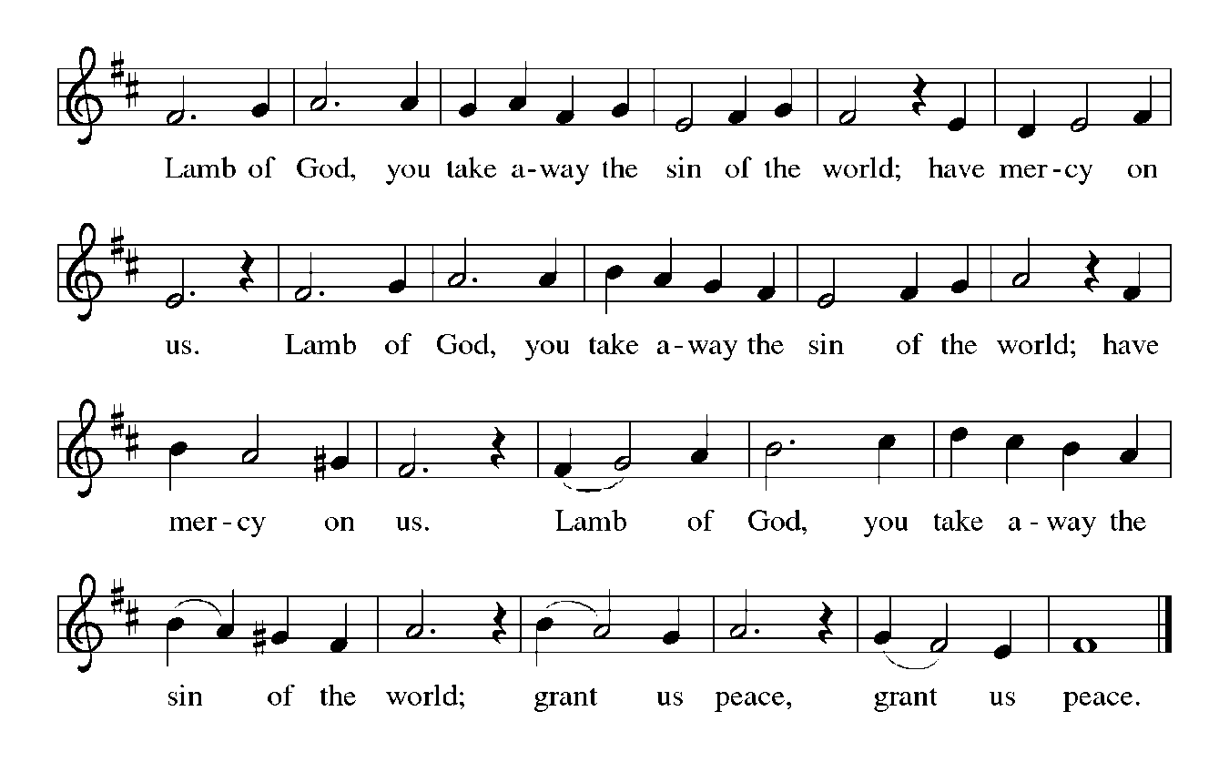

**HYMN DURING DISTRIBUTION 359 *Where Charity and Love Prevail***

**ELW 821 *Shout to the Lord***

**NSB 48 *I Am the Bread of Life (Talbot)***

**NSB 80 *Spirit of the Living God***

*As you are able please rise*

**THE POST-COMMUNION BLESSING**

P: The Body and Blood of our Lord Jesus Christ strengthen you and keep you in His grace.

**C: Amen.**

**THE POST-COMMUNION PRAYER**

A: Let us pray. Almighty God, we thank You that in Your great love You have given us

a foretaste of Your heavenly Banquet. Grant that this Sacrament may be to us a comfort

in affliction and pledge of our inheritance in that Kingdom where there is no death,

neither sorrow nor crying, but the fullness of joy with all Your saints; through Your

Son, Jesus Christ our Lord.

**C: Amen.**

**✠ SENDING ✠**

**THE BENEDICTION**

P: May God the Father Who raised Christ from the dead open to you the gate of everlasting

life.

**C: Amen.**

P: May God the Son Who burst from the grave give you joy as you celebrate His

resurrection.

**C: Amen.**

P: May God the Holy Spirit Who brought you to birth in Baptism fill you with strength

and peace.

**C: Amen.**

P: Almighty God: Father, Son, **✠** and Holy Spirit bless you now and forever.

**C: Amen.**

**SENDING SONG ELW 860 *I’m So Glad Jesus Lifted Me***

**THE DISMISSAL**

A: Alleluia! Christ is risen!

**C: He is risen indeed! Alleluia!**

A: Go in the peace of Christ, alleluia!

**C: Thanks be to God! Alleluia!**

**POSTLUDE**

**✠ To God Alone Be Glory ✠**

The Meditation is from *Pulpit Helps.* William Willimon, ed. Vol. 29, No. 2. (Inver Grove

Heights, MN: Logos Productions, 2001). 33-34.

The Greeting, Peace, Offertory, Post-Communion Prayers, and Dismissal are from *Sundays and Seasons.* Copyright 2000 Augsburg Fortress.

The Offertory Prayer is from *The Book of Alternative Services of the Anglican Church of*

*Canada.* (Toronto: Anglican Book Centre, 1985). 342.

**ANNOUNCEMENTS**

**Please remember to mail your offering to the Church Office** at 818 Franklin Street, Michigan City, IN 46360**.** Another alternative is to give on-line through Tithe.ly. Please see your closure letter for information on how to set up a Tithe.ly account.

**St. Paul Members are reminded to have** a loved one contact the office if you are hospitalized. Many times, the Pastor doesn’t know someone is in the hospital. If you call and leave a message, please tell us at which hospital the patient is located.

**Birthdays: Patricia Miller (5/16); Beverly Coburn(6/21)**

**Anniversaries: Fred & Judy LaBorn (5/19): William & Pamela Hackett (6/23)**

**PRAYER CONCERNS:** Larry Litchford, Sarah McNabb, Carol Radke, Jeanie Boatman Shepple, Nolan Wilson, Debbie Martin, Mark Tannehill, Brian Wiseman, Kathy Stein, Danielle Schnell, Jan Paholski, Laura Dovey, and Grace Romine.

**OFFICE HOURS:** Libby will be in the office on Mondays, Wednesdays, and Fridays; volunteers will cover Tuesdays and Thursdays.

Monday & Wednesday 8:00 a.m. – 5 p.m.

Tuesday & Thursday 9:00 a.m. – 12:00 p.m.

Friday 8:00 a.m. – 12:00 p.m.

**If you are listening to the worship broadcast on the radio and would like to watch the Sunday morning service live stream follow these steps:**

(1) If you have You Tube available on your TV, search for

**St. Paul Lutheran Church Michigan City, IN.**

(2) The direct link on the computer is

https://www.youtube.com/channel/UC5AIPNaKr3QN50984jGOa1g.

   (3) This link is also on the main page of the church’s website in

the church section and will continue to be posted weekly on the St.

Paul Facebook page.

And it will always be available on the radio broadcast Sunday mornings at 11:00 a.m.

on WEFM (95.9), and on the local cable access station #99 for the previous week’s

service on Sundays at 4:00 p.m. and the current service on Wednesdays at 7:00 p.m.

and Fridays at 8:30 p.m.

**Next Sunday’s lessons are Acts 16: 9-15; Psalm 67; Revelation 21: 10, 22—22: 5; John 14: 23-29 or John 5: 1-9:** for those of you who like to study them in advance.

**To send e-mail to the church office**, please use the following addresses:

 Pastor Mark Reshan: seniorpastor@stpaulmichigancity.com

 Church Office Secretary (Libby Pollock): churchsecretary@stpaulmichigancity.com

 Church Treasurer (Karen Fleming): finance@stpaulmichigancity.com

**2025 Church Council:**

Mark Reshan - Pastor

 Janet Bakken – President

 Donna Knoll – Vice President

 Judy Hunt – Secretary

 Karen Fleming – Treasurer

 Members: Paul Brooks, Diane Egilske, Sue Koziel, Judy Mutchler,

Jim Schraidt, Trish Sprague

**Worship Attendance:**

**Saturday , May 10, 2025 @ 4:00 p.m. 33**

**Sunday, May 11, 2025 @ 9:00 a.m. 73**

**TOTAL 106**

**2025 Financial Stewardship**

Weekly Church Operating Needs (x 2 weeks)

April 19-20, 2025; April 26-27, 2025: $ 13,545.00

General Fund (including General Memorials): $ 7,385.00

Overage/Shortage: — $ 6,160.00

Restricted Income (not including Memorials)

Supports IK Synod & Church wide Ministries: $ 171.00

Ministries in our Community/Congregation: $ 525.00

Capital Fund: $ 366.00

Memorials

General Fund: $ 30.00

**ACTIVITIES, EVENTS & MEETINGS**

**May 2025**

**Sunday,** May 11, 2025 @ 9:00 a.m. 4th Easter Worship Service

Coffee in the St. Paul Room after service

**Tuesday,** May 13, 2025 @ 7:00 p.m. Estuary/Luther House

**Wednesday,** May 14, 2025 @ 9:15 a.m. Bible Study/Luther House

  @10:00 a.m. God’s Purls/St. Paul Room

  @ 3:30p.m. Worship & Music Mtg./Luther House

  @ 4:30 p.m. Choir Rehearsal/Sanctuary

**Saturday,** May 17, 2025 @ 4:00 p.m. 5th Easter Worship Service

**Sunday,** May 18, 2025 @ 9:00a.m. 5th Easter Worship Service

**@10:15 a.m. CONGREGATIONAL MTG/St. Paul Room with a Pot Luck luncheon immediately following**

**Monday,** May 19, 2025 @ 1:00 p.m. Hope Circle/Green Room

  @2:00 p.m. Finance Committee Mtg/Luther House

  @ 3:00 p.m. Executive Board Meeting/Luther House

**Wednesday,** May 21, 2025 @ 9:15 a.m. Bible Study/Luther House

  @10:00 a.m. God’s Purls/St. Paul Room

  @ 4:30 p.m. Choir Rehearsal/Sanctuary

**Saturday,** May 24, 2025 @ 4:00 p.m. 6th Easter Worship Service

**Sunday,** May 25, 2025 @ 9:00 a.m. 6th Easter Worship Service Coffee in the St. Paul Room after service

**Monday,** May 26, 2025 **MEMORIAL DAY – OFFICE WILL BE CLOSED**

**Wednesday,** May 28, 2025 @ 9:15 a.m. Bible Study/Luther House

  @ 10:00 a.m. God’s Purls/St. Paul Room

  @ 4:30 p. m. Choir Rehearsal/Sanctuary

**Thursday,** May 29, 2025 @ 5:30 p.m. Church Council Mtg./St. Paul Room

**Saturday,** May 31, 2025 @ 4:00 p.m. 7th Easter Worship Service

**MISSION OF THE MONTH FOR MAY 2025**

Our Monthly Mission for the month of May, 2025, is Camp Sharing Meadows, part of the Share Foundation. Located in LaPorte, Camp Sharing Meadows is an inclusive Christian camp for adults with intellectual and/or developmental disabilities, where a vibrant blend of community, faith, and creative exploration takes center focus. The camps allow individuals with developmental and intellectual disabilities to have fun while learning faith-based values, participating in various activities, and making lifelong friendships. Monetary and check donations can be made out to the church and marked for Camp Sharing Meadows and placed in the offering plate. Noisy coin offering will also go to the Mission of the Month. Thank you for your generosity!

**Copies of the minutes from the March 27, 2025 and the May 1, 2025 Church Council meetings are on the back table in the upper Narthex. They were approved by the council via email.**

**FYI:**

In response to the ever rising costs for postage we will be putting your copy

of the “Good News” in your hanging file folder in the narthex each month

from now on. Those of you who are unable to attend services on a regular

basis may still receive your copies through your email address or in the

U.S. mail. If you normally receive your copy of the newsletter via your

email address anyway, nothing will change for you. Thank you so much for

your understanding and cooperation!

**The Good News Newsletter**: If you have an article or anything you want included in **The Good News** please send it to the following e-mail address: splcgoodnews@gmail.com. Pastor Pamela Thiede will be using this e-mail address to assemble **The Good News** each month. The deadline for getting information to Pastor Pamela will be the 20th of each month.



**POTLUCK MEAL**

Following the congregational meeting on today, May 18, 2025, we will have a potluck meal. The Council will not be providing the main course this time, so whatever entrees, salads, sides, and desserts we have will come from those who attend. No need to sign up for anything; simply bring a favorite dish to share and enjoy good food and better fellowship following the meeting.