REFORMATION
The Twentieth Sunday after Pentecost
October 26, 2025

“When it comes to defining something as elusive and misunderstood as ‘faith,’ perhaps the way to begin is to say what it isn’t. There are at least three fundamental misconceptions of ‘faith’ at work in our society ...
...First, ‘faith’ is not assent to doctrines about God, creation, Jesus Christ, etc. This does not mean that ‘faith’ has nothing to do with ‘beliefs’ or cherished ‘truths’ of the tradition; it has. But ‘faith’ isn’t to be equated with giving credence to these teachings ...
...Second, ‘faith’ is not accepting ‘on authority’ (the authority of the church, the tradition, the Bible, parents and teachers, etc.) what one cannot personally experience or feel to be true. There is a necessary personal dimension in ‘faith’...
...Third, faith is not a vague spirituality, a belief-ful attitude towards life ...Like most of the primary concepts of biblical religion (love, hope, grace, compassion, forgiveness, wrath, repentance) ‘faith’ is a category of relationship ...Faith is response in relationship; it is an ongoing thing, a process. You can never say that you ‘have’ it as if it were a possession! Christians sometimes affirm that ‘faith’ is ‘a gift.’ This is true if it means that the faith response is a consequence of God’s grace. But the statement is misleading if it implies that the ‘gift’ is something one is allowed to keep.
One has to continue receiving it like the manna of the wilderness or the `daily bread' of Jesus' prayer. When the Protestant Reformers, following St. Paul (e.g. Rom. 4: 16 f.), used the slogan, "justification by faith," they did not mean that we are considered righteous by God because we give assent to theological truths, or accept the teachings of the tradition on the church's authority, or cultivate a positive outlook; all such things the Reformers would have consigned to "works righteousness"! Rather, they meant that we are acceptable to God because we trust God. It is as simple and as profound as that.”

Douglas John Hall
“Faith: In Response to Relationship”

In the Name of Jesus

INTRODUCTION

On this day we celebrate the heart of our faith: the gospel of Christ—the good news—that makes us free! We pray that the Holy Spirit would continue to unite the church today in its proclamation and witness to the world. In the waters of baptism we are made one body; we pray for the day that all Christians will also be one at the Lord’s table.

Reformation Day

By the end of the seventeenth century, many Lutheran churches celebrated a festival commemorating Martin Luther's posting of the Ninety-five Theses, a summary of abuses in the church of his time. At the heart of the reform movement was the gospel, the good news that it is by grace through faith that we are justified and set free.

Simon and Jude, Apostles

Little is known about them. Simon is never mentioned apart from the list of disciples whom Jesus called, and Jude, sometimes called Thaddeus, is also mentioned as part of the Twelve. A traditional story about them says they traveled together on a missionary journey to Persia and were martyred there.

GATHERING

PRE-SERVICE MUSIC Grace Alone New Song Praise Band
(Scott Wesley Brown & Jeff Nelson)

ANNOUNCEMENTS

As you are able please rise

GATHERING SONG NSB 92 Trading My Sorrows

THE GREETING AND PRAYER OF THE DAY

P: The grace of our Lord Jesus Christ, the love of God, and the communion of the Holy
Spirit be with you all.

C: And also with you.

P: Let us pray. Almighty God, gracious Lord, we thank You that Your Holy Spirit renews
the church in every age. Pour out Your Holy Spirit on Your faithful people. Keep them
steadfast in Your word, protect and comfort them in times of trial, defend them against
all enemies of the gospel, and bestow on the church Your saving peace, through Jesus
Christ, our Savior and Lord, Who lives and reigns with You and the Holy Spirit, one
God, now and forever.

C: Amen.

The assembly is seated

WORD

FIRST READING Jeremiah 31: 31-34

In contrast to Judah's sin, which Jeremiah describes as "engraved on the tablet of their hearts" (17: 1), the prophet envisions a future day when the law will be written "on their hearts" (31: 33). To know God in this way is to have a direct and profound connection to God. Forgiveness of sins, which is so complete as to be forgotten, is the motivating force for keeping the law.

The days are surely coming, says the LORD, when I will make a new covenant with the house of Israel and the house of Judah. ³²It will not be like the covenant that I made with their ancestors when I took them by the hand to bring them out of the land of Egypt--a covenant that they broke, though I was their husband, says the LORD.
³³But this is the covenant that I will make with the house of Israel after those days, says the LORD: I will put my law within them, and I will write it on their hearts; and I will be their God, and they shall be my people. ³⁴No longer shall they teach one another, or say to each other, "Know the LORD," for they shall all know me, from the least of them to the greatest, says the LORD; for I will forgive their iniquity, and remember their sin no more.

The Word of the Lord.

Thanks be to God.

THE PSALM: Psalm 46 Antiphon by Aaron David Miller
Choir sings refrain first
followed immediately by the congregation and as indicated

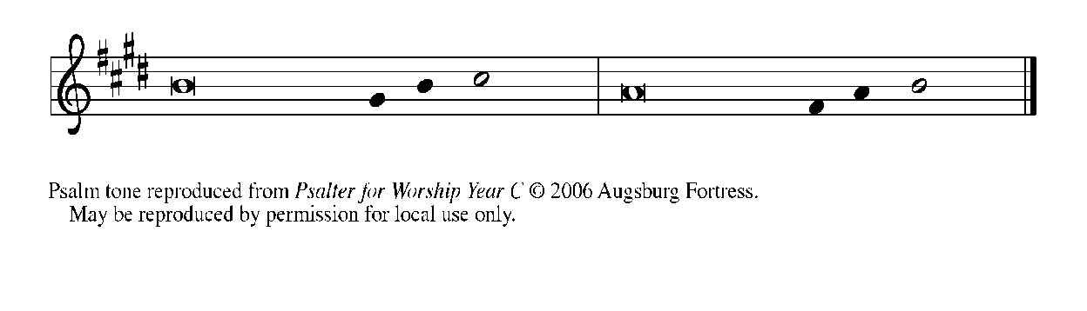
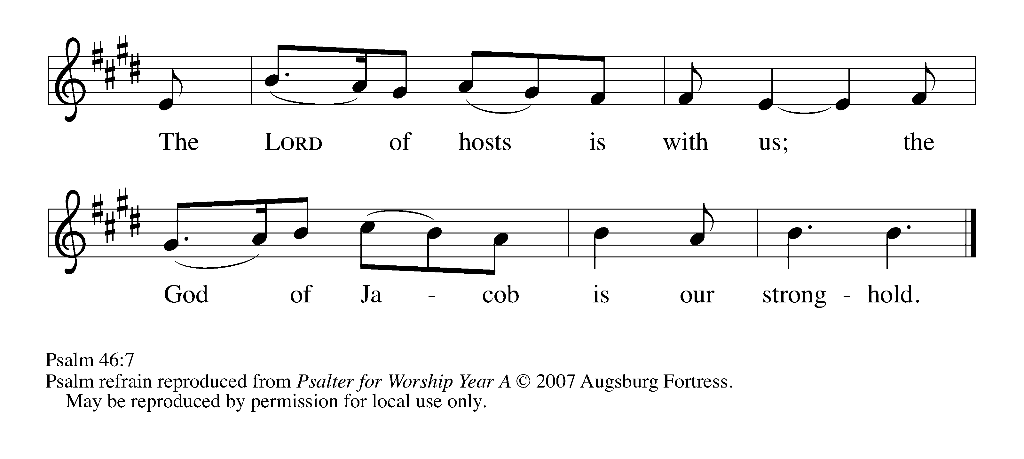
¹God is our ref- | uge and strength,*
a very present | help in trouble.

²Therefore we will not fear, though the | earth be moved,*
and though the mountains shake in the depths | of the sea;

³though its waters | rage and foam,*
and though the mountains tremble | with its tumult.

⁴There is a river whose streams make glad the cit- | y of God,*
the holy habitation of | the Most High.

⁵God is in the midst of the city; it shall | not be shaken;*
God shall help it at the | break of day.

⁶The nations rage, and the | kingdoms shake;*
God speaks, and the earth | melts away. REFRAIN

⁷The Lord of | hosts is with us;*
the God of Jacob | is our stronghold.

⁸Come now, regard the works | of the Lord,*
what desolations God has brought up-| on the earth.

⁹Behold the One Who makes war to cease in | all the world;*
Who breaks the bow, and shatters the spear, and burns the | shields with fire.

¹⁰"Be still, then, and know that | I am God;*
I will be exalted among the nations; I will be exalted | in the earth."

¹¹The Lord of | hosts is with us;*
the God of Jacob | is our stronghold. REFRAIN

SECOND READING Romans 3: 21-28

Martin Luther and other leaders of the Reformation believed the heart of the gospel was found in these words of Paul written to the Romans. All people have sinned, but God offers forgiveness of sins through Christ Jesus. We are justified--put right with God--by the gift of God's grace, through faith in Jesus.

¹⁹Now we know that whatever the law says, it speaks to those who are under the law, so that every mouth may be silenced, and the whole world may be held accountable to God. ²⁰For "no human being will be justified in his sight" by deeds prescribed by the law, for through the law comes the knowledge of sin.
²¹But now, apart from law, the righteousness of God has been disclosed, and is attested by the law and the prophets, ²²the righteousness of God through faith in Jesus Christ for all who believe. For there is no distinction, ²³since all have sinned and fall short of the glory of God; ²⁴they are now justified by His grace as a gift, through the redemption that is in Christ Jesus, ²⁵Whom God put forward as a sacrifice of atonement by His blood, effective through faith. He did this to show his righteousness, because in His divine forbearance He had passed over the sins previously committed; ²⁶it was to prove at the present time that He Himself is righteous and that He justifies the one who has faith in Jesus.
²⁷Then what becomes of boasting? It is excluded. By what law? By that of works? No, but by the law of faith. ²⁸For we hold that a person is justified by faith apart from works prescribed by the law.

The Word of the Lord.

Thanks be to God.

As you are able please rise

THE VERSE

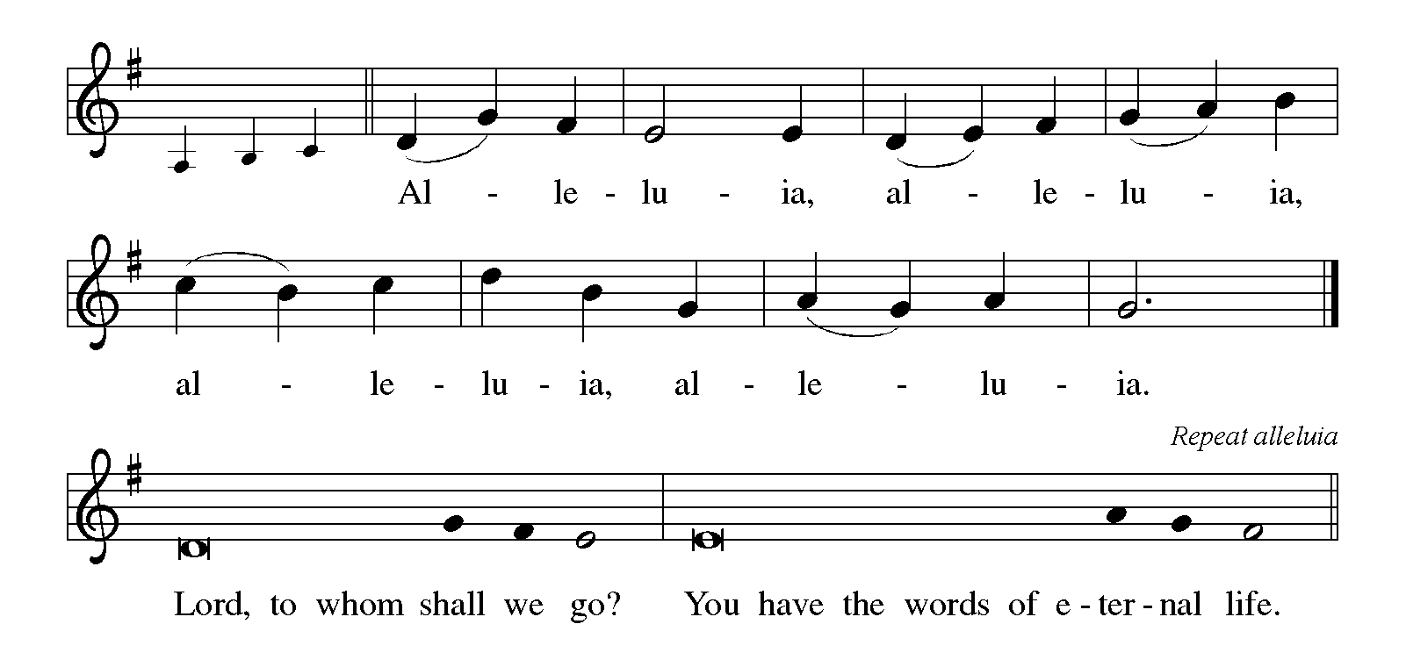

THE HOLY GOSPEL John 8: 31-36

True freedom is not related to ethnic distinctions or social class. Only Jesus can free us from slavery to sin, and he does this through the truth of the gospel.

P: The Holy Gospel according to St. John, the eighth chapter.

C: Glory to You, O Lord!

Jesus said to the Judeans who had believed in him, "If you continue in my word, you are truly my disciples; ³²and you will know the truth, and the truth will make you free." ³³They answered him, "We are descendants of Abraham and have never been slaves to anyone. What do you mean by saying, 'You will be made free'?"
³⁴Jesus answered them, "Very truly, I tell you, everyone who commits sin is a slave to sin. ³⁵The slave does not have a permanent place in the household; the son has a place there forever. ³⁶So if the Son makes you free, you will be free indeed."

P: The Gospel of the Lord.

C: Praise to You, O Christ!

The assembly is seated

THE SERMON

Silence for reflection follows the sermon

As you are able please rise

THE HYMN OF THE DAY Founded on Faith
(Sung to the tune of, “When in Our Music God is Glorified”)
Stanza 2 – men; Stanza 4 - women

1 Founded on faith, the church—alive by grace—
proclaims the gospel here and ev'ry place.
The word of God resounds through time and space:
Alleluia!

2 Your cross, O Christ, renews our life each day.
Baptized in You, we learn and teach and pray.
Fed by Your love, with thankful hearts, we say:
Alleluia!

3 Equipped by prayer, we live the Spirit's call.
Empow'red to serve with gifts, both great and small,
we bring the living hope of God to all.
Alleluia!

4 Growing in grace for God's created earth,
we yearn for justice, peace, and human worth;
a world restored; a faithful, caring church.
Alleluia!

5 Founded on faith, called forth, empow'red to serve,
we share God's endless love without reserve.
Then let us shout aloud the living Word!
Alleluia!

RECEPTION OF NEW MEMBERS

P: These persons have come to us from other Lutheran congregations and desire to transfer
their membership into our community of faith.

As their names are read the new members come forward

A: We welcome you as members of St. Paul Lutheran Church to join with us in worshiping
God, hearing His Word and sharing in His Supper, proclaiming the Good News of God
in Christ through word and deed, serving all people, and striving for justice and peace
in all the earth.

THE PRAYER OF THE CHURCH

A: That all people may come to know the grace of God in Christ, and be reformed into
God’s one people, let us know offer our prayer for the Church, the world, and all those
in need.

A: That the Church may constantly be reformed and renewed by God’s law of love written
on our hearts that we may proclaim Your hope, grace, and new life to the world, let us
pray to the Lord:

C: Lord, hear our prayer.

A: That by rain, rivers and oceans we might be reminded of how Your Word flows through
creation, surrounding us with grace and sealing us in the covenant of water and the
Spirit, let us pray to the Lord:

C: Lord, hear our prayer.

A: That God might break the bow, shatter the spear, burn the shield, and make wars to
cease, reconciling the nations to one another, let us pray to the Lord:

C: Lord, hear our prayer.

A: That this congregation might be renewed and re-formed by Jesus’ Word and live out
His forgiveness with humble, thankful, and loving hearts, let us pray to the Lord:

C: Lord, hear our prayer.

A: That caregivers might find respite, medical workers be infused with skill and
compassion, scientists and researchers might find cures, and those who need healing
and strength, especially: Larry Litchford; Joyce Stark; Major Payne; Jan
Paholski; Laura Dovey; David Weiss; Fred Weiss; Shirley Freels; Martha
Schroeder; John Bennitt; Wayne Simerlein; Lucas Bradshaw; Robert Bernth;
Jacque(Jackie) Gaines; and Shirley Shikany Long might find in God a very present
stronghold of rest and peace, let us pray to the Lord:

C: Lord, hear our prayer.

A: That with Martin Luther, renewer of the Church, and Simon and Jude, Apostles,
whom we commemorate this Day, and all the saints who have called the Church to
faithfulness to Christ we might continue in His Word until we receive a place in God’s
household forever, let us pray to the Lord:

C: Lord, hear our prayer.

A: We thank You, Lord, for these new members of our congregation: Aydan Dettman;
and David Jocelyn. That by Your life-giving power we might be bound to each other
in You; strengthened for service; and supported all our days until You bring us at last
to that Day when all Your children will be one and You will be All-in-All, let us pray
to the Lord:

C: Lord, hear our prayer.

P: Into Your gracious hands, O Lord, we commend all for whom we pray, trusting in Your
mercy through Your Son, Jesus Christ our Lord.

C: Amen.

MEAL

THE PEACE

P: The peace of the Lord be with you always.

C: And also with you.

The assembly is seated

THE OFFERING

THE VOLUNTARY God So Loved the World St. Paul Senior Choir
J. Stainer

As you are able please rise

THE PRESENTATION OF GIFTS (see p. 9) Let the Vineyards be Fruitful

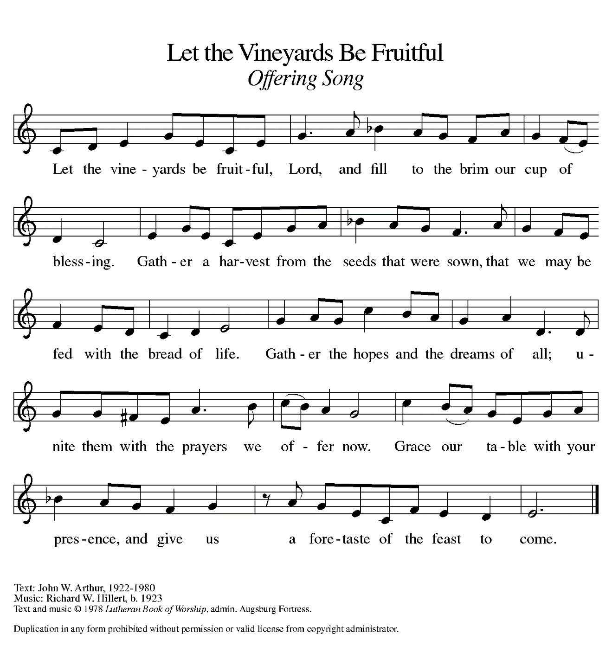 THE OFFERTORY PRAYER

A: Let us pray. Gracious God,

C: You put forward Your Son, Jesus Christ, as a sacrifice to make us one with You.
We put forward these gifts as a pledge to You of our whole lives. Receive them
and bless them for Your service. By this holy Sacrament, help us to know Your
grace, and free us to live and serve with joy as Your beloved people. We ask this
in the name of Jesus the Lord. Amen.

THE GREAT THANKSGIVING

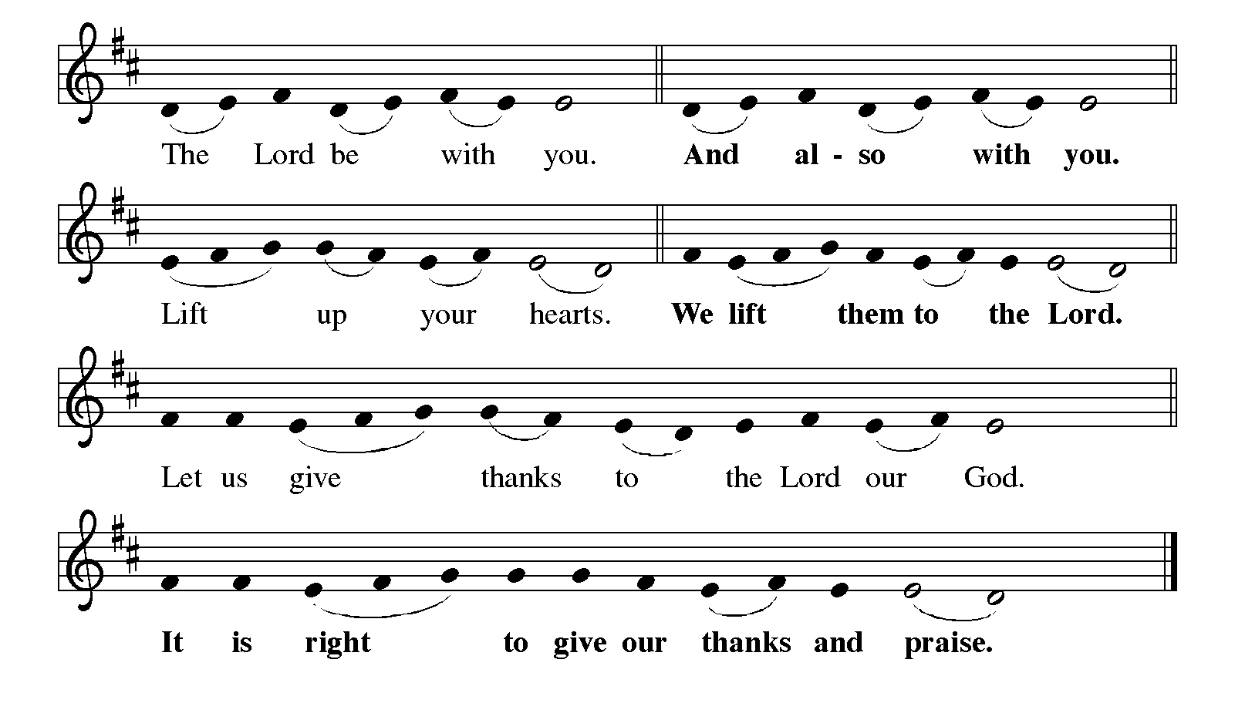
P: It is our duty and delight … and join their unending hymn:

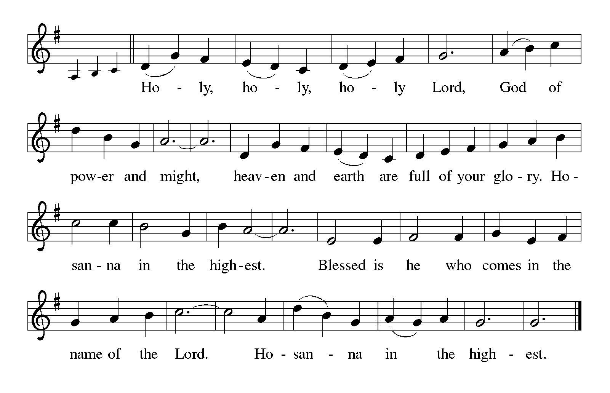
P: Holy God, our Refuge and Strength, we bless and praise You.
You are righteous in Your determination to always and forever have mercy.
That Your blessings of mercy might be known by all people, You chose Israel to be a
light of hope to the nations.
Ever faithful, even when they turned away, You promised a new covenant of
forgiveness that cannot be broken, and will yet come to pass.

At the last, You revealed Your righteousness in Your Son, Jesus Christ.
He is Your Word of truth Who makes us free.
In the night ... “Do this for the remembrance of Me.”
As often as we eat ... we proclaim the Lord’s death until He comes.
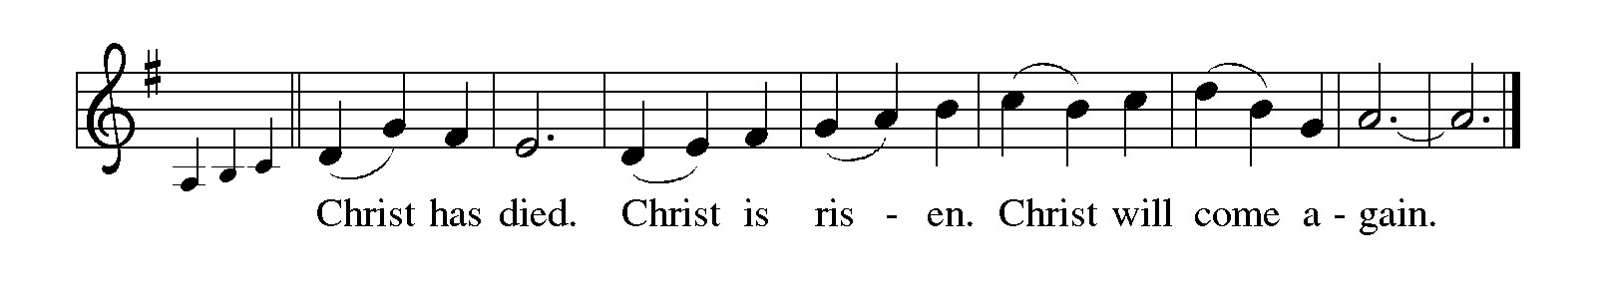
P: With this bread and cup we remember our Lord’s life, Your mercy in flesh and blood,
and His willing death that made us right with You.
You raised Him from death that we might live in freedom from the powers of sin, evil,
and death.
He has promised to return to fulfill Your promise that You will be our God and we will
be Your people forever.
Send Your Spirit on us and these Your gifts of bread and wine.
May we who share the Lord’s Body and Blood be kept from fear and despair and
strengthened in our trust in Your covenant of life with all the world.
To You, O God: Father, Son, and Holy Spirit, be all honor and glory, in Your holy
heaven and on earth, now and forever.
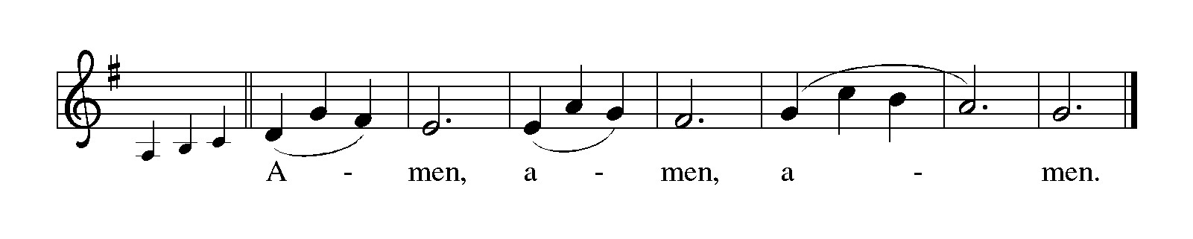
THE LORD’S PRAYER

P: That we may continue in Jesus’ word, let us pray as He taught His disciples:

C: (Sung) Music is on the front cover of the red hymnal

INVITATION TO THE MEAL

P: This is the Lamb of God Who takes away the sin of the world. Blessed are those who
are called to the Supper of the Lamb. God's holy gifts for God's holy people. Come,
for all is now ready.

The assembly is seated

THE DISTRIBUTION Lamb of God
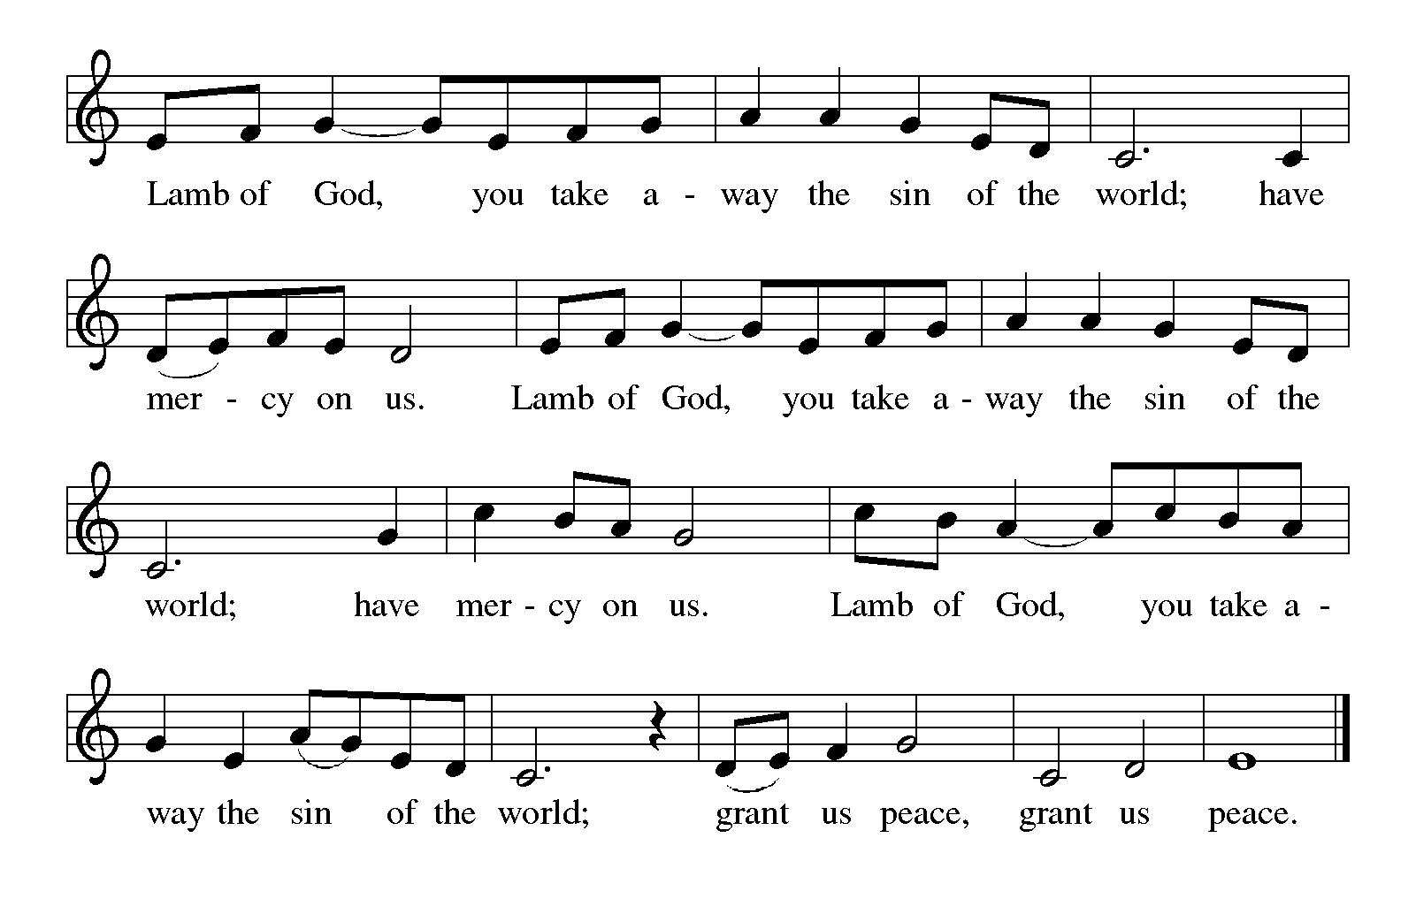
HYMN DURING DISTRIBUTION 654 The Church’s One Foundation
NSB 104 (2x) You Are My Hiding Place
NSB 75 You Are the Rock of My Salvation
ELW 581 You Are Mine
NSB 50 I Exalt Thee

As you are able please rise

POST-COMMUNION BLESSING

P: The Body and Blood of our Lord Jesus Christ strengthen you and keep you in His grace.

C: Amen.

THE POST-COMMUNION PRAYER

A: Let us pray. Merciful God, in this bread and cup of the new covenant You have again
forgiven our sins and drawn us into Your love. Help us to grow in faith as we proclaim
the truth of Your love. Grant this through Christ our Lord.

C: Amen.
SENDING

THE BENEDICTION

P: Almighty God: Father, Son, and Holy Spirit, bless you now and forever.

C: Amen.

SENDING HYMN 504 A Mighty Fortress

THE DISMISSAL

A: Go in peace to love and serve the Lord.

C: Thanks be to God!

POSTLUDE

To God Alone Be Glory

The Meditation is from The Text This Week Online: Lectionary, Scripture Study, and
Worship Resources.

ANNOUNCEMENTS

Please remember to mail your offering to the Church Office at 818 Franklin Street, Michigan City, IN 46360. Another alternative is to give on-line through Tithe.ly. Please see your closure letter for information on how to set up a Tithe.ly account.

St. Paul Members are reminded to have a loved one contact the office if you are hospitalized. Many times, the Pastor doesn’t know someone is in the hospital. If you call and leave a message, please tell us at which hospital the patient is located.

BIRTHDAYS: Judy Mutchler (10/25); Bob Kiser (10/26); Sandra Sobecki (10/28)

PRAYER CONCERNS: Bev Coburn; Barry Anderson; John Bennitt; Judy Gustum; Larry Litchford; Sarah McNabb; Jeanie Boatman Shepple; Debbie Martin; Mark Tannehill; Kathy Stein; Jan Paholski; Laura Dovey; Grace Romine; Roger and Margaret Miller; Bill Hazelgrove; Kerry Steinborn; Robert Bernth; Craig Hunt; Al Levenhagen;
Carl Wipperman ; Major Payne and Wayne Simmerlein.

OFFICE HOURS: Libby will be in the office on Mondays, Wednesdays, and Fridays; volunteers will cover Tuesdays and Thursdays.

Monday & Wednesday 8:00 a.m. – 5 p.m.
Tuesday & Thursday 9:00 a.m. – 12:00 p.m.
Friday 8:00 a.m. – 12:00 p.m.

If you are listening to the worship broadcast on the radio and would like to watch the Sunday morning service live stream follow these steps:

(1) If you have You Tube available on your TV, search for
St. Paul Lutheran Church Michigan City, IN.

(2) The direct link on the computer is https://
www.youtube.com/channel/UC5AIPNaKr3QN50984jGOa1g.

(3) This link is also on the main page of the church’s website in
the church section and will continue to be posted weekly on the St.
Paul Facebook page.

And it will always be available on the radio broadcast Sunday mornings at 11:00 a.m.
on WEFM (95.9), and on the local cable access station #99 for the previous week’s
service on Sundays at 4:00 p.m. and the current service on Wednesdays at 7:00 p.m.
and Fridays at 8:30 p.m.

To send e-mail to the church office, please use the following addresses:

Pastor Mark Reshan: seniorpastor@stpaulmichigancity.com

Church Office Secretary (Libby Pollock): churchsecretary@stpaulmichigancity.com

Church Treasurer (Karen Fleming): finance@stpaulmichigancity.com

2025 Church Council:

Mark Reshan - Pastor

Janet Bakken – President

Donna Knoll – Vice President

Judy Hunt – Secretary

Karen Fleming – Treasurer

Members: Paul Brooks, Diane Egilske, Sue Koziel, Judy Mutchler, Jim Schraidt, Trish Sprague

Worship Attendance:
Saturday , October 18, 2025 @ 4:00 p.m. 28
Sunday, October 19, 2025 @ 9:00 a.m. 58
TOTAL 86

Copies of the minutes from the August 28, 2025 and the September 25, 2025 Church Council meetings are on the back table in the upper Narthex. They were approved by the council via email.

The Good News Newsletter: If you have an article or anything you want included in The Good News please send it to the following e-mail address: splcgoodnews@gmail.com. Pastor Pamela Thiede will be using this e-mail address to assemble The Good News each month. The deadline for getting information to Pastor Pamela will be the 20th of each month.

Sunday’s lessons are Daniel 7: 1-3, 15-18; Psalm 149; Ephesians 1: 11-23; and Luke 6: 20-31 for those of you who like to study them in advance.

OCTOBER MONTHLY MISSION:
October’s monthly mission is Franciscan Health Woodland Cancer Care Center patients. The center is located on 400 North and provides the convenience of one location for a full spectrum of cancer services. We will be collecting care kits as well as money for this mission. There are paper lunch bags available in the Narthex. Please take as many bags as you want to fill with items to make a care kit for someone going through cancer treatments. Examples of items would be warm socks, hats, gloves, lotion, chapstick, hard candy, gum, snacks, hand sanitizer, small journals, books, activity books, small puzzles, or other activities to do while having treatment (which can take several hours). Please bring your completed care kits back by Sunday, November 2nd and place them in the bin in the Narthex. If you’d rather donate financially, they have a fund that goes toward local patients where they provide different things such as gas cards, or gift cards. Money can be placed in the offering plate and marked for the Cancer Center. Noisy coin for the month of October will also go toward the monthly mission. Thank you for your unwavering support each month!

BIG THANKS!

To all those who purchased and/or helped pack the Lutheran World Relief Kits. We packed 100 health kits, 100 School kits, and donated over $300 to the shipping fund to help get kits into hands of people struck by disaster around the world! Thank you for your generosity and hard work to make this mission a success each year!

And thank you for your support of our September Mission of the Month, ZERO Prostate Cancer. We raised over $782 to help us get closer to a world with zero lives lost due to Prostate Cancer!

Thank you for your giving hearts and helping hands!

NOVEMBER MISSION OF THE MONTH

The Mission of the Month for November: Nest Community Shelter, located at the old Sacred Heart Church, is a nonprofit organization delivering temporary emergency shelter for the homeless men and women (including women with children) in our community. Nest provides not just shelter but food and other resources. Nest is always in need of the following items:
-Bedding - blankets, pillows, pillow cases
-Food items – sugar, breakfast cereal, coffee, coffee filters, creamer, non-perishable goods
-Dining – 8 oz. foam cups, 12 oz. foam bowls, 6” & 9” plates, plastic flatware, paper towels, paper napkins, plastic wrap, aluminum foil, gallon Ziploc bags, large serving gloves
-Kitchen – 55 gallon trash bags, dish soap
-Hygiene items – liquid hand soap, hand sanitizer, all purpose cleaner, feminine hygiene products, toilet paper
Donations of goods can be placed in the bin in the Narthex. Monetary donations can be marked for Nest and placed in the offering plate. Noisy coin offering will also go toward the mission of the month. Thank you for your help in providing for those in need in our community!

NEW ADDRESS:

For those wanting to send a card to Judy Gustum her new address is:
Judy Gustum
c/o Brentwood at LaPorte
2002 Andrew Ave. Room #226
LaPorte, IN 46350

ACTIVITIES, EVENTS & MEETINGS
OCTOBER 2025

Saturday, October 25, 2025 @ 4:00 p.m. 20th Pent/Reformation Worship/Sanctuary

Sunday, October 26, 2025 @ 9:00 a.m. 20th Pent/Reformation Sunday Worship/
Sanctuary with Coffee after/St. Paul Room

Wednesday, October 29. 2025 @ 9:15 a.m. Bible Study/Luther House

@10:00 a.m. God’s Purls/St. Paul Room

@4:30 p.m. Choir Rehearsal/Sanctuary
ACTIVITIES, EVENTS & MEETINGS
November 2025

Saturday, November 1, 2025 @ 4:00 p.m. 21 Pent ALL SAINTS Worship

Sunday, November 2, 2025 @ 9:00 a.m. 21 Pent ALL SAINTS DAY Worship
Sanctuary/with coffee after/St. Paul Room

Tuesday, November 4, 2025 @ 10:00 a.m. Altar Guild/Green Room

Wednesday, November 5, 2025 @ 9:15 a.m. Bible Study/Luther House

@ 10:00 a.m. God’s Purls/St. Paul Room

@ 4:30 p.m. Choir Rehearsal/Sanctuary

Thursday, November 6, 2025 FAITH CIRCLE/Green Room

Saturday, November 8, 2025 @ 4:00 p.m. 22 Pent Worship Service/Sanctuary

Sunday, November 9, 2025 @ 9:00 a.m. 22 Pent Worship Service/Sanctuary
Immediately following: FALL CONGREGATIONAL MEETING/St. Paul
Room with POTLUCK luncheon to follow/St. Paul Room

Monday, November 10, 2025 @ 1:00 p.m. HOPE CIRCLE/Green Room

Tuesday, November 11, 2025 @ 7:00 p.m. Estuary/Luther House

Wednesday, November 12, 2025 @ 9:15 a.m. Bible Study/Luther House

@ 10:00 a.m. God’s Purls/St. Paul Room

@ 11:00 a.m. – 9:00 p.m. GIVE BACK @ SWINGBELLY’S

@ 3:30 p.m. Worship & Music Mtg./Luther House

@ 4:30 p.m. Choir Rehearsal/Sanctuary

Thursday, November 13, 2025 @ 4:00 p.m. 150th Anniv. Mtg./Luther House

Saturday, November 15, 2025 @ 4:00 p.m. 23 Pent Worship Service/Sanctuary

Sunday, November 16, 2025 @ 9:00 a.m. 23 Pent Worship Service/Sanctuary
with coffee after/ St. Paul Room
with coffee after/St. Paul Room
Monday, November 17, 2025 @ 2:00 p.m. Finance Comm. Mtg./Luther House
@ 3:00 p.m. Executive Board Meeting/Luther House
Wednesday, November 19, 2025 @ 4:30 p.m. Choir Rehearsal/Sanctuary
Thursday, November 20, 2025 @ 3:00 p.m. Church Council Mtg./Luther House
Saturday, November 22, 2025 @ 4:00 p.m. CHRIST THE KING Worship Service/ Sanctuary

Sunday, November 23, 2025 @ 9:00 a.m. CHRIST THE KING Worship Sanctuary
with coffee after/St. Paul Room
Wednesday, November 26, 2025 @10:00 a.m. God’s Purls/St. Paul Room

SAVE THE DATE!
On Sunday, November 9th, our regular fall congregational meeting will be held in the St. Paul Room following the Sunday morning worship service with a true POTLUCK luncheon to follow. The primary item on the agenda will be the election of officers and council members. There will also be a financial report. We need not only your presence at the meeting but your willingness to step in and fill those seats. Please consider how you might be able to serve. We have many gifted members whose presence in leadership roles would greatly enrich our congregation. You might be one of them. Agree to serve.

Thank$ for $haring
Thanks to all who participate in the Give Back opportunities! Our next Give Back will be at Swingbelly’s on Wednesday, November 12, 2025 from 11am—9 pm. Here are two coupons—one for you and one for a friend.

