THE FIFTEENTH SUNDAY AFTER PENTECOST
September 6, 2026

Too often, in matters of morality, our society seems to have replaced the “Golden Rule”–Do unto others as you would have them do unto you–with a new rule. Don’t do anything to or for others and, with luck, they will never do anything to or for you. We can all stay strangers, locked behind our walls of zealously guarded individualism.
We’ve got our “freedom,” our “individual autonomy.” Unfortunately, along with this arrangement, we also got a great deal of loneliness.

William Willimon

In a sense, then, these verses (Romans 13: 8-14) provide something of a contrast to or perhaps an overriding framework for understanding 13: 1-7. While certain cultural or civic obligations cannot be dismissed, ultimately, the transformation of the mind and offering of the body, being clothed with Christ, is to rearrange the mental furniture of those in Christ from what they had known. It is to owe nothing, and live differently than what they’ve known, to adopt a new pattern and ethic.
This is the transformation of the mind Paul writes about in Romans 12: 1-2; it is the way they are to give witness to the life that has died to sin and participates in the life of the Spirit as Paul writes in Romans 6-8; it is the life that walks according to the faith of Abraham in Romans 4; it is the life that judges not the brother or sister as Paul writes about in Romans 2.
To owe nothing but love to one another is to own the reality that we all are completely dependent on God’s grace for not only our forgiveness, but for our very existence, and it reframes how we live in relation to one another in our everyday interactions. It reframes it in such a way that other obligations become significantly less reality shaping than they once were.
Paul invites his audience to live in the present the eschatological life made possible through the cross and the work of the Spirit present among them. The exhortation is not unlike that of Jesus in Matthew’s Sermon on the Mount, that the church live as “light” -- “let your [plural!] light shine thusly: that people would see your good works and give glory to your father in heaven” (Matthew 5: 16). This is not the light of our own performance, of our hard work, of our status as good citizens, or even of great church programming. It is the light of Christ as we are together clothed with Christ, as those who have died to our old lives and who are now obligated to others nothing but love.
Kyle Frever
In the Name of Jesus

GATHERING

INTRODUCTION

Conflict is a part of relationships and life in community. Jesus' words in today's gospel are often used in situations having to do with church discipline. The prophet Ezekiel tells of warning the wicked to turn from their ways, and Paul reminds us that love is the fulfilling of the law. We gather in the name of Christ, assured that he is present among us with gifts of peace and reconciliation.

PRE-SERVICE MUSIC Come New Song Praise Band
(Brian Doerksen)

ANNOUNCEMENTS

As you are able please rise

CONFESSION AND ABSOLUTION

P: In the name of the Father and of the Son and of the Holy Spirit.

C: Amen.

P: “Now you, mortal, say to the house of Israel, Thus you have said: ‘Our transgressions
and our sins weigh upon us, and we waste away because of them; how then can we
live?’ Say to them, As I live, says the LORD God, I have no pleasure in the death of
the wicked, but that the wicked turn from their ways and live ...” (Ezekiel 33: 10-11)
God desires that we too turn from our sin in repentance. Let us therefore unburden
ourselves from the weight of our sins, that God may fulfill His desire to bring us again
from death to new life.

Silence for self-examination and reflection is kept

P: Most merciful God,

C: We confess that we have sinned against You in thought, word, and deed. We have
not kept Your commandments. (Psalm 119: 35). We have not loved our neighbor
as ourselves. (Romans 13: 9) We are guilty of gossip and false witness against
others. (Matthew 18: 15-17) We have insisted on living in ways that bring
separation and death instead of reconciliation and life. For all our transgressions,
have mercy upon us, O Lord. Forgive us, renew us in Your mercy, and equip us
again to “lay aside the works of darkness and put on the armor of light” (Romans
13: 12) that we may live and serve to Your honor and glory.

P: “Turn away the reproach which I dread (O Lord), because Your judgments are good.”
(Psalm 119: 39) God’s decision about you is good, for God yearns for wholeness and
life for you. Therefore, as a called and ordained minister of the Church of Christ, and
by His authority, I declare to you the entire forgiveness of all your sins, in the name of
the Father and of the Son and of the Holy Spirit.

C: Amen.

GATHERING SONG 793 Be Thou My Vision

THE GREETING AND PRAYER OF THE DAY

P: “Owe no one anything,

C: except to love one another.” (Romans 13:8)

P: The grace of our Lord Jesus Christ, the love of God, and the communion of the Holy
Spirit be with you all.

C: And also with you.

P: Let us pray. O Lord God, enliven and preserve Your church with Your perpetual mercy.
Without Your help, we mortals will fail; remove far from us everything that is harmful,
and lead us toward all that gives life and salvation, through Jesus Christ, our Savior and
Lord.

C: Amen.

The assembly is seated

WORD

FIRST READING Ezekiel 33: 7-11

Shortly before the fall of Jerusalem, the Lord commissions Ezekiel to serve as a sentinel. The role of watchman is crucial in the hills of Palestine, where early detection of approaching danger can mean the difference between victory and defeat. The prophet's task is also crucial: warn the wicked of the danger of retaining wicked ways.

You, mortal, I have made a sentinel for the house of Israel; whenever you hear a word from My mouth, you shall give them warning from Me. ⁸If I say to the wicked, "O wicked ones, you shall surely die," and you do not speak to warn the wicked to turn from their ways, the wicked shall die in their iniquity, but their blood I will require at your hand. ⁹But if you warn the wicked to turn from their ways, and they do not turn from their ways, the wicked shall die in their iniquity, but you will have saved your life.
¹⁰Now you, mortal, say to the house of Israel, Thus you have said: "Our transgressions and our sins weigh upon us, and we waste away because of them; how then can we live?" ¹¹Say to them, As I live, says the Lord God, I have no pleasure in the death of the wicked, but that the wicked turn from their ways and live; turn back, turn back from your evil ways; for why will you die, O house of Israel?

The Word of the Lord.

Thanks be to God.

THE PSALM: Psalm 119: 33-40 Read responsively

³³Teach me, O LORD, the way of Your statutes,
and I shall keep it |to the end.

³⁴Give me understanding, and I shall keep Your teaching;
I shall keep it with all my heart.

³⁵Lead me in the path of Your commandments,
for that is my desire.
³⁶Incline my heart to Your decrees
and not to unjust gain.

³⁷Turn my eyes from beholding falsehood;
give me life in Your way.

³⁸Fulfill Your promise to Your servant,
which is for those who fear You.

³⁹Turn away the reproach that I dread,
because Your judgments are good.

⁴⁰Behold, I long for Your commandments;
by Your righteousness enliven me.

SECOND READING Romans 13: 8-14

Although Paul insists that we are reconciled to God through faith rather than through works of the law, he encourages Christians to practice God's law of love while we wait for the salvation that is to come.

Owe no one anything, except to love one another; for the one who loves another has fulfilled the law. ⁹The commandments, "You shall not commit adultery; You shall not murder; You shall not steal; You shall not covet"; and any other commandment, are summed up in this word, "Love your neighbor as yourself." ¹⁰Love does no wrong to a neighbor; therefore, love is the fulfilling of the law.
¹¹Besides this, you know what time it is, how it is now the moment for you to wake from sleep. For salvation is nearer to us now than when we became believers; ¹²the night is far gone, the day is near. Let us then lay aside the works of darkness and put on the armor of light; ¹³let us live honorably as in the day, not in reveling and drunkenness, not in debauchery and licentiousness, not in quarreling and jealousy. ¹⁴Instead, put on the Lord Jesus Christ, and make no provision for the flesh, to gratify its desires.

The Word of the Lord.

Thanks be to God.

As you are able please rise

THE VERSE Sung twice (see p. 5)

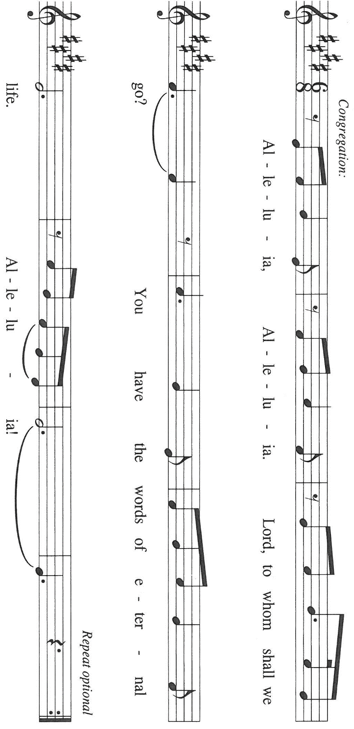

THE HOLY GOSPEL Matthew 18: 15-20

Jesus has just said that God's concern for every individual is like that of a shepherd who will leave the entire herd to look for one sheep that is lost. Now, he says, the church should reach out to and welcome members who sin.

P: The Holy Gospel according to St. Matthew, the eighteenth chapter.

C: Glory to You, O Lord!

[Jesus said to the disciples:] "If another member of the church sins against you, go and point out the fault when the two of you are alone. If the member listens to you, you have regained that one. ¹⁶But if you are not listened to, take one or two others along with you, so that every word may be confirmed by the evidence of two or three witnesses.
¹⁷If the member refuses to listen to them, tell it to the church; and if the offender refuses to listen even to the church, let such a one be to you as a Gentile and a tax collector. ¹⁸Truly I tell you, whatever you bind on earth will be bound in heaven, and whatever you loose on earth will be loosed in heaven. ¹⁹Again, truly I tell you, if two of you agree on earth about anything you ask, it will be done for you by My Father in heaven. ²⁰For where two or three are gathered in My name, I am there among them."

P: The Gospel of the Lord.

C: Praise to You, O Christ!

The assembly is seated

THE SERMON
Silence for reflection follows the sermon

As you are able please rise

THE HYMN OF THE DAY Beloved, God’s Chosen
(Sung to the tune of, We Praise You, O God on p. 870 in red hymnal)
Beloved, God’s chosen, put on as a garment
Compassion, forgiveness, and goodness of heart
Above all, before all, let love be your raiment
That binds into one ev’ry dissonant part.

Within, call forth Wisdom, to dwell in you richly;
Let peace rule your hearts and that peace be of Christ.
And from the heart’s chamber, beloved and holy,
That binds into one ev’ry dissonant part.
Beloved, God’s chosen, put on as a garment
Compassion, forgiveness, and goodness of heart
Above all, before all, let love be your raiment
That binds into one ev’ry dissonant part.

THE APOSTLES’ CREED

A: God has made us His people through our Baptism into Christ. Living together in trust
and hope, we confess our faith.

C: I believe in God, the Father almighty,
creator of heaven and earth.

I believe in Jesus Christ, His only Son, our Lord.
He was conceived by the power of the Holy Spirit
and born of the virgin Mary.
He suffered under Pontius Pilate,
was crucified, died, and was buried.
He descended into hell.
On the third day He rose again.
He ascended into heaven,
and is seated at the right hand of the Father.
He will come again to judge the living and the dead.

I believe in the Holy Spirit,
the holy catholic Church,
the communion of saints,
the forgiveness of sins,
the resurrection of the body,
and the life everlasting. Amen

THE PRAYER OF THE CHURCH

A: God’s Word tells us that those who love their neighbors have fulfilled the Law. Out of
love and compassion for a broken world, let us therefore intercede for our neighbors in
the Church and the world.

A: That the Church may practice in our own community life the commandment of love we
proclaim to others: Lord Jesus, as we are gathered in Your name,

C: Be among us and hear us.

A: That God’s Spirit might bring about peace and reconciliation in places of hatred,
bitterness and warfare, especially in Ukraine; Iran, Lebanon, Israel, the Middle East,
Sudan, and Myanmar: Lord Jesus, as we are gathered in Your name,

C: Be among us and hear us.

A: That the lonely, the homebound, the unemployed, and the sick, especially:
Angela Cook; Jeremy Martin; Martha Schroeder; Pastor Dale Zylstra;
Mark Tannehill; Jeff Seifert; Debbie Martin; Jon Samuelson; Hazel Miller;
and Dale Thomas; might know the power of God’s healing: Lord Jesus, as we are
gathered in Your name,

C: Be among us and hear us.

A: That those celebrating birthdays, especially: Joan Seifert; Mary Knaup; and John
Konkol; might be filled with grace this day and every day and grow in grace in the
days ahead: Lord Jesus, as we are gathered in Your name,

C: Be among us and hear us.

A: That with all the saints, we may one day know Jesus’ presence face to face: Lord Jesus,
as we are gathered in Your name,

C: Be among us and hear us.

P: Lord God, it is Your desire always to have mercy and to bring life out of all our deaths.
Hear these prayers that we lift before You. Grant them according to Your gracious and
saving will, and conform both our prayers and our lives to the will and mind of Christ
Jesus our Lord, in Whose name we pray.

C: Amen.

MEAL

THE PEACE

P: The peace of the Lord be with you always.

C: And also with you.

The assembly is seated

THE OFFERING

THE VOLUNTARY I’m Putting on the Love of the Lord New Song Praise Band
(John Schreiner)

As you are able please rise

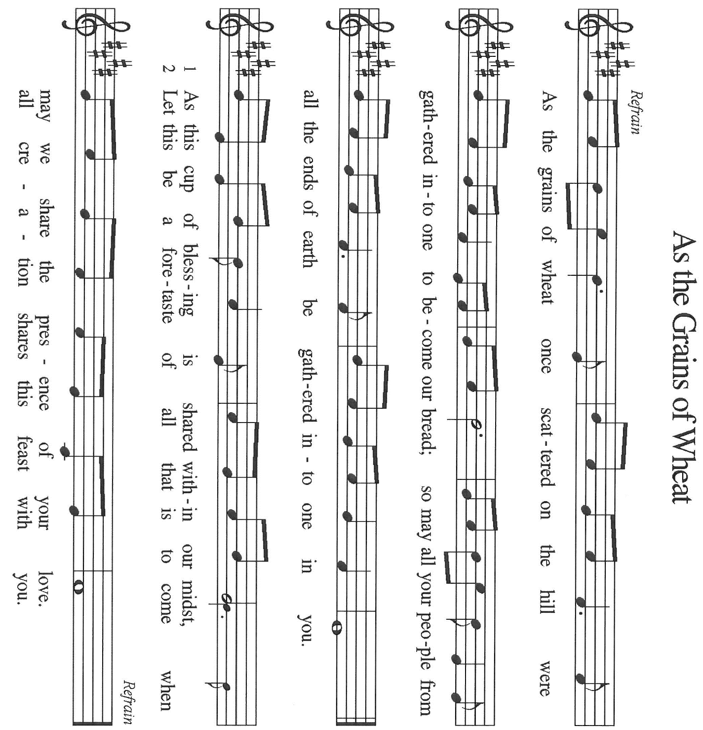
THE OFFERTORY As the Grains of Wheat

THE OFFERTORY PRAYER

A: Let us pray. Lord Jesus,

C: You promise to be among us when we gather in Your name. Be present now in
these offerings of our time, our hopes, and ourselves. As You give Yourself to us
in this holy Sacrament, strengthen us to give our lives in service to You and love
of our neighbor. We bless You now and forever. Amen.
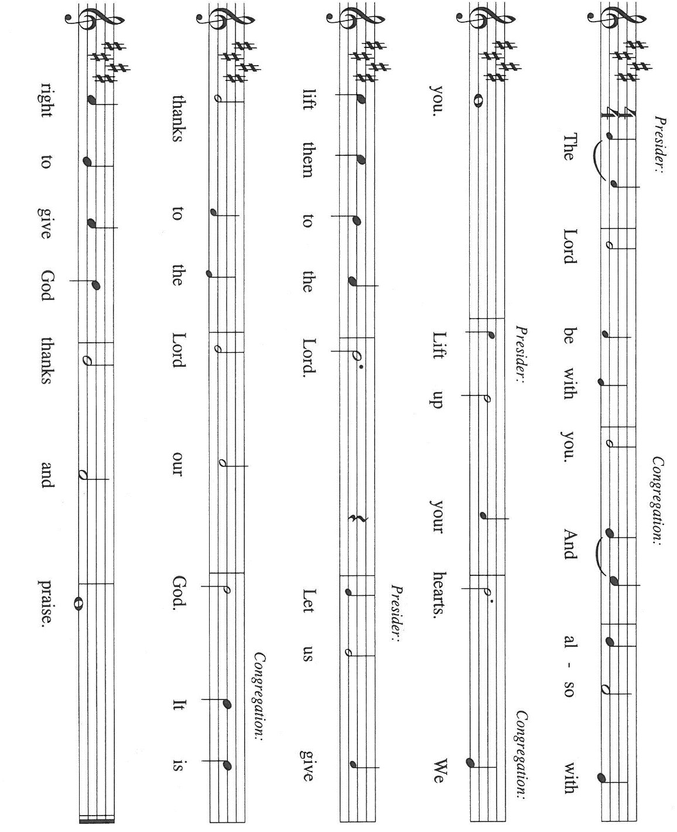
THE GREAT THANKSGIVING

P: It is our duty and delight …join their unending hymn:

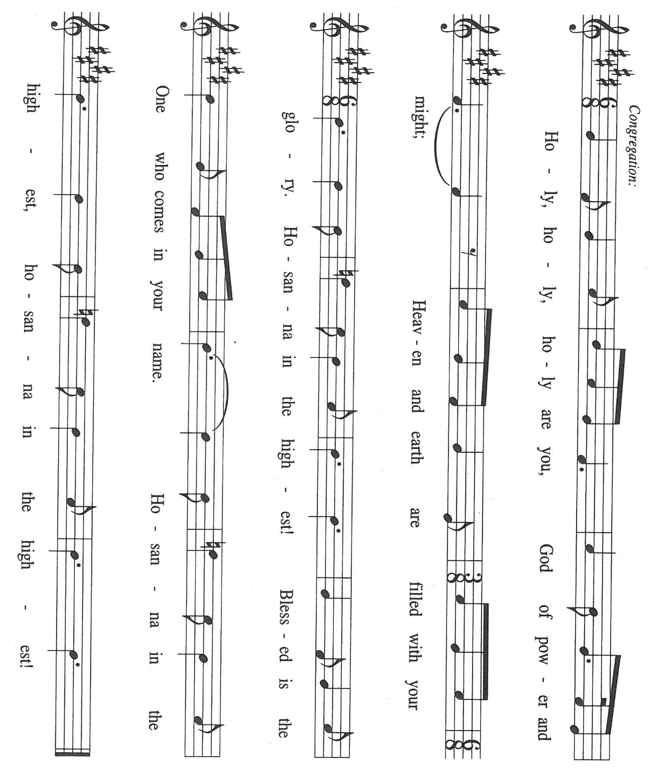

P: Holy God, Source of all, we bring You our adoration.
For the goodness of creation, we praise You.
For Israel, Your chosen, Your blessing to all nations, we praise You.
For Your commandments of life, Your law of love, and the prophets who call us to
repentance, obedience, and forgiveness, we praise You.

At the last we praise You for Your only-begotten Son, Jesus Christ.
In Him You are among our prayer, our song, and our feasting.
In the night ... “Do this for the remembrance of Me.”
As often as we eat ... we proclaim the Lord’s death until He comes.

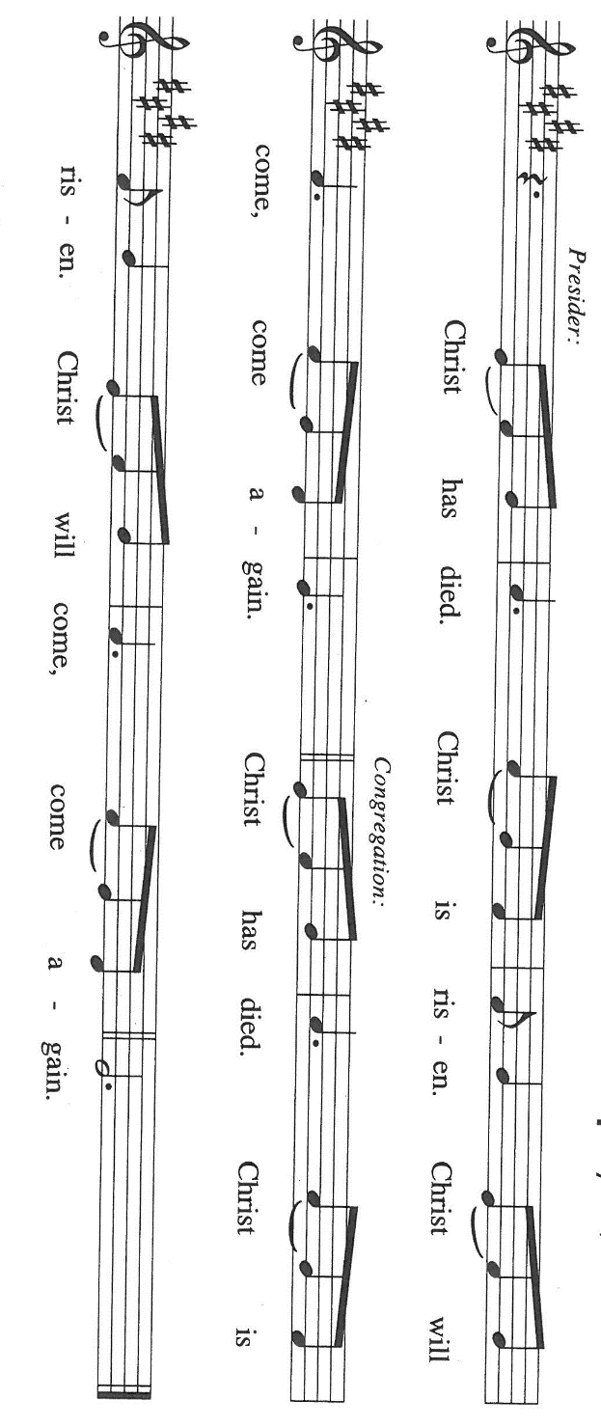

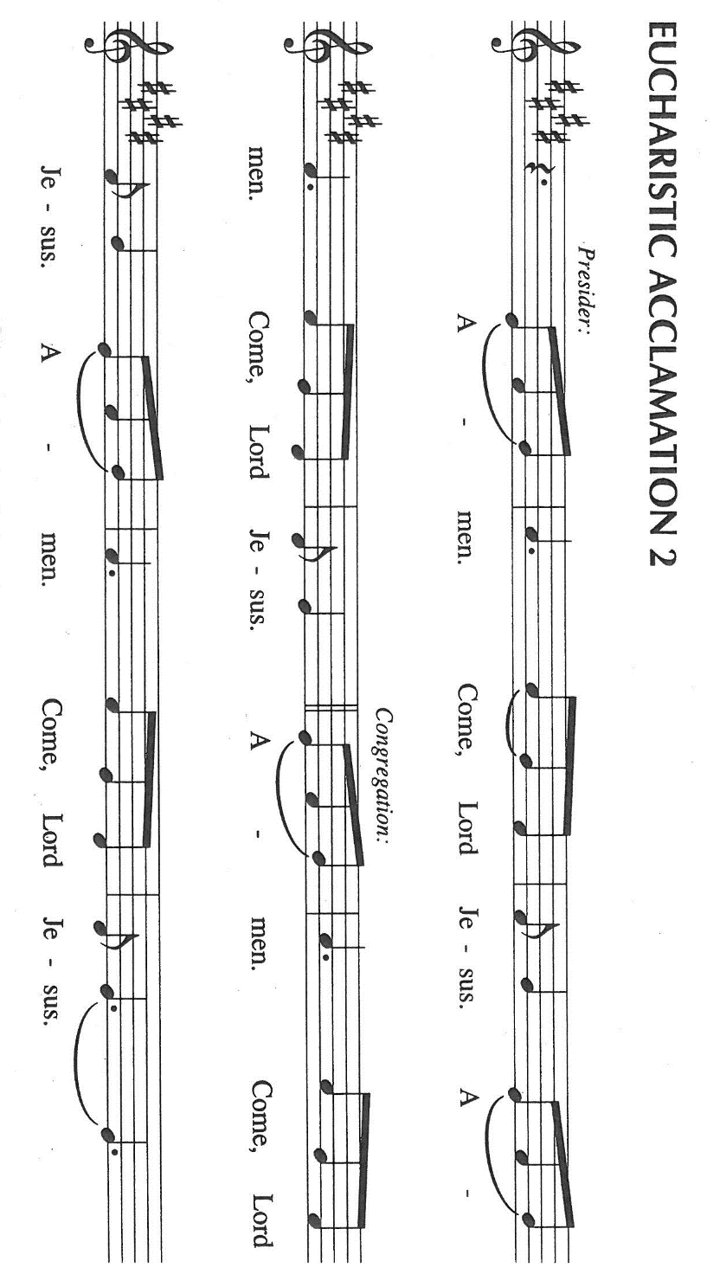

P: With this bread and cup we remember Your mighty acts in Jesus Christ:
His birth into our humanity, His baptism for our sin, His compassion for our suffering
His bearing of the cross and rising from the dead.
When He ascended, He promised to come again to host Your Feast of victory.

As we await His return, send Your Spirit on us and this bread and wine.
Strengthen us through this Meal that we may live in forgiveness and reconciliation with
and for one another.

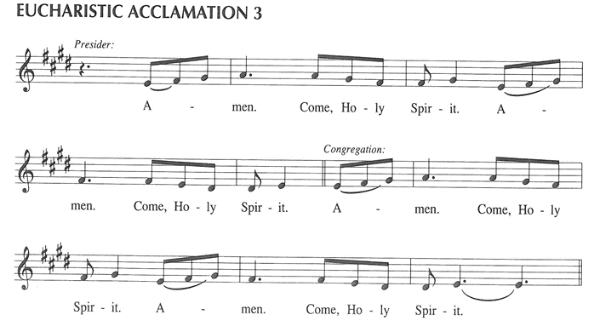

To You, O God: Father, Son, and Holy Spirit, be all honor and glory, in Your holy
Church, in heaven and on earth, now and forever.

C: Amen!

THE LORD’S PRAYER

P: With trust in God Whose providence nourishes and sustains us, let us now pray as Jesus
taught us:

C: Our Father in heaven, hallowed be Your name.
Your Kingdom come, Your will be done on earth as in heaven.
Give us today our daily bread, and forgive us our sins, as we forgive
those who sin against us.
Save us from the time of trial, and deliver us from evil.
For the Kingdom, the power, and the glory are Yours, now and forever.
Amen.

INVITATION TO THE MEAL

P: Behold the living Bread come down from heaven. Those who eat of it will never die.
Behold the cup of eternal life. Those who drink of it will life forever. God’s holy gifts
for God’s holy people. Come, for all is now ready.

The assembly is seated

THE DISTRIBUTION Lamb of God (see p. 13)

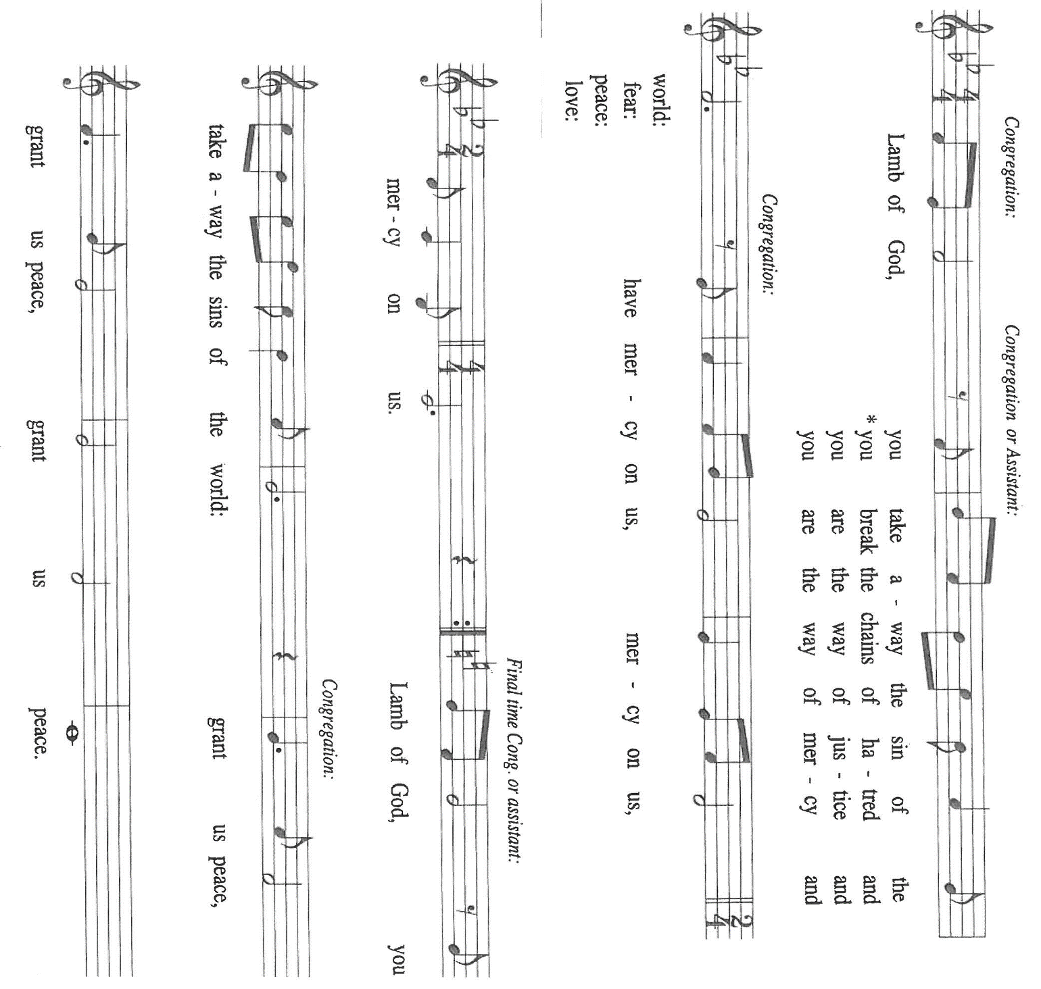

HYMN DURING DISTRIBUTION 836 Joyful, Joyful We Adore Thee

NSB 90 ‘Tis So Sweet to Trust in Jesus

NSB 89 Thy Word

NSB 14 Bind Us Together

NSB 54 I Love You Lord

As you are able please rise

THE POST-COMMUNION BLESSING

P: The Body and Blood of our Lord Jesus Christ strengthen you and keep you in His grace.

C: Amen.

THE POST-COMMUNION PRAYER

A: Let us pray. God of grace, once again Your salvation has drawn near to us in the Body
and Blood of Your Son. By our eating and drinking, help us to live honorably, to put
on the Lord Jesus, and by Your mercies, to fulfill Your law of love for one another. We
ask this in the name of Jesus the Lord.

C: Amen.

SENDING
THE BENEDICTION
P: Almighty God: Father, Son, and Holy Spirit bless you now and forever.
C: Amen.
SENDING HYMN 543 Go, My Children, With My Blessing
THE DISMISSAL
A: Go in peace to love and serve the Lord.
C: Thanks be to God!
THE POSTLUDE
To God Alone Be Glory

The Meditations are from Pulpit Resource. William Willimon, ed. Vol. 33, No. 3 July, August, September, 2005. (Inver Heights, MN: Logos Publications, Inc.) 44; and Sundays and Seasons Online. Copyright 2023 Luther Seminary.

The Prayers, Introduction to the Lord’s Prayer, and Invitation to the Meal are adapted from Prayers for Sundays and Seasons. Year A. Peter J. Scagnelli.(Chicago: Liturgy Training Publications, 1998) 116-117.

The musical setting of the liturgy, “Now the Feast and Celebration” by Marty Haugen, is
used by permission of GIA Publishers, Inc. OneLicense.net License #A-702836.

ANNOUNCEMENTS

Please remember to mail your offering to the Church Office at 818 Franklin Street, Michigan City, IN 46360. Another alternative is to give on-line through Tithe.ly. Please see your closure letter for information on how to set up a Tithe.ly account.

St. Paul Members are reminded to have a loved one contact the office if you are hospitalized. Many times, the Pastor doesn’t know someone is in the hospital. If you call and leave a message, please tell us at which hospital the patient is located.

BIRTHDAYS: Joan Seifert (9/8); Mary Knaup (9/9); John Konkol(9/10)

PRAYER CONCERNS: Debbie Martin; Mark Tannehill; Kathy Stein; Jan Paholski; Laura Dovey; Bill Hazelgrove; Al Levenhagen; Carl Wipperman; Major Payne.

OFFICE HOURS: Libby will be in the office on Mondays, Wednesdays, and Fridays; volunteers will cover Tuesdays and Thursdays.

Monday & Wednesday 8:00 a.m. – 5 p.m.
Tuesday & Thursday 9:00 a.m. – 12:00 p.m.
Friday 8:00 a.m. – 12:00 p.m.

If you are listening to the worship broadcast on the radio and would like to watch the Sunday morning service live stream follow these steps:

(1) If you have You Tube available on your TV, search for
St. Paul Lutheran Church Michigan City, IN.

(2) The direct link on the computer is https://
www.youtube.com/channel/UC5AIPNaKr3QN50984jGOa1g

(3) This link is also on the main page of the church’s website in
the church section and will continue to be posted weekly on the St.
Paul Facebook page.

And it will always be available on the radio broadcast Sunday mornings at 11:00 a.m.
on WEFM (95.9), and on the local cable access station #99 for the previous week’s
service on Sundays at 4:00 p.m. and the current service on Wednesdays at 7:00 p.m.
and Fridays at 8:30 p.m.

To send e-mail to the church office, please use the following addresses:

Pastor Mark Reshan: seniorpastor@stpaulmichigancity.com

Church Office Secretary (Libby Pollock): churchsecretary@stpaulmichigancity.com

Church Treasurer (Karen Fleming): finance@stpaulmichigancity.com

2026 Church Council:

Pastor - Mark Reshan

President - Donna Knoll

Vice President - Jan Bakken

Secretary - Judy Hunt

Treasurer - Karen Fleming

Members: Sue Koziel; Jim Schraidt; Trish Sprague; Bob Kiser; Barry Anderson; and
Pam Soule

Worship Attendance:

Saturday, August 29, 2026 @ 4:00 p.m. 36

Sunday, August 30, 2026 @ 9:00 a.m. 60

TOTAL 96

Copies of the minutes from the June 25, 2026 and July 23, 2026 Church Council meetings are on the back table in the upper Narthex. They were approved by the council via email.

Good News Newsletter: If you have an article or anything you want included in The Good News please send it to the following e-mail address: splcgoodnews@gmail.com. Pastor Pamela Thiede will be using this e-mail address to assemble The Good News each month. The deadline for getting information to Pastor Pamela will be the 20th of each month.

Next week’s lessons are Numbers 21: 4b - 9; Psalm 98: 1-4; 1 Corinthians 1; 18-24;
John 3: 13-17 for those of you who like to study them in advance.

SEPTEMBER 2026 MONTHLY MISSION:
SHRINER’S CHILDREN’S HOSPITAL

We all know Shriner’s from their commercials and their little red hats, but nearly 20,000 children each year get to know Shriner’s Children’s Hospital in Chicago for their incredible pediatric specialty care. The hospital opened in March of 1926 with 60 beds.
60 0% of patients suffered with polio and often lived at the hospital for up to a year. Over the next few decades, an orthopedic residency, bone rodding surgery, halo ring implantation, cleft lip and palate repair, pediatric spinal cord injury surgery, and motion analysis services were added. Our very own little one, Maggie Brooks, has been visiting Shriner’s in Chicago since four weeks old to correct bilateral clubfoot, a condition where she was born with both feet turned inward and upward. Shriner’s offers care to all families no matter their ability to pay or insurance status. They even have financial assistance programs that help reimburse for transportation or lodging if needed.
At Shriner’s Chicago, every child who is inpatient receives a handmade blanket and goody bag upon arrival to the hospital. We will be collecting the following items to help fill their goody bags:

Small cars or toys

Card games

Small activity books

New or gently used children’s books

Please place items in the bin in the outer narthex. If you would like to support Shriner’s financially, please make checks out to St. Paul’s and mark for Shriner’s Children’s Hospital and place in the offering plate. Noisy coin offering will also go towards the mission of the month. Thank you for your generosity!

PANCAKE BREAKFAST
There will be a pancake breakfast at St. Paul Lutheran Church, 818 Franklin Street in Michigan City on Saturday, September 12th from 8:30 am – 11:00 am and everyone is welcome! Menu includes pancakes, sausage, scrambled eggs, orange juice, and coffee – all for just $5. Come join us for food and fellowship!

2026 Financial Stewardship

Weekly Church Operating Needs (x 2 weeks)
August 22-23, 2026 and August 29-30, 2026: $ 11,211.00

General Fund (including General Memorials): $ 6,719.25

Overage/Shortage: — $ 4,491.75

Restricted Income (not including Memorials)
Supports IK Synod & Church wide Ministries: $ 330.00

Ministries in our Community/Congregation: $ 495.00

Capital Fund: $ 395.00

ACTIVITIES, EVENTS & MEETINGS
SEPTEMBER 2026

Monday, August 31, 2026 @ 7:00 p.m. Women’s Bible Study/St. Paul Room

Tuesday, September 1, 2026 @ 10:0 a.m. Altar Guild Meeting/St. Paul Room

Wednesday, September 2, 2026 @ 10:00 a.m. God’s Purls

@ 4:30 p.m. NO CHOIR TODAY

Thursday, September 3, 2026 Faith Circle?

Saturday, September 5, 2026 @ 4:00 p.m. 15th Pentecost Worship Service/Sanctuary

Sunday, September 6, 2026 @ 9:00 a.m. 15th Pentecost Worship Service/Sanctuary
with coffee after

Wednesday, September 9, 2026 @9:15 a.m. Bible Study/Luther House

@ 10:00 a.m. God’s Purls

@ 11:00 a.m. – close GIVE Back @ Swingbelly’s

@ 3:45 p.m. Worship & Music Comm. Mtg./Luther House

@ 4:30 p.m. Choir Rehearsal/Sanctuary

Saturday, September 12, 2026 @ 8:30 a.m. – 11:00 a.m. PANCAKE BREAK - FAST/St. Paul Room

@ 4:00 p.m. 16th Pentecost Worship Service/Sanctuary

Sunday, September 13, 2026 @ 9:00 a.m. 16th Pentecost Worship Service /Sanctuary
with coffee after

Monday, September 14, 2026 @ 1:00 p.m. Hope Circle/St. Paul Room

@ 7:00 p.m. Women’s Bible Study/St. Paul Room

Wednesday, September 16, 2026 @ 9:15 a.m. Bible Study/Luther House

@ 10:00a.m. God’s Purls

@ 4:30 p.m. Choir Rehearsal/Sanctuary

Saturday, September 19, 2026 @ 9:00 a.m. – 3:00 p.m. Stained Glass Window Tour

@ 4:00 p.m. 17th Pentecost Worship Service/Sanctuary

Sunday, September 20, 2026 @ 9:00 a.m. 17th Pentecost Worship Serviice/Sanctuary with coffee after

Monday, September 21, 2026 @ 2:00 p.m. Finance Comm.Meeting/Luther House

@3:00 p.m. Executive Board Meeting/Luther House

@7:00 p.m. Women’s Bible Study/St. Paul Room

Wednesday, September 23, 2026 @ 9:15 a.m. Bible Study/Luther House

@ 10:00 a.m. God’s Purls

@ 4:30 p.m. Choir Rehearsal/Sanctuary

Thursday, September 24, 2026 @ 3:00 p.m. Church Council Meeting/St. Paul Room
Saturday, September 26, 2026 @ 4:00 p.m. 18th Pentecost Worship Service/Sanctuary

Sunday, September 27, 2026 29:00 a.m. 18th Pentecost Worship Service/Sanctuary with coffee after
Monday, September 28, 2026 @ 7:00 p.m. Women’s Bible Study/St. Paul Room

Wednesday, September 30, 2026 @ 9:15 a.m. Bible Study/Luther House

@ 10:00 a.m. God’s Purls

PLEASE NOTE:
God’s Purls are still meeting every week on Wednesdays at 10:00 a.m. but they are no longer meeting in the St. Paul Room at the church. If you have any questions or concerns please contact Judy Mutchler at (219) 229-4764.

Thank$ for $haring
Thank you to all who participate in our Give-Back opportunities each month. We earned $108 from our GIVE BACK at 5 Guys on July 15, 2026. Our GIVE BACK will be at Swingbelly’s on Wednesday, September 9, 2026 from 11:00 am—Close. Here are two coupons. One for you and one for a friend.

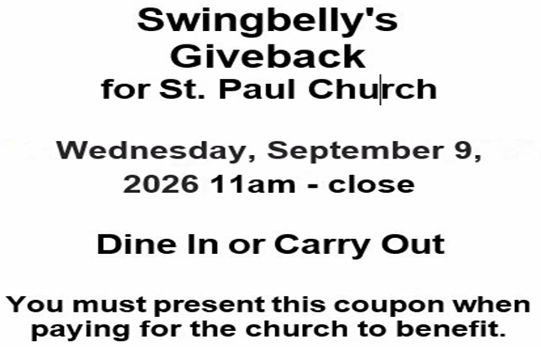



Docent guided tour of Michigan City’s historic collection of
Stained Glass Windows
Tour begins and ends at:
Immanuel Lutheran Church
1237 E. Coolspring Avenue, Michigan City, IN
Please register via telephone at 219-326-7259
or email: creativity52 @comcast.net
by September 11, 2026
and let us know if you will be riding our bus or driving your own car.
Light refreshments will be provided

The churches participating in the tour are:
Immanuel Lutheran Church
Saint Paul Lutheran Church
Saint Stanislaus Roman Catholic Church
Trinity Church
Saint Mary Roman Catholic Church
Notre Dame Catholic Church

