THE THIRD SUNDAY OF EASTER
April 19, 2026

“(This text from Luke) takes people on the road, going home, back to ordinary life, who are saddened that their greatest hopes have not come to pass. In spite of all they knew, all the stories they could rehearse, in spite of the witness of others, they simply had not seen Jesus--nor had anyone else they knew. The prophecies of Jesus and hope of redemption grew cold and were not able to sustain them any longer. They began to suspect that the whole thing had been a mistake, a worthy hope and one unlikely ever to be realized. For them, Good Friday had not been Good. Time had passed and there was no change, no resurrection, no Jesus.
Does not time also pass for us, as we go our many ways "back"? We "outgrow" our hopes or become more realistic and we no longer expect anything real to happen. We know the stories. We've heard the biblical word. Notice that even when Jesus propounds all of Scripture to the two travelers in the story, they do not recognize him!...”
“ …There is a kind of resignation in all this, both Luke's story and often our own lives. Get real. Grow up. Back to work. .. But, they don't go home, or at least not right away. The heart of this passage, the place where the dynamic changes, is the meal in Emmaus. This is a strange little story in its own right. The two travelers have to nearly force Jesus to stay with them … But it did not come to that, of course. Jesus was planning to stay the whole time. In fact, Jesus was there the whole time.
It was in Jesus' characteristic behavior of giving, of feeding, of caring for his sheep--whatever way you want to describe the blessing and distributing of bread--that they knew him. Suddenly. Fully. Jesus spent a lot of time in Luke's gospel eating with people of all sorts. He described a wise and faithful disciple as one who makes sure others have what they need to eat at the right time (Luke 12: 23-24).
In feeding others at the right time and in receiving the bread broken for us with thanksgiving, we are given Jesus. Stop talking, stop everything, and pay attention as you reach out to receive what is blessed. A glimpse of the Lord may propel you to new confidence, new hope, even a new way of remembering.
Cleopas and his companion are us. They know a lot. They care a lot. They think about things and are saddened by their diminished hopes. More important, they don't even know that their eyes have been closed until suddenly they are opened. We can't control the One who opens and closes eyes. But from this story, we might find hope that Jesus walks with us. We do find hope that in the breaking of the bread (24: 35), we catch a glimpse of our Lord.
Sarah Henrich

In the Name of Jesus

INTRODUCTION

Today's gospel begins with two disciples walking to Emmaus, overcome with sadness, loss, and disappointment. They had hoped Jesus, who was crucified, would be the one to redeem Israel! Yet the risen Christ walks with them, and then opens their eyes in the breaking of the bread. Each Sunday our hearts burn within us as the scriptures are proclaimed and Christ appears to us as bread is broken and wine is poured. The story of Emmaus becomes the pattern of our worship each Lord's day.

GATHERING

PRE-SERVICE MUSIC Alive, Forever, Amen New Song Praise Band
(Cottrell, Moffitt & Smith)

THE EASTER ACCLAMATION

P: Christ is risen! Alleluia!

C: He is risen indeed! Alleluia!

ANNOUNCEMENTS

As you are able please rise

CONFESSION AND ABSOLUTION

P: In the name of the Father and of the Son and of the Holy Spirit.

C: Amen.

P: “I love the LORD, because He has heard the voice of my supplication; because He has
inclined His ear to me whenever I call upon Him.” (Psalm 116: 1) Let us, then, with
confidence and hope, call upon the LORD in confession, that He may in mercy again
do “good things for me.” (Psalm 116: 10)

Silence for reflection and self-examination

P: Most merciful God,

C: In calling Jesus from the tomb, You destroyed the power of sin and death. Hear
us as we confess our failure to live the Good News of the Resurrection. We have
not recognized Your Son in the pathways of our lives. (Luke 24: 16) Our hearts
have not been filled with genuine love for one another. (1 Peter 1: 22) Our eyes
have been closed to the joy and peace He lives to lavish upon us. Grant us the
radiant power of Your grace, O God. Forgive us, heal us, and renew us, that we
may know the abundant life given in Jesus Christ, the Risen and Living Lord.

P: “Repent ... every one of you in the name of Jesus Christ so that your sins may be forgiven
... for the promise is for you, for your children, and for all who are far away, everyone
whom the Lord calls to Him.” (Acts 2: 38-39) God’s promise “for you” is this: as a
called and ordained minister of the church of Christ, and by His authority, I therefore
declare to you the entire forgiveness of all your sins, in the name of the Father and of the Son and of the Holy Spirit.

C: Amen.

GATHERING SONG NSB 38 Glorify Thy Name

THE GREETING

P: Alleluia! Christ is risen!

C: Christ is risen indeed! Alleluia!

P: The grace of our Lord Jesus Christ, the love of God, and the communion of the Holy
Spirit be with you all.

C: And also with you.

THE HYMN OF PRAISE (see p. 4)
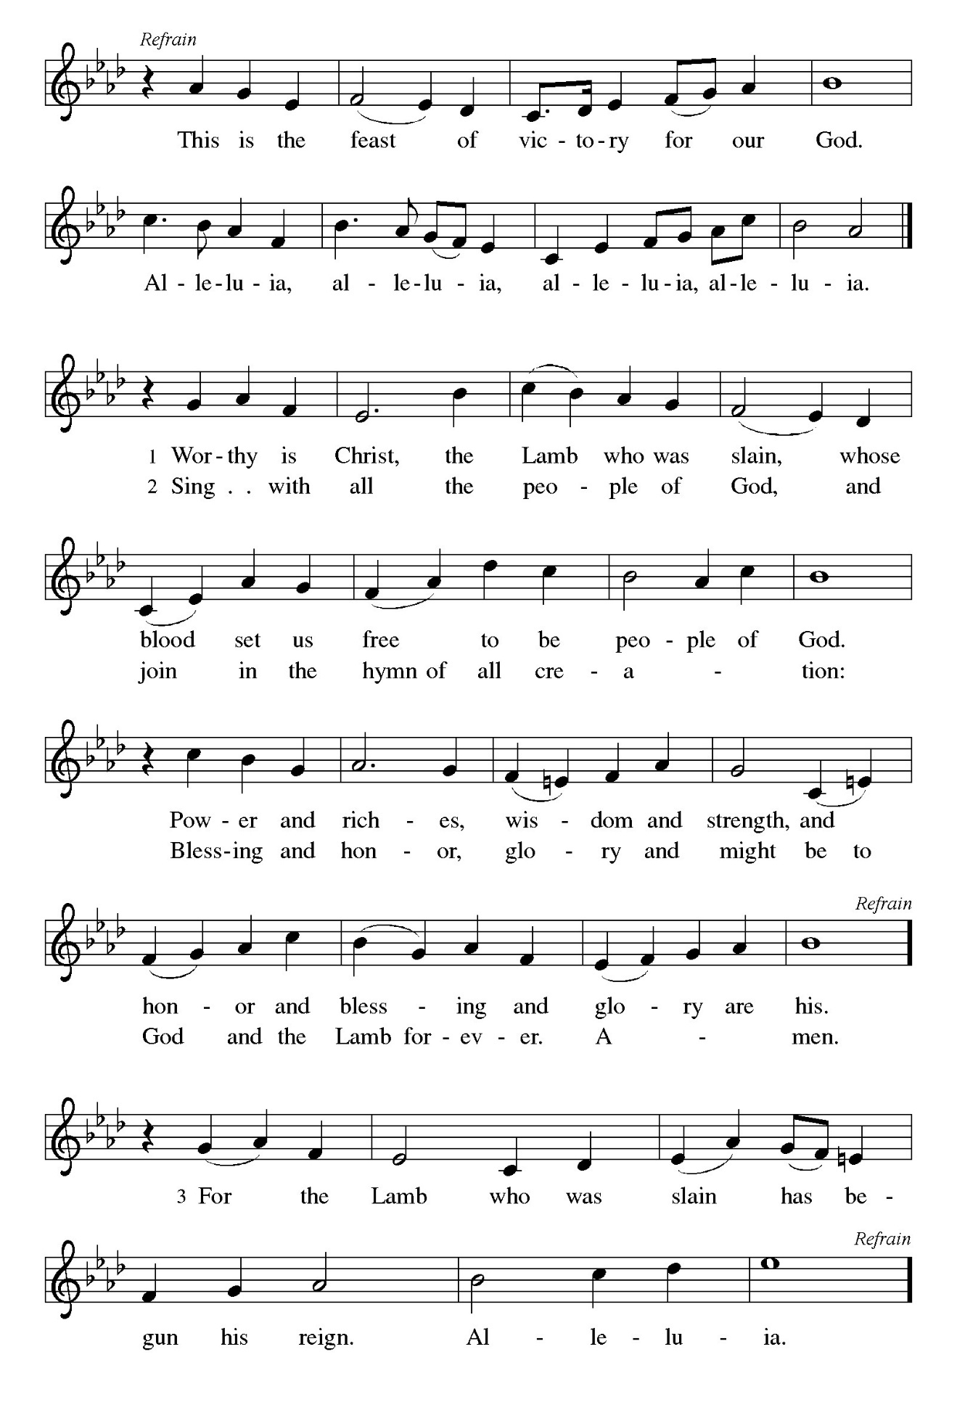

THE PRAYER OF THE DAY

P: The Lord be with you.

C: And also with you.

P: Let us pray. O God, Your Son makes Himself known to all His disciples in the breaking
of bread. Open the eyes of our faith, that we may see Him in His redeeming work,
Who lives and reigns with You and the Holy Spirit, one God, now and forever.

C: Amen.

The assembly is seated

WORD

FIRST READING Acts 2: 14a, 36-41

Today's reading is the conclusion of Peter's sermon preached following the giving of the Holy Spirit to the apostles on the day of Pentecost. The center of his preaching is the bold declaration that God has made the crucified Jesus both Lord and Christ.

Peter, standing with the eleven, raised his voice and addressed the people:
³⁶"Therefore let the entire house of Israel know with certainty that God has made Him both Lord and Messiah, this Jesus Whom you crucified."
³⁷Now when they heard this, they were cut to the heart and said to Peter and to the other apostles, "Brothers, what should we do?" ³⁸Peter said to them, "Repent, and be baptized every one of you in the name of Jesus Christ so that your sins may be forgiven; and you will receive the gift of the Holy Spirit.
³⁹For the promise is for you, for your children, and for all who are far away, everyone whom the Lord our God calls to Him." ⁴⁰And he testified with many other arguments and exhorted them, saying, "Save yourselves from this corrupt generation." ⁴¹So those who welcomed his message were baptized, and that day about three thousand persons were added.

The Word of the Lord.

Thanks be to God.

THE PSALM: 116: 1-4, 12-19 Antiphon by Mark Sedio

Choir sings refrain first, followed immediately by the congregation
and as indicated

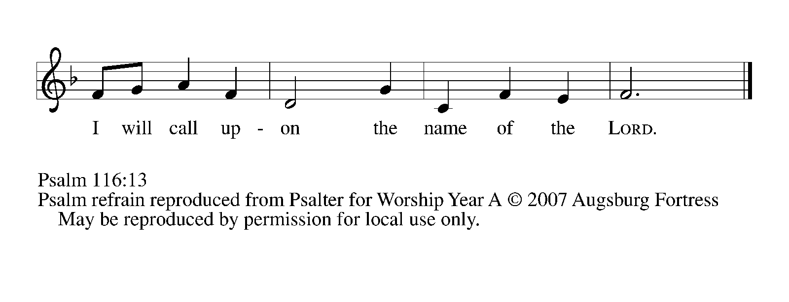
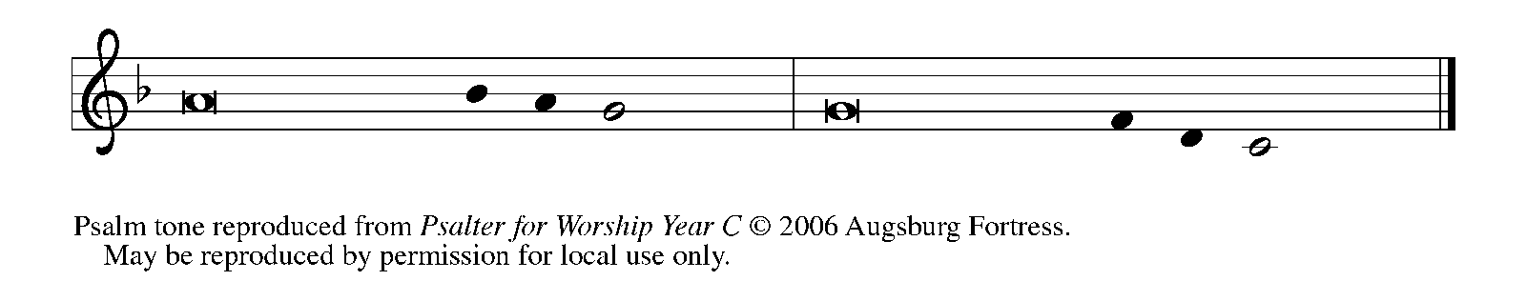

¹I love the LORD, Who has | heard my voice,
and listened to my | supplication,

²for the LORD has given | ear to me
whenev- | er I called.

³The cords of death entangled me; the anguish of the grave
| came upon me;
I came to | grief and sorrow.

⁴Then I called upon the name | of the LORD:
"O LORD, I pray You, | save my life." REFRAIN

¹²How shall I re- | pay the LORD
for all the good things God has | done for me?

¹³I will lift the cup | of salvation
and call on the name | of the LORD.

¹⁴I will fulfill my vows | to the LORD
in the presence of | all God's people.

¹⁵Precious in Your | sight, O LORD,
is the death | of Your servants.

¹⁶O LORD, truly I | am Your servant;
I am Your servant, the child of Your handmaid;
You have freed me | from my bonds.

¹⁷I will offer You the sacrifice | of thanksgiving
and call upon the name | of the LORD. REFRAIN
¹⁸I will fulfill my vows | to the LORD
in the presence of | all God's people,

¹⁹in the courts of | the LORD's house,
in the midst of you, O Jerusalem. | Hallelujah! REFRAIN

SECOND READING 1 Peter 1: 17-23

The First Letter of Peter uses the image of "exile" to describe the experience of new Christians who are no longer at home in the non-Christian world. Their faith in the risen Christ distinguishes them from their ancestors and neighbors and calls them to place their faith and hope in God.

If you invoke as Father the One Who judges all people impartially according to their deeds, live in reverent fear during the time of your exile. ¹⁸You know that you were ransomed from the futile ways inherited from your ancestors, not with perishable things like silver or gold, ¹⁹but with the precious blood of Christ, like that of a lamb without defect or blemish.
²⁰He was destined before the foundation of the world, but was revealed at the end of the ages for your sake. ²¹Through Him you have come to trust in God, Who raised Him from the dead and gave Him glory, so that your faith and hope are set on God.
²²Now that you have purified your souls by your obedience to the truth so that you have genuine mutual love, love one another deeply from the heart. ²³You have been born anew, not of perishable but of imperishable seed, through the living and enduring word of God.

The Word of the Lord.

Thanks be to God.

As you are able please rise

THE VERSE

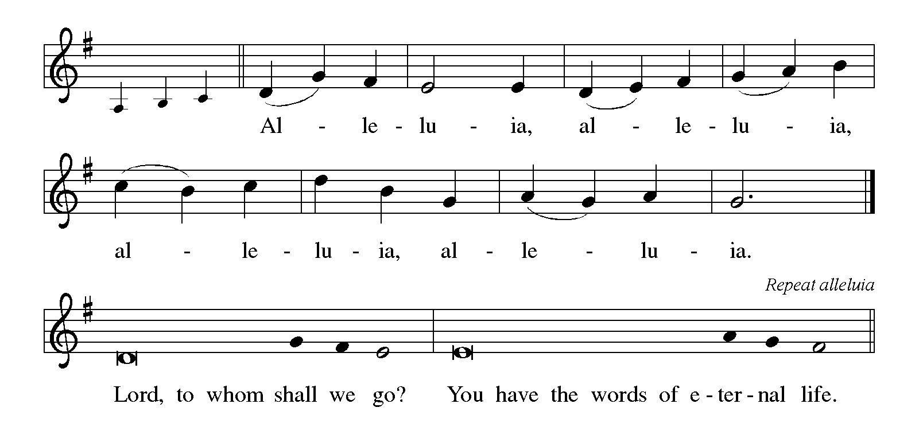
THE HOLY GOSPEL Luke 24: 13-35

The colorful story of Jesus’ appearance to two disciples on the road to Emmaus answers the question of how Jesus is to be recognized among us. Here, He is revealed through the Scriptures and in the breaking of bread.

P: The Holy Gospel according to St. Luke, the twenty-fourth chapter.

C: Glory to You, O Lord!

Now on that same day when Jesus had appeared to Mary Magdalene, two of them were going to a village called Emmaus, about seven miles from Jerusalem, ¹⁴and talking with each other about all these things that had happened. ¹⁵While they were talking and discussing, Jesus Himself came near and went with them, ¹⁶but their eyes were kept from recognizing Him.
¹⁷And He said to them, "What are you discussing with each other while you walk along?" They stood still, looking sad. ¹⁸Then one of them, whose name was Cleopas, answered him, "Are you the only stranger in Jerusalem who does not know the things that have taken place there in these days?" ¹⁹He asked them, "What things?" They replied, "The things about Jesus of Nazareth, Who was a prophet mighty in deed and word before God and all the people, ²⁰and how our chief priests and leaders handed Him over to be condemned to death and crucified Him.
²¹But we had hoped that He was the one to redeem Israel. Yes, and besides all this, it is now the third day since these things took place. ²²Moreover, some women of our group astounded us. They were at the tomb early this morning, ²³and when they did not find His body there, they came back and told us that they had indeed seen a vision of angels who said that He was alive.
²⁴Some of those who were with us went to the tomb and found it just as the women had said; but they did not see Him." ²⁵Then He said to them, "Oh, how foolish you are, and how slow of heart to believe all that the prophets have declared! ²⁶Was it not necessary that the Messiah should suffer these things and then enter into His glory?" ²⁷Then beginning with Moses and all the prophets, He interpreted to them the things about Himself in all the scriptures.
²⁸As they came near the village to which they were going, He walked ahead as if He were going on. ²⁹But they urged Him strongly, saying, "Stay with us, because it is almost evening and the day is now nearly over." So He went in to stay with them.
³⁰When He was at the table with them, He took bread, blessed and broke it, and gave it to them. ³¹Then their eyes were opened, and they recognized Him; and He vanished from their sight. ³²They said to each other, "Were not our hearts burning within us while He was talking to us on the road, while He was opening the scriptures to us?"
³³That same hour they got up and returned to Jerusalem; and they found the eleven and their companions gathered together. ³⁴They were saying, "The Lord has risen indeed, and He has appeared to Simon!" ³⁵Then they told what had happened on the road, and how He had been made known to them in the breaking of the bread.

P: The Gospel of the Lord.

C: Praise to You, O risen Christ!

The assembly is seated

THE SERMON

Silence for reflection follows the sermon

As you are able please rise

THE HYMN OF THE DAY (see p. 9) Day of Arising

Stanza 2—Men; Stanza 3—Women
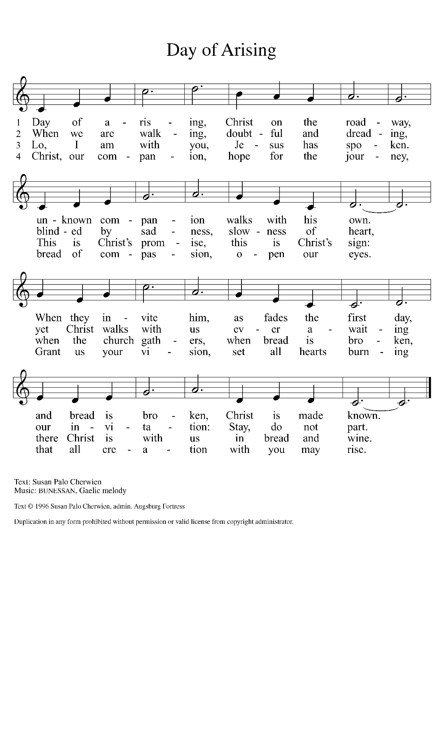
THE NICENE CREED

A: God has made us His people through our Baptism into Christ. Living together in trust
and hope, we confess our faith.

We believe in one God,
the Father, the Almighty,
maker of heaven and earth,
of all that is, seen and unseen.

We believe in one Lord, Jesus Christ,
the only Son of God,
eternally begotten of the Father,
God from God, Light from Light,
true God from true God,
begotten, not made,
of one Being with the Father.
Through Him all things were made.
For us and for our salvation
He came down from heaven;
by the power of the Holy Spirit
He became incarnate from the virgin Mary, and was made man.
For our sake He was crucified under Pontius Pilate;
He suffered death and was buried.
On the third day He rose again
in accordance with the Scriptures;
He ascended into heaven
and is seated at the right hand of the Father.
He will come again in glory to judge the living and the dead,
and His kingdom will have no end.

We believe in the Holy Spirit, the Lord, the giver of life,
Who proceeds from the Father and the Son.
With the Father and the Son He is worshiped and glorified.
He has spoken through the prophets.
We believe in one holy catholic and apostolic Church.
We acknowledge one Baptism for the forgiveness of sins.
We look for the resurrection of the dead,
and the life of the world to come. Amen

THE PRAYER OF THE CHURCH

A: Let us who journey on the Way with Christ, risen and ever-present in mystery, pray for
the world, the Church, and all those in need.

A: That as the Church continues her journey with the risen Lord we may know Him in His
Word, in the breaking of bread, and the welcoming of every stranger, we pray:

C: Hear us, risen Lord.

A: That God’s Spirit of new life might lead this world away from mistrust, hatred,
violence, and oppression into Jesus’ will for mutual love, we pray:

C: Hear us, risen Lord.

A: That among this assembly to whom the Lord opens the Scriptures again this Day we
might come to trust more fully in God and be mighty in deeds of charity and service,
we pray:

C: Hear us, risen Lord.

A: That all who suffer disease of body, mind, or spirit, especially: Mark Tannehill;
Martha Schroeder; Amanda Seedorf; Christine Kiser; and Debbie Martin might
be loosed from their bonds and restored to wholeness, we pray:

C: Hear us, risen Lord.

A: That those celebrating birthdays, especially Diane Sunde and Jean Kleinschmidt; and anniversaries, especially, Stacie & Tim Crozier and Stephen & Lauretta Hapke might grow in grace this day and be filled with grace for the days ahead, we pray:

C: Hear us, risen Lord.

P: Preserve us all, O Lord, and take us home to Your heart, so that all our lives may be
woven together in prayer and praise, through Jesus Christ our Lord.

C: Amen.

MEAL

THE PEACE

P: The risen Christ stood among the disciples and said, “Peace be with you.”
The peace of the risen Lord be with you always.

C: And also with you.

The assembly is seated

THE OFFERING

THE VOLUNTARY Rejoice, He Is Alive! St. Paul Senior Choir
(J. A.Shafferman, Arr. By P. Drennan, Orhestrated by L. Shackly)

As you are able please rise

THE OFFERTORY (see p. 12) This Joyful Eastertide

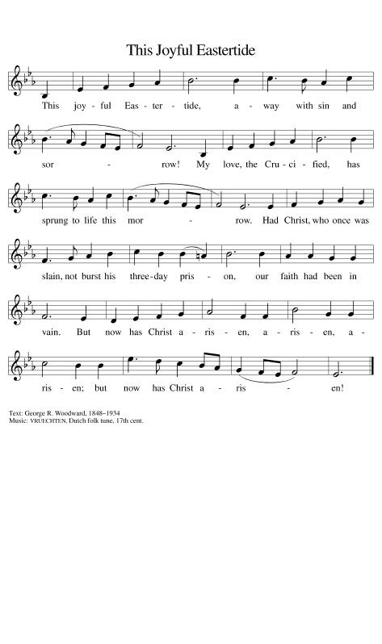
THE OFFERTORY PRAYER

A: Let us pray. Lord Jesus,

C: Be known to us in the breaking of the bread, as You were made known to the
disciples. Receive these gifts, and the offering of our lives, that we may be Your
risen Body in the world. You are the Lord forevermore. Amen.

THE GREAT THANKSGIVING

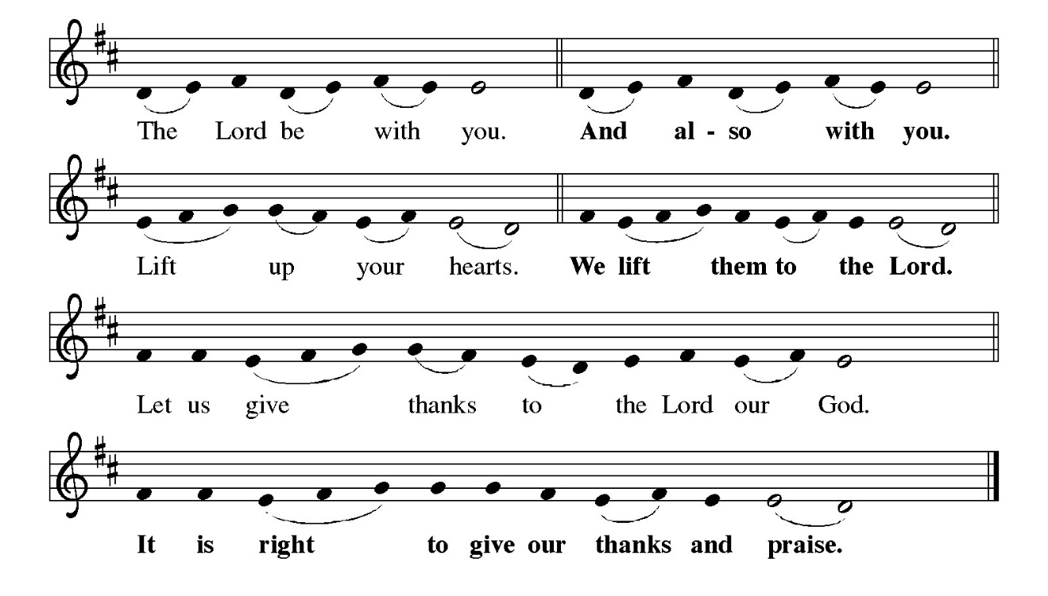
P: It is indeed right, our duty and our joy … and join their unending hymn:

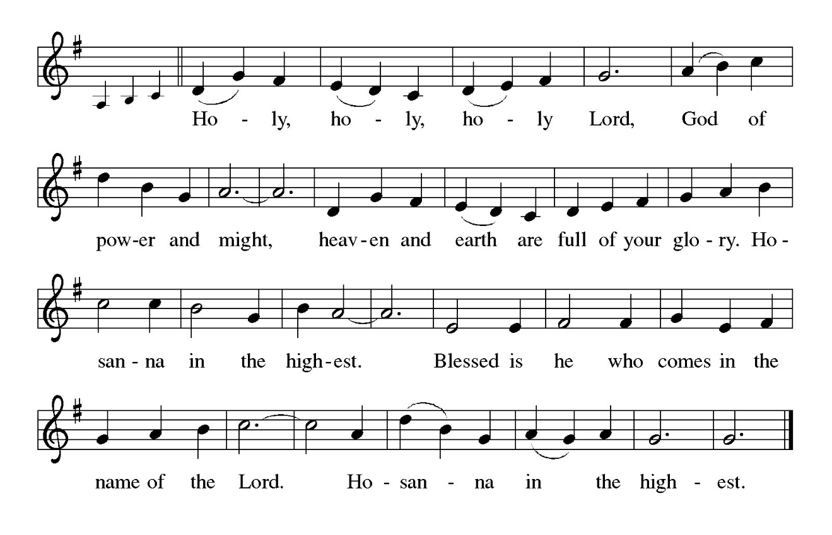

P: Blessing God, You walk with us from the Jerusalem of our failure to the Emmaus of
Your glorious revelation.
You made us to be Your companions, and You gave us food and drink that we might
share Your substance with You.
You created us from the dust of the earth, and You re-created us by water and the
Spirit.
You called Your chosen people, You sent Moses and the prophets, and You came
among us in Jesus that we might know You in His crucified and broken Body
and celebrate You in the everlasting joy of His resurrection.
Breaking God, when Your Son sat at table with His crestfallen disciples, He was made
known to them in the breaking of the bread.
Come among us now in the power of Your Holy Spirit, that Your people may discover
You in the breaking of the bread, that You may stay with us and make Your
home among us, and that these gifts of bread and wine may become for us the
Body and Blood of Your Son Jesus Christ,
Who, in the night … “Do this for the remembrance of Me.”
As often as we eat … we proclaim the Lord’s death until He comes.

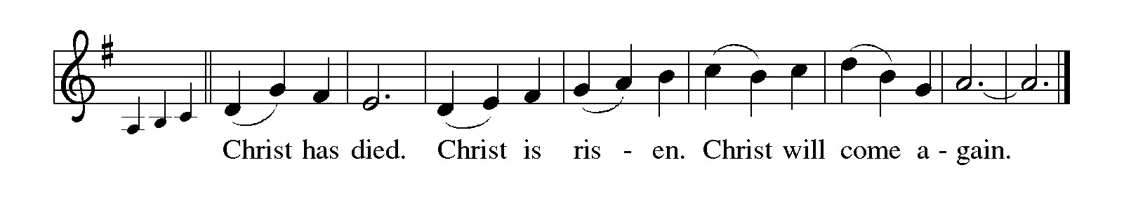

P: Sharing God, in the power of Your Holy Spirit repeat among us Your Son’s actions of
taking, blessing, breaking and sharing, that You may take, bless, break, and
share us, and that the world may recognize You in the way You act on our lives.
Breathe Your Spirit on Your Church, that we might feel our hearts on fire as You talk
with us and explain the Scriptures to us.
Inspire all who stand still, looking sad.
Open the eyes of all who are kept from perceiving You.
Bring Your bread of life to feed all who hunger in body, mind, or spirit, until the Day
when we live Your life abundant with the communion of saints, in the presence
and companionship of Your Holy Trinity,
Father, Son, and Holy Spirit, ever one God.



THE LORD’S PRAYER

P: Alleluia! The risen Christ intercedes on our behalf before the throne of God. Let us
therefore join Him in His prayers in the words He taught us:

C: Our Father, Who art in heaven, hallowed be Thy Name. Thy Kingdom come, Thy
will be done on earth as it is in heaven. Give us this day our daily bread, and
forgive us our trespasses as we forgive those who trespass against us. And lead us
not into temptation but deliver us from evil. For Thine is the Kingdom, and the
power, and the glory, forever and ever. Amen.

INVITATION TO THE MEAL

P: When we eat this Bread we share the Body of Christ.

C: Amen.

P: When we drink from this cup we share the Blood of Christ.

C: Amen.

P: Reveal Yourself to us, O Lord, in the breaking of bread:

C: As once You revealed Yourself to Your disciples.

P: Behold the Lamb of God, Who takes away the sin of the world. Happy are they who
are called to His Table.

C: Lord, I am not worthy to receive you. Only say the Word and I shall be healed.

The assembly is seated

THE DISTRIBUTION Lamb of God

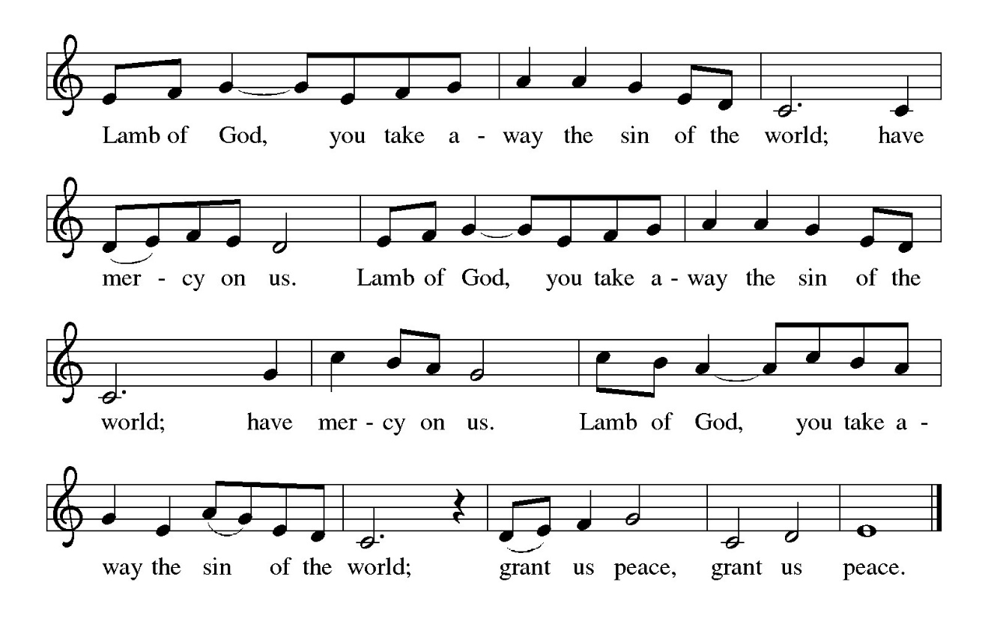

HYMN DURING DISTRIBUTION 377 Alleluia! Jesus is Risen!

ELW 325 I Want Jesus to Walk With Me

ELW 479 We Come to the Hungry Feast

NSB 67 Nothing But the Blood

NSB 70 Open Our Eyes, Lord

As you are able please rise

THE POST-COMMUNION BLESSING

P: The Body and Blood of our Lord Jesus Christ strengthen you and keep you in His grace.

C: Amen.

THE POST-COMMUNION PRAYER

A: Let us pray. Life-giving God, in the mystery of Christ’s death and resurrection, You
send light to conquer darkness, water to give new life, and the Bread of heaven to
nourish Your people. Send us forth as witnesses of Your Son’s resurrection that we
may show Your glory to all the world; through Jesus Christ our Lord.

C: Amen.

SENDING

THE BENEDICTION

P: Almighty God: Father, Son, and Holy Spirit bless you now and forever.

C: Amen.

SENDING HYMN 539 Abide, O Dearest Jesus

THE DISMISSAL

A: Go in peace. Proclaim the risen Lord. Alleluia! Alleluia!

C: Thanks be to God! Alleluia! Alleluia!

THE POSTLUDE

To God Alone Be Glory

The Meditation is from Richer Fare for the Christian People. Gail Ramshaw, ed. (New
York: Pueblo Publishing House, 1990) 36-37.

The Greeting, Prayers, Peace, and Dismissal are adapted from Sundays and Seasons.
Copyright 2001 Augsburg Fortress.

The Prayers, Introduction to the Lord’s Prayer, and Invitation to the Meal are adapted from
Prayers for Sundays and Seasons. Year A. Peter J. Scagnelli. (Chicago: Liturgy
Training Publications, 1998) 44-45.
ANNOUNCEMENTS

Please remember to mail your offering to the Church Office at 818 Franklin Street, Michigan City, IN 46360. Another alternative is to give on-line through Tithe.ly. Please see your closure letter for information on how to set up a Tithe.ly account.

St. Paul Members are reminded to have a loved one contact the office if you are hospitalized. Many times, the Pastor doesn’t know someone is in the hospital. If you call and leave a message, please tell us at which hospital the patient is located.

BIRTHDAYS: Diane Sunde (4/19); Jean Kleinschmidt (4/23)

ANNIVERSARIES: Stacie & Tim Crozier (4/22); Stephen & Lauretta Hapke( 4/24)

PRAYER CONCERNS: John Bennitt; Debbie Martin; Mark Tannehill; Kathy Stein; Jan Paholski; Laura Dovey; Bill Hazelgrove; Al Levenhagen; Carl Wipperman; Major Payne.

OFFICE HOURS: Libby will be in the office on Mondays, Wednesdays, and Fridays; volunteers will cover Tuesdays and Thursdays.

Monday & Wednesday 8:00 a.m. – 5 p.m.
Tuesday & Thursday 9:00 a.m. – 12:00 p.m.
Friday 8:00 a.m. – 12:00 p.m.

If you are listening to the worship broadcast on the radio and would like to watch the Sunday morning service live stream follow these steps:

(1) If you have You Tube available on your TV, search for
St. Paul Lutheran Church Michigan City, IN.

(2) The direct link on the computer is https://
www.youtube.com/channel/UC5AIPNaKr3QN50984jGOa1g

(3) This link is also on the main page of the church’s website in
the church section and will continue to be posted weekly on the St.
Paul Facebook page.

And it will always be available on the radio broadcast Sunday mornings at 11:00 a.m.
on WEFM (95.9), and on the local cable access station #99 for the previous week’s
service on Sundays at 4:00 p.m. and the current service on Wednesdays at 7:00 p.m.
and Fridays at 8:30 p.m.

To send e-mail to the church office, please use the following addresses:

Pastor Mark Reshan: seniorpastor@stpaulmichigancity.com

Church Office Secretary (Libby Pollock): churchsecretary@stpaulmichigancity.com

Church Treasurer (Karen Fleming): finance@stpaulmichigancity.com

2026 Church Council:

Pastor - Mark Reshan

President - Donna Knoll

Vice President - Jan Bakken

Secretary - Judy Hunt

Treasurer - Karen Fleming

Members: Sue Koziel; Jim Schraidt; Trish Sprague; Bob Kiser; Barry Anderson; and
Pam Soule

Worship Attendance:

Saturday, April 11, 2026 @ 4:00 p.m. 22

Sunday, April 12, 2026 @ 9:00 a.m. 57

TOTAL 79

Copies of the minutes from the February 26, 2026 and March 26, 2026 Church Council meetings are on the back table in the upper Narthex. They were approved by the council via email.

The Good News Newsletter: If you have an article or anything you want included in The Good News please send it to the following e-mail address: splcgoodnews@gmail.com. Pastor Pamela Thiede will be using this e-mail address to assemble The Good News each month. The deadline for getting information to Pastor Pamela will be the 20th of each month.

Next week’s lessons are Acts 2: 42-47; Psalm 23; 1 Peter 2: 19-25; John 10: 1-10 for those of you who like to study them in advance.

MONTHLY MISSION FOR APRIL 2026
BOYS & GIRLS CLUBS OF LAPORTE COUNTY

The Boys & Girls Clubs of LaPorte County provide a safe space for kids to go after school, during the summer, and while school is operating online, to learn and grow beyond the classroom. Members receive access to homework help, mentoring, sports programs, STEAM enrichment, community service opportunities, and much more. Their programs include the following:

Career Explorations SMART Moves and SMART Decisions
Food Programs Ultimate Journey/STEAM
Game Changers Volunteering
Homework Help/Tutoring/Power Hour

If you would like to support this mission, we will be collecting both supplies and monetary donations. Please make checks payable to St. Paul and mark for the Boys & Girls Clubs and place in the offering. Noisy coin for the month of April will also go to support the Boys & Girls Clubs. The following supplies can be placed in the bin in the upper Narthex:

Felt Dixie Cups
Glue bottles, sticks, or bulk pourable Plain block Legos
Bulk pourable tempura paint Play Doh
Markers & crayons

Construction paper and card stock of all colors; and plain white paper
Paper towels, Kleenex, disinfectant/cleaning wipes
K-8th grade appropriate board and card games
Small “treasure box” type prizes

Thank you for your support of Daisy Lee’s STEM trips for our young students. We raised $476 to help fund this year’s STEM trips! Thank you for your unwavering support for our community each month! Lora

FOR THOSE WHO WOULD LIKE TO KNOW MORE ABOUT THE BOYS & GIRLS CLUBS there are printed handouts on the table in the lower narthex for your reading pleasure!

MISSION OF THE MONTH FOR MAY 2026

The Dolly Fund at Lubeznik Center for the Arts is our Mission of the Month for May 2026. The Dolly Fund is an endowment fund that supports scholarships for students age 7- 18 to LCA’s art classes for youth. It was initiated by Paul Marshall, in honor of his late wife and former LCA director, Dolly Marshall. Dolly had a life-long belief that arts education for children was crucial to their development. Some of the classes LCA offers are abstract painting, mixed media for young artists, figure drawing, digital illustration, abstract landscapes, poetry and performance workshops, printmaking, and much more!

Please make checks payable to St. Paul and mark for the Dolly Fund and place in the offering. Noisy coin offering for the month of May will also go to support the Dolly Fund. Thank you for your generosity each month! Lora

2026 Financial Stewardship

Weekly Church Operating Needs (x 2 weeks)
March 21-22 & March 28-29, 2026: $ 11,756.00

General Fund (including General Memorials): $ 9,805.00

\Overage/Shortage: + $ 1,951.00

Restricted Income (not including Memorials)
Supports IK Synod & Church wide Ministries: $ 416.00

Ministries in our Community/Congregation: $ 50.00

Capital Fund: $ 342.00

Memorials
General Fund $ 6,475.00

ACTIVITIES, EVENTS & MEETINGS
APRIL 2026

Sunday, April 12, 2026 @ 9:00 a.m. 2 Easter Worship Service/Sanctuary with
coffee after
Wednesday, April 15, 2026 @ 9:15 a.m. Bible Study/Luther House
@ 10:00 a.m. God’s Purls/St. Paul Room
@ 4:30 p.m. Choir Rehearsal/Sanctuary
Saturday, April 18, 2026 @ 4:00 p.m. 3 Easter Worship Service/Sanctuary

Sunday, April 19, 2026 @ 9:00 a.m. 3 Easter Worship Service/Sanctuary
with coffee after
Monday, April 20, 2026 @1:00 p.m. Hope Circle/Green Room
@ 2:00 p.m. Finance Committee Mtg./Luther House
@ 3:00 p.m. Executive Board Mtg./Luther House
Wednesday, April 22, 2026 @ 9:15 a.m. Bible Study/Luther House
@ 10:00 a.m. God’s Purls/St. Paul Room
@ 4:30 p.m. Choir Rehearsal/Sanctuary
Thursday, April 23, 2026 @ 3:00 p.m. Church Council Meeting/St. Paul Room
Saturday, April 25, 2026 @ 4:00 p.m. 4 Easter Worship Service/Sanctuary

Sunday, April 26, 2026 @ 9:00 a.m. 4 Easter Worship Service/Sanctuary with
coffee after
Wednesday, April 29, 2026 @ 9:15 a.m. Bible Study/Luther House
@ 10:00 a.m. God’s Purls/St. Paul Room
@ 4:30 p.m. Choir Rehearsal/Sanctuary
Saturday, May 2, 2026 @ 4:00 p.m. 5 Easter Worship Service/Sanctuary

Sunday, May 3, 2026 @ 9:00 a.m. 5 Easter Worship Service/Sanctuary with the
Annual SPRING CONGREGATIONAL MEETING immediately after worship
AND A True POTLUCK following the meeting. Please bring a dish to share.



The annual Spring Congregational Meeting 2026
The annual Spring Congregational Meeting will be held on Sunday, May 3, 2026 immediately after Sunday morning worship. It is very important to attend the meeting as we will be approving the budget for the 2026-2027 year. There will also be updates on the 150th anniversary events and some information on Evangelism events on which we need your input. And finally, there will be a true Potluck following the meeting. Please bring a dish to pass and let’s enjoy each other’s fellowship!

SIMPLY GRATEFUL

Dear Pastor Reshan and the people of St. Paul Lutheran Church,

The peace of the risen Christ be with you. I want to offer my heartfelt thanks for the gracious invitation to preach and preside with you on the significant occasion of your 150th anniversary. It was a deep joy and an honor to share in worship and celebration with you.

Your hospitality was warm and spirit-filled. The meal we shared was wonderfully delightful, and the humor and laughter that filled the space were a gift, a true sign of the love and life you share as a community of faith.
Thank you as well for the wonderful cups you gave to both Meme and me, especially with our names inscribed. That thoughtful and generous gesture means more than you know, and we will remember you each time we use them.

Thank you again for your kindness, your generosity, and the privilege of joining you in this celebration.

With deep appreciation, and in Christ’s love,

Bishop Tim and Meme

