**THE SIXTH SUNDAY OF EASTER**

**May 25, 2025**

To say good-bye to someone we love is an experience filled with pain and sadness. We see such scenes at airports when distance will bring a physical separation between people who love each other. The ultimate farewell comes at the time of death when we must release a loved one to a new realm, even though their absence leaves a deep void in our heart.

Jesus addresses similar concerns in his "farewell discourse" in John's gospel. He speaks of his going away and his coming again. In John's gospel, Jesus' departure is his death, resurrection, and ascension to the Father. His coming again is the gift of the Holy Spirit, the Advocate, who will keep alive his words and deeds among his followers.

Jesus provides for us even though he is not physically present as he was in the first century. He gives us the gift of peace that transcends our everyday concerns in the world. It is a peace that assures us we are not alone. It is a peace that deepens our trust in the mystery of Easter, the wonderful news that new life arises from death.

In the Eucharist we hear these words of Jesus: "Peace be with you." The Spirit of Christ in our midst is the gift of peace that God provides for the Church even today. Even so, we feel the pain of separation. Our hearts thirst for the fullness of life, the salvation we will know only at our own final death and resurrection--our entrance into the New Jerusalem promised in the book of Revelation. Until then, we will know the reality of both Christ's absence and presence, as we long for peace in our hearts, peace in our families and relationships, and peace in the world.

**Words for Worship**

Faith, when I think about it, doesn't so much take away all the difficult things in life as makes them bearable. It's actually a little more than that. Faith doesn't take away the difficult things in life, it just keeps them from dominating, from having mastery, from defining who I am and the possibilities around me. It's like these things -- our needs, wants, broken places -- they still are accurate *descriptions* of us, at least parts of us, but they no longer *define* us. We are more than what's missing. We are, as Paul says and Revelation promises, a new creation. Faith makes this possible. Faith understood not as some divine plug for the hole we each carry around inside of us, but rather as a summons to be more, to live and love more, to share more because there is so much more that God desires and designed for us.

I suspect, on the whole, that there are probably two view of the religious life. Both acknowledge that this world we share is full of tumults and challenges, of sometimes seismic ups and downs. One view of the life of faith assumes that when you come to faith, things settle down, stop shaking, and make suddenly sense. The other view of faith, however, doesn't promise an end to the tremors but enables you to keep your footing amid them.

I think that's what Jesus is talking about. After all, the Spirit he promises comes as the Advocate -- the one who takes to our defense when we're accused -- and the Comforter -- the one who will not leave our side during trouble. Understood that way, there is nothing about Jesus' words that would suggest either that he's promising us an end to problems or that he's inviting us to ignore them. Rather, he promises *peace* -- not merely the cessation of disturbance but instead a confident expectation and hope about the future.

**David Lose**

In the dark of the moon, in flying snow, in the dead of winter,  
war spreading, families dying, the world in danger,  
I walk the rocky hillside, sowing clover.

**Wendell Berry, “February 2, 1968”**

**✠ In the Name of Jesus ✠**

**✠ GATHERING ✠**

**INTRODUCTION**

Visions abound in the readings for the sixth Sunday of Easter. Paul has a vision about what to do. John has a vision of what will be. The risen Lord Jesus provides visions of peace that passes human understanding and power beyond human imagination.

**Nicolaus Copernicus, died 1543; Leonhard Euler, died 1783; scientists**

*These two men were both scientists who helped to explain the wonders of God’s universe. Copernicus is best known for promoting the idea that the sun, not the earth, is at the center of our solar system. Euler was one of the founders of pure mathematics, and contributed to many other fields.*

**PRELUDE**

**THE EASTER ACCLAMATION**

P: Christ is risen! Alleluia!

**C: Christ is risen indeed! Alleluia!**

**ANNOUNCEMENTS**

*As you are able please rise*

**CONFESSION AND ABSOLUTION**

P: In the name of the Father and of **✠** the Son and of the Holy Spirit.

**C: Amen.**

P: With the Psalmist we cry, “May God be merciful to us, and bless us, show us the light

of His countenance, and come to us.” (Psalm 67: 1) Let us therefore turn to God in

repentance, that God might “come to us” with mercy and forgiveness.

*Silence for self-examination and reflection is kept*

P: Most merciful God,

**C: We confess that we are in bondage to sin and cannot free ourselves. We have not**

**kept Your Word to love others as You have loved us. We have not been open to**

**the Spirit’s leading and teaching. (John 14: 25) We have forgotten Your words**

**and commands. We have sought the peace the world gives. (14: 27) We have been**

**troubled and afraid. For the sake of Your Son, Jesus Christ, “be merciful to us**

**and bless us.” Forgive us, and by Your Spirit, renew us in hope, fill us with joy,**

**and grant us Your peace.**

P: “Let Your ways be known upon earth, Your saving health among all nations.” (Psalm

67: 2) God’s “saving health” is “known” among you this Day: for as a called and

ordained minister of the Church of Christ, and by His authority, I therefore declare to

you the entire forgiveness of all your sins, in the name of the Father and of **✠** the Son

and of the Holy Spirit.

**C: Amen.**

**GATHERING HYMN 804 *Come Down, O Love Divine***

**THE GREETING AND PRAYER OF THE DAY**

P: Christ is risen! Alleluia!

**C: Christ is risen indeed! Alleluia!**

P: The grace of our Lord Jesus Christ, the love of God, and the communion of the Holy

Spirit be with you all.

**C: And also with you.**

P: Let us pray. Bountiful God, You gather Your people into Your realm, and You promise

us food from Your tree of life. Nourish us with Your Word, that empowered by Your

Spirit we may love one another and the world You have made, through Jesus Christ,

our Savior and Lord, Who lives and reigns with You and the Holy Spirit, one God, now

and forever.

**C: Amen.**

*The assembly is seated*

**✠ WORD ✠**

**FIRST READING Acts 16: 9-15**

*In the midst of his second missionary journey, Paul preaches in Greece. There he meets Lydia, an important person in the business community, whose heart has been opened by God to receive the gospel. Her conversion and baptism provides the impetus for the founding of the church at Philippi.*

9During the night Paul had a vision: there stood a man of Macedonia pleading with him and saying, "Come over to Macedonia and help us." 10When he had seen the vision, we immediately tried to cross over to Macedonia, being convinced that God had called us to proclaim the good news to them.

11We set sail from Troas and took a straight course to Samothrace, the following day to Neapolis, 12and from there to Philippi, which is a leading city of the district of Macedonia and a Roman colony. We remained in this city for some days. 13On the sabbath day we went outside the gate by the river, where we supposed there was a place of prayer; and we sat down and spoke to the women who had gathered there.

14A certain woman named Lydia, a worshiper of God, was listening to us; she was from the city of Thyatira and a dealer in purple cloth. The Lord opened her heart to listen eagerly to what was said by Paul. 15When she and her household were baptized, she urged us, saying, "If you have judged me to be faithful to the Lord, come and stay at my home." And she prevailed upon us.

The Word of the Lord.

**Thanks be to God.**

**THE PSALM: Psalm 67** Antiphon by Carl Schalk

Choir sings refrain first, followed immediately by the congregation

and as indicated

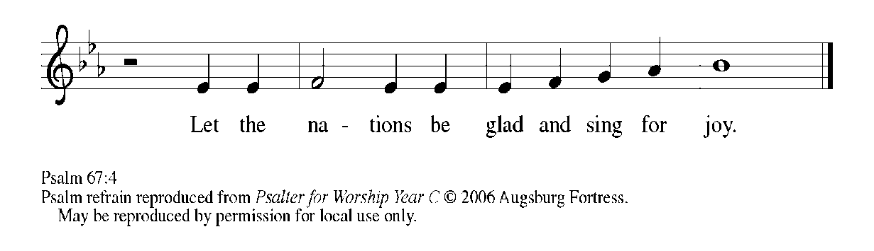

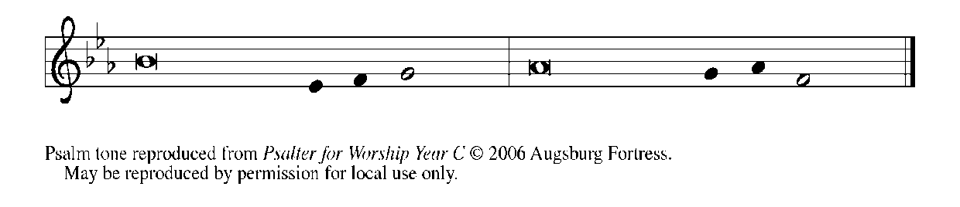

1May God be merciful to | us and bless us;

     may the light of God's face | shine upon us.

**2Let Your way be known | upon earth,**

**Your saving health a- | mong all nations.**

3Let the peoples praise | You, O God;

     let all the | peoples praise You.

**4Let the nations be glad and | sing for joy,**

**for You judge the peoples with equity and guide all the na- | tions on earth.   REFRAIN**

5Let the peoples praise | You, O God;

     let all the | peoples praise You.

**6The earth has brought | forth its increase;**

**God, our own | God, has blessed us.**

7May God | give us blessing,

     and may all the ends of the earth | stand in awe.   **REFRAIN**

**SECOND READING Revelation 21: 10, 22--22: 5**

*In John's vision of a new Jerusalem coming out of heaven, there is continuity with God's past actions. Its walls and gates are inscribed with the names of the twelve tribes of Israel; the walls have twelve foundations bearing the names of the apostles. In this new city, God's presence replaces the temple, and the glory of God and the Lamb supplant sun and moon.*

10And in the spirit he carried me away to a great, high mountain and showed me the holy city Jerusalem coming down out of heaven from God.

22I saw no temple in the city, for its temple is the Lord God the Almighty and the Lamb. 23And the city has no need of sun or moon to shine on it, for the glory of God is its light, and its lamp is the Lamb. 24The nations will walk by its light, and the kings of the earth will bring their glory into it. 25Its gates will never be shut by day--and there will be no night there. 26People will bring into it the glory and the honor of the nations. 27But nothing unclean will enter it, nor anyone who practices abomination or falsehood, but only those who are written in the Lamb's book of life.

22:1Then the angel showed me the river of the water of life, bright as crystal, flowing from the throne of God and of the Lamb 2through the middle of the street of the city. On either side of the river is the tree of life with its twelve kinds of fruit, producing its fruit each month; and the leaves of the tree are for the healing of the nations.

3Nothing accursed will be found there any more. But the throne of God and of the Lamb will be in it, and His servants will worship Him; 4they will see His face, and His name will be on their foreheads. 5And there will be no more night; they need no light of lamp or sun, for the Lord God will be their light, and they will reign forever and ever.

The Word of the Lord.

**Thanks be to God.**

*As you are able please rise*

**THE VERSE**

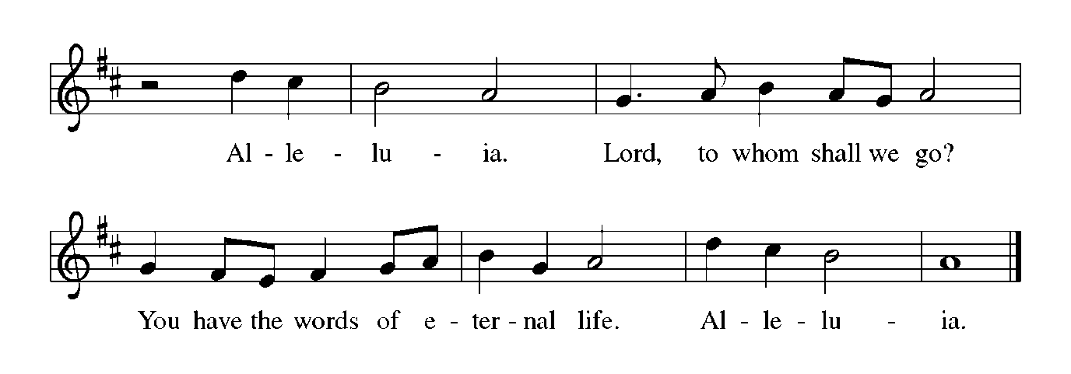

**THE HOLY GOSPEL John 14: 23-29**

*Jesus promises to send the Advocate to teach and remind us of all Jesus taught. Under this Spirit's guidance, we shall gain a deepened understanding of what Jesus has told us, and we shall experience Jesus' gift of peace that overcomes fear.*

P: The Holy Gospel according to St. John, the fourteenth chapter.

**C: Glory to You, O Lord!**

23Jesus answered Judas (not Iscariot),"Those who love Me will keep My word, and My Father will love them, and we will come to them and make our home with them. 24Whoever does not love Me does not keep My words; and the word that you hear is not Mine, but is from the Father Who sent Me.

25"I have said these things to you while I am still with you. 26But the Advocate, the Holy Spirit, Whom the Father will send in My name, will teach you everything, and remind you of all that I have said to you.

27Peace I leave with you; My peace I give to you. I do not give to you as the world gives. Do not let your hearts be troubled, and do not let them be afraid. 28You heard Me say to you, 'I am going away, and I am coming to you.' If you loved Me, you would rejoice that I am going to the Father, because the Father is greater than I. 29And now I have told you this before it occurs, so that when it does occur, you may believe."

P: The Gospel of the Lord.

**C: Praise to You, O Christ!**

*The assembly is seated*

**THE SERMON**

*Silence for reflection follows the sermon*

*As you are able please rise*

**THE HYMN OF THE DAY NSB 80 (x2) *Spirit of the Living God***

**THE NICENE CREED**

A: God has made us His people through our Baptism into Christ. Living together in trust

and hope, we confess our faith.

**C: We believe in one God,**

**the Father, the Almighty,**

**maker of heaven and earth,**

**of all that is, seen and unseen.**

**We believe in one Lord, Jesus Christ,**

**the only Son of God,**

**eternally begotten of the Father,**

**God from God, Light from Light,**

**true God from true God,**

**begotten, not made,**

**of one Being with the Father.**

**Through Him all things were made.**

**For us and for our salvation**

**He came down from heaven;**

**by the power of the Holy Spirit**

**He became incarnate from the virgin Mary, and was made man.**

**For our sake He was crucified under Pontius Pilate;**

**He suffered death and was buried.**

**On the third day He rose again**

**in accordance with the Scriptures;**

**He ascended into heaven**

**and is seated at the right hand of the Father.**

**He will come again in glory to judge the living and the dead,**

**and His kingdom will have no end.**

**We believe in the Holy Spirit, the Lord, the giver of life,**

**who proceeds from the Father and the Son.**

**With the Father and the Son He is worshiped and glorified.**

**He has spoken through the prophets.**

**We believe in one holy catholic and apostolic Church.**

**We acknowledge one Baptism for the forgiveness of sins.**

**We look for the resurrection of the dead,**

**and the life of the world to come. Amen**

**THE PRAYER OF THE CHURCH**

A: God gives His good gifts of love and peace. That this gracious goodness may flow

through us to all the world, let us offer our prayers for the Church, the world, and all

who long for the grace of new life.

A: Blessed are You, O God, for You are the River and the Tree of Life. Preserve Your

whole Church, sending the promised Advocate, Your Holy Spirit, that we may

faithfully keep Your Word: God of our salvation,

**C: Hear our prayer.**

A: Blessed are You, O God, for You are the glory and honor of the nations. Send Your

healing peace upon all peoples and places torn by bloodshed, terrorism, and war,

especially in Ukraine, India and Pakistan, Haiti, Sudan, Darfur, and the Democratic

Republic of Congo. Bring an end to hatred, and break the hopeless cycle of violence

and retaliation: God of our salvation,

**C: Hear our prayer.**

A: Blessed are You, O God, in Your fight against the powers of oppression and evil in the

world. As we remember those in our armed forces who have died protecting our

freedoms and joining You in Your work of overcoming the powers of darkness, keep

those serving in our military safe in their work, especially **Blake Waltz and Katreen**

**Sommers.** God of our salvation,

**C: Hear our prayer.**

A: Blessed are You, O God, for You were the hope of Lydia, Your disciple. Open the

hearts of this congregation, that we may eagerly listen to Your Word and demonstrate

Your love to the world: God of our salvation,

**C:** **Hear our prayer.**

A: Blessed are You, O God, for You heal those who are ill. Restore to wholeness all who

are in any need: **Fred Weiss; Carol Pauluhn; Nick Henrich; Lucas Bradshaw;**

**Larry Litchford; Joyce Stark; Russ Fischer; Kevin Thiede; Martha Schroeder;**

**and Carol Radke:** God of our salvation,

**C: Hear our prayer.**

A: Blessed are You, O God, for You are the Author of life. We thank You for those

celebrating birthdays, especially **Marvin Dirks and** **Sally Timm;** and anniversaries, especially **Clay and**

**Kim Payne**. Grant that they may know Your grace this day and every day, and grow

in grace in the days ahead: God of our salvation,

**C: Hear our prayer.**

A: Blessed are You, O God, for You are the End toward which You move creation. Grant

that we, with all the faithful, especially **Nicolaus Copernicus, and Leonhard Euler;**

**scientists** whom we commemorate this Day, may enter the gates of the heavenly

Jerusalem to serve and praise You forever: God of our salvation

**C: Hear our prayer.**

P: Gracious God, we thank You for the power of Your love and for the presence of Your

Spirit among us. Guide us in our praying and living into Your greatest love, Your Son,

Jesus Christ our Lord, in Whose name we pray.

**C: Amen.**

**✠ MEAL ✠**

**THE PEACE**

P: The peace of the risen Lord be with you always.

**C: And also with you.**

*The assembly is seated*

**OFFERING**

**THE VOLUNTARY**

*As you are able please rise*

**THE OFFERTORY**

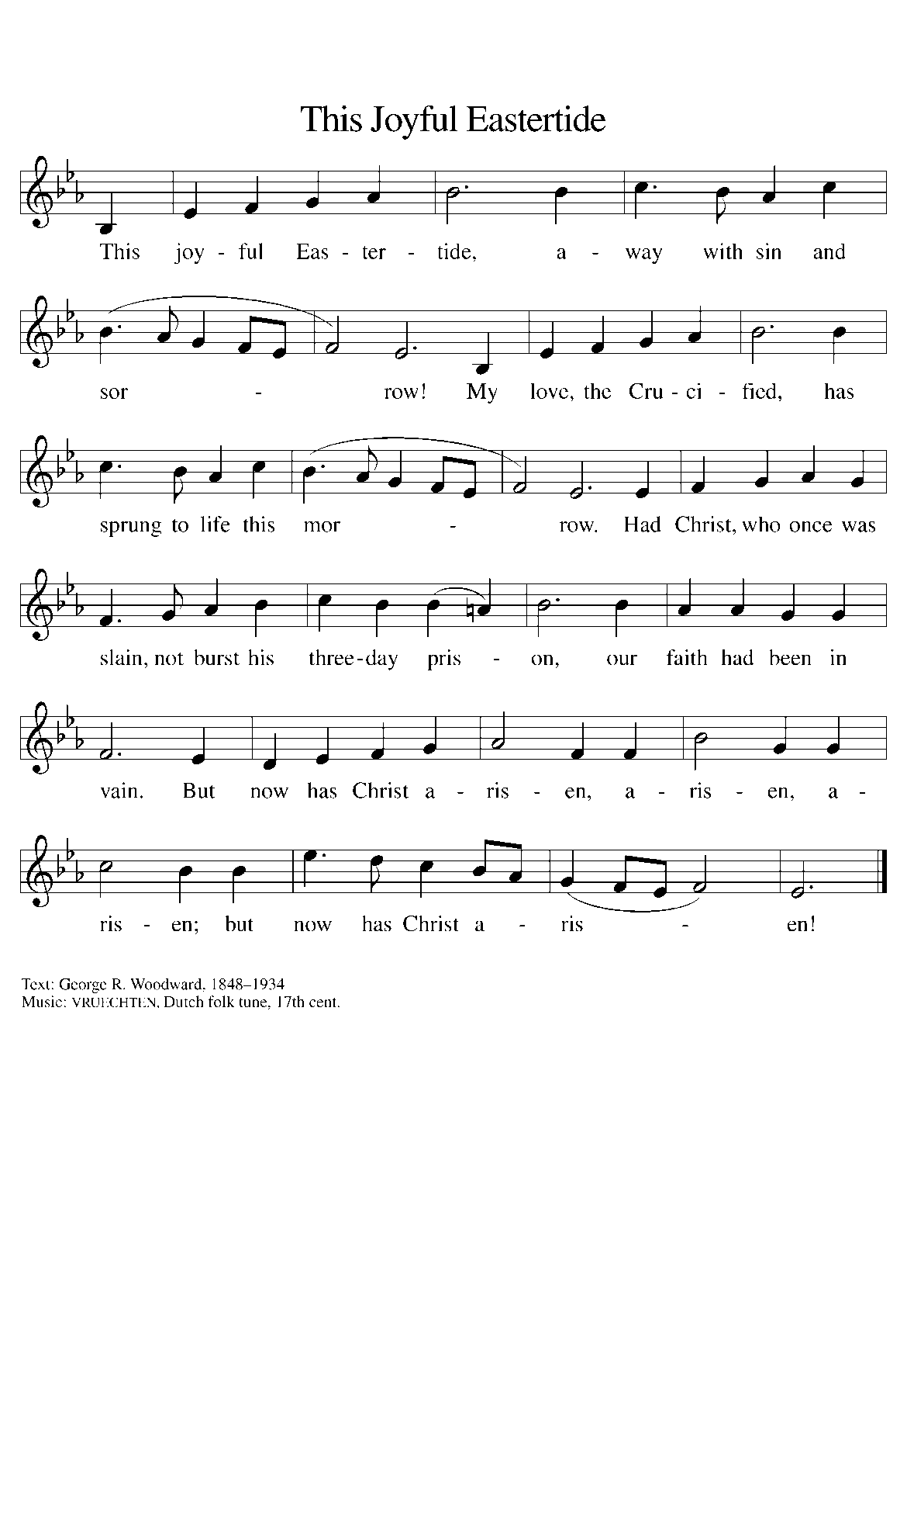

**THE OFFERTORY PRAYER**

A: Let us pray. God of blessing and glory,

**C: With people of every language and nation we bring the first fruits of our labor.**

**Let the sharing of these gifts proclaim our joyful hope in Jesus Christ, the first**

**fruits of the resurrection. Thanksgiving and honor be to You, O God, forever and**

**ever. Amen.**

**THE GREAT THANKSGIVING**

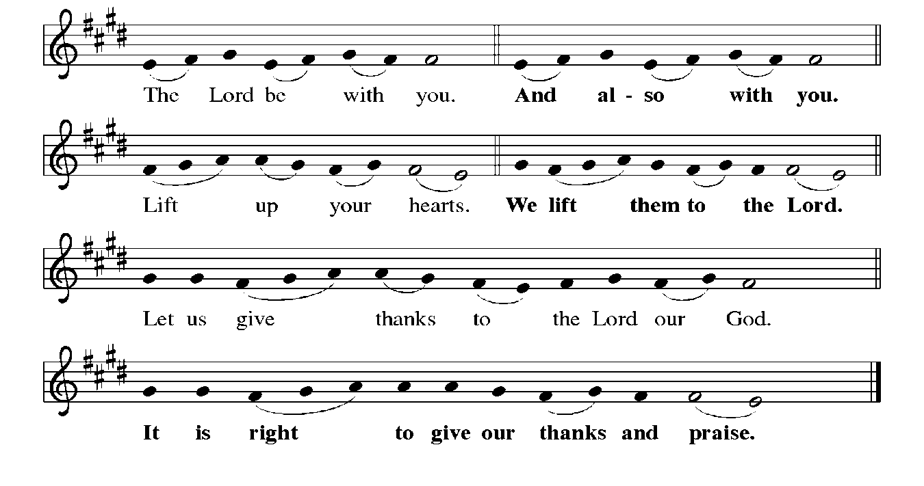

P: It is indeed right, our duty, and our joy … join their unending hymn:

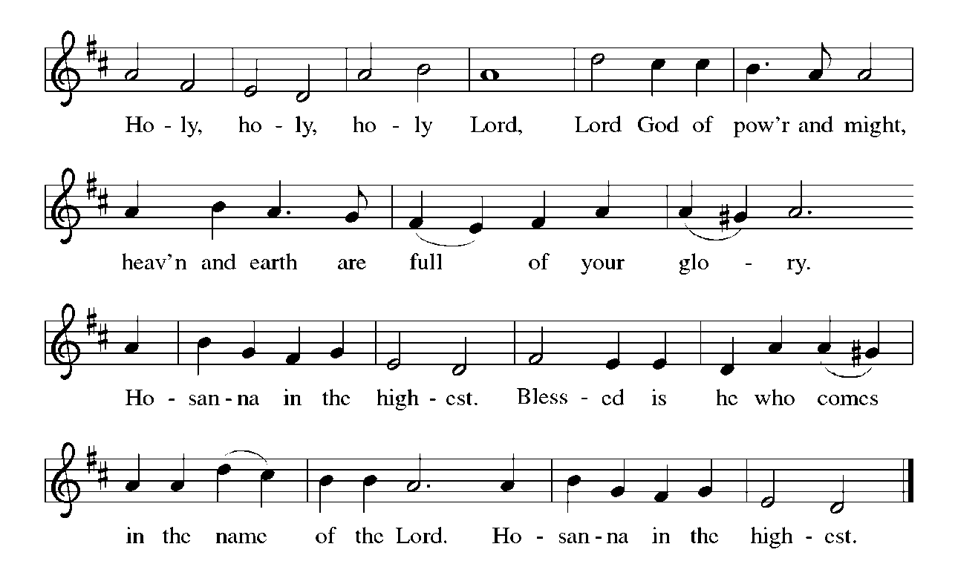

P: We lift our hearts in praise to You, God of glory, because in every time and place

You have shown Yourself to Your people and revealed Your purpose to dwell

with them always.

In the wilderness You made Your place of dwelling in a tabernacle.

In Jerusalem the temple became a theater of encounter with You.

In Jesus Your Son You came among us, making Your home in human flesh.

In His death He faced the consequences of our sin, and in His resurrection He made

possible an everlasting home for us at Your right hand.

You have prepared for us a holy city of heavenly lights where we will dwell with You

forever.

Lord God Almighty, from Your throne flows the river of life.

Fed from that river, Your tree of life bears fruit for the healing of the nations.

Nourish Your Church in this sacred Meal, that the bread and wine we receive may be

poured out through us as life abundant.

By the power of Your Holy Spirit make Your Church a healing balm in places of

suffering and sorrow.

Make this bread and cup holy that they may be for us the Body and Blood of Your

Son;

Who in the night ... “Do this for the remembrance of Me.”

As often as we eat ... we proclaim the Lord’s death until He comes.

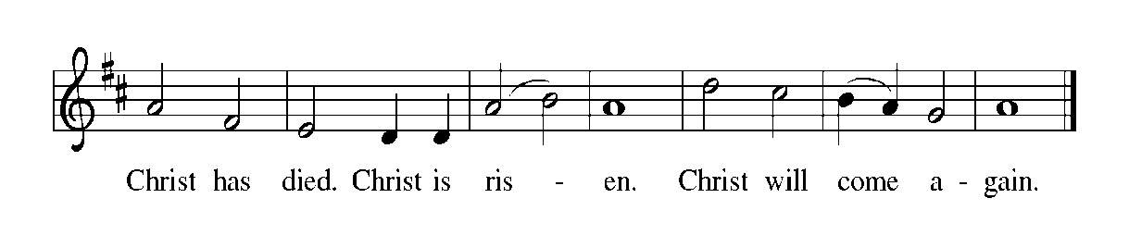

P: Revealing God, Whose radiance is all holiness, make Your face to shine upon us

that we may be saved.

Look with mercy upon those who turn to You in hope and long for peace the world

cannot give.

Hold in Your light of compassion every troubled heart that waits for the dawn of Your

one eternal Day.

Shine with the fullness of Your love into every fear-filled soul, and make Yourself

known to all who long to see Your race;

Until that hour when night is no more, and there is no need of lamp or sun, when You

will be our light, and when in Your eternal radiance

You shall reign forever and ever, one God: Father, **✠** Son, and Holy Spirit.



**THE LORD’S PRAYER**

P: Risen from the dead, Jesus lives to intercede for us and join us as He taught us to pray:

**C: (Sung) Music is on the front cover of the red hymnal**

**INVITATION TO THE MEAL**

P: Alleluia! Christ the Lamb of God has been sacrificed. Therefore, let us celebrate His

Feast with joy. Blessed are those who are called to the Supper of the Lamb. God’s

holy gifts for God’s holy people. Come, for all is now ready.

*The assembly is seated*

**THE DISTRIBUTION**

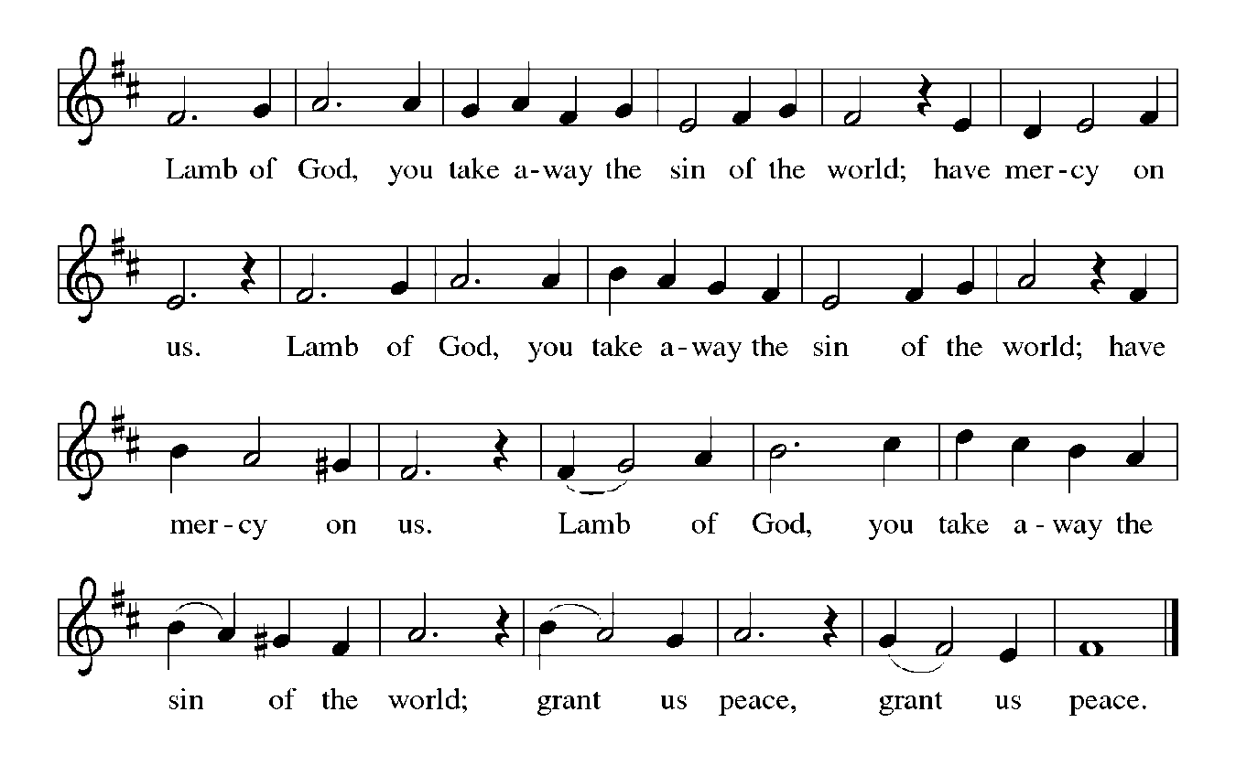

**HYMN DURING DISTRIBUTION 628 *Jerusalem, My Happy Home***

**ELW 423 *Shall We Gather at the River***

**ELW 785 *When Peace Like a River***

**ELW 581 *You Are Mine***

*As you are able please rise*

**THE POST-COMMUNION BLESSING**

P: The Body and Blood of our Lord Jesus Christ strengthen you and keep you in His grace.

**C: Amen.**

**THE POST-COMMUNION PRAYER**

A: Let us pray. Living God, as the disciples ate and drank with their risen Lord, we have

been nourished by the very presence of Christ. Through this Meal may we be

strengthened to keep Your Word and to proclaim the power of Your saving love in

Jesus Christ our Lord.

**C: Amen.**

**✠ SENDING ✠**

**THE BENEDICTION**

P: May God the Father Who raised Christ from the dead open to you the gate of everlasting

life.

**C: Amen.**

P: May God the Son Who burst from the grave give you joy as you celebrate His

resurrection.

**C: Amen.**

P: May God the Holy Spirit Who brought you to birth in Baptism fill you with strength

and peace.

**C: Amen.**

P: Almighty God: Father, Son, **✠** and Holy Spirit bless you now and forever.

**C: Amen.**

**SENDING HYMN ELW 866 *We Are Marching in the Light of God***

**THE DISMISSAL**

A: Alleluia! Christ is risen!

**C: He is risen indeed! Alleluia!**

A: Go in the peace of Christ, alleluia!

**C: Thanks be to God! Alleluia!**

**POSTLUDE**

**✠ To God Alone Be Glory ✠**

The Meditation is from *Words for Worship.* Copyright 1995 Augsburg Fortress.

**ANNOUNCEMENTS**

**Please remember to mail your offering to the Church Office** at 818 Franklin Street, Michigan City, IN 46360**.** Another alternative is to give on-line through Tithe.ly. Please see your closure letter for information on how to set up a Tithe.ly account.

**St. Paul Members are reminded to have** a loved one contact the office if you are hospitalized. Many times, the Pastor doesn’t know someone is in the hospital. If you call and leave a message, please tell us at which hospital the patient is located.

**Birthdays: Marvin Dirks (5/25); Sally Timm (5/30)**

**Anniversaries: Clay & Kimberly Payne (5/29)**

**PRAYER CONCERNS:** Larry Litchford, Sarah McNabb, Carol Radke, Jeanie Boatman Shepple, Nolan Wilson, Debbie Martin, Mark Tannehill, Brian Wiseman, Kathy Stein, Danielle Schnell, Jan Paholski, Laura Dovey, and Grace Romine.

**OFFICE HOURS:** Libby will be in the office on Mondays, Wednesdays, and Fridays; volunteers will cover Tuesdays and Thursdays.

Monday & Wednesday 8:00 a.m. – 5 p.m.

Tuesday & Thursday 9:00 a.m. – 12:00 p.m.

Friday 8:00 a.m. – 12:00 p.m.

**If you are listening to the worship broadcast on the radio and would like to watch the Sunday morning service live stream follow these steps:**

(1) If you have You Tube available on your TV, search for

**St. Paul Lutheran Church Michigan City, IN.**

(2) The direct link on the computer is

https://www.youtube.com/channel/UC5AIPNaKr3QN50984jGOa1g.

   (3) This link is also on the main page of the church’s website in

the church section and will continue to be posted weekly on the St.

Paul Facebook page.

And it will always be available on the radio broadcast Sunday mornings at 11:00 a.m.

on WEFM (95.9), and on the local cable access station #99 for the previous week’s

service on Sundays at 4:00 p.m. and the current service on Wednesdays at 7:00 p.m.

and Fridays at 8:30 p.m.

**To send e-mail to the church office**, please use the following addresses:

Pastor Mark Reshan: seniorpastor@stpaulmichigancity.com

Church Office Secretary (Libby Pollock): churchsecretary@stpaulmichigancity.com

Church Treasurer (Karen Fleming): finance@stpaulmichigancity.com

**2025 Church Council:**

Mark Reshan - Pastor

Janet Bakken – President

Donna Knoll – Vice President

Judy Hunt – Secretary

Karen Fleming – Treasurer

Members: Paul Brooks, Diane Egilske, Sue Koziel, Judy Mutchler,

Jim Schraidt, Trish Sprague

**Worship Attendance:**

**Saturday , May 17, 2025 @ 4:00 p.m. 24**

**Sunday, May 18, 2025 @ 9:00 a.m. 70**

**TOTAL 94**

**2025 Financial Stewardship**

Weekly Church Operating Needs (x 2 weeks)

April 19-20, 2025; April 26-27, 2025: $ 13,545.00

General Fund (including General Memorials): $ 7,385.00

Overage/Shortage: — $ 6,160.00

Restricted Income (not including Memorials)

Supports IK Synod & Church wide Ministries: $ 171.00

Ministries in our Community/Congregation: $ 525.00

Capital Fund: $ 366.00

Memorials

General Fund: $ 30.00

**ACTIVITIES, EVENTS & MEETINGS**

**May 2025**

**Monday,** May 19, 2025 @ 1:00 p.m. Hope Circle/Green Room

@2:00 p.m. Finance Committee Mtg/Luther House

@ 3:00 p.m. Executive Board Meeting/Luther House

**Wednesday,** May 21, 2025 @ 9:15 a.m. Bible Study/Luther House

@10:00 a.m. God’s Purls/St. Paul Room

@ 4:30 p.m. Choir Rehearsal/Sanctuary

@5:30 p.m. Anniversary Comm. Mtg./Luther House

**Saturday,** May 24, 2025 @ 4:00 p.m. 6th Easter Worship Service

**Sunday,** May 25, 2025 @ 9:00 a.m. 6th Easter Worship Service Coffee in the St. Paul Room after service

**Monday,** May 26, 2025 **MEMORIAL DAY – OFFICE WILL BE CLOSED**

**Wednesday,** May 28, 2025 @ 9:15 a.m. Bible Study/Luther House

@ 10:00 a.m. God’s Purls/St. Paul Room

@ 4:30 p. m. Choir Rehearsal/Sanctuary

**Saturday,** May 31, 2025 @ 4:00 p.m. 7th Easter Worship Service

**MISSION OF THE MONTH FOR MAY 2025**

Our Monthly Mission for the month of May, 2025, is Camp Sharing Meadows, part of the Share Foundation. Located in LaPorte, Camp Sharing Meadows is an inclusive Christian camp for adults with intellectual and/or developmental disabilities, where a vibrant blend of community, faith, and creative exploration takes center focus. The camps allow individuals with developmental and intellectual disabilities to have fun while learning faith-based values, participating in various activities, and making lifelong friendships. Monetary and check donations can be made out to the church and marked for Camp Sharing Meadows and placed in the offering plate. Noisy coin offering will also go to the Mission of the Month. Thank you for your generosity!

**Copies of the minutes from the March 27, 2025 and the May 1, 2025 Church Council meetings are on the back table in the upper Narthex. They were approved by the council via email.**

**FYI:**

In response to the ever rising costs for postage we will be putting your copy

of the “Good News” in your hanging file folder in the narthex each month

from now on. Those of you who are unable to attend services on a regular

basis may still receive your copies through your email address or in the

U.S. mail. If you normally receive your copy of the newsletter via your

email address anyway, nothing will change for you. Thank you so much for

your understanding and cooperation!

**The Good News Newsletter**: If you have an article or anything you want included in **The Good News** please send it to the following e-mail address: splcgoodnews@gmail.com. Pastor Pamela Thiede will be using this e-mail address to assemble **The Good News** each month. The deadline for getting information to Pastor Pamela will be the 20th of each month.

**Do you love to sing?**

**The St. Paul Choir is hosting an open rehearsal on Wednesday, June 11, 2025 from 4:30 p.m. – 5:30 p.m. in the Sanctuary.** It’s OK if you don’t know if you are a Bass, Tenor, Alto or Soprano (our rockstar director, Maggie, can help you with that) and you don’t need to know how to read music! During the open rehearsal we will learn a simple song to sing during the service on Sunday, June 15. Then the choir will be on summer break from mid-June until after Labor Day, giving you time to consider joining in September. We look forward to seeing everyone on June 11th!

Thank$ for $haring

Thank you for all who participate in our Give Back days! On April 3 we met at Galveston Steakhouse and earned $150. Our May 7th Give Back at Swingbelly’s earned $125. Our next Give Back will be at Holly’s on Tuesday, June 10th from 11:00 am — close. A coupon is required in order for us to claim the discount. Here are two coupons: one for you and one for a friend.

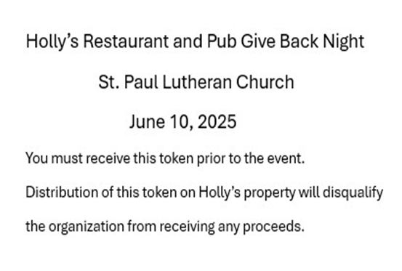

**MISSION OF THE MONTH FOR JUNE 2025**

**The mission of the month for St. Paul Lutheran is the Team Kentucky Storm Relief Fund.** The governor of Kentucky has established this fund to assist those impacted by the severe weather and tornadoes this year. The fund has no administration fees, so every dollar goes to help Kentuckians affected by the historic flooding and sever weather. Governor Beshear has said that the fund will first go towards paying funeral expenses for those lost to the storms, stating that people who have lost so much in a natural disaster shouldn’t have to worry about how to bury their loved ones. Please make checks payable to St. Paul and mark for the June Mission of the Month and place in the offering plate. June noisy coin offering will also support the mission of the month. Thank you for your generosity in helping those affected by this natural disaster as well as your continued prayers for the victims and their loved ones.

**THANK YOU!**

**Our sincere thanks go out to Jon’s Tree Service, Inc. for their generous donation of free mulch used to enhance the landscaping around the church and Luther House. It is greatly appreciated.**

