THE ELEVENTH SUNDAY AFTER PENTECOST
August 9, 2026

O Jesus, gentle love, you who are the true and complete peace in every discord, bring peace and concord to every conflict.
Let my enemies come, who in the world are so numerous; but if I feel myself to be with you, I overthrow them all, and the world itself I overthrow. I am like a fish that rests in the sea; when the waves sweep over it and the great tempests assail it, the fish enjoys swimming, because it cannot be captured, and it leaps more nimbly.
Thus do I in this world that is a troubled sea: the great currents arise, and I sail below them, and I take shelter in your bosom, and let them pass by. Feeling myself with you I have no fear of the currents. But if I do not possess you, I am like the whale that when the tide goes out sits on the sand and is condemned to death, because without the tide it no longer has the chance to escape.

Umilta of Faenza

Perhaps a better way to approach this text … is to emphasize Peter’s faith. In spite of the fear of initially thinking he sees a ghost, in spite of the rough seas, and in spite of the law of physics that says that humans do not float, Peter calls Jesus “Lord” and steps out of the boat. None of the other disciples do this.
And even when Peter falters, doubts and begins drowning, he calls Jesus “Lord” once again and trusts that only he can save him. All of this leads finally not only to Peter but to the whole group of disciples professing Jesus as God’s Son.
As finite beings, humans will always have finite faith. Doubt is an essential part of the experience of faith … this text can help (people) quit feeling guilty about their doubts and see instead see that their faith, when placed as trust in Jesus as the Son of God, is greater than any doubt or danger they can ever face.

O. Wesley Allen Jr.

INTRODUCTION

Elijah finds the presence of God not in earthquake, wind, or fire, but in the sound of sheer silence. When the disciples face a great storm on the sea, they cry out with fear. Jesus says: "Take heart, it is I; do not be afraid." Amid the storms of life, we gather to seek the calm presence of Christ that soothes our fears. In comforting words of scripture and in the refreshing bread and cup of the eucharist, God grants us peace and sends us forth to be a sign of God's presence to others.

Lawrence, deacon, martyr, died 258

As one of the seven deacons of the church at Rome, Lawrence was responsible for the church's financial matters and for the care of the poor. Asked by the emperor to gather the church's treasure, he presented a collection of orphans, lepers, and the like. The enraged emperor had him put to death.

GATHERING
PRELUDE Mountain of the Lord New Song Praise Band
(Andy Parks)
ANNOUNCEMENTS

As you are able please rise

CONFESSION AND ABSOLUTION

P: In the name of the Father and of the Son and of the Holy Spirit.

C: Amen.

P: “Truly, (God’s) salvation is very near to those who fear Him ...” (Psalm 85: 9) God
comes this Day to bring rescue from our doubt, fear, and unbelief. Let us with
confidence therefore confess our sins and “call upon the name of the Lord.” (Romans
10: 13)

Silence for self-examination and reflection is kept

P: Most merciful God,

C: We confess that we have sinned against You in thought, word, and deed. With
Elijah, we run from our calling to proclaim Your Word. (1 Kings 19: 9) Our feet
have been slow in bringing Your Good News to the fearful. (Romans 10: 15) We
have failed to hear Your voice amid the storms of life. (Matthew 14: 27) We have
doubted Your presence, and sunk into despair. (14: 30) For the sake of Your
Son, Jesus Christ, have mercy on us. Draw near to us, and save us from our sin,
that we may worship You with thanksgiving and joy.

P: “I will listen to what the LORD God is saying, for He is speaking peace to His faithful
people and to those who turn their hearts to Him.” (Psalm 85: 8) Hear then “the Word
that is near you” (Romans 10: 8): as a called and ordained minister of the Church of
Christ, and by His authority, I therefore declare to you the entire forgiveness of all your
sins, in the name of the Father and of the Son and of the Holy Spirit.

C: Amen.

GATHERING SONG NSB 104 You Are My Hiding Place

THE GREETING AND PRAYER OF THE DAY

P: The grace of our Lord Jesus Christ, the love of God, and the communion of the Holy
Spirit be with you all.

C: And also with you.

P: Let us pray. O God our defender, storms rage around and within us and cause us to be
afraid. Rescue Your people from despair, deliver Your sons and daughters from fear,
and preserve us in the faith of Your Son, Jesus Christ, our Savior and Lord.

C: Amen.

The assembly is seated

WORD

FIRST READING 1 Kings 19: 9-18

On the mountain where God had appeared to Moses with typical signs of God's presence--earthquake, wind, and fire--Elijah is now presented with a dramatic shift in the understanding of where God is to be found. God is not to be found in these signs. Rather, God is among the people, where the will of God is being lived out.

At [Horeb, the mount of God, Elijah] came to a cave, and spent the night there. Then the word of the LORD came to him, saying, "What are you doing here, Elijah?" ¹⁰He answered, "I have been very zealous for the LORD, the God of hosts; for the Israelites have forsaken Your covenant, thrown down Your altars, and killed Your prophets with the sword. I alone am left, and they are seeking my life, to take it away."
¹¹He said, "Go out and stand on the mountain before the LORD, for the LORD is about to pass by." Now there was a great wind, so strong that it was splitting mountains and breaking rocks in pieces before the LORD, but the LORD was not in the wind; and after the wind an earthquake, but the LORD was not in the earthquake; ¹²and after the earthquake a fire, but the LORD was not in the fire; and after the fire a sound of sheer silence.
¹³When Elijah heard it, he wrapped his face in his mantle and went out and stood at the entrance of the cave. Then there came a voice to him that said, "What are you doing here, Elijah?" ¹⁴He answered, "I have been very zealous for the LORD, the God of hosts; for the Israelites have forsaken Your covenant, thrown down Your altars, and killed Your prophets with the sword. I alone am left, and they are seeking my life, to take it away."
¹⁵Then the LORD said to him, "Go, return on your way to the wilderness of Damascus; when you arrive, you shall anoint Hazael as king over Aram. ¹⁶Also you shall anoint Jehu son of Nimshi as king over Israel; and you shall anoint Elisha son of Shaphat of Abel-meholah as prophet in your place. ¹⁷Whoever escapes from the sword of Hazael, Jehu shall kill; and whoever escapes from the sword of Jehu, Elisha shall kill. ¹⁸Yet I will leave seven thousand in Israel, all the knees that have not bowed to Baal, and every mouth that has not kissed him."

The Word of the Lord.

Thanks be to God.

THE PSALM: Psalm 85: 8-13 Antiphon by Ray Makeever

Choir sings refrain first, followed immediately by the congregation
and as indicated

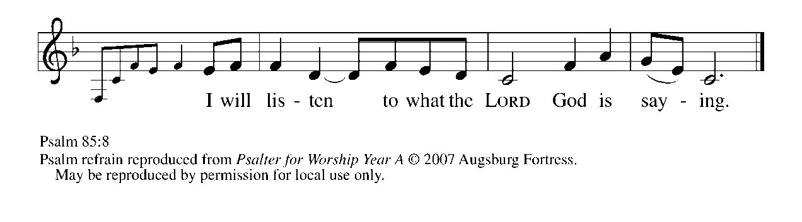
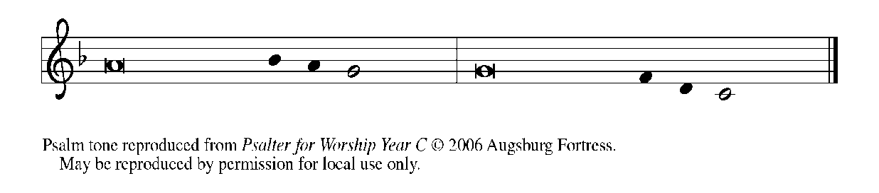

⁸I will listen to what the LORD | God is saying;
for You speak peace to Your faithful people
and to those who turn their | hearts to You.

⁹Truly, Your salvation is very near to | those who fear You,
that Your glory may dwell | in our land. REFRAIN

¹⁰Steadfast love and faithfulness have | met together;
righteousness and peace have | kissed each other.

¹¹Faithfulness shall spring up | from the earth,
and righteousness shall look | down from heaven.

¹²The LORD will indeed | grant prosperity,
and our land will | yield its increase.

¹³Righteousness shall go be- | fore the LORD
and shall prepare for | God a pathway. REFRAIN

SECOND READING Romans 10: 5-15

Paul discusses how we may attain the righteousness that leads to salvation. One way would be to keep the law, but he has already shown that it is impossible. Then, he proclaims the good news about "righteousness that comes by faith."

Moses writes concerning the righteousness that comes from the law, that "the person who does these things will live by them." ⁶But the righteousness that comes from faith says, "Do not say in your heart, 'Who will ascend into heaven?' " (that is, to bring Christ down) ⁷"or 'Who will descend into the abyss?' " (that is, to bring Christ up from the dead). ⁸But what does it say?
"The word is near you,
on your lips and in your heart"
(that is, the word of faith that we proclaim); ⁹because if you confess with your lips that Jesus is Lord and believe in your heart that God raised Him from the dead, you will be saved.
¹⁰For one believes with the heart and so is justified, and one confesses with the mouth and so is saved. ¹¹The scripture says, "No one who believes in Him will be put to shame." ¹²For there is no distinction between Jew and Greek; the same Lord is Lord of all and is generous to all who call on Him. ¹³For, "Everyone who calls on the name of the Lord shall be saved."
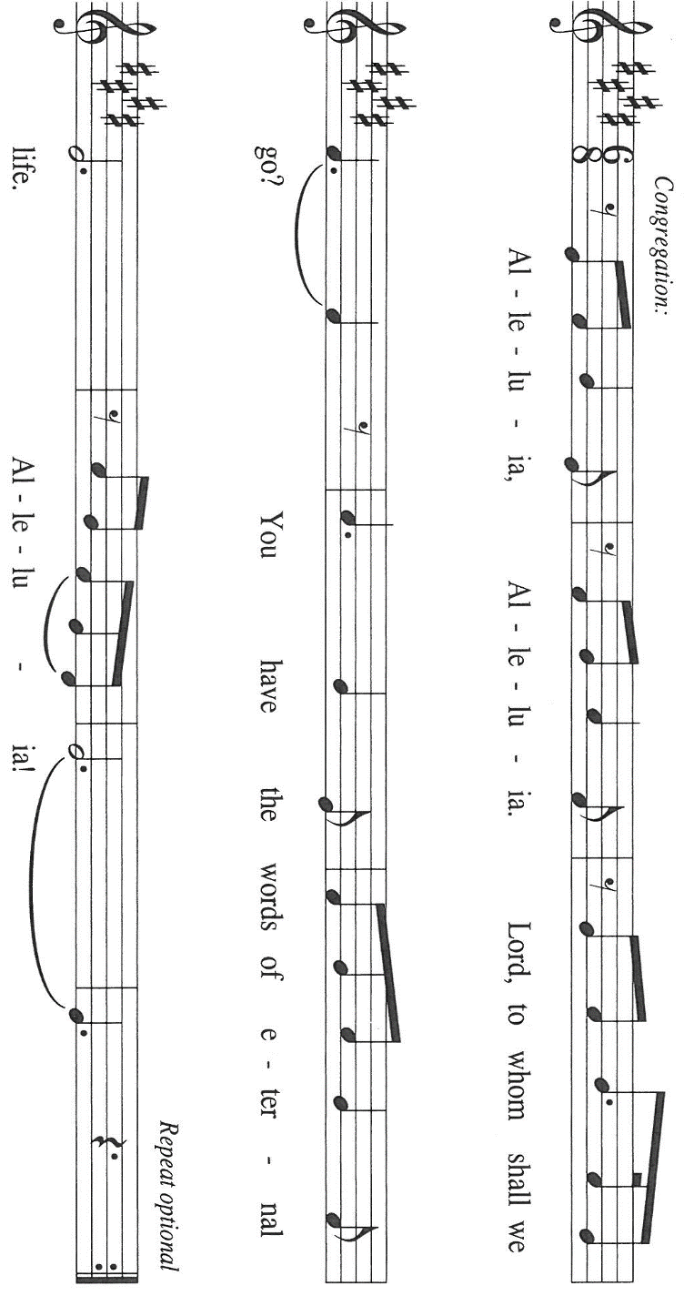
¹⁴But how are they to call on one in whom they have not believed? And how are they to believe in One of Whom they have never heard? And how are they to hear without someone to proclaim Him? ¹⁵And how are they to proclaim Him unless they are sent? As it is written, "How beautiful are the feet of those who bring good news!"

The Word of the Lord.

Thanks be to God.

As you are able please rise

THE VERSE Sung twice

THE HOLY GOSPEL Matthew 14: 22-33

Matthew’s gospel typically portrays Jesus’ disciples as people of “little faith,” who fail despite their best intentions. In this story, Matthew shows how Jesus comes to the disciples when they are in trouble and sustains them in their time of fear and doubt.

P: The Holy Gospel according to St. Matthew, the fourteenth chapter.

C: Glory to You, O Lord!

[Jesus] made the disciples get into the boat and go on ahead to the other side of the Sea of Galilee, while He dismissed the crowds. ²³And after He had dismissed the crowds, He went up the mountain by Himself to pray. When evening came, He was there alone, ²⁴but by this time the boat, battered by the waves, was far from the land, for the wind was against them.
²⁵And early in the morning He came walking toward them on the sea. ²⁶But when the disciples saw Him walking on the sea, they were terrified, saying, "It is a ghost!" And they cried out in fear. ²⁷But immediately Jesus spoke to them and said, "Take heart, it is I; do not be afraid."
²⁸Peter answered Him, "Lord, if it is You, command me to come to You on the water." ²⁹He said, "Come." So Peter got out of the boat, started walking on the water, and came toward Jesus.
³⁰But when he noticed the strong wind, he became frightened, and beginning to sink, he cried out, "Lord, save me!" ³¹Jesus immediately reached out His hand and caught him, saying to him, "You of little faith, why did you doubt?" ³²When they got into the boat, the wind ceased. ³³And those in the boat worshiped Him, saying, "Truly You are the Son of God."

P: The Gospel of the Lord.

C: Praise to You, O Christ!

THE SERMON
Silence for reflection follows the sermon

As you are able please rise

THE HYMN OF THE DAY 756 Eternal Father, Strong to Save
Stanza 2—Women; Stanza 3--Men

THE APOSTLES’ CREED

A: God has made us His people through our Baptism into Christ. Living together in trust
and hope, we confess our faith.

C: I believe in God, the Father almighty,
creator of heaven and earth.

I believe in Jesus Christ, His only Son, our Lord.
He was conceived by the power of the Holy Spirit
and born of the virgin Mary.
He suffered under Pontius Pilate,
was crucified, died, and was buried.
He descended into hell.
On the third day He rose again.
He ascended into heaven,
and is seated at the right hand of the Father.
He will come again to judge the living and the dead.
I believe in the Holy Spirit,
the holy catholic Church,
the communion of saints,
the forgiveness of sins,
the resurrection of the body,
and the life everlasting. Amen.

THE PRAYER OF THE CHURCH

A: We are the ark of the Church, at times storm-tossed and frightened. Let us cry out in
faith for our own needs and the needs of the world.

A: That Christians may not grow discouraged with winds and waves against them, but take
heart in Jesus, Who will safely see us through, let us cry out to the Lord:

C: Lord, save us!

A: That nations battered by terrorism, the storms of war and political unrest, especially in
Ukraine, Russia, Iran, Lebanon, Israel, and Myanmar, may one day come to rejoice in
peace and reconciliation, let us cry out to the Lord:

C: Lord, save us!

A: That farmers might be spared from drought, and sailors and all who work on the seas
be kept from violent storms, let us cry out to the Lord:

C: Lord, save us!

A: That we, disciples of “little faith,” to whom the Lord still draws near, may be joyfully
aware of Christ’s presence among us, let us cry out to the Lord:

C: Lord, save us!

A: That nurses, doctors, therapists, aides, counselors, and all who practice healing
ministries would serve with wisdom and compassion, let us cry out to the Lord:

C: Lord, save us!

A: That those caught in addictions of body or mind, for those who feel powerless and sink
ever deeper into despair, and for the sick, especially: Kathy Thielman; Deb Prybylla;
John Ripka; Jon Samuelson; Jeff Timmrick; Pastor Dale Zystra; Amanda
Seedorf; Dale Thomas; Martha Schroeder; Hazel Miller; and Mark Tannehill, let
us cry out to the Lord:

C: Lord, save us!

A: That those celebrating birthdays, especially: Carol Hanft; Susan Dolson; Ruth
Baker; Jim Tomscheck and Diane Egilske may be filled with grace this day and
every day and grow in grace in the days ahead, let us cry out to the Lord:

C: Lord, save us!
A: That with all the saints, especially Lawrence, Deacon and martyr, whom we
commemorate this Day we too may one day be rescued from sin and everlasting death,
let us cry out to the Lord:

C: Lord, save us!

P: O true and faithful God, You are the hope of those who cry out to You. Hear our
petitions. Where there is no faith, awaken it; where there is little faith, enlarge it, that
one day we may all come to acknowledge Jesus as Your Son and the Savior of the
world. We ask this in His name, Who is one with You and the Holy Spirit, God, forever
and ever.

C: Amen.

MEAL

THE PEACE

P: The peace of the Lord be with you always.

C: And also with you.

The assembly is seated

THE OFFERING

THE VOLUNTARY It is Well With My Soul St. Paul Senior Choir
(arr. John Ness Beck)

As you area able please rise

THE PRESENTATION OF GIFTS (see p. 9) As the Grains of Wheat

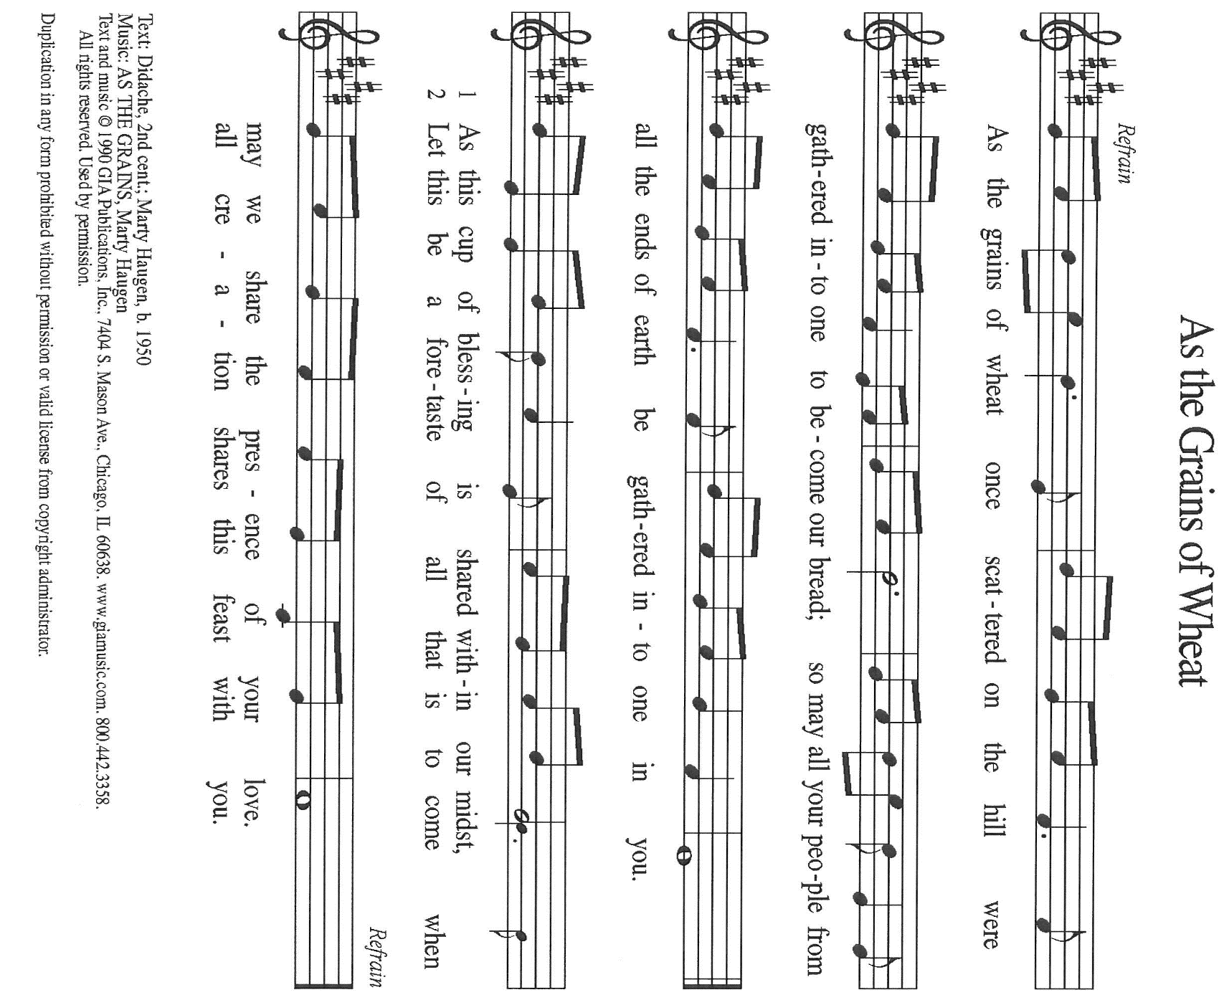

THE OFFERTORY PRAYER

A: Let us pray. God of mercy,

C: With these gifts we offer You our hearts and lives. In this bread and wine You
offer us the Body and Blood of Your Son. Through our eating and drinking may
we take heart in Your promises, and proclaim Your presence with joy and hope.
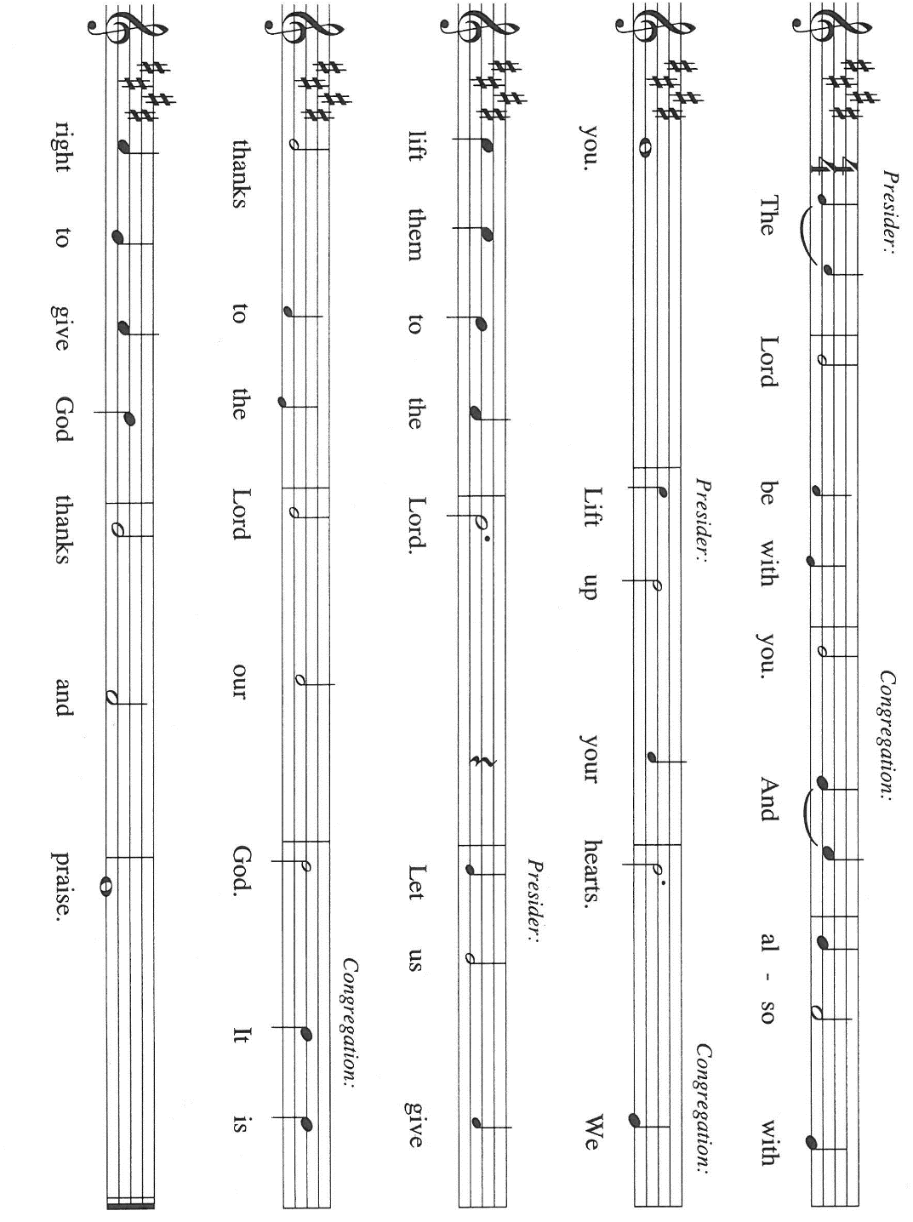
We ask this in the name of Jesus the Lord. Amen.

THE GREAT THANKSGIVING

P: It is our duty and delight …join their unending hymn:

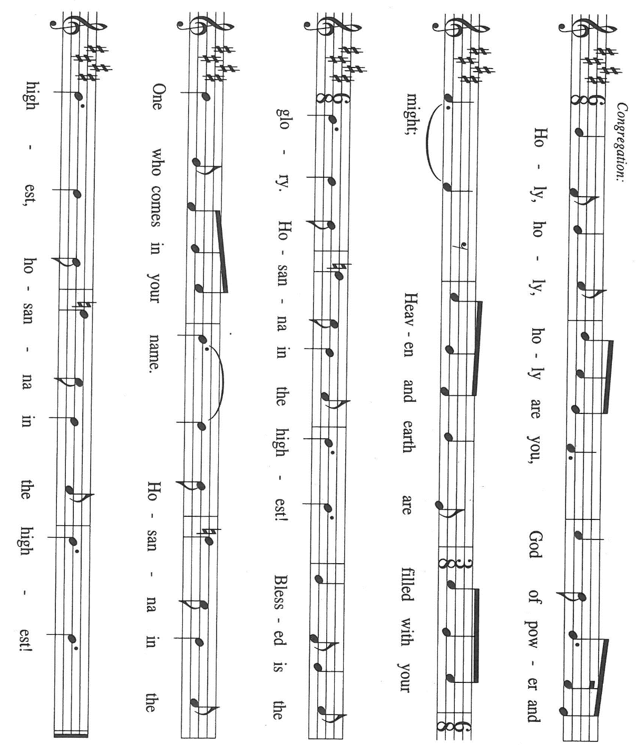

P: Holy God, God of hosts, Creator of heaven and earth, we praise You.
By Your Word You ordered the chaos, and called creation into being.
In the power of Your Spirit You renew the prosperity of the earth.
You called Israel to be Your chosen, that through their witness all hearts might turn to
You.
At the last You sent Your best and final Word, Your Son, Jesus Christ.
Everyone who calls upon His name will be saved.
In the night ... “Do this for the remembrance of Me.”
As often as we eat ... we proclaim the Lord’s death until He comes.

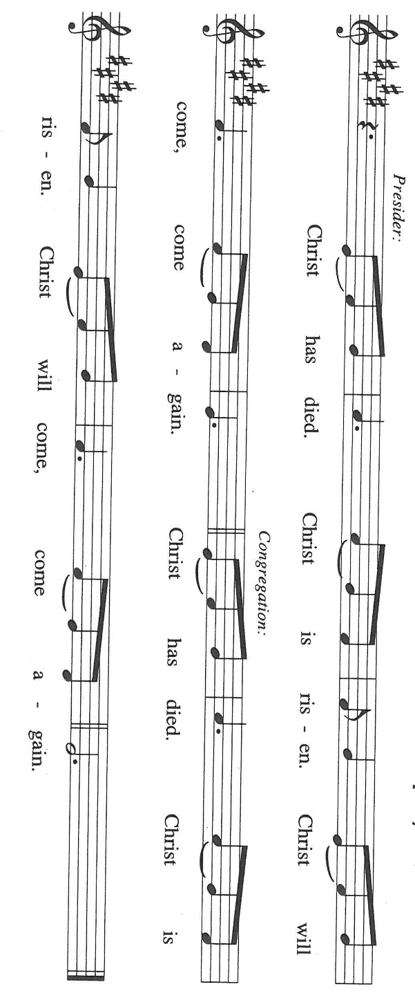

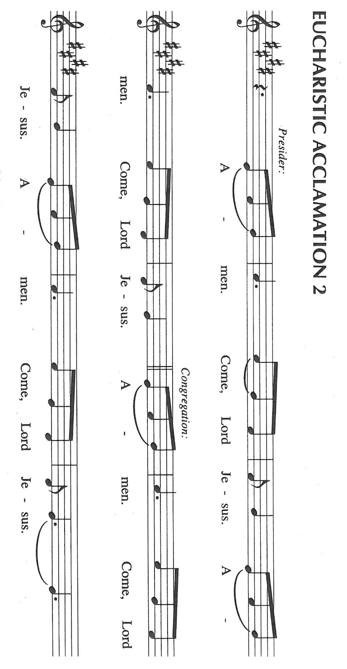

P: With this bread and cup, O God, we remember the life our Lord offered for
us: He lived and loved freely, even into the abyss of death.
You raised Him from death, and He ascended to Your right hand of power, from where
He will return in glory to host Your final Feast of victory.

P: We ask You: send Your Spirit on us and these Your gifts of bread and wine.
By our eating and drinking our fears may be calmed, our faith increased, and our
witness to Christ strengthened until He comes in triumph.

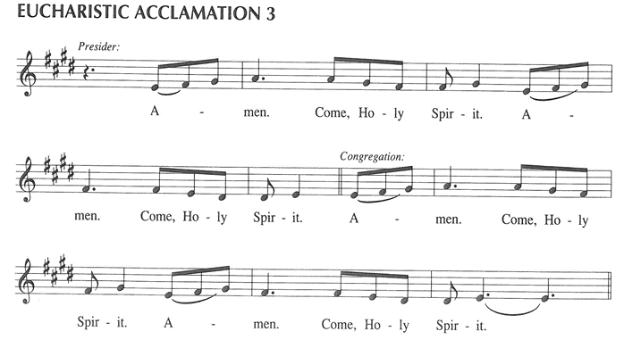

P: To You, O God: Father, Son, and + Holy Spirit, be all honor and glory, in Your holy
Church, in heaven and on earth, now and forever.

C: Amen!

THE LORD’S PRAYER

P: With trust in God Whose providence nourishes and sustains us, we pray now as Jesus
taught us:

C: Our Father, Who art in heaven, hallowed by Thy name.
Thy Kingdom come, Thy will be done on earth as it is in heaven.
Give us this day our daily bread, and forgive us our trespasses as we forgive those
who trespass against us.
And lead us not into temptation, but deliver us from evil.
For Thine is the Kingdom, and the power, and the glory, forever and ever. Amen.

INVITATION TO THE MEAL

P: Behold the living Bread come down from heaven: those who eat of it will never die.
Behold the cup of eternal life: those who drink of it will live forever. God’s holy gifts
for God’s holy people. Come, for all is now ready.

The assembly is seated

THE DISTRIBUTION Lamb of God
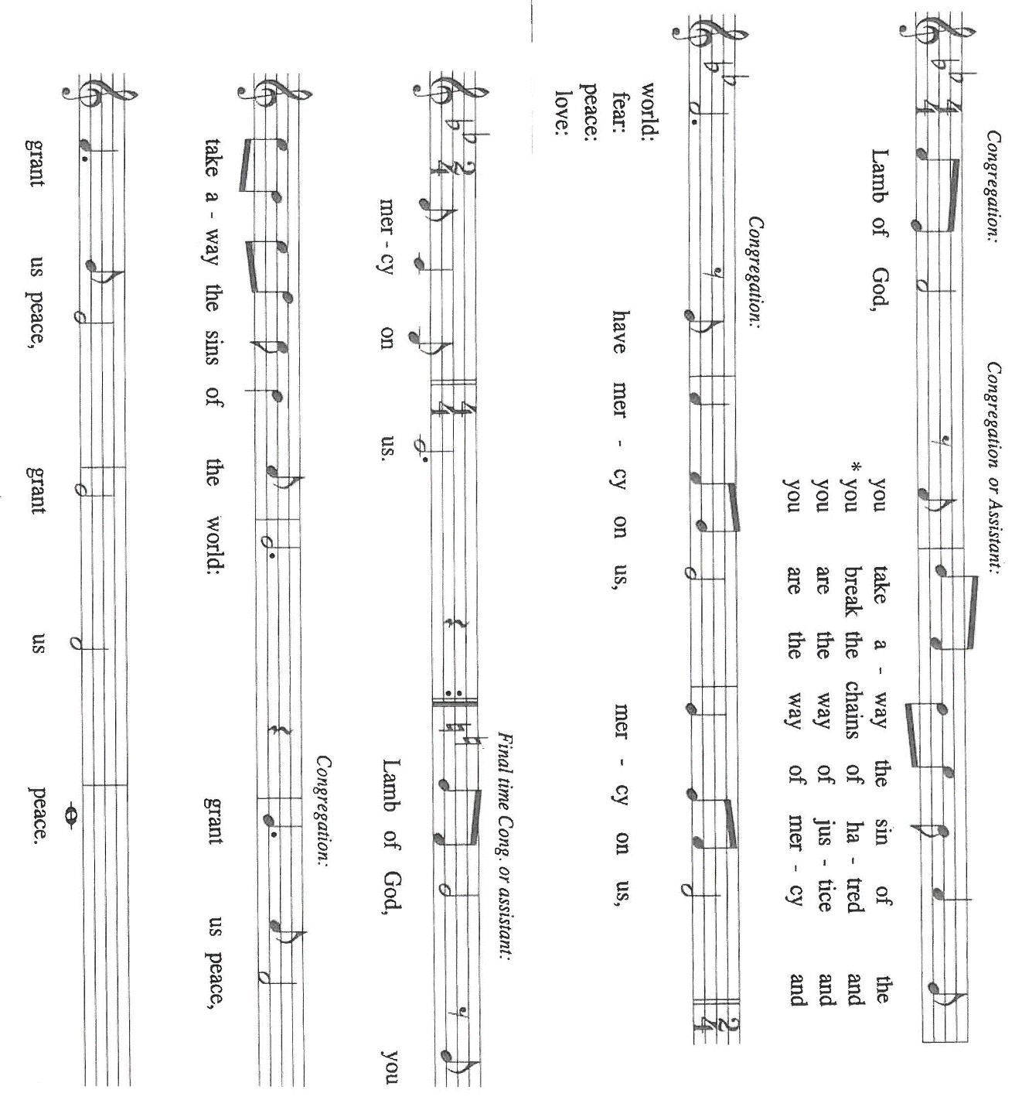

Those wishing to receive the Laying on of Hands, Anointing with Oil
and prayer for healing may go to Pastor at the side aisle

HYMN DURING DISTRIBUTION 773 Precious Lord, Take My Hand

ELW 471 Let Us Break Bread Together

ELW 481 Come to the Table

ELW 822 O, Sing to the Lord

ELW 821 Shout to the Lord

As you are able please rise

THE POST-COMMUNION BLESSING

P: The Body and Blood of our Lord Jesus Christ strengthen you and keep you in His grace.

C: Amen.

THE POST-COMMUNION PRAYER

A: Let us pray. Lord Jesus, You have again brought Your Word of grace near to our hearts
and lips through this holy Sacrament. Help us to believe Your promises, embolden our
confession of Your salvation, and make our feet beautiful in bringing Your Good News
to all who are frightened and sinking in despair. You are the Lord forevermore.

C: Amen.

SENDING

THE BENEDICTION

P: Almighty God: Father, Son, and Holy Spirit bless you now and forever.

C: Amen.

THE SENDING HYMN 774 What a Fellowship, What a Joy Divine

THE DISMISSAL

A: Go forth with God’s blessing to love and serve the Lord.

C: Thanks be to God!

POSTLUDE

To God Alone Be Glory

The Meditation is from Sundays and Seasons.com. Copyright 2011 Augsburg Fortress.

The Prayers, Introduction to the Lord’s Prayer, and Invitation to the Meal are adapted from
Prayers for Sundays and Seasons. Year A. Peter J. Scagnelli. (Chicago: Liturgy Training Publications, 1998) 116-118.

The musical setting of the liturgy, “Now the Feast and Celebration” by Marty Haugen, is
used by permission of GIA Publishers, Inc. OneLicense.net License #A-702836.

ANNOUNCEMENTS

Please remember to mail your offering to the Church Office at 818 Franklin Street, Michigan City, IN 46360. Another alternative is to give on-line through Tithe.ly. Please see your closure letter for information on how to set up a Tithe.ly account.

St. Paul Members are reminded to have a loved one contact the office if you are hospitalized. Many times, the Pastor doesn’t know someone is in the hospital. If you call and leave a message, please tell us at which hospital the patient is located.

BIRTHDAYS: Carol Hanft (8/9); Susan Dolson (8/11); Ruth Baker (8/13); James Tomsheck (8/14); Diane Egilske (8/ 15)

PRAYER CONCERNS: Debbie Martin; Mark Tannehill; Kathy Stein; Jan Paholski; Laura Dovey; Bill Hazelgrove; Al Levenhagen; Carl Wipperman; Major Payne.

OFFICE HOURS: Libby will be in the office on Mondays, Wednesdays, and Fridays; volunteers will cover Tuesdays and Thursdays.

Monday & Wednesday 8:00 a.m. – 5 p.m.
Tuesday & Thursday 9:00 a.m. – 12:00 p.m.
Friday 8:00 a.m. – 12:00 p.m.

If you are listening to the worship broadcast on the radio and would like to watch the Sunday morning service live stream follow these steps:

(1) If you have You Tube available on your TV, search for
St. Paul Lutheran Church Michigan City, IN.

(2) The direct link on the computer is https://
www.youtube.com/channel/UC5AIPNaKr3QN50984jGOa1g

(3) This link is also on the main page of the church’s website in
the church section and will continue to be posted weekly on the St.
Paul Facebook page.

And it will always be available on the radio broadcast Sunday mornings at 11:00 a.m.
on WEFM (95.9), and on the local cable access station #99 for the previous week’s
service on Sundays at 4:00 p.m. and the current service on Wednesdays at 7:00 p.m.
and Fridays at 8:30 p.m.

To send e-mail to the church office, please use the following addresses:
Pastor Mark Reshan: seniorpastor@stpaulmichigancity.com
Church Office Secretary (Libby Pollock): churchsecretary@stpaulmichigancity.com
Church Treasurer (Karen Fleming): finance@stpaulmichigancity.com

2026 Church Council:
Pastor - Mark Reshan
President - Donna Knoll
Vice President - Jan Bakken
Secretary - Judy Hunt
Treasurer - Karen Fleming

Members: Sue Koziel; Jim Schraidt; Trish Sprague; Bob Kiser; Barry Anderson; and
Pam Soule

Worship Attendance:

Wednesday, July 29, 2026 Organ Concert @12:15 p.m. 80

Saturday, August 1, 2026 @ 4:00 p.m. 24

Sunday, August 2, 2026 @ 9:00 a.m. 61

TOTAL 165

Copies of the minutes from the June 25, 2026 and July 23, 2026 Church Council meetings are on the back table in the upper Narthex. They were approved by the council via email.

The Good News Newsletter: If you have an article or anything you want included in The Good News please send it to the following e-mail address: splcgoodnews@gmail.com. Pastor Pamela Thiede will be using this e-mail address to assemble The Good News each month. The deadline for getting information to Pastor Pamela will be the 20th of each month.

Next week’s lessons are Isaiah 56: 1, 6-8; Psalm 67; Romans 11: 1-2a, 29-32;
Matthew 15: [10-20] 21-28 for those of you who like to study them in advance.

MISSION OF THE MONTH FOR AUGUST 2026

Mission of the Month for August 2026 is for Michigan City Area Schools – we will be collecting money to support different projects in various elementary schools in Michigan City through Donors Choose. Donors Choose provides a list of teacher-led classroom projects that need funding. Please consider donating to help fund our local teachers’ classroom projects. Checks can be written to St. Paul and can be marked for MCAS and placed in the offering plate. Noisy coin offering will also support the mission of the month. To see a full list of projects, visit www.donorschoose.org and search for Michigan City.

PLEASE NOTE:

From now through Wednesday, August 19, 2026 the front doors of the church (those doors facing Franklin Street) will be open on Wednesdays to invite new visitors in to hear the organ concert. Any Wednesday, at your choosing, at 11:30 a.m. Concerts begin at 12:15 p.m. Please come and help us greet visitors. Your help is appreciated.

2026 Financial Stewardship

Weekly Church Operating Needs (x 2 weeks)
July 25-26, 2026 and August 1-2, 2026: $ 11,501.00

General Fund (including General Memorials): $ 7,482.00

Overage/Shortage: — $ 4,019.00

Restricted Income (not including Memorials)
Supports IK Synod & Church wide Ministries: $ 345.00

Ministries in our Community/Congregation: $ 3,060.00

Capital Fund: $ 340.00

MEMORIALS
General Fund $ 100.00

ACTIVITIES, EVENTS & MEETINGS
AUGUST 2026

Saturday, August 8, 2026 @4:00 p.m. 11th Pentecost Worship Service/Sanctuary

Sunday, August 9, 2026 @ 9:00 a.m. 11th Pentecost Worship Service/Sanctuary/coffee after

Monday, August 10, 2026 @ 1:00 p.m. Hope Circle/Green Room

@ 7:00 p.m. Women’s Bible Study/St. Paul Room

Tuesday, August 11, 2026 @ 11:00 a.m. – close GIVE BACK at Holly’s

Wednesday, August 12, 2026 @ 10:00 a.m. God’s Purls/St. Paul Room

@12:15 p.m. Organ Concert Summer Series/Sanctuary
@ 3:30 p.m. Worship and Music Mtg./Luther House

Thursday, August 13, 2026 @ 5:00 p.m. Volunteer Dinner/St. Paul Rm

Saturday, August 15, 2026 @ 4:00 p.m. 12th Pentecost Worship Service/Sanctuary

Sunday, August 16, 2026 @ 9:00 a.m. 12th Pentecost Worship Service /Sanctuary/coffee after

Monday, August 17, 2026 @ 7:00 p.m. Women’s Bible Study/St. Paul Room

Wednesday, August 19, 2026 @ 10:00 a.m. God’s Purls/St. Paul Room

@ 12:15 p.m. Last Organ Concert Summer Series. 2026

@ 4:30 p.m. Choir Rehearsal/Sanctuary

Saturday, August 22, 2026 @ 4:00 p.m. 13th 21`Pentecost Worship Service/Sanctuary

Sunday, August 23, 2026 @ 9:00 a.m. 13th Pentecost Worship Service/Sanctuary/coffee after

Monday, August 24, 2026 @ 2:00 p.m Finance Comm. Mtg./Luther House

@ 3:00 p.m. Executive Board Mtg./Luther House

Wednesday, August 26, 2026 @ 10:00 a.m. God’s Purls/St. Paul Room

Thursday, August 27, 2026 @ 3:00 p.m. Church Council Mtg./St. Paul Room

Saturday, August 29, 2026 @ 4:00p.m 14 Pentecost Worship Service/Sanctuary

Sunday, August 30, 2026 @ 9:00 a.m. 14 Pentecost Worship Service/Sanctuary/coffee after

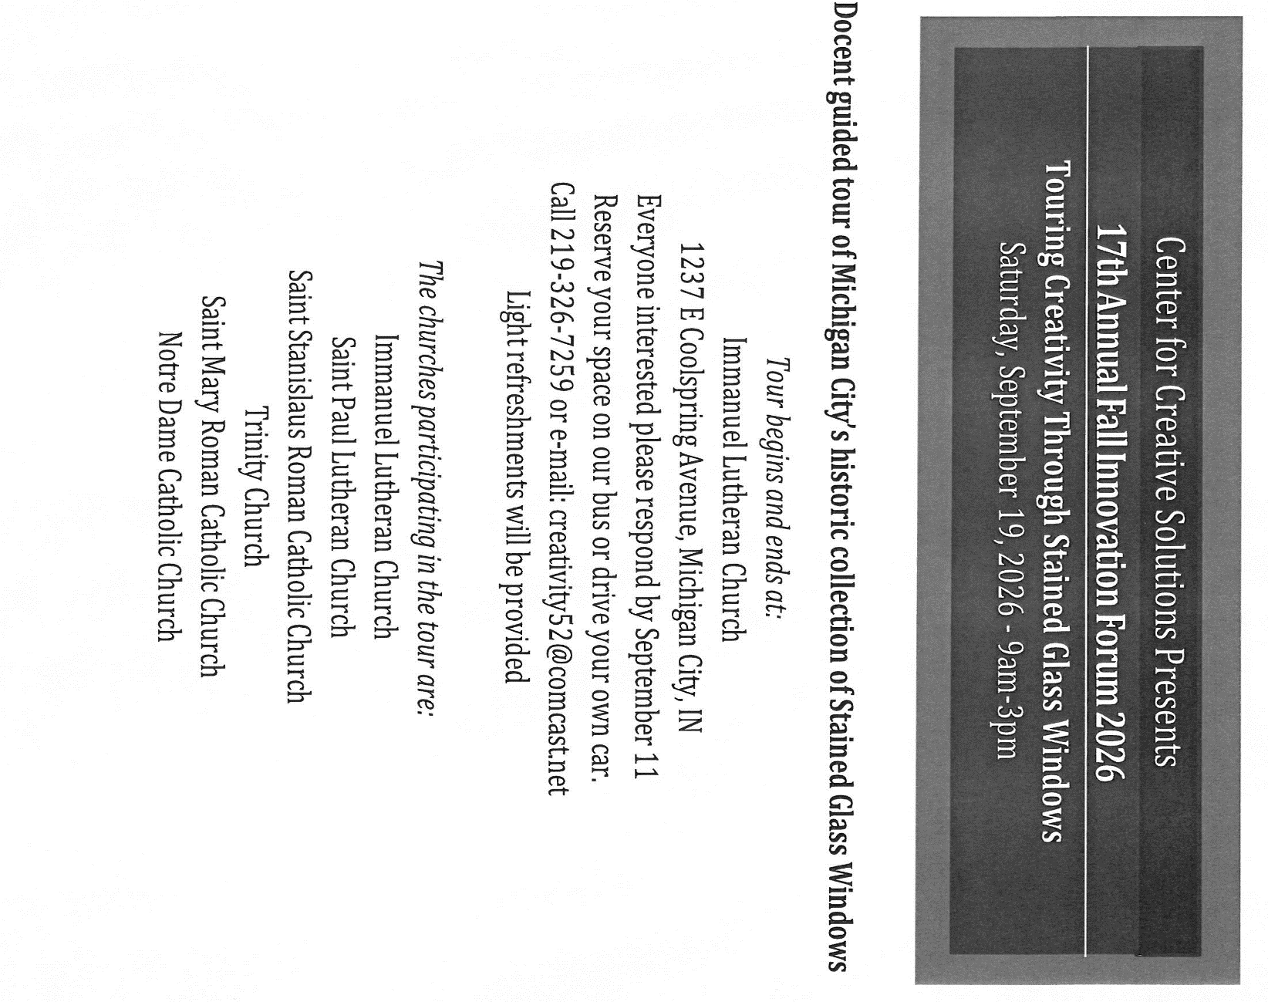

Thank$ for $haring
Thank you to all who participate in our Give-Back opportunities each month. We earned $108 from our GIVE BACK at 5 Guys on July 15, 2026. We’ll be meeting at Holly’s Restaurant & Pub on Tuesday, August 11, 2026 from 11:00—close for our next GIVE BACK. Here are two coupons. One for you and one for a friend.

