THE FESTIVAL OF ST. MICHAEL AND ALL ANGELS
The Eighteenth Sunday after Pentecost
September 27, 2026

Christianity, following Judaism (and followed in turn by Islam), speaks of an order of heavenly messengers, the angels, create by God to do His bidding and differing from humans by having a fully spiritual nature and no physical body. They are mentioned by Jesus as watching over children (Matthew 18: 10) and rejoicing over penitent sinners (Luke 15: 10), and there are numerous references to them in the Scripture. Michael the archangel is mentioned in the books of Daniel (10: 13ff; 12: 1)), Jude (9), and Revelation (12: 7-9), as well as in apocryphal literature. Michael is the only angel assigned a liturgical observance before the ninth century.
The cult of Michael originated in Phrygia, where he was venerated as a healer. Hot springs were dedicated to him in Greece and Asian. Beginning in the fourth century churches were dedicated to him, and his popularity spread to the West. He is said to have made an appearance on Mt. Garganus on the southwest coast of Italy in the fifth or sixth century during an invasion by the Goths. This apparition was traditionally commemorated on May 5.
Michael, whose name is popularly thought to mean, ‘Who is like God?’ is usually shown in art as youthful, strong, and clad in armor. He has been regarded as the helper of Christian armies and protector of individual Christians against the devil, especially at the hour of death.

Philip Pfatteicher
Festivals and Commemorations

Forget the vain pursuit of halo and harp. Enough of those larger than life, militant seraphim who support our propensity for war. Put aside the hierarchical, patriarchal imagery. Angels have something important to teach us about ourselves and God.
Angels remind us that our material world is influenced by the world of the spirit, and that we are intrinsically capable of inhabiting both worlds with equal ease. Humanity may rank a little lower than the angels because we are flesh as well as spirit, yet through Jesus who is God's own Word made flesh, we can rise above the angels to share in the very life of God.
Look closely, and you will see that angels reveal God's secrets, guard and protect the vulnerable, are witness to miracles, are called to unending praise. Today we celebrate not only their achievements, but also that potential in ourselves to be and do the same.

Miriam Therese Winter, SCMM

In the Name of Jesus

INTRODUCTION

Angels visited Abraham at Mamre; the angel Gabriel announced to Mary that she would be the mother of Jesus; a great company of angels sang at Jesus’ birth. Michael the archangel, captain of the heavenly hosts and protector of Christians, is remembered on this day with all the angels of God.
Michael and All Angels

Michael the archangel, captain of the heavenly hosts, is remembered on this day along with the other angels and archangels. The word "angel" means messenger, and in Judaism, Christianity, and Islam, these beings have a fully spiritual nature and no physical body.

GATHERING

PRELUDE

ANNOUNCEMENTS

As you are able please rise

DIALOGUE OF THE ANGELS

P: Bless the Lord, all you multitude of angels.

C: Bless the Lord, O inhabitants of earth.

P: God sends forth His angels for divine service:

C: To serve those who are to inherit salvation.

P: The Lord commands His angels concerning you:

C: To watch and guard you in all your ways.

P: When the Son of Man comes with the clouds:

C: He will order His angels to gather the elect.

P: Then around the throne we shall all gather:

C: And sing with all the heavenly host: “Holy, Holy, Holy, Lord!”

THE PROCESSIONAL HYMN 413 Holy, Holy, Holy

The congregation faces the cross as it enters

THE GREETING AND PRAYER OF THE DAY

P: “Bless the LORD, all you His hosts, you ministers of His who do His will.

C: Bless His holy name!” (Psalm 103: 21)

P: The grace of our Lord Jesus Christ, the love of God, and the communion of the Holy
Spirit be with you all.

C: And also with you.

P: Let us pray. Everlasting God, You have ordained and constituted in a wonderful order
the ministries of angels and mortals. Mercifully grant that, as Your holy angels always
serve and worship You in heaven, so by Your appointment they may help and defend
us here on earth; through Your Son, Jesus Christ our Lord, Who lives and reigns with
You and the Holy Spirit, one God, now and forever.

C: Amen.

The assembly is seated

WORD

FIRST READING Daniel 10: 10-14, 12: 1-3

Daniel trembles in the presence of an angel. That angels tells the prophet about the good and terrible future when the dead will be resurrected and the archangel Michael will usher in the deliverance of the nation.

A hand touched me and roused me to my hands and knees. ¹¹He said to me, “Daniel, greatly beloved, pay attention to the words that I am going to speak to you. Stand on your feet, for I have now been sent to you.” So while he was speaking this word to me, I stood up trembling.
¹²He said to me, “Do not fear, Daniel, for from the first day that you set your mind to gain understanding and to humble yourself before your God, your words have been heard, and I have come because of your words. ¹³But the prince of the kingdom of Persia opposed me twenty-one days. So Michael, one of the chief princes, came to help me, and I left him there with the prince of the kingdom of Persia, ¹⁴and have come to help you understand what is to happen to your people at the end of days. For there is a further vision for those days.
^{12L1}At that time Michael, the great prince, the protector of your people, shall arise. There shall be a time of anguish, such as has never occurred since nations first came into existence. But at that time your people shall be delivered, everyone who is found written in the book.
²Many of those who sleep in the dust of the earth shall awake, some to everlasting life, and some to shame and everlasting contempt. ³Those who are wise shall shine like the brightness of the sky, and those who lead many to righteousness, like the stars forever and ever.”

The Word of the Lord.

Thanks be to God.

THE PSALM: Psalm 103: 1-5, 20-22 Antiphon by Anne Krentz Organ

Choir sings refrain first, followed immediately by the congregation
and as indicated
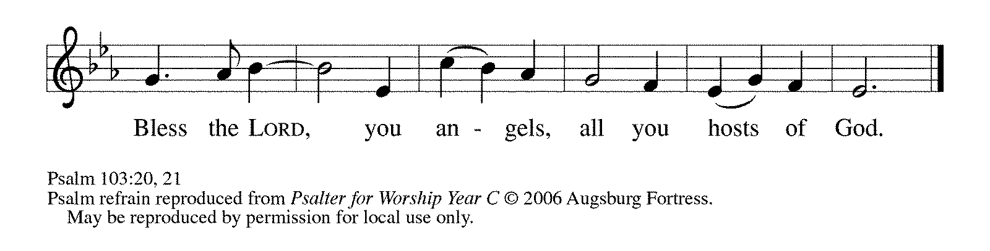
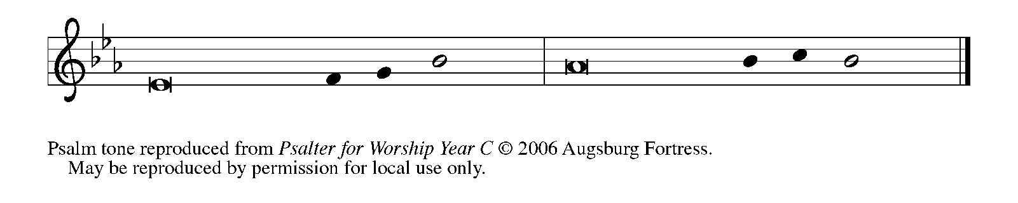

¹Bless the LORD, | O my soul,
and all that is within me, bless God's | holy name.

²Bless the LORD, | O my soul,
and forget not | all God's benefits—

³Who forgives | all your sins
and heals all | your diseases;

⁴Who redeems your life | from the grave
and crowns you with steadfast | love and mercy;

⁵Who satisfies your desires | with good things
so that your youth is renewed | like an eagle's.

²⁰Bless the LORD, you angels, you mighty ones who | do God's bidding,
who obey the voice | of God's word. REFRAIN

²¹Bless the LORD, all you | hosts of God,
you servants who | do God's will.

²²Bless the LORD, all you works of God, in all places | where God rules;
bless the LORD, | O my soul. REFRAIN

SECOND READING Revelation 12: 7-12

Armed with the power of God, Michael and the angels of God fight those armed with the power of evil, the devil and the devil’s angels. The “blood of the Lamb,” our crucified Lord Jesus, gives Michael the power to force the devil from a place in heaven.

War broke out in heaven; Michael and his angels fought against the dragon. The dragon and his angels fought back, ⁸but they were defeated, and there was no longer any place for them in heaven. ⁹The great dragon was thrown down, that ancient serpent, who is called the Devil and Satan, the deceiver of the whole world—he was thrown down to the earth, and his angels were thrown down with him.
¹⁰Then I heard a loud voice in heaven, proclaiming, “Now have come the salvation and the power and the kingdom of our God and the authority of His Messiah, for the accuser of our comrades has been thrown down, who accuses them day and night before our God.
¹¹But they have conquered him by the blood of the Lamb and by the word of their testimony, for they did not cling to life even in the face of death. ¹²Rejoice then, you heavens and those who dwell in them! But woe to the earth and the sea, for the devil has come down to you with great wrath, because he knows that his time is short!

The Word of the Lord.

Thanks be to God.

As you are able please rise

THE VERSE

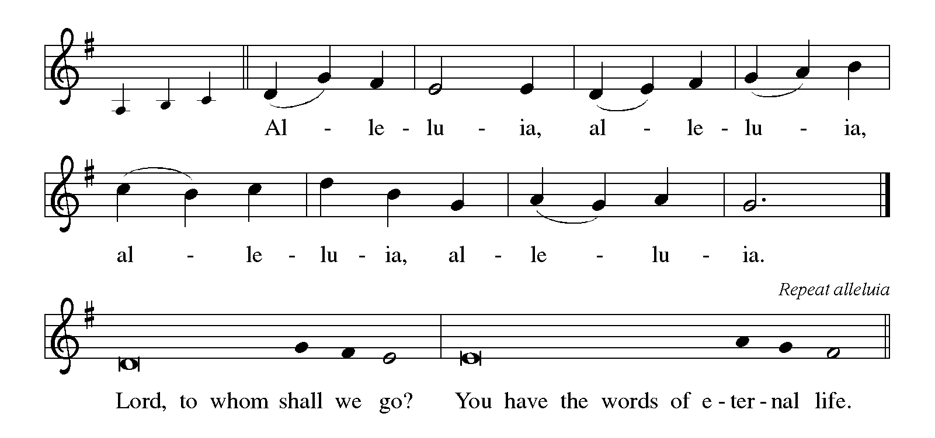

THE HOLY GOSPEL Luke 10: 17-20

The missionary church (“the seventy-two”) is given magnificent power. Greater than this gift of power over the enemy, however, is the gift of salvation: their names are written in heaven.

P: The Holy Gospel according to St. Luke, the tenth chapter.

C: Glory to You, O Lord!

The seventy-two returned with joy, saying, “Lord, in Your name even the demons submit to us!” ¹⁸He said to them, “I watched Satan fall from heaven like a flash of lightening. ¹⁹See, I have given you authority to tread on snakes and scorpions, and over all the power of the enemy; and nothing will hurt you. ²⁰Nevertheless, do not rejoice at this, that the spirits submit to you, but rejoice that your names are written in heaven.”

The Gospel of the Lord.

Praise to You, O Christ!

The assembly is seated

THE SERMON

Silence for reflection follows the sermon

As you are able please rise

THE HYMN OF THE DAY NSB 2 Above All

THE NICENE CREED

A: God has made us His people through our Baptism into Christ. Living together in trust
and hope, we confess our faith.

We believe in one God,
the Father, the Almighty,
Maker of heaven and earth,
of all that is, seen and unseen.

We believe in one Lord, Jesus Christ,
the only Son of God,
eternally begotten of the Father,
God from God, Light from Light,
true God from true God,
begotten, not made,
of one Being with the Father.
Through Him all things were made.
For us and for our salvation
He came down from heaven;
by the power of the Holy Spirit
He became incarnate from the virgin Mary, and was made man.
For our sake He was crucified under Pontius Pilate;
He suffered death and was buried.
On the third day He rose again
in accordance with the Scriptures;
He ascended into heaven
and is seated at the right hand of the Father.
He will come again in glory to judge the living and the dead,
and His kingdom will have no end.

We believe in the Holy Spirit, the Lord, the giver of life,
Who proceeds from the Father and the Son.
With the Father and the Son He is worshiped and glorified.
He has spoken through the prophets.
We believe in one holy catholic and apostolic Church.
We acknowledge one Baptism for the forgiveness of sins.
We look for the resurrection of the dead,
and the life of the world to come. Amen

THE PRAYER OF THE CHURCH

A: Drawing near to the throne of the living God, where countless angels gather in
thunderous praise, let us intercede through Jesus our Mediator for the Church, the
world, and those in any need.
A: Almighty God, we thank You for the wonder of Your creation and the variety of orders
within it. We thank You for Your servants, the angels, whom You send to us on our
behalf. Above all we thank You for Your Son, enthroned above the cherubim, for the
salvation He won by His blood. Gracious God,

C: Hear our prayer.

A: Send holy Michael, the archangel, great defender of the faithful, to be our defender in
times of trouble and temptation. Gracious God,

C: Hear our prayer.

A: Send Your archangel Gabriel, holy bearer of glad tidings, to bring us Your Word and
to help us to understand and do it. Gracious God,

C: Hear our prayer.

A: Send Your archangel Raphael, great healer of Your people, to bring wholeness,
strength, and health to all who suffer diseases and distresses, especially: Linda Barnes;
Martha Schroeder; Mark Tannehill; Jon Samuelson; Dale Thomas; Angela Cook;
Mike Fitzgerald; Jeff Timmrick; Deb Prybylla; and John Ripka. Gracious God,

C: Hear our prayer.

A: Enrich those celebrating anniversaries, especially Jim and Sue Tomscheck that they
may be filled with grace this day and every day and grow in grace in the days ahead.
Gracious God,

C: Hear our prayer.

A: And at the last, send forth Your trumpeting angels to waken us from our sleep and take
us, with all the faithful who have gone before us to Your heavenly Kingdom. Gracious
God,

C: Hear our prayer.

P: Holy God, mighty Lord, King of the universe, in Your goodness and by Your grace,
You show favor to Your people by giving us Your Son, our Lord Jesus Christ, and by
sending Your holy angels to minister to us as they ministered to Him in the wilderness.
For all this, we thank You. Hear our prayers, so that we might praise Your holy name
with one voice with all the host of heaven; through Jesus Christ, our Savior and Lord,
Who lives and reigns with You and the Holy Spirit, one God, forever and ever.

C: Amen!

MEAL

THE PEACE

P: The peace of the Lord be with you always.

C: And also with you.

The assembly is seated

THE OFFERING

THE VOLUNTARY Wondrous Love St. Paul Senor Choir (L. Schackley)

As you are able please rise

THE PRESENTATION OF GIFTS 531 The Trumpets Sound, the Angels Sing
(Stanzas 1, 3)

THE OFFERTORY PRAYER

A: Let us pray. Lord God,

C: By the ministries of Your angels receive our praise and thanksgiving. Accept these
gifts we gratefully offer. May our lives we set before You testify to Your victory
over evil through Your Son, Jesus Christ our Lord. Amen.

THE GREAT THANKSGIVING

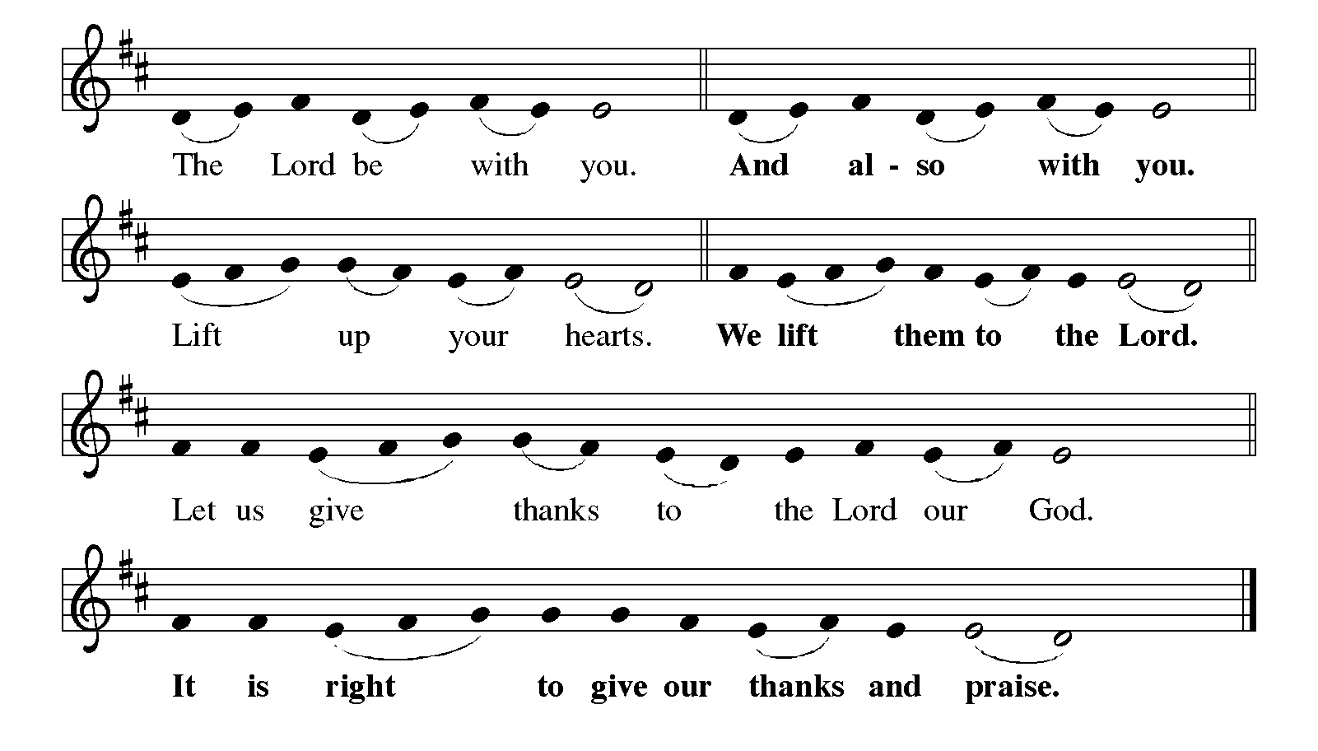

P: It is our duty and delight … and join their unending hymn:

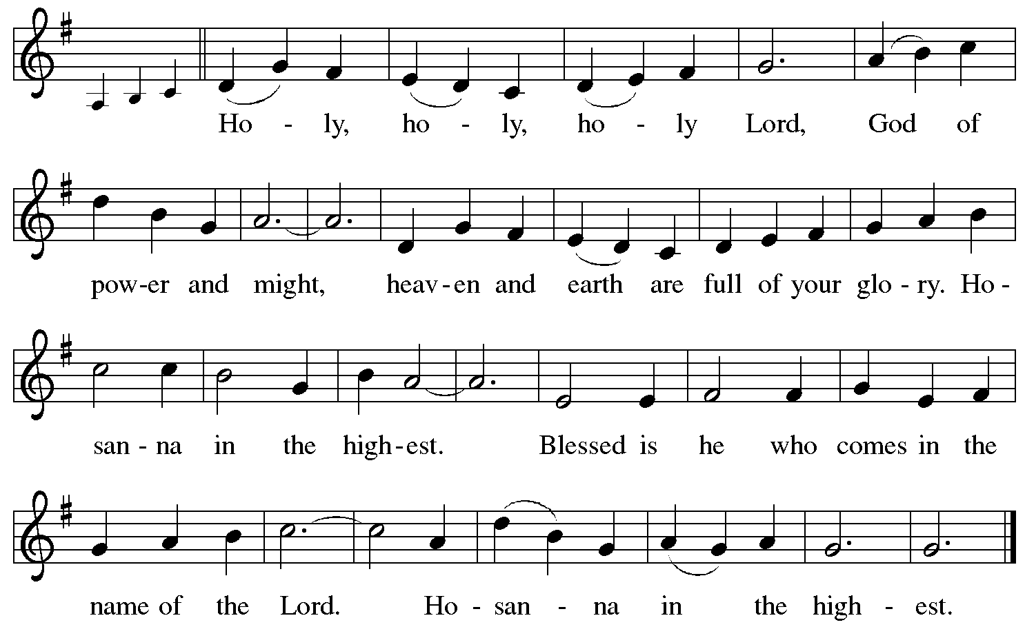

P: Blessed are You, O Lord our God, King of the universe. All creation worships You,
and all creatures, visible and invisible, adore You.
You have set Your throne in the heavens, and You rule over all the earth.
You chose Israel to be Your own, and through judges and prophets, kings and angels
You rescued them from danger and defeat to keep Your covenant alive and
Your promise of blessing true.

At the last in love You sent Your only-begotten Son, Jesus Christ.
By the blood of His cross He has made peace and won for You a holy victory.
In the night … “Do this in remembrance of Me.”
As often as we eat … we proclaim the Lord’s death until He comes.

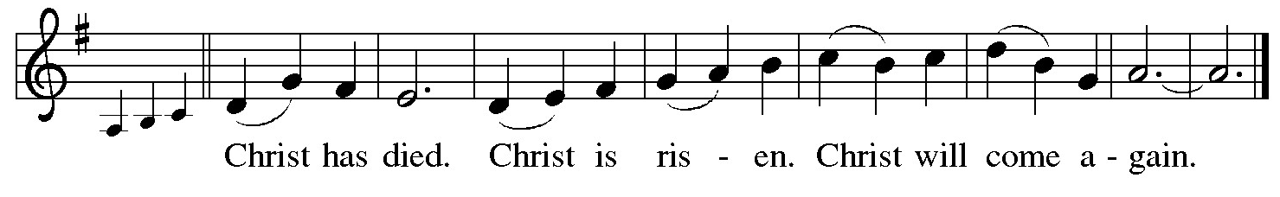
P: With this bread and cup, O God, we remember that by His life, death, and rising the
Lord Jesus crushed evil, sin, and death forever.
He ascended to Your right hand, and promised to return in triumph to share with us
Your final Feast of victory.
Send now Your Holy Spirit on us and these Your gifts of bread and wine, that we and
all who share the Lord’s Body and Blood
May be bold in our testimony that Jesus yet conquers evil, and, supported by the angels,
remain faithful to Christ until He comes in glory.
To You, O God: Father, Son, and Holy Spirit, be all honor and glory, in Your holy
Church, in heaven and on earth, now and forever.
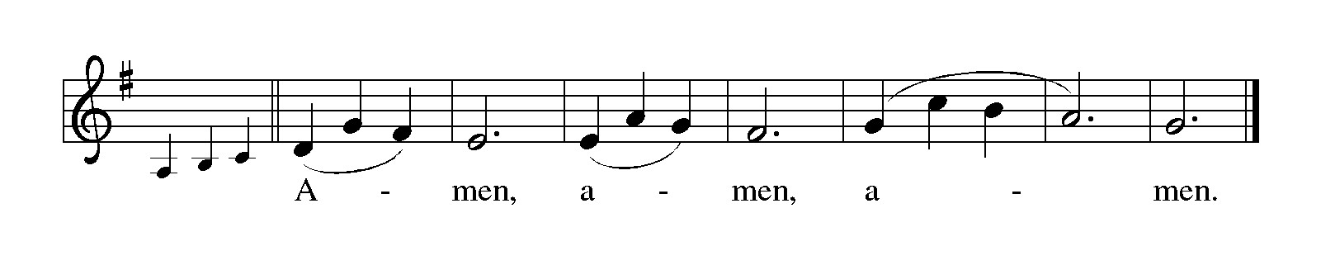
THE LORD’S PRAYER

P: Gathered into one by the Holy Spirit. let pray as Jesus taught us:

C: (Sung) Music is on the front cover of the red hymnal

INVITATION TO THE MEAL

P: This is the Lamb of God Who takes away the sin of the world. Blessed are those who
are called to the Supper of the Lamb. God’s holy gifts for God’s holy people. Come,
for all is now ready.

The assembly is seated

THE DISTRIBUTION Lamb of God

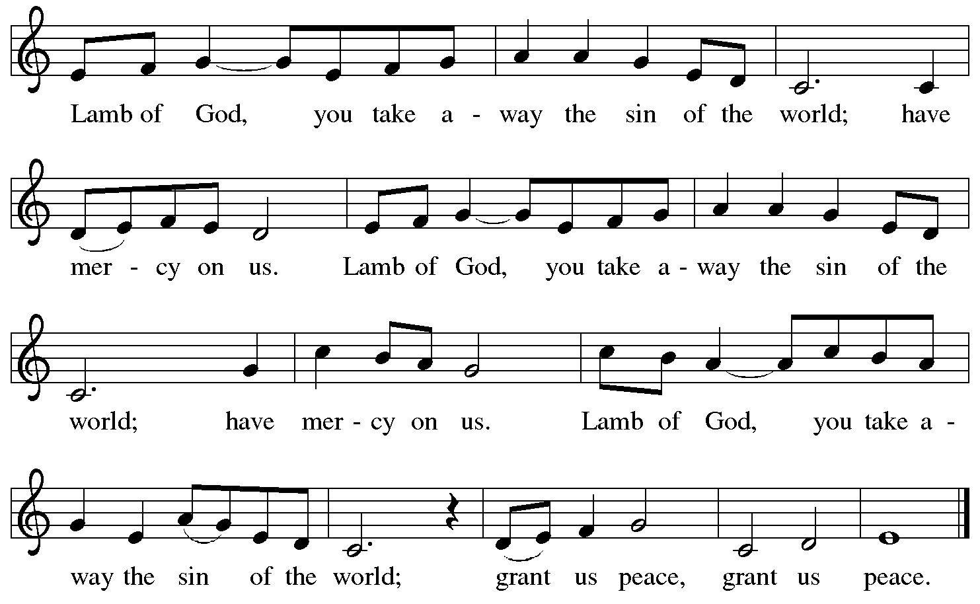

HYMN DURING DISTRIBUTION 864 Praise My Soul, the God of Heaven

NSB 16 Blessed Be Your Name

NSB 67 Nothing But the Blood

NSB 48 I Am the Bread of Life (Talbot)

NSB 50 I Exalt Thee

As you are able please rise

THE POST-COMMUNION BLESSING

P: The Body and Blood of our Lord Jesus Christ strengthen you and keep you in His grace.

C: Amen.

THE POST-COMMUNION PRAYER

A: Let us pray. Almighty God, hear the prayers of those whom You renew with the Bread
of Life. Made strong by the courage it gives, and under the watchful care of the angels,
keep us in fellowship with them until at the last we may attain to Your everlasting
glory. Grant this through Christ our Lord.

C: Amen.

SENDING

THE BENEDICTION

P: May the God of heaven and earth shower His grace and favor upon you.

C: Amen.

P: May He always send His holy angels to minister to you in your times of need.

C: Amen.

P: May you stand with the saints and all the angels of heaven before Christ’s eternal throne.

C: Amen.

P: May almighty God: Father, Son, and Holy Spirit bless you now and forever.

C: Amen.

THE SENDING SONG 538 The Lord Now Sends Us Forth

THE DISMISSAL

A: Go in peace. Remember the poor.

C: Thanks be to God!

POSTLUDE

To God Alone Be Glory

The Introduction to the Day of St. Michael and All Angels is from Festivals and
Commemorations. Philip Pfatteicher. (Minneapolis: Augsburg Publishing House,
1984) 368.

The Meditation is from Sundays and Seasons Online. Copyright 2013 Augsburg Fortress
Publishing.

The Dialog of the Angels and the Prayers are adapted from Thomas Weitzel, Liturgy of the
Angels for St. Michael and All Angels.

ANNOUNCEMENTS

Please remember to mail your offering to the Church Office at 818 Franklin Street, Michigan City, IN 46360. Another alternative is to give on-line through Tithe.ly. Please see your closure letter for information on how to set up a Tithe.ly account.

St. Paul Members are reminded to have a loved one contact the office if you are hospitalized. Many times, the Pastor doesn’t know someone is in the hospital. If you call and leave a message, please tell us at which hospital the patient is located.

ANNIVERSARIES: Jim& Sue Tomsheck (10/4)

PRAYER CONCERNS: Debbie Martin; Mark Tannehill; Kathy Stein; Jan Paholski; Laura Dovey; Bill Hazelgrove; Al Levenhagen; Carl Wipperman; Major Payne.

OFFICE HOURS: Libby will be in the office on Mondays, Wednesdays, and Fridays; volunteers will cover Tuesdays and Thursdays.

Monday & Wednesday 8:00 a.m. – 5 p.m.
Tuesday & Thursday 9:00 a.m. – 12:00 p.m.
Friday 8:00 a.m. – 12:00 p.m.

If you are listening to the worship broadcast on the radio and would like to watch the Sunday morning service live stream follow these steps:

(1) If you have You Tube available on your TV, search for
St. Paul Lutheran Church Michigan City, IN.

(2) The direct link on the computer is https://
www.youtube.com/channel/UC5AIPNaKr3QN50984jGOa1g

(3) This link is also on the main page of the church’s website in
the church section and will continue to be posted weekly on the St.
Paul Facebook page.

And it will always be available on the radio broadcast Sunday mornings at 11:00 a.m.
on WEFM (95.9), and on the local cable access station #99 for the previous week’s
service on Sundays at 4:00 p.m. and the current service on Wednesdays at 7:00 p.m.
and Fridays at 8:30 p.m.

To send e-mail to the church office, please use the following addresses:

Pastor Mark Reshan: seniorpastor@stpaulmichigancity.com

Church Office Secretary (Libby Pollock): churchsecretary@stpaulmichigancity.com

Church Treasurer (Karen Fleming): finance@stpaulmichigancity.com

2026 Church Council:

Pastor - Mark Reshan

President - Donna Knoll

Vice President - Jan Bakken

Secretary - Judy Hunt

Treasurer - Karen Fleming

Members: Sue Koziel; Jim Schraidt; Trish Sprague; Bob Kiser; Barry Anderson; and
Pam Soule

Worship Attendance:

Saturday, September 19, 2026 @ 4:00 p.m. 21

Sunday, September 20, 2026 @ 9:00 a.m. 51

TOTAL 72

Copies of the minutes from the June 25, 2026 and July 23, 2026 Church Council meetings are on the back table in the upper Narthex. They were approved by the council via email.

Good News Newsletter: If you have an article or anything you want included in The Good News please send it to the following e-mail address: splcgoodnews@gmail.com. Pastor Pamela Thiede will be using this e-mail address to assemble The Good News each month. The deadline for getting information to Pastor Pamela will be the 20th of each month.

Next week’s lessons are Isaiah 5: 1-7; Psalm 80: 7-15; Philippians 3: 4b-14;
Matthew 21: 33-46 for those of you who like to study them in advance.

SEPTEMBER 2026 MONTHLY MISSION:

SHRINER’S CHILDREN’S HOSPITAL

We all know Shriner’s from their commercials and their little red hats, but nearly 20,000 children each year get to know Shriner’s Children’s Hospital in Chicago for their incredible pediatric specialty care. The hospital opened in March of 1926 with 60 beds.

60 0% of patients suffered with polio and often lived at the hospital for up to a year. Over the next few decades, an orthopedic residency, bone rodding surgery, halo ring implantation, cleft lip and palate repair, pediatric spinal cord injury surgery, and motion analysis services were added. Our very own little one, Maggie Brooks, has been visiting Shriner’s in Chicago since four weeks old to correct bilateral clubfoot, a condition where she was born with both feet turned inward and upward. Shriner’s offers care to all families no matter their ability to pay or insurance status. They even have financial assistance programs that help reimburse for transportation or lodging if needed.

At Shriner’s Chicago, every child who is inpatient receives a handmade blanket and goody bag upon arrival to the hospital. We will be collecting the following items to help fill their goody bags:

Small cars or toys

Card games

Small activity books

New or gently used children’s books

Please place items in the bin in the outer narthex. If you would like to support Shriner’s financially, please make checks out to St. Paul’s and mark for Shriner’s Children’s Hospital and place in the offering plate. Noisy coin offering will also go towards the mission of the month. Thank you for your generosity!

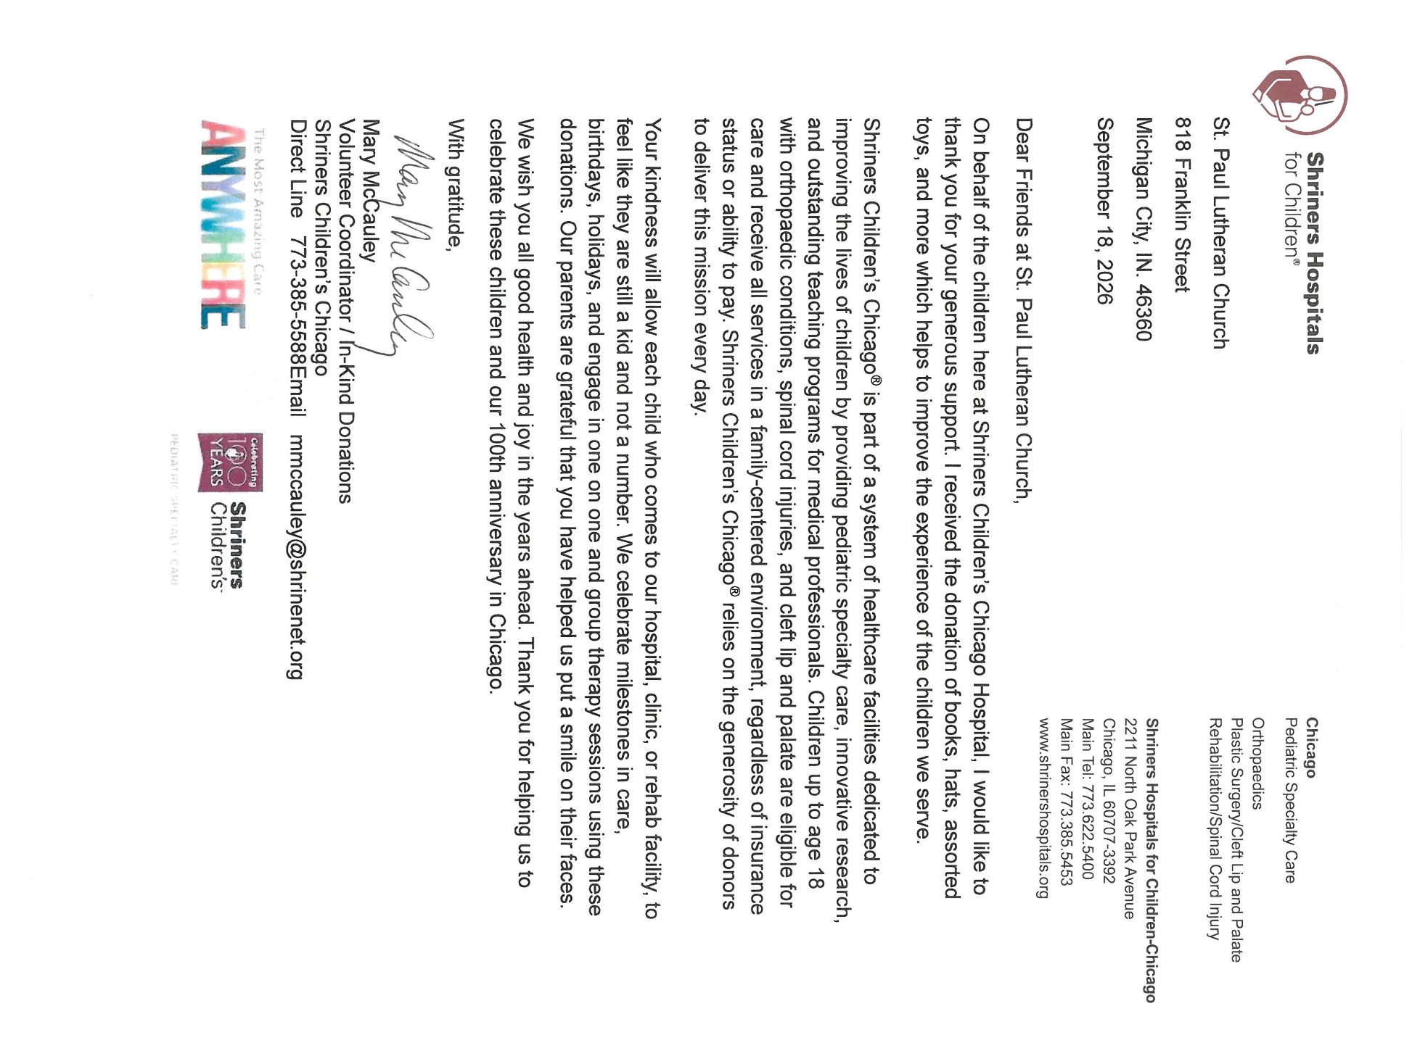

Mission of the Month for October 2026
Our mission for October is collecting care kits for the Woodland Cancer Center. Please grab a bag or two from the bin in the outer narthex and fill with small items that will help bring a smile to someone’s face as they go through cancer treatments. Gender neutral socks, gloves, hats, snacks, chapstick, gum, mints, candy and small journals or activity books are just some examples of items to fill the care kits with. We will also collect monetary donations to go towards their fund that helps people with treatment expenses when needed. Please make checks out to St. Paul and mark for the Woodland Cancer Center and place in the offering. Noisy coin will also support the mission of the month. Thank you for your giving hearts!

Hymn Festival
The third and final celebration to commemorate our congregation’s 150th Anniversary of St. Paul Lutheran Church will take place on Sunday, October 25, 2026 when we celebrate Reformation Day. It will be held at 4:00 p.m. and will be led by Dr. Steven Wente, Professor Emeritus of Organ and Church Music at Concordia University-Chicago. Steve has played for us a number of times, and we have always been uplifted and inspired by his musical gifts.
We will sing hymns celebrating Reformation Day, All Saints and Christ the King. We will have a combined choir of members of the Harbor Country Singers, and those from our own Senior Choir; there will also be a brass quintet, all under the direction of Maggie Martin. It will be a powerful evening of song, Scripture readings, and prayer, followed by a light reception in the St. Paul Room.

Retirement Luncheon for Pastor Reshan

To commemorate Pastor Reshan’s Retirement there will be a Potluck luncheon in the St. Paul Room following the service on Sunday morning, November 1, 2026. There will be no charge for the meal. Chicken from Al’s Supermarket will be provided. Then please bring a dish to pass.
Reservations are required due to seating capacity being limited to 120 persons in our fellowship hall. We will begin to receive reservations on September 27, 2026. Reservation forms will be printed in the bulletins and newsletter, and available in the narthex for people to fill out and place in the offering plate. If you are unable to attend a service in October and would like to reserve a seat for the luncheon, please email the church at: churchsecretary@stpaulmichigancity.com or call the church office at (219) 874-7293 and leave your name, number of seats to reserve, and phone number. Please respond in a timely manner and come enjoy great food and fellowship!

Reservations for Pastor Reshan’s Retirement Luncheon
To commemorate Pastor Reshan’s Retirement there will be a luncheon in the St. Paul Room immediately following the service on Sunday, November 1, 2026. Reservations are required due to seating capacity being limited to 120 persons in our fellowship hall. Reservations will begin to be received on September 27, 2026. There will be no charge for the meal. Chicken from Al’s Supermarket will be provided. Then please bring a dish to pass. This is first come, first served. Once we reach the 120 person limit no more reservations will be accepted.
If you are unable to attend a service in October and would like to reserve a seat for the luncheon, please email the church at churchsecretary@stpaulmicigancity.com or call the church office at (219) 874-7293 with your name, number of seats to reserve, and phone number. Please respond in a timely manner and come enjoy great food and fellowship!
To reserve a seat, please fill out the form below and place in the offering plate during the month of October.

Name: __________________________________________________

Phone number: ___________________________________________

# of seats to reserve: _______________________________________

If you have reserved a seat but are unable to attend, please let the church office know.

ACTIVITIES, EVENTS & MEETINGS
SEPTEMBER 2026

Sunday, September 20, 2026 @ 9:00 a.m. 17th Pentecost Worship Service/Sanctuary with coffee after

Monday, September 21, 2026 @ 2:00 p.m. Finance Comm. Meeting/Luther House

@3:00 p.m. Executive Board Meeting/Luther House

@7:00 p.m. Women’s Bible Study/St. Paul Room

Wednesday, September 23, 2026 @ 9:15 a.m. Bible Study/Luther House

@ 10:00 a.m. God’s Purls

@ 4:30 p.m. Choir Rehearsal/Sanctuary

Thursday, September 24, 2026 @ 3:00 p.m. Church Council Mtg./St. Paul Room

Saturday, September 26, 2026 @ 4:00 p.m. 18th Pentecost Worship Service/Sanctuary

Sunday, September 27, 2026 29:00 a.m. 18th Pentecost Worship Service/Sanctuary with coffee after

Monday, September 28, 2026 @ 7:00 p.m. Women’s Bible Study/St. Paul Room

Wednesday, September 30, 2026 @ 9:15 a.m. Bible Study/Luther House

@ 10:00 a.m. God’s Purls

Thursday, October 1, 2026 FAITH CIRCLE ?

@ 4:00 p.m. –10:00 p.m. GIVE BACK @ GALVESTON STEAK HOUSE

Friday, October 2, 2026 @ 3pm set-up for LWR Kits

Saturday, October 3, 2026 @ 2:30 p.m. Packing LWR Kits

@ 4:00 p.m. 19th Pentecost Worship Service/Sanctuary

PLEASE NOTE:
God’s Purls are still meeting every week on Wednesdays at 10:00 a.m. but they are no longer meeting in the St. Paul Room at the church. If you have any questions or concerns please contact Judy Mutchler at (219) 229-4764.

Thank$ for $haring
Thank you to all who participate in our Give-Back opportunities each month. We earned $155 from our GIVE BACK at Holly’s on August 11, 2026. And at our GIVE BACK at Swingbelly’s on Wednesday, September 9, 2026 we earned? Our next GIVE BACK will be at Galveston Steakhouse on Thursday, October 1, 2026 from 4pm—10 pm. Here are two coupons. One for you and one for a friend.

