**THE TWENTY-SIXTH SUNDAY AFTER PENTECOST**

**November 17, 2024**

In that hour when darkness like a cloak shall be spread over all things, may Your grace, O Lord, shine on us in the place of the earthly sun.

On that day when all people are called to earthly burial, make us worthy, O Lord, to rejoice in heavenly rest.

In that day when all darkness shall cease, and all are freed from weariness, grant, O Lord, that we may take our light in the joys of the life to come.

**Ephraem, Second century**

**Sermon 13**

“…In a nutshell, apocalyptic literature (of which this chapter in Mark is an example) stems from a worldview that believes that everything happening on earth represents and correlates with a larger, heavenly struggle between good and evil. It therefore reads into earthly events cosmic significance and anticipates future events on earth in light of the coming battle between the forces of God and the devil. Hence, it often tries to make sense of current events and experiences by casting them in a larger, cosmic framework and in this way give comfort to people who are currently suffering or being oppressed.

Because of this dualism, and because apocalyptic literature tends to be highly symbolic, it’s ripe for reading all kinds of things into it – like predictions about the end of the world! But this chapter in Mark – and other passages, notably the book of Revelation – were not written so that we could ferret out signs of the end. Rather, they were written to offer comfort to first-century believes struggling to make sense of their world and lives. For this reason, it’s way more helpful to read this and similar passages in light of the challenges its original readers were facing, challenges that might be akin to some of our own.

From this passage and those to come in this chapter, for instance, we can gather that Mark’s community was not only struggling with the disruptions the fall of the Jerusalem Temple introduced into first-century Judaism and Christianity, but also that they had been harassed by some people claiming to be Jesus or some other messianic figure returned. Mark’s people were literally caught up in “wars and rumors of war” and probably found comfort in the belief that Jesus had already anticipated this and was offering words of encouragement to them through this Gospel.

When it comes to our own day and age, that kind of encouragement is still valuable, for though our wars may be different, yet we are still harassed at times by a fear that the world is falling apart. To twenty-first century believers, just as to first century disciples, Jesus says the same “do not fear.””

**David Lose**

**✠ In the Name of Jesus ✠**

**INTRODUCTION**

November begins with All Saints Day and ends in or near Advent, when we anticipate Christ's coming again. So the readings today tell of the final resurrection and the end time. In the turmoil of hope, fear, and disbelief that these predictions provoke in us, Hebrews sounds a note of confident trust. Christ makes a way for us where there is no way, and we walk it confidently, our hearts and bodies washed in baptismal water, trusting the one who has promised. The more we see the last day approaching, the more important it is to meet together to provoke one another to love.

**Elizabeth of Hungary, renewer of society, died 1231**

*Born in Hungary, Elizabeth was betrothed to the son of the Landgrave of Thuringia, and at age four was taken to be raised with him at the Wartburg Castle. Ten years later they were married. She was very generous to the poor, and after her husband's death she lived in cruel hardship until her own death at age twenty-four.*

**✠ GATHERING ✠**

**PRE-SERVICE MUSIC I’ll Fly Away Medley New Song Praise Band**

**(All Public Domain)**

**ANNOUNCEMENTS**

As you are able please rise

**CONFESSION AND ABSOLUTION**

P: In the name of the Father and of **✠**  the Son and of the Holy Spirit.

**C: Amen.**

P: “Therefore, my friends, since we have confidence to enter the sanctuary by the blood of Jesus

... and since we have a great high priest over the house of God, let us approach with a true heart

in the full assurance of faith, with our hearts sprinkled clean from an evil conscience and our

bodies washed with pure water.” (Hebrews 10:19, 21) With hearts full of faith and hope, let

us confess our sins.

*Silence for self-examination and reflection is kept*

P: Most merciful God,

**C: We confess that we have sinned against You in thought, word, and deed. Because of**

**hardship and suffering, we have wavered in our hope (Hebrews 10:23). We have believed**

**You to be unfaithful to Your promises (10:23). We have neglected to provoke one another**

**to love and good deeds. We have not encouraged each other to faith and love (10:24).**

**For these and all our sins, known and unknown, O God, we beg Your forgiveness. For**

**the sake of Your Son, Jesus Christ, make us new in Your grace, that we may be made**

**strong in love and service.**

P: “You will show me the path of life, (O God); in Your presence there is fullness of joy ...”

(Psalm 16:11) God’s joy is yours today, for “He Who has promised is faithful.” And God’s

promise is this: as a called and ordained minister of the Church of Christ, and by His authority,

I therefore declare to you the entire forgiveness of all your sins, in the name of the Father and

of **✠** the Son and of the Holy Spirit.

**C: Amen.**

**GATHERING SONG ACS 951 *Deep River*  see p. 3**

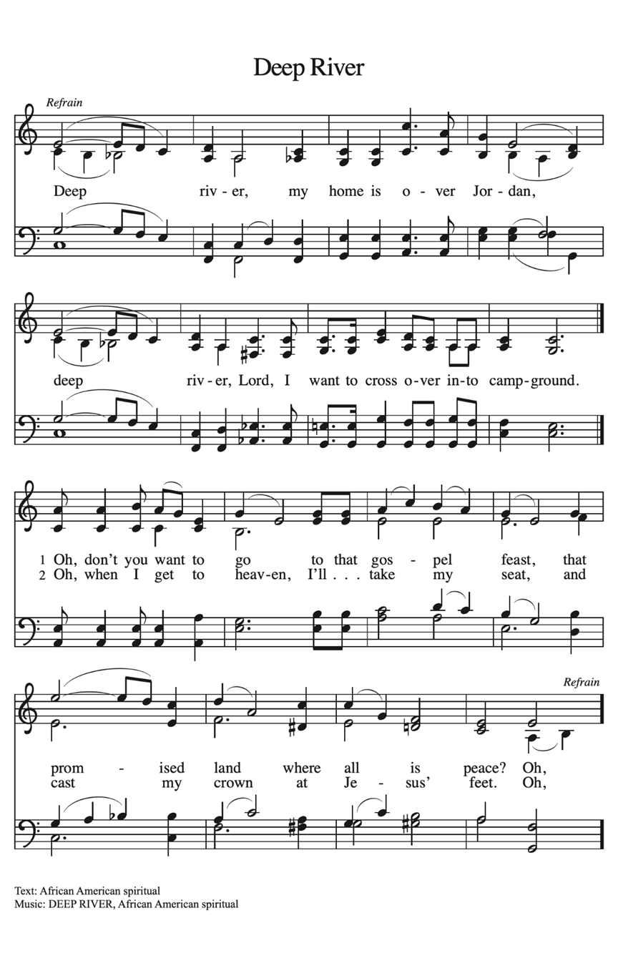

**THE GREETING AND PRAYER OF THE DAY**

P: God is Alpha and Omega, the First and the Last,

**C: The One Who is, and Who was, and Who is to come.**

P: The grace of our Lord Jesus Christ, the love of God, and the communion of the Holy Spirit be

with you all.

**C: And also with you.**

P: Let us pray. Almighty God, Your sovereign purpose brings salvation to birth. Give us faith to

be steadfast amid the tumults of this world, trusting that Your Kingdom comes and Your will

is done through Your Son, Jesus Christ, our Savior and Lord.

**C: Amen.**

*The assembly is seated*

**✠ WORD ✠**

**FIRST READING Daniel 12: 1-3**

*The book of Daniel represents a kind of literature called "apocalyptic," which is full of bizarre visions, strange symbolism, and supernatural happenings. Arising during times of great persecution, apocalyptic literature employs a vivid language that prevents outsiders to the faith from understanding its content. Overall, it is concerned with God's revelation about the end-time and the coming kingdom of God, when God will vindicate the righteous who have been persecuted.*

"At that time Michael, the great prince, the protector of your people, shall arise. There shall be a time of anguish, such as has never occurred since nations first came into existence. But at that time your people shall be delivered, everyone who is found written in the book. 2Many of those who sleep in the dust of the earth shall awake, some to everlasting life, and some to shame and everlasting contempt.

3Those who are wise shall shine like the brightness of the sky, and those who lead many to righteousness, like the stars forever and ever."

The Word of the Lord.

**Thanks be to God.**

**THE PSALM: Psalm 16** Antiphon by William Beckstrand

Choir sings refrain first, followed immediately by the congregation

and as indicated

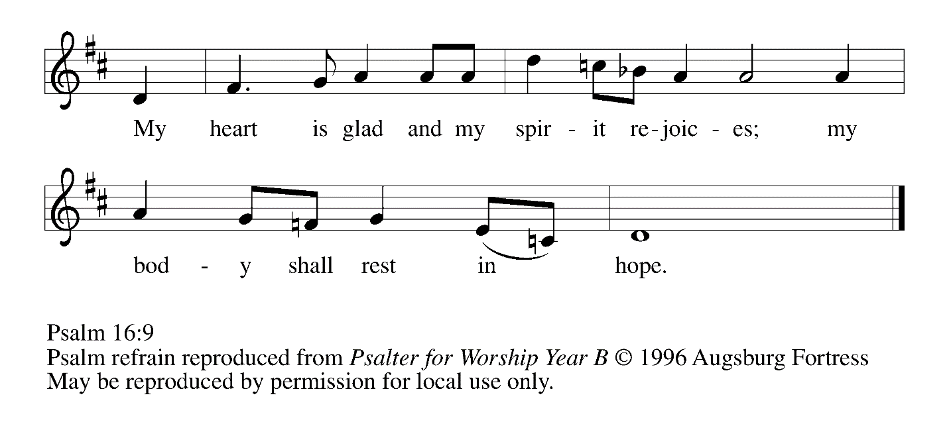

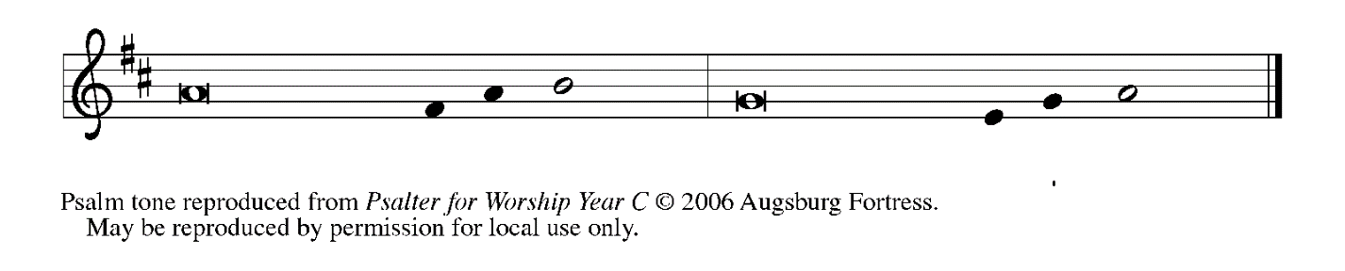

1Protect me, O God, for I take ref- | uge in You;*

I have said to the LORD, "You are my Lord, my good a- | bove all other."

**2All my delight is in the godly that are | in the land,\***

**upon those who are noble a- | mong the people.**

3But those who run after | other gods*

shall have their troubles | multiplied.

**4I will not pour out drink offering | to such gods,\***

**never take their names up- | on my lips. REFRAIN**

5O LORD, You are my portion | and my cup;*

it is You who up- | hold my lot.

**6My boundaries enclose a | pleasant land;\***

**indeed, I have a | rich heritage.**

7I will bless the LORD Who | gives me counsel;*

my heart teaches me, night | after night.

**8I have set the LORD al- | ways before me;\***

**because God is at my right hand I shall| not be shaken. REFRAIN**

9My heart, therefore, is glad, and my spir- | it rejoices;*

my body also shall | rest in hope.

**10For you will not abandon me | to the grave,\***

**nor let Your holy one | see the pit.**

11You will show me the | path of life;*

in Your presence there is fullness of joy,

and in Your right hand are pleasures for- | evermore. **REFRAIN**

**SECOND READING Hebrews 10: 11-25**

*The letter to the Hebrews presents an extended discussion of how Christ offered himself as a sacrifice so that sinners, cleansed by his blood, might have life. Therefore, the writer concludes, our life together should be marked by confidence, assurance, hope, and encouragement.*

11Every priest stands day after day at his service, offering again and again the same sacrifices that can never take away sins. 12But when Christ had offered for all time a single sacrifice for sins, "He sat down at the right hand of God," 13and since then has been waiting "until His enemies would be made a footstool for His feet." 14For by a single offering He has perfected for all time those who are sanctified.

15And the Holy Spirit also testifies to us, for after saying,

16"This is the covenant that I will make with them

after those days, says the Lord:

I will put my laws in their hearts,

and I will write them on their minds,"

17He also adds,

"I will remember their sins and their lawless deeds no more."

18Where there is forgiveness of these, there is no longer any offering for sin.

19Therefore, my friends, since we have confidence to enter the sanctuary by the blood of Jesus, 20by the new and living way that He opened for us through the curtain (that is, through His flesh), 21and since we have a great priest over the house of God, 22let us approach with a true heart in full assurance of faith, with our hearts sprinkled clean from an evil conscience and our bodies washed with pure water.

23Let us hold fast to the confession of our hope without wavering, for He Who has promised is faithful. 24And let us consider how to provoke one another to love and good deeds, 25not neglecting to meet together, as is the habit of some, but encouraging one another, and all the more as you see the Day approaching.

The Word of the Lord.

**Thanks be to God.**

*As you are able please rise*

**THE VERSE (see p. 5)**

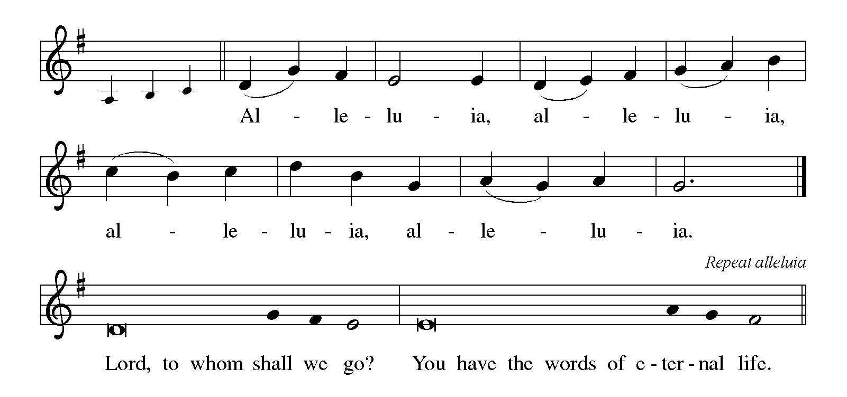

**THE HOLY GOSPEL Mark 13: 1-8**

*In the last week of His life, Jesus warned the disciples concerning trials that were to come upon them and upon the world. He exhorts the listener: Do not be alarmed.*

P: The Holy Gospel according to St. Mark, the thirteenth chapter.

**C: Glory to You, O Lord!**

1As Jesus came out of the temple, one of His disciples said to him, "Look, Teacher, what large stones and what large buildings!" 2Then Jesus asked him, "Do you see these great buildings? Not one stone will be left here upon another; all will be thrown down."

3When He was sitting on the Mount of Olives opposite the temple, Peter, James, John, and Andrew asked Him privately, 4"Tell us, when will this be, and what will be the sign that all these things are about to be accomplished?"

5Then Jesus began to say to them, "Beware that no one leads you astray. 6Many will come in My name and say, 'I am he!' and they will lead many astray. 7When you hear of wars and rumors of wars, do not be alarmed; this must take place, but the end is still to come. 8For nation will rise against nation, and kingdom against kingdom; there will be earthquakes in various places; there will be famines. This is but the beginning of the birth pangs."

P: The Gospel of the Lord.

**C: Praise to You, O Christ!**

*The assembly is seated*

**THE SERMON** *Silence for reflection follows the sermon*

*As you are able please rise*

**THE HYMN OF THE DAY 327 *Through the Night of Doubt and Sorrow***

Stanza 2—Women; Stanza 3--Men

**THE APOSTLES' CREED**

A: God has made us His people through our Baptism into Christ. Living together in trust and

hope, we confess our faith.

**C: I believe in God, the Father almighty,**

**creator of heaven and earth.**

**I believe in Jesus Christ, His only Son, our Lord.**

**He was conceived by the power of the Holy Spirit**

**and born of the virgin Mary.**

**He suffered under Pontius Pilate**

**was crucified, died, and was buried.**

**He descended into hell.**

**On the third day He rose again.**

**He ascended into heaven,**

**and is seated at the right hand of the Father.**

**He will come again to judge the living and the dead.**

**I believe in the Holy Spirit,**

**the holy catholic Church,**

**the communion of saints,**

**the forgiveness of sins,**

**the resurrection of the body,**

**and the life everlasting. Amen.**

**THE PRAYER OF THE CHURCH**

A: As creation moves toward fulfillment, let us pray through Jesus, the Son of Man, Who is

coming with great power and glory.

A: That the Church may faithfully share the wisdom handed on to it by God and lead many to

faith and trust in the Lord as the Day of the Lord draws near, we pray, O God:

**C: Let Your Kingdom come.**

A: That nations and peoples engulfed in conflict and war, especially in Ukraine, Israel, Gaza,

Lebanon, Sudan, and Haiti may find the path to peace, we pray, O God:

**C: Let Your Kingdom come.**

A: That in the midst of natural disasters, violence, and social upheaval, the people of God will

remain faithful in word and deed to Christ and generously serve all in need, we pray, O God:

**C: Let Your Kingdom come.**

A: That this congregation may be stirred by the Spirit to ever deeper acts of compassion and

charity to those who in their need seek the presence of the Lord, we pray, O God:

**C: Let Your Kingdom come.**

A: That those who suffer from despair, guilt, grief, hunger, homelessness, and sickness, especially:

**Martha Schroeder; Venia Wendt; Ken Mulder; Janet Green; Jess Kalvaitis; Joyce Stark;**

**Kathy Stein; Russ Fischer; and Mark Tannehill** may find hope in Christ’s words and help

from His disciples, we pray, O God:

**C: Let Your Kingdom come.**

A: That those celebrating birthdays, especially **JoAnne Sydow;** and anniversaries, especially

**Bob and Karen Kiser** may be filled with grace this day and every day and grow in grace in

the days ahead, we pray, O God:

**C: Let Your Kingdom come.**

A: That with the saints at rest in Christ, especially **Elizabeth of Hungary, renewer of society**

whom we commemorate this Day we too may awake to everlasting life and shine like the stars

for all eternity, we pray, O God:

**C: Let Your Kingdom come.**

P: Loving God, You know our hopes and fears even before we speak them; hear the prayers of

Your people. Help us in our struggle to stay alert that we may be ready for the hour of Your

coming. We ask this through Christ our Lord.

**C: Amen.**

**✠ MEAL ✠**

**THE PEACE**

P: The peace of the Lord be with you always.

**C: And also with you.**

*The assembly is seated*

**THE OFFERING**

**THE VOLUNTARY *Fear Not, I Am With You* St. Paul Senior Choir**

(L. Larson)

*As you are able please rise*

**THE PRESENTATION OF THE GIFTS**



**THE OFFERTORY PRAYER**

A: Let us pray. Gracious God,

**C: In this Eucharist we renew the covenant of our Baptism. Help us, through the offering**

**of ourselves to turn from all things that draw us from Your love that we may be alert and**

**watchful for Your return in glory. We ask this in the name of Jesus the Lord. Amen.**

**THE GREAT THANKSGIVING**

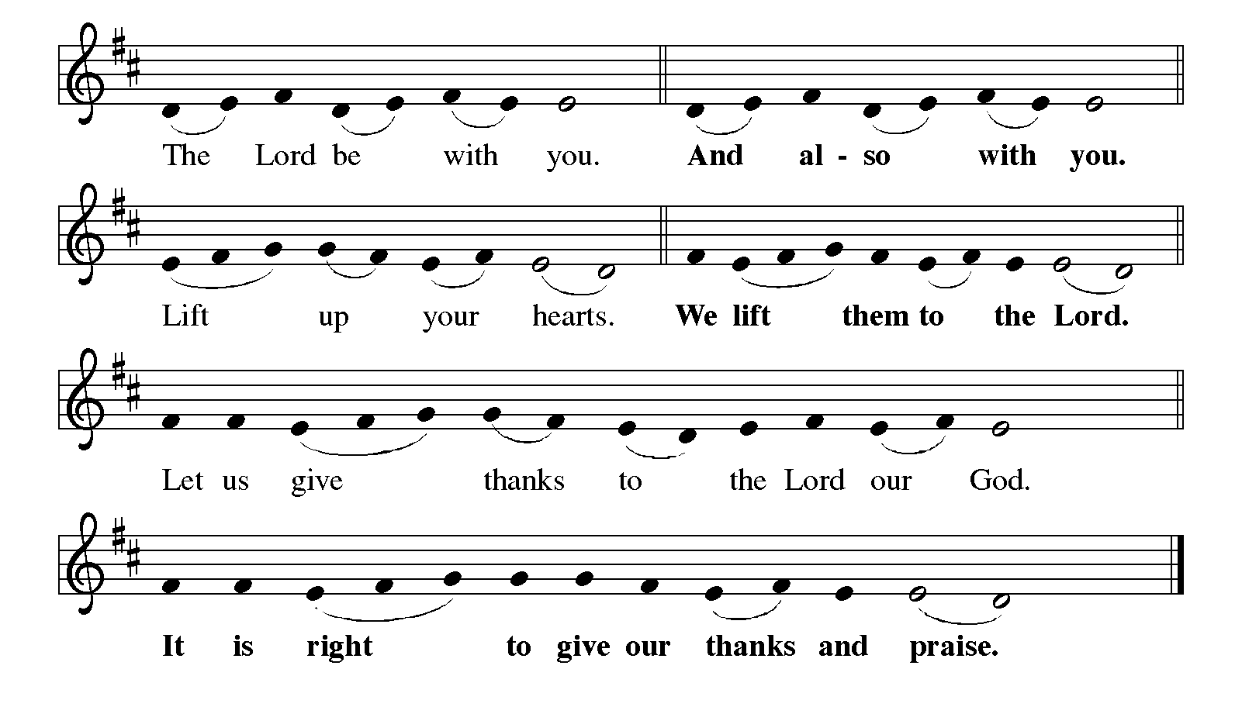

P: It is our duty and delight … and join their unending hymn:

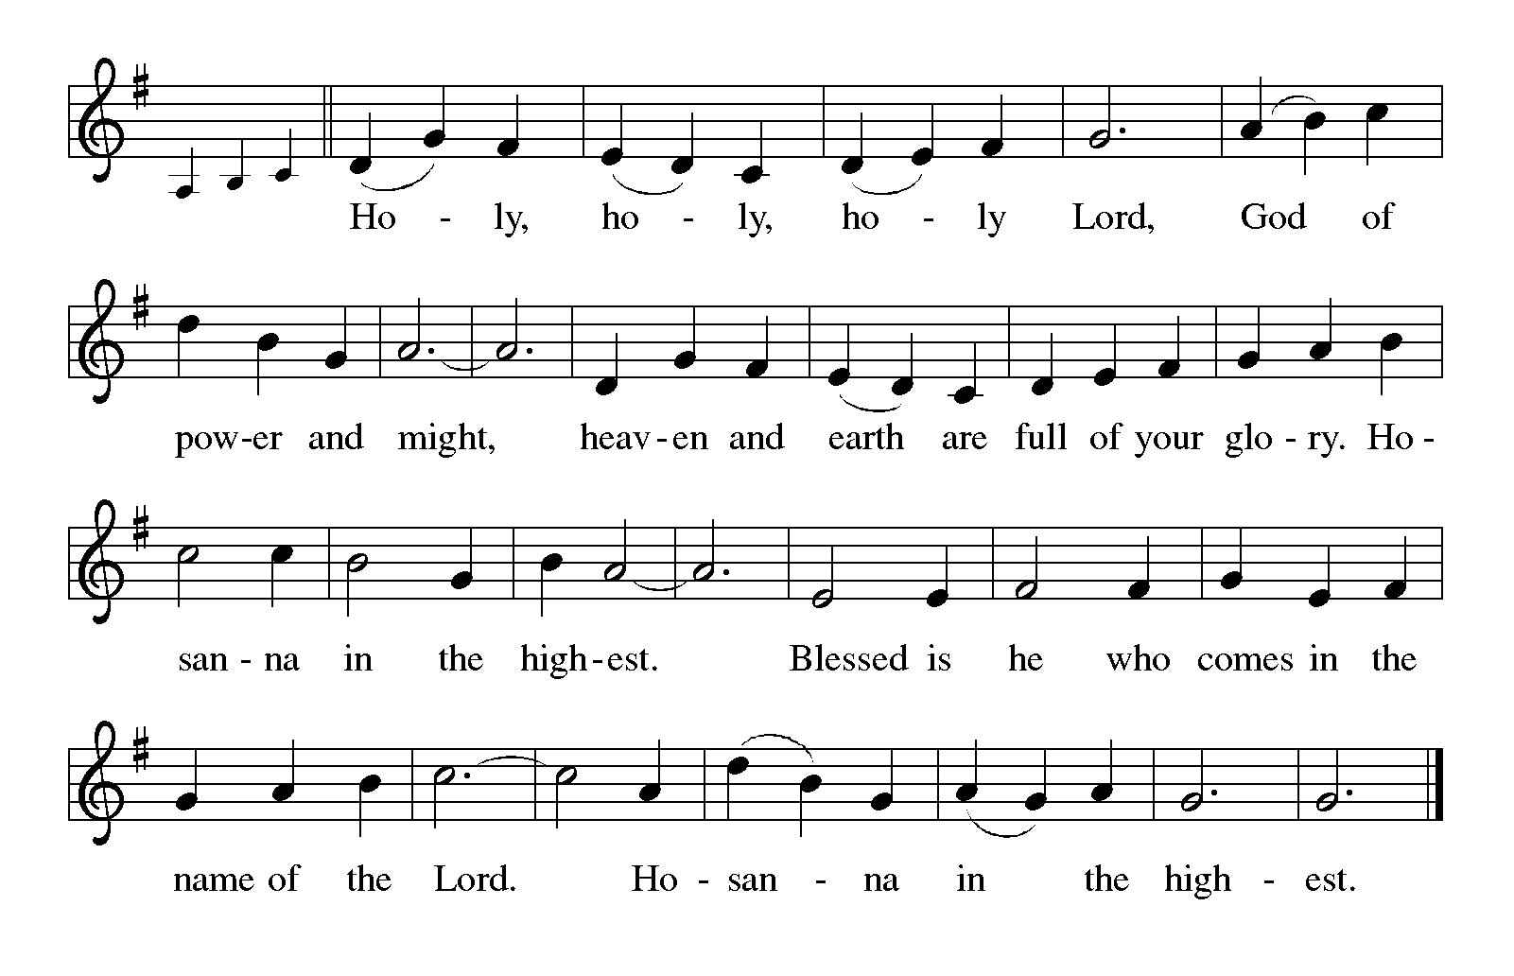

P: Faithful and abiding God, we give You thanks and praise, for from the foundation of the

world You sought to bring us into covenant relationship with You.

You created us to enjoy You and one another, You called Abraham to lead a family in

Your ways, and through Moses You liberated Your people to be Your companions

forever.

After those days You promised to put Your laws into our hearts and write them in our

minds, and to remember our sins no more.

In Jesus our great High Priest You opened a new and living way into Your presence to

share eternal communion with You.

Inviting God, You bring us to Your Table, meeting true hearts that yearn to come before

You with full assurance of faith.

Give us a double portion of Your Spirit that we may glow with the radiance of Your glory.

Through the power of that same Spirit bless this bread and cup, that they may be for

us the Body and Blood of Your Son Jesus,

Who, in the night … “Do this for the remembrance of Me.”

As often as we eat … we proclaim the Lord’s death until He comes.

**C: Christ has died. Christ is risen. Christ will come again.**

P: Completing and perfecting God, in Your Son’s cross You took on the grief and failure of

the world, and in His resurrection You dismantled the power of sin and death.

Look with mercy on all Your people whose longings are unmet.

When Your children plead for the chance to be creative, productive, or nurturing, give

them gentleness, fulfillment, and purpose.

When Your people long to bring joy into the life of others, comfort to the afflicted, or trust

to the wounded, give them courage, wisdom, and patience.

When Your Kingdom seems far off, strengthen Your Church to wait with faith and hope

and love, until the Day when You are all in all,

One God: Father, Son, **✠** and Holy Spirit.

**C: Amen!**

**THE LORD'S PRAYER**

P: With longing for the coming of God’s Kingdom, let us pray as Jesus taught us:

**C: Our Father in heaven, hallowed be Your name. Your Kingdom come. Your will be done**

**on earth as in heaven. Give us this day our daily bread, and forgive us our sins as we**

**forgive those who sin against us. Save us from the time of trial and deliver us from evil,**

**for the Kingdom, the power, and the glory are Yours, now and forever. Amen.**

**INVITATION TO THE MEAL**

P: This is the Lamb of God Who takes away the sin of the world. Blessed are those who are called

to the Supper of the Lamb. God's holy gifts for God's holy people. Come, for all is now ready.

*The assembly is seated*

**THE DISTRIBUTION**

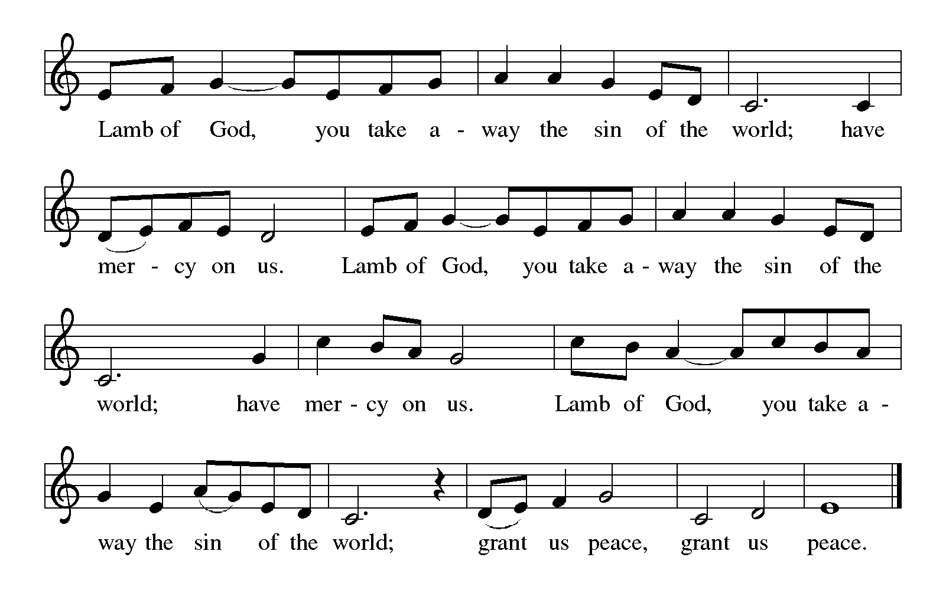

**HYMN DURING DISTRIBUTION 438 *My Lord, What a Morning***

**NSB 10 *Beautiful Savior***

**NSB 48 *I Am the Bread of Life***

**ELW 496 *One Bread, One Body***

*As you are able please rise*

**THE POST-COMMUNION BLESSING**

P: The Body and Blood of our Lord Jesus Christ strengthen you and keep you in His grace.

**C: Amen.**

**THE POST-COMMUNION PRAYER**

A: Let us pray. Lord God, in this holy Sacrament You have again refreshed us in Your new

covenant. Through this eating and drinking keep us strong in faith and hope until the Day

when You make the whole creation new. Grant this through Christ our Lord.

**C: Amen.**

**✠ SENDING ✠**

**THE BENEDICTION**

P: Almighty God: Father, Son, **✠** and Holy Spirit bless you now and forever.

**C: Amen.**

**SENDING SONG ELW 661 *I Love to Tell the Story***

**THE DISMISSAL**

A: Go in peace to bear Christ's love to the world.

**C: Thanks be to God!**

**POSTLUDE**

**✠ *To God Alone Be Glory* ✠**

The Meditation, Greeting, Prayer of the Church, and Dismissal are adapted from *Sundays and*

*Seasons.* Copyright Augsburg Fortress, 1999.

The Eucharistic Prayer is adapted from *Eucharistic Prayers.* Samuel Wells and Abigail Kocher.

(Grand Rapids: Eerdmann’s Publishing Company, 2016) 326-27.

**ANNOUNCEMENTS**

**Please remember to mail your offering to the Church Office** at 818 Franklin Street, Michigan City, IN 46360**.** Another alternative is to give on-line through Tithe.ly. Please see your closure letter for information on how to set up a Tithe.ly account.

**St. Paul Members are reminded to have** a loved one contact the office if you are hospitalized. Many times, the Pastor doesn’t know someone is in the hospital. If you call and leave a message, please tell us which hospital the patient is at.

**Birthdays: JoAnne Sydow (11/23)**

**Anniversaries: Bob & Karen Kiser (11/23)**

**PRAYER CONCERNS:** Jeanie Boatman Shepple, Joan Seifert, Nolan Wilson, Debbie Martin, Mark Tannehill, Brian Wiseman, Kathy Stein, Danielle Schnell; Venia Wendt, Jan Paholski, Laura Dovey, Nancy Hoover, Grace Romine and Janet Green.

**OFFICE HOURS:** Libby will be in the office on Mondays, Wednesdays,

and Fridays; volunteers will cover Tuesdays and Thursdays.

Monday & Wednesday 8:00 a.m. – 5 p.m.

Tuesday & Thursday 9:00 a.m. – 12:00 p.m.

Friday 8:00 a.m. – 12:00 p.m.

**If you are listening to the worship broadcast on the radio and would like to watch the Sunday morning service live stream follow these steps:**

(1) If you have You Tube available on your TV, search for

**St. Paul Lutheran Church Michigan City, IN.**

(2) The direct link on the computer is

https://www.youtube.com/channel/UC5AIPNaKr3QN50984jGOa1g.

   (3) This link is also on the main page of the church’s website in

the church section and will continue to be posted weekly on the St.

Paul Facebook page.

And it will always be available on the radio broadcast Sunday mornings at 11:00 a.m.

on WEFM (95.9), and on the local cable access station #99 for the previous week’s

service on Sundays at 4:00 p.m. and the current service on Wednesdays at 7:00 p.m.

And Fridays at 8:30 p.m.

**Next Sunday’s lessons are Daniel 7: 9-10, 13-14; Psalm 93; Revelation 1: 4b—8 and John 18: 33-37** for those of you who like to study them in advance.

**To send e-mail to the church office**, please use the following addresses:

Pastor Mark Reshan: seniorpastor@stpaulmichigancity.com

Church Office Secretary (Libby Pollock): churchsecretary@stpaulmichigancity.com

Church Treasurer (Karen Fleming): finance@stpaulmichigancity.com

**The Good News Newsletter**: If you have an article or anything you want included

in **The Good News** please send it to the following e-mail address: splcgoodnews@gmail.com. Pastor Pamela Thiede will be using this e-mail address to assemble **The Good News** each month. The deadline for getting information to Pastor Pamela will be the 20th of each month.

**Worship Attendance:**

**Saturday, November 9, 2024 @ 4:00 p.m. 23**

**Sunday, November 10, 2024 @ 9:00 a.m. 64**

**TOTAL 87**

**Copies of the minutes from the September 26, 2024 Church Council meeting and from the October 24, 2024 Church Council meeting are on the back table in the upper Narthex. They were approved by the council via email.**

**NOVEMBER MONTHLY MISSION: Guardians of the Children of Michiana**

**Guardians of the Children of Michiana** is a non-profit organization dedicated to protecting the victims of child abuse. The Guardians go to court with abused children, any types of abuse, to provide support to the child and their family. They hold monthly events for the kids to keep their mind off of the courts and pain or traumas they’ve faced, including taking them to do fun things like bowling, swimming, horseback riding, skating, etc. They also have holiday parties and, this year, will be providing for 21 children at Christmas. We will be collecting monetary donations that they can use to purchase specific gifts for each child and to fund their holiday party. Please place your donations in the offering plate marked for Guardians of the children. Noisy coin offering will also go toward the mission of the month. Thanks for your support!

**TODAY,** after the service, come to the St. Paul Room all of you who have birthdays during the months of September, October, and November. We will celebrate your day of birth with coffee and cake and joyous singing!

**WELCOME NEW BISHOP on Tuesday, November 19,** we will be hosting a group of local ELCA clergy for a “Meet and Greet” with our new Bishop Timothy Graham of the Indiana-Kentucky Synod. There will be a worship service beginning at 9:30 a.m. with Pastor Reshan presiding and Bishop Graham preaching. Afterwards the Bishop and the clergy will move to the St. Paul Room for a discussion and light lunch. The congregation is invited to the worship service so feel free to join us. In order to help prepare for Communion we are asking those who will be attending to call the church office so that we may have at least a general idea of a count.

**2024 Financial Stewardship**

Weekly Church Operating Needs (x 2 weeks): $ 14,825.00

November 2-3, November 9-10, 2024

General Fund (including General Memorials): $ 7,556.00

Overage/Shortage: —- $ 7,269.00

Restricted Income (not including Memorials)

Supports IK Synod & Church wide Ministries: $ 208.00

Ministries in our Community/Congregation: $ 320.00

Capital Fund: $ 431.00

**ACTIVITIES, EVENTS & MEMORIALS**

**NOVEMBER 2024**

**Saturday,** November 16, 2024 @ 4:00 p.m. 26th Pentecost Worship Service

**Sunday,** November 17, 2024 @ 9:00 a.m. 26th Pentecost Worship Service

**Monday,** November 18, 2024 @10:30 a.m. Choir Rehearsal/Sanctuary

@ 2:00 p.m. Finance Committee Mtg/Luther House

@3:00 p.m. Executive Board Mtg/Luther House

**Tuesday,** November 19, 2024 @ 9:30 a.m. **Welcome service** for new Bishop,

Timothy Graham; with Ministerium to

follow in St. Paul Room

**Wednesday,** November 20, 2024 @ 9:15 a.m. Bible Study/Luther House

@10:00 a.m. God’s Purls/St. Paul Room

**Thursday,** November 21, 2024 @ 5:30 p.m. Church Council Mtg/St. Paul Room

**Saturday,** November 23, 2024 @ 4:00 p.m. **Christ the King** (27th Pentecost) Worship Service

**Sunday,** November 24, 2024 @ 9:00 a.m. **Christ the King** (27th Pentecost) Worship Service

**Monday,** November 25, 2024 @ 10:30 a.m. Choir Rehearsal/Sanctuary

**Wednesday,** November 27, 2024 @ 9:15 a.m. Bible Study/Luther House

@ 10:00 a.m. God’s Purls/St. Paul Room

**Saturday,** November 30, 2024 @ 4:00 p.m. First Advent Worship Service

**Sunday,** December 1, 2024 @ 9:00 a.m. First Advent Worship Service

**YOUR HELP IS NEEDED**

The St. Paul Fellowship Organization is hosting a volunteer project on Saturday, December 7, 2024 from 10 a.m. to 7 p.m. Volunteers will be collecting donations for the Salvation Army Kettle Campaign. Our assigned kettle is located at Al’s Supermarket, 3535 Franklin Street, the North door entrance — indoors. No need to worry about the temperature, wind, rain, or snow! Because we will be near the registers Al’s has requested no bells be rung inside. Volunteers can wear festive holiday attire and signs will be provided to quietly attract attention to potential donors.

The day long drive has been divided into one hour segments, beginning on the hour. For safety reasons, we are asking that two people be with the red kettle for each hour. A sign up sheet is located in the upper narthex. If you have any questions,

**contact Virginia Murray at (219) 872-9063.**

**We have received two complimentary tickets** to “Christmas at Valpo: How Great Our Joy!” on Friday, December 6 at 7:30pm & Saturday, December 7 at 5:00pm.

This is a ticketed event sponsored by the Department of Music and the Chapel. Members of the two departments have come together to plan an inspirational evening that will also include hymn singing, scripture, and prayers. Musicial ensembles to be featured are Chorale, Kantorei, Bach Choir, Symphony Orchestra, Chamber Concert Band, and the Resurrection Ringers Handbell Choir.

Please email Rachel Webb ([rachel.webb@valpo.edu](mailto:rachel.webb@valpo.edu)) if you would like to attend. These tickets are offered on a first-come, first-served basis.

**We are deeply grateful** to our new members, Clay Putnam and Tina Zimmerman-Putnam for the beautiful lights adorning our trees and for the remainder of the outside Christmas decorations that will go up as we draw closer to Advent and the Nativity. Their company, Christmas Décor by Serviscape is so generously donating the time, labor, and materials for the work that will take place over the next weeks. Thank you, Clay and Tina! The church is going to look stunning.

**Christmas Poinsettias**

Time to place your order! Yes, it’s time to start thinking about purchasing a Christmas Poinsettia from St. Paul’s Church. Each plant will be a 7.5 in pot with 4-11 blooms. You will have a choice in color, between red, white, or pink. If you do not specify a color, red will be chosen. Each plant will cost $15.00 and can be put ‘In Memory or Honor of a Loved One’. Please place your order through the Church Office, by calling 219-874-7293, or place your information on an envelope with a check made out to the church or cash, and place in offering plate. All checks should be made out to St. Paul Church. All plants will be available to take home after the Christmas Eve Service.

Orders must be placed by Wednesday, December 11th. The final count is turned in that day!

**HAVE YOU HEARD?**

The United Methodist Women of Faith are still having their famous Cookie Walk – Thanks to the generosity of St. Luke Lutheran Church!

**DATE: Saturday, December 14, 2024**

**TIME: 9:00 a.m. until 12 Noon**

**PLACE: St. Luke Lutheran Church**

**2000 E. Coolspring Ave.**

**(Trail Creek)**

**Michigan City, IN 46360**

Please come and visit us - - - - we will still have the same yummy cookies for you to choose from AND they are still only $8.00 per pound!