**THE DAY OF ST. BARTHOLOMEW**

**The Eleventh Sunday After Pentecost**

**August 24, 2025**

This feast came to the West from the East around the eighth century. The date presumably reflects the translation of Bartholomew’s relics to Daros by the emperor Anastasius. The East has rather consistently identified Bartholomew with the Nathaniel of John 1: 43-51. Only in recent times have Western Christians used John 1 as the Gospel for Saint Bartholomew’s Day.

Since Bartholomew’s name is adjacent to that of Philip in the Gospel lists, he has been identified with Nathanael. Even acceptance of this hypothesis does not result in a massive accession of biographical information. Legend sent Bartholomew to India and Arabia, the latter being the site of his martyrdom. Lack of data opens the opportunity for meditation upon the meaning of discipleship and church.

It is not possible to overlook the sad irony that on this occasion of celebration, one group of sixteenth-century Christians took it upon themselves to slaughter another group ([assassinations](https://en.wikipedia.org/wiki/Assassination) and a wave of [Catholic](https://en.wikipedia.org/wiki/Catholic_Church) [mob violence](https://en.wikipedia.org/wiki/Mob_violence) directed against the [Huguenots](https://en.wikipedia.org/wiki/Huguenots) (French [Calvinist](https://en.wikipedia.org/wiki/Calvinist) [Protestants](https://en.wikipedia.org/wiki/Protestant)) during the [French Wars of Religion](https://en.wikipedia.org/wiki/French_Wars_of_Religion)). This history should recall all to ponder the meaning of the apostolic faith.

**John Tietjen**

**✠ In the Name of Jesus ✠**

**✠ GATHERING ✠**

**INTRODUCTION**

*The Gospels of Matthew, Mark, and Luke include Bartholomew in their lists of the Twelve. Partly due to his connection with Philip, many scholars believe Bartholomew is probably the same person as Nathanael in John’s Gospel. Nathanael is one of the first disciples called to “come and see” (John’s version of “follow Me”), and he is present on the shore of the Sea of Tiberias when the risen Christ invites His friends to “come and have breakfast” (John 21: 12).*

**Bartholomew, Apostle**

*Mentioned as one of Jesus' disciples in Matthew, Mark, and Luke, Bartholomew's name is replaced in John's gospel by Nathanael, leading many to believe that the two are different names for the same person. Little is known about his work, though some traditions place him later in India or Armenia.*

**PRE-SERVICE MUSIC  *Eagles’ Wings* New Song Praise Band**

**(Reuben Morgan)**

**ANNOUNCEMENTS**

*As you are able please rise*

**THE GATHERING SONG NSB 16 *Blessed Be Your Name***

**THE GREETING AND PRAYER OF THE DAY**

P: The grace of our Lord Jesus Christ, the love of God, and the communion of the Holy Spirit be

with you all.

**C: And also with you.**

P: Let us pray. Almighty and everlasting God, You gave to Your apostle Bartholomew grace to

truly believe and courageously to preach Your Word. Grant that Your Church may proclaim

the good news to the end of the earth, through Jesus Christ, our Savior and Lord, Who lives

and reigns with you and the Holy Spirit, one God, now and forever.

**C: Amen.**

*The assembly is seated*

**✠ WORD ✠**

**FIRST READING Exodus 19: 1-6**

*Israel is called to be God’s priestly kingdom and holy nation.*

1 On the third new moon after the Israelites had gone out of the land of Egypt, on that very day, they came into the wilderness of Sinai. 2 They journeyed from Rephidim, entered the wilderness of Sinai, and camped in the wilderness; Israel camped there in front of the mountain. 3 Then Moses went up to God; the Lord called to him from the mountain, “Thus you shall say to the house of Jacob and tell the Israelites: 4 ‘You have seen what I did to the Egyptians and how I bore you on eagles’ wings and brought you to myself.

5 Now, therefore, if you obey My voice and keep My covenant, you shall be My treasured possession out of all the peoples. Indeed, the whole earth is Mine, 6 but you shall be for Me a priestly kingdom and a holy nation.’ These are the words that you shall speak to the Israelites.”

The Word of the Lord.

**Thanks be to God.**

**THE PSALM: Psalm 12** Antiphon by Anne Organ Krentz

Refrain sung first by choir and then immediately by the congregation and

as indicated

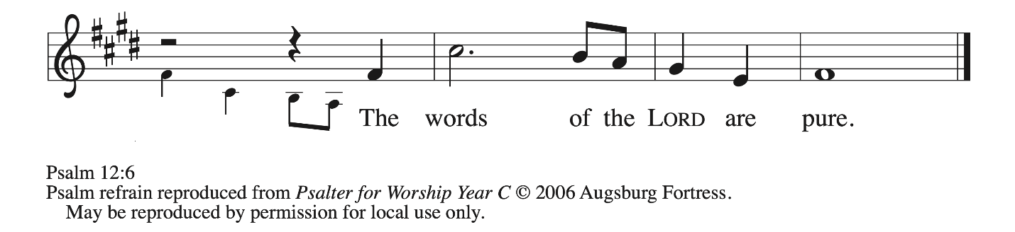

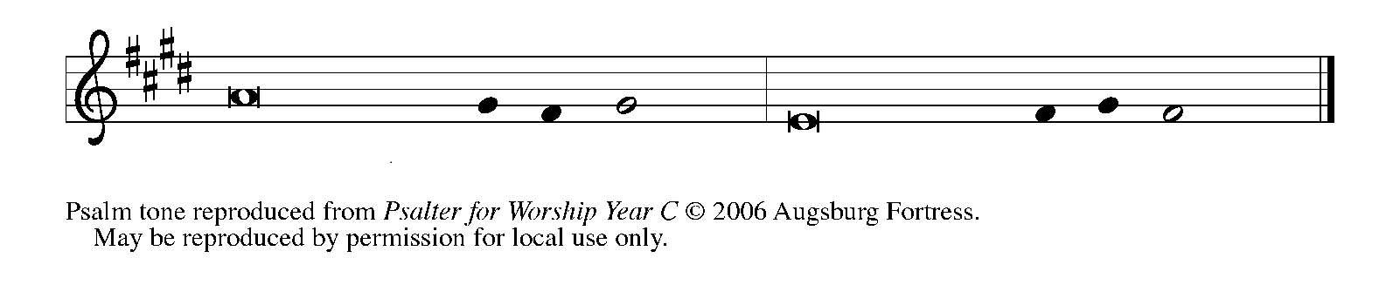

1Help me, Lord, for there is no god- **|** ly one left;

the faithful have vanished **|** from among us.

**2People tell lies | to each other;**

**they use smooth words but speak from a | double heart.**

3May the Lord cut off all **|** lips that flatter,

and the tongues **|** that speak boastfully—

**4those who say, “With our tongue we | will prevail;**

**our lips are our own; who is lord | over us?” REFRAIN**

5“Because the needy are oppressed, and the poor cry **|** out in misery,

I will rise up,” says the Lord, “and give them the **|** help they long for.”

**6The words of the | Lord are pure,**

**like silver refined from ore and purified seven times | in the fire.**

7O Lord, watch **|** over us

and save us from this genera- **|** tion forever.

**8The wicked prowl on | every side,**

**and everyone prizes that | which is worthless. REFRAIN**

**SECOND READING 1 Corinthians 12: 27-31a**

*The Body of Christ has many gifts and callings.*

27 Now you are the body of Christ and individually members of it. 28 And God has appointed in the church first apostles, second prophets, third teachers, then deeds of power, then gifts of healing, forms of assistance, forms of leadership, various kinds of tongues. 29 Are all apostles? Are all prophets? Are all teachers? Do all work powerful deeds? 30 Do all possess gifts of healing? Do all speak in tongues? Do all interpret? 31 But strive for the greater gifts. And I will show you a still more excellent way.

The Word of the Lord.

**Thanks be to God.**

*As you able please rise*

**THE VERSE** (Sung twice)

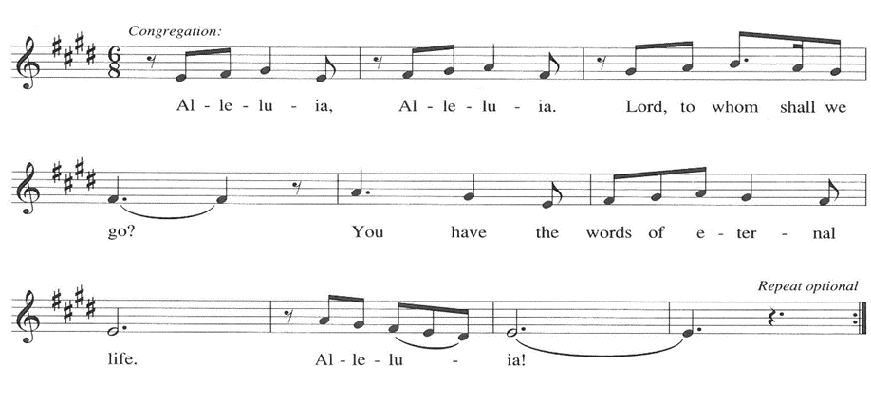

**THE HOLY GOSPEL John 1: 43-51**

*Jesus invites disciples to follow Him.*

P: The Holy Gospel according to St. John, the first chapter.

**C: Glory to You, O Lord!**

43The next day Jesus decided to go to Galilee. He found Philip and said to him,

"Follow me."

44Now Philip was from Bethsaida, the city of Andrew and Peter.

45Philip found Nathanael and said to him, "We have found Him about Whom Moses

in the law and also the prophets wrote, Jesus son of Joseph from Nazareth."

46Nathanael said to him, "Can anything good come out of Nazareth?" Philip said to him,

"Come and see."

47When Jesus saw Nathanael coming toward Him, He said of him, "Here is truly an

Israelite in whom there is no deceit!"

48Nathanael asked Him, "Where did You get to know me?" Jesus answered, "I saw you

under the fig tree before Philip called you."

49Nathanael replied, "Rabbi, You are the Son of God! You are the King of Israel!"

50Jesus answered, "Do you believe because I told you that I saw you under the fig tree?

You will see greater things than these."

51And He said to him, "Very truly, I tell you, you will see heaven opened and the angels

of God ascending and descending upon the Son of Man."

P: The Gospel of the Lord.

**C: Praise to You, O Christ!**

**THE SERMON**

*Silence for reflection follows the sermon*

*As you are able please rise*

**THE HYMN OF THE DAY 421 *By All Your Saints***

Stanza 1, 19, and Last

**THE PRAYER OF THE CHURCH**

A: United with the great cloud of witnesses throughout the ages, we pray for the church, the world,

and all who are in need.

A: We pray for the church. For all bishops, especially **Elizabeth and Timothy;** pastors, especially

**Dale and Mark, Pamela and Mark;** deacons, and other ministers. For those who travel far

from home in mission and service. Strengthen those who respond Your call to ministry, and

grant wisdom to all who shepherd Your people. Hear us, O God.

**C: For Your mercy is great.**

A: We pray for the creation. For wilderness areas, local parks, and community gardens. For fields

and forests, canyons and rivers. For olive groves and pastures, farms and vineyards. Bless those

who harvest crops and all whose labor brings food to our tables. Hear us, O God.

**C: For Your mercy is great.**

A: We pray for those who govern the nations. For our elected officials, local leaders, and all public

servants. Inspire them to use their power with honor and integrity. Bring an end to prejudice,

violence, and injustice. Strengthen all who work for peace. Hear us, O God.

**C: For Your mercy is great.**

A: We pray for those in need. For all who are overlooked or belittled because of their background.

For those who suffer for the sake of conscience. For those who grieve, and for all who are ill,

especially: **Joyce Stark; Mike Galinowski; John Bennitt; Martha Schroeder; Bill**

**Hazelgrove; Fred Weiss; David Weiss; Bill Hazelgrove; Barry Anderson; Bob Pheanis;**

**Lucas Bradshaw; Shirley Freels; and Larry Litchford**. Bring them comfort, healing, and

hope. Hear us, O God.

**C: For Your mercy is great.**

A: We pray for this assembly. For those struggling with doubts and for those seeking purpose and

direction in life. For teachers, counselors, and mentors. As You have called us to follow You,

send us out to share the good news. Hear us, O God.

**C: For Your mercy is great.**

A: With thanksgiving, we remember Bartholomew and all who have gone before us in the faith.

Inspire us by their witness and bring us at last to feast with You at the heavenly banquet. Hear

us, O God.

**C: For Your mercy is great.**

P: In the company of Your saints we commend all for whom we pray, trusting in Your eternal

mercy and love; through Jesus Christ our Savior and Lord.

**C: Amen.**

**✠ MEAL ✠**

**THE PEACE**

P: The peace of the Lord be with you always.

**C: And also with you.**

*The assembly is seated*

**THE OFFERING**

**THE VOLUNTARY*****Seek Ye First* St. Paul Senior Choir** (K. Lafferty)

*As you are able please rise*

**THE OFFERTORY 465 *As the Grains of Wheat***

**THE OFFERTORY PRAYER**

A: Let us pray. Holy God, gracious and merciful,

**C: You bring forth food from the earth and nourish Your whole creation. Turn our hearts**

**toward those who hunger in any way, that all may know Your care; and prepare us now**

**to feast on the Bread of Life, Jesus Christ, our Savior and Lord. Amen.**

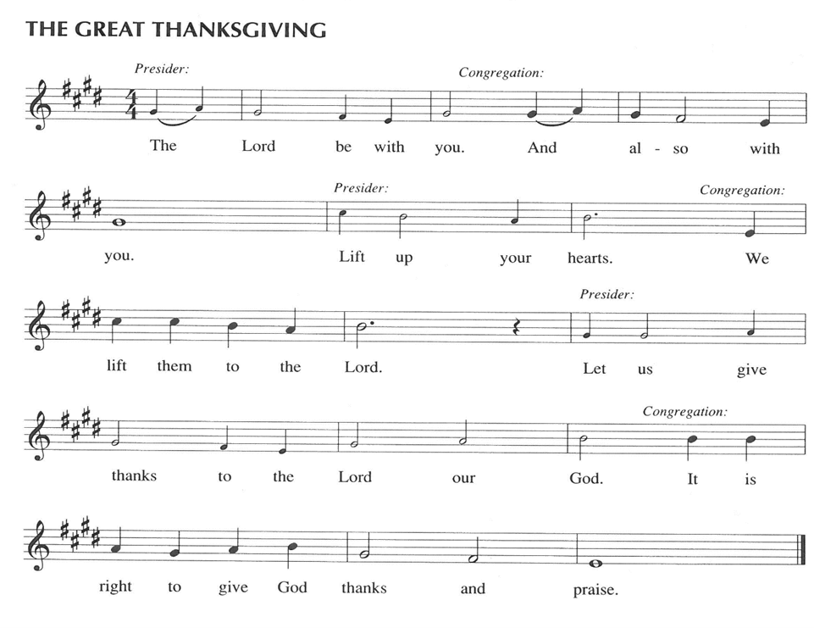

P: It is our duty and delight … join their unending hymn

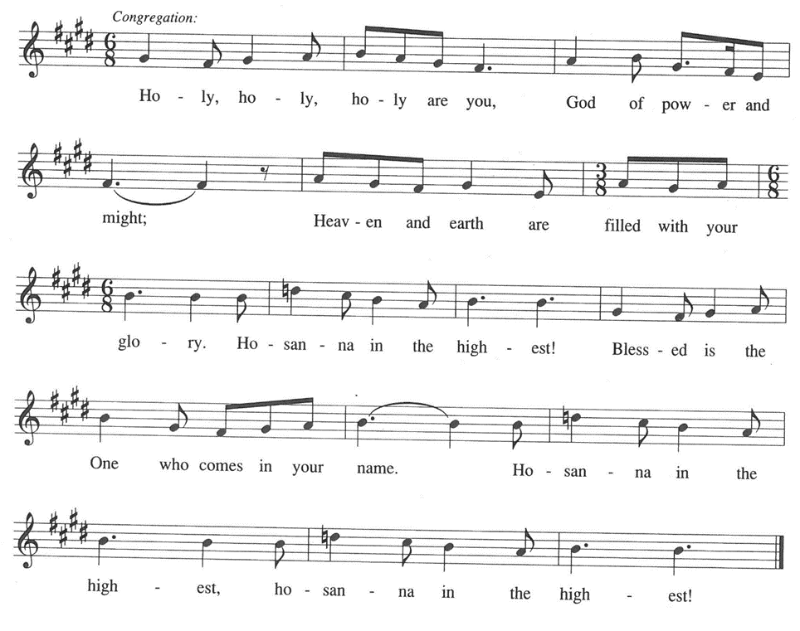

P: O God most mighty,

O God most merciful,

O God our rock and our salvation, hear us as we praise, call us to Your table, grant us

Your life.

When the earth was a formless void, You formed order and beauty.

When Abraham and Sarah were barren, You sent them a child;

When the Israelites were enslaved, You led them to freedom.

Ruth faced starvation, David fought Goliath, and the psalmists cried out for healing, and

full of compassion, You granted the people your life.

You entered our sorrows in Jesus our brother.

He was born among the poor, He lived under oppression, He wept over the city.

With infinite love, He granted the people Your life.

In the night … “Do this for the remembrance of Me.” in which he was betrayed,

As often as we eat … we proclaim the Lord’s death until He comes.

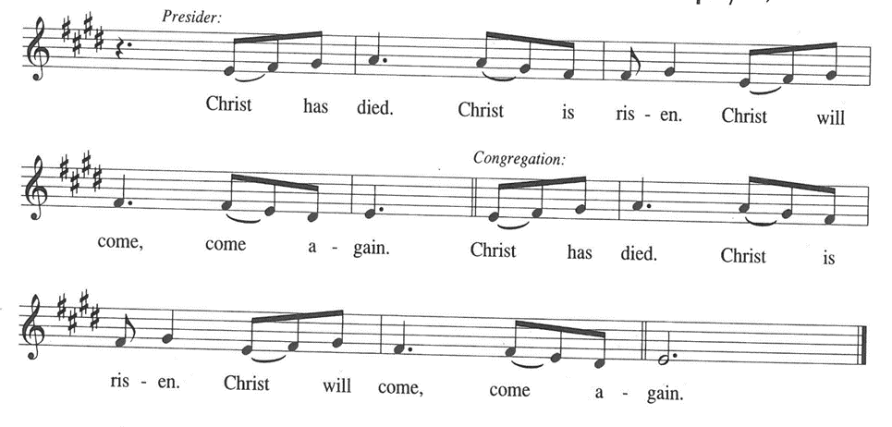

P: O God, You are Breath: send Your Spirit on this meal.

O God, You are Bread: feed us with Yourself.

O God, You are Wine: warm our hearts and make us one.

O God, You are Fire: transform us with hope.

O God most majestic, O God most motherly, O God our strength and our song, You show us

a vision of a tree of life with fruits for all and leaves that heal the nations.

Grant us such life, the life of the Father to the Son, the life of the Spirit of our risen Savior,

life in You, now and forever.

**C: Amen.**

**THE LORD’S PRAYER**

P: Setting our hearts on the unfailing treasure of God’s Kingdom, with trust in God’s daily care

for us, we now pray as Jesus taught us:

**C: Our Father, Who art in heaven, hallowed by Thy name.**

**Thy Kingdom come, Thy will be done on earth as it is in heaven.**

**Give us this day our daily bread, and forgive us our trespasses as we forgive those**

**who trespass against us.**

**And lead us not into temptation, but deliver us from evil.**

**For Thine is the Kingdom, and the power, and the glory, forever and ever. Amen.**

**INVITATION TO THE MEAL**

P: They will come from east and west and north and south to sit at Table in the Kingdom of God.

Blessed are those who are called to the Supper of the Lamb. God’s holy gifts for God’s holy

people. Come, for all is now ready.

.

*The assembly is seated*

**THE DISTRIBUTION “Lamb of God”**

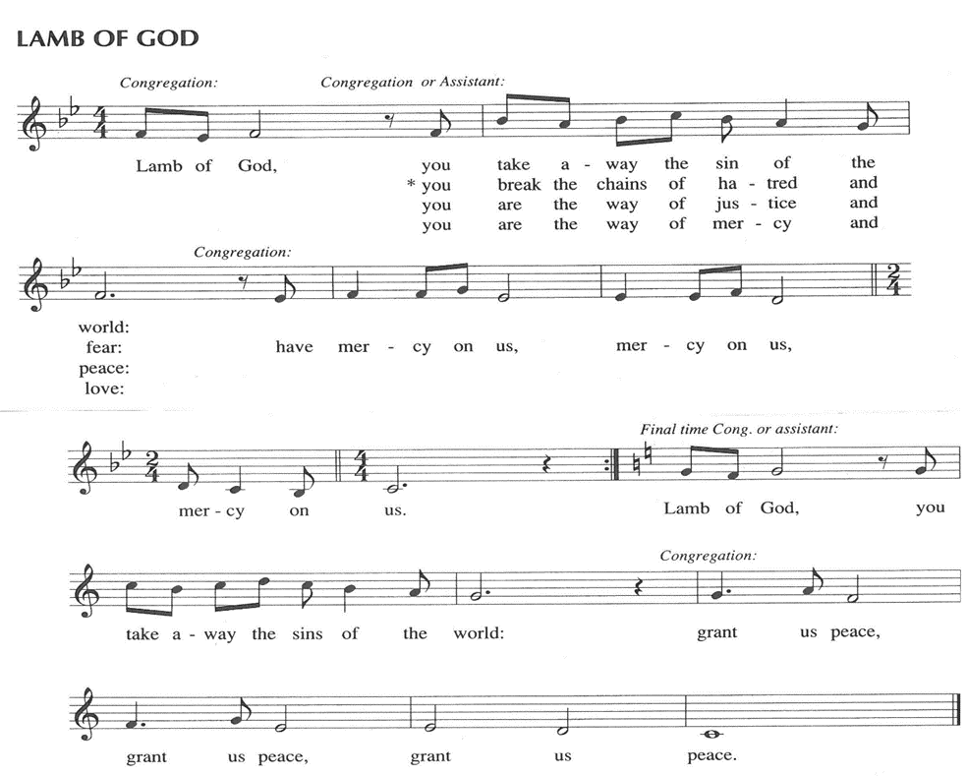

*As you are able please rise*

**HYMN DURING DISTRIBUTION 858 *Praise to the Lord, the Almighty***

**ELW 787 *On Eagles’ Wings***

**ELW 768 *Lead Me, Guide Me***

**NSB 23 *Come and See***

**THE POST-COMMUNION BLESSING**

P: The Body and Blood of our Lord Jesus Christ strengthen you and keep you in His grace.

**C: Amen.**

**THE POST-COMMUNION PRAYER**

A: Let us pray.

God of abundance, with this bread of life and cup of salvation You have united us with Christ, making us one with all Your people. Now send us forth in the power of Your Spirit, that we may proclaim Your redeeming love to the world and continue forever in the risen life of Jesus Christ, our Lord.

**C: Amen.**

**✠ SENDING ✠**

**THE BENEDICTION**

P: Almighty God: Father, Son, **✠** and Holy Spirit bless you now and forever.

**C: Amen.**

**THE SENDING HYMN 576 *We All Are One in Mission***

**THE DISMISSAL**

A: Go in peace to bear Christ’s love to all the world.

**C: Thanks be to God!**

**POSTLUDE**

**✠ To God Alone Be Glory ✠**

The musical setting of the liturgy, “Now the Feast and Celebration” by Marty Haugen, is used by

permission of GIA Publishers, Inc. OneLicense.net License #A-702836.

**ANNOUNCEMENTS**

**Please remember to mail your offering to the Church Office** at 818 Franklin Street, Michigan City, IN 46360**.** Another alternative is to give on-line through Tithe.ly. Please see your closure letter for information on how to set up a Tithe.ly account.

**St. Paul Members are reminded to have** a loved one contact the office if you are hospitalized. Many times, the Pastor doesn’t know someone is in the hospital. If you call and leave a message, please tell us at which hospital the patient is located.

**BIRTHDAYS: David Jocelyn (8/27); Sandra Galinowski (8/31)**

**PRAYER CONCERNS:** Bev Coburn; Barry Anderson; John Bennitt; Judy

Gustum; Bob Pheanis; Larry Litchford, Sarah McNabb, Jeanie Boatman Shepple,

Debbie Martin, Mark Tannehill, Kathy Stein, Jan Paholski, Laura Dovey, Grace

Romine; Mike Galinowski and Bill Hazelgrove.

**OFFICE HOURS:** Libby will be in the office on Mondays, Wednesdays, and Fridays; volunteers will cover Tuesdays and Thursdays.

  Monday & Wednesday 8:00 a.m. – 5 p.m.

Tuesday & Thursday 9:00 a.m. – 12:00 p.m.

Friday 8:00 a.m. – 12:00 p.m.

**If you are listening to the worship broadcast on the radio and would like to watch the Sunday morning service live stream follow these steps:**

(1) If you have You Tube available on your TV, search for

**St. Paul Lutheran Church Michigan City, IN.**

(2) The direct link on the computer is [https://](https://www.youtube.com/channel/UC5AIPNaKr3QN50984jGOa1g)

[www.youtube.com/channel/UC5AIPNaKr3QN50984jGOa1g](https://www.youtube.com/channel/UC5AIPNaKr3QN50984jGOa1g).

   (3) This link is also on the main page of the church’s website in

the church section and will continue to be posted weekly on the St.

Paul Facebook page.

And it will always be available on the radio broadcast Sunday mornings at 11:00 a.m.

on WEFM (95.9), and on the local cable access station #99 for the previous week’s

service on Sundays at 4:00 p.m. and the current service on Wednesdays at 7:00 p.m.

and Fridays at 8:30 p.m.

**Sunday’s lessons are Proverbs 25: 6-7; Psalm 112; Hebrews 13: 1-8, 15-16; and**

**Luke 14: 1, 7-14** for those of you who like to study them in advance.

**To send e-mail to the church office**, please use the following addresses:

Pastor Mark Reshan: seniorpastor@stpaulmichigancity.com

Church Office Secretary (Libby Pollock): churchsecretary@stpaulmichigancity.com

Church Treasurer (Karen Fleming): finance@stpaulmichigancity.com

**2025 Church Council:**

Mark Reshan - Pastor

 Janet Bakken – President

 Donna Knoll – Vice President

 Judy Hunt – Secretary

 Karen Fleming – Treasurer

 Members: Paul Brooks, Diane Egilske, Sue Koziel, Judy Mutchler,

Jim Schraidt, Trish Sprague

**Worship Attendance:**

**Saturday , August 16, 2025 @ 4:00 p.m. 19**

**Sunday, August 17, 2025 @ 9:00 a.m. 63**

**TOTAL 82**

**Copies of the minutes from the May 1, 2025 and the June 26, 2025 Church Council meetings are on the back table in the upper Narthex. They were approved by the council via email.**

**FYI:**

In response to the ever rising costs for postage we will be putting your copy

of the “Good News” in your hanging file folder in the narthex each month

from now on. Those of you who are unable to attend services on a regular

basis may still receive your copies through your email address or in the

U.S. mail. If you normally receive your copy of the newsletter via your

email address anyway, nothing will change for you. Thank you so much for

your understanding and cooperation!

**The Good News Newsletter**: If you have an article or anything you want included in **The Good News** please send it to the following e-mail address: splcgoodnews@gmail.com. Pastor Pamela Thiede will be using this e-mail address to assemble **The Good News** each month. The deadline for getting information to Pastor Pamela will be the 20th of each month.

**DOES YOUR BIRTHDAY OCCUR IN THE SUMMER MONTHS?** If you wereborn during June, July orAugust, come to the Coffee Hour after the Sunday service on Sunday, August 31, 2025. Join us as we celebrate you and all those who have a summer birthday.

**AUGUST 2025 MISSION OF THE MONTH**

**The Mission of the Month for August: Michigan City Area Schools – It’s back to school time already!** Let’s help our area kids start the year out on a good note! We will be collecting money to support different projects in various elementary schools in Michigan City through Donors Choose. Donors Choose provides a list of teacher-led classroom projects that need funding. Flexible seating, music education, and classroom supplies are some of the options we can provide to our elementary schools. Please consider donating to help fund our local teachers’ classroom projects! Checks can be written to St. Paul Lutheran Church and can be marked for MCAS and placed in the offering plate. Noisy coin offering will also support the mission of the month. To see a full list of projects visit, [www.donorschoose.org](http://www.donorschoose.org) and search for Michigan City.

**2025 Financial Stewardship**

Weekly Church Operating Needs (x 2 weeks)

August 9 -10, 2025; August 16 -17, 2025: $ 10,600.00

General Fund (including General Memorials): $ 7,388.00

Overage/Shortage: — $ 4,202.50

Restricted Income (not including Memorials)

Supports IK Synod & Church wide Ministries: $ 139.00

Ministries in our Community/Congregation: $ 160.00

Capital Fund: $ 261.00

**ACTIVITIES, EVENTS & MEETINGS**

**AUGUST 2025**

**Saturday,** August 16, 2025 @ 4:00 p.m. Pent 10 Worship Service/Sanctuary

**Sunday,** August 17, 2025 @ 9:00 a.m. Pent 10 Worship Service/Sanctuary

With coffee after/St. Paul Room

**Wednesday,** August 20, 2025 @10:00 a.m. God’s Purls/St. Paul Room

@3:30 p.m. Worship & Music Comm./Luther House

@4:30 p.m. Choir Rehearsal/Sanctuary

@ 5:30 p.m. 150th Anniv. Comm. Mtg./Luther House

**Saturday,** August 23, 2025 @ 4:00 p.m. Pent 11 Worship Service/Sanctuary

**Sunday,** August 24, 2025 @ 9:00 a.m. Pent 11 Worship Service/Sanctuary

With coffee after/St. Paul Room

**Monday,** August 25, 2025 @ 2:00 p.m. Finance Comm. Mtg./Luther House

@ 3:00 p.m. Executive Board Mtg./Luther House

**Wednesday,** August 27, 2025 @ 10:00 a.m. God’s Purls/St. Paul Room

**Thursday,** August 28, 2025 @ 5:30 p.m. Church Council Meeting/St. Paul Room

**Saturday,** August 30, 2025 @ 4:00 p.m. Pent 12 Worship Service/Sanctuary

**Sunday,** August 31, 2025 @ 9:00 a.m. Pent 12 Worship Service/Sanctuary with

Coffee after/St. Paul Room

**September 2025 Mission of the Month**

The Mission of the Month for September 2025: ZERO Prostate Cancer

September is Prostate Cancer Awareness Month. Prostate cancer will affect about one in seven men in their lifetime and about 35,000 men will die from prostate cancer this year. Fortunately, if detected early, prostate cancer can be successfully treated, and new treatments are becoming available to extend the lives of men with advanced disease. ZERO is the largest prostate cancer support, education and advocacy organization in the United States. It offers free support and education services to prostate cancer patients, and advocates for research funding and improved prostate cancer treatment. Jim Schraidt is a fifteen-year prostate cancer survivor and a member of the Board of Directors of ZERO. He leads a monthly ZERO-sponsored support group that meets in Chicago with simultaneous virtual access. Jim is happy to answer questions about prostate cancer and ZERO, and more information can be found at <https://zerocancer.org>.

Checks can be written to St. Paul and can be marked for ZERO and placed in the offering plate.

Noisy coin offering will also support the mission of the month.

Thank$ for $haring

Thanks to all who participate in the Give Back opportunities! Our next Give Back will be at Holly’s on Tuesday, September 9, 2025.  Here are two coupons—one for you and one for a friend.

