**THE FESTIVAL OF CHRIST THE KING**

**The Last Sunday after Pentecost**

**November 21, 2021**

“The ultimate weakness of violence is that it is a descending spiral, begetting the very thing it seeks to destroy. Instead of diminishing evil, it multiplies it. Through violence you may murder the liar, but you cannot murder the lie, nor establish the truth. Through violence you may murder the hater, but you do not murder hate. In fact, violence merely increases hate. So it goes. Returning violence for violence multiplies violence, adding deeper darkness to a night already devoid of stars. Darkness cannot drive out darkness: only light can do that. Hate cannot drive out hate: only love can do that.”

**Martin Luther King, Jr.**

While God’s kingdom will come regardless because it’s God’s after all, Revelation reminds us that Jesus “made us to be kings” (according to the Greek; not “a kingdom,” Revelation 1:6). And since we have been made to be kings (and queens) of God’s kingdom, it is our calling to work for that kingdom and not for those kingdoms of this world. It is our calling to strive for different. It is our calling to bring about “thy kingdom come” even with the promise of God’s kingdom coming.

Of course, part of the challenge in all of this is the penchant to limit kingdom to location. This is when the “reign of Christ” is a helpful corrective for this festival Sunday, not just for the sake how we talk about Jesus and the titles we give to Jesus, but for the sake of realizing that Jesus’ kingdom is a state of being, a way to live, a commitment to a particular way to view the world.

And in John, Jesus wants us to see that his kingdom is only about place if place indicates the profound and intimate “place” of relationship with God. Jesus’ kingdom is not about amassing additional amounts of control. Jesus’ kingdom is not about his ultimate rule over and above others. Jesus’ kingdom is about relationship.

“My kingdom is not from this world” because it is from God. Pilate attempts to construe the boundaries of Jesus’ kingdom in terms of those perpetuated by the kingdom to which he is beholden. But Jesus’ kingdom is from God, just as Jesus is from God (John 1:1) and Jesus is God’s kingdom. The concept of kingdom is radically recalculated in the Gospel of John, from kingdoms that strain and sever relationships to a kingdom that puts relationship at its core.

That’s a whole different perspective on kingdom. When kingdom is construed from the truth of relationship and not rule, from the truth of incarnation and not location, from the truth of love and not law, then Jesus as truth will ring true.

**Karoline Lewis**

***✠ In the Name of Jesus✠***

**INTRODUCTION**

Even after Israel had experienced the vagaries of kings, they still longed for a true king to set things right. He would have the king's title of Anointed One (Messiah); he would be the "one like a human being" (Son of Man) given dominion in Daniel's vision. Jesus is given these titles, even though he is nothing like an earthly king. His authority comes from the truth to which he bears witness, and those who recognize the truth voluntarily listen to him. We look forward to the day he is given dominion, knowing his victory will be the nonviolent victory of love.

**Clement, Bishop of Rome, died around 100**

*Clement was the third bishop of Rome. He is best remembered for a letter he wrote to the congregation in Corinth, still struggling with the same problems that led to Paul's letters to them. As did Paul, he focused on the need for love among Christians.*

**Miguel Agustín Pro, martyr, died 1927**

*Pro grew up in a time when the Mexican revolutionaries accused the church of siding with the wealthy. He became a Jesuit priest, and worked on behalf of the poor and homeless. Falsely accused of throwing a bomb at a government official, he was executed, but not before crying out "Long live Christ the King!"*

**✠ GATHERING✠**

**PRE-SERVICE MUSIC Ancient of Days Praise Band**

**ANNOUNCEMENTS**

As you are able please rise

**THE GATHERING SONG 525 *You Are Holy*  page 11**

**THE GREETING AND PRAYER OF THE DAY**

P: God is Alpha and Omega, the First and the Last,

C: **The One Who is, and Who was, and Who is to come.**

P: The grace of our Lord Jesus Christ, the love of God, and the communion of the Holy

Spirit be with you all.

C: **And also with you.**

P: Let us pray. Almighty and eternal God, to Jesus Christ, the first-born from the dead,

You have granted everlasting dominion and a kingship that shall not pass away.

Remove from us every desire for privilege and power, that we may imitate the

sacrificial love of Christ our King, and, as a royal and priestly people, serve You

humbly in our brothers and sisters. Grant this through our Lord Jesus Christ, Your Son,

Who lives and reigns with You in the unity of the Holy Spirit, God forever and ever.

C: **Amen.**

*The assembly is seated*

**✠WORD✠**

**FIRST READING Daniel 7: 9-10, 13-14**

*To the community for whom this passage was written, it seemed as though the oppression they (God's people) were experiencing would never end. Daniel's message is: Indeed, it shall end. The Ancient One who is judge will call all nations to account and will give dominion to God's people who are represented by "one like a human being."*

As I watched,

thrones were set in place,

and an Ancient One took His throne,

His clothing was white as snow,

and the hair of His head like pure wool;

His throne was fiery flames,

and its wheels were burning fire.

10A stream of fire issued

and flowed out from his presence.

A thousand thousands served him,

and ten thousand times ten thousand stood attending him.

The court sat in judgment,

and the books were opened.

13As I watched in the night visions,

I saw one like a human being

coming with the clouds of heaven.

And he came to the Ancient One

and was presented before Him.

14To him was given dominion

and glory and kingship,

that all peoples, nations, and languages

should serve him.

His dominion is an everlasting dominion

that shall not pass away,

and his kingship is one

that shall never be destroyed.

The Word of the Lord.

**Thanks be to God.**

**THE PSALM: Psalm 93 Read responsively**

The LORD is king, robed in majesty;

the LORD is robed in majesty and armed with strength.

     The LORD has made the world so sure that it cannot be moved.

**2Ever since the world began, Your throne has been established;**

**You are from everlasting.**

3The waters have lifted up, O LORD, the waters have lifted up their voice;

     the waters have lifted up their pounding waves.

**4Mightier than the sound of many waters,**

**mightier than the breakers of the sea,**

**mightier is the LORD Who dwells on high.**

5Your testimonies are very sure,

     and holiness befits Your house, O LORD,

     forever and forevermore.

**SECOND READING Revelation 1:4b-8**

*The book of Revelation begins with a series of messages addressed to seven churches. John's greeting to these churches extols God as one who controls their past, present, and future.*

Grace to you and peace from Him Who is and Who was and Who is to come, and from the seven spirits who are before His throne, 5and from Jesus Christ, the faithful witness, the firstborn of the dead, and the ruler of the kings of the earth.

To Him Who loves us and freed us from our sins by His blood, 6and made us to be a kingdom, priests serving His God and Father, to Him be glory and dominion forever and ever. Amen.

7Look! He is coming with the clouds;

every eye will see Him,

even those who pierced Him;

and on His account all the tribes of the earth will wail.

So it is to be. Amen.

8"I am the Alpha and the Omega," says the Lord God, Who is and Who was and Who is to come, the Almighty.

The Word of the Lord.

**Thanks be to God.**

*As you are able please rise*

**THE VERSE**

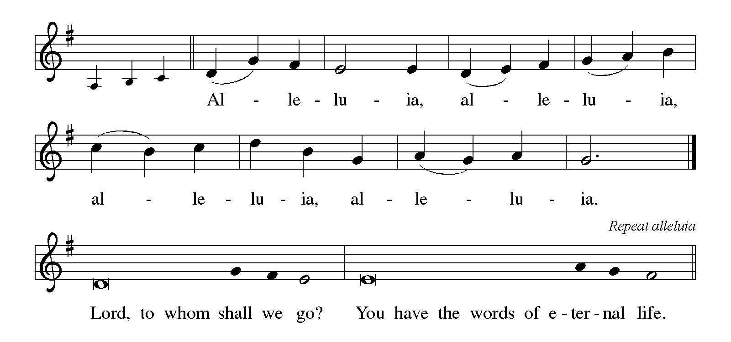

**THE HOLY GOSPEL John 18:33-37**

*In John’s Gospel, the story of Jesus and Pilate presents two different ways of exercising power: through force or with love.*

P: The Holy Gospel according to St. John, the eighteenth chapter.

C: **Glory to You, O Lord!**

Pilate entered the headquarters again, summoned Jesus, and asked Him, "Are You the King of the Judeans?" 34Jesus answered, "Do you ask this on your own, or did others tell you about Me?" 35Pilate replied, "I am not a Judean, am I? Your own nation and the chief priests have handed You over to me. What have You done?"

36Jesus answered, "My kingdom is not from this world. If My kingdom were from this world, My followers would be fighting to keep Me from being handed over to the Judeans. But as it is, My kingdom is not from here." 37Pilate asked Him, "So You are a king?" Jesus answered, "You say that I am a king. For this I was born, and for this I came into the world, to testify to the truth. Everyone who belongs to the truth listens to My voice."

P: The Gospel of the Lord.

C: **Praise to You, O Christ!**

*The assembly is seated*

**THE SERMON**

*Silence for reflection follows the sermon*

*As you are able please rise*

**THE HYMN OF THE DAY 408 *Come, Thou Almighty King*  page 12**

**THE NICENE CREED**

A: God has made us His people through our Baptism into Christ. Living together in trust

and hope, we confess our faith.

C: **We believe in one God,**

**the Father, the Almighty,**

**maker of heaven and earth,**

**of all that is, seen and unseen.**

**We believe in one Lord, Jesus Christ,**

**the only Son of God,**

**eternally begotten of the Father,**

**God from God, Light from Light,**

**true God from true God,**

**begotten, not made,**

**of one Being with the Father.**

**Through him all things were made.**

**For us and for our salvation**

**He came down from heaven;**

**by the power of the Holy Spirit**

**He became incarnate from the virgin Mary, and was made man.**

**For our sake He was crucified under Pontius Pilate;**

**He suffered death and was buried.**

**On the third day He rose again**

**in accordance with the Scriptures;**

**He ascended into heaven**

**and is seated at the right hand of the Father.**

**He will come again in glory to judge the living and the dead,**

**and His kingdom will have no end.**

**We believe in the Holy Spirit, the Lord, the giver of life,**

**Who proceeds from the Father and the Son.**

**With the Father and the Son He is worshiped and glorified.**

**He has spoken through the prophets.**

**We believe in one holy catholic and apostolic Church.**

**We acknowledge one Baptism for the forgiveness of sins.**

**We look for the resurrection of the dead,**

**and the life of the world to come. Amen**

**THE PRAYER OF THE CHURCH**

A: Let us offer our prayers before God’s throne of grace, asking that God’s mercy be

poured out on all who wait for Christ’s promised Reign of justice and peace, and that

all people everywhere may be united under the gentle rule of Christ.

A: That the Church, the sign of God’s Reign, may faithfully share in Christ’s suffering

love for the world, we pray:

C: **May Your kingdom come, O Lord.**

A: That the leaders of nations may be turned from governance by force or violence and

conformed to Christ’s rule of mercy and justice, we pray:

C: **May Your kingdom come, O Lord.**

A: That those who are seeking God or striving to know the Truth may find in the life of

our congregation the faith and love that point to Christ, we pray:

C: **May Your kingdom come, O Lord.**

A: That the sick, especially: . . .may know the healing presence of Christ, we pray:

C: **May Your kingdom come, O Lord.**

A: That when Christ comes to judge the living and the dead, we, with all the faithful,

especially **Clement, Bishop of Rome; and Miguel Agustin Pro, martyr,** whom we

commemorate this day will be ready to welcome Him with grateful hearts, we pray:

C: **May Your kingdom come, O Lord.**

P: Your Reign, O God, endures forever, and in Christ we are free to be your saints and

servants. Hear our prayers for the sake of him who died and rose again, and lives with

you in the company of all your saints in light, Jesus Christ, our Lord and king.

C: **Amen.**

**✠ MEAL ✠**

**THE PEACE**

P: The peace of the Lord be with you always.

C: **And also with you.**

*The assembly is seated*

**THE VOLUNTARY A*ll the Nations* Praise Band**

*As you are able please rise*

**THE OFFERTORY PRAYER**

A: Let us pray. Eternal God,

C: **In His great love Your Son offered His life for us. By Your great grace You have**

**made us priests to serve You and Your whole creation. With thankful devotion we offer You these gifts, and with them, our very lives. Receive them for the sake of Your Son. By this holy Sacrament, strengthen us to faithfully testify to the truth of Your everlasting reign in Christ Jesus our Lord. Amen.**

**THE GREAT THANKSGIVING**

P: The Lord be with you.

C: **And also with you.**

P: Lift up your hearts.

C: **We lift them to the Lord.**

P: Let us give thanks to the Lord our God.

C: **It is right to give Him thanks and praise.**

P: Glory and dominion be to You, Lord God for Your Word was alive in creation, is

present in the power of the Spirit, and will come in glory on the Last Day.

You made with the house of David and everlasting covenant, and Your goodness is

like the sun on a cloudless morning, gleaming from the rain on a grassy land.

You sent Jesus Christ, the faithful witness, the firstborn of the dead, and ruler of the

kings of the earth.

He freed us from our sins by His blood and made us a kingdom of priests serving You

forever.

God of truth, Your Son came to testify to You and lead us into all righteousness.

You have prepared for us such things as pass our understanding.

Send Your Holy Spirit upon Your people that Your Word may be on our lips.

Make holy this bread and wine, that they may be for us the Body and Blood of Your

Son Jesus Christ,

Who, in the night ... “Do this for the remembrance of Me.”

As often as we eat ... we proclaim the Lord’s death until He comes.

C: **Christ has died. Christ is risen. Christ will come again.**

P: God of all beginnings and endings, Your Son declared that His Kingdom was not of

this world.

Bless the governance of every earthly kingdom, that it may be ruled justly, in spirit

and in truth.

Visit Your children who live in fear, dwell under oppression, experience cruelty, or

suffer discrimination.

Turn struggle into hope, hope into freedom, freedom into justice, and justice into

love.

Bring to those who have never known You, or have forgotten or rejected You, the

light of Your grace and the thirst for Your mercy,

Until Your Son comes with the clouds, and all eyes will see Him, and every tribe and

tongue will lift Your name on high,

Ever one God: Father, ✠Son, and Holy Spirit

C: **Amen!**

**THE LORD'S PRAYER**

P: With longing for the coming of God’s Kingdom, let us pray as Jesus taught us:

C: **Our Father in heaven, hallowed be Your name. Your Kingdom come. Your will**

**be done on earth as in heaven. Give us this day our daily bread. Forgive us our**

**sins as we forgive those who sin against us. Save us from the time of trial and**

**deliver us from evil. For the Kingdom, the power, and the glory are Yours, now**

**and forever. Amen.**

**INVITATION TO THE MEAL**

P: They will come from east and west and north and south to sit at table in the Kingdom

of God. Blessed are those who are called to the Supper of the Lamb. God’s holy gifts

for God’s holy people. Come, for all is now ready.

**THE DISTRIBUTION**

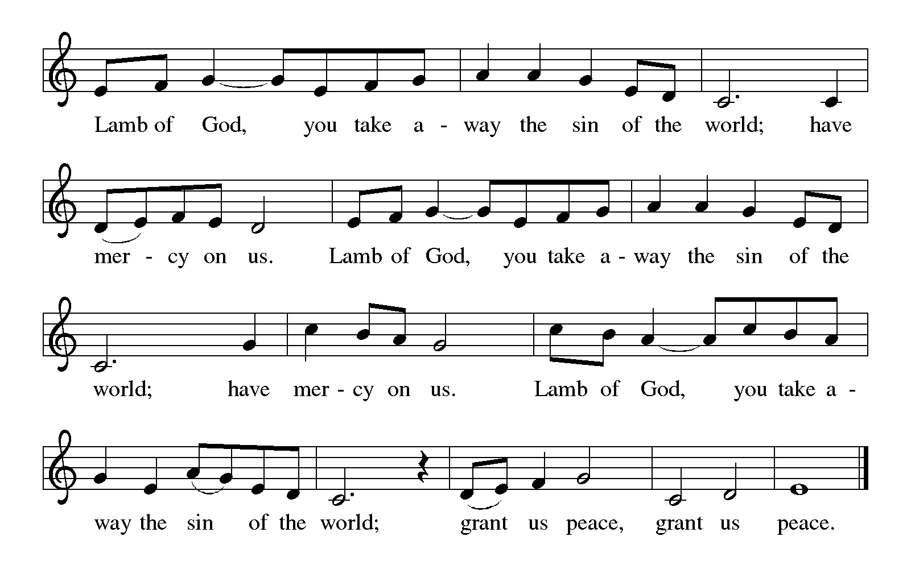

**HYMN DURING DISTRIBUTION 430 *Rejoice! For Christ is King!* page 13**

**855 *Crown Him with Many Crowns*  page 14**

**NSB 25 *Crown Him King of Kings*  page 15**

**NSB 50 *I Exalt Thee*  page 16**

*As you are able please rise*

**THE POST-COMMUNION BLESSING**

P: The Body and Blood of our Lord Jesus Christ strengthen you and keep you in His grace.

C: **Amen.**

**THE POST-COMMUNION PRAYER**

A: Let us pray. Almighty God, You have made us a royal priesthood in the Kingdom of

Your Son, our Savior Jesus Christ. Make known His victory through us, we pray, that

all the world may see His light, and be joined in love under His glorious rule. Grant

this through Christ our King.

C: **Amen.**

**✠ SENDING ✠**

**THE BENEDICTION**

P: Almighty God: Father, Son, ✠and Holy Spirit bless you now and forever.

C: **Amen.**

**SENDING HYMN 838 *Beautiful Savior*  page 17**

**THE DISMISSAL**

A: In the name of Jesus Christ, the faithful witness, Who is, Who was, and Who is to come,

go in peace to love and serve the Lord.

C: **Thanks be to God!**

**POSTLUDE  *Christ the King* Dom Paul Benoit O.S.B.**

***✠ To God Alone Be Glory ✠***

The Meditations are from *In the Meantime: Connecting Faith and Life.* Online

commentary by David Lose. 2015; and *Sundays and Seasons Online.* Copyright

Augsburg Fortress 2021.

The Prayers are adapted from *Prayers for Sundays and Seasons. Year B.* Peter J. Scagnelli.

(Chicago: Liturgy Training Publications, Inc). 1998, 144-45.

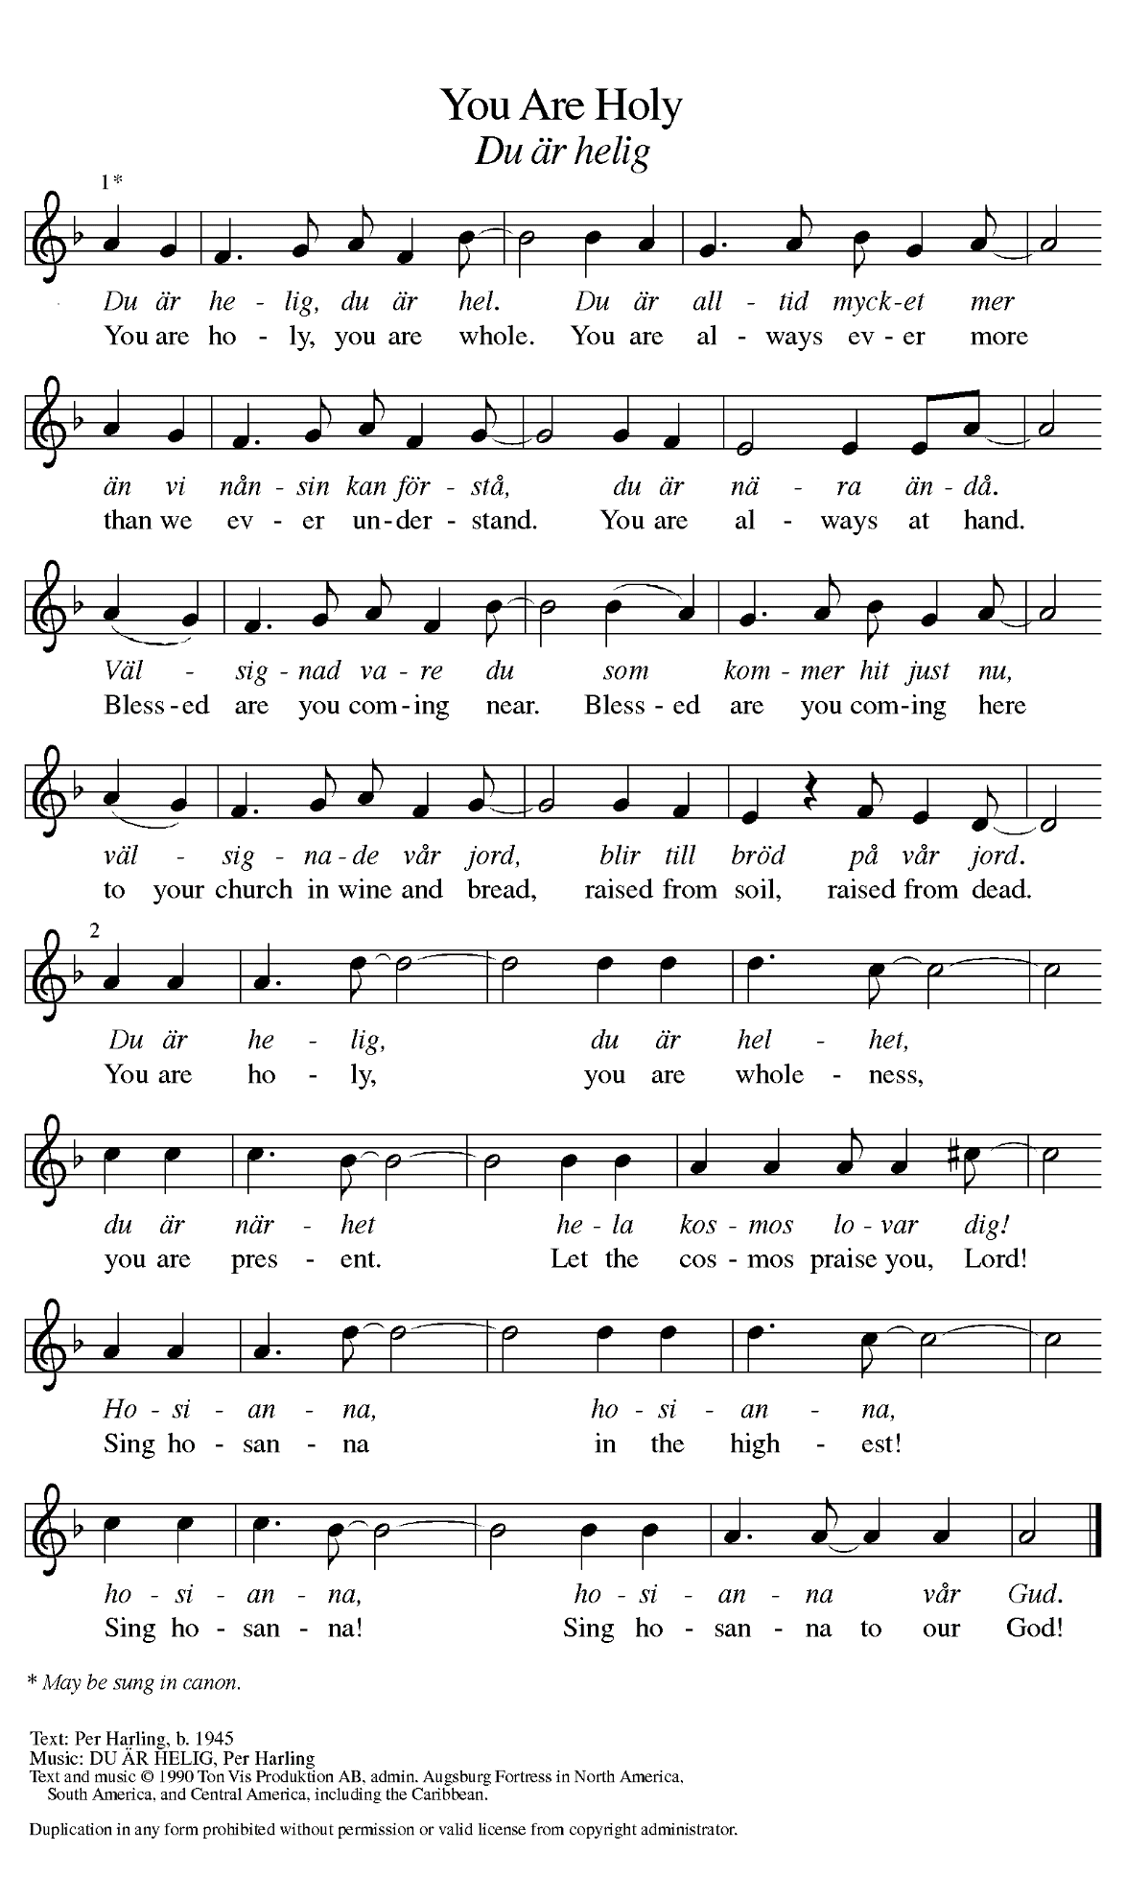

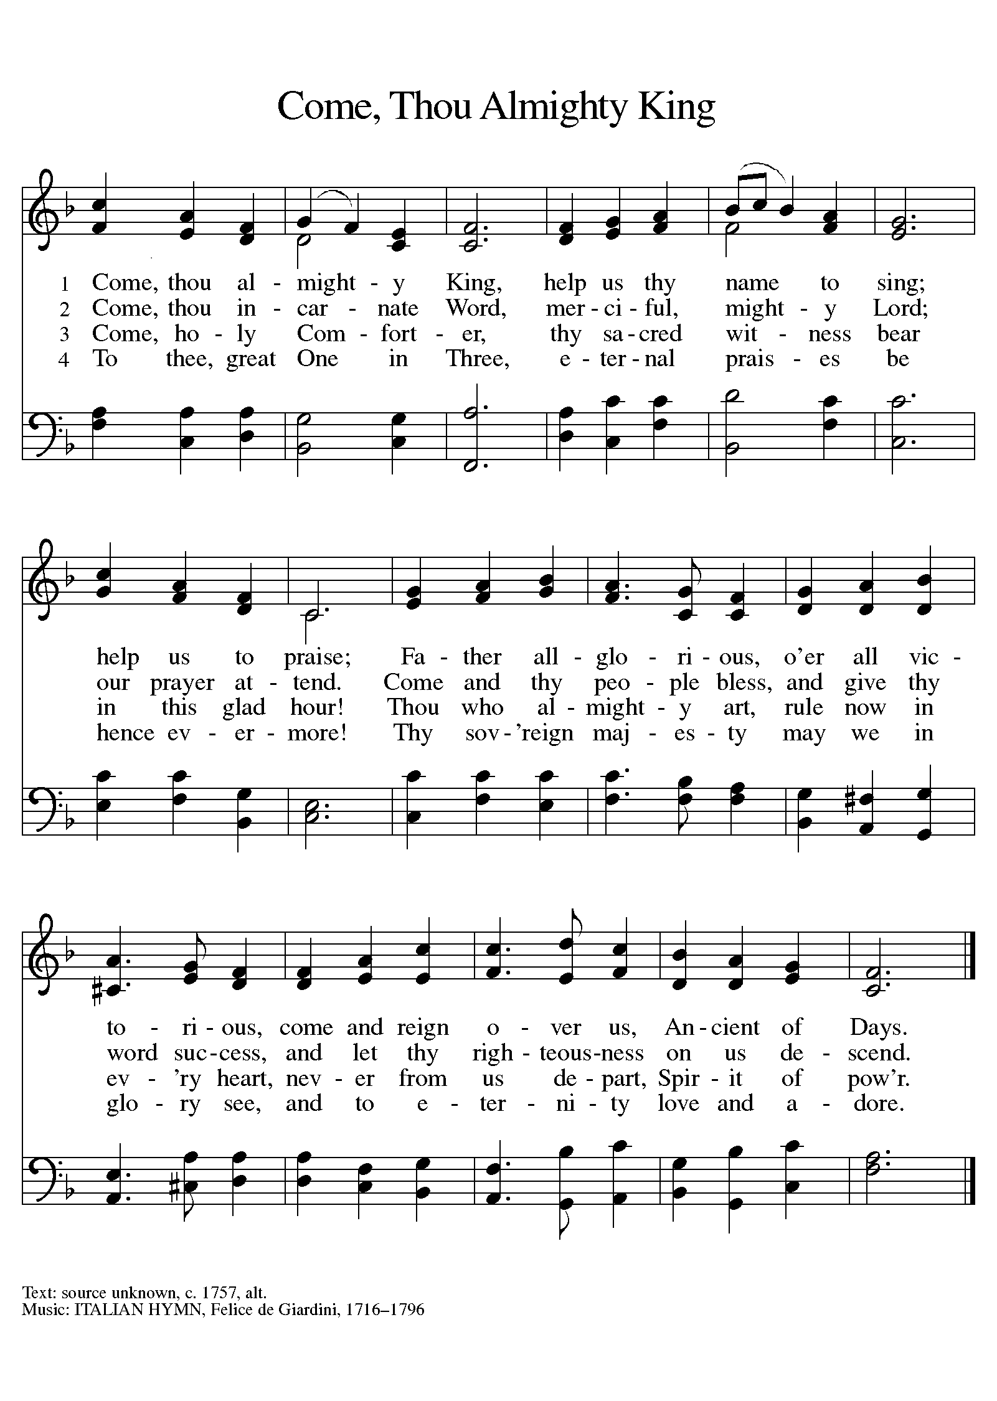

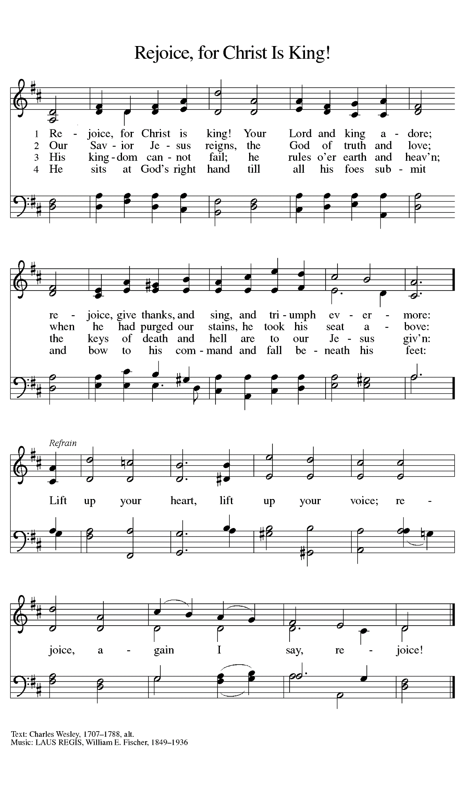

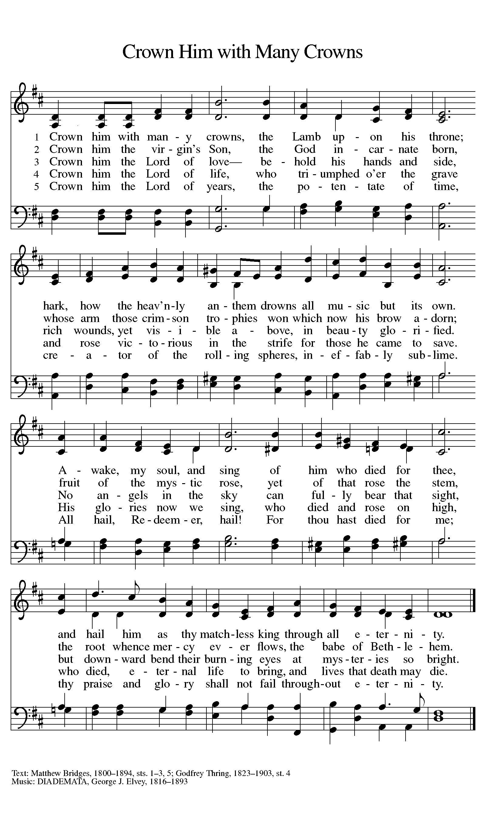

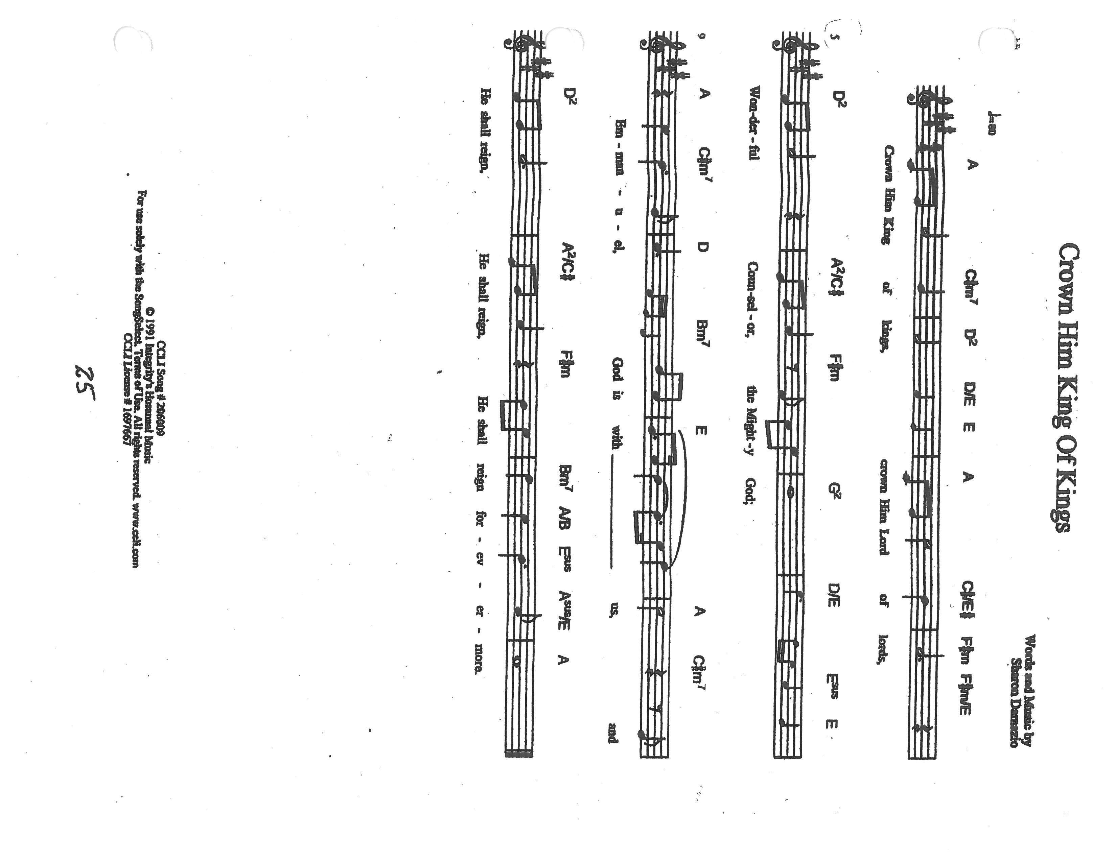

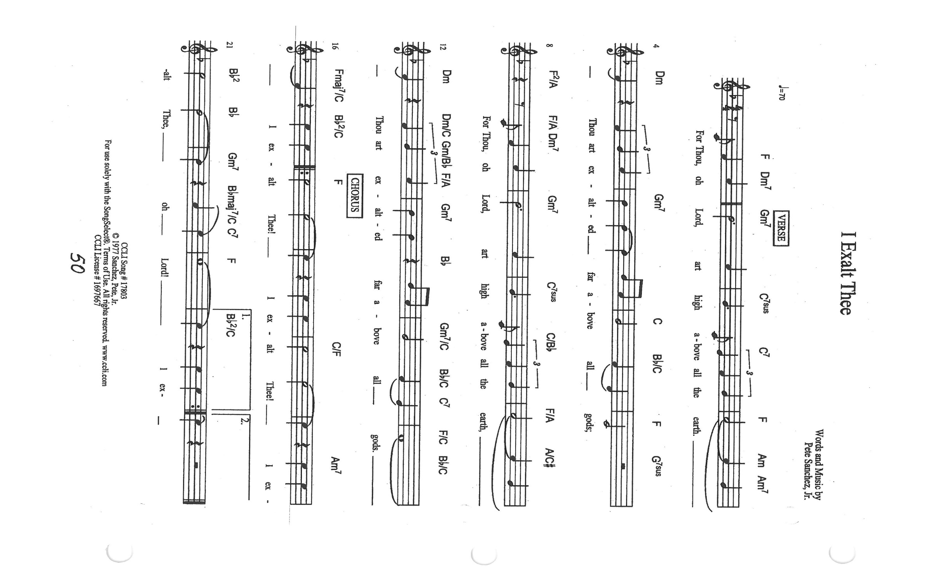

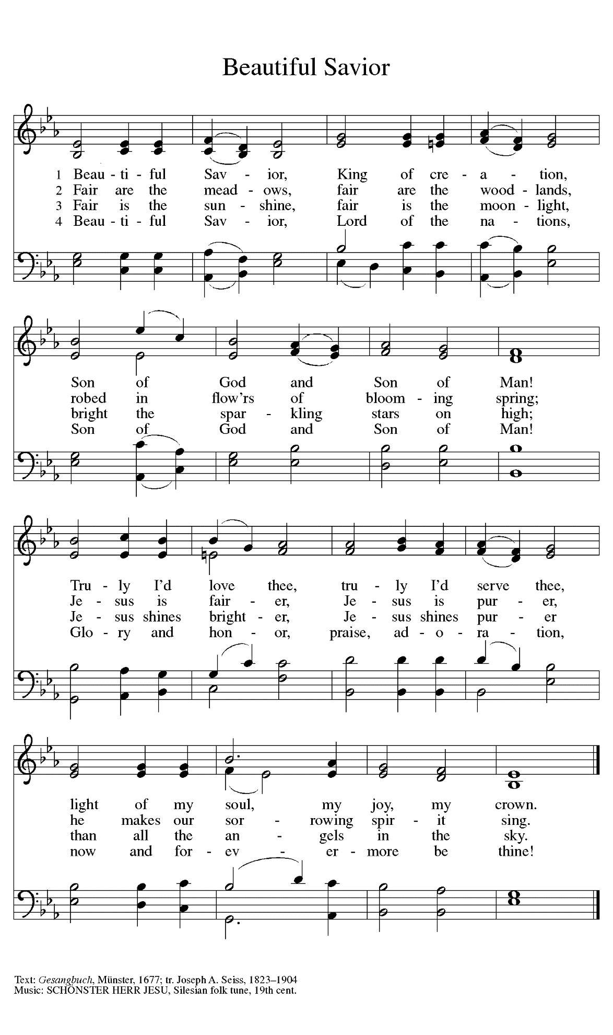

**ANNOUNCEMENTS**

**Please remember to mail your offering to the Church Office** at 818 Franklin Street, Michigan City, IN 46360**.** Another alternative is to give on-line through Tithe.ly. Please see your closure letter for information on how to set up a Tithe.ly account.

**St. Paul Members are reminded to have** a loved one contact the office if you are hospitalized. Many times, the Pastor doesn’t know someone is in the hospital. If you call and leave a message, please tell us which hospital the patient is at.

**Next Sunday’s lessons are Jeremiah 33: 14-16; Psalm 25: 1-10; I Thessalonians 3: 9-13; Luke 21: 25-36** for those of you who like to study them in advance.

**PRAYER CONCERNS:** Kathy Thielman, Audrey Beyer, Joyce and Bethany Manning, Marla Furness, Kay Peglow, Lee Timm, Ryan Krueger, Donna Bostater, Diane Gielow, Jeff Jensen, Maxine Powell, Jess Kalvaitis, Pastor Al Lorentzen, Jan Paholski, Laura Dovey, Heidi Happel, Shane Nevels, Irene Bohnstadt, Joan Coughlin, Jim Tomscheck, Wally & Betty Ratliff, Laura Moore, Cameron Rackard, Erik Tannehill, Ruth Lubs, Ed Gustum, Ken Mulder, Ashton Steele, Christian Martinez, Nancy Wisser, Ryan Sirk, Tyler Brown, Jary Tannehill, Susan McKinnon, Jim Gleason, Carl Loetz and the Biggs Fmily.

**If you requested someone’s name to be on the prayer list and are aware that they need continued imminent prayer then contact the church office and let us know.** Otherwise we will gradually transfer names to the long-term list.

**OFFICE HOURS:** Libby will be in the office on Mondays, Wednesdays, and Fridays; volunteers will cover Tuesdays and Thursdays.

Monday & Wednesday 8:00 a.m. – 5 p.m.

Tuesday & Thursday 9:00 a.m. – 12:00 p.m.

Friday 8:00 a.m. – 12:00 p.m.

**If you are listening to the worship broadcast on the radio and would like to watch the Sunday morning service live stream follow these steps:**

1. If you have You.Tube available on your TV, search for

**St. Paul Lutheran Church Michigan City, IN.**

1. The direct link on the computer is

<https://www.youtube.com/channel/UC5AIPNaKr3QN50984jGOa1g>.

1. This link is also on the main page of the church’s website in the church section and will continue to be posted weekly on the St. Paul Facebook page.

And it will always be available on the radio broadcast Sunday mornings at 11:00 a.m. on WEFM (95.9), and on the local cable access station #99 for the previous week’s service on Sundays at 4:00 p.m. and the current service on Wednesdays at 7:00 p.m. and Fridays at 8:30 p.m.

**To send e-mail to the church office**, please use the following addresses:

 Pastor Mark Reshan: [seniorpastor@stpaulmichigancity.com](mailto:seniorpastor@stpaulmichigancity.com)

 Church Office Secretary (Libby Pollock): [churchsecretary@stpaulmichigancity.com](mailto:churchsecretary@stpaulmichigancity.com)

 Church Treasurer (Karen Fleming) and Bookkeeper (Billie Atchinson):

[finance@stpaulmichigancity.com](mailto:finance@stpaulmichigancity.com).

**The Good News Newsletter**: If you have an article or anything you want included in **The Good News** please send it to the following e-mail address: splcgoodnews@gmail.com. Pastor Pamela Thiede will be using this e-mail address to assemble **The Good News** each month. The deadline for getting information to Pastor Pamela will be the 20th of each month.

**WORSHIP ATTENDANCE for November 13 and 14, 2021**

**4:00 p.m. 26**

**9:00 a.m. 52**

**Total = 78**

**The Community Soup Kitchen serving out of First United Methodist is in need of volunteers.** Sunday through Tuesday is always need, as is occasionally Wednesdays and Thursdays. Hours are 9:30 a.m. to 1:15 p.m. and it is not necessary to stay the entire time. There is also a need for volunteers to be available to help pick up deliveries from the Food Bank when they arrive. If you are able to help please contact their church office at 872-7200.

**MEETINGS & ACTIVITIES IN NOVEMBER**

Worship Service: Saturday, November 20, 2021 at 4:00 pm

Worship Service: Sunday, November 21, 2021 at 9:00 am

Wednesday Bible Study: Wednesday November 24, 2021 at 9:45 am/Luther House

THANKSGIVING

Worship Service: Saturday, November 27, 2021 at 4:00 pm

Worship Service: Sunday, November 28, 2021 at 9:00 am

**2021 Financial Stewardship**

Weekly Church Operating Needs (x 2 weeks): $14,116.36

November 6 and 7, 13 and 14, 2021

General Fund (including General Memorials): $10,331.24

Overage/Shortage: --$3,785.12

Restricted Income (not including Memorials)

Supports IK Synod & Churchwide Ministries: $184.00

Capital Fund: $500.00



**CHRISTMAS POINSETTIAS**

It’s time to start thinking about purchasing a Christmas Poinsettia. Each plant will be in a 6½-inch single plant pot with 3 – 6 blooms. Each plant will cost $6.50 and can be given “in memory of” or “in honor of” a loved one. Please place your order through the church office (219-874-7293); or place your information on an envelope with cash or a check made out to St. Paul Lutheran Church, and place it in the offering plate. You are welcome to take your plant(s) home after the Christmas Eve, Christmas Day, or Sunday (December 26) service. **Orders must be placed by Monday, December 13.** The final count will be turned in that day.

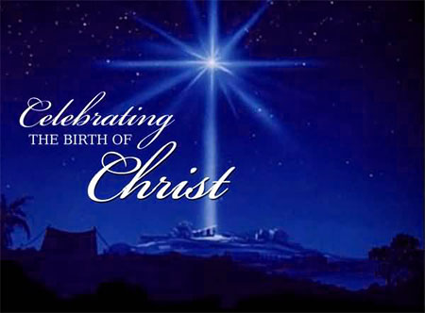

It is not too early to post information about our end-of-Advent and Christmas Eve/Day and following worship services. We will include them in the December newsletter as well, but it might be helpful to mark your calendars now for these special liturgies.

**Saturday, December 18** Fourth Saturday in Advent 4:00 p.m.

**Sunday, December 19** Fourth Sunday in Advent 9:00 a.m.

**Friday, December 24** Christmas Eve 6:00 p.m.

**Saturday, December 25** Christmas Day 10:00 a.m.

**(No 4:00 p.m. worship)**

**Sunday, December 26** The First Sunday of Christmas 9:00 a.m.