**CHRISTMAS EVE**

**December 24, 2021**

The events of Jesus’ life, and his own divine powers, teach those who can learn that he is true God, and his sufferings openly proclaim him true man. For if he was not flesh, for what reason did Mary bring him forth? And if he was not God, whom then did Gabriel call Lord? If he was not flesh, who then lay in the manger? If he was not God, to whom did the angels coming on earth give glory? If he was not man, who was wrapped in swaddling clothes? If he was not God, whom then did the shepherds adore? . . . If he was not a man, who cried out “My God, why have you forsaken me”? And if he was not God, who then said “Father, forgive them, for they know not what they do”? . . If he were not both God and human, then is our salvation a false thing.

**Ephraem**

**Fourth century**

There are many of you in this congregation who think to yourselves: “If only I had been there! How quick I would have been to help the Baby! I would have washed his linen.” But if you had been there at that time, you would have done no better than the people of Bethlehem. Childish and silly thoughts are these! Why don’t you do it now? You have Christ in your neighbor: you ought to serve him, for what you do to your neighbor in need, you do to the Lord Christ himself.

**Martin Luther**

**INTRODUCTION**

*At darkest night we gather to celebrate the great light of our salvation. More than the celebration of a birth, Christmas marks the mystery of the incarnation--God sharing our humanity. In this liturgy Christ is present among us--as the word of hope and peace proclaimed to us, and as the word made flesh in communion. With the heavenly host we sing, "Glory to God in the highest heaven," and like the shepherds we return to our homes, workplaces, and communities to tell of the wonders we have seen and heard.*

**✠ In the Name of Jesus✠**

**✠GATHERING✠**

**PRE-SERVICE MUSIC**

Organ and Flute ***O Little Town of Bethlehem*** **arr. Larry Shackley**

Choir ***Shine the Light of Your Love***

Choir ***Welcome to Our World***

Organ and Flute ***On Christmas Night*****arr. Ralph Vaughn Willians**

Band ***Jesus, What a Wonderful Child***

**ANNOUNCEMENTS**

*As you are able please rise*

**THE CHRISTMAS PROCLAMATION**

*This is a contemporary translation of an ancient proclamation used on Christmas Eve or Christmas Day. It places the birth of Christ into human history yet avoids a literalistic accounting of time. The last phrase makes it clear that the nativity of Jesus is not only then but now, today, in our own time.*

P: Many ages from the time when God created the heavens and the earth

and then formed man and woman in His own image;

long after the great flood, when God made the rainbow shine forth as a sign of the

covenant;

twenty-one centuries from the time the promise was given to Abraham and Sarah;

thirteen centuries after Moses led the people of Israel out of Egypt and Miriam danced

in freedom;

eleven hundred years from the time of Ruth and the judges;

one thousand years from the anointing of David as king;

in fulfillment of the times and years and months and days discerned by the prophets;

in the one hundred and ninety-fourth Olympiad;

the seven hundred and fifty-second year from the foundation of the city of Rome;

the forty-second year of the reign of Octavian Augustus;

while the whole world enjoyed a span of peace,

Jesus Christ, eternal God and Son of the eternal Father,

desiring to make holy the world by His most merciful coming,

being conceived by the Holy Spirit

and nine months of growth in the womb of His mother—

now in our own times is the nativity of our Lord Jesus Christ,

God made flesh.

**PROCESSIONAL HYMN 283 *Oh, Come, All Ye Faithful*  page 14**

The congregation faces the cross as it enters

**THE GREETING**

P: To us is born this day a Savior, Jesus Christ our Lord.

The grace of our Lord Jesus Christ, the love of God, and the communion of the Holy Spirit be

with you all.

C: **And also with you.**

**THE HYMN OF PRAISE**

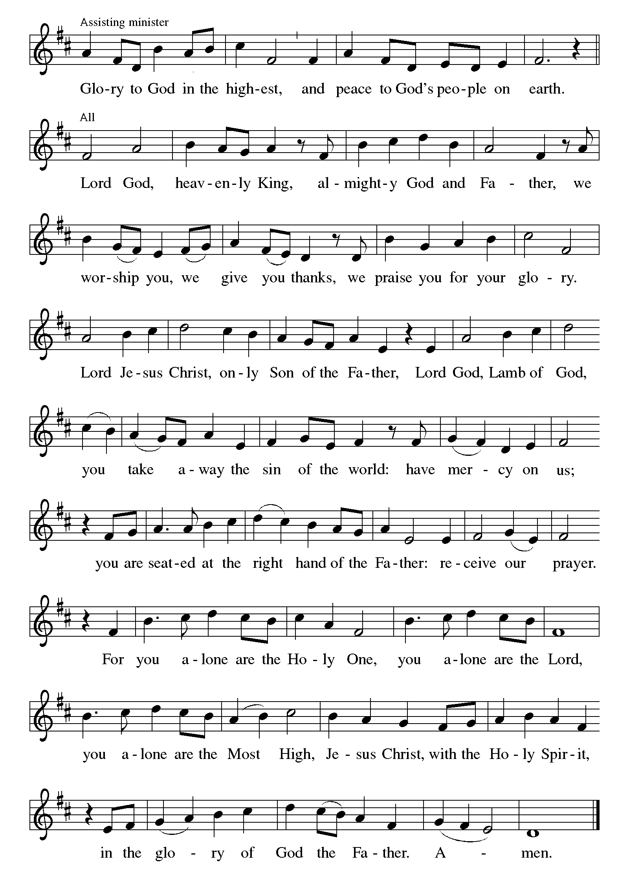**THE PRAYER OF THE DAY**

P: The Lord be with you.

C: **And also with you.**

P: Let us pray. Almighty God, You made this holy Night shine with the brightness of the true

Light. Grant that here on earth we may walk in the light of Jesus’ presence, and at the last Day

wake to the brightness of His glory; through Your only Son, Jesus Christ our Lord, Who lives

and reigns with You and the Holy Spirit, one God, now and forever.

C: **Amen.**

*The assembly is seated*

**✠WORD✠**

**FIRST READING Isaiah 9:2-7**

*Originally, this poem was written to celebrate either the birth or the coronation of a new Davidic king. After the fall of Jerusalem, this poem came to be viewed as an expression of the hope that eventually God would raise up a new ruler who would possess the qualities described in the text.*

The people who walked in darkness

have seen a great light;

those who lived in a land of deep darkness--

on them light has shined.

3You have multiplied the nation,

you have increased its joy;

they rejoice before you

as with joy at the harvest,

as people exult when dividing plunder.

4For the yoke of their burden,

and the bar across their shoulders,

the rod of their oppressor,

you have broken as on the day of Midian.

5For all the boots of the tramping warriors

and all the garments rolled in blood

shall be burned as fuel for the fire.

6For a child has been born for us,

a son given to us;

authority rests upon his shoulders;

and he is named

Wonderful Counselor, Mighty God,

Everlasting Father, Prince of Peace.

7His authority shall grow continually,

and there shall be endless peace

for the throne of David and his kingdom.

He will establish and uphold it

with justice and with righteousness

from this time onward and forevermore.

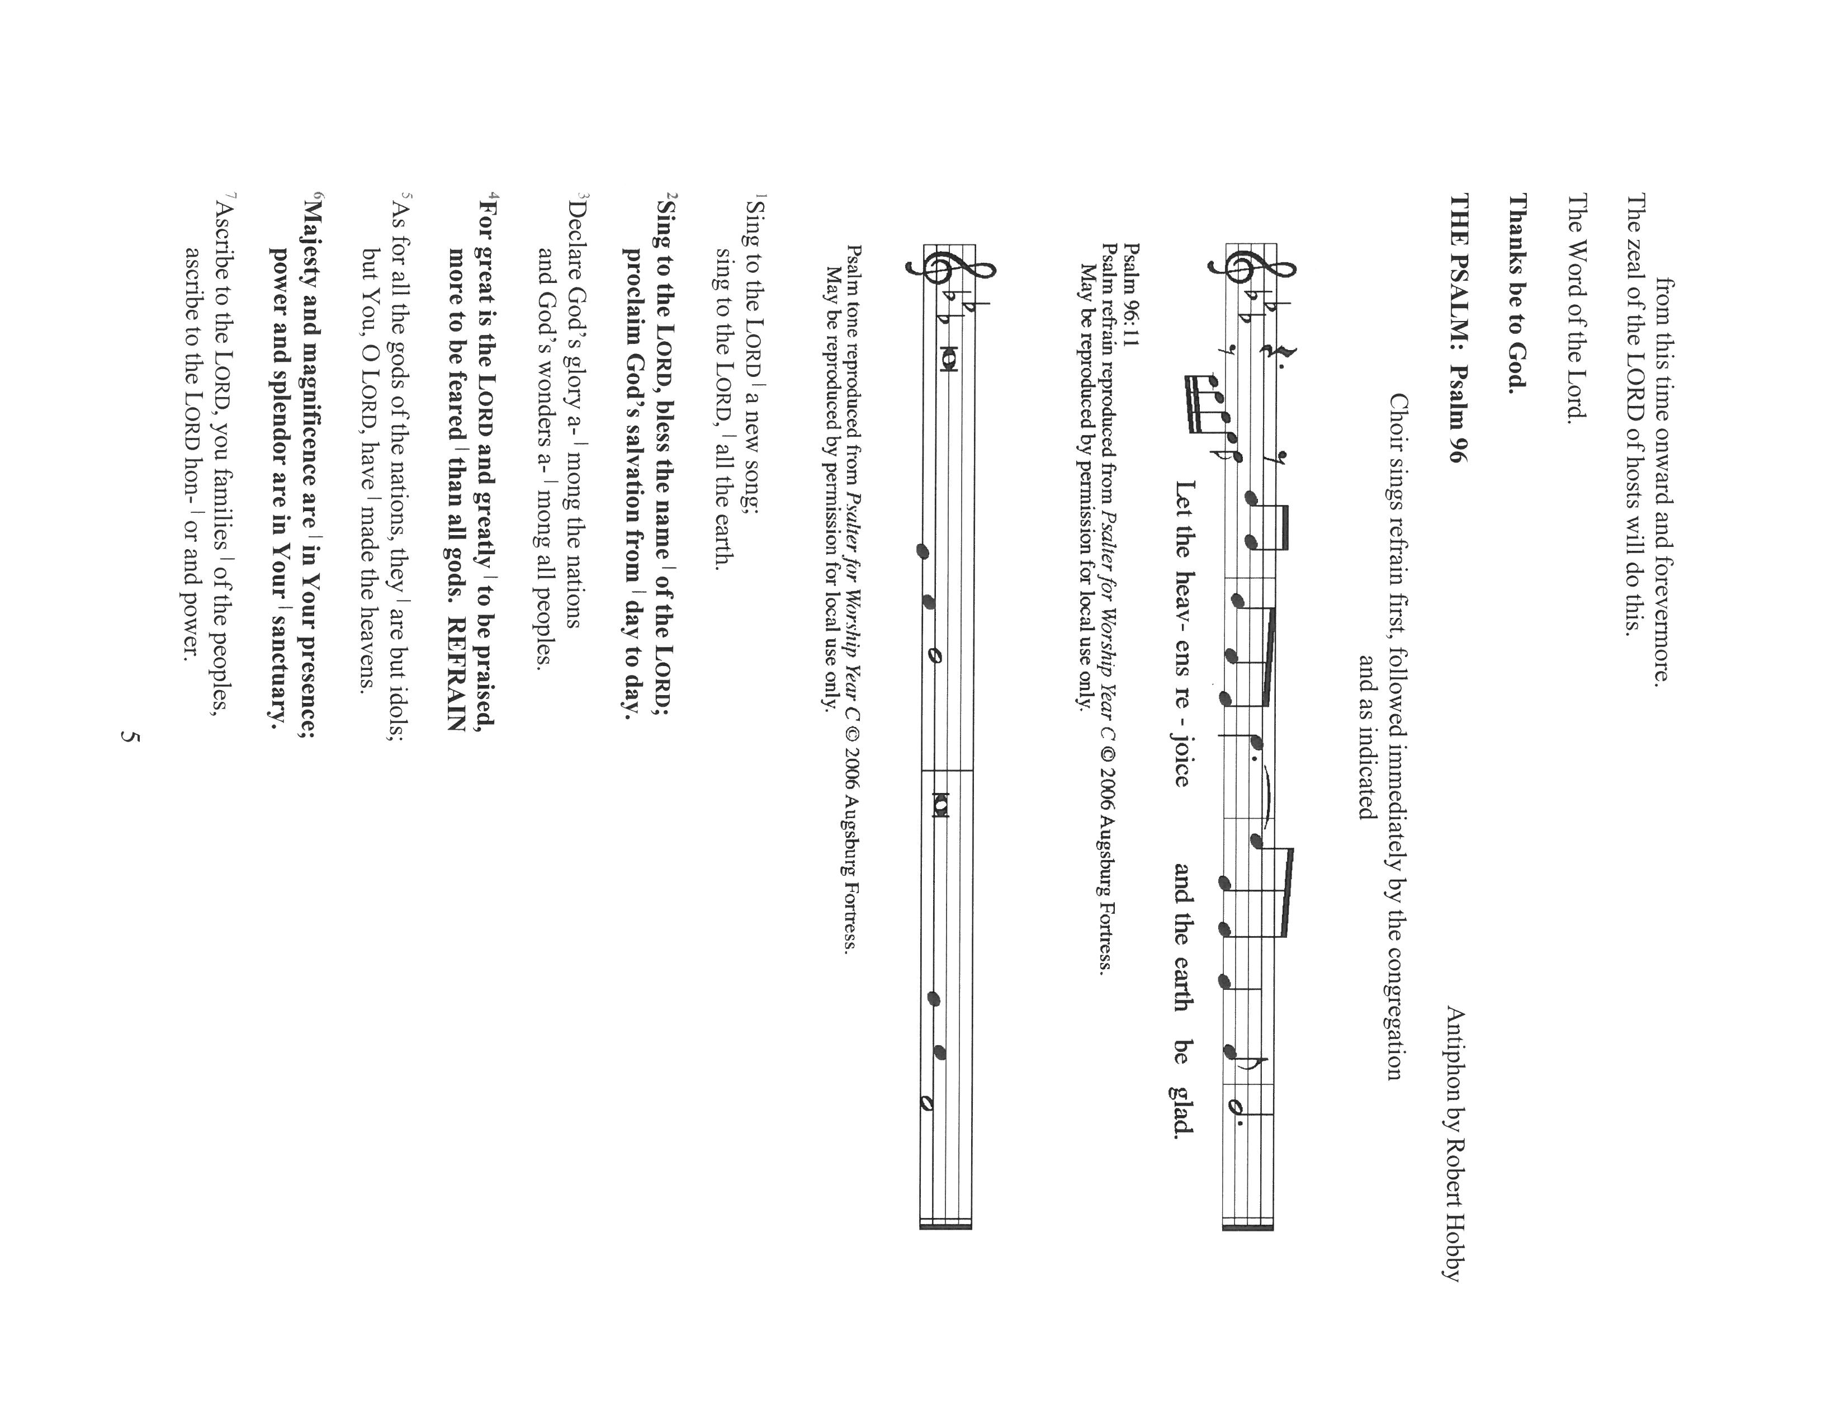

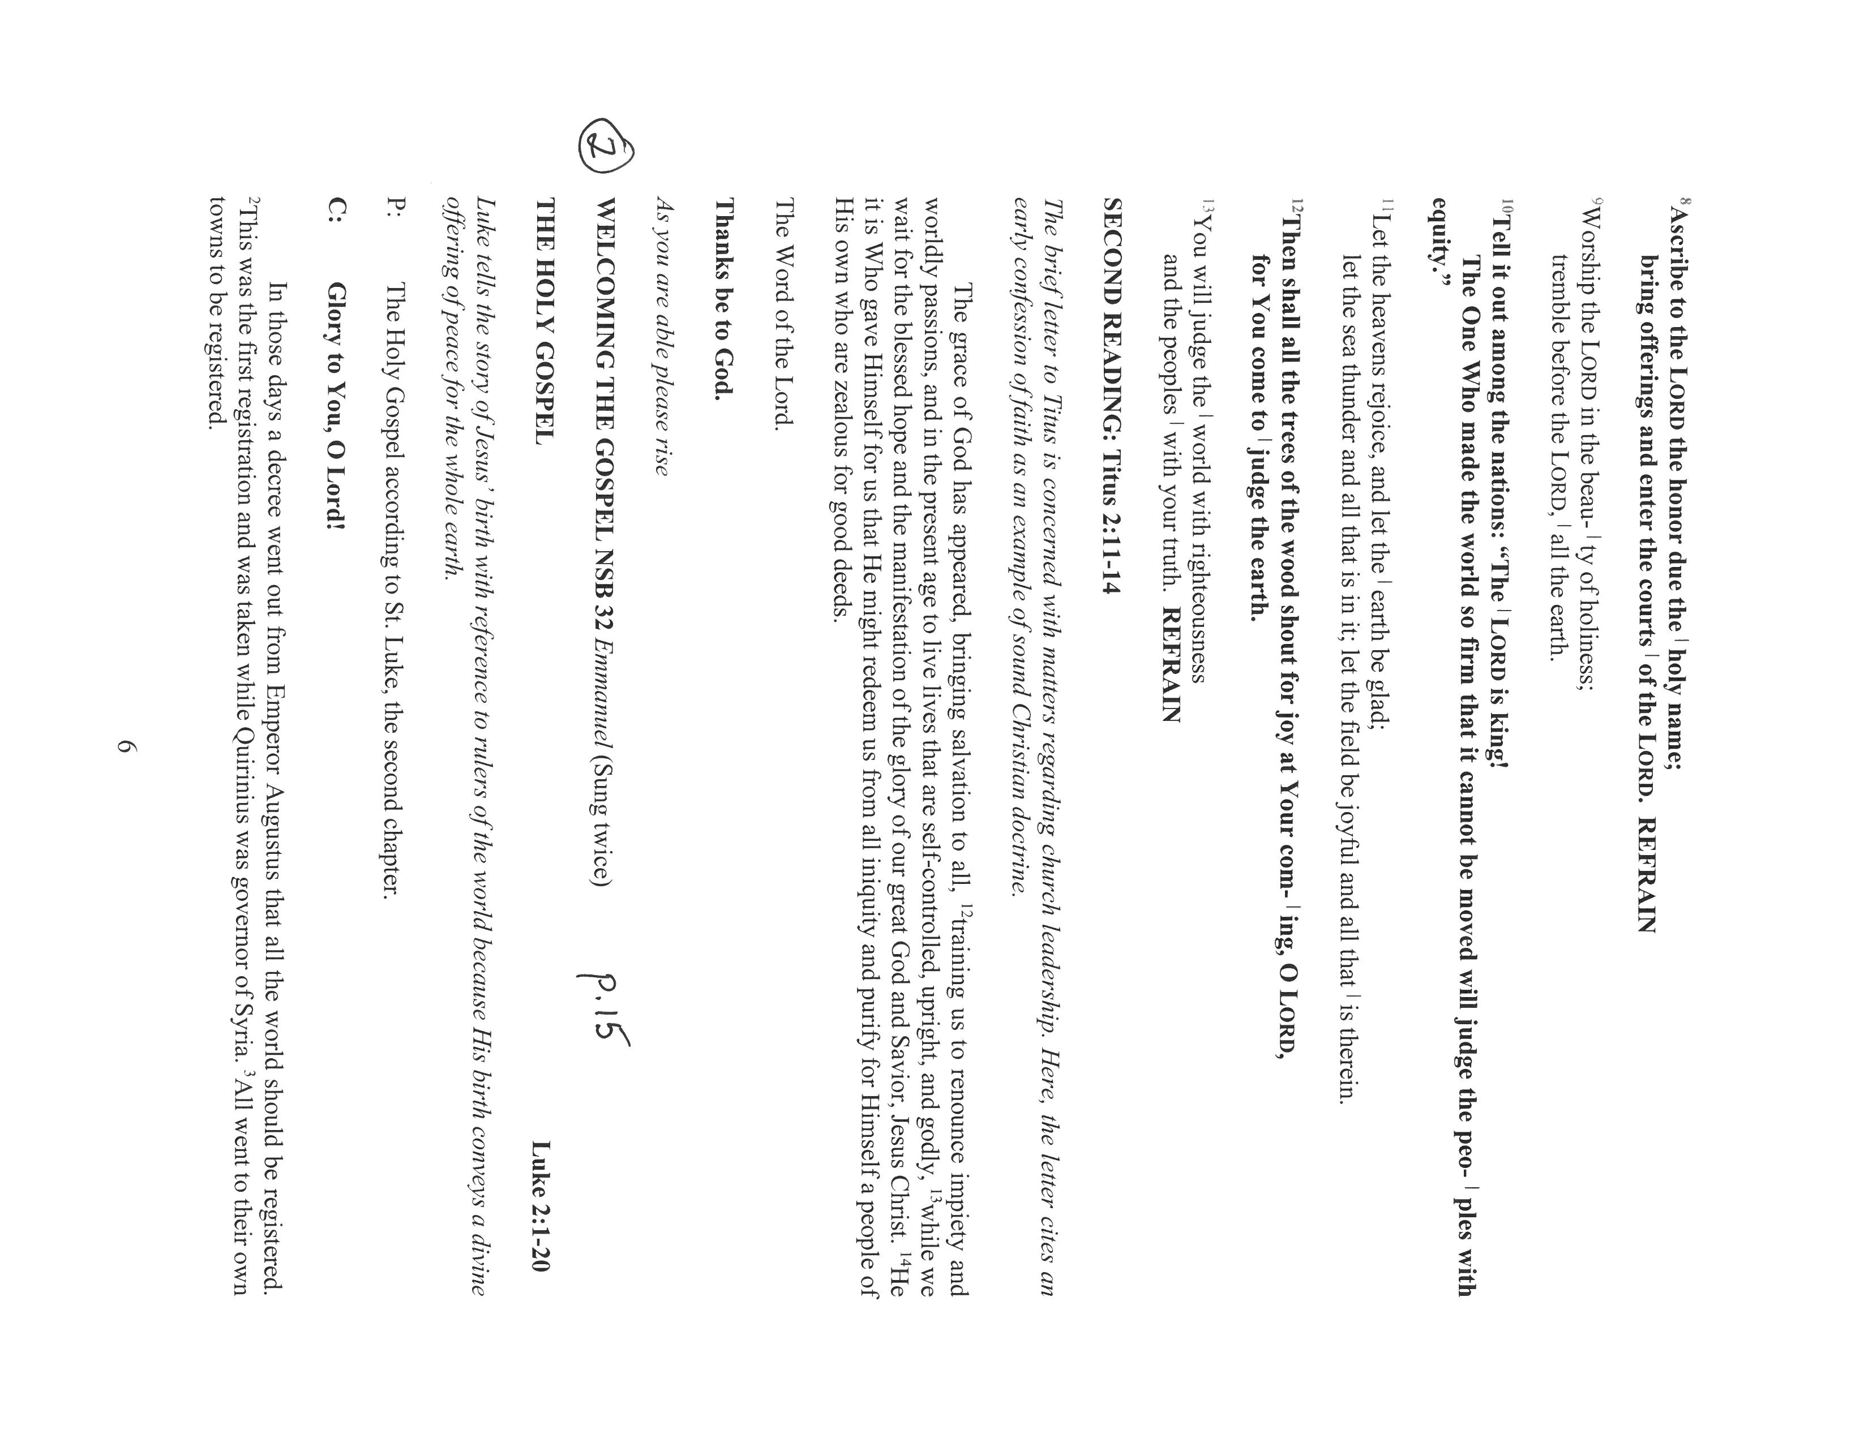

**WELCOMING THE GOSPEL NSB 32 *Emmanuel***(Sung twice) **page 15**

**THE HOLY GOSPEL Luke 2:1-20**

*Luke tells the story of Jesus’ birth with reference to rulers of the world because His birth conveys a divine offering of peace for the whole earth.*

P: The Holy Gospel according to St. Luke, the second chapter.

C: **Glory to You, O Lord!**

In those days a decree went out from Emperor Augustus that all the world should be registered. 2This was the first registration and was taken while Quirinius was governor of Syria. 3All went to their own towns to be registered.

4Joseph also went from the town of Nazareth in Galilee to Judea, to the city of David called Bethlehem, because he was descended from the house and family of David. 5He went to be registered with Mary, to whom he was engaged and who was expecting a child. 6While they were there, the time came for her to deliver her child. 7And she gave birth to her firstborn Son and wrapped Him in bands of cloth, and laid him in a manger, because there was no place for them in the inn.

8In that region there were shepherds living in the fields, keeping watch over their flock by night. 9Then an angel of the Lord stood before them, and the glory of the Lord shone around them, and they were terrified. 10But the angel said to them, "Do not be afraid; for see--I am bringing you good news of great joy for all the people: 11to you is born this day in the city of David a Savior, who is the Messiah, the Lord. 12This will be a sign for you: you will find a child wrapped in bands of cloth and lying in a manger." 13And suddenly there was with the angel a multitude of the heavenly host, praising God and saying,

14"Glory to God in the highest heaven,

and on earth peace among those whom He favors!

15When the angels had left them and gone into heaven, the shepherds said to one another, "Let us go now to Bethlehem and see this thing that has taken place, which the Lord has made known to us." 16So they went with haste and found Mary and Joseph, and the child lying in the manger.

17When they saw this, they made known what had been told them about this child; 18and all who heard it were amazed at what the shepherds told them. 19But Mary treasured all these words and pondered them in her heart. 20The shepherds returned, glorifying and praising God for all they had heard and seen, as it had been told them.

P: The Gospel of the Lord.

C: **Praise to You, O Christ!**

*The assembly is seated*

**THE HOMILY**

*Silence for reflection and meditation follows the homily*

*As you are able please rise*

**THE SONG OF THE DAY 290 *Go, Tell It On the Mountain*  page 16**

**THE NICENE CREED**

A: God has made us His people through our Baptism into Christ. Living together in trust and

hope, we confess our faith.

C: **We believe in one God,**

**the Father, the Almighty,**

**maker of heaven and earth,**

**of all that is, seen and unseen.**

**We believe in one Lord, Jesus Christ,**

**the only Son of God,**

**eternally begotten of the Father,**

**God from God, Light from Light,**

**true God from true God,**

**begotten, not made,**

**of one Being with the Father.**

**Through him all things were made.**

**For us and for our salvation**

**He came down from heaven;**

**by the power of the Holy Spirit**

**He became incarnate from the virgin Mary, and was made man.**

**For our sake He was crucified under Pontius Pilate;**

**He suffered death and was buried.**

**On the third day He rose again**

**in accordance with the Scriptures;**

**He ascended into heaven**

**and is seated at the right hand of the Father.**

**He will come again in glory to judge the living and the dead,**

**and His kingdom will have no end.**

**We believe in the Holy Spirit, the Lord, the giver of life,**

**Who proceeds from the Father and the Son.**

**With the Father and the Son He is worshiped and glorified.**

**He has spoken through the prophets.**

**We believe in one holy catholic and apostolic Church.**

**We acknowledge one Baptism for the forgiveness of sins.**

**We look for the resurrection of the dead,**

**and the life of the world to come. Amen**

**THE PRAYER OF THE CHURCH**

A: This Night the eternal Word of God is born in us. We pray for Christ’s light of life to take

flesh in the Church, the creation, and all people of God.

A: We bring to the manger our longing for the visible unity of the Church of Jesus Christ, that

with one heart and one voice it might proclaim the One Whose birth brings good news of great

joy to all people. Lord, in Your mercy,

C: **Hear our prayer.**

A: We bring to the manger hope for the well-being of creation, that every valley might be lifted

up and every rough place be made plain for the coming of its Lord in flesh and blood among

us. Lord, in Your mercy,

C: **Hear our prayer.**

A: We bring to the manger our dream of the reign of the Prince of Peace, that all nations, tribes,

and peoples will see and cherish in each other the very image of Christ. Lord, in Your mercy,

C: **Hear our prayer.**

A: We bring to the manger our prayers for those who have no place to lay their heads this Night,

and for those who dwell in the shadow of loneliness, despair, illness, or death. We beg that

the Child for Whom there was no room will open the doors of our hearts to the needs of our

neighbors. Lord, in Your mercy,

C: **Hear our prayer.**

A: We bring to the manger all who, like the Holy Family, gather with children in the joy of this

most holy Night, that the gift of faith might be passed and grow in another generation. Lord,

in Your mercy,

C**: Hear our prayer.**

A: We bring to the manger the hopes and dreams of all the years that with Mary and Joseph, angels

and archangels, saints and martyrs, loved ones of every time and place, our prayers and praises

join in a common song uniting heaven and earth in a single peace. Lord, in Your mercy,

C: **Hear our prayer.**

P: Into Your outstretched arms, O God, we commend ourselves and those for whom we pray,

trusting in Jesus Christ the Light and Life of the world.

C: **Amen.**

**✠ MEAL✠**

**THE PEACE**

P: The peace of the Lord be with you always.

C: **And also with you.**

*The assembly is seated*

**THE VOLUNTARY *Mary, Did You Know?***

*As you are able please rise*

**THE OFFERTORY PRAYER**

A: Let us pray. Blessed are You,

C: **O Lord our God, Source of all light and gladness. Through Your goodness we have these**

**gifts to share. Receive all we offer You on this joyful Feast. Nourish us at Your Table,**

**that Your Word may take flesh in our lives, and we may grow up in Him Who unites our**

**lives to Yours, Jesus Christ our Lord. Amen.**

**THE GREAT THANKSGIVING**

P: The Lord be with you.

C: **And also with you.**

P: Lift up your hearts.

C: **We lift them up to the Lord.**

P: Let us give thanks to the Lord our God.

C: **It is right to give Him thanks and praise.**

P: It is indeed right, our duty, and our joy … join their unending hymn:

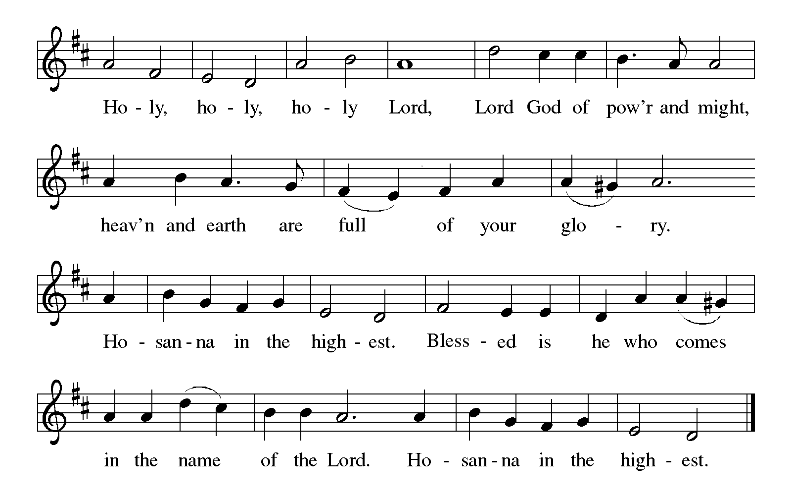

P: Almighty God, You shape Your very life to create and restore and enjoy us forever.

We gather around Your altar like those who thronged Your Son’s manger, longing for You

to reassemble men and women, kings and working people, Jews and Gentiles,

heaven and earth at the place where Your divinity and our humanity meet.

You had too much love to keep it for Yourself; and though we took up arms against

You and one another You disarmed us in coming into our midst as a defenseless

Baby.

As His arms were tied in swaddling clothes, so later His hands were nailed to the cross;

Yet You made His birth the foretaste of our redemption and His death the gateway to

resurrection life.

God of new birth, as You laid Your Son in Mary’s arms, You place these gifts of bread and

wine in our hands.

Sanctify Your Church to be as fragile and tender and true as the infant Savior.

Send down Your Holy Spirit, that this bread gathered from the fields and this cup of grapes

gathered from the vineyards may be for us the Body and Blood of Your Son,

Jesus Christ,

Who, in the night ... “Do this for the remembrance of Me.”

As often as we eat ... we proclaim the Lord’s death until He comes.

C: **Christ has died. Christ is risen. Christ will come again.**

P: God Who exalts the humble and humbles the exalted, as You drew the shepherds to

the manger call us to Yourself, and bring Your creation to its consummation.

Lift Your whole Church, living and departed, to the vision of Your glory, once

made flesh in a humble family, now exalted and reigning with justice and mercy.

In this Banquet restore us to Your image, surround us with Your company, and prepare

us for Your freedom, after the pattern of Your Son,

Through Whom and with Whom and in Whom, in the unity of the Holy Spirit, all honor

and glory is Yours, Almighty Father, now and forever.

C: **Amen!**

**THE LORD’S PRAYER**

P: The Word became flesh and dwelled among us, that as children of God we might dare to

pray:

C: **Our Father in heaven, hallowed be Your name. Your Kingdom come. Your will be done**

**on earth as in heaven. Give us this day our daily bread, and forgive us our sins as we**

**forgive those who sin against us. Save us from the time of trial and deliver us from evil,**

**for the Kingdom, the power, and the glory are Yours, now and forever. Amen.**

**INVITATION TO THE MEAL**

P: Behold Mary’s Child, the promised Savior, of Whose fullness we have all received. Blessed

are those who are called to the Supper of the Lamb. God’s holy gifts for God’s holy people.

Come, for all is now ready.

*The assembly is seated*

**THE DISTRIBUTION**

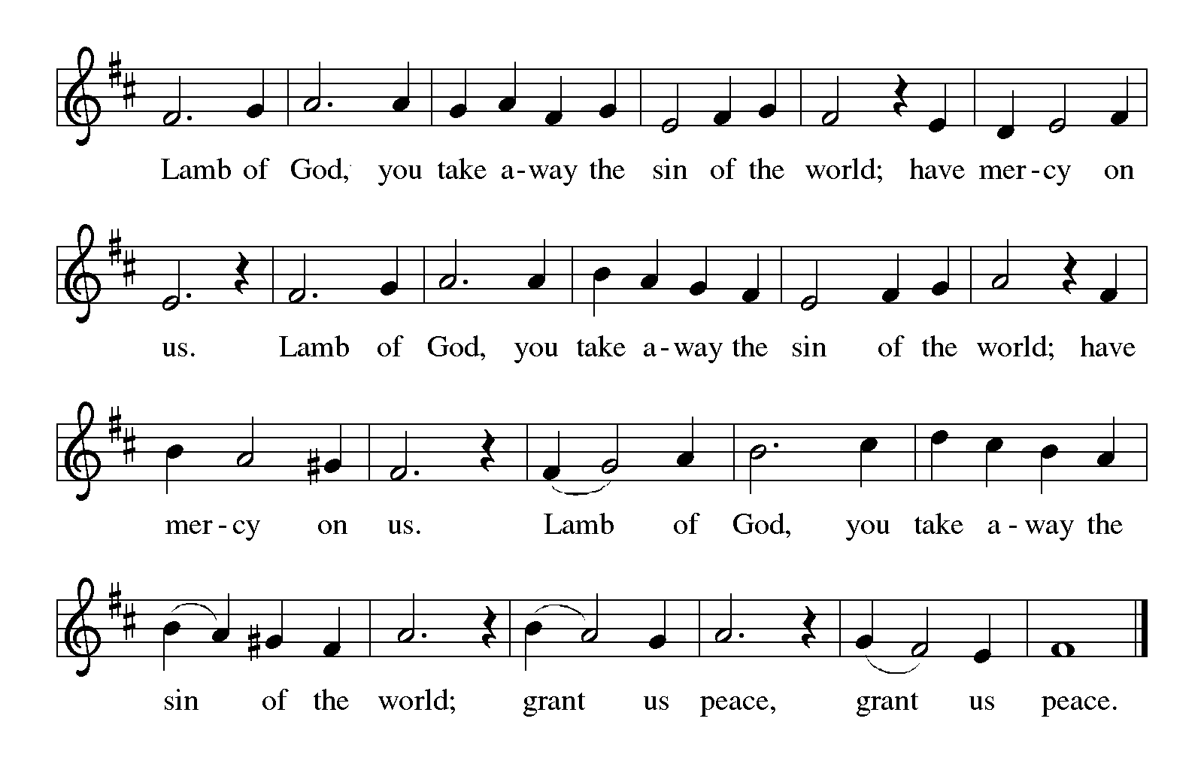

**ST. PAUL SENIOR CHOIR *Christmas Communion Song***

**HYMNS DURING DISTRIBUTION 276 *Infant Holy, Infant Lowly*  page17**

**279 *O Little Town of Bethlehem*  page 18**

**289** ***Angels We Have Heard on High*  page 19**

*As you are able please rise*

**THE POST-COMMUNION BLESSING**

P: The Body and Blood of our Lord Jesus Christ strengthen you and keep you in His grace.

C: **Amen.**

**HYMN DURING THE CANDLE-LIGHTING *Peace, Peace w/Silent Night* SPS CHOIR**

**THE HOLY GOSPEL John 1:1-5, 14**

P: The Holy Gospel according to St. John, the first chapter.

C: **(With candles raised) Glory to You, O Lord!**

In the beginning was the Word, and the Word was with God, and the Word was God. He was in the beginning with God. All things came into being through Him, and without Him not one thing came into being. What has come into being through Him is life, and the life was the light of all people. The light shines in the darkness, and the darkness did not overcome it.

And the Word became flesh, and lived among us, and we have seen His glory, glory as of a Father’s only Son, full of grace and truth.

P: The Gospel of the Lord.

C: **(With candles raised) Praise to You, O Christ!**

**THE HYMN 281 *Silent Night*  page 20**

**THE POST-COMMUNION PRAYER**

A: Let us pray. Gracious God, You gave Your only Son that we may know and love You with

body, heart, and mind. United in the body of Christ, may we glorify and praise You in our

lives for all that we have heard and seen in the wonder of the Word made flesh, Jesus Christ

our Lord.

C: **Amen.**

**✠ SENDING ✠**

**BENEDICTION**

P: May the Father, Who in these last days has spoken to us by a Son, bless you.

May the Son, born of Mary, enthroned in a manger, bless you.

May the Holy Spirit, ✠ power of the Most High, bless you.

C: **Amen.**

**THE RECESSIONAL HYMN 267** ***Joy to the World*  page 21**

The congregation faces the cross as it leaves

**THE DISMISSAL**

A: Glory to God in the highest!

C: **Peace to God’s people on earth!**

A: Go in peace. Serve the Lord.

C: **Thanks be to God!**

**POSTLUDE** ***Joy to the World***

**✠ To God Alone Be Glory✠**

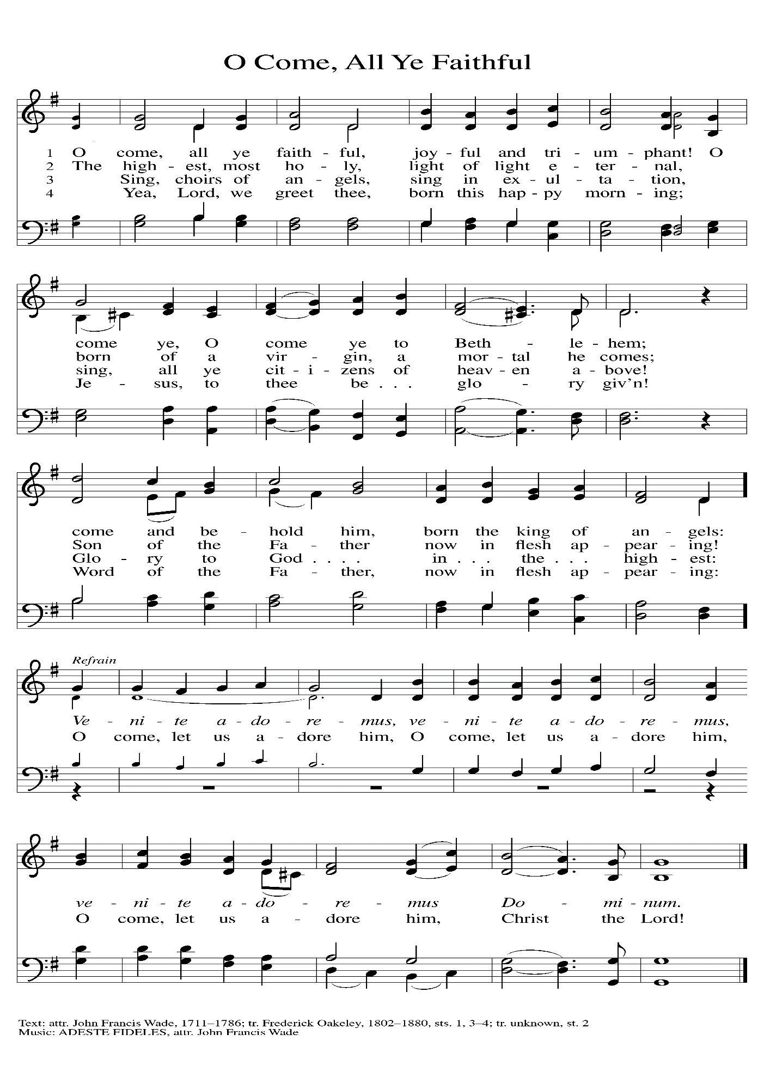

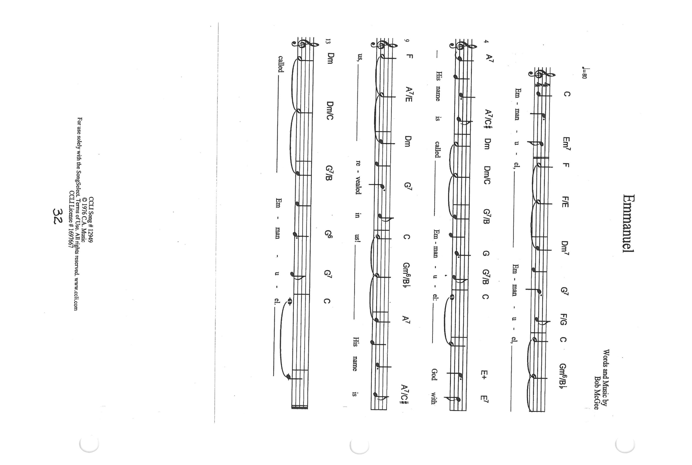

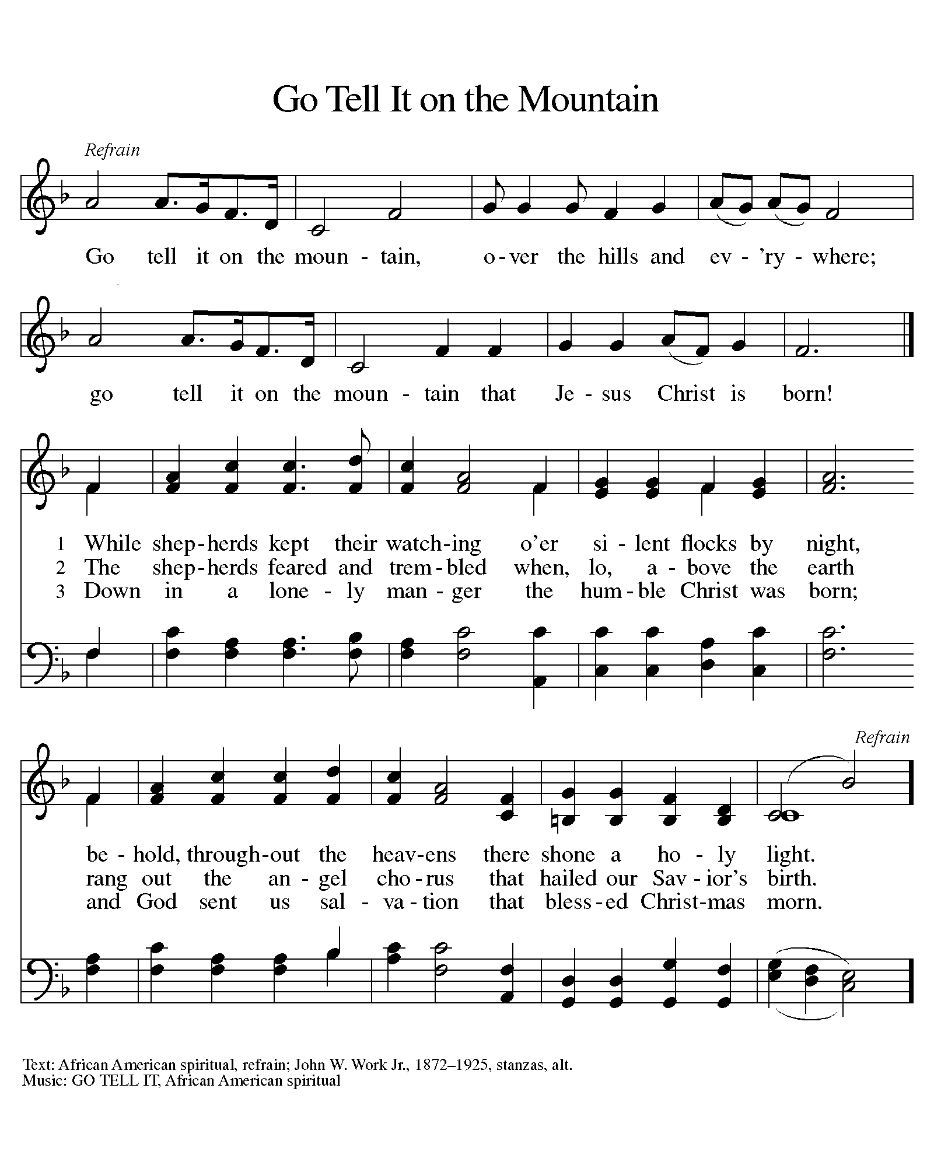

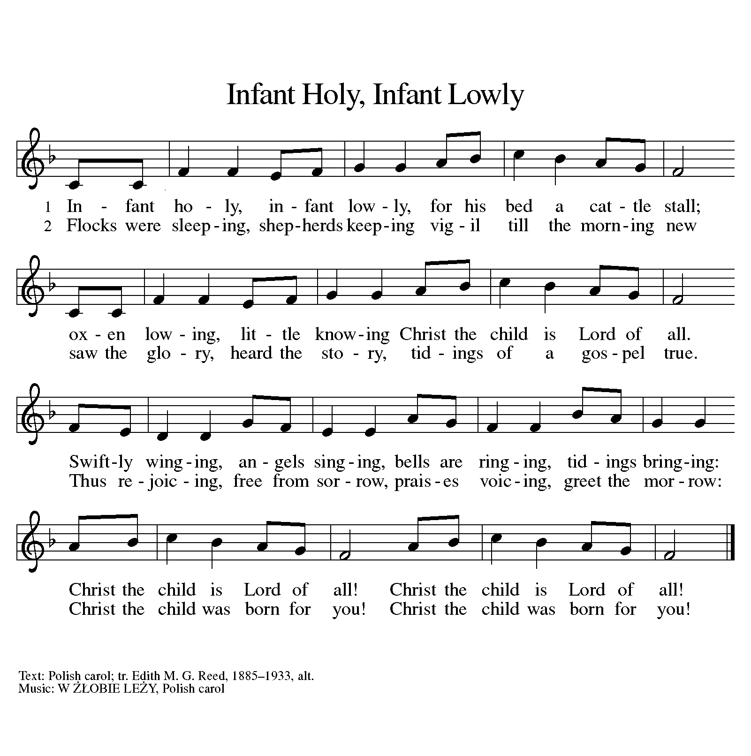

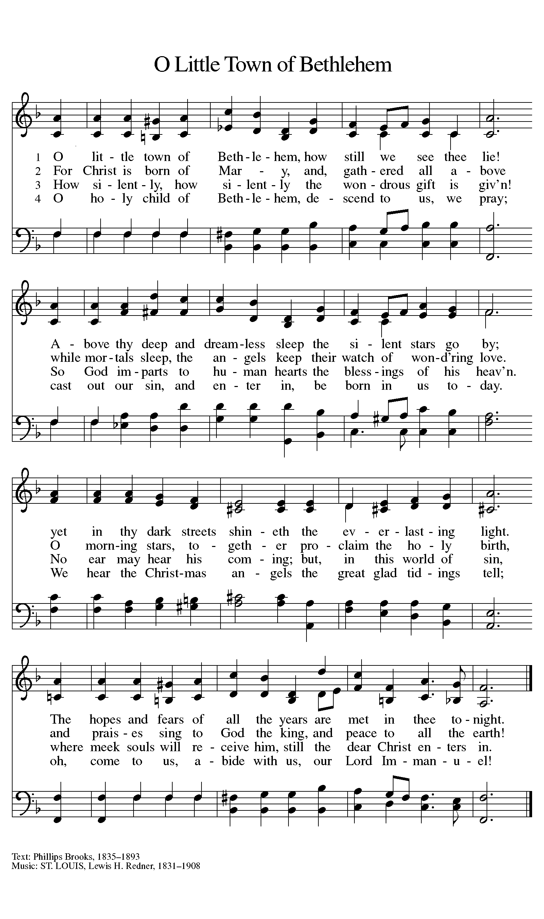

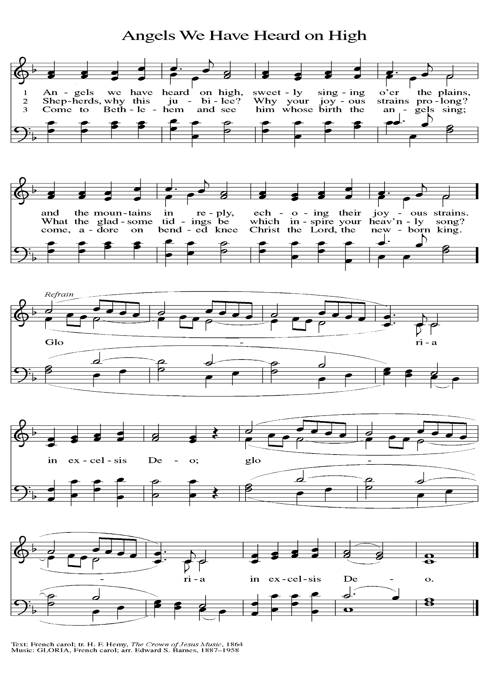

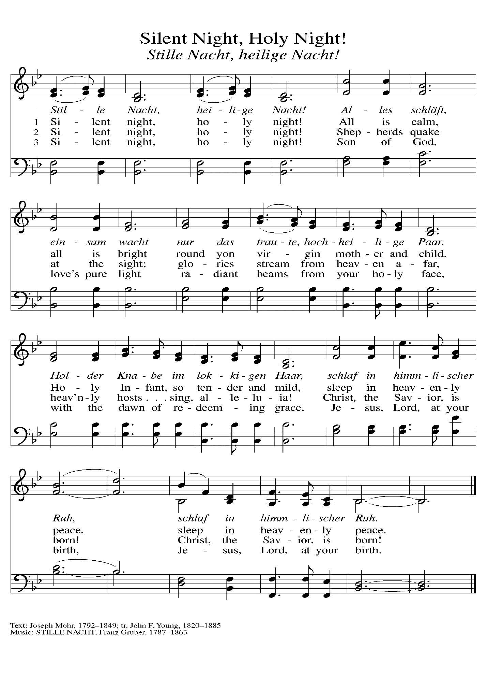

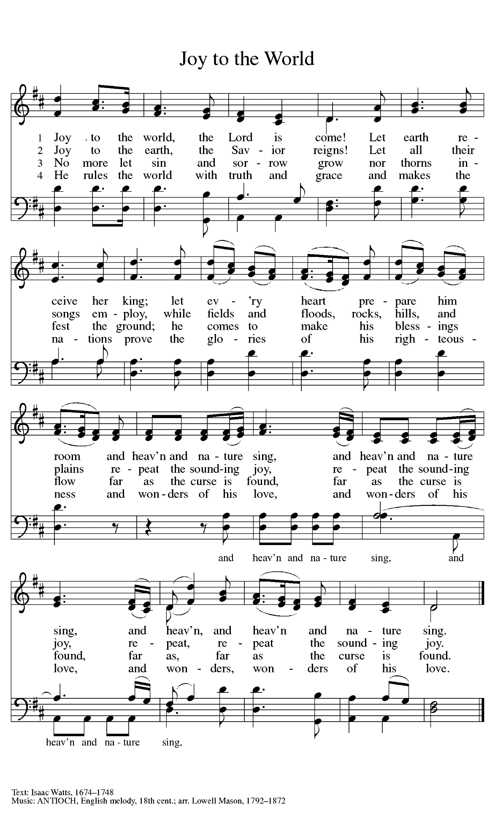

**POINSETTIAS 2021**

Mary Knaup 3 plants. One in memory of Victor Herbert; one in memory of Kathryn Herbert; and one in memory of Dennis Knaup

Rich & Karen Fleming 2 plants. One in memory of Karen’s mother Mary Knapp and one in memory of Norma Fleming

Beverly Johnson 2 plants in honor of family

Paul & Lora Brooks 1 plant in memory of

Dan Reef and Maggie Brooks

Diane Gielow 1 plant in memory of loved ones

Melinda Nagle 2 plants. One plant in memory of her parents, Randall & Lois Miller and one in honor of her new grandson, Miles Andres

Pamela Thiede 1 plant in memory of her parents

Rynold & Evelyn Thiede

Richard Thielman 3 plants. One in loving memory of Lori Hall; one in loving memory of Norman & Marcella O’Donnell; and one in loving memory of Donald & Desolyn Thielman

Nancy Mauman and family 3 plants. One in loving memory of

her husband, John Mauman; one in loving memory of her parents, Dorothy & Wally Liebig; and one in loving memory of loved ones

Richard & Pamela Henderson 3 plants. One in memory of her Mom, Suzanne Cains; one in memory of his Father, Gary Henderson; and one in honor of their daughters,

Madeline and Audrey

Mike and Marge Bockover 3 plants in memory of loved ones

Susan Koziel 2 plants. One in memory of loved ones; and one in honor of her children and grandchildren

Don & Beth Thompson 2 plants. One in memory of Palmer and Ruth Thompson and loved ones; and one in memory of Suzanne Cains and in honor of Richard Cains

Gail Leffew 1 plant in memory of Paul Leffew

Sandy Robbins 1 plant in memory of Sonny (Henry) Robbins

Bob and Karen Kiser 1 plant in memory of loved ones

Maxine Powell 2 plants. One in memory of Clint Powell and one in memory of Connie Hollis

Virginia Murray 1 plant in memory of loved ones

Carol & Fred Weiss 2 plants. 1 plant in memory of their son Donald; and 1 plant in memory of Fred’s sister Suzanne Cains

Janet Bakken 2 plants in memory of loved ones and in honor of family and friends

Susan Bagby 1 plant in memory of her parents Raymond and Hazel Reiter

Brenda Biggs 2 plants. One in memory of Sue Biggs wife of Roland, and one in memory of her mother, Sue Biggs and grandmother to her nieces and nephews Sue Biggs

Bill & Carol Geleske 1 plant in memory of Clarence & Leona Lange and 1 in memory of

Robert & Shirley Lange Timm

Tim & Laura Mellen 1 plant

Larry & Judy Litchford 2 plants. 1 in honor of all those in the military; and 1 in honor of all police officers

Chip &Audrey Claussen 2 plants; 1 in memory of her parents, Ollie & Josephine Olson and brother, Richard Olson; and 1 in memory of his parents, Edward & Solveig Claussen

Jason & Carey Howard 2 plants. 1 in memory of her Dad, John Foldenauer; and 1 in memory of his Mom, Christine Leslie

The family of Richard Cains 6 plants in loving memory of Wife, Mother, Grandmother, Suzanne Cains

Carol Radke 1 plant in memory of Al Radke

**ANNOUNCEMENTS**

**Please remember to mail your offering to the Church Office** at 818 Franklin Street, Michigan City, IN 46360**.** Another alternative is to give on-line through Tithe.ly. Please see your closure letter for information on how to set up a Tithe.ly account.

**St. Paul Members are reminded to have** a loved one contact the office if you are hospitalized. Many times, the Pastor doesn’t know someone is in the hospital. If you call and leave a message, please tell us which hospital the patient is at.

**PRAYER CONCERNS:** Kathy Thielman, Audrey Beyer, Bethany Manning, Marla Furness, Kay Peglow, Lee Timm, Ryan Krueger, Donna Bostater, Diane Gielow, Jeff Jensen, Maxine Powell, Jess Kalvaitis, Pastor Al Lorentzen, Jan Paholski, Laura Dovey, Heidi Happel, Shane Nevels, Irene Bohnstadt, Joan Coughlin, Jim Tomscheck, Wally & Betty Ratliff, Laura Moore, Cameron Rackard, Erik Tannehill, Ed Gustum, Ken Mulder, Ashton Steele, Christian Martinez, Nancy Wisser, Ryan Sirk, Tyler Brown, Jary Tannehill, Jim Gleason, Carl Loetz, Knox Shepherd, Patsy Humbers, Ed Riddle and Blythe Topa.

**If you requested someone’s name to be on the prayer list and are aware that they need continued imminent prayer then contact the church office and let us know.** Otherwise we will gradually transfer names to the long-term list.

**OFFICE HOURS:** Libby will be in the office on Mondays, Wednesdays, and Fridays; volunteers will cover Tuesdays and Thursdays.

Monday & Wednesday 8:00 a.m. – 5 p.m.

Tuesday & Thursday 9:00 a.m. – 12:00 p.m.

Friday 8:00 a.m. – 12:00 p.m.

**If you are listening to the worship broadcast on the radio and would like to watch the Sunday morning service live stream follow these steps:**

1. If you have You.Tube available on your TV, search for

**St. Paul Lutheran Church Michigan City, IN.**

(2) The direct link on the computer is

https://www.youtube.com/channel/UC5AIPNaKr3QN50984jGOa1g.

(3) This link is also on the main page of the church’s website in the church section and will continue to be posted weekly on the St. Paul Facebook page.

And it will always be available on the radio broadcast Sunday mornings at 11:00 a.m. on WEFM (95.9), and on the local cable access station #99 for the previous week’s service on Sundays at 4:00 p.m. and the current service on Wednesdays at 7:00 p.m. and Fridays at 8:30 p.m.

**To send e-mail to the church office**, please use the following addresses:

 Pastor Mark Reshan: seniorpastor@stpaulmichigancity.com

 Church Office Secretary (Libby Pollock): churchsecretary@stpaulmichigancity.com

 Church Treasurer (Karen Fleming) and Bookkeeper (Billie Atchinson):

finance@stpaulmichigancity.com.

**The Good News Newsletter**: If you have an article or anything you want included in **The Good News** please send it to the following e-mail address: splcgoodnews@gmail.com. Pastor Pamela Thiede will be using this e-mail address to assemble **The Good News** each month. The deadline for getting information to Pastor Pamela will be the 20th of each month.

**WORSHIP ATTENDANCE for December 18 and 19, 2021**

**4:00 p.m. 35**

**9:00 a.m. 53**

**Total = 88**

**The Community Soup Kitchen serving out of First United Methodist is in need of volunteers.** Sunday through Tuesday is always need, as is occasionally Wednesdays and Thursdays. Hours are 9:30 a.m. to 1:15 p.m. and it is not necessary to stay the entire time. There is also a need for volunteers to be available to help pick up deliveries from the Food Bank when they arrive. If you are able to help please contact their church office at 872-7200.