**THE NATIVITY OF OUR LORD**

**December 25, 2022**

In our Christmas is our Good Friday and our Easter. The incarnation happened, quite simply, so that the redemption could take place. Calvary thoughts at Bethlehem’s stall? But of course. This event we memorialize is no idyll of infancy to be sentimentalized into a tale of the sugar-plum fairy. This is the story of the earthly beginnings of a man who died young, executed as an enemy of the state. Our capacity for self-deceit is such that we can sentimentalize even that.

But the person at the center of these stories was not a sentimental sort. He thought that life had a certain hard quality, that it made demands. The birth of Jesus is about a holy people, the redeemed of the Lord. The people are no less than the people Israel become the church.

Apart from the patriarchs and matriarchs, there is no crib, no cross, no life beginning for us on this day. It is all a gift from start to finish. I speak only the truth of God when I spell out what a life of fidelity to the newborn Jesus could mean. A person who can change your life is born this day in Bethlehem of Judea.

**Gerard S. Sloyan**

**INTRODUCTION**

On this Christmas morning the people of God gather to celebrate the birth of the Word made flesh, Christ our Lord. Luke recounts the familiar story of shepherds and angels; John's gospel tells of the Word that dwells among us, full of grace and truth. The meaning of Christmas is made clear: the light shines in the darkness. It is in the liturgy that we encounter the Word made flesh—in the people of God gathered together as the body of Christ, and in the meal around the holy table. We go forth to be bearers of light as we proclaim this good news to all the ends of the earth.

**✠ In the Name of Jesus ✠**

**✠ GATHERING ✠**

**PRELUDE *Infant Holy, Infant Lowly*  Neil Harmon**

**ANNOUNCEMENTS**

*As you are able please rise*

**A CHRISTMAS CALL TO WORSHIP (Based on Psalm 98)**

P: Sing to God something brand new!

**C: For God has done wonderful things!**

P: God has not forgotten to love us all!

**C: Even the ends of the earth have heard!**

P: Make a joyful noise!

**C: Break forth in song!**

P: With strings and horns,

**C: Sing praise to the Holy One!**

P: With the roaring sea and everything in it!

**C: With all the land and everything in it!**

P: The floods clap their hands,

**C: The hills sing for joy.**

P: Thank God! He is coming to set everything right:

**C: Justice for everyone, everything fair!**

P: Sing to God something brand new!

**C: For God has done wonderful things!**

**PROCESSIONAL HYMN 253 *He Came Down***

The congregation faces the cross as it enters its midst

**THE GREETING AND PRAYER OF THE DAY**

P: To us is born this day a Savior, Jesus Christ our Lord.

The grace of our Lord Jesus Christ, the love of God, and the communion of the Holy

Spirit be with you all.

**C: And also with you.**

**THE HYMN OF PRAISE**

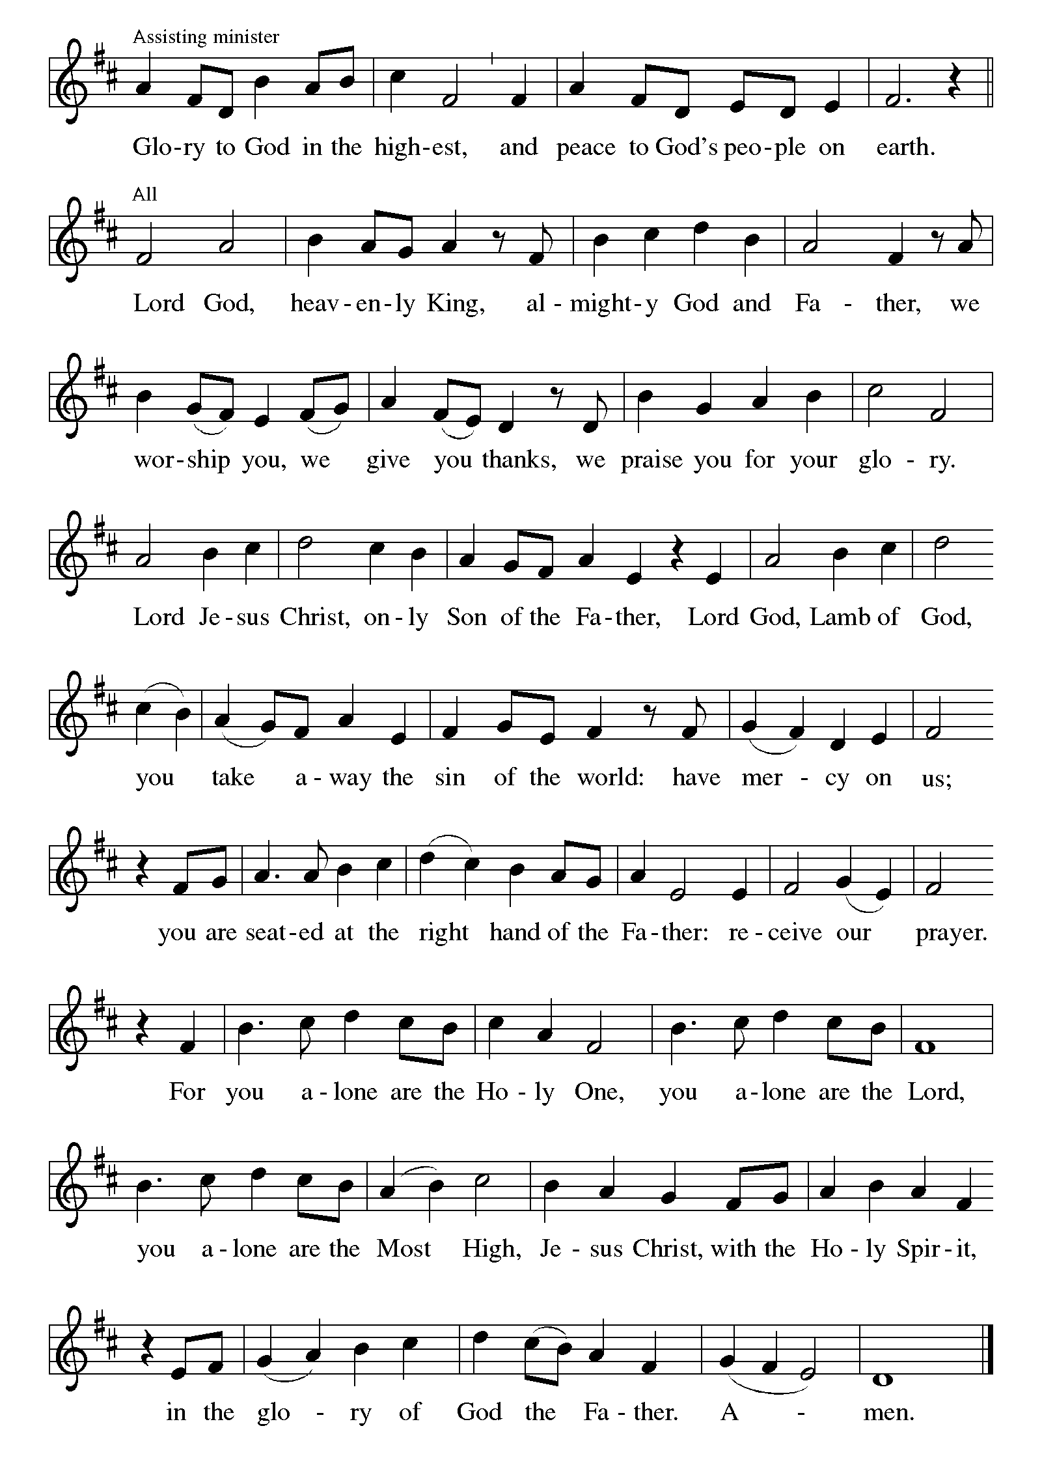

**THE PRAYER OF THE DAY**

P: The Lord be with you.

**C: And also with you.**

P: Let us pray. Almighty God, You wonderfully created and yet more wonderfully

restored the dignity of human nature. In Your mercy, let us share the divine life of

Jesus Christ Who came to share our humanity, and Who now lives and reigns with You

and the Holy Spirit, one God, now and forever

**C: Amen.**

*The assembly is seated*

**✠ WORD ✠**

**THE HOMILY**

**THE HYMN 763 *My Life Flows On in Endless Song***

**FIRST READING Isaiah 52:7-10**

*In chapters 40-55, the prophet announces that the Lord will soon end the exile of God's people in Babylon. In today's reading, the prophet again announces this victory. Note that he is so certain this victory will take place that he announces his message in the past tense, as though it has already happened.*

How beautiful upon the mountains

are the feet of the messenger who announces peace,

who brings good news,

who announces salvation,

who says to Zion, "Your God reigns."

8Listen! Your sentinels lift up their voices,

together they sing for joy;

for in plain sight they see

the return of the LORD to Zion.

9Break forth together into singing,

you ruins of Jerusalem;

for the LORD has comforted his people,

he has redeemed Jerusalem.

10The LORD has bared his holy arm

before the eyes of all the nations;

and all the ends of the earth shall see

the salvation of our God.

The Word of the Lord.

**Thanks be to God.**

**THE PSALM: Psalm 98 Read responsively**

1Sing a new song to the LORD, Who has done marvelous things,

     Whose right hand and holy arm have won the victory.

**2O LORD, You have made known Your victory,**

**You have revealed Your righteousness in the sight of the nations.**

3You remember Your steadfast love and faithfulness to the house of Israel;

     all the ends of the earth have seen the victory of our God.

**4Shout with joy to the LORD, all you lands;**

**lift up your voice, rejoice, and sing.**

5Sing to the LORD with the harp,

     with the harp and the voice of song.

**6With trumpets and the sound of the horn**

**shout with joy before the king, the LORD.**

7Let the sea roar, and all that fills it,

     the world and those who dwell therein.

**8Let the rivers clap their hands,**

**and let the hills ring out with joy before the LORD, Who comes to judge the earth.**

9The LORD will judge the world with righteousness

     and the peoples with equity.

**SECOND READING Hebrews 1:1-4**

*The opening words of this stately epistle present Jesus as the ultimate message of God to us, as the one who perfectly reveals God's glory and being.*

Long ago God spoke to our ancestors in many and various ways by the prophets, 2but in these last days He has spoken to us by a Son, Whom He appointed heir of all things, through Whom He also created the worlds.

3He is the reflection of God's glory and the exact imprint of God's very being, and He sustains all things by His powerful word. When He had made purification for sins, He sat down at the right hand of the Majesty on high, 4having become as much superior to angels as the name He has inherited is more excellent than theirs.

The Word of the Lord.

**Thanks be to God.**

**THE HYMN 487 *What Feast of Love***

*As you are able please rise*

**THE VERSE**

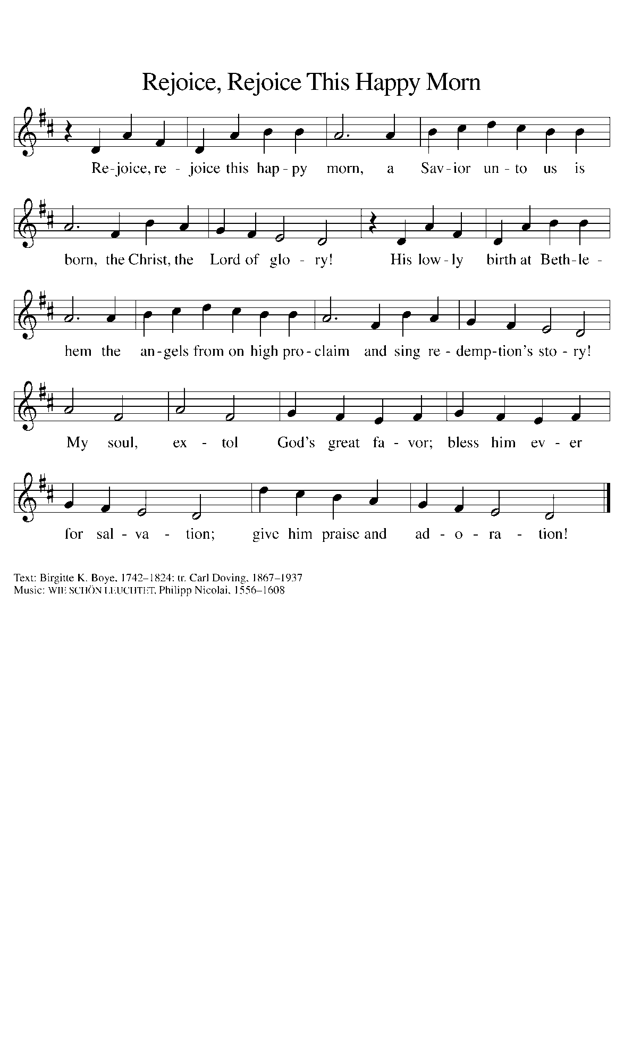

**THE HOLY GOSPEL John 1:1-14**

*The prologue to the gospel of John describes Jesus as the creative word of God made flesh, God's true presence among us, the one whose very existence reveals God as "full of grace and truth."*

P: The Holy Gospel according to St. John, the first chapter.

**C: Glory to You, O Lord!**

In the beginning was the Word, and the Word was with God, and the Word was God. 2He was in the beginning with God. 3All things came into being through Him, and without Him not one thing came into being. What has come into being 4in Him was life, and the life was the light of all people. 5The light shines in the darkness, and the darkness did not overcome it.

6There was a man sent from God, whose name was John. 7He came as a witness to testify to the light, so that all might believe through him. 8He himself was not the light, but he came to testify to the light. 9The true light, which enlightens everyone, was coming into the world.

10He was in the world, and the world came into being through Him; yet the world did not know Him. 11He came to what was His own, and His own people did not accept Him. 12But to all who received Him, who believed in His name, He gave power to become children of God, 13who were born, not of blood or of the will of the flesh or of the will of man, but of God.

14And the Word became flesh and lived among us, and we have seen His glory, the glory as of a father's only son, full of grace and truth.

P: The Gospel of the Lord.

**C: Praise to You, O Christ!**

**THE HYMN OF THE DAY 291 *Let Our Gladness Have No End***

**THE NICENE CREED**

A: God has made us His people through our Baptism into Christ. Living together in trust

and hope, we confess our faith.

**We believe in one God,**

**the Father, the Almighty,**

**Maker of heaven and earth,**

**of all that is, seen and unseen.**

**We believe in one Lord, Jesus Christ,**

**the only Son of God,**

**eternally begotten of the Father,**

**God from God, Light from Light,**

**true God from true God,**

**begotten, not made,**

**of one Being with the Father.**

**Through Him all things were made.**

**For us and for our salvation**

**He came down from heaven;**

**by the power of the Holy Spirit**

**He became incarnate from the virgin Mary, and was made man.**

**For our sake He was crucified under Pontius Pilate;**

**He suffered death and was buried.**

**On the third day He rose again**

**in accordance with the Scriptures;**

**He ascended into heaven**

**and is seated at the right hand of the Father.**

**He will come again in glory to judge the living and the dead,**

**and His kingdom will have no end.**

**We believe in the Holy Spirit, the Lord, the giver of life,**

**Who proceeds from the Father and the Son.**

**With the Father and the Son He is worshiped and glorified.**

**He has spoken through the prophets.**

**We believe in one holy catholic and apostolic Church.**

**We acknowledge one Baptism for the forgiveness of sins.**

**We look for the resurrection of the dead,**

**and the life of the world to come. Amen**

**THE PRAYER OF THE CHURCH**

A: As Christmas fills the earth with the Good News of the Word-made-flesh let our prayer

embrace the needs of all God’s children.

A: You, O God, form Your Church as the Body of Christ. Reshape our hearts to know

Your grace, open our vision to see Your truth, and make our mouths ready to proclaim

Your glory. Lord, in Your mercy,

**C: Hear our prayer.**

A: You speak and the creation comes into being. Call us by a new Word to live in harmony

with our fragile planet that is our common home. Lord, in Your mercy,

**C: Hear our prayer.**

A: You announce peace and salvation to all the earth. Inspire our leaders to find achievable

paths toward greater comfort, justice, and peace for all Your children. Lord, in Your

mercy,

**C: Hear our prayer.**

A: Your years never end, O God. Sustain those whose increasing years have made them

weary; console the young who have already known struggle, and protect newborns

whose lives are just beginning. Lord, in Your mercy,

**C: Hear our prayer.**

A: Anoint us with the oil of Your gladness, that we may celebrate the birth of our Savior

with joy and thanksgiving. Lord, in Your mercy,

**C: Hear our prayer.**

A: That enlivened with the Word-made-flesh in bread and wine, this congregation might

more faithfully live as signs of Christ’s presence in the world. Lord, in Your mercy,

**C: Hear our prayer.**

A: That those who are overshadowed with the darkness of grief, guilt, loneliness, hunger,

poverty, or illness, especially . . . might be filled with the light of God’s warm and

healing love. Lord, in Your mercy,

**C: Hear our prayer.**

A: That with those who have testified in every age to Your glory, full of grace and truth,

we too may live forever in the presence of God’s majesty on high. Lord, in Your

mercy,

**C: Hear our prayer.**

P: Loving Father of the Child Jesus Christ, continue to look upon Your people and

generously answer our prayers, through Your Son, Jesus Christ, Who is Lord and God

this night and forever.

**C: Amen.**

**✠ MEAL ✠**

**THE PEACE**

P: At the birth of Christ the angels sang a song of peace and goodwill.

The peace of the Lord be with you always.

**C: And also with you.**

*The assembly is seated*

**THE OFFERING**

**THE VOLUNTARY *Gesu Bambino*  Pietro A. Yon**

**(soloist Susan Bagby)**

*As you are able please rise*

**THE PRESENTATION OF THE GIFTS 268 *From Heaven Above***

*(*Stanzas 1-3, 12-14)

**THE OFFERTORY PRAYER**

A: Let us pray. Blessed are You,

**C: God of all creation. Through Your goodness we have these gifts to share. Receive**

**our offerings, and nourish us at Your Table, that Your Word might take flesh in**

**our lives; for the sake of Him Who gave Himself for us, Jesus Christ our Lord.**

**Amen.**

**THE GREAT THANKSGIVING**

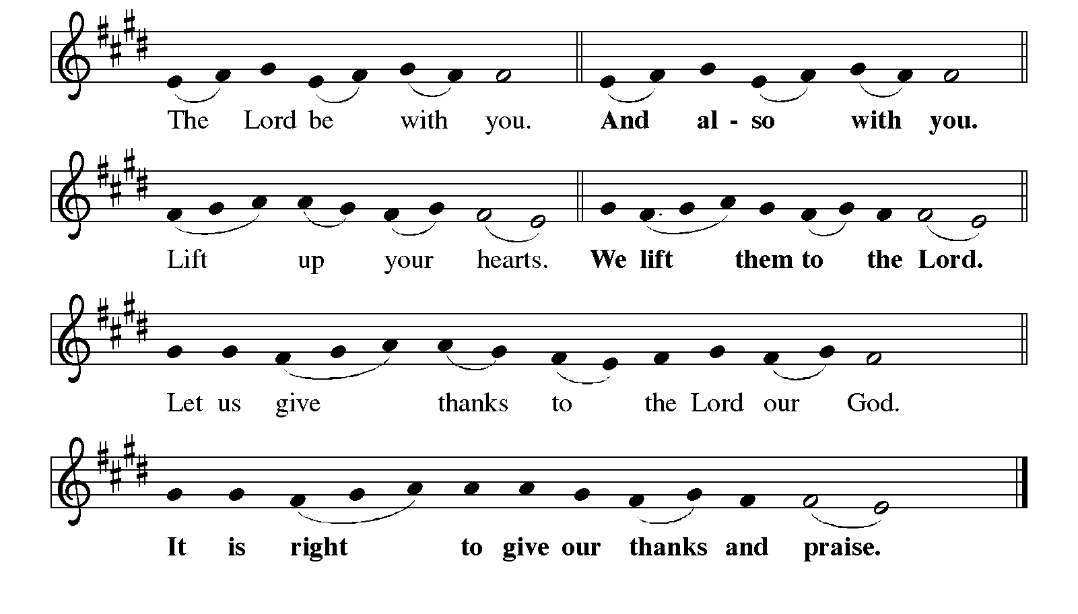

P: It is indeed right and salutary … we praise Your name and join their unending hymn:

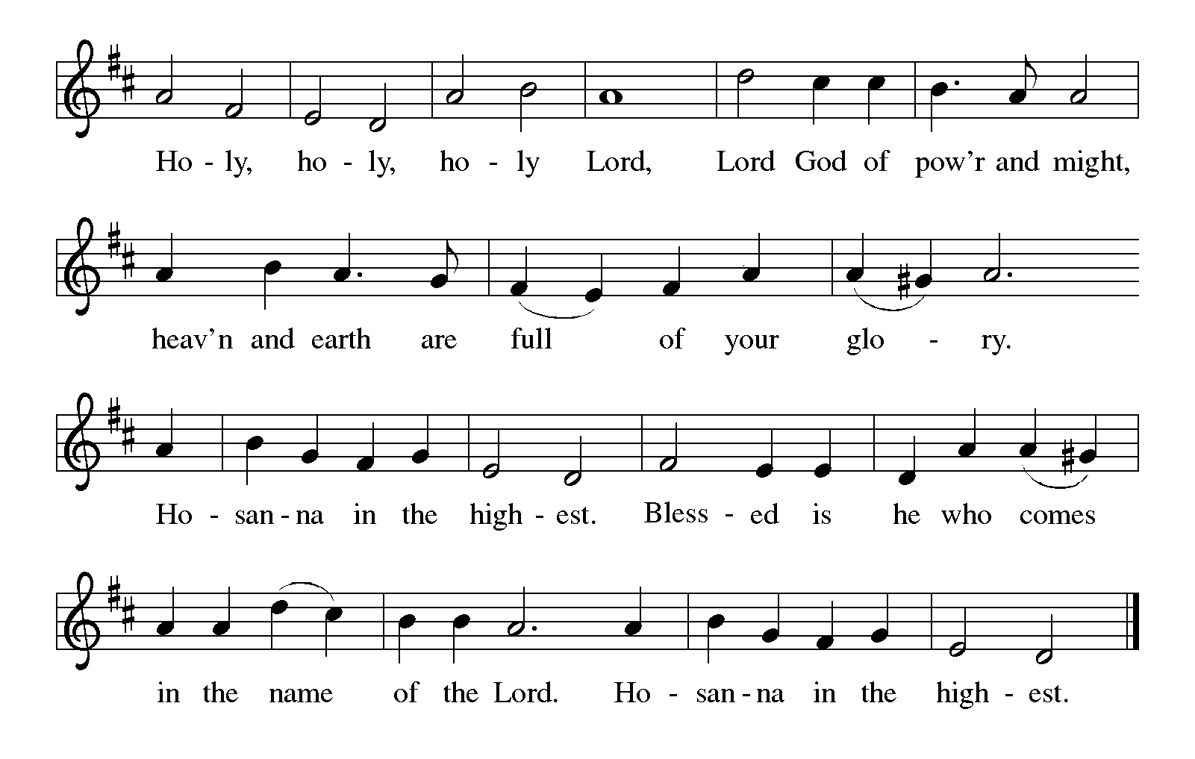

P: Holy One, the Beginning and the End, the Giver of life:

Blessed are You for the birth of creation.

Blessed are You in the darkness and in the light.

Blessed are You for the promise to Your people.

Blessed are You in the prophets’ hopes and dreams.

Blessed are You for Mary’s openness to Your will.

Blessed are You for Your Son Jesus, the Word-made-flesh.

In the night …“Do this for the remembrance of Me.”

As often as we eat ... we proclaim the Lord’s death until He comes.

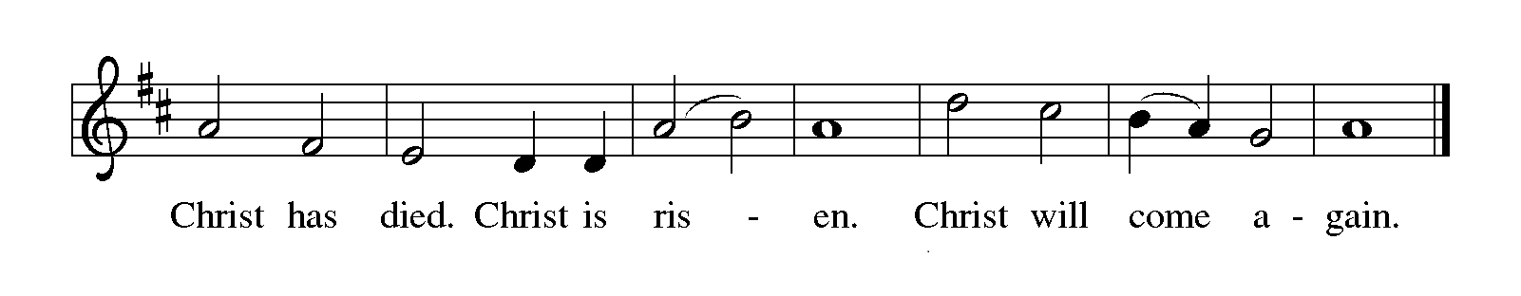

P: With this bread and cup we remember Your Word dwelling among us, full of grace

and truth.

We remember our new birth in His death and resurrection.

We look with hope for His coming.

Holy God, we long for Your Spirit.

Come among us.

Bless this Meal.

May Your Word take flesh in us.

Awake Your people.

Fill us with Your light.

Bring the gift of peace on earth.

All praise and glory are Yours, Holy One of Israel,

Word of God incarnate,

Power of the Most High,

one God, now and forever.

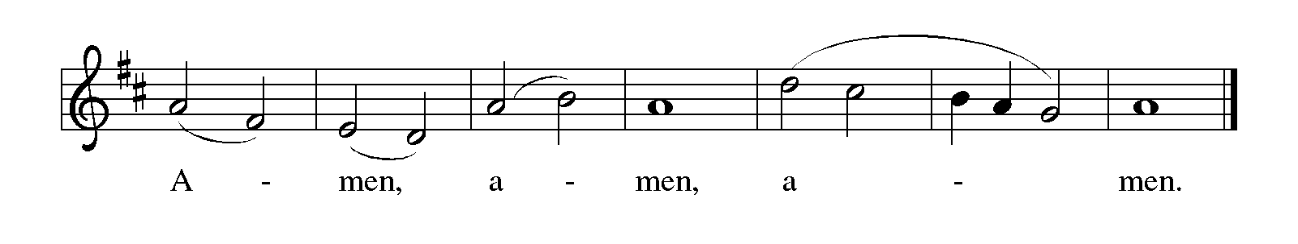

**THE LORD’S PRAYER**

P: The Word became flesh and dwelled among us, that as children of God we might dare

to pray:

**C: Our Father, Who art in heaven, hallowed be Thy Name. Thy Kingdom come.**

**Thy will be done on earth as it is in heaven. Give us this day our daily bread, and**

**forgive us our trespasses as we forgive those who trespass against us. And lead us**

**not into temptation, but deliver us from evil, for Thine is the Kingdom, and the**

**power, and glory, forever and ever. Amen.**

**INVITATION TO THE MEAL**

P: Behold the Light of the world, begotten of the Father’s glory, of Whose fullness and

grace we have all received. Blessed are those who are called to the Supper of the Lamb.

Come, for all is now ready.

*The assembly is seated*

**THE DISTRIBUTION**

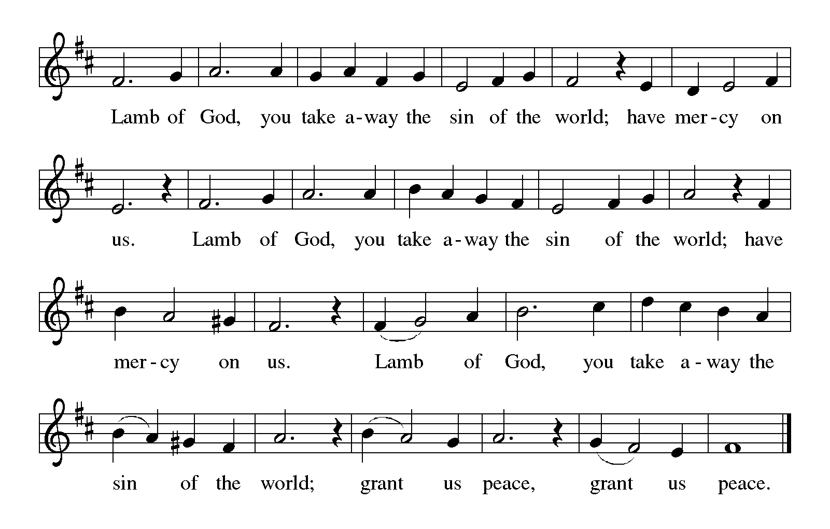

**HYMN DURING DISTRIBUTION 278 *Away in a Manger***

*As you are able please rise*

**THE POST-COMMUNION BLESSING**

P: The Body and Blood of our Lord Jesus Christ strengthen you and keep you in His grace.

**C: Amen.**

**THE POST-COMMUNION PRAYER**

A: Let us pray. God of mystery, in Baptism You give us new birth as Your children. In

this Meal we behold Your living presence among us. Strengthen us with these gifts of

grace, that all creation may know that You dwell among Your people in Jesus, Your

Son, Your Word-made-flesh.

**C: Amen.**

**✠ SENDING ✠**

P: May the Father, Who in these last days has spoken to us by a Son, bless you.

May the Son, born of Mary, enthroned in a manger, bless you.

May the Holy Spirit, ✠ power of the Most High, bless you.

**C: Amen.**

**THE SENDING HYMN 267 *Joy to the World***

The assembly faces the cross as it leaves

**THE DISMISSAL**

A: Glory to God in the highest!

**C: Peace to God’s people on earth!**

A: Go in peace. Serve the Lord.

**C: Thanks be to God!**

**POSTLUDE *Hark the Herald Angels Sing*  Robert A. Hobby**

***✠ To God Alone Be Glory✠***

The Meditation is from *Sundays and Seasons Online.* Copyright 2015 Augsburg Fortress.

The Greeting, Peace, Prayers, and Dismissal and adapted from *Sundays and Seasons.*

Copyright 2017 Augsburg Fortress.

The Eucharistic Prayer is from *Evangelical Lutheran Worship. Leaders Guide.*

(Minneapolis: Augsburg Fortress Publishing House, 2006). 459.

**ANNOUNCEMENTS**

**Please remember to mail your offering to the Church Office** at 818 Franklin Street, Michigan City, IN 46360**.** Another alternative is to give on-line through Tithe.ly. Please see your closure letter for information on how to set up a Tithe.ly account.

**St. Paul Members are reminded to have** a loved one contact the office if you are hospitalized. Many times, the Pastor doesn’t know someone is in the hospital. If you call and leave a message, please tell us which hospital the patient is at.

**PRAYER CONCERNS:** Audrey Beyer, Ryan Krueger, Donna Bostater, MaxinePowell, Jim Tomscheck, Eloise Ponder, Mark & Jary Tannehill, Marvin Dirks, Leonard Cross, George Ottersen, Valerie Waltz, Margie Torres, Dan Pursely, Jayla Jacobi and Lyle Peters.

**If you requested someone’s name to be on the prayer list and are aware that they need continued imminent prayer then contact the church office and let us know.** Otherwise we will gradually transfer names to the long-term list.

**There are some names on the long-term prayer list that have been listed for many months.** We would like to keep the list current so if you requested them to be included please contact the church office and tell us whether you would still like them on the list: Robert Atwood; Laura Eilers-Straight; Terry Hygema; Jess Kalvaitis; Tom and Larry Lueth; Duane Ormsby; Cameron Rackard; Ryan Sirk; Jean Thomas; Heidi Happel; Christian Martinez; Ron Armer.

**OFFICE HOURS:** Libby will be in the office on Mondays, Wednesdays, and Fridays; volunteers will cover Tuesdays and Thursdays.

  Monday & Wednesday 8:00 a.m. – 5 p.m.

Tuesday & Thursday 9:00 a.m. – 12:00 p.m.

Friday 8:00 a.m. – 12:00 p.m.

**If you are listening to the worship broadcast on the radio and would like to watch the Sunday morning service live stream follow these steps:**

(1) If you have You.Tube available on your TV, search for

**St. Paul Lutheran Church Michigan City, IN.**

(2) The direct link on the computer is

https://www.youtube.com/channel/UC5AIPNaKr3QN50984jGOa1g.

(3) This link is also on the main page of the church’s website in the church sec-

tion and will continue to be posted weekly on the St. Paul Facebook page.

And it will always be available on the radio broadcast Sunday mornings at 11:00 a.m. on WEFM (95.9), and on the local cable access station #99 for the previous week’s service on Sundays at 4:00 p.m. and the current service on Wednesdays at 7:00 p.m. and Fridays at 8:30 p.m.

**To send e-mail to the church office**, please use the following addresses:

Pastor Mark Reshan: seniorpastor@stpaulmichigancity.com

Church Office Secretary (Libby Pollock): churchsecretary@stpaulmichigancity.com

Church Treasurer (Karen Fleming): [finance@stpaulmichigancity.com](mailto:finance@stpaulmichigancity.com)

**The Good News Newsletter**: If you have an article or anything you want included in **The Good News** please send it to the following e-mail address: splcgoodnews@gmail.com. Pastor Pamela Thiede will be using this e-mail address to assemble **The Good News** each month. The deadline for getting information to Pastor Pamela will be the 20th of each month.

**WORSHIP ATTENDANCE for December 14, 17 and 18, 2022**

**10:00 a.m. 25**

**4:00 p.m. 25**

**9:00 a.m. 55**

**Total = 105**

**A Reminder**

**The discussion group “Estuary”** led by Pastor Dale Zylstra meets the second Tuesday of the month in the Luther House at 7:00 p.m. The group addresses topics of interest to the participants and is open to everyone.

**Activities, Events & Meetings**

**December 2022**

**Saturday,** December 24, 2022 at 6:00 p.m. Christmas Eve. Worship Service

**Sunday,** December 25, 2022 at 9:00 a.m. Christmas Day Worship Service

**Saturday,** December 31, 2022 at 4:00 p.m. The First Saturday After Christmas Worship

**Sunday,** January 1, 2023 at 9:00 a.m. The First Sunday After Christmas Worship Service

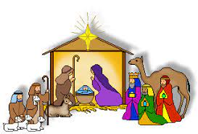

**Christmas Decorations**

We are blessed to have volunteers who are willing year after year to organize and put up the beautiful decorations for our celebration of Advent and The Twelve Days of Christmas. Normally, we list those generous and hard workers after the decorations have come down; but this year, it seemed good to honor them beforehand so that when you see them you might thank them for all their faithful work. Many of them have been doing the same jobs for a long time, and we are so grateful to them for their selfless service at a time of year when everyone is busy and weary.

Christmas Tree Bob and Karen Kiser; Larry and Judy

Litchford; Wayne and Suzann Dolson;

Kyle Petter; Casey, Kelly and Brad Neulieb

Advent Log Virginia Murray

Poinsettia plants Virginia Murray; Sue Koziel

Large wooden cross Janet Bakken; Sue Koziel; Karen Steinborn

Garland (outer narthex and Communion railings) Karen Steinborn; Sue Koziel

Window treatments (nave and outside) Mary Knaup

Upper narthex nativity scene and creche Pastor Mark Kloess; Jary Tannehill;

Stacie Crozier

**POINSETTIA MEMORIALS 2022**

Mike & Marge Bockover: *in memory of loved ones*

Nancy Mauman; Tom & Gail Mauman;

And TJ & Megan Pruzin and family: *in loving memory of**Dorothy & Walter Liebig and*

*John Mauman and loved ones*

Janice White; her niece Elizabeth and her husband John: *in honor of Diane Egilske; and in memory of loved ones*

William, Jr, Bethany, and Kirk Manning: *in loving memory of our parents William, Sr & Joyce Manning*

Sandy Robbins: *in memory of Henry (Sonny) Robbins*

Beverly Johnson: *in memory of Ron Johnson from Bev*

Ivye Benson: *in memory of my parents Irv & Pearl Carlson*

Sally Timm: *in memory of my husband Lee Timm*

Jim & Bernadette Krueger: *in memory of Mom & Dad Krueger and in memory of Mom & Dad Losiniecki*

Rick & Nancy Hawkins and Tom Gielow*: in memory of Roger & Diane Gielow from their children*

*Nancy and Tom*

Janet Bakken: *in memory of Diane Gielow*

Steve & Lauretta Hapke: *in memory of Norma Wolgast and Elizabeth Hapke*

Susan Dolson: *in memory of Howard & Yvonne Johnson; and Maurits & Adrianna VanGemeren from their family*

John & Amy VanGemeren: *in memory of George & Irma Dolson from their grandchildren*

Fred Weiss: *in memory of wife Carol and son Donald*

Virginia Murray: *in memory of loved ones*

Bob & Karen Kiser: *in memory of loved ones*

Susan Koziel: *in memory of husband Joseph Koziel and in honor of my children and grandchildren*

Tim & Stacie Crozier: *in memory of our parents*

Chip & Audrey Claussen: *in memory of loved ones who have passed away and in honor of all family and friends*

Chuck & Sherry Payne: *in memory of loved ones*

Charles, Sr. & Jana Thomas: *in memory of Otto Mayer & family and Allie Thomas family*

Charles, Jr. & Carol Thomas: *in memory of Stanley & Gloria Redmon*

The Johnson Women: *in memory of their father Ron Johnson*