**THE FIRST SUNDAY IN LENT**

**March 9, 2025**

Come, said Satan, come away,

I’ll soon see if you’ll obey!

John for disobedience bled,

But you can turn the stones to bread.

God’s high king and God’s high priest

Shall plant their glories in your breast,

If Caiaphas you will obey,

If Herod you with bloody prey

Feed with the sacrifice, and be

Obedient, fall down, worship me.

**William Blake**

Whether we gaze with longing into the garden or with fear and trembling into the desert, of this we can be sure–God walked there first! And when we who have sinned and despoiled the garden are challenged now to face the desert, we do not face it alone; Jesus has gone there before us to struggle with every demon that has ever plagued a human heart. Face the desert we must if we would reach the garden, but Jesus has gone there before us.

**James Healy**

**✠*****In the Name of Jesus* ✠**

**INTRODUCTION**

*In the forty days of Lent, the scriptures challenge the Christian community to ponder its origins in baptism. How are we to live as baptized Christians in the world today? God who is faithful and merciful, calls us to consider our faithfulness to the covenant sealed in the waters of new life.*

**Perpetua and Felicity and companions, martyrs at Carthage, died 202**

*Vibia Perpetua, a noblewoman, and Felicity, an enslaved woman, were catechumens at Carthage, northern Africa. They, with four other catechumens, had defied the Roman emperor who had forbidden conversions to Christianity, and were put to death in the amphitheater.*

**Harriet Tubman, died 1913; Sojourner Truth, died 1883; renewers of society**

*Harriet Tubman, born into slavery, helped about 300 others to escape slavery until the institution was abolished. Sojourner Truth, whose birth name was Isabella, was freed after slavery was abolished, and discerned a call to be a preacher. Taking the name Sojourner Truth, she set out on an evangelistic journey, where people found her testimony to be deeply moving.*

**✠ GATHERING ✠**

**PRE-SERVICE MUSIC *Eagle’s Wings*  New Song Praise Band**

**(Reuben Morgan)**

**ANNOUNCEMENTS**

*As you are able please rise*

**THE INVITATION TO THE PROCESSION**

P: In the name of the Father, and of the **✠** Son, and of the Holy Spirit.

**C: Amen.**

P: The grace, mercy, and peace of God be with you all.

**C: And also with you.**

P: Lent is the church's journey to Easter and the saving waters of rebirth. With the church

throughout the world, we journey with catechumens who are preparing for baptism at

the Easter Vigil. For those of us already baptized, we continue our baptismal journey

of conversion, daily dying to sin that we might walk in newness of life.

Our procession today is in the spirit of the Israelites, as they journeyed through the

wilderness to the promised land. As we begin our Lenten pilgrimage, we join with the

universal church, supported by the saints of all times and places. We journey from

slavery to freedom, from darkness to light, from death to life. Let us go forth in joy, for

the goal of our journey is the new life of the resurrection, which will renew the world,

the church, and our lives.

**THE GREAT LITANY 238**

The congregation turns toward the cross as it processes around the nave

**THE PRAYER OF THE DAY**

P: The Lord be with you.

**C: And also with you.**

P: Let us pray. Lord God, our strength, the battle of good and evil rages within and around

us, and our ancient foe tempts us with his deceits and empty promises. Keep us

steadfast in Your Word and, when we fall, raise us again and restore us through Your

Son, Jesus Christ our Lord, Who lives and reigns with You and the Holy Spirit, one

God, now and forever.

**C: Amen.**

*The assembly is seated*

**✠** **WORD ✠**

**FIRST READING Deuteronomy 26: 1-11**

*The annual harvest festival called the Feast of Weeks provides the setting for this reading. This festival celebrates the first fruits of the produce of the land offered back to God in thanks. In this text, worshipers announce God's gracious acts on behalf of Israel.*

1When you have come into the land that the Lord your God is giving you as an inheritance to possess, and you possess it, and settle in it, 2you shall take some of the first of all the fruit of the ground, which you harvest from the land that the Lord your God is giving you, and you shall put it in a basket and go to the place that the Lord your God will choose as a dwelling for his name. 3You shall go to the priest who is in office at that time, and say to him, "Today I declare to the Lord your God that I have come into the land that the Lord swore to our ancestors to give us."

4When the priest takes the basket from your hand and sets it down before the altar of the Lord your God, 5you shall make this response before the Lord your God: "A wandering Aramean was my ancestor; he went down into Egypt and lived there as an alien, few in number, and there he became a great nation, mighty and populous. 6When the Egyptians treated us harshly and afflicted us, by imposing hard labor on us, 7we cried to the Lord, the God of our ancestors; the Lord heard our voice and saw our affliction, our toil, and our oppression. 8The Lord brought us out of Egypt with a mighty hand and an outstretched arm, with a terrifying display of power, and with signs and wonders; 9and He brought us into this place and gave us this land, a land flowing with milk and honey.

10So now I bring the first of the fruit of the ground that You, O Lord, have given me." You shall set it down before the Lord your God and bow down before the Lord your God. 11Then you, together with the Levites and the aliens who reside among you, shall celebrate with all the bounty that the Lord your God has given to you and to your house.

The Word of the Lord.

**Thanks be to God.**

**THE PSALM: Psalm 91: 1-2, 9-16** Antiphon by Carl Schalk

Choir sings refrain first, followed immediately by the congregation

and as indicated

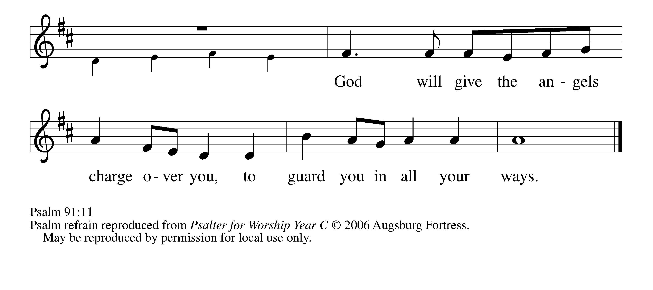

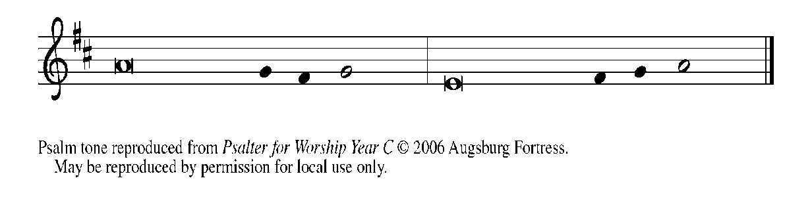

1You who dwell in the shelter of | the Most High,

     who abide in the shadow of | the Almighty—

**2you will say to the LORD, "My refuge | and my stronghold,**

**my God in Whom I | put my trust."   REFRAIN**

9Because you have made the | LORD your refuge,

     and the Most High your | habitation,

**10no evil | will befall you,**

**nor shall affliction come | near your dwelling.**

11For God will give the angels charge | over you,

     to guard you in | all your ways.

**12Upon their hands they will | bear you up,**

**lest you strike your foot a- | gainst a stone.   REFRAIN**

13You will tread upon the lion | cub and viper;

     you will trample down the lion | and the serpent.

**14I will deliver those who | cling to Me;**

**I will uphold them, because they | know My name.**

15They will call Me, and I will | answer them;

     I will be with them in trouble; I will rescue and | honor them.

**16With long life will I | satisfy them,**

**and show them | My salvation.   REFRAIN**

**SECOND READING Romans 10: 8b-13**

*Paul shares with the Christians at Rome what is necessary for salvation: the confession of faith in the risen Jesus as Lord.*

8b"The word is near you,

on your lips and in your heart"

(that is, the word of faith that we proclaim); 9because if you confess with your lips that Jesus is Lord and believe in your heart that God raised Him from the dead, you will be saved.

10For one believes with the heart and so is justified, and one confesses with the mouth and so is saved. 11The scripture says, "No one who believes in Him will be put to shame." 12For there is no distinction between Jew and Greek; the same Lord is Lord of all and is generous to all who call on him. 13For, "Everyone who calls on the name of the Lord shall be saved”

The Word of the Lord.

**Thanks be to God.**

*As you are able please rise*

**THE VERSE**

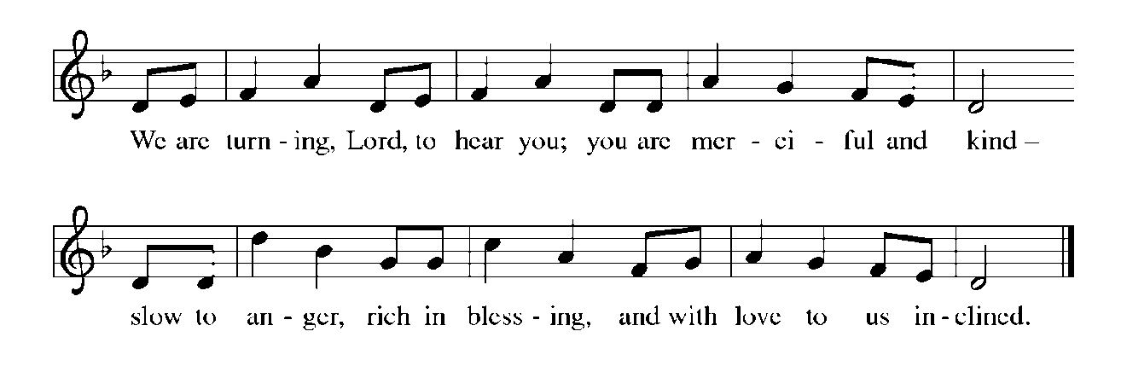

**THE HOLY GOSPEL Luke 4: 1-13**

*After being filled with the Holy Spirit at His baptism, Jesus is tempted by the devil regarding what it means to be called "the Son of God."*

P: The Holy Gospel according to St. Luke, the fourth chapter.

**C: Glory to You, O Lord!**

1Jesus, full of the Holy Spirit, returned from the Jordan and was led by the Spirit in the wilderness, 2where for forty days He was tempted by the devil. He ate nothing at all during those days, and when they were over, He was famished. 3The devil said to Him, "If You are the Son of God, command this stone to become a loaf of bread." 4Jesus answered him, "It is written, 'One does not live by bread alone.' "

5Then the devil led Him up and showed him in an instant all the kingdoms of the world. 6And the devil said to Him, "To you I will give their glory and all this authority; for it has been given over to me, and I give it to anyone I please. 7If You, then, will worship me, it will all be yours." 8Jesus answered him, "It is written,

'Worship the Lord your God,

and serve only Him.' "

9Then the devil took Him to Jerusalem, and placed Him on the pinnacle of the temple, saying to Him, "If You are the Son of God, throw Yourself down from here, 10for it is written,

'He will command His angels concerning you,

to protect you,'

11and

'On their hands they will bear you up,

so that you will not dash your foot against a stone.' "

12Jesus answered him, "It is said, 'Do not put the Lord your God to the test.' "

13When the devil had finished every test, he departed from Him until an opportune time.

P: The Gospel of the Lord.

**C: Praise to You, O Christ!**

*The assembly is seated*

**THE SERMON**

*Silence for reflection follows the sermon*

*As you are able please rise*

**THE HYMN OF THE DAY *When We Are Tested* (see p. 7)**

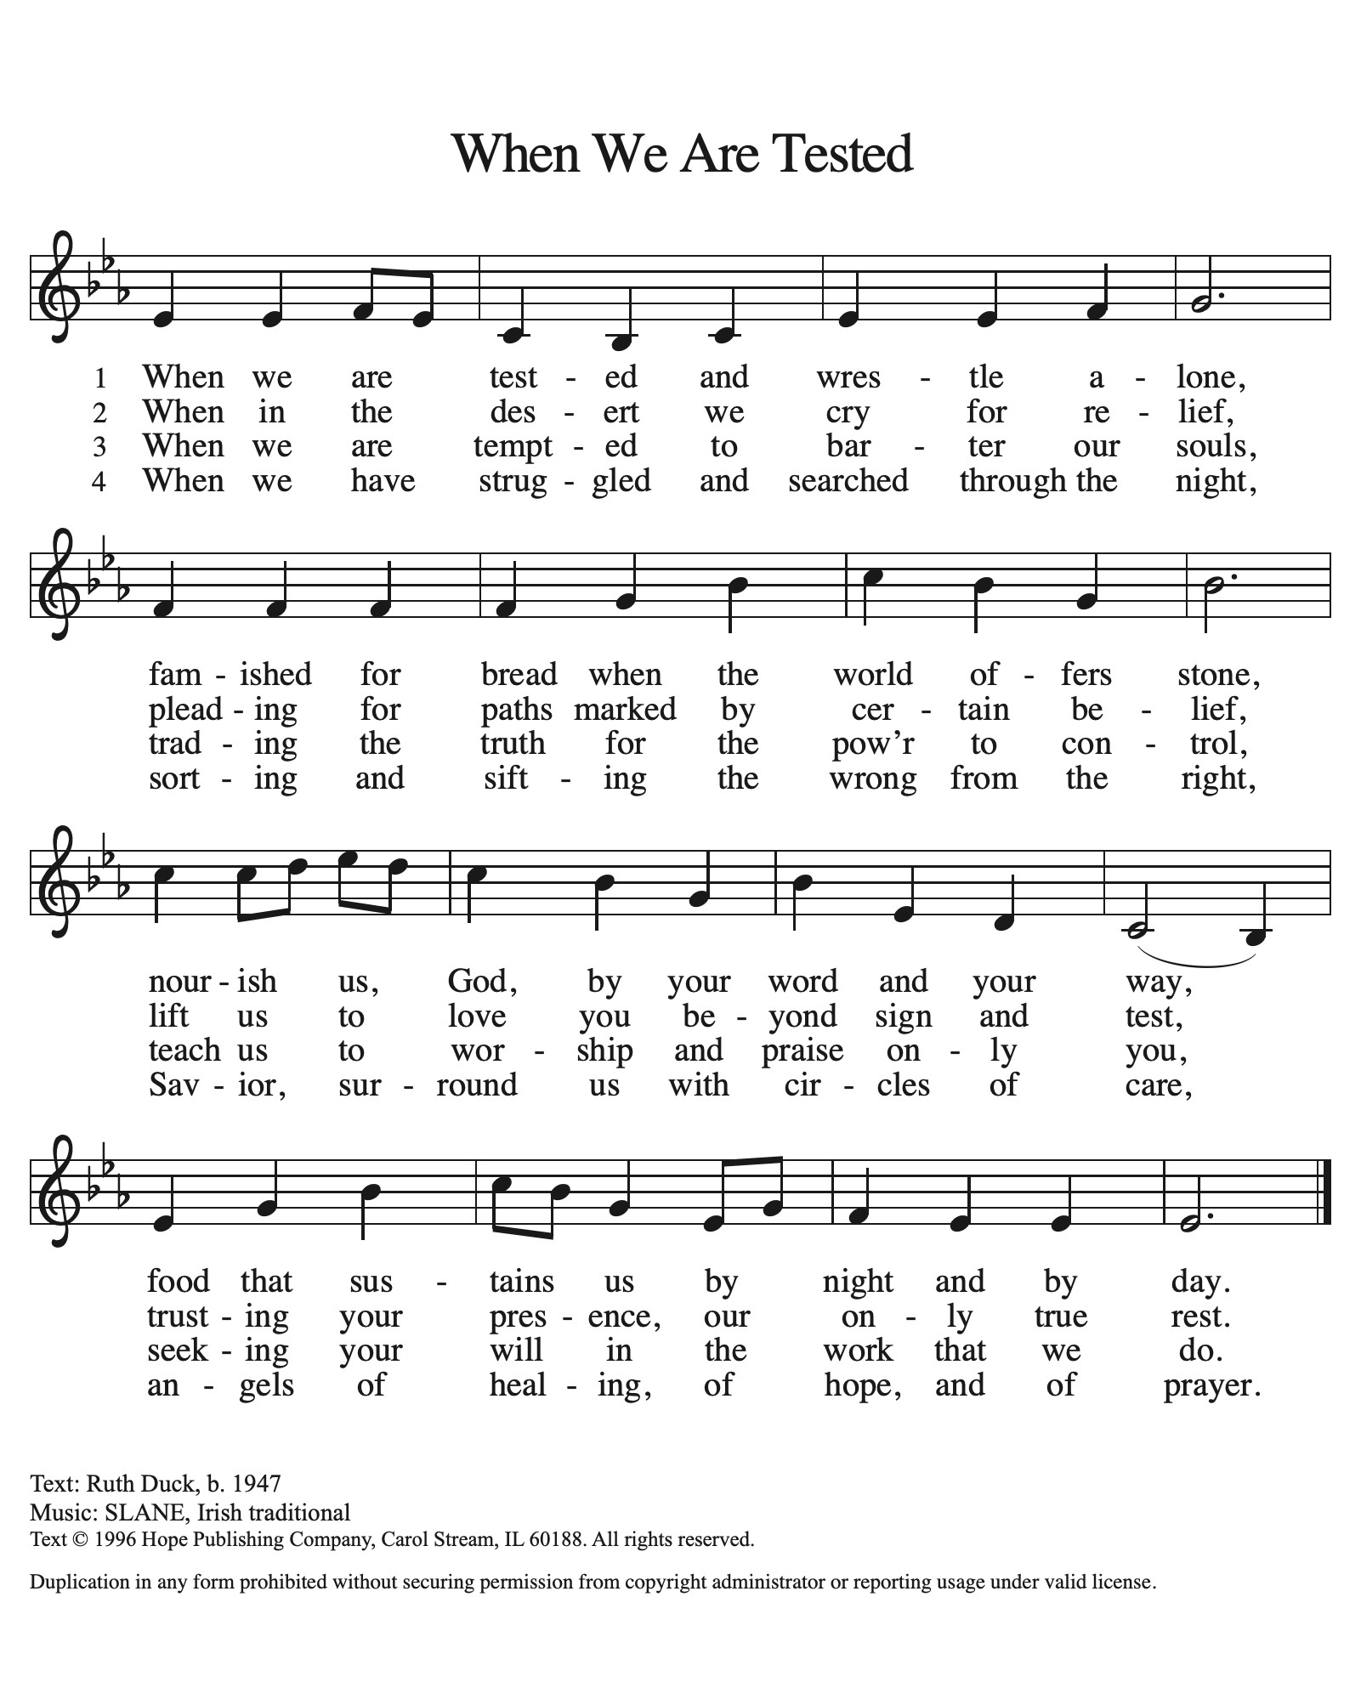

**THE NICENE CREED**

A: God has made us His people through our Baptism into Christ. Living together in trust and

hope, we confess our faith.

**C: We believe in one God,**

**the Father, the Almighty,**

**maker of heaven and earth,**

**of all that is, seen and unseen.**

**We believe in one Lord, Jesus Christ,**

**the only Son of God,**

**eternally begotten of the Father,**

**God from God, Light from Light,**

**true God from true God,**

**begotten, not made,**

**of one Being with the Father.**

**Through Him all things were made.**

**For us and for our salvation**

**He came down from heaven;**

**by the power of the Holy Spirit**

**He became incarnate from the virgin Mary, and was made man.**

**For our sake He was crucified under Pontius Pilate;**

**He suffered death and was buried.**

**On the third day He rose again**

**in accordance with the Scriptures;**

**He ascended into heaven**

**and is seated at the right hand of the Father.**

**He will come again in glory to judge the living and the dead,**

**and His kingdom will have no end.**

**We believe in the Holy Spirit, the Lord, the giver of life,**

**Who proceeds from the Father and the Son.**

**With the Father and the Son He is worshiped and glorified.**

**He has spoken through the prophets.**

**We believe in one holy catholic and apostolic Church.**

**We acknowledge one Baptism for the forgiveness of sins.**

**We look for the resurrection of the dead,**

**and the life of the world to come. Amen**

**THE PRAYER OF THE CHURCH**

A: As we journey toward the Easter Feast, let us turn to God Who is gracious and merciful,

slow to anger, and abounding in steadfast love.

A: For peace in places where there is war and conflict, especially in Ukraine; for healing

and comfort in places where there is disease and famine, especially in Africa and North

Korea; and that Your Gospel would reach all peoples of the earth who long for its good

news, let us pray to the Lord:

**C: Lord, have mercy.**

A: For strength for the Church in its forty-day Lenten journey, that it might learn again

that we do not live by bread alone, and be delivered from every temptation and harm

and be found faithful on the day of Christ’s coming, let us pray to the Lord:

**C: Lord, have mercy.**

A: For this congregation, that in this season we may find joy in returning the first-fruits of

our labors on behalf of the hungry, the poor, and needy, let us pray to the Lord:

**C: Lord, have mercy.**

A: For everyone troubled with sickness or weariness, especially: **Larry Litchford; Sarah**

**McNabb;** **Martha Schroeder; Russ Fischer; Carol Radke; Pope Francis;**

**Mackenzie O’Donnell; Debbie Martin; Christine Kiser; Joyce Stark; Jan**

**Paholski; and Laura Dovey** that they may be touched by the Lord and uplifted, let us

pray to the Lord:

**C: Lord, have mercy.**

A: For those celebrating birthdays, especially **Jean Warner,** that they may be filled with

Your grace this day and every day and grow in grace in the days ahead, let us pray to

the Lord:

**C: Lord, have mercy.**

A: For those who have been called to God’s service, past and present, especially **Perpetua,**

**Felicity, and companions, martyrs; and Harriet Tubman and Sojourner Truth,**

**renewers of society,** whom we commemorate this Day we give thanks. That we might

remain faithful until we join them in God’s heavenly Kingdom, let us pray to the Lord:

**C: Lord, have mercy.**

P: Strong and faithful God, hear us as we cry to You. Stretch out Your hand to save us,

that we may praise You for Your mercy. Grant this through Christ our Lord.

**C: Amen.**

**✠ MEAL ✠**

**THE PEACE**

P: Through Christ we have been reconciled to God, Who has given us the ministry of

reconciliation. Let us be reconciled with one another.

The peace of the Lord be with you always.

**C: And also with you.**

*The assembly is seated*

**THE OFFERING**

**THE VOLUNTARY** ***Behold the Love, the Grace of God*** **St. Paul Senior Choir**

**(B. Stone; adapted by T. Fettke)**

*As you are able please rise*

**THE PRESENTATION OF THE GIFTS (see p. 11)**

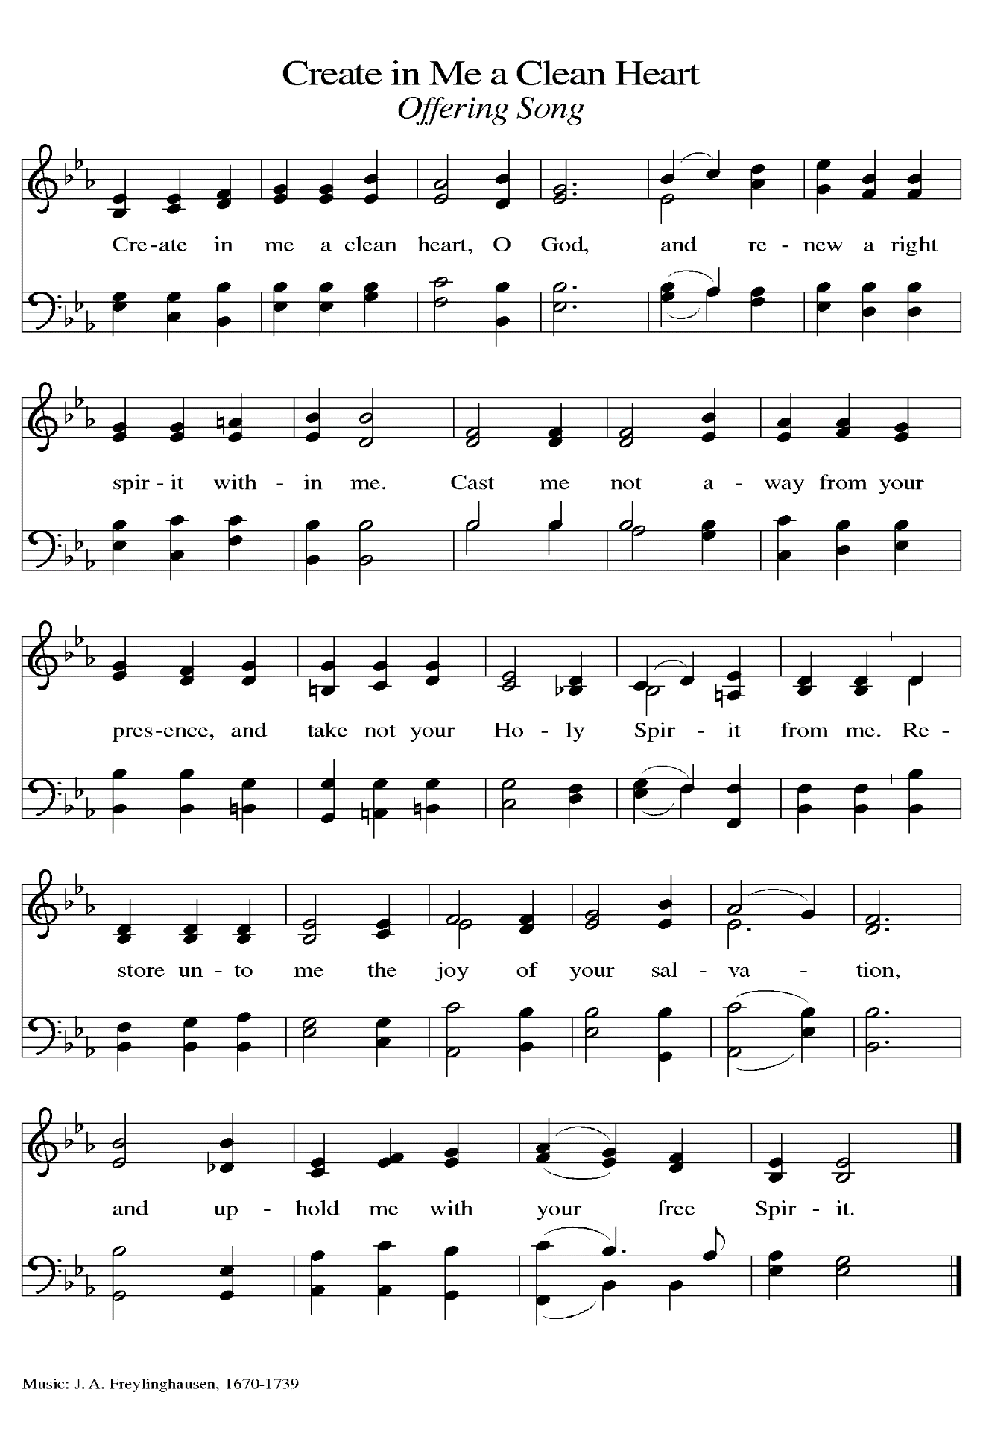

**THE OFFERTORY PRAYER**

A: Let us pray. God our strength,

**C: By these offerings we confess that You alone are God. Receive them as our prayer**

**for the fulfillment of Your vision for this world, and use them as our worship of**

**You through service to others. We ask this in the name of Jesus the Lord. Amen.**

**THE GREAT THANKSGIVING**

P: The Lord be with you.

**C: And also with you.**

P: Lift up your hearts.

**C: We lift them up to the Lord.**

P: Let us give thanks to the Lord our God.

**C: It is right to give Him thanks and praise.**

P: It is indeed right, our duty, and our joy …join their unending hymn:

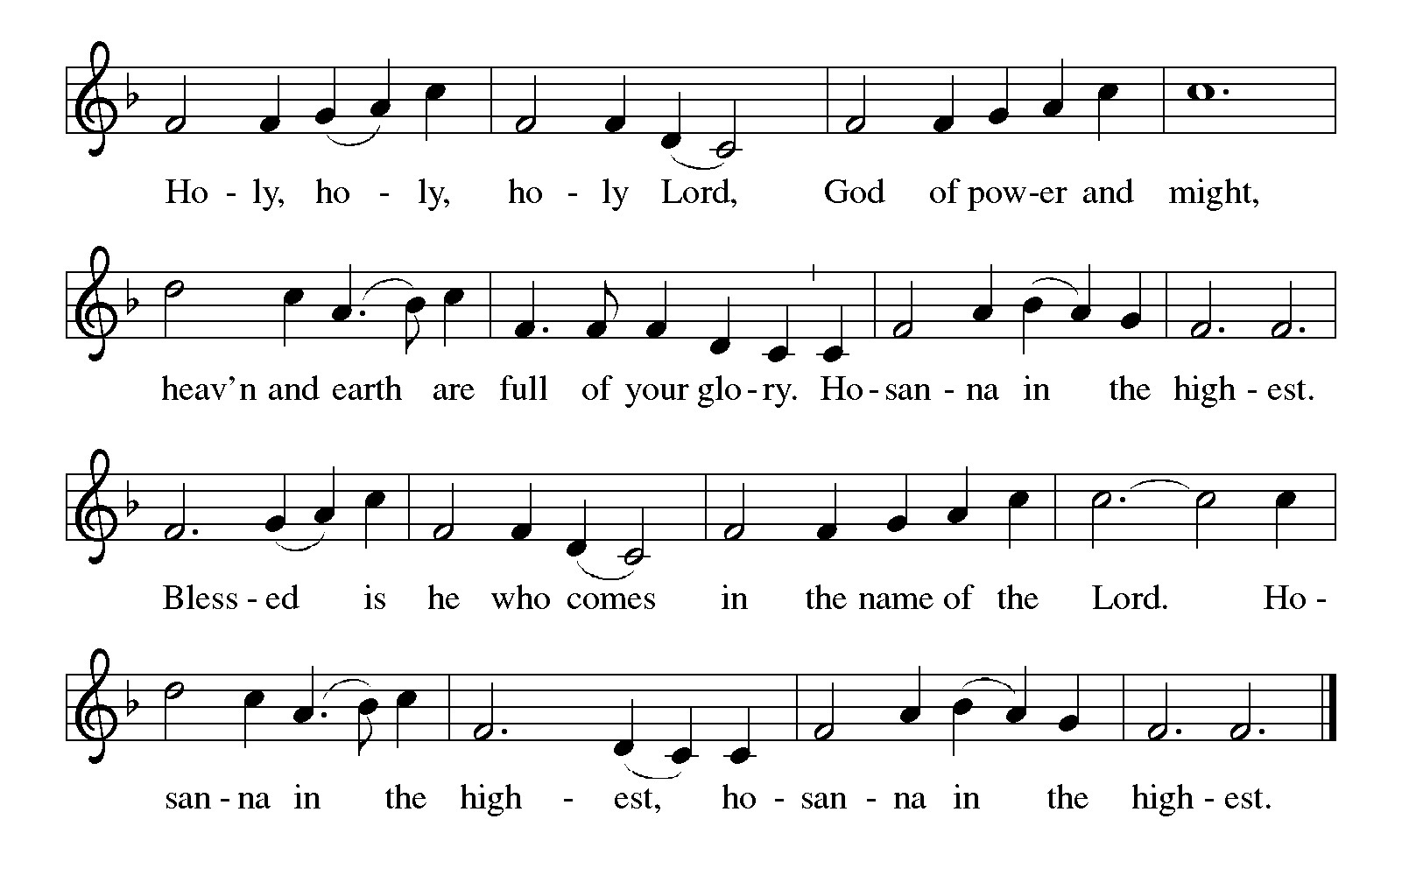

P: Praise and thanksgiving belong to You, God of every blessing. for You shaped all

creation to grow into Your abundant and eternal harvest.

You called a holy people to share life with You, and when they were captive in Egypt,

with a mighty hand and an outstretched arm You brought them out of

oppression, through the temptations of the wilderness, into a land flowing

with milk and honey.

In time, Your Son came among us, facing wilderness and temptation and hunger to

bring us out of our bondage to sin and to taste and see that You, the Lord,

are good.

God of mercy, You gave Your people manna day by day during their time of testing:

and because no one can live by bread alone, You gave Jesus to be our Bread from heaven.

Send Your Holy Spirit upon Your Church to live as a sign of the way You transform

this manna into mercy for all.

With Your Spirit, bless this bread and this cup that they may be for us the Body and

Blood of Your Son Jesus Christ,

Who, in the night ... “Do this for the remembrance of Me.”

As often as we eat ... we proclaim the Lord’s death until He comes.

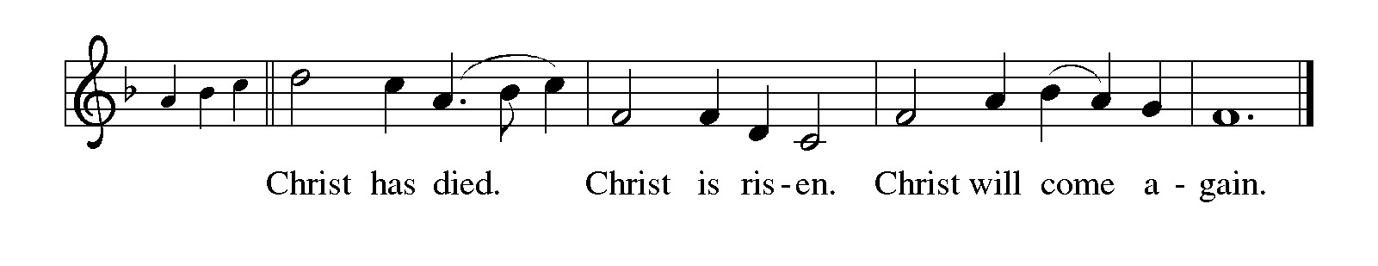

P: Faithful God, Whose Son did not escape suffering and death but accepted and finally

overcame them, bring Your disciples by way of His cross to the joy of

Easter.

Strengthen Your Church to resist evil of every kind and turn from sin.

With Your mighty hand and outstretched arm, uphold those enduring trials and any

who know their very life is at stake.

Be with Your children who are heavy laden, and all who labor beneath the misuse of

power by another.

Amid temptations shape Your children first to be faithful to Your Kingdom, until the

Day when in Your resurrected glory there is one life, one sharing, one holy

communion among all saints with You to Whom all glory belongs forever,

Father, **✠** Son, and Holy Spirit.



**THE LORD’S PRAYER**

P: Baptized into Christ’s death that we might share in the resurrection, let us pray for the

fulfillment of the mystery as Jesus taught us:

**C: Our Father, Who art in heaven, hallowed be Thy Name. Thy Kingdom come, Thy**

**will be done on earth as it is in heaven. Give us this day our daily bread, and**

**forgive us our trespasses as we forgive those who trespass against us. And lead us**

**not into temptation but deliver us from evil. For Thine is the Kingdom, and the**

**power, and the glory, forever and ever. Amen.**

**INVITATION TO THE MEAL**

P: Behold the Servant of God, obedient unto death on a cross, highly exalted as Lord of

glory. Blessed are those who are called to the banquet of the Lamb. God’s holy gifts

for God’s holy people. Come, for all is now ready.

*The assembly is seated*

**THE DISTRIBUTION**

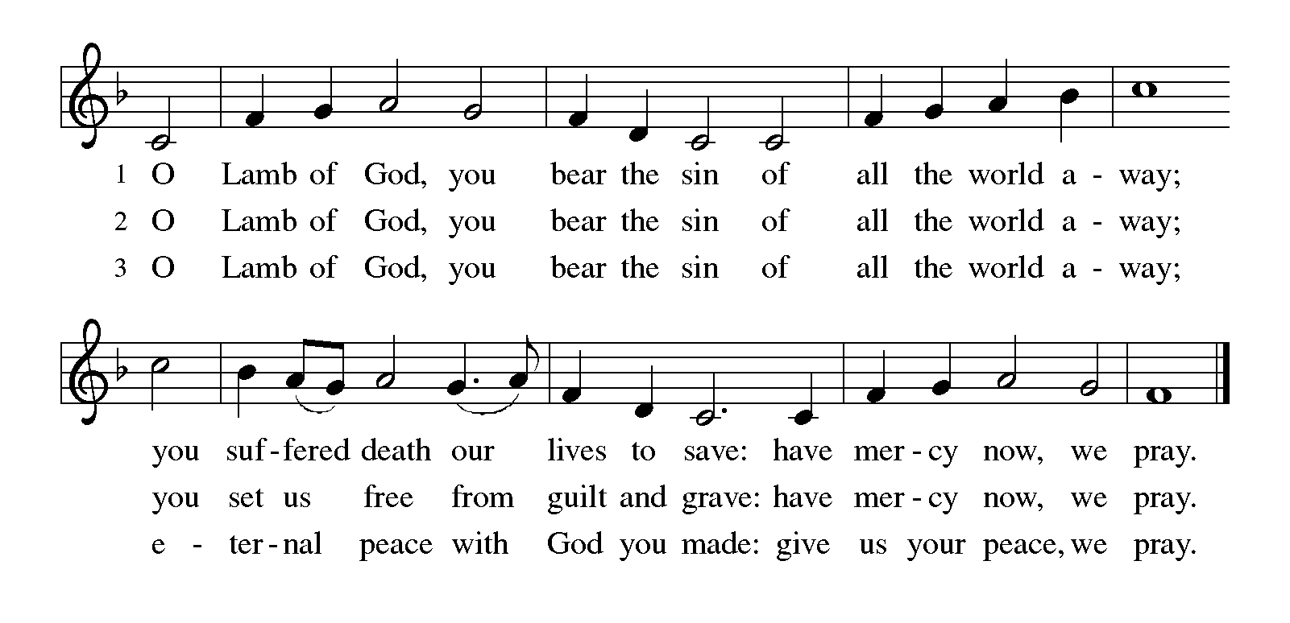

Those wishing to receive the Laying on of Hands and Anointing with Oil

may go to Pastor at the side aisle

**HYMN DURING DISTRIBUTION 319 *O Lord, Throughout These Forty Days***

**ELW 787 *On Eagle’s Wings***

**ELW 574 *I the Lord of Sea and Sky***

**ELW 325 *I Want Jesus to Walk with Me***

**NSB 105 *You Are My All in All***

*As you are able please rise*

**THE POST COMMUNION BLESSING**

P: The Body and Blood of our Lord Jesus Christ strengthen you and keep you in His

grace.

**C: Amen.**

**THE POST-COMMUNION PRAYER**

A: Let us pray. Lord Jesus Christ, we were weary amid many temptations, but You have

refreshed us again with Your Body and Blood. Increase our faith and hope and love,

and by Your Spirit, give us strength to follow in Your Way. We bless You now and

forever.

**C: Amen.**

**✠ SENDING ✠**

**THE BENEDICTION**

P: Jesus took the form of a servant and was obedient to death, even death on a cross. May

you follow His example and share in the resurrection.

**C: Amen.**

P: Almighty God: Father, Son, **✠** and Holy Spirit bless you now and forever.

**C: Amen.**

**SENDING SONG 774 *What a Fellowship***

**THE DISMISSAL**

A: Reconciled to God through Christ, let us go out into the world in peace.

**C: Thanks be to God!**

**THE POSTLUDE**

**✠ *To God Alone Be Glory* ✠**

The Meditations are from *Pulpit Resource.* Vol. 32. No. 1 (Inver Heights, MN: Logos

Productions, Inc., 2004). 44.

**ANNOUNCEMENTS**

**Please remember to mail your offering to the Church Office** at 818 Franklin Street, Michigan City, IN 46360**.** Another alternative is to give on-line through Tithe.ly. Please see your closure letter for information on how to set up a Tithe.ly account.

**St. Paul Members are reminded to have** a loved one contact the office if you are hospitalized. Many times, the Pastor doesn’t know someone is in the hospital. If you call and leave a message, please tell us which hospital the patient is at.

**Birthdays: Jean Warner (3/14)**

**PRAYER CONCERNS:** Pope Francis, Sarah McNabb, Carol Radke, Jeanie Boatman Shepple, Nolan Wilson, Debbie Martin, Mark Tannehill, Brian Wiseman, Kathy Stein, Danielle Schnell, Jan Paholski, Laura Dovey, and Grace Romine.

**OFFICE HOURS:** Libby will be in the office on Mondays, Wednesdays, and Fridays; volunteers will cover Tuesdays and Thursdays.

Monday & Wednesday 8:00 a.m. – 5 p.m.

Tuesday & Thursday 9:00 a.m. – 12:00 p.m.

Friday 8:00 a.m. – 12:00 p.m.

**If you are listening to the worship broadcast on the radio and would like to watch the Sunday morning service live stream follow these steps:**

(1) If you have You Tube available on your TV, search for

**St. Paul Lutheran Church Michigan City, IN.**

(2) The direct link on the computer is

https://www.youtube.com/channel/UC5AIPNaKr3QN50984jGOa1g.

   (3) This link is also on the main page of the church’s website in

the church section and will continue to be posted weekly on the St.

Paul Facebook page.

And it will always be available on the radio broadcast Sunday mornings at 11:00 a.m.

on WEFM (95.9), and on the local cable access station #99 for the previous week’s

service on Sundays at 4:00 p.m. and the current service on Wednesdays at 7:00 p.m.

and Fridays at 8:30 p.m.

**Next Sunday’s lessons are Genesis 15: 1-12, 17-19; Psalm 27: 1-2, 9-16; Philippians 3: 17- 4: 1; Luke 13: 31-35** for those of you who like to study them in advance.

**To send e-mail to the church office**, please use the following addresses:

Pastor Mark Reshan: seniorpastor@stpaulmichigancity.com

Church Office Secretary (Libby Pollock): churchsecretary@stpaulmichigancity.com

Church Treasurer (Karen Fleming): finance@stpaulmichigancity.com

**The Good News Newsletter**: If you have an article or anything you want included in **The Good News** please send it to the following e-mail address: splcgoodnews@gmail.com. Pastor Pamela Thiede will be using this e-mail address to assemble **The Good News** each month. The deadline for getting information to Pastor Pamela will be the 20th of each month.

**Worship Attendance:**

**Saturday , February 22, 2025 @ 4:00 p.m. 32**

**Sunday, February 23, 2025 @ 9:00 a.m. 74**

**TOTAL 106**

**Copies of the minutes from the January 23, 2025 and February 27, 2025 Church Council meetings are on the back table in the upper Narthex. They were approved by the council via email.**

**FYI:**

In response to the ever rising costs for postage we will be putting your copy

of the “Good News” in your hanging file folder in the narthex each month

from now on. Those of you who are unable to attend services on a regular

basis may still receive your copies through your email address or in the

U.S. mail. If you normally receive your copy of the newsletter via your

email address anyway, nothing will change for you. Thank you so much for

your understanding and cooperation!

**2025 Financial Stewardship**

Weekly Church Operating Needs (x 2 weeks)

February 22-23 and March 1-2, 2025: $ 12, 271.38

General Fund (including General Memorials): $ 9,549.00

Overage/Shortage: — $ 2,677.00

Restricted Income (not including Memorials)

Supports IK Synod & Church wide Ministries: $ 334.00

Ministries in our Community/Congregation: $ 515.00

Capital Fund: $ 326.00

**MISSION OF THE MONTH FOR MARCH 2025:**

We will be supporting The Social and Learning Institute as our Mission of the Month for March. The Institute has been serving LaPorte County since 1976 by helping individuals with developmental disabilities expand their minds, learn important life skills and recognize their worth through a structured balance of socialization and learning activities. If you would like to make a monetary donation, please make checks out to St. Paul and mark it for the March mission and place in the offering plate. Noisy coin offering will also go to support the monthly mission. The Institute also has an Amazon wish list of classroom supplies. When ordering from the wish list, select Abby Hinsch LaPorte, IN as the shipping address and items will be delivered directly to the Institute. If you prefer to shop in person, items can be placed in the bin in the Narthex.

**Wishlist URL (also available on our Facebook page; note: the last 3 characters are zero f zero):** [**https://shorturl.at/xg0f0**](https://shorturl.at/xg0f0)

**Items needed:**

**Personal Care:** Facial tissues w/ lotion, 2-ply toilet paper, band aids, first aid kits

**Cleaning**: Sweeper wet mopping pad refills, Lysol disinfectant spray or wipes, 30 gallon and kitchen sized drawstring trash bags, nitrile gloves

**Games/Toys:** Magnatiles, board games, stress balls or squishy toys, Montessori learning toys, sensory toys

**Classroom:** Colored cardstock, construction paper, crayons, Elmer’s liquid glue or glue sticks, retractable permanent markers, Post-it pop up notes, bulletin board supplies (paper, boarders, letters, mounting tape)

**ACTIVITIES, EVENTS & MEETINGS**

**MARCH 2025**

**Saturday,** March 8, 2025 @ 4:00 p.m. 1st Lent Worship Service

**Sunday,** March 9, 2025 @ 9:00 a.m. 1st Lent Worship Service

**Monday,** March 10, 2025 @ 1:00 p.m. Hope Circle/Green Room

**Tuesday,** March 11, 2025 **@ 11:00 a.m. – close GIVE BACK at Holly’s Restaurant & Pub**

@ 7:00 p.m. Estuary/Luther House

**Wednesday,** March 12, 2025 @ 9:15 a.m. Bible Study/Luther House

@ 10:00 a.m. God’s Purls/St. Paul Room

@ 4:30 p.m. Choir Rehearsal/Sanctuary

@6:00 p.m. **Lenten Service**

**Saturday,** March 15, 2025 @ 4:00 p.m. 2nd Lent Worship Service

**Sunday,** March 16, 2025 @ 9:00 a.m. 2nd Lent Worship Service

**Wednesday,** March 19, 2025 @ 9:15 a.m. Bible Study/Luther House

@ 10:00 a.m. God’s Purls/St. Paul Room

@ 4:30 p.m. Choir Rehearsal/Sanctuary

@ 6:00 p.m. **Lenten Service**

**Saturday,** March 22, 2025 @ 4:00 p.m. 3rd Lent Worship Service

**Sunday,** March 23, 2025 @ 9:00 a.m. 3rd Lent Worship Service

**Monday,** March 24, 2025 @ 2:00 p.m. Finance Committee Mtg./Luther House

@ 3:00 p.m. Executive Board Committee Mtg./Luther House

**Wednesday,** March 26, 2025 @ 9:15 a.m. Bible Study/Luther House

@ 10:00 a.m. God’s Purls/St. Paul Room

@ 4:30 p.m. Choir Rehearsal/Sanctuary

@6:00 p.m. **Lenten Service**

**Thursday,** March 27, 2025 @ 5:30 p.m. Church Council Mtg./Luther House

**Saturday,** March 29, 2025 @ 4:00 p.m. 4th Lent Worship Service

**Sunday,** March 30, 2025 @ 9:00 a.m. 4th Lent Worship Service

**Easter Plants**

A variety of spring plants will be available to order for decorating St. Paul’s Church on Easter Morning! The varieties available will be Lily, Daffodil, Hyacinth, Tulip, Hydrangea, Florist Mum, and Hanging Fern Basket. Orders must be placed by Monday, March 31st.

The varieties and color available are Lily, Daffodil, Hyacinth in purple, pink, or white. Tulips in yellow, red, white, or pink. Florist Mum (Daisy like form) in pink, white, or yellow. Hydrangeas in pink or purple/blue, and the 10” Hanging Fern Basket.

Cost per plant is as follows:

Lily - $10.00

Daffodil - $9.00

Hyacinth - $9.00 (purple, pink, or white)

Tulip - $9.00 (yellow, red, white, or pink)

Florist Mum - $11.00 (pink, white, or yellow)

Hydrangea - $15.00 (pink or purple/blue)

Hanging Fern - $15.00

Please specify your choice of plant and your choice of color when applicable.

Orders MUST be placed by Monday morning, March31st.

Your order may be placed ‘In Memory or Honor of a Loved One’. Please call the Church Office, 219-874-7293, or place your order in an envelope and title it ‘EasterPlants’ for ordering.

REMEMBER, you must specify what type of plant and color, if applicable!! All checks should be made out to St. Paul Church.

Please plan on picking up your plant after the Easter Morning Service by 11:00 a.m..

Thank$ for $haring

Thank you for all who participate in our Give Back days! On January 7, 2025 we met at Holly’s and we earned $235. Our next Give Back is coming up on Tuesday, March 11 at Holly’s.  Here are two coupons: one for you and one for a friend.

