**THE NINETEENTH SUNDAY AFTER PENTECOST**

**The Festival of the Day of St. Luke**

**October 19, 2025**

“Luke is a gentile, probably a Greek, and is believed to have come from Antioch in Syria or perhaps Philippi. Not much is known of his life except that he was a physician (Colossians 4: 4) and was a disciple of St. Paul and a worker with him. He has traditionally been regarded as one of the seventy disciples commissioned by Jesus, although in his Gospel (1: 2) he says that he was not an eyewitness of what he writes.

A later tradition that he was a painter seems not to be reliable. Luke accompanied St. Paul on some of his journeys and may have been left in charge of the church at Philippi between visits by the apostle. He is generally believed to have been with Paul during two of his imprisonments. “Lucius of Cyrene” (Acts 13:1) and “Lucius my fellow countryman” (Romans 16: 21) may refer to Luke. According to early traditions he wrote his Gospel in Greece and preached the faith here and in Bithynia, an important province in northwest Asia Minor.

St. Luke is said to have died at the age of eighty-four, never having married. Some manuscripts give the place of his death as Boetia and some give Egypt or Bithynia or Achaia. The Emperor Constantine II had the supposed relics of St. Luke transferred from Thebes in Boeoria to Constantinople with those of St. Andrew and place in the Church of the Holy Apostles there on March 3, 357.

The observance of the feast of St. Luke is probably quite old in the East; it appears on Western calendars only in the eighth century. The date of this commemoration is universally October 18, and this may be perhaps based on the actual date of his death.

St. Luke’s day is a traditional time to emphasize the church’s ministry of healing by showing concerns for hospitals and nursing homes, for doctors and nurses, and by conducting healing services …”

**Philip Pfatteicher**

***Festivals and Commemorations***

***✠ In the Name of Jesus ✠***

**INTRODUCTION**

From the visit of Mary to Elizabeth’s house; through the visits of Jesus to Zacchaeus’s house, Mary and Martha’s house, and Levi’s house; to the visit of the risen Christ to Cleopas’s house, Luke’s gospel is a story of God’s hospitality. God is guest and host, and Jesus’ meal fellowship is a proclamation of God’s inner circle of outsiders, a gathering not of the righteous but of those who have received God’s mercy.

**✠ GATHERING ✠**

**PRE-SERVICE MUSIC God Will Make a Way New Song Praise Band**

**(Don Moen)**

**ANNOUNCEMENTS**

As you are able please rise

**GATHERING SONG NSB 70 (2x) *Open Our Eyes***

**THE GREETING AND PRAYER OF THE DAY**

P: The grace of our Lord Jesus Christ, the love of God, and the communion of the Holy

Spirit be with you all.

**C: And also with you.**

P: Let us pray. Almighty God, You inspired Your servant Luke to reveal in his Gospel

the love and healing power of Your Son. Give Your church the same love and power

to heal, and to proclaim Your salvation among the nations to the glory of Your name,

through Jesus Christ, Your Son, our healer, Who lives and reigns with You and the

Holy Spirit, one God, now and forever.

**C: Amen.**

*The assembly is seated*

**✠ WORD ✠**

**FIRST READING Isaiah 35: 5-8**

*The prophet promises those in exile that God will come to them to rescue them, heal them, and bring them home again.*

5Then the eyes of the blind shall be opened,

and the ears of the deaf unstopped;

6then the lame shall leap like a deer,

and the tongue of the speechless sing for joy.

For waters shall break forth in the wilderness, and

streams in the desert;

7the burning sand shall become a pool,

and the thirsty ground springs of water;

the haunt of jackals shall become a swamp,

the grass shall become reeds and brushes.

8A highway shall be there, and it shall be called

the Holy Way;

the unclean shall not travel on it, but it shall be

for God’s people;

no traveler, not even fools shall go astray.

The Word of the Lord.

**Thanks be to God.**

**THE PSALM: Psalm 124** **Read responsively**

1If the LORD had not been on our side,

let Israel now say;

**2if the LORD had not been on our side,**

**when enemies rose up against us,**

3then would they have swallowed us up alive

in their fierce anger toward us;

**4then would the waters have overwhelmed us**

**and the torrent gone over us;**

5then would the raging waters

have gone right over us.

**6Blessed be the LORD**

**Who has not given us over to be a prey for their teeth.**

7We have escaped like a bird from the snare of the fowler;

the snare is broken, and we have escaped.

**8Our help is in the name of the LORD,**

**the maker of heaven and earth.**

**SECOND READING 2 Timothy 4: 5-11**

Knowing that death draws near, Paul, a prisoner in Rome, closes his letter to Timothy in a way that exemplifies how Christians face death: thankful for the grace to finish the race and trusting in the final blessing that awaits him in Christ.

5As for you, always be sober, endure suffering, do the work of an evangelist, carry out your ministry fully. 6As for me, I am already being poured out as a libation, and the time of my departure has come. 7I have fought the good fight, I have finished the race, I have kept the faith. 8From now on there is reserved for me the crown of righteousness, which the Lord, the righteous judge, will give me on that day, and not only to me, but also to all who have longed for His appearing.

9Do your best to come to me soon,10for Demas, in love with this present world, has deserted me and gone to Thessalonica; Crescens has gone to Galatia, Titus to Dalmatia.11Only Luke is with me. Get Mark and bring him with you, for he is useful in my ministry.

The Word of the Lord.

**Thanks be to God.**

*As you are able please rise*

**THE VERSE (see p. 4)**

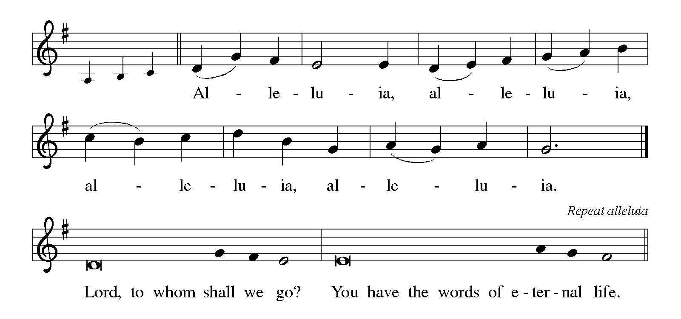

**THE HOLY GOSPEL Luke 1: 1-4; 24: 44-53**

These introductory and concluding verses of Luke’s gospel provide us with the reason he is writing: so that we might know the truth about Jesus Christ who, in his suffering, death, and resurrection, fulfilled the ancient promises of God.

P: The Holy Gospel according to St. Luke, the first and twenty-fourth chapters.

**C: Glory to You, O Lord!**

1Since many have undertaken to set down an orderly account of the events as they have been fulfilled among us, 2just as they were handed on to us by those who from the beginning were eyewitnesses and servants of the Word, 3I too decided, after investigating everything carefully from the very first, to write an orderly account for you, most excellent Theophilus, 4so that you may know the truth concerning the things about which you have been instructed.

44Then (Jesus ) said to them, “These are My words that I spoke to you while I was still with you—that everything written about Me in the law of Moses, the prophets and the psalms must be fulfilled.” 45Then He opened their minds to understand the Scriptures, 46and He said to them, “Thus it is written, that the Messiah is to suffer and rise from the dead on the third day,47and that repentance and forgiveness of sins is to be proclaimed in His name to all nations, beginning from Jerusalem. 48You are witnesses of these things.

49And see, I am sending upon you what My Father promised; so stay here in the city until you are clothed with power from on high.” 50Then He led them out as far as Bethany, and, lifting up His hands, He blessed them. 51While He was blessing them, He withdrew from them and was carried up into heaven. 52And they worshiped Him, and returned to Jerusalem with great joy; 53and they were continually in the temple blessing God.

P: The Gospel of the Lord.

**C: Praise to You, O Christ!**

*The assembly is seated*

**THE SERMON**

*Silence for reflection follows the sermon*

*As you are able please rise*

**THE HYMN OF THE DAY**



**THE NICENE CREED**

A: God has made us His people through our Baptism into Christ. Living together in trust

and hope, we confess our faith.

**C: We believe in one God,**

**the Father, the Almighty,**

**maker of heaven and earth,**

**of all that is, seen and unseen.**

**We believe in one Lord, Jesus Christ,**

**the only Son of God,**

**eternally begotten of the Father,**

**God from God, Light from Light,**

**true God from true God,**

**begotten, not made,**

**of one Being with the Father.**

**Through Him all things were made.**

**For us and for our salvation**

**He came down from heaven;**

**by the power of the Holy Spirit**

**He became incarnate from the virgin Mary, and was made man.**

**For our sake He was crucified under Pontius Pilate;**

**He suffered death and was buried.**

**On the third day He rose again**

**in accordance with the Scriptures;**

**He ascended into heaven**

**and is seated at the right hand of the Father.**

**He will come again in glory to judge the living and the dead,**

**and His kingdom will have no end.**

**We believe in the Holy Spirit, the Lord, the giver of life,**

**Who proceeds from the Father and the Son.**

**With the Father and the Son He is worshiped and glorified.**

**He has spoken through the prophets.**

**We believe in one holy catholic and apostolic Church.**

**We acknowledge one Baptism for the forgiveness of sins.**

**We look for the resurrection of the dead,**

**and the life of the world to come. Amen**

**THE PRAYER OF THE CHURCH**

A: Let us pray for all who suffer. Merciful Lord, You sent Your Son to be our peace.

Help all who suffer pain or grief to find in Him strength and peace, so that their trust in

Your promises may be renewed. Lord, in Your mercy,

**C: Hear our prayer.**

A: Let us pray for the healing of the nations. Almighty God, Prince of Peace: let Your

Spirit of peace descend upon all places of turmoil, and upon all peoples and nations

who suffer from the tragedies of war and natural disasters, especially in Ecuador,

Ukraine, Sudan, Myanmar, and Gaza. Send waters of refreshing comfort into all dry

places of unrest and conflict. Lord, in Your mercy,

**C: Hear our prayer.**

A: Let us pray for those in affliction. Almighty and everlasting God, comfort of the sad

and strength of those who suffer: let the prayers of Your children who are in any trouble

rise to You. Especially we remember: **Jacque Gaines; Joyce Stark; Shirley Freels;**

**Fred Weiss; Martha Schroeder; Robert Bernth; David Weiss; Marsha Logan;**

**Wayne Simerlein; John Bennitt; Lucas Bradshaw; and Larry Litchford**. To

everyone in distress grant mercy, grant relief, grant refreshment. Lord, in Your mercy,

**C: Hear our prayer.**

A: Let us pray for those who minister in healing. Almighty God, source of human

knowledge and skill: guide physicians and nurses and all those You have called to

practice the arts of healing. Strengthen them by Your life-giving Spirit, that, by their

ministries, the health of all people may be promoted and Your creation may be

glorified. Lord, in Your mercy,

**C: Hear our prayer.**

A: Let us pray for the ministry of family and friends. Loving God, our Creator and

Redeemer: give strength and gentleness, patience and faithfulness to family members

and friends. Let their hope be in You, and by their ministry of love let Your love be

known. Lord, in Your mercy,

**C: Hear our prayer.**

A: Let us pray for those celebrating birthdays, especially: **Judy Mutchler and Bob Kiser;**

and anniversaries, especially: **Warren and Karen Schacht; Ken and Ruth Baker;**

**and Jim and Kim Summers** that they may be filled with grace this day and every day

and grow in grace in the days ahead: Lord, in Your mercy,

**C: Hear our prayer.**

A: Let us give thanks for all the apostles, evangelists and missionaries who have witnessed

to Christ in word and deed, especially for Your servant Luke. That we may follow their

example of faith and service: Lord, in Your mercy,

**C: Hear our prayer.**

P: Praise to You, O God, mighty Healer and Source of all comfort. Grant our prayers

according to Your good and gracious will, through Your Son, Jesus Christ our Lord.

**C: Amen.**

**✠ MEAL ✠**

**THE PEACE**

P: The peace of the Lord be with you always.

**C: And also with you.**

*The assembly is seated*

**THE OFFERING**

**THE VOLUNTARY *Goodness of God* New Song Praise Band**

**(Jenn Johnson)**

*As you are able please rise*

**THE PRESENTATION OF THE GIFTS**

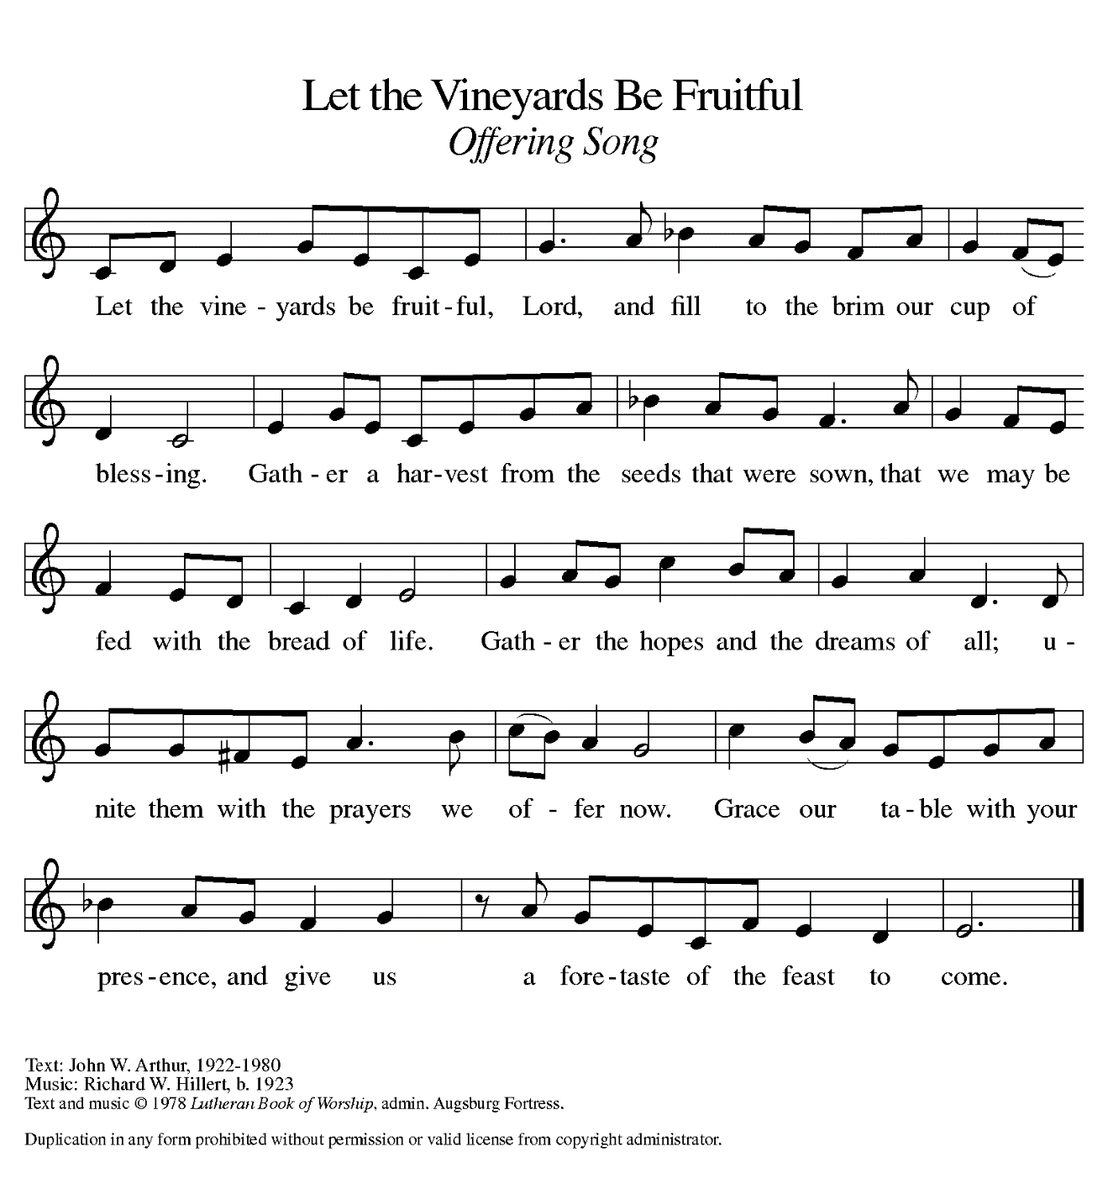

**THE OFFERTORY PRAYER**

A: Let us pray. God of life,

**C: All that we have is a sign of Your love; all that we are is a gift from Your hand.**

**Receive these offerings and the sacrifice of our thanksgiving. By this holy**

**Sacrament, grant us forgiveness, healing, and new life and hope in Christ our**

**Lord. Amen.**

**THE GREAT THANKSGIVING**

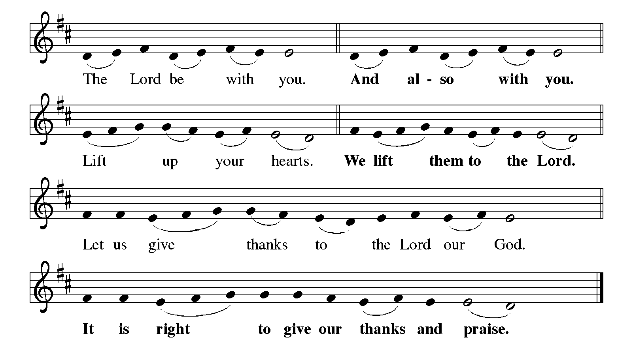

P: It is our duty and delight … and join their unending hymn:

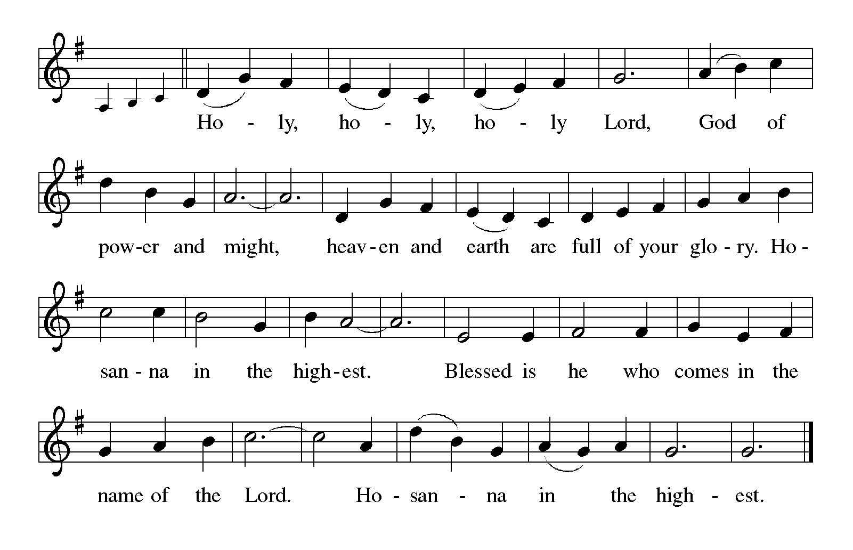

P: You are holy, Father, Maker of heaven and earth.

In You there is life, healing, and salvation; in Your name is our help.

In great love You rescued Israel from slavery and exile, defeat and shame, and sent

prophets with the promise of new life and salvation for all.

Finally, in Jesus Your Son, You reconciled the world to Yourself.

In the night ... “Do this for the remembrance of Me.”

As often as we eat this bread ... we proclaim the Lord’s death until He comes.

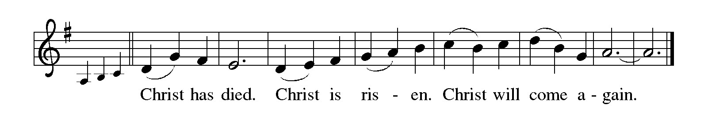

P: Remembering our Lord’s healing, suffering, and death for us all,

We await His promised appearing to banish suffering and death forever.

Send now Your Holy Spirit on us and these gifts of bread and wine, that we and all

who share the Lord’s Body and Blood

May, made whole by Your grace, be faithful stewards of Your healing to all in need.

To You, O God: Father, Son, and Holy Spirit, be all honor and glory, in Your holy

Church, in heaven and on earth, now and forever.

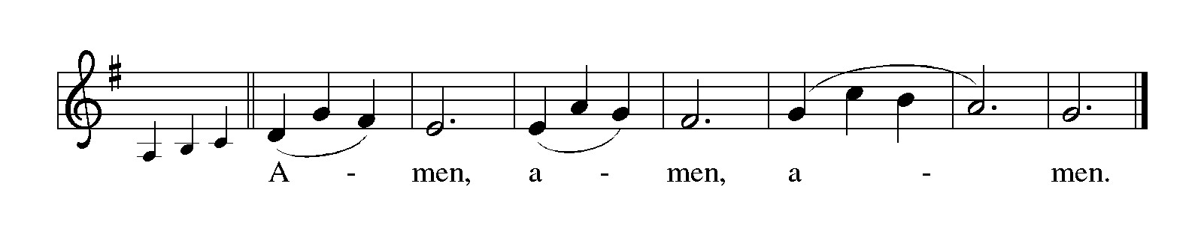

**THE LORD'S PRAYER**

P: Because in Christ we have received the Spirit of adoption, as daughters and sons of God

we dare to pray:

**C: Our Father in heaven, hallowed be Your name. Your Kingdom come. Your will**

**be done on earth as it is in heaven. Give us this day our daily bread, and forgive**

**us our sins as we forgive those who sin against us. Save us from the time of trial**

**and deliver us from evil. For the Kingdom, the power, and the glory are Yours,**

**now and forever. Amen.**

**INVITATION TO THE MEAL**

P: This is the Lamb of God Who takes away the sin of the world. Blessed are those who

are called to the Supper of the Lamb. God's holy gifts for God's holy people. Come,

for all is now ready.

*The assembly is seated*

**THE DISTRIBUTION *Lamb of God (see p. 11)***

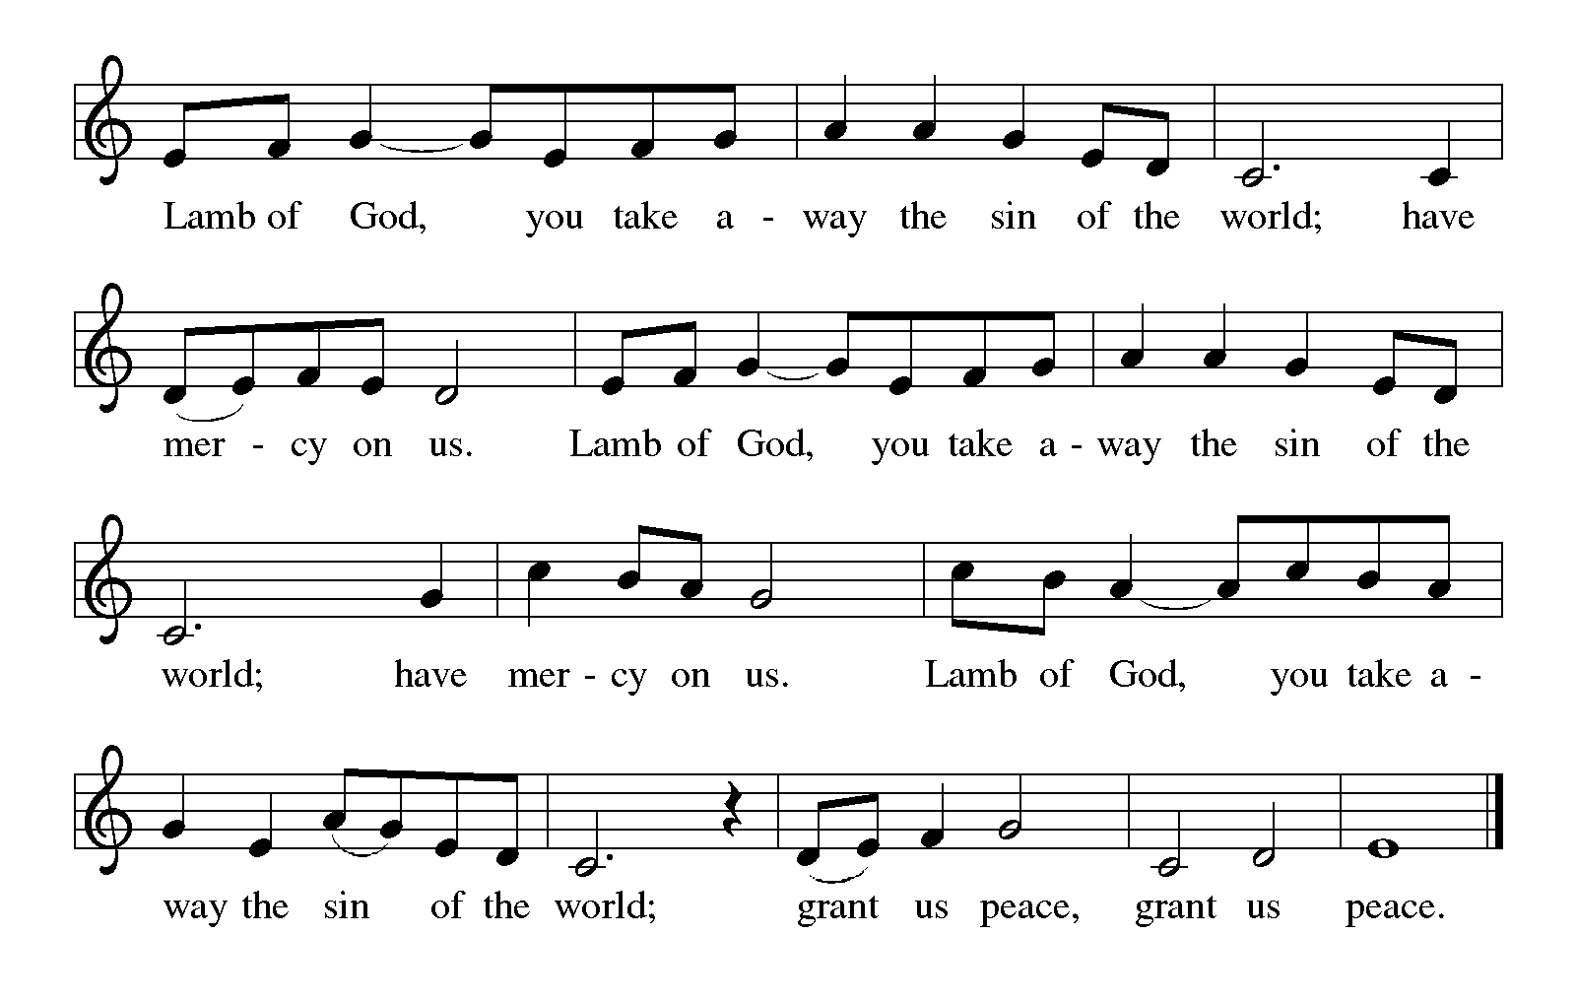

During the Distribution those wishing to receive prayer, anointing with oil,

and the laying on of hands are invited to go to one of the Pastors at the side aisle

**HYMN DURING DISTRIBUTION 614 *There is a Balm in Gilead***

**ELW 770 *Give Me Jesus***

**ELW 612 *Healer of Our Every Ill***

**ELW 485 *I Am the Bread of Life***

**ELW 487 *What Feast of Love***

*As you are able please rise*

**THE POST-COMMUNION BLESSING**

P: The Body and Blood of our Lord Jesus Christ strengthen you and keep you in His grace.

**C: Amen.**

**THE POST-COMMUNION PRAYER**

A: Let us pray. We give You thanks, almighty God, that You have again refreshed us with

the healing power of this Gift of life; and we pray that in Your mercy, You would

strengthen us through this Gift in faith toward You, and in perfect love toward one

another; for the sake of Jesus Christ our Lord.

**C: Amen.**

**✠ SENDING ✠**

**THE BENEDICTION**

P: Almighty God: Father, Son, **✠** and Holy Spirit bless you now and forever.

**C: Amen.**

**THE RECESSIONAL HYMN 843 *Praise the One Who Breaks the Darkness***

The congregation faces the cross as it leaves

**THE DISMISSAL**

A: Go in peace to bear Christ's love to the world.

**C: Thanks be to God!**

**POSTLUDE**

***✠ To God Alone Be Glory ✠***

The Meditation is from Philip Pfatteicher. *Festivals and Commemorations.* (Minneapolis:

Augsburg Press, 1980) 396.

**ANNOUNCEMENTS**

**Please remember to mail your offering to the Church Office** at 818 Franklin Street, Michigan City, IN 46360**.** Another alternative is to give on-line through Tithe.ly. Please see your closure letter for information on how to set up a Tithe.ly account.

**St. Paul Members are reminded to have** a loved one contact the office if you are hospitalized. Many times, the Pastor doesn’t know someone is in the hospital. If you call and leave a message, please tell us at which hospital the patient is located.

**BIRTHDAYS: Judy Mutchler (10/25); Bob Kiser (10/26)**

**ANNIVERSARIES: Warren & Karen Schacht (10/21); Ken & Ruth Baker (10/24);**

**Jim & Kim Summers (10/24)**

**PRAYER CONCERNS:** Bev Coburn; Barry Anderson; John Bennitt; Judy Gustum; Larry Litchford; Sarah McNabb; Jeanie Boatman Shepple; Debbie Martin; Mark Tannehill; Kathy Stein; Jan Paholski; Laura Dovey; Grace Romine; Roger and Margaret Miller; Bill Hazelgrove; Kerry Steinborn; Robert Bernth; Craig Hunt; Al Levenhagen and Carl Wipperman.

**If you are listening to the worship broadcast on the radio and would like to watch the Sunday morning service live stream follow these steps:**

(1) If you have You Tube available on your TV, search for

**St. Paul Lutheran Church Michigan City, IN.**

(2) The direct link on the computer is [https://](https://www.youtube.com/channel/UC5AIPNaKr3QN50984jGOa1g)

[www.youtube.com/channel/UC5AIPNaKr3QN50984jGOa1g](https://www.youtube.com/channel/UC5AIPNaKr3QN50984jGOa1g).

   (3) This link is also on the main page of the church’s website in

the church section and will continue to be posted weekly on the St.

Paul Facebook page.

And it will always be available on the radio broadcast Sunday mornings at 11:00 a.m.

on WEFM (95.9), and on the local cable access station #99 for the previous week’s

service on Sundays at 4:00 p.m. and the current service on Wednesdays at 7:00 p.m.

and Fridays at 8:30 p.m.

**LET’S CELEBRATE OUR PASTOR!**

**October is Pastor Appreciation Month.** Please join us during the coffee hour after our Sunday Worship Service today as we celebrate our appreciation for Pastor Reshan. Special treats, fellowship and a chance to say thank you face to face.

**OFFICE HOURS:** Libby will be in the office on Mondays, Wednesdays, and Fridays; volunteers will cover Tuesdays and Thursdays.

  Monday & Wednesday 8:00 a.m. – 5 p.m.

Tuesday & Thursday 9:00 a.m. – 12:00 p.m.

Friday 8:00 a.m. – 12:00 p.m.

**To send e-mail to the church office**, please use the following addresses:

Pastor Mark Reshan: seniorpastor@stpaulmichigancity.com

Church Office Secretary (Libby Pollock): churchsecretary@stpaulmichigancity.com

Church Treasurer (Karen Fleming): finance@stpaulmichigancity.com

**2025 Church Council:**

Mark Reshan - Pastor

 Janet Bakken – President

 Donna Knoll – Vice President

 Judy Hunt – Secretary

 Karen Fleming – Treasurer

Members: Paul Brooks, Diane Egilske, Sue Koziel, Judy Mutchler, Jim Schraidt, Trish Sprague

**Worship Attendance:**

**Saturday, October 11, 2025 @ 4:00 p.m. 32**

**Sunday, October 12, 2025 @ 9:00 a.m. 74**

**TOTAL 106**

**Copies of the minutes from the August 28, 2025 and the September 25, 2025 Church Council meetings are on the back table in the upper Narthex. They were approved by the council via email.**

**The Good News Newsletter**: If you have an article or anything you want included in **The Good News** please send it to the following e-mail address: splcgoodnews@gmail.com. Pastor Pamela Thiede will be using this e-mail address to assemble **The Good News** each month. The deadline for getting information to Pastor Pamela will be the 20th of each month.

**Sunday’s lessons are Jeremiah 31: 31-34; Psalm 46; Romans 3: 19-28; and John 8: 31-36** for those of you who like to study them in advance.

**OCTOBER MONTHLY MISSION:**

October’s monthly mission is Franciscan Health Woodland Cancer Care Center patients. The center is located on 400 North and provides the convenience of one location for a full spectrum of cancer services. We will be collecting care kits as well as money for this mission. There are paper lunch bags available in the Narthex. Please take as many bags as you want to fill with items to make a care kit for someone going through cancer treatments. Examples of items would be warm socks, hats, gloves, lotion, chapstick, hard candy, gum, snacks, hand sanitizer, small journals, books, activity books, small puzzles, or other activities to do while having treatment (which can take several hours). Please bring your completed care kits back by **Sunday, November 2nd** and place them in the bin in the Narthex. If you’d rather donate financially, they have a fund that goes toward local patients where they provide different things such as gas cards, or gift cards. Money can be placed in the offering plate and marked for the Cancer Center. Noisy coin for the month of October will also go toward the monthly mission. Thank you for your unwavering support each month!

**BIG THANKS!**

To all those who purchased and/or helped pack the Lutheran World Relief Kits. We packed 100 health kits, 100 School kits, and donated over $300 to the shipping fund to help get kits into hands of people struck by disaster around the world! Thank you for your generosity and hard work to make this mission a success each year!

. **2025 Financial Stewardship**

Weekly Church Operating Needs (x 2 weeks)

October 4-5, 2025; and October 11-12, 2025: $ 12, 671.50

General Fund (including General Memorials): $ 11,148.50

Overage/Shortage: — $ 1,523.00

Restricted Income (not including Memorials)

Supports IK Synod & Church wide Ministries: $ 161.00

Ministries in our Community/Congregation: $ 144.00

Capital Fund: $ 211.00

General Fund: $ 1,495.00

**ACTIVITIES, EVENTS & MEETINGS**

**OCTOBER 2025**

**Saturday,** October 18, 2025 @ 4:00 p.m. 19th Pent Worship Service/Sanctuary

**Sunday,** October 19, 2025 @ 9:00 a.m. 19th Pent Worship/Sanctuary with coffee after

**Pastor Appreciation Celebration**

**Monday,** October 20, 2025 @ 2:00 p.m. Finance Comm. Mtg./Luther House

@ 3:00 p.m. Executive Board Mtg./Luther House

**Wednesday,** October 22, 2025 @ 9:15 a.m. Bible Study/Luther House

@ 10:00 a.m. God’s Purls/St. Paul Room

@ 4:30 p.m. Choir Rehearsal/Sanctuary

**Thursday,** October 23, 2025 @ 4:30 p.m. 150th Anniv. Comm. Mtg/Luther House

@ 5:30 p.m. Church Council Meeting/St. Paul Room

**Saturday,** October 25, 2025 @ 4:00 p.m. 20th Pent/**Reformation** Worship/Sanctuary

**Sunday,** October 26, 2025 @ 9:00 a.m. 20th Pent/**Reformation Sunday** Worship/

Sanctuary with Coffee after/St. Paul Room

**Wednesday,** October 29. 2025 @ 9:15 a.m. Bible Study/Luther House

@10:00 a.m. God’s Purls/St. Paul Room

@4:30 p.m. Choir Rehearsal/Sanctuary