**THE THIRTEENTH SUNDAY AFTER PENTECOST**

**September 7, 2025**

“At verse 25 (of the Gospel text) Luke alerts the reader that what follows will be spoken to a different audience from that in verses 1-24. From semiprivate conversations in a home Jesus returns to the public arena. We are given no geographical reference, but again large crowds gather.

It is evident that Jesus is not facing reluctance but enthusiasm, similar to that which he met in 9:57. These people come to him (v. 26), he is not calling them to a life of discipleship. One is to read what follows, therefore, as the response of Jesus to the enthusiasm of persons who seem totally unaware that he is going to Jerusalem and the cross…”

“ … but what is the nature of (his) journey? Is it a funeral procession? Apparently only Jesus has seriously faced the issue of his death; the Twelve certainly have not yet grasped it. Is it a march? Very likely some think so, investing a good deal of emotion in imagining the projected clash: Galilee verses Jerusalem, peasants versus power, laity versus clergy, Jews versus Romans, Jesus versus the establishment.

Is it a parade? Obviously this crowd thinks so, oblivious to any conflict, any price to pay, any cross to bear. The crowd swells; everybody loves a parade. What does Jesus have to say to hasty volunteers? In sum, his word is, Think about what you are doing and decide if you are willing to stay with me all the way.

To the call to cross bearing … is added the almost frightening demand to hate one’s family and one’s own life (v. 26). To hate is a Semitic expression meaning to turn away from, to detach oneself from. There is nothing of that emotion we experience in the expression, “I hate you” …And to hate one’s own life is not a call for self-loathing, to regard oneself as a worm, to toss oneself on the trash heap of the world …”

“ …What is demanded of disciples, however, is that in the network of many loyalties in which all of us live, the claim of Christ and the gospel not only takes precedence but, in fact, redefines the others. This can and will necessarily involve some detaching, some turning away.”

**Fred Craddock**

**✠ In the Name of Jesus ✠**

**✠ GATHERING ✠**

**INTRODUCTION**

Called to contemplate the cost of discipleship today, we might be helped by translating Paul’s request to Philemon into our prayer of the day: Refresh my heart in Christ. Strengthened by the company and forgiveness of the Christ in the blessed sacrament and recalling God’s grace in remembrance of baptism, we can be strengthened in this hour to "choose life"—to choose life in God as our own.

**PRE-SERVICE MUSIC  *Change Me On the Inside* New Song Praise Band**

**(Brian Doerksen)**

**ANNOUNCEMENTS**

*As you are able please rise*

**CONFESSION AND ABSOLUTION**

P: In the name of the Father and of **✠** the Son and of the Holy Spirit.

**C: Amen.**

P: “I call heaven and earth to witness against you today that I have set before you life and

death, blessings and curses. Choose life so that you and your descendants may live ...”

(Deuteronomy 30: 19) God’s life is given through the gift of forgiveness. Let us

therefore confess our sins, that with hope and joy we may receive the blessing of

forgiven life God sets before us this day.

*Silence for reflection and self-examination.*

P: Most merciful God,

**C: We confess that we have sinned against You in thought, word, and deed. We have**

**not loved You with our whole heart. (Deuteronomy 30: 17) We have not walked**

**in Your ways. (30: 16) We have failed to observe Your commandments, decrees,**

**and ordinances. (30: 16) We have counted the cost of faithfulness to You and**

**turned away from our discipleship. (Luke 14: 28) We have not taken up the cross**

**and followed in the ways of Christ. (14: 27) In Your great compassion, have**

**mercy on us. Forgive us for the sake of Your Son, Jesus Christ, and grant us the**

**strength to be His disciples.**

P: God rescues us from the curse of sin and death. God’s life is for you this day, for as a

called and ordained minister of the Church of Christ, and by His authority, I therefore

declare to you the entire forgiveness of all your sins, in the name of the Father and of

**✠**  the Son and of the Holy Spirit.

**C: Amen.**

**GATHERING SONG NSB 84 *The Potter’s Hand***

**THE GREETING AND PRAYER OF THE DAY**

P: The grace of our Lord Jesus Christ, the love of God, and the communion of the Holy

Spirit be with you all.

**C: And also with you.**

P: Let us pray. Direct us, O Lord God, in all our doings with Your continual help, that in

all our works, begun, continued, and ended in You, we may glorify Your holy name;

and finally, by Your mercy, bring us to everlasting life, through Jesus Christ, our Savior

and Lord.

**C: Amen.**

*The assembly is seated*

**✠ WORD ✠**

**FIRST READING Deuteronomy 30: 15-20**

*Life and blessing are the benefits of keeping the law God has given through Moses. In this passage, Moses presents the consequences of choosing between life and death.*

15See, I have set before you today life and prosperity, death and adversity. 16If you obey the commandments of the Lord your God that I am commanding you today, by loving the Lord your God, walking in His ways, and observing His commandments, decrees, and ordinances, then you shall live and become numerous, and the Lord your God will bless you in the land that you are entering to possess.

17But if your heart turns away and you do not hear, but are led astray to bow down to other gods and serve them, 18I declare to you today that you shall perish; you shall not live long in the land that you are crossing the Jordan to enter and possess.

19I call heaven and earth to witness against you today that I have set before you life and death, blessings and curses. Choose life so that you and your descendants may live, 20loving the Lord your God, obeying Him, and holding fast to Him; for that means life to you and length of days, so that you may live in the land that the Lord swore to give to your ancestors, to Abraham, to Isaac, and to Jacob.

The Word of the Lord.

**Thanks be to God.**

**THE PSALM: Psalm 1** **Read responsively**

1Happy are they who have not walked in the counsel of the wicked,

     nor lingered in the way of sinners, nor sat in the seats of the scornful!

**2Their delight is in the law of the LORD,**

**and they meditate on God's teaching day and night.**

3They are like trees planted by streams of water, bearing fruit in due season, with leaves

that do not wither; everything they do shall prosper.

**4It is not so with the wicked;**

**they are like chaff which the wind blows away.**

5Therefore the wicked shall not stand upright when judgment comes,

     nor the sinner in the council of the righteous.

**6For the LORD knows the way of the righteous,**

**but the way of the wicked shall be destroyed.**

**SECOND READING Philemon 1-21**

*While Paul was in prison, he was aided by a runaway slave named Onesimus. The slave's master, Philemon, was a Christian friend of Paul's. Paul told Onesimus to return to his master, but encouraged Philemon to receive Onesimus back as a brother.*

1Paul, a prisoner of Christ Jesus, and Timothy our brother,

To Philemon our dear friend and co-worker, 2to Apphia our sister, to Archippus our fellow soldier, and to the church in your house:

3Grace to you and peace from God our Father and the Lord Jesus Christ.

4When I remember you in my prayers, I always thank my God 5because I hear of your love for all the saints and your faith toward the Lord Jesus. 6I pray that the sharing of your faith may become effective when you perceive all the good that we may do for Christ. 7I have indeed received much joy and encouragement from your love, because the hearts of the saints have been refreshed through you, my brother.

8For this reason, though I am bold enough in Christ to command you to do your duty, 9yet I would rather appeal to you on the basis of love--and I, Paul, do this as an old man, and now also as a prisoner of Christ Jesus. 10I am appealing to you for my child, Onesimus, whose father I have become during my imprisonment. 11Formerly he was useless to you, but now he is indeed useful both to you and to me.

12I am sending him, that is, my own heart, back to you. 13I wanted to keep him with me, so that he might be of service to me in your place during my imprisonment for the gospel; 14but I preferred to do nothing without your consent, in order that your good deed might be voluntary and not something forced. 15Perhaps this is the reason he was separated from you for a while, so that you might have him back forever, 16no longer as a slave but more than a slave, a beloved brother--especially to me but how much more to you, both in the flesh and in the Lord.

17So if you consider me your partner, welcome him as you would welcome me. 18If he has wronged you in any way, or owes you anything, charge that to my account. 19I, Paul, am writing this with my own hand: I will repay it. I say nothing about your owing me even your own self. 20Yes, brother, let me have this benefit from you in the Lord! Refresh my heart in Christ. 21Confident of your obedience, I am writing to you, knowing that you will do even more than I say.

The Word of the Lord.

**Thanks be to God.**

*As you are able please rise*

**THE VERSE** Sung twice

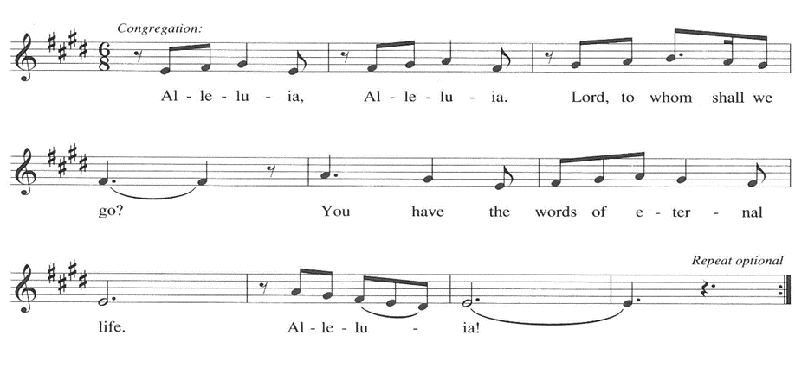

**THE HOLY GOSPEL Luke 14: 25-33**

Jesus speaks frankly about the fearsome costs of discipleship. Those who follow him should know from the outset that completing the course of discipleship will finally mean renouncing all other allegiances.

P: The Holy Gospel according to St. Luke, the fourteenth chapter.

**C: Glory to You, O Lord!**

25Now large crowds were traveling with Jesus; and He turned and said to them, 26"Whoever comes to Me and does not hate father and mother, wife and children, brothers and sisters, yes, and even life itself, cannot be My disciple. 27Whoever does not carry the cross and follow Me cannot be My disciple.

28For which of you, intending to build a tower, does not first sit down and estimate the cost, to see whether he has enough to complete it? 29Otherwise, when he has laid a foundation and is not able to finish, all who see it will begin to ridicule him, 30saying, 'This fellow began to build and was not able to finish.'

31Or what king, going out to wage war against another king, will not sit down first and consider whether he is able with ten thousand to oppose the one who comes against him with twenty thousand? 32If he cannot, then, while the other is still far away, he sends a delegation and asks for the terms of peace. 33So therefore, none of you can become My disciple if you do not give up all your possessions."

P: The Gospel of the Lord.

**C: Praise to You, O Christ!**

*The assembly is seated*

**THE SERMON**

*Silence for reflection follows the sermon*

*As you are able please rise*

**THE HYMN OF THE DAY 1004 Faith Begins By Letting Go**



**THE APOSTLES’ CREED**

A: God has made us His people through our Baptism into Christ. Living together in trust

and hope, we confess our faith.

**C: I believe in God, the Father almighty,**

**creator of heaven and earth.**

**I believe in Jesus Christ, His only Son, our Lord.**

**He was conceived by the power of the Holy Spirit**

**and born of the virgin Mary.**

**He suffered under Pontius Pilate,**

**was crucified, died, and was buried.**

**He descended into hell.**

**On the third day He rose again.**

**He ascended into heaven,**

**and is seated at the right hand of the Father.**

**He will come again to judge the living and the dead.**

**I believe in the Holy Spirit,**

**the holy catholic Church,**

**the communion of saints,**

**the forgiveness of sins,**

**the resurrection of the body,**

**and the life everlasting. Amen.**

**THE PRAYER OF THE CHURCH**

A: The mercy of the Lord is faithful and sure. Let us therefore gather the needs of the

Church, the world, and all those in need, and present them to God with joy and hope.

A: For the Church, that it might be like a tree planted by baptismal streams of water,

bearing the fruit of Christ’s love for the life of the world, we pray to the Lord:

**C: Lord, have mercy.**

A: For an end to turmoil and violence in Ukraine and Gaza; for a peace in Indonesia; Haiti;

and Colombia; for hope in the Middle East, and for our enemies, we pray to the Lord:

**C: Lord, have mercy.**

A: For Christians who suffer persecution, imprisonment, and oppression, especially in

North Korea, Afghanistan, Somalia, and Pakistan, we pray to the Lord:

**C: Lord, have mercy.**

A: For this congregation, that we may be more faithful disciples of Jesus, we pray to the

Lord:

**C: Lord, have mercy.**

A: For the sick, especially: **Bob Pheanis; Lucas Bradshaw; Kerry Steinborn; Martha**

**Schroeder; Jess Kalvaitis; Fred Weiss; David Weiss; Larry Litchford; Debbie**

**Martin; Christine Kiser; Shirley Freels; Mike Galinowski; John Bennitt; and**

**Judy Gustum,** we pray to the Lord:

**C: Lord, have mercy.**

A: For those celebrating birthdays, especially **Joan Seifert**; **Mary Knaup; John Konkel;**

**and Bob Pheanis;** and anniversaries, especially **Al & Sue Green** that they may be

filled with grace this day and every day and grow in grace in the days ahead, we pray

to the Lord:

**C: Lord, have mercy.**

A: For all who have died bearing the Cross of Christ, we offer our praise. That their lives

of faith and courage may inspire us to greater service and ministry, we pray to the Lord:

**C: Lord, have mercy.**

P: Loving God, You are our life and our hope. Fill us with Your wisdom; hear us and the

needs of the world, that we may care well for Your creation. We ask this in the name

of Jesus the Lord.

**C: Amen.**

**✠ MEAL ✠**

**THE PEACE**

P: The peace of the Lord be with you always.

**C: And also with you.**

*The assembly is seated*

**OFFERING**

**THE VOLUNTARY *Jesus Messiah* New Song Praise Band**

**(Carson, Tomlin, Cash, Reeves)**

*As you are able please rise*

**THE OFFERTORY 465 *As the Grains of Wheat***

**THE OFFERTORY PRAYER**

A: Let us pray. Gracious God,

**C: Daily You call us to take up the cross and follow You with our whole lives. Receive these gifts as the offering of all that we are and have to Your service. As You so freely give to us of this holy Sacrament, strengthen us through this Meal toward greater and more faithful discipleship. We ask this in the name of Jesus the Lord. Amen.**

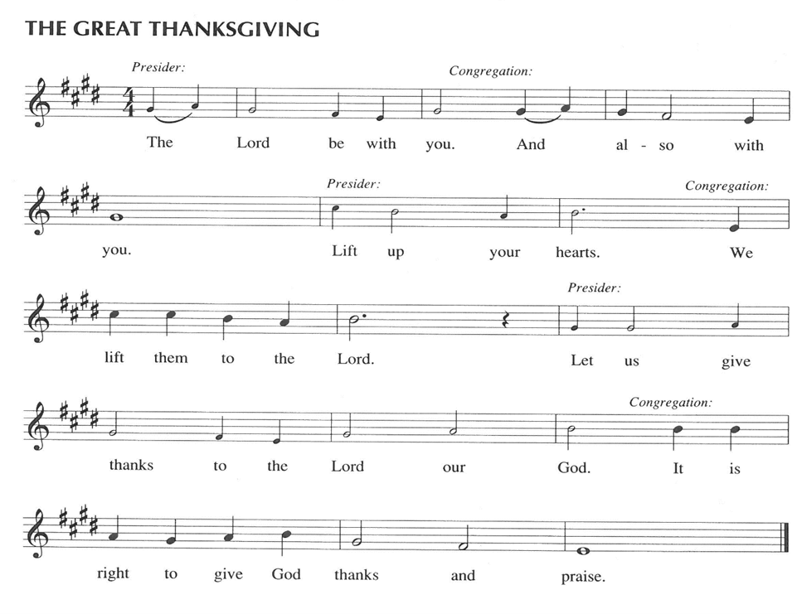

P: It is our duty and delight …and join their unending hymn:

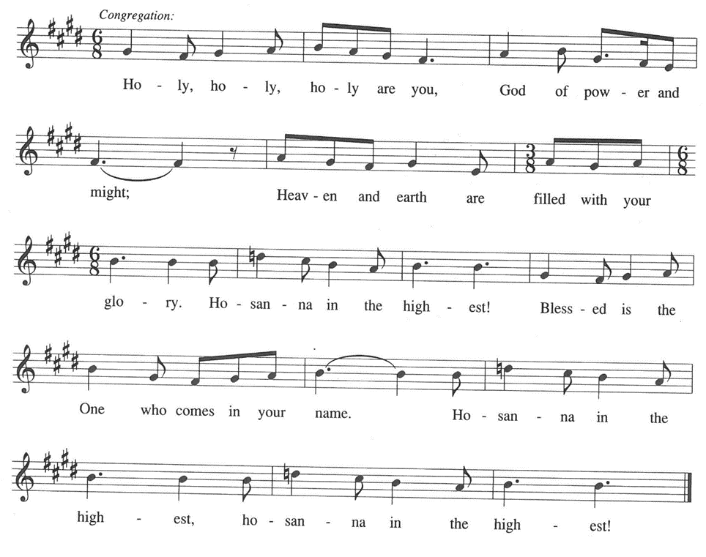

P: Praise be unto You, God of the prophets, for You have taken into Your own two hands

the redemption of the world and refashioned us from brokenness into life

everlasting with You.

Like a potter You fashioned Your chosen people, making them into a vessel worthy of

Your glory.

When that vessel was spoiled You called Your people to repentance and sent prophets

to renew their faith.

In the fullness of time, through the death and resurrection of Your Son, You reworked

the clay like a potter at a wheel, and remade a vessel revealing Your

goodness and grace through the forgiveness of sins, raising us up from the

dust of the earth to the hope of everlasting life.

God of love, You welcome us at this Table as sisters and brothers in a new family.

Shape our life together by the way we belong to one another in You.

Send Your Holy Spirit upon Your Church to make us faithful witnesses to Your

beloved community.

Make this bread and cup holy that they may be for us the Body and Blood of Your

Son,

Who, in the night ... “Do this for the remembrance of Me.”

As often as we eat ... we proclaim the Lord’s death until He comes.

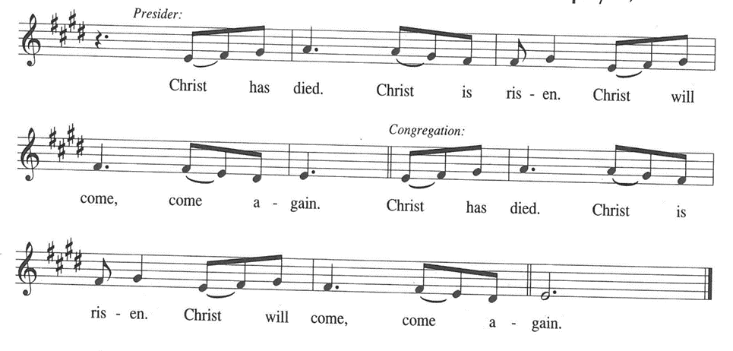

P: Creating and re-creating God, You are the potter and we are the clay.

Renew Your Church today in the touch of Your hands.

Search and know the places that are broken and the hearts that long to be mended.

Form Your people in faithfulness to Jesus.

Shape us to be His disciples, to take up our cross and follow Him.

Have Your own way with us, Lord: mold us and make us, search us and try us,

touch us and heal us, till all shall see Christ, only, always, living in us.

Bring us at last to the blessed Day when we are one with the family of saints gathered

around Your throne,

In the company of the Holy Spirit, in union with Christ,

Father most holy, now and always.

**C: Amen!**

**THE LORD’S PRAYER**

P: Gathered into one by the Spirit, let us pray as Jesus taught us:

**C: Our Father in heaven, hallowed be Your name. Your Kingdom come. Your will**

**be done on earth as it is in heaven. Give us this day our daily bread, and forgive**

**us our sins as we forgive those who sin against us. Save us from the time of trial**

**and deliver us from evil. For the Kingdom, the power, and the glory are Yours,**

**now and forever. Amen.**

**INVITATION TO THE MEAL**

P: This is the Lamb of God Who takes away the sin of the world. Blessed are those who

are called to the Supper of the Lamb. God’s holy gifts for God’s holy people. Come,

for all is now ready.

*The assembly is seated*

**THE DISTRIBUTION *Lamb of God***

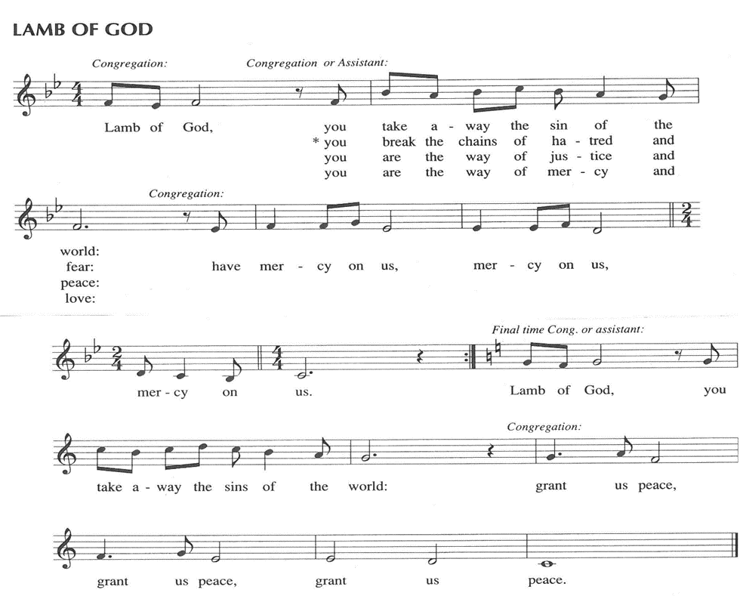

**HYMN DURING DISTRIBUTION 810 *O Jesus, I Have Promised***

**ELW 525 *You Are Holy***

**ELW 423 *Shall We Gather at the River***

**NSB 48 *I Am the Bread of Life (Talbot)***

*As you are able please rise*

**THE POST-COMMUNION BLESSING**

P: The Body and Blood of our Lord Jesus Christ strengthen you and keep you in His grace.

**C: Amen.**

**THE POST-COMMUNION PRAYER**

A: Let us pray. Lord Jesus Christ, once again You have set before us the rich Feast of

Your Body and Blood. Bless us through this Meal, that we may love You, obey You,

and hold fast to You in our service, even as You hold us through life and death into the

life to come. You are the Lord forevermore.

**C: Amen.**

**✠ SENDING ✠**

**THE BENEDICTION**

P: Almighty God: Father, Son, **✠** and Holy Spirit bless you now and forever.

**C: Amen.**

**THE SENDING HYMN 660 *Lift High the Cross***

**THE DISMISSAL**

A: Go in peace to bear Christ’s love to all the world.

**C: Thanks be to God!**

**POSTLUDE**

**✠ To God Alone Be Glory ✠**

The Meditation is from *Interpretation: A Bible Commentary for Preaching and*

*Teaching.* Luke: Fred Craddock. (Louisville: John Knox Press, 1990) 181-82.

The Eucharistic Prayer is adapted from *Eucharistic Prayers.* Samuel Wells and Abigail

Kocher. (Grand Rapids: Eerdmann’s Publishing Company, 2016) 272-73.

**ANNOUNCEMENTS**

**Please remember to mail your offering to the Church Office** at 818 Franklin Street, Michigan City, IN 46360**.** Another alternative is to give on-line through Tithe.ly. Please see your closure letter for information on how to set up a Tithe.ly account.

**St. Paul Members are reminded to have** a loved one contact the office if you are hospitalized. Many times, the Pastor doesn’t know someone is in the hospital. If you call and leave a message, please tell us at which hospital the patient is located.

**BIRTHDAYS: Joan Seifert (9/8); Mary Knaup (9/8);**

**John Konkel (9/10); Bob Pheanis (9/14)**

**ANNIVERSARIES: Al & Sue Green (9/15)**

**PRAYER CONCERNS:** Bev Coburn; Barry Anderson; John Bennitt; Judy

Gustum; Bob Pheanis; Larry Litchford; Sarah McNabb; Jeanie Boatman Shepple; Debbie Martin; Mark Tannehill; Kathy Stein; Jan Paholski; Laura Dovey; Grace Romine; Mike Galinowski; Bill Hazelgrove; and Kerry Steinborn.

**OFFICE HOURS:** Libby will be in the office on Mondays, Wednesdays, and Fridays; volunteers will cover Tuesdays and Thursdays.

  Monday & Wednesday 8:00 a.m. – 5 p.m.

Tuesday & Thursday 9:00 a.m. – 12:00 p.m.

Friday 8:00 a.m. – 12:00 p.m.

**If you are listening to the worship broadcast on the radio and would like to watch the Sunday morning service live stream follow these steps:**

(1) If you have You Tube available on your TV, search for

**St. Paul Lutheran Church Michigan City, IN.**

(2) The direct link on the computer is [https:// www.youtube.com/channel/UC5AIPNaKr3QN50984jGOa1g](https://www.youtube.com/channel/UC5AIPNaKr3QN50984jGOa1g).

   (3) This link is also on the main page of the church’s website in

the church section and will continue to be posted weekly on

the St. Paul Facebook page.

And it will always be available on the radio broadcast Sunday mornings at 11:00 a.m.

on WEFM (95.9), and on the local cable access station #99 for the previous

week’s service on Sundays at 4:00 p.m. and the current service on

Wednesdays at 7:00 p.m. and Fridays at 8:30 p.m.

**Sunday’s lessons are Numbers 21: 4b-9; Psalm 98: 1-4 or Psalm 78: 102, 34-38;**

**I Corinthians 1: 18-24; and John 3: 13-17** for those of you who like to study them in advance.

**To send e-mail to the church office**, please use the following addresses:

Pastor Mark Reshan: seniorpastor@stpaulmichigancity.com

Church Office Secretary (Libby Pollock): churchsecretary@stpaulmichigancity.com

Church Treasurer (Karen Fleming): finance@stpaulmichigancity.com

**2025 Church Council:**

Mark Reshan - Pastor

 Janet Bakken – President

 Donna Knoll – Vice President

 Judy Hunt – Secretary

 Karen Fleming – Treasurer

 Members: Paul Brooks, Diane Egilske, Sue Koziel, Judy Mutchler,

Jim Schraidt, Trish Sprague

**Worship Attendance:**

**Saturday , August 30, 2025 @ 4:00 p.m. 22**

**Sunday, August 31, 2025 @ 9:00 a.m. 76**

**TOTAL 98**

**Copies of the minutes from the June 26, 2025 and the Augut 28, 2025 Church Council meetings are on the back table in the upper Narthex. They were approved by the council via email. There was no Council meeting in July 2025.**

**The Good News Newsletter**: If you have an article or anything you want included in **The Good News** please send it to the following e-mail address: splcgoodnews@gmail.com. Pastor Pamela Thiede will be using this e-mail address to assemble **The Good News** each month. The deadline for getting information to Pastor Pamela will be the 20th of each month.

**2025 Financial Stewardship**

Weekly Church Operating Needs (x 2 weeks)

August 23-24, 2025; August 30-31, 2025: $ 10,600.00

General Fund (including General Memorials): $ 7,340.00

Overage/Shortage: — $ 4,250.50

Restricted Income (not including Memorials)

Supports IK Synod & Church wide Ministries: $ 120.00

Ministries in our Community/Congregation: $ 380.00

Capital Fund: $ 30.00

**September 2025 Mission of the Month**

The Mission of the Month for September 2025: ZERO Prostate Cancer

September is Prostate Cancer Awareness Month. Prostate cancer will affect about one in seven men in their lifetime and about 35,000 men will die from prostate cancer this year. Fortunately, if detected early, prostate cancer can be successfully treated, and new treatments are becoming available to extend the lives of men with advanced disease. ZERO is the largest prostate cancer support, education and advocacy organization in the United States. It offers free support and education services to prostate cancer patients, and advocates for research funding and improved prostate cancer treatment. Jim Schraidt is a fifteen-year prostate cancer survivor and a member of the Board of Directors of ZERO. He leads a monthly ZERO-sponsored support group that meets in Chicago with simultaneous virtual access. Jim is happy to answer questions about prostate cancer and ZERO, and more information can be found at <https://zerocancer.org>.

Checks can be written to St. Paul and can be marked for ZERO and placed in the offering plate.

Noisy coin offering will also support the mission of the month.

**ACTIVITIES, EVENTS & MEETINGS**

**SEPTEMBER 2025**

**Saturday,** September 6, 2025 @ 4:00 p.m. Pent 13 Worship Service/Sanctuary

**Sunday,** September 7, 2025 @ 9:00 a.m. Pent 13 Worship Service/Sanctuary with

coffee after in the St. Paul Room

**Monday,** September 8, 2025 @ 1:00 p.m. Hope Circle/Green Room

**Tuesday,** September 9, 2025 all day until close **GIVE BACK at Holly’s Restaurant**

@ 7:00 p.m. Estuary/Luther House

**Wednesday,** September 10, 2025 @ 10:00 a.m. God’s Purls/St. Paul Room

@ 4:30 p.m. Choir Rehearsal/Sanctuary

**Saturday,** September 13, 2025 @ 4:00 p.m. Pent 14 (Holy Cross Day) Worship

**Sunday,** September 14, 2025 @ 9:00 a.m. Pent 14 (Holy Cross Day) Worship

Installation of Musicians with coffee after/St. Paul Room

**Wednesday,** September 17, 2025 @ 9:15 a.m. Bible Study/Luther House

@10:00 a.m. God’s Purls/St. Paul Room

@ 4:30 p.m. Choir Rehearsal/Sanctuary

**Saturday,** September 20, 2025 @ 4:00 p.m. Pent 15 (Day of St. Matthew) Worship

**Sunday,** September 21, 2025 @9:00 a.m. Pent 15 (Day of St. Matthew) Worship with coffee after/St. Paul Room

**Monday,** September 22, 2025 @ 2:00 p.m. Finance Comm. Mtg./Luther House

@3:00 p.m. Executive Board Mtg./Luther House

**Tuesday,** September 23, 2025 @ 4:00 p.m. 150th Anniv. Comm. Mtg./Luther House

**Wednesday,** September 24, 2025 @ 9:15 a.m. Bible Study/Luther House

@ 10:00 a.m. God’s Purls/St. Paul Room

@ 4:30 p.m. Choir Rehearsal/Sanctuary

**Thursday,** September 25, 2025 @ 5:30 p.m. Church Council Mtg./St. Paul Room

**Saturday,** September 27, 2025 @ 4:00 p.m. Pent 16 (Day of St. Michael &All The Angels) Worship Service/Sanctuary

**Sunday,** September 28, 2025 @ 9:00 a.m. Pent 16 (Day of St. Michael &All The Angels) Worship with coffee after/St. Paul Room

Thank$ for $haring

Thanks to all who participate in the Give Back opportunities! Our next Give Back will be at Holly’s on Tuesday, September 9, 2025.  Here are two coupons—one for you and one for a friend.

