**THE COMMEMORATION OF ST. MATTHEW**

**The Fifteenth Sunday after Pentecost**

**September 21, 2025**

Matthew (the son of Alphaeus, according to Mark) was a tax collector for the Roman government in Capernaum. He is called Levi in the accounts of his call to discipleship, although in the lists of the Twelve he is always called Matthew.

It is frequently believed that Levi was his original name and that Matthew (Hebrew, “gift from God”) was given to him after he became a disciple. Since the second century the authorship of the first gospel has been attributed to Matthew. He is usually represented in art by a winged man (suggested by Ezekiel 1: 1-10 and 10: 8-14). His feast day in the Eastern church is November 16.

**Philip Pfatteicher and Carlos Messerli**

***Manual on the Liturgy***

This life therefore is not righteousness

but growth in righteousness;

not health but healing

not being but becoming,

not rest but exercise.

We are not yet what we shall be

but we are growing toward it,

the process is not yet finished,

but it is going on.

This is not the end

but it is the road.

All does not yet gleam in glory

But all is being purified.

**Martin Luther**

***✠ In the Name of Jesus ✠***

**INTRODUCTION**

*In the time of Jesus, tax collectors were social outcasts. Many were known for being dishonest and brutal in their collection of taxes. Jesus called Matthew to be his disciple and willingly shared a meal with this seemingly unsavory fellow. To his critics, Jesus said, I did not come to call the virtuous, but sinners. Here is the source of our hope: Jesus has no desire to condemn us, but to forgive and heal us.*

**Matthew, Apostle and Evangelist**

*Matthew (or Levi) was a tax collector in Capernaum for the Roman government. Tax collectors were frequently despised for dishonesty and for assisting the occupiers. Jesus nevertheless showed love for them, and chose Matthew to be a disciple.*

**✠ GATHERING ✠**

**PRE-SERVICE MUSIC *By Grace We Have Been Saved by Faith* New Song Praise Band**

**(Rory Cooney)**

**ANNOUNCEMENTS**

*As you are able please rise*

**THE GATHERING SONG NSB 68 *O, the Deep Deep Love of Jesus***

**THE GREETING AND PRAYER OF THE DAY**

P: The grace of our Lord Jesus Christ, the love of God, and the communion of the Holy Spirit be

with you all.

**C: And also with you.**

P: Let us pray. Almighty God, Your Son our Savior called a despised collector of taxes to become

one of His apostles. Help us, like Matthew, to respond to the transforming call of Your Son,

Jesus Christ our Lord, Who lives and reigns with You and the Holy Spirit, one God, now and

forever.

**C: Amen.**

*The assembly is seated*

**✠ WORD ✠**

**FIRST READING Ezekiel 2: 8--3: 11**

*Following the call of the prophet to speak the Word of God, this passage relates in vivid imagery the need to consume the Word until it is fully assimilated by the prophet.*

8You, mortal, hear what I say to you; do not be rebellious like that rebellious house; open your mouth and eat what I give you. 9I looked, and a hand was stretched out to me, and a written scroll was in it. 10He spread it before me; it had writing on the front and on the back, and written on it were words of lamentation and mourning and woe.

3:1He said to me, O mortal, eat what is offered to you; eat this scroll, and go, speak to the house of Israel. 2So I opened my mouth, and he gave me the scroll to eat. 3He said to me, Mortal, eat this scroll that I give you and fill your stomach with it. Then I ate it; and in my mouth it was as sweet as honey.

4He said to me: Mortal, go to the house of Israel and speak my very words to them. 5For you are not sent to a people of obscure speech and difficult language, but to the house of Israel 6not to many peoples of obscure speech and difficult language, whose words you cannot understand. Surely, if I sent you to them, they would listen to you.

7But the house of Israel will not listen to you, for they are not willing to listen to Me; because all the house of Israel have a hard forehead and a stubborn heart. 8See, I have made your face hard against their faces, and your forehead hard against their foreheads. 9Like the hardest stone, harder than flint, I have made your forehead; do not fear them or be dismayed at their looks, for they are a rebellious house.

10He said to me: Mortal, all My words that I shall speak to you receive in your heart and hear with your ears; 11then go to the exiles, to your people, and speak to them. Say to them, "Thus says the Lord God"; whether they hear or refuse to hear.

The Word of the Lord.

**Thanks be to God.**

**THE PSALM: Psalm 119: 33-40** **Read responsively**

33Teach me, O LORD, the way of Your statutes,

     and I shall keep it to the end.

**34Give me understanding, and I shall keep Your teaching;**

**I shall keep it with all my heart.**

35Lead me in the path of Your commandments,

     for that is my desire.

**36Incline my heart to Your decrees**

**and not to unjust gain.**

37Turn my eyes from beholding falsehood;

     give me life in Your way.

**38Fulfill Your promise to Your servant,**

**which is for those who fear You.**

39Turn away the reproach that I dread,

     because Your judgments are good.

**40Behold, I long for Your commandments;**

**by Your righteousness enliven me.**

**SECOND READING Ephesians 2: 4-10**

*The author of this letter is eager to show God’s love for sinners. God reaches into the deathly snare of sin and death in order to draw us out into life with Christ. This act is nothing less than the gift of God’s mercy.*

1You were dead through the trespasses and sins 2in which you once lived, following the course of this world, following the ruler of the power of the air, the spirit that is now at work among those who are disobedient. 3All of us once lived among them in the passions of our flesh, following the desires of flesh and senses, and we were by nature children of wrath, like everyone else.

4But God, Who is rich in mercy, out of the great love with which He loved us 5even when we were dead through our trespasses, made us alive together with Christ--by grace you have been saved--6and raised us up with Him and seated us with Him in the heavenly places in Christ Jesus, 7so that in the ages to come He might show the immeasurable riches of His grace in kindness toward us in Christ Jesus.

8For by grace you have been saved through faith, and this is not your own doing; it is the gift of God--9not the result of works, so that no one may boast. 10For we are what He has made us, created in Christ Jesus for good works, which God prepared beforehand to be our way of life.

The Word of the Lord.

**Thanks be to God.**

*As you are able lease rise*

**THE VERSE** Sung twice

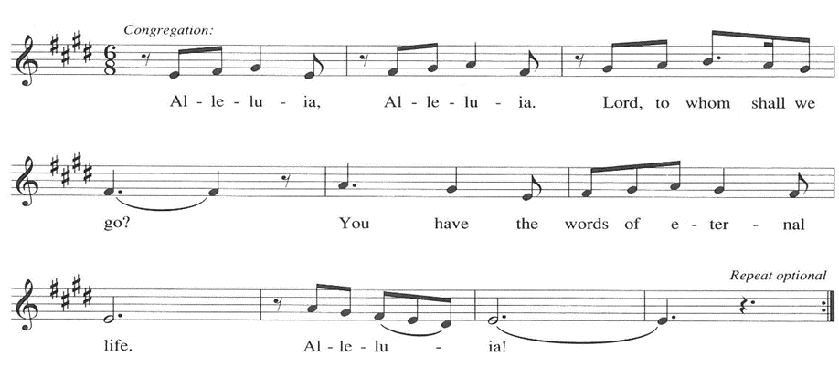

**THE HOLY GOSPEL Matthew 9: 9-13**

P: The Holy Gospel according to St. Matthew, the ninth chapter.

**C: Glory to You, O Lord!**

*Regarded as a traitor to his people and an oppressor of the poor, this tax collector follows Jesus and then offers him hospitality. In the sharing of a meal Jesus reveals his mission: to serve God's mercy.*

9As Jesus was walking along, He saw a man called Matthew sitting at the tax booth; and He said to him, "Follow Me." And he got up and followed Him.

10And as He sat at dinner in the house, many tax collectors and sinners came and were sitting with Him and His disciples. 11When the Pharisees saw this, they said to His disciples, "Why does your teacher eat with tax collectors and sinners?" 12But when He heard this, He said, "Those who are well have no need of a physician, but those who are sick. 13Go and learn what this means, 'I desire mercy, not sacrifice.' For I have come to call not the righteous but sinners."

P: The Gospel of the Lord.

**C: Praise to You, O Christ!**

*The assembly is seated*

**THE SERMON**

*Silence for reflection follows the sermon*

*As you are able please rise*

**THE HYMN OF THE DAY 421 (see p. 6) *By All Your Saints***

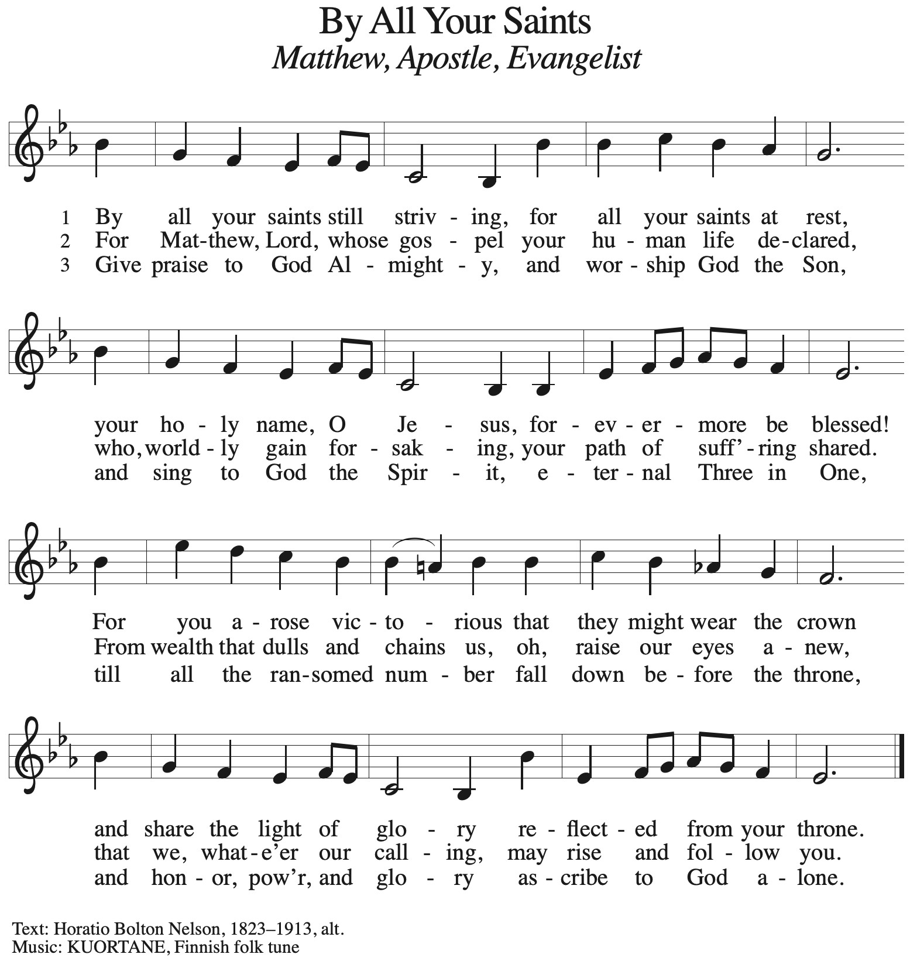

**THE NICENE CREED**

A: God has made us His people through our Baptism into Christ. Living together in trust and

hope, we confess our faith.

**C: We believe in one God,**

**the Father, the Almighty,**

**maker of heaven and earth,**

**of all that is, seen and unseen.**

**We believe in one Lord, Jesus Christ,**

**the only Son of God,**

**eternally begotten of the Father,**

**God from God, Light from Light,**

**true God from true God,**

**begotten, not made,**

**of one Being with the Father.**

**Through Him all things were made.**

**For us and for our salvation**

**He came down from heaven;**

**by the power of the Holy Spirit**

**He became incarnate from the virgin Mary, and was made man.**

**For our sake He was crucified under Pontius Pilate;**

**He suffered death and was buried.**

**On the third day He rose again**

**in accordance with the Scriptures;**

**He ascended into heaven**

**and is seated at the right hand of the Father.**

**He will come again in glory to judge the living and the dead,**

**and His kingdom will have no end.**

**We believe in the Holy Spirit, the Lord, the giver of life,**

**Who proceeds from the Father and the Son.**

**With the Father and the Son He is worshiped and glorified.**

**He has spoken through the prophets.**

**We believe in one holy catholic and apostolic Church.**

**We acknowledge one Baptism for the forgiveness of sins.**

**We look for the resurrection of the dead,**

**and the life of the world to come. Amen**

**THE PRAYER OF THE CHURCH**

A: As we await the harvest of the Spirit, let us offer our prayers to God Who is abundant in every

good gift.

A: That with compassion and mercy the Church may welcome all sinners, as God’s mercy has

welcomed us, let us pray to the Lord:

**C: Lord, hear our prayer.**

A: That all leaders and teachers of the Church might be strengthened for courageous speaking and

living of God’s Word in and for the world, let us pray to the Lord:

**C: Lord, hear our prayer.**

A: That in all places of turmoil and terror, violence and bloodshed there might be a harvest of

reconciliation, justice, and peace, let us pray to the Lord:

**C: Lord, hear our prayer.**

A: That in this week we may produce an abundance of the good works for which You have created

us, let us pray to the Lord:

**C: Lord, hear our prayer.**

A: That those who suffer, especially the sick: **Fred Weiss; David Weiss; Martha Schroeder;**

**Shirley Freels; Christine Kiser; Debbie Martin; Larry Litchford; Joyce Stark;**

**Lucas Bradshaw; John Bennitt; Bill Hazelgrove and Al Levenhagen** might be raised up

into God’s healing, let us pray to the Lord:

**C: Lord, hear our prayer.**

A: That those who mourn, especially the family and friends of **Mike Galinowski,**

nephew of Jim and Sandy, who died in the Lord this week, may be comforted by the

promise of resurrection to life everlasting and of being reunited with those they love

before the throne of the Lamb, let us pray to the Lord:

C: **Lord, hear our prayer.**

A: That those celebrating birthdays, especially **Kay Peglow;** **Helen Wiese and Fred Weiss** may

be filled with grace this day and every day and grow in grace in the days ahead, let us pray to

the Lord:

**C: Lord, hear our prayer.**

A: That with **St. Matthew, Evangelist and Apostle,**whom we commemorate this Day, we may

faithfully proclaim the generous mercy of God, let us pray to the Lord:

**C: Lord, hear our prayer.**

P: Teach us to pray, O God, and grant us wisdom in our asking, in the name of Jesus Christ our

Lord.

**C: Amen.**

**✠ MEAL ✠**

**THE PEACE**

P: The peace of the Lord be with you always.

**C: And also with you.**

*The assembly is seated*

**THE OFFERING**

**THE VOLUNTARY  *To You, O Lord* New Song Praise Band**

**(Graham Kendrick)**

*As you are able please rise*

**THE OFFERTORY 465 *As the Grains of Wheat***

**THE OFFERTORY PRAYER**

A: Let us pray. Gracious God,

**C: You are rich in mercy and have loved us from death to new life in Christ. Receive these**

**gifts we offer You, and guide us with Your love as You nourish the faith of the Church**

**by the preaching of Your apostles. We ask this in the name of Jesus the Lord. Amen.**

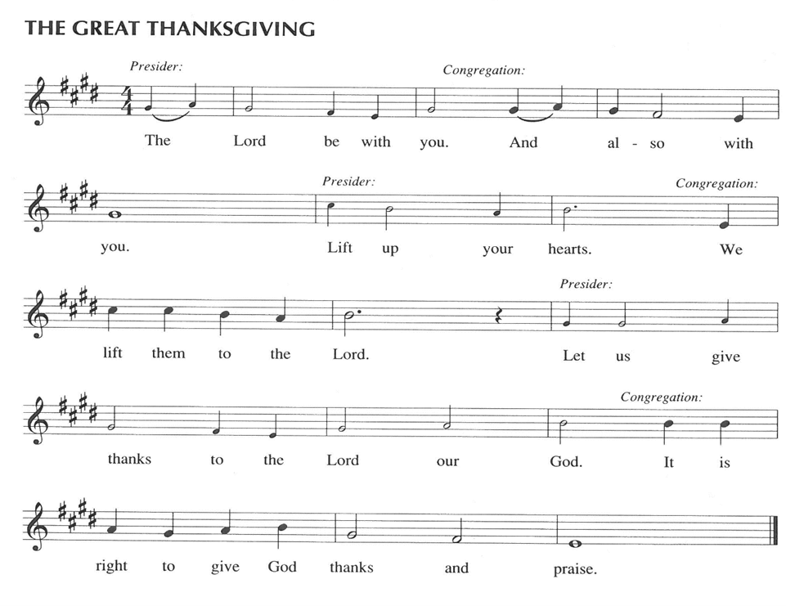

P: It is our duty and delight … join their unending hymn:

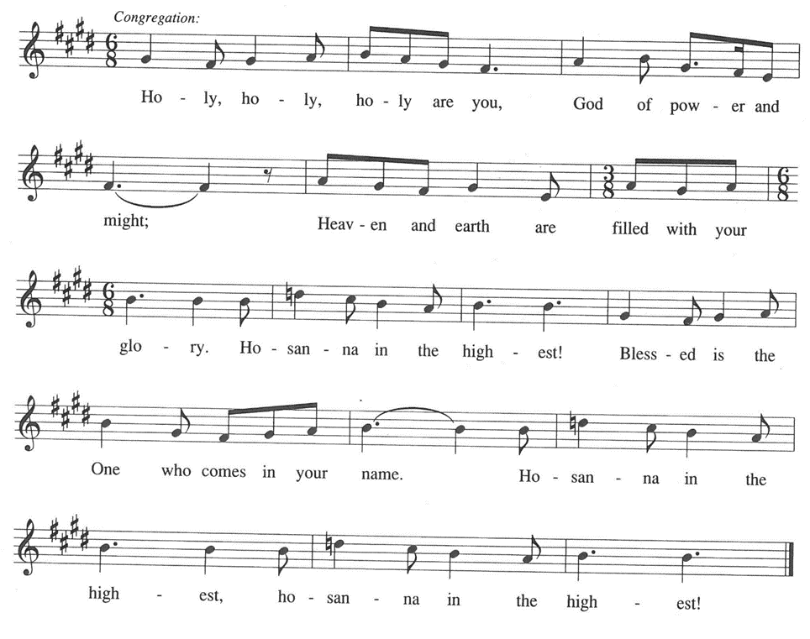

P: Holy God of mercy, we bless and praise You.

For in great love You created us and all creatures.

You chose the house of Israel to bring Your ways to all the world.

When they turned away, You sent judges, kings, and prophets to call them

from sin and death to new life.

At the last, You sent Your only-begotten Son, Jesus Christ.

In Him we are made alive in Your love.

In the night ... “Do this for the remembrance of Me.”

As often as we eat ... we proclaim the Lord’s death until He comes.

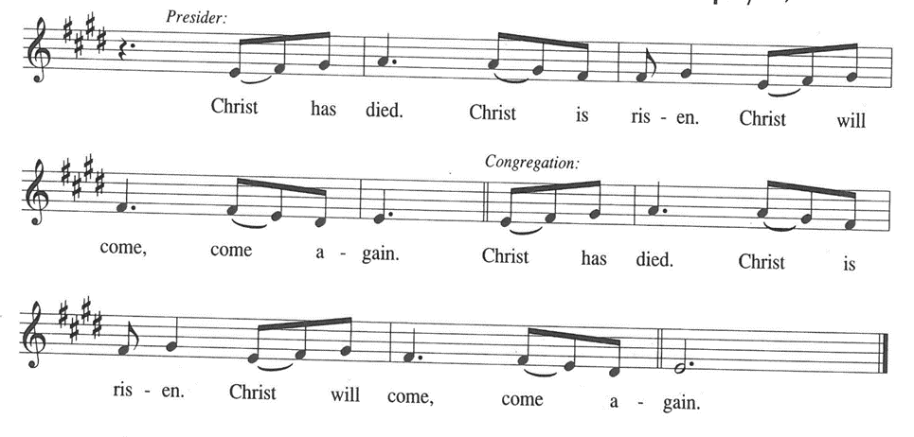

P: With this bread and cup we remember the sacrifice of our Lord’s life.

He fed the hungry, welcomed sinners, and loved us even into death.

Raised from death and seated at Your right hand, He will return in glory to

overcome all Your enemies with the immeasurable riches of His love.

Send Your Spirit on us and these Your gifts of bread and wine.

May this Meal transform us as we respond to His daily call to follow Him

in lives of good works until we receive Your gift of full life in Christ.

To You, O God: Father, Son, **✠** and Holy Spirit, be all honor and glory, in Your holy Church,

in heaven and on earth, now and forever.

**C: Amen!**

**THE LORD’S PRAYER**

P: Gathered into one by the Spirit, let us pray as Jesus taught us:

**C: Our Father in heaven, hallowed be Your name.**

**Your Kingdom come, Your will be done on earth as in heaven.**

**Give us today our daily bread, and forgive us our sins, as we forgive**

**those who sin against us.**

**Save us from the time of trial, and deliver us from evil.**

**For the Kingdom, the power, and the glory are Yours, now and forever.**

**Amen.**

**INVITATION TO THE MEAL**

P: This is the Lamb of God Who takes away the sin of the world. Blessed are those who are called

to the Supper of the Lamb. God’s holy gifts for God’s holy people. Come, for all is now ready.

*The assembly is seated*

**THE DISTRIBUTION “Lamb of God”**

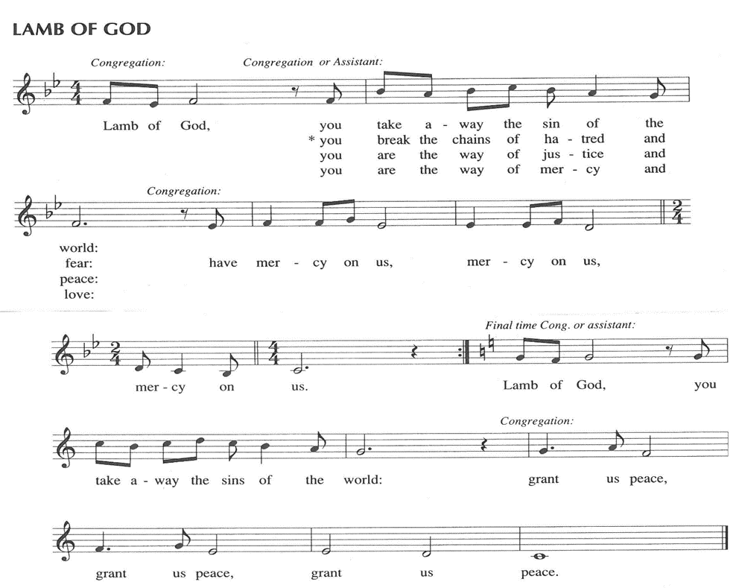

**HYMN DURING DISTRIBUTION 428 *Give Thanks for Saints***

**ELW 793 *Be Thou My Vision***

**ELW 638 *Blessed Assurance***

**ELW 583 *Take My Life, That I May Be***

*As you are able please rise*

**THE POST-COMMUNION BLESSING**

P: The Body and Blood of our Lord Jesus Christ strengthen you and keep you in His grace.

**C: Amen.**

**THE POST-COMMUNION PRAYER**

A: Let us pray. God of mercy and compassion, we have shared the joy of salvation that Matthew

knew when Jesus called him. May this Food renew our life in Him Who came not to call the

righteous but sinners to new life in His Kingdom, Your Son, Jesus Christ our Lord.

**C: Amen.**

**✠ SENDING ✠**

**THE BENEDICTION**

P: Almighty God: Father, Son, **✠** and Holy Spirit bless you now and forever.

**C: Amen.**

**THE RECESSIONAL HYMN 424 *Ye Watchers and Ye Holy Ones***

**THE DISMISSAL**

A: Go in peace. Remember the poor.

**C: Thanks be to God!**

**POSTLUDE**

**✠ To God Alone Be Glory ✠**

The Meditation is from *Manual on the Liturgy.* Philip Pfatteicher and Carlos Messerli.

(Minneapolis: Augsburg Publishing House, 1979) 37.

**ANNOUNCEMENTS**

**Please remember to mail your offering to the Church Office** at 818 Franklin Street, Michigan City, IN 46360**.** Another alternative is to give on-line through Tithe.ly. Please see your closure letter for information on how to set up a Tithe.ly account.

**St. Paul Members are reminded to have** a loved one contact the office if you are hospitalized. Many times, the Pastor doesn’t know someone is in the hospital. If you call and leave a message, please tell us at which hospital the patient is located.

**BIRTHDAYS: Kay Peglow (9/19); Helen Wiese (9/22); Fred Weiss (9/26)**

**PRAYER CONCERNS:** Bev Coburn; Barry Anderson; John Bennitt; Judy

Gustum; Larry Litchford, Sarah McNabb, Jeanie Boatman Shepple, Debbie Martin, Mark Tannehill, Kathy Stein, Jan Paholski, Laura Dovey, Grace Romine; Al Levenhagen;

Bill Hazelgrove; Kerry Steinborn; Robert Bernth and Craig Hunt.

**OFFICE HOURS:** Libby will be in the office on Mondays, Wednesdays, and Fridays; volunteers will cover Tuesdays and Thursdays.

  Monday & Wednesday 8:00 a.m. – 5 p.m.

Tuesday & Thursday 9:00 a.m. – 12:00 p.m.

Friday 8:00 a.m. – 12:00 p.m.

**If you are listening to the worship broadcast on the radio and would like to watch the Sunday morning service live stream follow these steps:**

(1) If you have You Tube available on your TV, search for

**St. Paul Lutheran Church Michigan City, IN.**

(2) The direct link on the computer is [https://](https://www.youtube.com/channel/UC5AIPNaKr3QN50984jGOa1g)

[www.youtube.com/channel/UC5AIPNaKr3QN50984jGOa1g](https://www.youtube.com/channel/UC5AIPNaKr3QN50984jGOa1g).

   (3) This link is also on the main page of the church’s website in

the church section and will continue to be posted weekly on the St.

Paul Facebook page.

And it will always be available on the radio broadcast Sunday mornings at 11:00 a.m.

on WEFM (95.9), and on the local cable access station #99 for the previous week’s

service on Sundays at 4:00 p.m. and the current service on Wednesdays at 7:00 p.m.

and Fridays at 8:30 p.m.

**Sunday’s lessons are Daniel 10: 10 -14; Psalm 103: 1-5; Revelation 12: 7-12; and Luke 10: 17-20** for those of you who like to study them in advance.

**To send e-mail to the church office**, please use the following addresses:

Pastor Mark Reshan: seniorpastor@stpaulmichigancity.com

Church Office Secretary (Libby Pollock): churchsecretary@stpaulmichigancity.com

Church Treasurer (Karen Fleming): finance@stpaulmichigancity.com

**2025 Church Council:**

Mark Reshan - Pastor

 Janet Bakken – President

 Donna Knoll – Vice President

 Judy Hunt – Secretary

 Karen Fleming – Treasurer

 Members: Paul Brooks, Diane Egilske, Sue Koziel, Judy Mutchler,

Jim Schraidt, Trish Sprague

**Worship Attendance:**

**Saturday , September 13, 2025, 2025 @ 4:00 p.m. 24**

**Sunday, September 14, 2025 @ 9:00 a.m. 72**

**TOTAL 96**

**Copies of the minutes from the June 26, 2025 and the August 28, 2025 Church Council meetings are on the back table in the upper Narthex. They were approved by the council via email. There was no Council meeting in July 2025.**

**The Good News Newsletter**: If you have an article or anything you want included in **The Good News** please send it to the following e-mail address: splcgoodnews@gmail.com. Pastor Pamela Thiede will be using this e-mail address to assemble **The Good News** each month. The deadline for getting information to Pastor Pamela will be the 20th of each month.

**THANK YOU! For your support of MCAS schools** through Donors Choose during our August Monthly Mission. We collected $716 and were able to provide math cubes to a classroom at Pine Elementary School to help the students learn basic addition, subtraction, 2 digit subtraction within 100, and the base 10 system. We also donated towards a simulator for the child development class at the high school, which will help students understand what happens within a baby’s brain after experiencing shaken baby syndrome.

**September 2025 Mission of the Month**

The Mission of the Month for September 2025: ZERO Prostate Cancer

September is Prostate Cancer Awareness Month. Prostate cancer will affect about one in seven men in their lifetime and about 35,000 men will die from prostate cancer this year. Fortunately, if detected early, prostate cancer can be successfully treated, and new treatments are becoming available to extend the lives of men with advanced disease. ZERO is the largest prostate cancer support, education and advocacy organization in the United States. It offers free support and education services to prostate cancer patients, and advocates for research funding and improved prostate cancer treatment. Jim Schraidt is a fifteen-year prostate cancer survivor and a member of the Board of Directors of ZERO. He leads a monthly ZERO-sponsored support group that meets in Chicago with simultaneous virtual access. Jim is happy to answer questions about prostate cancer and ZERO, and more information can be found at <https://zerocancer.org>.

Checks can be written to St. Paul and can be marked for ZERO and placed in the offering plate.

Noisy coin offering will also support the mission of the month.

**2025 Financial Stewardship**

Weekly Church Operating Needs (x 2 weeks)

September 6 -7, 2025; and September 13 -14, 2025 : $ 10,600.00

General Fund (including General Memorials): $ 8,222.00

Overage/Shortage: — $ 3,216.50

Restricted Income (not including Memorials)

Supports IK Synod & Church wide Ministries: $ 163.50

Ministries in our Community/Congregation: $ 1,205.00

Capital Fund: $ 248.50

General Fund: $ 70.00

September Mission: $ 100.00

**ACTIVITIES, EVENTS & MEETINGS**

**SEPTEMBER 2025**

**Sunday,** September 14, 2025 @ 9:00 a.m. Pent 14 (Holy Cross Day) Worship

Installation of Musicians with coffee after/St. Paul Room

**Wednesday,** September 17, 2025 @ 9:15 a.m. Bible Study/Luther House

@10:00 a.m. God’s Purls/St. Paul Room

@ 4:30 p.m. Choir Rehearsal/Sanctuary

**Saturday,** September 20, 2025 @ 4:00 p.m. Pent 15 (Day of St. Matthew) Worship

**Sunday,** September 21, 2025 @9:00 a.m. Pent 15 (Day of St. Matthew) Worship with coffee after/St. Paul Room

**Monday,** September 22, 2025 @ 2:00 p.m. Finance Comm. Mtg./Luther House

@3:00 p.m. Executive Board Mtg./Luther House

**Tuesday,** September 23, 2025 @ 4:00 p.m. 150th Anniv. Comm. Mtg./Luther House

**Wednesday,** September 24, 2025 @ 9:15 a.m. Bible Study/Luther House

@ 10:00 a.m. God’s Purls/St. Paul Room

@ 4:30 p.m. Choir Rehearsal/Sanctuary

**Thursday,** September 25, 2025 @ 5:30 p.m. Church Council Mtg./St. Paul Room

**Saturday,** September 27, 2025 @ 4:00 p.m. Pent 16 (Day of St. Michael &All The Angels) Worship Service/Sanctuary

**Sunday,** September 28, 2025 @ 9:00 a.m. Pent 16 (Day of St. Michael &All The Angels) Worship with coffee after/St. Paul Room

**LWR Kit Packing: We will be gathering in the St. Paul Room (church basement) on Saturday, October 11th at 2:30 p.m. to pack the school and personal care kits for Lutheran World Relief.** We have 100 school kits and 100 personal care kits to pack. More hands make light work and the packing goes pretty quickly. Fellowship and refreshments to follow. No purchase or experience necessary. All ages are welcome. If you aren’t comfortable packing, come observe and join us for fellowship after! The kits will be delivered to Christ Lutheran Church in Valparaiso the following weekend, where they will be sent to an LWR warehouse in either Minnesota or Maryland. From there, they will be sent any where in the world where disaster has struck and need is great. This year so far kits have been sent to Texas after the flash floods in July, North Carolina after Hurricane Helene, and Democratic Republic of Congo due to war and unrest.

**OCTOBER MONTHLY MISSION:**

October’s monthly mission is Franciscan Health Woodland Cancer Care Center patients. The center is located on 400 North and provides the convenience of one location for a full spectrum of cancer services. We will be collecting care kits as well as money for this mission. There are paper lunch .bags available in the Narthex. Please take as many bags as you want to fill with items to make a care kit for someone going through cancer treatments. Examples of items would be warm socks, hats, gloves, lotion, chapstick, hard candy, gum, snacks, hand sanitizer, small journals, books, activity books, small puzzles, or other activities to do while having treatment (which can take several hours). Please bring your completed care kits back by **Sunday, November 2nd** and place them in the bin in the Narthex. If you’d rather donate financially, they have a fund that goes toward local patients where they provide different things such as gas cards, or gift cards. Money can be placed in the offering plate and marked for the Cancer Center. Noisy coin for the month of October will also go toward the monthly mission. Thank you for your unwavering support each month!



Thank$ for $haring

Thanks to all who participate in the Give Back opportunities! We raised $240 at our Give Back night on September 9th at Holly’s Restaurant & Pub. Our next Give Back will be at Galveston Steak House on Thursday, October 2, 2025 from 4pm—10pm.  Here are two coupons—one for you and one for a friend.



