THE SIXTH SUNDAY AFTER PENTECOST
July 5, 2026

Come to me, all you that labor and are burdened, and I will refresh you, where there is wondrous gifts, and joy without compare, rest unchanging, happiness without end, unceasing melody, perpetual glory, unwearied giving of thanks, loving absorption in divine things, infinite riches, a kingdom without end, through all ages and ages, deeps of compassion, an ocean of mercy and kindness—which the human tongue cannot describe but makes known only through figures.

Take my yoke upon you, and learn of me, and you shall find rest for your souls, where the hidden treasures of wisdom and knowledge shall be revealed. Come to me, all you that hunger and thirst after justice, and I will fill you with all that you desire. Come to me, for whoever comes to me I shall not cast forth.

Ephraem
Fourth century

“The rest that is promised to the weary is not, however, the rest of inactivity. Jesus did not come to abolish the torah (teaching) of Moses but to fulfill it by providing its ultimate fulfillment (Matthew 5: 17). What he offers is not a vacation from the torah but a less burdensome way of fulfilling it … torah observance as a whole will be simplified by his emphasis on the “weightier matters of the torah: justice and mercy and faithfulness (23: 23) and on the double commandment of love (of God and neighbor; 22: 37-40). The “rest” is made possible through the provision of a new yoke…”
“…Jesus’ yoke will be kind to our shoulders, enabling us to carry the load more easily. Jesus does not diminish the weight of our accountability to God but helps us to bear this responsibility …”
“ …In this word (11: 28-30) Jesus may be saying, “Become my yoke mate, and learn how to pull the load by working beside me and watching how I do it. The heavy labor will seem lighter when you allow me to help you with it.”

Douglas Hare

INTRODUCTION

The mystery of God's ways is sometimes hidden from the wise and intelligent. Jesus associates with the lowly and outcast. Like Paul, we struggle with our own selfish desires and seek God's mercy and forgiveness. We gather to be refreshed by Christ's invitation: "Come to me, all you that are weary." Gathered around word, water, and meal, we find rest for our souls.

Jan Hus, martyr, died 1415

Hus was a Bohemian (present-day Czech Republic) priest who spoke against abuses in the church, and was seen by Martin Luther as his predecessor in the reforming movement. He was found guilty of heresy by a council of the church, and burned at the stake.

GATHERING

PRE-SERVICE MUSIC This is Amazing Grace New Song Praise Band
(Phil Wickham)

ANNOUNCEMENTS

As you are able please rise

CONFESSION AND ABSOLUTION

P: In the name of the Father and of the Son and of the Holy Spirit.

C: Amen.

P: “The LORD is gracious and full of compassion, slow to anger and of great kindness.”
(Psalm 145: 8) Let us turn to the Lord in repentance and faith, that in His compassion
and kindness He may draw near with mercy and forgiveness.

Silence for self-examination and reflection is kept

P: Most merciful God,

C: We confess that we are captive to sin and cannot free ourselves. The good we have
wanted to do we have not done, and the evil we do not want is always close at hand.
(Romans 7: 19-21) Even when we desire to love You and keep Your commands,
we cannot do it. (7: 18) We beg Your forgiveness, O God. Rescue us from our sin
and the many deaths it brings. Free us from the burden of our guilt and shame,
and grant us again this day the rest of Your healing grace. (Matthew 11: 29)

P: Jesus said, “Come to Me, all you that are weary and are carrying heavy burdens, and I
will give you rest.” (Matthew 11: 30) He desires you to know the peace that His
forgiveness brings. Take heart, for “the LORD is faithful in all His words, and merciful
in all His deeds.” (Psalm 145: 14) So as a called and ordained minister of the Church
of Christ, and by His authority, I declare to you the entire forgiveness of all your sins,
in the name of the Father and of the Son and of the Holy Spirit.

C: Amen.

GATHERING SONG 888 O Beautiful for Spacious Skies

THE GREETING AND PRAYERS OF THE DAY

P: The grace of our Lord Jesus Christ, the love of God, and the communion of the Holy
Spirit be with you all.

C: And also with you.

P: Let us pray. You are great, O God, and greatly to be praised. You have made us for
Yourself, and our hearts are restless until they rest in You. Grant that we may believe
in You, call upon You, know You, and serve You, through Your Son, Jesus Christ, our
Savior and Lord.
C: Amen.

P: Let us pray. Lord of all the worlds, guide this nation by Your Spirit to go forward in
justice and freedom. Give to all living in these lands the blessings of well-being and
harmony, but above all things give us faith in You, that our nation may bring glory to
Your name and blessings to all peoples, through Jesus Christ, our Savior and Lord.

C: Amen.

The assembly is seated

WORD

FIRST READING Zechariah 9: 9-12

The period after the Jews had returned from Babylonian exile was a time of extreme crisis. The return was not the glorious event announced by the prophet (Isa. 40-55). Serious social, economic, political, and religious problems confronted the people. They then looked to the future when God would intervene on their behalf.

Rejoice greatly, O daughter Zion!
Shout aloud, O daughter Jerusalem!
Lo, your king comes to you;
triumphant and victorious is he,
humble and riding on a donkey,
on a colt, the foal of a donkey.
¹⁰He will cut off the chariot from Ephraim
and the warhorse from Jerusalem;
and the battle bow shall be cut off,
and he shall command peace to the nations;
his dominion shall be from sea to sea,
and from the River to the ends of the earth.
¹¹As for you also, because of the blood of my covenant with you,
I will set your prisoners free from the waterless pit.
¹²Return to your stronghold, O prisoners of hope;
today I declare that I will restore to you double.

The Word of the Lord.

Thanks be to God.

THE PSALM: Psalm 145: 8-14 Read responsively

⁸The LORD is gracious and full of compassion,
slow to anger and abounding in steadfast love.

⁹LORD, You are good to all,
and Your compassion is over all Your works.

¹⁰All Your works shall praise You, O LORD,
and Your faithful ones shall bless You.
¹¹They shall tell of the glory of Your kingdom
and speak of Your power,

¹²that all people may know of Your power
and the glorious splendor of Your kingdom.

¹³Your kingdom is an everlasting kingdom;
Your dominion endures throughout all ages.
You, LORD, are faithful in all Your words,
and loving in all Your works.

¹⁴The Lord upholds all those who fall
and lifts up those who are bowed down.

SECOND READING Romans 7: 15-25a

In his letter to the Romans, Paul argues that we are made right with God through Christ's action rather than through our own works. To illustrate our need for Christ, he offers us a picture of one who tries to do what is right, only to discover good intentions are not enough.

I do not understand my own actions. For I do not do what I want, but I do the very thing I hate. ¹⁶Now if I do what I do not want, I agree that the law is good. ¹⁷But in fact it is no longer I that do it, but sin that dwells within me. ¹⁸For I know that nothing good dwells within me, that is, in my flesh. I can will what is right, but I cannot do it. ¹⁹For I do not do the good I want, but the evil I do not want is what I do. ²⁰Now if I do what I do not want, it is no longer I that do it, but sin that dwells within me.
²¹So I find it to be a law that when I want to do what is good, evil lies close at hand. ²²For I delight in the law of God in my inmost self, ²³but I see in my members another law at war with the law of my mind, making me captive to the law of sin that dwells in my members. ²⁴Wretched man that I am! Who will rescue me from this body of death? ²⁵Thanks be to God through Jesus Christ our Lord!

The Word of the Lord.

Thanks be to God.

As you are able please rise

THE VERSE Sung twice (see p. 5)

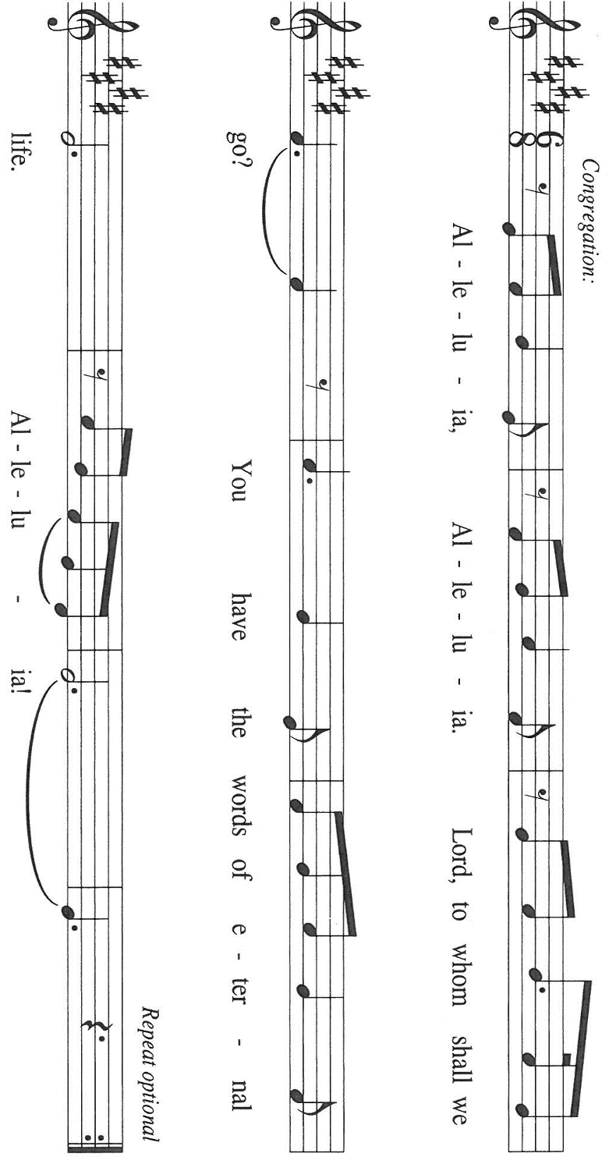

THE HOLY GOSPEL Matthew 11: 16-16, 25-30

In Matthew's gospel, John the Baptist and Jesus are described as having very different approaches to ministry, though they both proclaim the same message of God's kingdom. Here, Jesus chides people who seem to find fault with all preachers as an excuse for ignoring the word of God.

P: The Holy Gospel according to St. Matthew, the eleventh chapter.

C: Glory to You, O Lord!

[Jesus spoke to the crowd saying:] "To what will I compare this generation? It is like children sitting in the marketplaces and calling to one another,
¹⁷'We played the flute for you, and you did not dance;
we wailed, and you did not mourn.'
¹⁸For John came neither eating nor drinking, and they say, 'He has a demon'; ¹⁹the Son of Man came eating and drinking, and they say, 'Look, a glutton and a drunkard, a friend of tax collectors and sinners!' Yet wisdom is vindicated by her deeds."
²⁵At that time Jesus said, "I thank You, Father, Lord of heaven and earth, because You have hidden these things from the wise and the intelligent and have revealed them to infants; ²⁶yes, Father, for such was Your gracious will. ²⁷All things have been handed over to Me by My Father; and no one knows the Son except the Father, and no one knows the Father except the Son and anyone to whom the Son chooses to reveal Him.
²⁸"Come to Me, all you that are weary and are carrying heavy burdens, and I will give you rest. ²⁹Take My yoke upon you, and learn from Me; for I am gentle and humble in heart, and you will find rest for your souls. ³⁰For My yoke is easy, and My burden is light."
P: The Gospel of the Lord.

C: Praise to You, O Christ!

The assembly is seated

THE SERMON

Silence for reflection follows the sermon

As you are able please rise

THE HYMN OF THE DAY 611 I Heard the Voice of Jesus Say

THE APOSTLES’ CREED

A: God has made us His people through our Baptism into Christ. Living together in trust
and hope, we confess our faith.

C: I believe in God, the Father almighty,
creator of heaven and earth.

I believe in Jesus Christ, His only Son, our Lord.
He was conceived by the power of the Holy Spirit
and born of the virgin Mary.
He suffered under Pontius Pilate,
was crucified, died, and was buried.
He descended into hell.
On the third day He rose again.
He ascended into heaven,
and is seated at the right hand of the Father.
He will come again to judge the living and the dead.

I believe in the Holy Spirit,
the holy catholic Church,
the communion of saints,
the forgiveness of sins,
the resurrection of the body,
and the life everlasting. Amen.

THE PRAYER OF THE CHURCH

A: Come to prayer, all who labor and are heavy laden, and God will give us rest. Come
to prayer, for the Church, the world, and all those in need.

A: That the Church in all its words and actions might reflect God’s graciousness,
compassion, and great kindness; God of grace:

C: Hear our prayer.

A: That God would cut off instruments of battle and war and command peace to all the
nations, God of grace:

C: Hear our prayer.

A: That as the United States of America marks its declaration of independence, those
whom we have entrusted with authority may govern with the spirit of wisdom, and curb
every abuse of that trust, so that both here and abroad, justice, humility, and peace may
flourish, God of grace:

C: Hear our prayer.

A: That this congregation might serve this community with gentleness and humbleness of
heart; God of grace:

C: Hear our prayer.

A: That Your eyes might be especially upon the least, the lost, the forgotten, those who
live with poverty, who yearn to be free, those seeking refuge, the incarcerated, detained,
or disappeared, those burdened with hunger, loneliness, addiction, or illness,
especially: Jean Warner; Mark Tannehill; Major Payne; Jon Samuelson; Martha
Schroeder; and Pastor Dale Zylstra might find rest, healing, and wholeness; God of
grace:

C: Hear our prayer.

A: That those celebrating birthdays, especially David Squires; Sharon McCay; and
Norma Milzarek may be filled with grace this day and every day, and grow in grace
in the days ahead; God of grace:

C: Hear our prayer.

A: That with all the faithful who have gone before us, especially Jan Hus, martyr, whom
we commemorate this Day, we might finally be brought by Jesus into His everlasting
rest; God of grace:

C: Hear our prayer.

P: O God, give us faith to trust Your promises, that our lives may glorify Your name,
through Your Son, Jesus Christ our Lord.

C: Amen.

MEAL

THE PEACE

P: The peace of the Lord be with you always.

C: And also with you.

The assembly is seated

THE OFFERING

THE VOLUNTARY You Raise Me Up New Song Praise Band
(Brendan Graham & Rolf Graham; arr. Rogefr Emerson)

As you are able please rise

THE PRESENTATION OF GIFTS As the Grains of Wheat

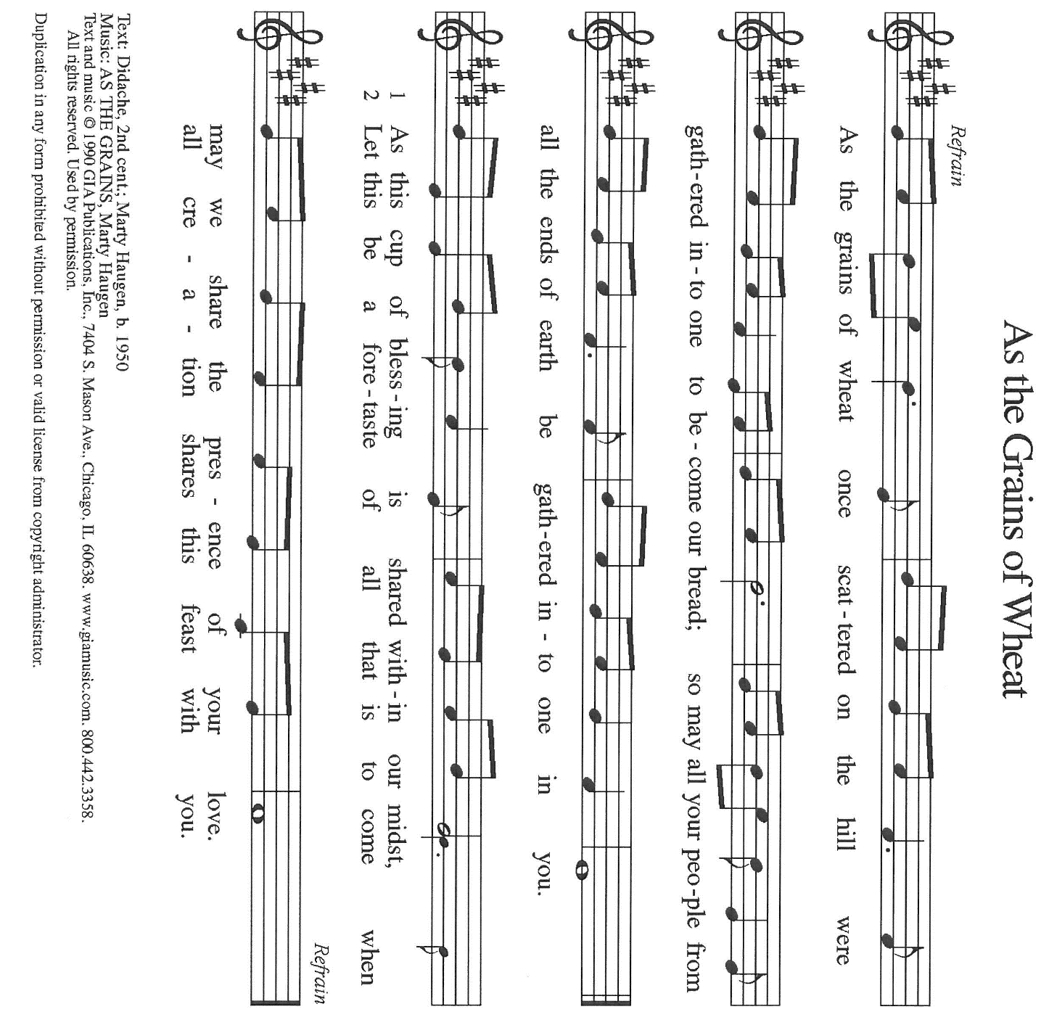

THE OFFERTORY PRAYER

A: Let us pray. Lord Jesus,

C: You invite us to come in our weariness and bring our burdens to You. With these
gifts we offer our whole lives into Your hands. Receive them and us into Your
rest. By Your Body and Blood of life, rescue us from our body of death. You are
the Lord forevermore. Amen.

THE GREAT THANKSGIVING

P: The Lord be with you.

C: And also with you.

P: Lift up your hearts.

C: We lift them up to the Lord.

P: Let us give thanks to the Lord our God.

C: It is right to give Him thanks and praise.

P: Holy God, You alone are Majesty,
You alone are Excellency,
You alone are Sovereign.

Within the vast reaches You splashed into being,
You formed our star and this planet:
purple mountains, fruited plains,
crystal waters, towering forests, gleaming mines.
Here You fashioned human beings
in our infinite variety and hue,
yet each one created equal,
to care for one another
and our earthly home.

In a time of peace
enforced by the cruelty of empire,
You came in Jesus to share our life.
Born under the rule of a merciless king,
Jesus revealed the merciful realm of God.
Moving across borders
to people broken and oppressed,
Jesus brought healing, restoration, and freedom.

In the night …Do this for the remembrance of Me.
As often as we eat … we proclaim the Lord’s death until He comes.
Remembering, therefore,
Christ’s execution at the hands of a ruthless regime,
Christ’s resurrection that buries death,
Christ’s ascension to rule with love forever,
we declare the revolutionary mystery of faith:

C: Christ has died. Christ is risen. Christ will come again.

P: God, shed Your grace on us.
Shower Your Holy Spirit
on these gifts of bread and wine
and on Your people gathered this day.
Ignite in us the flame of freedom—
freedom from prejudice, from supremacy, from fear;
freedom for acceptance, for welcome,
for the shalom that you have first shown to us.

Faithful God, loving God:
Your Majesty shines forth in weakness.
Your Excellency is revealed to infants.
Your Sovereignty reigns from a cross.
Yours, O God,
Father, Son, and Holy Spirit,
is the everlasting kingdom,
the peaceable power,
and the humble glory,
now and forever.

C: Amen.

THE LORD’S PRAYER

P: Seeking first the Kingdom of God and its righteousness, with trust in God’s daily care
for us, we now pray:

C: Our Father in heaven, hallowed be Your name.
Your Kingdom come, Your will be done on earth as in heaven.
Give us today our daily bread, and forgive us our sins, as we forgive
those who sin against us.
Save us from the time of trial, and deliver us from evil.
For the Kingdom, the power, and the glory are Yours, now and forever.
Amen.

INVITATION TO THE MEAL

P: Come to Me, says the Lord, all you that are weary, and I will give you rest. Blessed
are those who are called to the Supper of the Lamb. God’s holy gifts for God’s holy
people. Come, for all is now ready.

The assembly is seated

THE DISTRIBUTION Lamb of God (see p. 11)

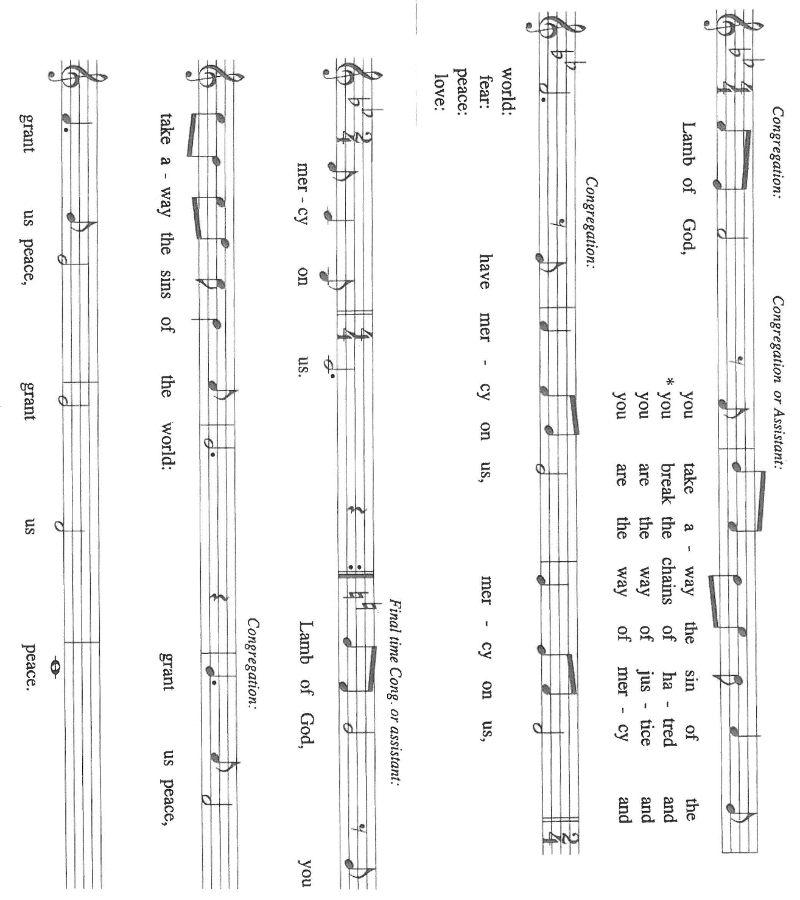

HYMN DURING DISTRIBUTION 742 What a Friend We Have in Jesus

ELW 472 Eat This Bread, Drink This Cup

ELW 614 There is a Balm in Gilead

NSB 56 I Offer My Life

NSB 6 Amazing Love

As you are able please rise

THE POST-COMMUNION BLESSING

P: The Body and Blood of our Lord Jesus Christ strengthen you and keep you in His
grace.

C: Amen.

THE POST-COMMUNION PRAYER

A: Let us pray. God our Redeemer, by the Blood of Your Son You set us free from the
powers of sin and death. Lift up all who are burdened and bowed down by life, teach
us Your way of gentleness and humility, and send us to witness to the joy of Your
salvation. We ask this in the name of Jesus the Lord.

C: Amen.

SENDING

THE BENEDICTION

P: Almighty God: Father, Son, and Holy Spirit bless you now and forever.

C: Amen.

THE SENDING HYMN 891 God Bless Our Native Land

THE DISMISSAL

A: Go forth with God’s blessing to love and serve the Lord.

C: Thanks be to God!

POSTLUDE All Hail the Power of Jesus’ Name

To God Alone Be Glory

The Meditations are from Richer Fare for the Christian People. Gail Ramshaw, ed. (New
York: Pueblo Publishing Company, 1990) 74; and Sundays and Seasons Online. Copyright 2023 Luther Seminary.

The Prayers, Introduction to the Lord’s Prayer, and Invitation to the Meal are from Prayers
For Sundays and Seasons. Year A. Peter J. Scagnelli. (Chicago: Liturgy Training
Publications, 1998) 90-91.

The musical setting of the liturgy, “Now the Feast and Celebration” by Marty Haugen, is
used by permission of GIA Publishers, Inc. OneLicense.net License #A-702836.

The Eucharistic Prayer is adapted from Eucharistic Prayers. Samuel Wells and Abigail
Kocher. (Grand Rapids: Wm. Eerdmanns Publishing Company, 2016). 212-213.

PLEASE NOTE

During the month of July, the front doors of the church (those doors facing Franklin Street) will be open on Wednesdays to invite new visitors in to hear the organ concert. Any Wednesday, at your choosing, at 11:30 a.m. Concerts begin at 12:15 p.m. Please come and help us greet visitors. Your help is appreciated.
ANNOUNCEMENTS

Please remember to mail your offering to the Church Office at 818 Franklin Street, Michigan City, IN 46360. Another alternative is to give on-line through Tithe.ly. Please see your closure letter for information on how to set up a Tithe.ly account.

St. Paul Members are reminded to have a loved one contact the office if you are hospitalized. Many times, the Pastor doesn’t know someone is in the hospital. If you call and leave a message, please tell us at which hospital the patient is located.

BIRTHDAYS: David Squires (7/6); Al Green (7/8); Sharon McCay (7/10);
Norma Milzarek (7/12)

PRAYER CONCERNS: Debbie Martin; Mark Tannehill; Kathy Stein; Jan Paholski; Laura Dovey; Bill Hazelgrove; Al Levenhagen; Carl Wipperman; Major Payne.

OFFICE HOURS: Libby will be in the office on Mondays, Wednesdays, and Fridays; volunteers will cover Tuesdays and Thursdays.

Monday & Wednesday 8:00 a.m. – 5 p.m.
Tuesday & Thursday 9:00 a.m. – 12:00 p.m.
Friday 8:00 a.m. – 12:00 p.m.

If you are listening to the worship broadcast on the radio and would like to watch the Sunday morning service live stream follow these steps:

(1) If you have You Tube available on your TV, search for
St. Paul Lutheran Church Michigan City, IN.

(2) The direct link on the computer is https://
www.youtube.com/channel/UC5AIPNaKr3QN50984jGOa1g

(3) This link is also on the main page of the church’s website in
the church section and will continue to be posted weekly on the St.
Paul Facebook page.

And it will always be available on the radio broadcast Sunday mornings at 11:00 a.m.
on WEFM (95.9), and on the local cable access station #99 for the previous week’s
service on Sundays at 4:00 p.m. and the current service on Wednesdays at 7:00 p.m.
and Fridays at 8:30 p.m.

To send e-mail to the church office, please use the following addresses:

Pastor Mark Reshan: seniorpastor@stpaulmichigancity.com

Church Office Secretary (Libby Pollock): churchsecretary@stpaulmichigancity.com

Church Treasurer (Karen Fleming): finance@stpaulmichigancity.com

2026 Church Council:

Pastor - Mark Reshan

President - Donna Knoll

Vice President - Jan Bakken

Secretary - Judy Hunt

Treasurer - Karen Fleming

Members: Sue Koziel; Jim Schraidt; Trish Sprague; Bob Kiser; Barry Anderson; and
Pam Soule

Worship Attendance:

Saturday, June 27, 2026 @ 4:00 p.m. 25

Sunday, June 28, 2026 @ 9:00 a.m. 73

TOTAL 98

Copies of the minutes from the May 21, 2026 and June 25, 2026 Church Council meetings are on the back table in the upper Narthex. They were approved by the council via email.

The Good News Newsletter: If you have an article or anything you want included in The Good News please send it to the following e-mail address: splcgoodnews@gmail.com. Pastor Pamela Thiede will be using this e-mail address to assemble The Good News each month. The deadline for getting information to Pastor Pamela will be the 20th of each month.

Next week’s lessons are Isaiah 55: 10-13; Psalm 65: [1-18] 9-13; Romans 8: 1-11; Matthew 13: 1-9, 18-23 for those of you who like to study them in advance.

MISSION OF THE MONTH FOR JULY, 2026
July’s mission of the month will be the Lutheran World Relief Kits. Attached is the order form for people to sponsor kits and place this order form with payment in the offering plate or send to the church office.

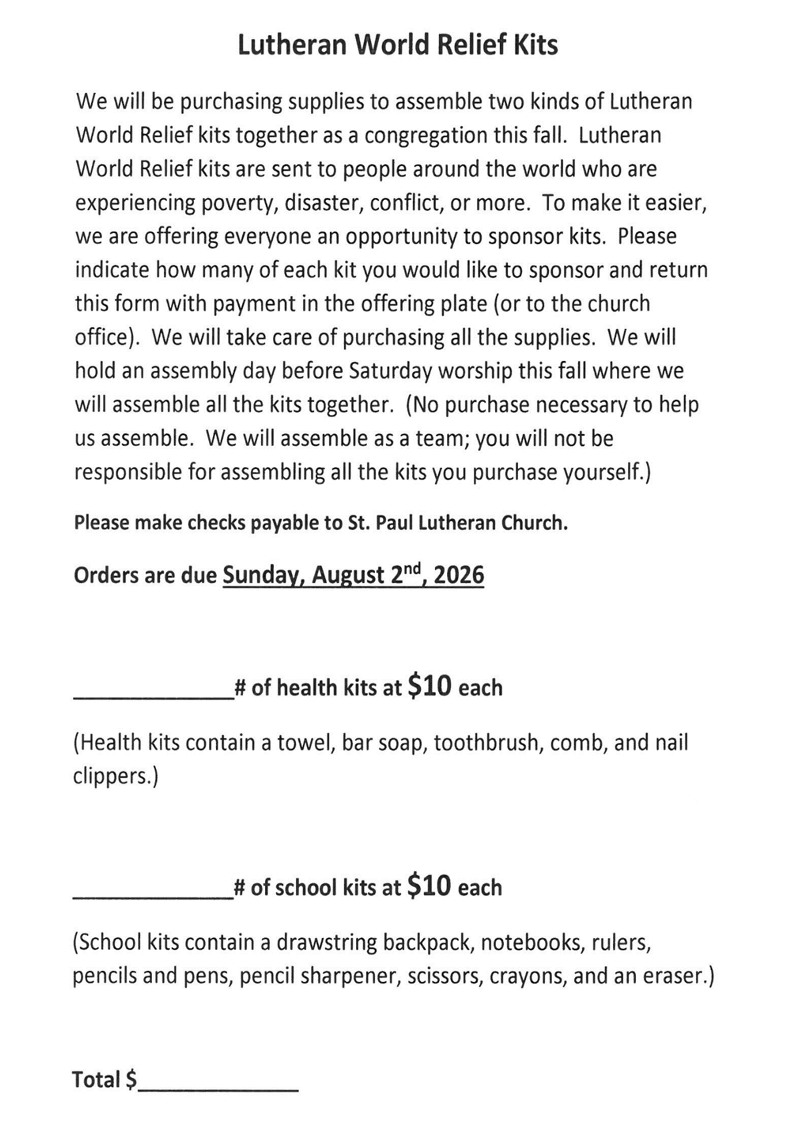

ACTIVITIES, EVENTS & MEMORIALS
JULY 2026

Sunday, July 5, 2026 @ 9:00 a.m. 6 Pentecost Worship Service/Sanctuary; with coffee after
Wednesday, July 8, 2026 @ 10:00 a.m. God’s Purls/St. Paul Room

@12:15 p.m. Organ Concert Summer Series/Sanctuary

Saturday, July 11, 2026 @ 4:00 p.m. 7 Pentecost Worship Service/Sanctuary

Sunday, July 12, 2026 @ 9:00 a.m. 7 Pentecost Worship Service/Sanctuary to
include the Baptism of Maggie Louise Brooks; with coffee after

Monday, July 13, 2026 @ 1:00 p.m. Hope Circle

Wednesday, July 15, 2026 @ 10:00 a.m. God’s Purls/St. Paul Room

@ 10:00 a.m. – 9:00 p.m. GIVE BACK @ 5 GUYS
@12:15 p.m. Organ Concert Summer Series/Sanctuary

Saturday, July 18, 2026 @ 4:00 p.m. 8 Pentecost Worship Service/Sanctuary

Sunday, July 19, 2026 @ 9:00 a.m. 8 Pentecost Worship Service/Sanctuary; with

coffee after @ 10:30 a.m. ICE CREAM SOCIAL/St. Paul Room

Wednesday, July 22, 2026 @ 10:00 a.m. God’s Purls/St. Paul Room

@ 12:15 p.m. Organ Concert Summer Series/Sanctuary

Saturday, July 25, 2026 9 Pentecost Worship Service/Sanctuary

Sunday, July 26, 2026 @ 9:00 a.m. 9 Pentecost Worship Service/Sanctuary; with coffee after
Wednesday, July 29, 2026 @ 10:00 a.m. God’s Purls/St. Paul Room

@ 12:15 p.m. Organ Concert Summer Series/Sanctuary

Thank$ for $haring
Thank you to all who participate in our Give-Back opportunities each month. On Wednesday, July 15, 2026 from 10:00 a.m. —9:00 p.m. we’ll be meeting at 5 Guys Restaurant for our GIVE BACK for July. Here are two coupons. One for you and one for a friend.

