-
August, 2026
MARK: MY WORDS

It is a skill at which we in the Church are not always good and consistent: saying, “Thank you.” It is so easy for all of us to walk into the building and expect there will be beautiful decorations, stirring and uplifting music, worship that flows smoothly and meaningfully, comfortable temperatures, Word and Sacraments ready to be administered and received.
But, of course, as I have noted especially at particularly festive times of the church year, none of these things happen on their own. The decorations don’t magically appear; the music doesn’t come without hours of practice; worship liturgies must be planned and bulletins printed; heating and air conditioning systems must constantly be monitored, repaired, and regulated; the Baptismal font and altar require careful preparation.
None of this could happen without the dozens of tireless, dedicated volunteers who serve us each week, often behind the scenes. None of them do it for praise or recognition. It is the way in which they offer back to God the gifts He has lavishly bestowed upon them with deep joy and thanksgiving. And in that process we all are richly blessed and strengthened in our faith, love, and hope.
For the past several years, we have intentionally chosen a time to recognize, honor, and thank the many volunteers who power our various ministries. We have catered a meal on an evening in which there is no other agenda than saying, “Thank you.” In the past, we held the dinner in late winter; but that was often before the time change, and it was still dark. We had a good number of people who did not attend because they don’t drive after sunset.
So, this year we moved the dinner to Thursday, August 13, at 5:30 p.m. It will still be nice and bright (unless we are experiencing a monsoon), and hopefully this different time will allow more of our volunteers to attend. It is always a night of great food and easy, fun fellowship. We hope that if you have received an invitation, you will be able to join us. If you have not offered your time and talents in the past, we encourage you to peruse the list of services for which we need help and share your gifts for our good and God’s glory.
Here are the categories of service which we will be honoring that night:
Church council Altar Guild Candle upkeep
Counters Funeral luncheon servers Choir
Assisting Ministers New Song Praise Band Director of Music
God’s Purls (Knitting group) Office staff/volunteers Meals on Wheels
Deacons Miscellaneous service Newsletter editor
Audio/Visual recording and streaming



THE BISHOP’S VISIT

As detailed in last month’s newsletter, the first step in the call process for seeking a new pastor is the visit of the Bishop for a meeting with me and the Church Council. That will take place on Thursday, August 27. He and I will meet from 2:30-3:00 p.m., and he and the Council will discuss the process from 3:00-4:00 or 4:30 p.m. Although he will not be personally involved in each step, it is important for him to establish contact with the Council as the process begins.
His Assistant for Ministry Transition will probably be the one to be more intimately involved with the Call Committee and Council. Between the two of them and other synod staff as needed, the congregation will be guided, informed, and instructed in the holy work of discerning the direction of the congregation’s ministry and who best will help lead that work. Regular updates to the congregation will be provided along the way.



At the 4:00 worship service on Saturday, August 29, we will celebrate the Confirmation of Cole Ponder, son of Heidi and grandson of Judy Gleason. Heidi approached me several weeks ago and asked if it would be possible for Cole to be confirmed. He is autistic and has not undergone any special instruction, but it is important for Heidi and Cole to be able to publicly affirm his faith in Christ.
We will adapt the Affirmation of Baptism rite for his needs, and joyfully receive him as the newest confirmed member of our community of faith.



A FESTIVAL COMMEMORATION

As you are aware, the season of Pentecost takes up a major portion of the church year. Depending on the date of Easter, it usually begins in late April or early May and runs until the latter half of November when the church year ends with the Christ the King Sunday. For example, this year that day falls on the 26th Sunday after Pentecost. So many weeks of the season spread over so many months can seem numbingly monotonous.
So, whenever there is a chance to celebrate a festival day or commemoration of one of the heroes or heroines of the faith, it is good to observe it. Unfortunately, August only contains two minor festival days: Mary, Mother of Our Lord, on August 15, and Bartholomew, Apostle, on August 24.
We celebrated the Day of Bartholomew last year, so I would like to observe the Feast Day of Mary this year. It falls on the Saturday of that weekend’s worship. We last observed her day two years ago. As I wrote then, Lutherans have a strange relationship with Mary. Because many of us were taught growing up that since Roman Catholics “prayed to Mary,” we should avoid any similar idolatry. This has unfortunately limited even our mention of her to our observance of Christmas.
Yet, Martin Luther revered Mary deeply, and some of his most personal and beautiful devotional writings are found in his commentary on The Magnificat (Luke 1:46-55). It is possible to remember and give thanks for her life without misguided devotion; and, as pointed out in last month’s newsletter, it is important to hold up women models of the faith amid all the male examples in our commemorations and festivals.
So, through our hymns and prayers, Word and Meal, we will give thanks to God for Mary’s life and her role in bearing “the Word become flesh” among us. May God grant us her faithfulness and willingness to be God’s servant in whatever way He needs and sees fit.


BACK TO SCHOOL TRIP—NOT!!

For the first time in four years, I will not be traveling this month to Cleveland or Terre Haute to bring my sons Dan and Jacob to school. It is a wonderful feeling. Both of their graduation ceremonies were outstanding and uplifting. We are so proud of them.
Jacob drove to Dallas on Sunday, July 13, and Monday, July 14, to move into his apartment with his roommate, one of his classmates from school. He began work at Texas Instruments on Monday, July 20. Dan is still in the process of searching for a job and is living with us at home. We are confident that he will find something that will utilize his great science and math skills. Thank you to everyone who has asked about them. Your care and support are a great blessing.



St. Paul will be hosting a Dog and Suds cookout on Friday, August 7, from 4 to 8 p.m. in the church parking lot. The event will include hot dogs with all the trimmings, chips, and Carlson's root beer. We will have entertainment provided by our talented Praise Band and games in addition to great fellowship. The event is open to the public so please invite family, friends, and neighbors. We hope to have a huge turnout and show Michigan City that St Paul is alive and vibrant. Please help us to make this a huge success!!!



You are invited to join a new Bible study led by Heidi Ponder on Mondays at 7 p.m. in the St. Paul Room. We are going through a 52-week survey of the Bible. All women are welcome.

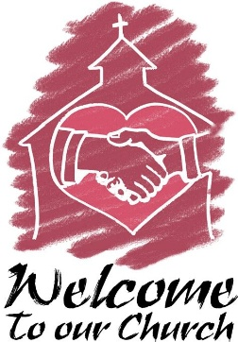
On July 12, we welcomed two new members to St. Paul: Maggie Louise Brooks, daughter of Paul and Lora, was baptized; and Linda Green was received as a new member.
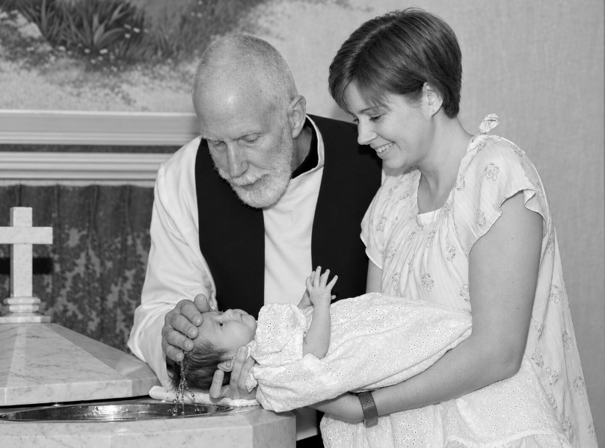
At the font is Pastor Reshan, Lora, and daughter Maggie Louise.
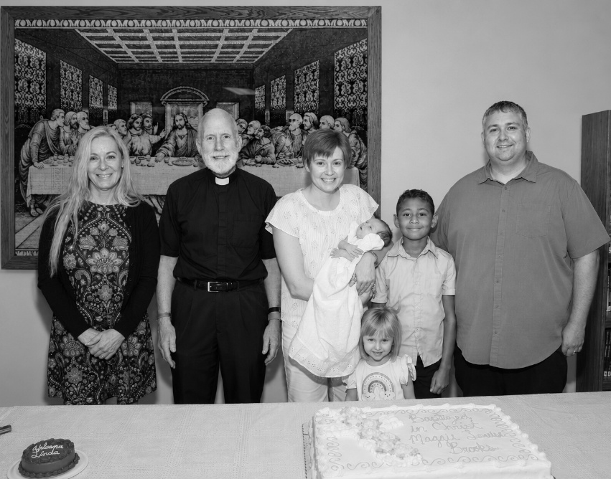
(Left to right): Linda Green, Pastor Reshan, Lora Brooks with Maggie, Leah, Cam (Maggie’s sponsor), and Paul Brooks.
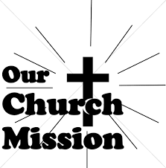
AUGUST MONTHLY MISSION
MICHIGAN CITY AREA SCHOOLS

This month we will be collecting money to support different projects in various elementary schools in Michigan City through Donors Choose. Donors Choose provides a list of teacher-led classroom projects that need funding. Please consider donating to help fund our local teachers' classroom projects! Checks can be written to St. Paul and can be marked for MCAS and placed in the offering plate. The noisy coin offering will also support the mission of the month. To see a full list of projects, visit www.donorschoose.org and search for Michigan City.


UPDATE!

A great time was had by all, enjoying delicious ice cream Sundaes and fellowship! After paying our final bill, including tip, we are pleased to announce that Bubbles Ice Cream returned their check ($175) and asked us to donate it to Katie’s Purse. A BIG “Thank You!” to Bubbles for their generosity and service in helping us celebrate our 150th Anniversary!



Thank you for the cards, gifts, and prayers for Maggie’s birth and for sharing in our joy and celebration of Maggie’s baptism with fellowship hour. Your blessings and warm wishes made our day even more meaningful!
Paul, Lora, Leah, and Maggie Brooks

17th Annual Fall Innovation Forum 2026
  - Touring Creativity Through Stained Glass Windows
Saturday, September 19, 2026 - 9am-3pm
Docent guided tour of Michigan City’s historic collection of Stained Glass Windows
Tour begins and ends at:
Immanuel Lutheran Church
1237 E Coolspring Avenue, Michigan City, IN Everyone interested please respond by September 11 Reserve your space on our bus or drive your own car. Call 219-326-7259 or e-mail: creativity52@comcast.net
Light refreshments will be provided

The churches participating in the tour are:
Immanuel Lutheran Church
Saint Paul Lutheran Church
Saint Stanislaus Roman Catholic Church
Trinity Church
Saint Mary Roman Catholic Church
Notre Dame Catholic Church
Center for Creative Solutions Presents


August Birthdays August Anniversaries
1 Susan Dolson 3 John & Amy VanGemeren
2 Terri Bartels 5 Virgil & Patricia Miller
3 Robin Cross 9 Richard & Karen Fleming, Jr.
4 Sandra Robbins 10 David & Amy Haring
James Galinowski
David Haring
Hannah Payne
5 Richard Thielman
6 Robert Ziesmer
Michael Bockover
8 Lynn Wilson
Thomas Ottersen
Jason Schacht
9 Carol Hanft
Brooklyn Howard
10 Stacey Richardson
11 Karen Peters
Deborah Reagor
12 Anna Kreighbaum
Becky Greenlaw
14 James Tomsheck
15 Diane Egilske
Diane Dirks
Frankie Thomas III
16 Jaimee Przybylinski
Reilly Wilson
19 Shirley McCarty
20 Nancy Squires
28 Reese Robbins
30 Michael Maesch



Long-Term Prayer List

Lucas Bradshaw Laura Dovey Bethany Manning
Debbie Martin Shirley McCarty Jan Paholski
Martha Schroeder Jeanie Boatman Shepple Kathy Stein
Mark Tannehill Kathy Thielman Delores Williams
Brian Wiseman

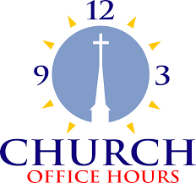

Monday 8:00 a.m. – 5 p.m.
Tuesday 9:00 a.m. – 12:00 noon
Wednesday 8:00 a.m. – 5 p.m.
Thursday 9:00 a.m. – 12 noon
Friday 8:00 a.m. – 12 noon

St. Paul Lutheran Church Staff
Pastor Rev. Mark Reshan
Secretary Libby Pollock
Accompanists Jary Tannehill, Mark Tannehill, Jacob Tannehill
Custodian Mark Kloess

Thank$ for $haring

Last month, we raised $108 from the Give Back at Five Guys. Thanks to every who participated.

This month, we are going to Holly’s on Tuesday, August 11. Here are two coupons—one for you and one for a friend.
