THE SIXTH SUNDAY OF EASTER
May 10, 2026

The Holy Spirit is called the Spirit of God, and the Spirit of Truth, who proceeds from the Father, the Spirit of virtue, a commanding Spirit. When we hear of the Spirit, the mind must form to itself an idea of an intelligent Being, infinite in power, of greatness without measure, bounded neither by time nor by ages, bountiful of its own goodness, to whom all turn who need sanctification, to whom all aspire who live in holiness, as though watered and assisted by its breath to arrive at their due perfection.
This is a Being who perfects others, itself needing nothing; existing, as not needing to be renewed, yet giving life abundantly; enlarging through no addition, but at once complete; at rest within itself, yet in all places; the source of holiness, the light of the mind, and providing light from itself to every faculty of the soul that searches for truth.
So the Spirit, to each one who receives it, as though given to that believer alone, pours forth sufficient and perfect grace to each one, and so is enjoyed by each one.

Basil, Bishop of Caesarea
Fourth century

“At the last supper Jesus has been telling the disciples about his coming departure, which raises the disturbing prospect of separation (John 13: 33, 36; 14: 2, 5). In years to come he knows that the disciples will feel like "orphans." Easter will be a joyous reunion, but the resurrection appearances will not continue indefinitely. As the years pass, people will be called to believe in a Jesus they have never seen or heard. Jesus' words and actions will be conveyed to them through the tradition of the church in a world that may seem indifferent at best and hostile at worst to the message about a crucified Messiah …”

In John's gospel, faith is a relationship with a living being. For there to be authentic faith in Jesus, people must be able to relate to the living Jesus--a Jesus who is not absent but present. Otherwise faith is reduced to the memory of a Jesus who died long ago. But here is the conundrum: Why would anyone believe that authentic life comes from a Jesus who was crucified under Pontius Pilate, a Jesus whom they cannot see? The honest answer is that no one would believe it--apart from the work of the Spirit. For it is the Spirit who makes the presence of the living Jesus and his Father known …

… John's gospel calls the Spirit the paraklētos or Advocate, a term for someone who is called to one's side as a source of help. In modern contexts someone may serve as an advocate in the court system, in the health care network, or in an educational institution, while other advocates may press the legislature to act on behalf of a certain cause. A quick reading of John may give the impression that the Spirit is the Advocate who brings our case up before God in the hope that God will do something merciful for us.

But here the direction is the opposite. God has already given the gift of love unstintingly through the death and resurrection of Jesus, and such love is what creates genuine life. The Spirit is the Advocate who brings the truth of that love and life to people in this time after Easter, which makes faith possible…the Spirit discloses the presence of the risen Jesus and his Father to the community of faith.”
Craig Koester

In the Name of Jesus

INTRODUCTION

Jesus does not leave his followers orphaned. Through the Holy Spirit Jesus comes to abide with his disciples of every generation. As Pentecost draws near, we are reminded that the risen Christ dwells in us as the Spirit of truth. We receive this Spirit in baptism and pray that in our gathering around the Lord's table the Spirit will transform us to be the body of the risen Christ in the world.

GATHERING

PRELUDE

THE EASTER ACCLAMATION

P: Christ is risen! Alleluia!

C: He is risen indeed! Alleluia!

ANNOUNCEMENTS

As you are able please rise

CONFESSION AND ABSOLUTION

P: In the name of the Father and of the Son and of the Holy Spirit.

C: Amen.

P: “While God has overlooked the times of human ignorance, now He commands all
people everywhere to repent, because He has fixed a day on which He will have the
world judged in righteousness by a Man Whom He has appointed ...” (Acts 17: 30)
God calls us to repentance this Day. Let us therefore confess our sin, that God may
“attend the voice of our prayer” (Psalm 66: 17) for mercy and forgiveness.

Silence for self-examination and reflection is kept

P: Most merciful God,

C: We confess that we have sinned against You in thought, word, and deed. We have
failed to tell others what You have done for us (Psalm 66: 14). We have not always
been eager to do good (1 Peter 3: 13) nor made our hearts holy in Christ (3: 15).
Our defense of the hope that is in us is often weak, O God (3: 15), and we have not
always lived with gentleness and reverence (3: 16). We have not kept Your
commandments (John 14: 15). For these and all the ways we have offended you
and our neighbor, we beg Your forgiveness, O Lord. Have mercy on us, and send
Your Spirit to lead us into Your truth, Your life, and Your ever-faithful love.
P: “Blessed be God, Who has not rejected my prayer, nor withheld His love from me”
(Psalm 66: 18). God’s loving forgiveness is freely yours this day, for as a called and
ordained minister of the church of Christ, and by His authority, I therefore declare to
You the entire forgiveness of all your sins, in the name of the Father and of the Son
and of the Holy Spirit.

C: Amen.

GATHERING HYMN 398 Holy Spirit, Truth Divine

THE GREETING AND PRAYER OF THE DAY

P: Alleluia! Christ is risen!

C: Christ is risen indeed! Alleluia!

P: The grace of our Lord Jesus Christ, the love of God, and the communion of the Holy
Spirit be with you all.

C: And also with you.

P: Let us pray. Almighty and ever-living God, You hold together all things in heaven and
on earth. In Your great mercy receive the prayers of all Your children, and give to all
the world the Spirit of Your peace and truth, through Your Son, Jesus Christ, our Savior
and Lord, Who lives and reigns with You and the Holy Spirit, one God, now and
forever.

C: Amen.

The assembly is seated

WORD

FIRST READING Acts 17: 22-31

In Athens, Paul faces the challenge of proclaiming the gospel to Greeks who know nothing of either Jewish or Christian tradition. He proclaims that the "unknown god" whom they worship is the true Lord of heaven and earth who will judge the world with justice through Jesus, whom God has raised from the dead.

Paul stood in front of the Areopagus and said, "Athenians, I see how extremely
religious you are in every way.
²³For as I went through the city and looked carefully at the objects of your
worship, I found among them an altar with the inscription, 'To an unknown
god.' What therefore you worship as unknown, this I proclaim to you.
²⁴The God Who made the world and everything in it, He Who is Lord of heaven and
earth, does not live in shrines made by human hands,
²⁵nor is He served by human hands, as though He needed anything, since He Himself
gives to all mortals life and breath and all things.
²⁶From one ancestor He made all nations to inhabit the whole earth, and He allotted
the times of their existence and the boundaries of the places where they would live,
²⁷so that they would search for God and perhaps grope for Him and find Him--though
indeed He is not far from each one of us.
²⁸For 'In Him we live and move and have our being'; as even some of your own poets
have said,
'For we too are His offspring.'
²⁹Since we are God's offspring, we ought not to think that the deity is like gold,
or silver, or stone, an image formed by the art and imagination of mortals.
³⁰While God has overlooked the times of human ignorance, now He commands
all people everywhere to repent,
³¹because He has fixed a day on which He will have the world judged in righteousness
by a man Whom He has appointed, and of this He has given assurance to all
by raising Him from the dead."

The Word of the Lord.

Thanks be to God.

THE PSALM: Psalm 66:8-20 Read responsively

⁸Bless our God, you peoples;
let the sound of praise be heard.

⁹Our God has kept us among the living
and has not allowed our feet to slip.

¹⁰For You, O God, have tested us;
You have tried us just as silver is tried.

¹¹You brought us into the net;
You laid heavy burdens upon our backs.

¹²You let people ride over our heads; we went through fire and water,
but You brought us out into a place of refreshment.

¹³I will enter Your house with burnt offerings
and will pay You my vows—

¹⁴those that I promised with my lips
and spoke with my mouth when I was in trouble.

¹⁵I will offer You burnt offerings of fatlings with the smoke of rams;
I will give You oxen and goats.

¹⁶Come and listen, all you who believe,
and I will tell you what God has done for me.

¹⁷I called out to God with my mouth,
and praised the Lord with my tongue.

¹⁸If I had cherished evil in my heart,
the Lord would not have heard me;

¹⁹but in truth God has heard me
and has attended to the sound of my prayer.

²⁰Blessed be God, who has not rejected my prayer,
nor withheld unfailing love from me.

SECOND READING 1 Peter 3: 13-22

The First Letter of Peter calls Christians, who may be overwhelmed by the challenges of living and working in a non-Christian world, to use their way of life and their words to witness to the power of Easter manifested to them through baptism.

Who will harm you if you are eager to do what is good?
¹⁴But even if you do suffer for doing what is right, you are blessed. Do not fear
what they fear, and do not be intimidated,
⁵but in your hearts sanctify Christ as Lord. Always be ready to make your defense
to anyone who demands from you an accounting for the hope that is in you;
¹⁶yet do it with gentleness and reverence. Keep your conscience clear, so that,
when you are maligned, those who abuse you for your good conduct in Christ
may be put to shame.
¹⁷For it is better to suffer for doing good, if suffering should be God's will, than
to suffer for doing evil.
¹⁸For Christ also suffered for sins once for all, the righteous for the unrighteous,
in order to bring you to God. He was put to death in the flesh, but made alive
in the spirit,
¹⁹in which also He went and made a proclamation to the spirits in prison,
²⁰who in former times did not obey, when God waited patiently in the days of Noah,
during the building of the ark, in which a few, that is, eight persons, were
saved through water.
^{\21}And baptism, which this prefigured, now saves you--not as a removal of dirt from
the body, but as an appeal to God for a good conscience, through the resurrection
of Jesus Christ,
²²Who has gone into heaven and is at the right hand of God, with angels, authorities,
and powers made subject to Him.

The Word of the Lord.

Thanks be to God.

As you are able please rise

THE VERSE (see p. 6)

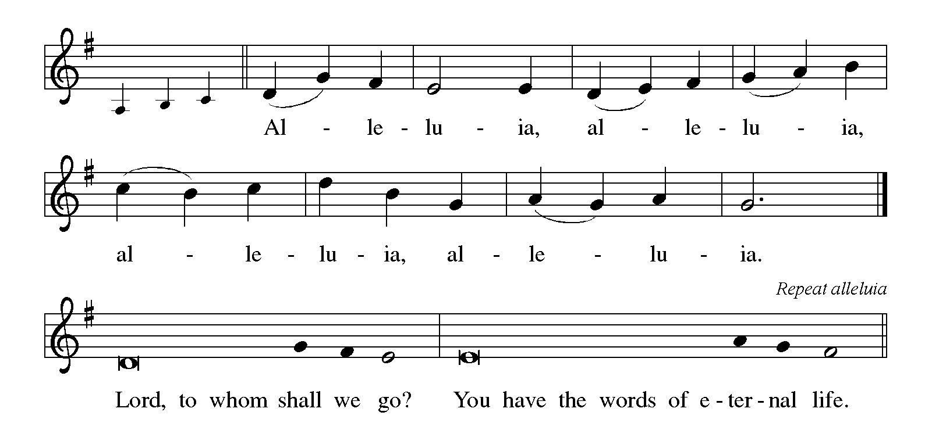

THE HOLY GOSPEL John 14: 15-21

John's gospel is concerned with the faith of disciples who no longer have Jesus with them physically. Jesus promises that they will receive the Spirit and that He will continue to reveal Himself to those who love Him.

P: The Holy Gospel according to St. John, the fourteenth chapter.

C: Glory to You, O Lord!

[Jesus said to the disciples:] "If you love Me, you will keep My commandments.
¹⁶And I will ask the Father, and He will give you another Advocate, to be with
you forever.
¹⁷This is the Spirit of truth, Whom the world cannot receive, because it neither sees
Him nor knows Him. You know Him, because He abides with you, and He
will be in you.
¹⁸"I will not leave you orphaned; I am coming to you.
¹⁹In a little while the world will no longer see Me, but you will see Me; because I live,
you also will live.
²⁰On that day you will know that I am in My Father, and you in Me, and I in you.
²¹They who have My commandments and keep them are those who love Me; and those
who love Me will be loved by My Father, and I will love them and reveal
Myself to them."

P: The Gospel of the Lord.

C: Praise to You, O Christ!

The assembly is seated

THE SERMON

Silence for reflection follows the sermon

As you are able please rise

THE HYMN OF THE DAY 396 Spirit of Gentleness

THE NICENE CREED

A: God has made us His people through our Baptism into Christ. Living together in trust
and hope, we confess our faith.

We believe in one God,
the Father, the Almighty,
maker of heaven and earth,
of all that is, seen and unseen.

We believe in one Lord, Jesus Christ,
the only Son of God,
eternally begotten of the Father,
God from God, Light from Light,
true God from true God,
begotten, not made,
of one Being with the Father.
Through Him all things were made.
For us and for our salvation
He came down from heaven;
by the power of the Holy Spirit
He became incarnate from the virgin Mary, and was made man.
For our sake He was crucified under Pontius Pilate;
He suffered death and was buried.
On the third day He rose again
in accordance with the Scriptures;
He ascended into heaven
and is seated at the right hand of the Father.
He will come again in glory to judge the living and the dead,
and His kingdom will have no end.

We believe in the Holy Spirit, the Lord, the giver of life,
Who proceeds from the Father and the Son.
With the Father and the Son He is worshiped and glorified.
He has spoken through the prophets.
We believe in one holy catholic and apostolic Church.
We acknowledge one Baptism for the forgiveness of sins.
We look for the resurrection of the dead,
and the life of the world to come. Amen

THE PRAYER OF THE CHURCH

A: Trusting in Jesus Who will never leave us orphaned, let us pray in the power of the
Spirit for the Church, the world, and all those in need.

A: That the Church may always be ready to testify to the hope in Christ that is in us, we
pray:

C: Hear us, risen Lord.

A: That children who are victims of violence in this world, especially those who are
orphaned by war, disease, and disaster, may be sustained by the Spirit of the Christ
Who was Himself abandoned and rejected, we pray:

C: Hear us, risen Lord.

A: That this congregation might more faithfully follow Jesus in this week through
obedience to His commands and love of one another, we pray:

C: Hear us, risen Lord.

A: That all mothers and those who give motherly care might always reflect Your own
faithful compassion, mercy, and kindness, we pray:

C: Hear us, risen Lord.

A: That to those who cry out in anguish, loneliness, hunger, or illness, especially: Mark
Tannehill; Verne Lee; Martha Schroeder; Christine Kiser; and Debbie Martin
God would attend to their prayer, we pray:

C: Hear us, risen Lord.

A: That those celebrating birthdays, especially Pat Miller and Melinda Nagle; and
anniversaries, especially Fred and Judy LaBorn may grow in grace this day and every
day and be filled with grace for the days ahead, we pray:

C: Hear us, risen Lord.

A: That with all the faithful who have gone before us we too may abide in God forever,
we pray:

C: Hear us, risen Lord.

P: Good and gracious God, Your Holy Spirit speaks for us. Grant what our Advocate
inspires us to ask in the name of the risen Christ our Lord.

C: Amen.

MEAL

THE PEACE

P: The risen Christ stood among the disciples and said, “Peace be with you.”
The peace of the risen Lord be with you always.

C: And also with you.

The assembly is seated

THE OFFERING

THE VOLUNTARY Awesome God New Song Praise Band
(Rich Mullens)

As you are able please rise

THE OFFERTORY

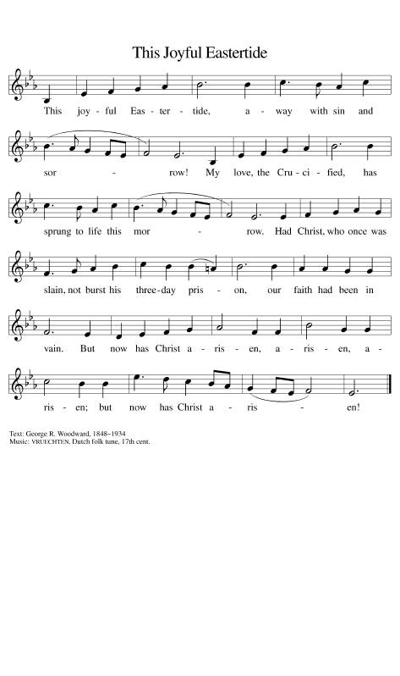

THE OFFERTORY PRAYER

A: Let us pray. Gracious God,

C: Accept our prayers of thanksgiving and the offering of our lives that we bring
before You. Make us worthy of this holy Sacrament of love by granting us Your
forgiveness. Reveal Yourself to us in this Meal, and send Your Spirit to be with
us forever. We ask this in the name of Jesus the Lord. Amen.
THE GREAT THANKSGIVING

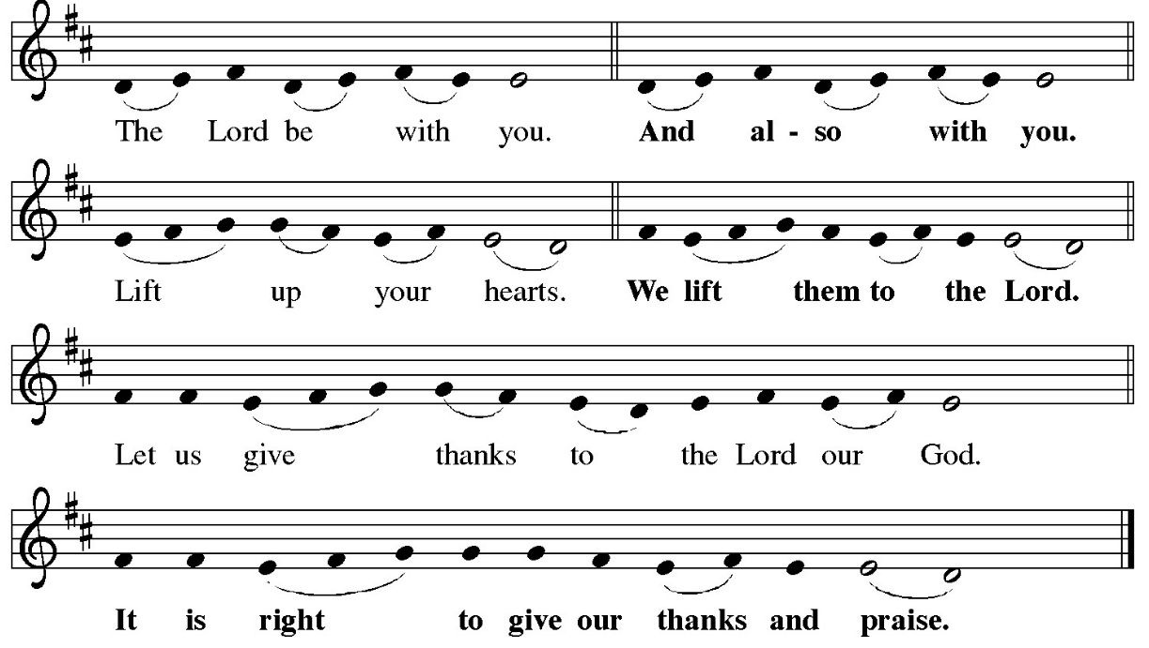

P: It is indeed right, our duty and our joy … and join their unending hymn:

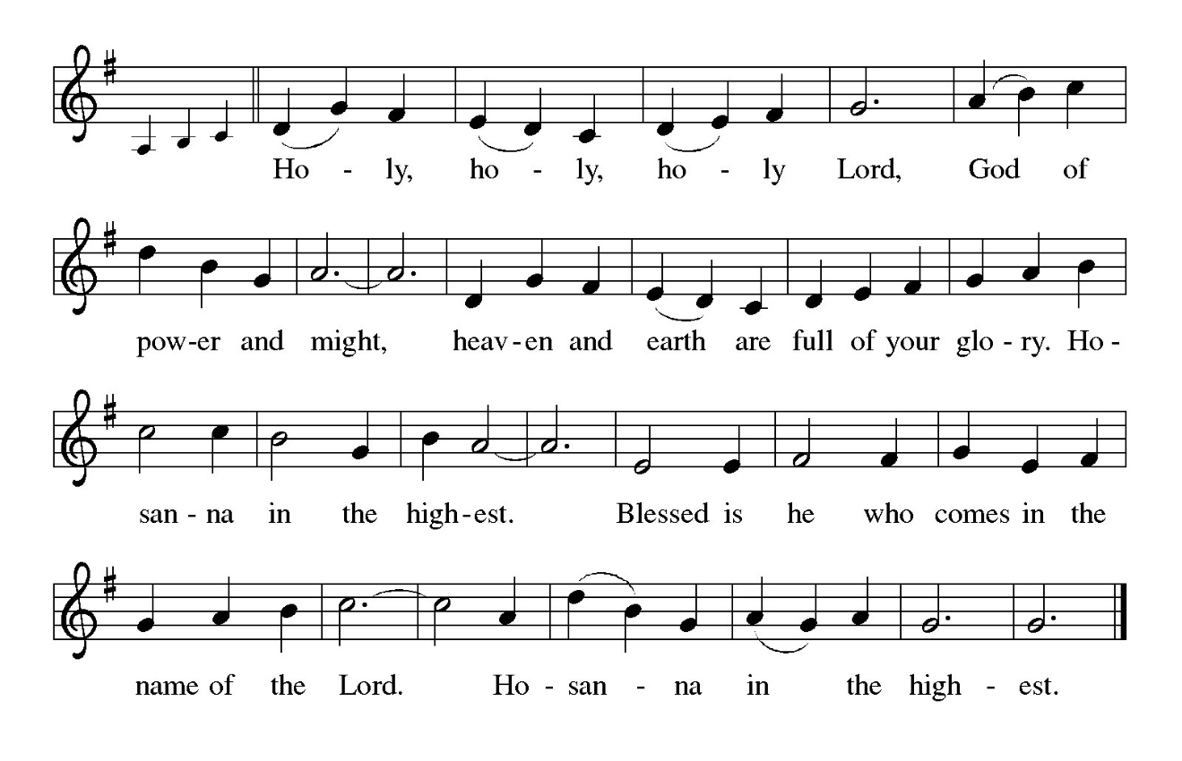
P: Unknown yet revealing God, it is our duty and joy to thank and praise You, because
from one ancestor You made all nations to inhabit the earth, and You allotted
their times and boundaries, so they would search for You, in Whom they live and
move and have their being.
While our lives are circumcised by the limitations of our minds and bodies, Your life
is beyond our reach and outside our imagining.
Yet in Your mercy You embodied all Your promises to Your people in the sending of
Your Son, and through His dying and rising You have brought us to Your throne
of grace.
Sending and accompanying God, You do not leave us orphaned, but in Christ You
make us Your adopted children, and in Your Spirit You send an Advocate to be
with us forever.
By the power of that same Spirit, take the fragile flesh of Your people and transform it
into the resurrected glory of Your Church; and come down upon these gifts of
bread and wine and make them be for us the Body and Blood of Your Son Jesus
Christ;
Who in the night ... “Do this for the remembrance of Me.”
As often as we eat ... we proclaim the Lord’s death until He comes.

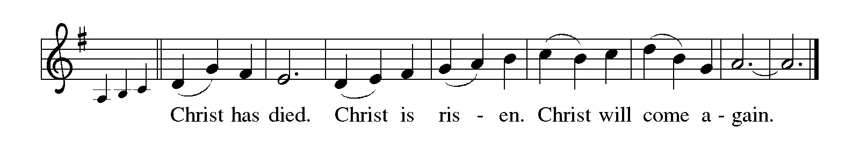

P: Sanctifying God, from the abundance of Your limitless glory, bless Your children who
suffer for doing right.
Give to those who stand trial the gentleness and reverence of Your Son.
As in Christ You proclaimed Your Word to the spirits in prison, make Yourself known
to all who find themselves incarcerated in body, mind, or spirit.
Be close to all who live with public shame, and all who carry the humiliation of others
in their hearts.
Breathe Your power upon Your people where they face persecution, oppression, or
false charge, that in truth You shall lead us to all truth,
Until that Day when the whole world is judged in righteousness by the One You
have appointed and raised from the dead, and we stand before You, forgiven,
loved, and free,
Ever one God, Father, Son, and Holy Spirit.

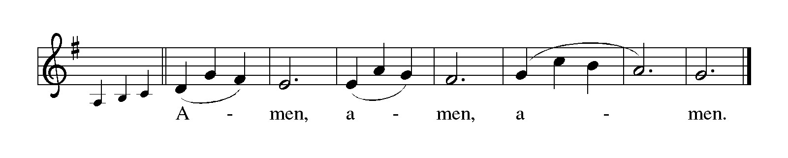

THE LORD’S PRAYER

P: Alleluia! The risen Christ intercedes on our behalf before the throne of God. Let us
therefore join Him in His prayers in the words He taught us:
C: Our Father, Who art in heaven, hallowed be Thy Name. Thy Kingdom come, Thy
will be done on earth as it is in heaven. Give us this day our daily bread, and
forgive us our trespasses as we forgive those who trespass against us. And lead us
not into temptation but deliver us from evil. For Thine is the Kingdom, and the
power, and the glory, forever and ever. Amen.

INVITATION TO THE MEAL

P: Jesus said, I am the true Vine. Abide in Me as I abide in you. Blessed are those who
are called to the Supper of the Lamb. God’s holy gifts for God’s holy people. Come,
for all is now ready.

The assembly is seated

THE DISTRIBUTION Lamb of God

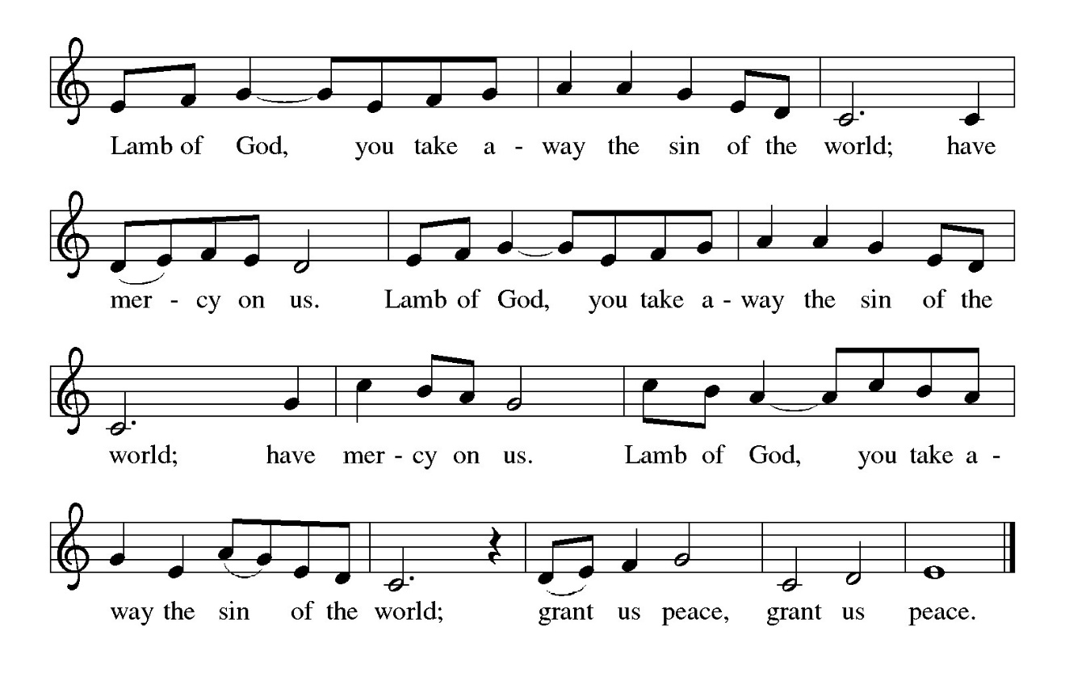

Those wishing to receive the Laying on of Hands, Anointing with Oil, and Prayer for Healing may go to Pastor at the side aisle

HYMN DURING DISTRIBUTION 804 Come Down, O Love Divine

ELW 781 Children of the Heavenly Father

ELW 459 Wade in the Water

ELW 408 Come Thou Almighty King

NSB 105 You Are My All in All

As you are able please rise

THE POST-COMMUNION BLESSING

P: The Body and Blood of our Lord Jesus Christ strengthen you and keep you in His grace.

C: Amen.

THE POST-COMMUNION PRAYER

A: Let us pray. Almighty and ever-living Lord, You restored us to life by raising Christ
from death. Strengthen us by this Easter sacrament. Preserve us in Your grace, and
empower us to enact Your commandment of love. Grant this through Christ our Lord.

C: Amen.
SENDING

THE BENEDICTION

P: Almighty God: Father, Son, and Holy Spirit bless you now and forever.

C: Amen.

SENDING HYMN 449 We Know That Christ is Raised

THE DISMISSAL

A: Go in peace. Proclaim the risen Lord. Alleluia! Alleluia!

C: Thanks be to God! Alleluia! Alleluia!

THE POSTLUDE

To God Alone Be Glory

The Greeting, Prayers, Peace, and Dismissal are adapted from Sundays and Seasons.
Copyright 2001 Augsburg Fortress.

The Prayers, Introduction to the Lord’s Prayer, and Invitation to the Meal are adapted from
Prayers for Sundays and Seasons. Year A. Peter J. Scagnelli. (Chicago: Liturgy
Training Publications, 1998) 64-65.

ANNOUNCEMENTS

Please remember to mail your offering to the Church Office at 818 Franklin Street, Michigan City, IN 46360. Another alternative is to give on-line through Tithe.ly. Please see your closure letter for information on how to set up a Tithe.ly account.

St. Paul Members are reminded to have a loved one contact the office if you are hospitalized. Many times, the Pastor doesn’t know someone is in the hospital. If you call and leave a message, please tell us at which hospital the patient is located.

BIRTHDAYS: Patricia Miller (5/16); Melinda Nagle (5/17)

ANNIVERSARIES: Fred & Judy LaBorn (5/19)

PRAYER CONCERNS: Debbie Martin; Mark Tannehill; Kathy Stein; Jan Paholski; Laura Dovey; Bill Hazelgrove; Al Levenhagen; Carl Wipperman; Major Payne.

OFFICE HOURS: Libby will be in the office on Mondays, Wednesdays, and Fridays; volunteers will cover Tuesdays and Thursdays.

Monday & Wednesday 8:00 a.m. – 5 p.m.
Tuesday & Thursday 9:00 a.m. – 12:00 p.m.
Friday 8:00 a.m. – 12:00 p.m.

If you are listening to the worship broadcast on the radio and would like to watch the Sunday morning service live stream follow these steps:

(1) If you have You Tube available on your TV, search for
St. Paul Lutheran Church Michigan City, IN.

(2) The direct link on the computer is https://
www.youtube.com/channel/UC5AIPNaKr3QN50984jGOa1g

(3) This link is also on the main page of the church’s website in
the church section and will continue to be posted weekly on the St.
Paul Facebook page.

And it will always be available on the radio broadcast Sunday mornings at 11:00 a.m.
on WEFM (95.9), and on the local cable access station #99 for the previous week’s
service on Sundays at 4:00 p.m. and the current service on Wednesdays at 7:00 p.m.
and Fridays at 8:30 p.m.

To send e-mail to the church office, please use the following addresses:

Pastor Mark Reshan: seniorpastor@stpaulmichigancity.com

Church Office Secretary (Libby Pollock): churchsecretary@stpaulmichigancity.com

Church Treasurer (Karen Fleming): finance@stpaulmichigancity.com

2026 Church Council:

Pastor - Mark Reshan

President - Donna Knoll

Vice President - Jan Bakken

Secretary - Judy Hunt

Treasurer - Karen Fleming

Members: Sue Koziel; Jim Schraidt; Trish Sprague; Bob Kiser; Barry Anderson; and
Pam Soule

Worship Attendance:

Saturday, May 2, 2026 @ 4:00 p.m. 31

Sunday, May 3, 2026 @ 9:00 a.m. 77

TOTAL 108

Copies of the minutes from the March 26, 2026 and April 23, 2026 Church Council meetings are on the back table in the upper Narthex. They were approved by the council via email.

The Good News Newsletter: If you have an article or anything you want included in The Good News please send it to the following e-mail address: splcgoodnews@gmail.com. Pastor Pamela Thiede will be using this e-mail address to assemble The Good News each month. The deadline for getting information to Pastor Pamela will be the 20th of each month.

Next week’s lessons are Acts 1: 1-11; Psalm 47 or Psalm 93; Ephesians 1: 15-23; Luke 24: 44-53 for those of you who like to study them in advance.

MISSION OF THE MONTH FOR MAY 2026

The Dolly Fund at Lubeznik Center for the Arts is our Mission of the Month for May 2026. The Dolly Fund is an endowment fund that supports scholarships for students age 7- 18 to LCA’s art classes for youth. It was initiated by Paul Marshall, in honor of his late wife and former LCA director, Dolly Marshall. Dolly had a life-long belief that arts education for children was crucial to their development. Some of the classes LCA offers are abstract painting, mixed media for young artists, figure drawing, digital illustration, abstract landscapes, poetry and performance workshops, printmaking, and much more!

Please make checks payable to St. Paul and mark for the Dolly Fund and place in the offering. Noisy coin offering for the month of May will also go to support the Dolly Fund. Thank you for your generosity each month!
Lora

ACTIVITIES, EVENTS & MEETINGS
MAY, 2026

Sunday, May 3, 2026 @ 9:00 a.m. 5 Easter Worship Service/Sanctuary with the Annual SPRING CONGREGATIONAL MEETING immediately after worship AND A True POTLUCK following the meeting. Please bring a dish to share.

Tuesday, May 5, 2026 @ 10:00 a.m. Altar Guild/Green Room
Wednesday, May 6, 2026 @ 9:15 a.m. Bible Study/Luther House
@ 10:00 a.m. God’s Purls/St. Paul Room
@ 4:30 p.m. NO CHOIR REHEARSAL
Thursday, May 7, 2026 @ 4p – 10 p GIVE -- BACK AT GALVESTON STEAK- HOUSE
Saturday, May 9, 2026 @ 4:00 p.m. 6 Easter Worship Service/Sanctuary

Sunday, May 10, 2026 @ 9:00 a.m. 6 Easter Worship Service/Sanctuary
MOTHER’S DAY with coffee after
Monday, May 11, 2026 @ 1:00 p.m. Hope Circle/Green Room
Wednesday, May 13, 2026 @ 9:15 a.m. Bible Study/Luther House
@ 10:00 a.m. God’s Purls/St. Paul Room
@ 3:30 p.m. Worship & Music Mtg./Luther House
@ 4:30 p.m. Choir Rehearsal/Sanctuary
Saturday, May 16, 2026 @ 4:00 p.m. 7 Easter Worship Service/Sanctuary

Sunday, May 17, 2026 @ 9:00 a.m. 7 Easter Worship Service/Sanctuary with
coffee after
Monday, May 18, 2026 @ 2:00 p.m. Finance Committee Mtg./Luther House
@3:00 p.m. Executive Board Mtg./Luther House
Wednesday, May 20, 2026 @ 10:00 a.m. God’s Purls/St. Paul Room
@ 4:30 p.m. Choir Rehearsal/Sanctuary
Thursday, May 21, 2026 @ 3:00 p.m. Church Council/St. Paul Room
Saturday, May 23, 2026 @ 4:00 p.m. Vigil for Pentecost Worship Service/ Sanctuary

Sunday, May 24, 2026 @ 9:00 a.m. Day of Pentecost Worship Service/Sanctuary w/ coffee after
Monday, May 25, 2026 is MEMORIAL DAY/OFFICE IS CLOSED
Wednesday, May 27, 2026 @ 10:00 a.m. God’s Purls/St. Paul Room
@ 4:30 p.m. Choir Rehearsal/Sanctuary
Saturday, May 30, 2026 @ 4:00 p.m. The Holy Trinity Worship Service/Sanctuary

Sunday, May 31, 2026 @ 9:00 a.m. The Holy Trinity Worship Service/Sanctuary w/ coffee after

