**THE EIGHTEENTH SUNDAY AFTER PENTECOST**

**October 12, 2025**

“The group of images (in the lectionary) designating the outsider illustrates how well it works as metaphor. Take for example the leper: thankfully, people with various skin ailments are no longer diagnosed as lepers and ostracized outside our communities. Thus a gospel reading about leprosy functions for us not as a literal directive from God, but as an image for us to contemplate: Who are our lepers? Whom do we fear? Whom do we ostracize? And if we judge ourselves as an outsider, we are the thief on the cross, welcomed inside the church by the presence of the body of Christ …”

“ … The hope is that attending to the outsider on Sunday morning will be practice for our lifelong turn toward the outsider … The lectionary offers the leper, the foreigner, the Samaritan, the tax collector, and the uncircumcised as images of the outsider whom we are called to embrace. There, outside, we will find Christ. And it will be good news, that there is no longer anyone we need to hate.”

**Gail Ramshaw**

***Treasures Old and New: Images in the Lectionary***

**“Outsider”**

**✠ In the Name of Jesus ✠**

**INTRODUCTION**

It’s a miracle! Multiple miracles! The waters of holy baptism have healed us. The body and blood of Jesus in holy communion have made us clean. We have died with Christ and been raised with him. For all this we have returned to offer thanks. From this place we are sent on our way rejoicing to share the good news

**✠ GATHERING ✠**

**PRE-SERVICE MUSIC *Healing in This House*  New Song Praise Band**

**(David & Lisa Binion)**

**ANNOUNCEMENTS**

*As you are able please rise*

**CONFESSION AND ABSOLUTION**

P: In the name of the Father and of **✠** the Son and of the Holy Spirit.

**C: Amen.**

P: “The LORD is gracious and full of compassion” (Psalm 111: 4) Trusting that God will

turn to us in forgiveness, and recognizing our need for God’s mercy, let us confess our

sin, and seek reconciliation with God and each other.

*Silence for reflection and self-examination*

P: Most merciful God,

**C: We confess that we have sinned against You in thought, word, and deed. We have**

**not “given thanks to You with our whole heart” (Psalm 111: 1). We are guilty of**

**taking Your abundant blessings for granted. We have denied You by our faithless**

**words and actions (2 Timothy 2: 12-13). For all our thanklessness, we beg for**

**Your mercy, O God. Grant us new and grateful hearts, that our lives may be**

**overflowing with adoration to You and service to others in Your name.**

P: Jesus said to the Samaritan, “Get up and go on your way; your faith has made you well.”

(Luke 17:19) You too may go in joy and peace, for God in Jesus has again made you

whole. For as a called and ordained minister of the Church of Christ, and by His

authority, I therefore declare to you the entire forgiveness of all your sins, in the name

of the Father and of **✠** the Son and of the Holy Spirit.

**C: Amen.**

**GATHERING SONG 822 *Oh, Sing to the Lord***

**THE GREETING AND PRAYER OF THE DAY**

P: The grace of our Lord Jesus Christ, the love of God, and the communion of the Holy

Spirit be with you all.

**C: And also with you.**

P: Let us pray. Almighty and most merciful God, Your bountiful goodness fills all

creation. Keep us safe from all that may hurt us, that, whole and well in body and spirit,

we may with grateful hearts accomplish all that You would have us do, through Jesus

Christ, our Savior and Lord.

**C: Amen.**

*The assembly is seated*

**✠ WORD ✠**

**FIRST READING 2 Kings 5: 1-3, 7-15c**

Naaman, a Syrian general, suffers from leprosy. In this passage Elisha miraculously cures his illness, but only after Naaman realizes, with the help of his servants, that he also needs healing for his pride. This foreign general then acknowledges the sovereignty of the God of Israel.

Naaman, commander of the army of the king of Aram, was a great man and in high favor with his master, because by him the LORD had given victory to Aram. The man, though a mighty warrior, suffered from leprosy. 2Now the Arameans on one of their raids had taken a young girl captive from the land of Israel, and she served Naaman's wife. 3She said to her mistress, "If only my lord were with the prophet who is in Samaria! He would cure him of his leprosy."

7When the king of Israel read the letter, he tore his clothes and said, "Am I God, to give death or life, that this man sends word to me to cure a man of his leprosy? Just look and see how he is trying to pick a quarrel with me."

8But when Elisha the man of God heard that the king of Israel had torn his clothes, he sent a message to the king, "Why have you torn your clothes? Let him come to me, that he may learn that there is a prophet in Israel." 9So Naaman came with his horses and chariots, and halted at the entrance of Elisha's house. 10Elisha sent a messenger to him, saying, "Go, wash in the Jordan seven times, and your flesh shall be restored and you shall be clean."

11But Naaman became angry and went away, saying, "I thought that for me he would surely come out, and stand and call on the name of the LORD his God, and would wave his hand over the spot, and cure the leprosy! 12Are not Abana and Pharpar, the rivers of Damascus, better than all the waters of Israel? Could I not wash in them, and be clean?" He turned and went away in a rage.

13But his servants approached and said to him, "Father, if the prophet had commanded you to do something difficult, would you not have done it? How much more, when all he said to you was, 'Wash, and be clean'?"

14So he went down and immersed himself seven times in the Jordan, according to the word of the man of God; his flesh was restored like the flesh of a young boy, and he was clean. 15Then he returned to the man of God, he and all his company; he came and stood before him and said, "Now I know that there is no God in all the earth except in Israel.

The Word of the Lord.

**Thanks be to God.**

**THE PSALM: Psalm 111** Antiphon by Dorothy Christopherson

Choir sings refrain first, followed immediately by the congregation

and as indicated

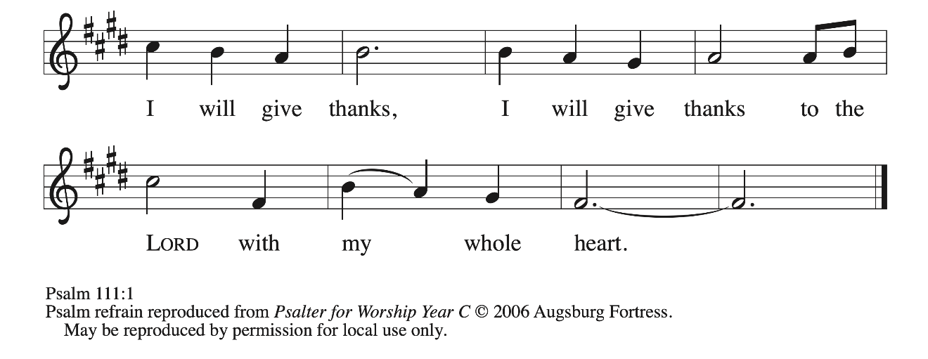

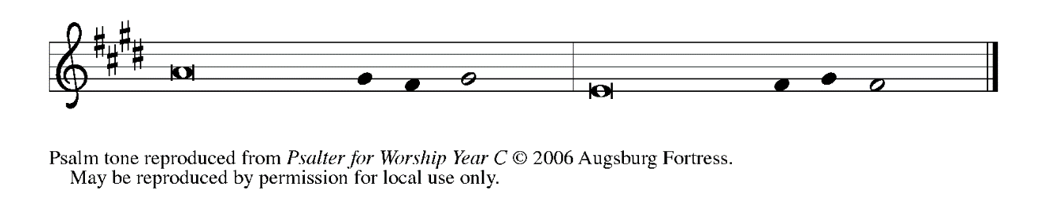

1Hallelujah! I will give thanks to the Lord with **|** my whole heart,

in the assembly of the upright, in the **|** congregation.

**2Great are Your | works, O Lord,**

**pondered by all who de- | light in them. REFRAIN**

3Majesty and splendor **|** mark Your deeds,

and Your righteousness en- **|** dures forever.

**4You cause Your wonders to | be remembered;**

**You are gracious and full | of compassion.**

5You give food to **|** those who fear You,

remembering forev- **|** er Your covenant.

**6You have shown Your people the power | of Your works**

**in giving them the lands | of the nations. REFRAIN**

7The works of Your hands are faithful- **|** ness and justice;

all of Your pre- **|** cepts are sure.

**8They stand fast forev- | er and ever,**

**because they are done in | truth and equity.**

9You sent redemption to Your people and commanded Your cove- **|** nant forever;

holy and awesome **|** is Your name.

**10The fear of the Lord is the begin- | ning of wisdom;**

**all who practice this have a good understanding. God’s praise en- | dures forever. REFRAIN**

**SECOND READING 2 Timothy 2: 8-15**

Though Paul is chained as a prisoner, he reminds Timothy that the word of God is never shackled or confined. He encourages his young friend to proclaim that word of freedom in an honest and upright life as well as in his teaching and preaching.

8Remember Jesus Christ, raised from the dead, a descendant of David — that is my gospel, 9for which I suffer hardship, even to the point of being chained like a criminal. But the word of God is not chained. 10Therefore I endure everything for the sake of the elect, so that they may also obtain the salvation that is in Christ Jesus, with eternal glory.

11The saying is sure:

If we have died with Him, we will also live with Him;

12if we endure, we will also reign with Him;

if we deny Him, He will also deny us;

13if we are faithless, He remains faithful —

for He cannot deny Himself.

14Remind them of this, and warn them before God that they are to avoid wrangling over words, which does no good but only ruins those who are listening. 15Do your best to present yourself to God as one approved by Him, a worker who has no need to be ashamed, rightly explaining the word of truth.

The Word of the Lord.

**Thanks be to God.**

*As you are able please rise*

**THE VERSE**

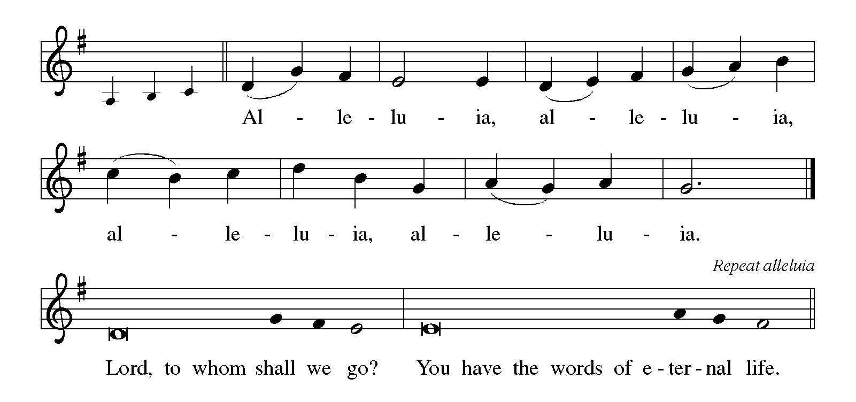

**THE HOLY GOSPEL Luke 17: 11-19**

Jesus' mission includes making the unclean clean again. Unexpectedly, a cleansed Samaritan leper becomes a model for those who would praise and worship God and give thanks for God's mercy.

P: The Holy Gospel according to St. Luke, the seventeenth chapter.

**C: Glory to You, O Lord!**

11On the way to Jerusalem Jesus was going through the region between Samaria and Galilee. 12As He entered a village, ten lepers approached Him. Keeping their distance, 13they called out, saying, "Jesus, Master, have mercy on us!"

14When He saw them, He said to them, "Go and show yourselves to the priests." And as they went, they were made clean. 15Then one of them, when he saw that he was healed, turned back, praising God with a loud voice. 16He prostrated himself at Jesus' feet and thanked Him. And he was a Samaritan.

17Then Jesus asked, "Were not ten made clean? But the other nine, where are they? 18Was none of them found to return and give praise to God except this foreigner?" 19Then He said to him, "Get up and go on your way; your faith has made you well."

P: The Gospel of the Lord.

**C: Praise to You, O Christ!**

*The assembly is seated*

**THE SERMON**

*Silence for reflection follows the sermon*

*As you are able please rise*

**THE HYMN OF THE DAY 610 *O, Christ, the Healer, We Have Come***

Stanza 2—Men; Stanza 3--Women

**THE APOSTLES’ CREED**

A: God has made us His people through our Baptism into Christ. Living together in trust

and faith, we confess our faith.

**C: I believe in God, the Father almighty,**

**creator of heaven and earth.**

**I believe in Jesus Christ, His only Son, our Lord.**

**He was conceived by the power of the Holy Spirit**

**and born of the virgin Mary.**

**He suffered under Pontius Pilate,**

**was crucified, died, and was buried.**

**He descended into hell.**

**On the third day He rose again.**

**He ascended into heaven,**

**and is seated at the right hand of the Father.**

**He will come again to judge the living and the dead.**

**I believe in the Holy Spirit,**

**the holy catholic Church,**

**the communion of saints,**

**the forgiveness of sins,**

**the resurrection of the body,**

**and the life everlasting. Amen.**

**THE PRAYER OF THE CHURCH**

A: Let us bow before our loving and compassionate God, offering our thanksgiving and

making known our requests for the Church, the world, and all those who cry out for

mercy.

A: God, You invite all to come to the water and be cleansed. That the Church may be

renewed in the gift of Baptism, and those who bear the sign of the cross be strengthened

for service, let us pray to the Lord:

**C: (Women) Lord, have mercy!**

**(Men) Lord, have mercy!**

**(All) Lord, have mercy!**

A: God, You provide water for our life and refreshment. That we may be good stewards

of the gifts of the oceans, rivers, lakes, and streams that nourish the earth, and that all

people may be blessed with clean, safe water, let us pray to the Lord:

**C: (Women) Lord, have mercy!**

**(Men) Lord, have mercy!**

**(All) Lord, have mercy!**

A: God, You are faithful even when we lose our way. Bless our leaders and all those who

govern. That they may be agents of Your faithfulness and justice, let us pray to the

Lord:

**C: (Women) Lord, have mercy!**

**(Men) Lord, have mercy!**

**(All) Lord, have mercy!**

A: God, Your Son ministered to lepers and restored their health and dignity. That those

whose illness carries shame or stigma, and all the sick, especially: **Fred Weiss; Martha**

**Schroeder; John Bennitt; David Weiss; Joyce Stark; Sally Timm; Carl**

**Wipperman; Shirley Freels; Lucas Bradshaw; Larry Litchford;**

**Marsha Logan; and Bill Hazelgrove** may be restored to health and wholeness, let us

pray to the Lord:

**C: (Women) Lord, have mercy!**

**(Men) Lord, have mercy!**

**(All) Lord, have mercy!**

A: God, You have given us saints and great heroes and heroines of the faith to inspire and

model faithful discipleship. That with them we too may obtain Your salvation that is

in Christ Jesus, let us pray to the Lord:

**C: (Women) Lord, have mercy!**

**(Men) Lord, have mercy!**

**(All) Lord, have mercy!**

P: Hear these words, O God, as You hear and understand the unspoken thoughts of our

hearts and minds, and grant their fulfillment according to Your merciful and gracious

will, through Your Son, Jesus Christ our Lord.

**C: Amen.**

**✠ MEAL ✠**

**THE PEACE**

P: The peace of the Lord be with you always.

**C: And also with you.**

*The assembly is seated*

**OFFERING**

**VOLUNTARY *It Is Well With My Soul***  **St. Paul Senior Choir**

Arr. J.N. Beck

*As you are able please rise*

**THE OFFERTORY 531 *The Trumpets Sound, the Angels Sing***

(Stanzas 1, 3)

**THE OFFERTORY PRAYER**

A: Let us pray. Merciful God,

**C: Everything in heaven and earth belongs to You. We joyfully release what You**

**have entrusted to us. May these gifts be signs of our whole lives returned to You,**

**given with deep joy and thanksgiving, and dedicated to the healing of all creation,**

**through Jesus Christ our Lord. Amen.**

**THE GREAT THANKSGIVING**

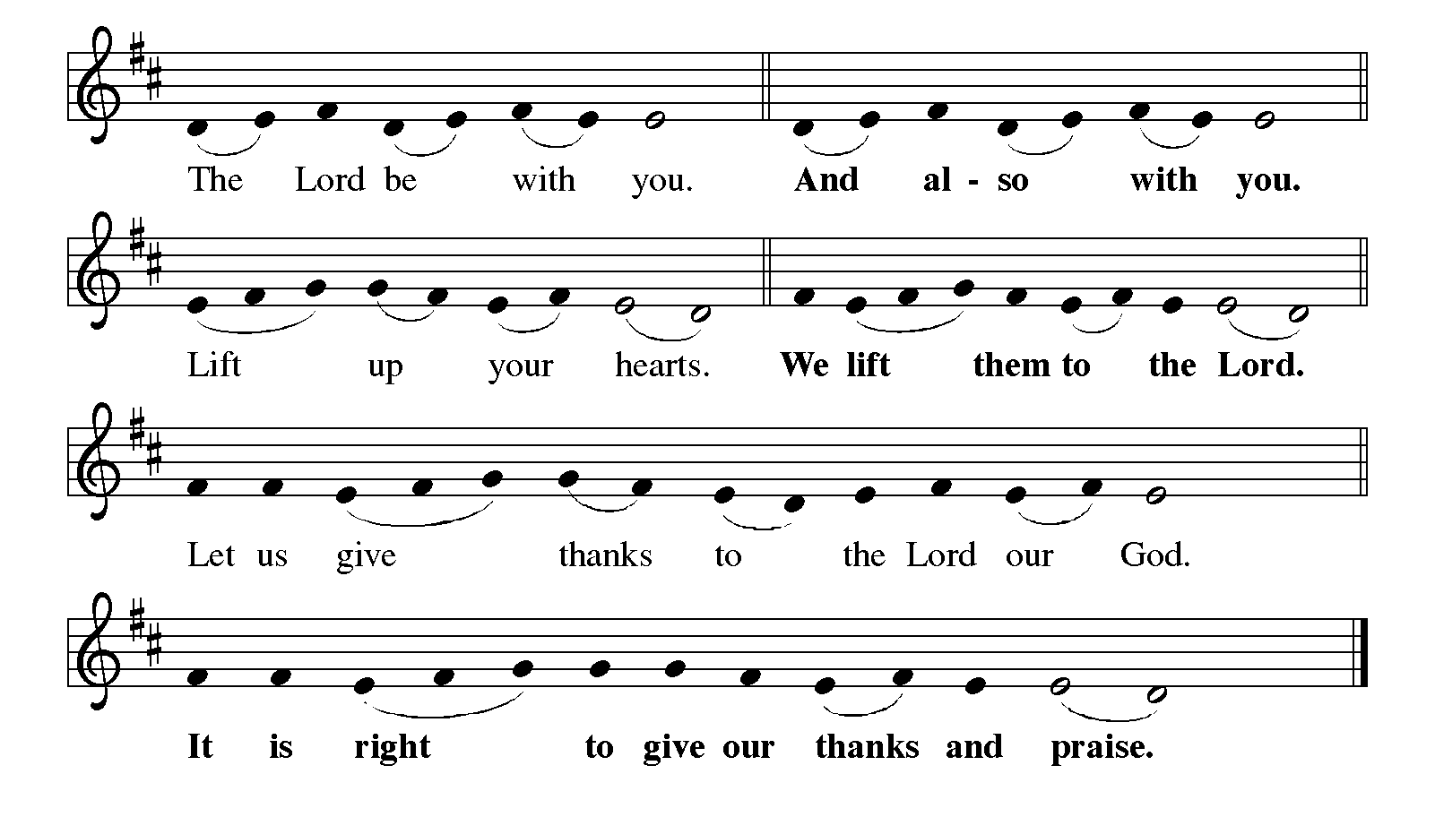

P: It is indeed right, our duty, and our joy … join their unending hymn:

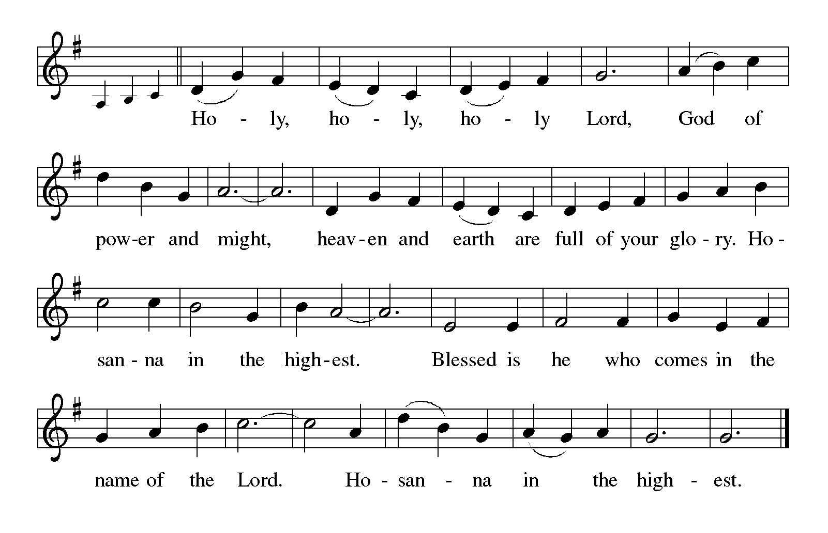

P: Trusting and abiding God, we lift our hearts to thank and praise You, because even

when we are faithless toward You, You are always faithful toward us.

In creation You made a myriad of wonders for us to enjoy; yet in our sin we saw

scarcity instead of abundance.

In Israel You made a people for Your own heart; but Your people longed to be like

other nations.

In exile You taught Your prophets and priests to seek the welfare of the city where

You had sent them.

There in a foreign land You made Yourself known to Your people in a new way,

so that when Your Son Jesus Christ was crucified for our salvation His

disciples saw in His servanthood the pattern of Your suffering love.

Restoring God, as in Christ You made a new community out of exiles, so today

You gather to Your Table the leper, the outcast, and the wounded.

Send Your Spirit upon Your Church that it may be a community of reconciliation

and truth.

Make holy these gifts of bread and wine: make them be for us the Body and Blood

of Your Son, Jesus Christ,

Who, in the night … “Do this for the remembrance of Me.”

As often as we eat … we proclaim the Lord’s death until He comes.

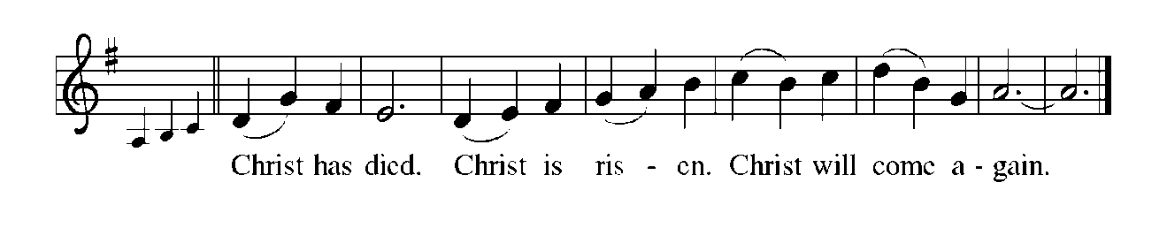

P: God of healing and grace, bless those who are in exile and see no way to reach home.

Be close to all who have no house to live in, no garden to plant, no food to eat, no

respite from sickness, prejudice, oppression, or danger.

By the power of Your Holy Spirit abide with those whose time is short, that they may

know that if they die with Christ, they will also live with Him;

That if they endure, they will also reign with Him; until that Day when He returns in

glory with judgment enfolded in mercy and truth embraced by grace,

Ever one God, Trinity of holiness and love.

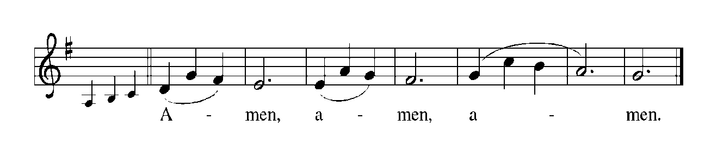

**THE LORD’S PRAYER**

P: Gathered into one by the Holy Spirit, let us pray as Jesus taught us:

**C: Our Father, Who art in heaven, hallowed be Thy name. Thy Kingdom come, Thy**

**will be done, on earth as it is in heaven. Give us this day our daily bread, and**

**forgive us our trespasses as we forgive those who trespass against us. And lead us**

**not into temptation, but deliver us from evil. For Thine is the Kingdom, and the**

**power, and the glory forever and ever. Amen.**

**INVITATION TO THE MEAL**

P: This is the Lamb of God Who takes away the sin of the world. Happy are they who are

called to His Table. God’s holy gifts for God’s holy people. Come, for all is now

ready.

*The assembly is seated*

**THE DISTRIBUTION**

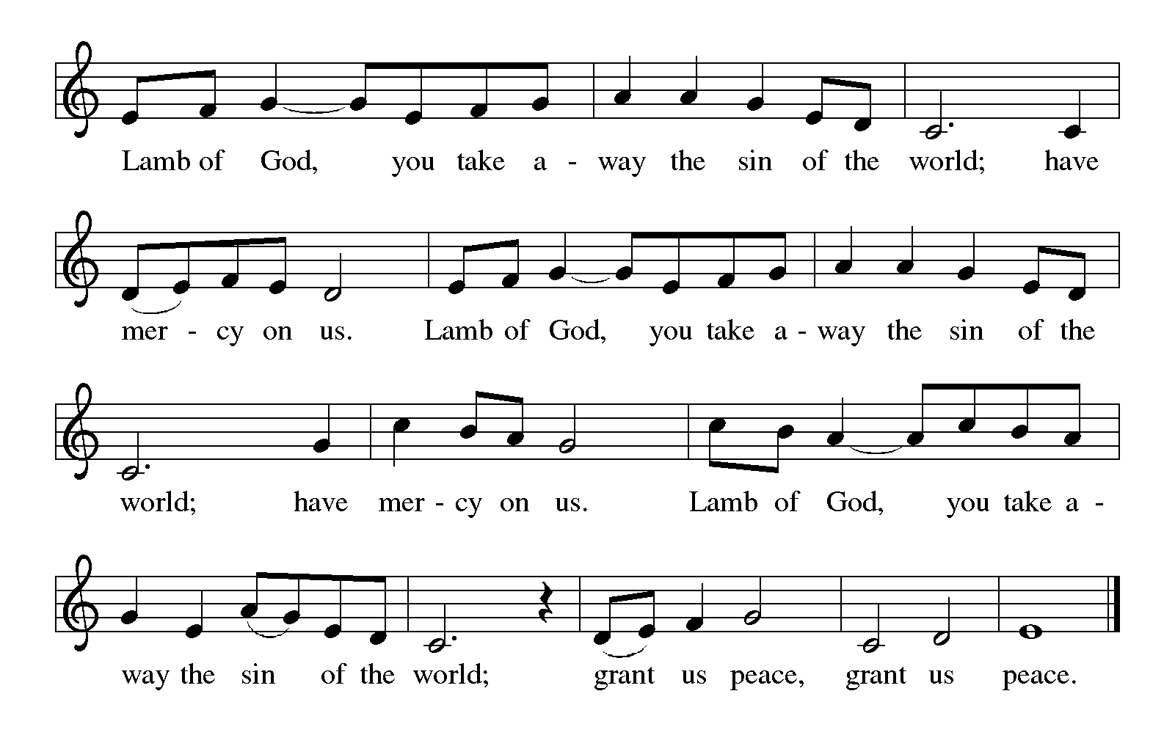

**HYMN DURING DISTRIBUTION 886 *Oh, For a Thousand Tongues to Sing***

**ELW 483 *Here is Bread***

**ELW 482 *I Come with Joy***

**ELW 860 *I’m So Glad Jesus Lifted Me***

**NSB 37 *Give Thanks***

*As you are able please rise*

**THE POST-COMMUNION BLESSING**

P: The Body and Blood of our Lord Jesus Christ strengthen you and keep you in His grace.

**C: Amen.**

**THE POST-COMMUNION PRAYER**

A: Let us pray. Loving God, You bring wholeness out of sickness, hope from despair, life

from death. Your restoring grace has again borne us from the cleansing waters of the

font to Your Table of thanksgiving. Send us now in the power of Your Spirit in lives

of thankful devotion and faithful service. Grant this through Christ our Lord.

**C: Amen.**

**✠ SENDING ✠**

**THE BENEDICTION**

P: Almighty God: Father, Son, **✠** and Holy Spirit bless you now and forever.

**C: Amen.**

**THE SENDING HYMN 839 *Now Thank We All Our God***

**THE DISMISSAL**

A: Go in peace. Remember the poor.

**C: Thanks be to God!**

**POSTLUDE**

**✠ To God Alone Be Glory ✠**

The Meditation is from *Sundays and Seasons Online.* Copyright 2013 Augsburg

Fortress.

The Prayers are adapted from *Sundays and Seasons.* Copyright 2009 Augsburg Fortress.

The Eucharistic Prayer is from *With One Voice. Leader’s Edition.* (Minneapolis:

Augsburg Publishing House, 1995) 72.

**ANNOUNCEMENTS**

**Please remember to mail your offering to the Church Office** at 818 Franklin Street, Michigan City, IN 46360**.** Another alternative is to give on-line through Tithe.ly. Please see your closure letter for information on how to set up a Tithe.ly account.

**St. Paul Members are reminded to have** a loved one contact the office if you are hospitalized. Many times, the Pastor doesn’t know someone is in the hospital. If you call and leave a message, please tell us at which hospital the patient is located.

**PRAYER CONCERNS:** Bev Coburn; Barry Anderson; John Bennitt; Judy

Gustum; Larry Litchford; Sarah McNabb; Jeanie Boatman Shepple; Debbie Martin; Mark Tannehill; Kathy Stein; Jan Paholski; Laura Dovey; Grace Romine; Roger and Margaret Miller; Bill Hazelgrove; Kerry Steinborn; Robert Bernth; Craig Hunt; Al

Levenhagen and Carl Wipperman.

**If you are listening to the worship broadcast on the radio and would like to watch the Sunday morning service live stream follow these steps:**

(1) If you have You Tube available on your TV, search for

**St. Paul Lutheran Church Michigan City, IN.**

(2) The direct link on the computer is [https://](https://www.youtube.com/channel/UC5AIPNaKr3QN50984jGOa1g)

[www.youtube.com/channel/UC5AIPNaKr3QN50984jGOa1g](https://www.youtube.com/channel/UC5AIPNaKr3QN50984jGOa1g).

   (3) This link is also on the main page of the church’s website in

the church section and will continue to be posted weekly on the St.

Paul Facebook page.

And it will always be available on the radio broadcast Sunday mornings at 11:00 a.m.

on WEFM (95.9), and on the local cable access station #99 for the previous week’s

service on Sundays at 4:00 p.m. and the current service on Wednesdays at 7:00 p.m.

and Fridays at 8:30 p.m.

**LET’S CELEBRATE OUR PASTOR!**

**October is Pastor Appreciation Month.** Please join us during the coffee hour after our Sunday Worship Service on October 19th as we celebrate our appreciation for Pastor Reshan. Special treats, fellowship and a chance to say thank you face to face.

**OFFICE HOURS:** Libby will be in the office on Mondays, Wednesdays, and Fridays; volunteers will cover Tuesdays and Thursdays.

  Monday & Wednesday 8:00 a.m. – 5 p.m.

Tuesday & Thursday 9:00 a.m. – 12:00 p.m.

Friday 8:00 a.m. – 12:00 p.m.

**To send e-mail to the church office**, please use the following addresses:

Pastor Mark Reshan: seniorpastor@stpaulmichigancity.com

Church Office Secretary (Libby Pollock): churchsecretary@stpaulmichigancity.com

Church Treasurer (Karen Fleming): finance@stpaulmichigancity.com

**2025 Church Council:**

Mark Reshan - Pastor

 Janet Bakken – President

 Donna Knoll – Vice President

 Judy Hunt – Secretary

 Karen Fleming – Treasurer

 Members: Paul Brooks, Diane Egilske, Sue Koziel, Judy Mutchler,

Jim Schraidt, Trish Sprague

**Worship Attendance:**

**Saturday , October 4, 2025 @ 4:00 p.m. 22**

**Sunday, October 5, 2025 @ 9:00 a.m. 69**

**TOTAL 91**

**Copies of the minutes from the August 28, 2025 and the September 25, 2025 Church Council meetings are on the back table in the upper Narthex. They were approved by the council via email.**

**The Good News Newsletter**: If you have an article or anything you want included in **The Good News** please send it to the following e-mail address: splcgoodnews@gmail.com. Pastor Pamela Thiede will be using this e-mail address to assemble **The Good News** each month. The deadline for getting information to Pastor Pamela will be the 20th of each month.

**Sunday’s lessons are Genesis 32: 22-31; Psalm 121; 2 Timothy 3: 14 - 4: 5; and Luke 18: 1-8** for those of you who like to study them in advance.

**OCTOBER MONTHLY MISSION:**

October’s monthly mission is Franciscan Health Woodland Cancer Care Center patients. The center is located on 400 North and provides the convenience of one location for a full spectrum of cancer services. We will be collecting care kits as well as money for this mission. There are paper lunch bags available in the Narthex. Please take as many bags as you want to fill with items to make a care kit for someone going through cancer treatments. Examples of items would be warm socks, hats, gloves, lotion, chapstick, hard candy, gum, snacks, hand sanitizer, small journals, books, activity books, small puzzles, or other activities to do while having treatment (which can take several hours). Please bring your completed care kits back by **Sunday, November 2nd** and place them in the bin in the Narthex. If you’d rather donate financially, they have a fund that goes toward local patients where they provide different things such as gas cards, or gift cards. Money can be placed in the offering plate and marked for the Cancer Center. Noisy coin for the month of October will also go toward the monthly mission. Thank you for your unwavering support each month!

.

**ACTIVITIES, EVENTS & MEETINGS**

**OCTOBER 2025**

**Sunday,** October 12, 2025 @ 9:00 a.m. 18th Pent Worship/Sanctuary with coffee after

**Monday,** October 13, 2025 @ 1:00 p.m. Hope Circle/Green Room

**Tuesday,** October 14, 2025 @ 7:00 p.m. Estuary/Luther House

**Wednesday,** October 15, 2025 @ 9:15 a.m. Bible Study/Luther House

@10:00 a.m. God’s Purls/St. Paul Room

@ 4:30 p.m. Choir Rehearsal/Sanctuary

**Thursday,** October 16, 2025 @ 6:00 p.m. **Card Making with Donna**/St. Paul Room

**Saturday,** October 18, 2025 @ 4:00 p.m. 19th Pent Worship Service/Sanctuary

**Sunday,** October 19, 2025 @ 9:00 a.m. 19th Pent Worship/Sanctuary with coffee after

**Pastor Appreciation Celebration**

**Monday,** October 20, 2025 @ 2:00 p.m. Finance Comm. Mtg./Luther House

@ 3:00 p.m. Executive Board Mtg./Luther House

**Wednesday,** October 22, 2025 @ 9:15 a.m. Bible Study/Luther House

@ 10:00 a.m. God’s Purls/St. Paul Room

@ 4:30 p.m. Choir Rehearsal/Sanctuary

**Thursday,** October 23, 2025 @ 4:30 p.m. 150th Anniv. Comm. Mtg/Luther House

@ 5:30 p.m. Church Council Meeting/St. Paul Room

**Saturday,** October 25, 2025 @ 4:00 p.m. 20th Pent/**Reformation** Worship/Sanctuary

**Sunday,** October 26, 2025 @ 9:00 a.m. 20th Pent/**Reformation Sunday** Worship/

Sanctuary with Coffee after/St. Paul Room

**Wednesday,** October 29. 2025 @ 9:15 a.m. Bible Study/Luther House

@10:00 a.m. God’s Purls/St. Paul Room

@4:30 p.m. Choir Rehearsal/Sanctuary