October, 2025

**MARK: MY WORDS**

As we hope you know, next year marks the 150th anniversary of our congregation. A committee consisting of Paul and Lora Brooks, Virginia Murray, Sue Koziel and me have been working for over two years on planning out the year and some special events. I have written about our work in previous newsletters, but I wanted to give an update on where our plans stand.

The centerpiece of the year will be the commemorative worship service on Sunday, March 15. This is closest to the date on which the congregation first gathered for worship in 1876. There will be no Saturday worship that weekend to encourage as many people to attend this special liturgy as possible.

We will be blessed to have our bishop of the Indiana-Kentucky Synod, Timothy Graham, with us to preach. We will invite former pastors and interns to attend with us. The service will be followed by a catered meal in the St. Paul Room. We looked at other venues, but the cost was prohibitive. We are trying hard to keep the price of tickets as reasonable as possible. Seating will be limited to 120, so we will encourage people to purchase their tickets soon after they go on sale.

Over the summer we will host an ice cream social, also in the St. Paul Room. We had originally considered an outdoor service and picnic, but concerns about weather and logistics convinced us that a simpler event like the social would be preferable.

The final major celebration of the year will be a hymn festival sometime around Reformation Sunday, All Saints Day, or closer to Christ the King Sunday at the end of November. I have contacted the Music Department at Valparaiso University to inquire about the availability of their Chapel Choir, the *Kantorei,* to serve as the choir for that day. We hope to have a brass quartet, and I am waiting for confirmation from my good friend, Dr. Steven Wente, from Concordia University-Chicago, to be the organist. Steve has played here a number of times. He is familiar with the organ and experienced at hymn festivals. If we are able to pull all of this together, it will be a wonderful way to wrap up our celebration of this important milestone in our congregation’s history.

In addition to these events, we are working on publishing a booklet highlighting the ministries of many of our organizations over the past 50 years. We will also have displays from the archives out for viewing at various times and other interesting information. This is a once-in-a-lifetime occurrence for us, and we hope that you will take advantage of as many of these commemorations as possible.

St. Paul has a rich and faithful history of serving this neighborhood and community. 2026 will be a year both to look back with praise and thanksgiving to God and forward with hope for what God will do in us and through us in the years to come.

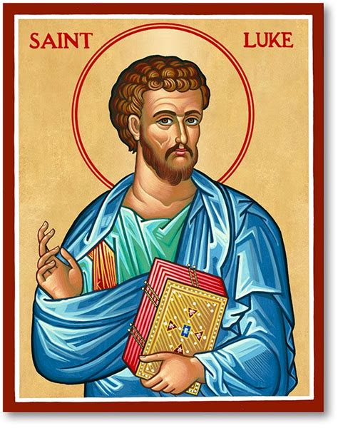

**THE DAY OF ST. LUKE**

It may seem redundant. For well over ten years now, we have offered the Laying on of Hands, Anointing with Oil, and Prayer for Healing on the second weekend of the month. It has been a rich blessing to see how participation in that rite has grown. When we first introduced it, some seemed hesitant to come forward for it. But over the years many more have joined the procession of those seeking God’s healing touch.

So, to call special attention to it seems unnecessary; but we have an opportunity this month to connect this rite with the Biblical figure with whom it is most closely associated: St. Luke. His feast day is October 18, which this year falls on a Friday—the *third* Friday of the month, the Friday *after* our usual offering of our healing part of the liturgy.

This month we will delay the rite until that third weekend so that we might celebrate his festival day on the 18th and 19th. Luke is one of the most important figures of the early church. Besides authoring one of the four Gospel accounts of Jesus’ life, he also wrote a follow-up volume on the life of the Jesus movement after Jesus’ Ascension. Between his Gospel and this “Acts of the Apostles,” his writings take up over one-fourth of the New Testament.

His theology plays a large part in what we know of life for the Church in those early years. Most scholars believe that sometimes in Acts he paints a rosier picture of the community’s life than was true; but overall, he provides an invaluable account of how the Church grew and developed in the years immediately after Jesus’ resurrection and ascension to the Father.

Luke’s writings are vital for another reason. In Acts, he is often a first-person reporter of the missionary work of perhaps the greatest New Testament figure of all, St. Paul. His eye-witness accounts of Paul’s travels, travails, hardships, sufferings, and preaching richly supplement Paul’s own accounts in his letters to various congregations that are part of our New Testament list of books. His faithfulness to Paul was unmatched. In one of the readings for his day, Paul writes, “Only Luke is with me.” When everyone else had deserted or given up on him, Luke was an incredible friend, support, helper, and companion.

For all of those reasons, he deserves to have a day on which we remember and give thanks for his ministry. We offer healing on that day because tradition says that Luke was a physician. He is a sign of God’s ongoing and ever-present work of bringing health and wholeness to whatever ailments of body, mind, or spirit with which we suffer.

We will be blessed by holding him and God’s promise of touching us with His mercy, favor, and compassion up before us again.



**MEALS ON WHEELS**

Last month we received a Certificate of Recognition from Meals on Wheels for 42 years of service of members of St. Paul. Our current team consists of Suzann and Wayne Dolson, Charmaine Imperato, Larry and Judy Litchford, Bob and Karen Kiser, Mary Knaup, and Team Captain Jan Bakken. Well done, good and faithful servants!



**LWR KIT PACKING**

On Saturday, October 11, at 2:30 p.m. we will gather in the St. Paul Room to pack school and personal health kits for Lutheran World Relief. Funds for the kit materials were donated a few months ago as the Mission of the Month. We have 100 school kits and 100 personal health kits to pack.

More hands make light work, and the packing goes quickly. Fellowship and refreshments will be provided afterward. No purchase or packing experience is necessary. All ages are welcome. If you aren’t comfortable packing, come observe and join us for fellowship.

The kits will be delivered to Christ Lutheran Church in Valparaiso the following weekend. From there, they will be sent to a LWR warehouse in either Minnesota or Maryland. Then they will be sent anywhere in the world where disaster has struck and the need is great. So far this year, kits have been sent to Texas after the flash floods in July, North Carolina after Hurricane Helene, and the Democratic Republic of the Congo due to war and unrest.

Thank you to all who so generously contributed funds for the purchase of these kits. The kit packing event has been great fun in the past few years. We hope that you will join us for this important ministry.



**NEW MEMBERS**

On Reformation weekend, we will be receiving some new members into our fellowship. As of this writing, there is not a final list. Watch for a picture and a full accounting of them in next month’s newsletter.

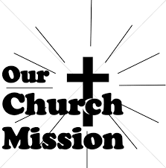

**MONTHLY MISSION: CANCER CARE KITS**

Thank you for your support of Michigan City Area Schools through Donors Choose during our August monthly mission.  We collected $716 and were able to provide math cubes to a classroom at Pine Elementary to help the students learn basic addition, subtraction, 2-digit subtraction within 100, and the base 10 system.  We also donated towards a simulator for the child development class at the high school, which will help students understand what happens within a baby’s brain after experiencing shaken baby syndrome.

October’s monthly mission is Franciscan Health Woodland Cancer Care Center patients.  The center is located on 400 North and provides the convenience of one location for a full spectrum of cancer services.  We will be collecting care kits as well as money for this mission.  There are paper lunch bags available in the Narthex.  Please take as many bags as you want to fill with items to make a care kit for someone going through cancer treatments.  Examples of items would be warm socks, hats, gloves, lotion, Chapstick, hard candy, gum, snacks, hand sanitizer, small journals, books, activity books, small puzzles, or other activities to do while having treatment (which can take several hours).  Please bring your complete care kits back by **Sunday, November 2,** and place in the bin in the Narthex.  If you’d rather donate financially, they have a fund that goes towards providing things such as gas cards or gift cards to local patients who need them.  Money can be placed in the offering plate and marked for the Cancer Center.  The noisy coin offering for the month will also go towards the monthly mission.  Thank you for your unwavering support each month!



**IN MEMORY OF BOB PHEANIS**

**General Fund** from Virginia Murray, Bob & Karen Kiser, Jim & Sandy Galinowski,

Jeff Timmrick

**IN MEMORY OF DON BURNS**

**Monthly Mission: ZERO Prostate Cancer** from Mike & Donna Knoll



Dear St. Paul Lutheran Church,

Thanks to your generous donations our classroom was transformed into a magical learning environment. When the students arrived on the first day of school their eyes lit up with excitement. As we have gotten settled in, our new classroom has become a calming experience that the students are thriving in. They immerse themselves in the full jungle theme. We are so grateful and thankful for the opportunity to experience such a wonderful gift every day of the year. It has created a calming atmosphere that all the students look forward to coming to everyday and are proud to share with others.

With gratitude,

Ms. Eiler

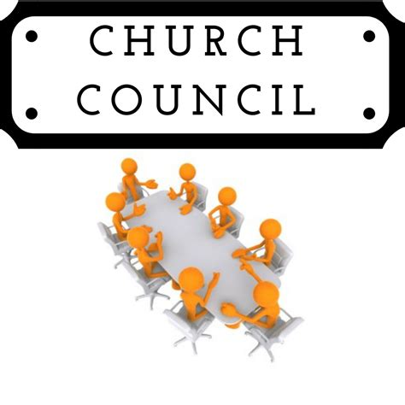

Would you like to be part of our Church Council? Donna Knoll and the Nominating Committee are looking for persons interested in serving on the Council next year. If you are interested, please contact Donna at [dknoll954@yahoo.com](mailto:dknoll954@yahoo.com) or call her at 219-262-4498 by October 10.

**DIRECTING TRAFFIC**

The middle week of September saw much repair and construction activity taking place on our buildings. After many months of waiting, the roof, gutters, and downspout on the Luther House were finally replaced. A two-to-three-week project began to replace all the thermostats in the church along with some work on the boilers in preparation for the heating season.

Crews were here early in the morning and working through the day. Present, as always, was our beloved head of maintenance, Bob Kiser, pictured above directing traffic around the crews and work materials. Bob coordinated with the companies and stayed for most of the days to answer any questions or provide help.

We are so deeply and richly blessed by Bob’s untiring dedication to keep our facilities in the best possible shape. Most of his work goes unseen by the congregation but we all reap the fruits of his work, along with his crew of Pastor Mark Kloess, Tim Crozier, Chuck Payne, Dave Squires, Larry Litchford, and Rich Fleming.

Our building is old and is in constant need of maintenance and repairs. We couldn’t do it without you, Bob. Make sure that when you see him and our other faithful helpers that you express your thanks for their faithful work.



**October Birthdays October Anniversaries**

1 Jacob Tannehill 4 James & Susan Tomsheck

2 Amy VanGemeren 9 James & Sandra Galinowski

4 Natalie Hendricks 18 Rick & Nancy Hawkins

5 Cynthia Payeur 21 Warren & Karen Schacht

Gary Larson 24 Kenneth & Ruth Baker

7 Dan McNabb James & Kimberly Summers

Milenda Simerlein

8 Anthony Gebbink

9 Judy Gustum

Carol Thomas

11 Laura Childers

18 Richard Fleming, Jr.

19 Kay Peglow

25 Judith Mutchler

26 Bob Kiser

28 Sandra Sobecki

29 Kristen Schacht

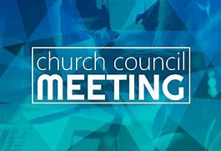

**SEPTEMBER COUNCIL HIGHLIGHTS**

There will be a **Congregational Meeting** on Sunday, November 9, following the worship service. The primary business of this meeting will be the election of officers and Church Council members. The meeting will be followed by a potluck meal.

Copies of the September 25 minutes will be available in the narthex after they are approved.

**Long-Term Prayer List**

Barry Anderson John Bennitt Laura Dovey

Jess Kalvaitis Christine Kiser Larry Litchford

Bethany Manning Debbie Martin Shirley McCarty

Sarah McNabb Jan Paholski Grace Romine

Martha Schroeder Jeanie Boatman Shepple Joyce Stark

Kathy Stein Mark Tannehill Kevin Thiede

Kathy Thielman David Weiss Brian Wiseman

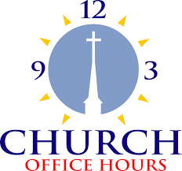

Monday 8:00 a.m. – 5 p.m.

Tuesday 9:00 a.m. – 12:00 noon

Wednesday 8:00 a.m. – 5 p.m.

Thursday 9:00 a.m. – 12 noon

Friday 8:00 a.m. – 12 noon

**St. Paul Lutheran Church Staff**

Pastor Rev. Mark Reshan

Secretary Libby Pollock

Accompanists Jary Tannehill, Mark Tannehill, Jacob Tannehill

Custodian Mark Kloess

Thank$ for $haring

Last month, the giveback night at Holly’s raised $240. Thanks to all who participated!

This month, are going to Galveston on Thursday, October 2.  Here are two coupons—one for you and one for a friend.

GALVESTON STEAKHOUSE

GIVE BACK NIGHT

St. Paul Church

Thursday, October 2, 2025

4:00 PM – 10:00 PM

Dine-In Only, Coupon required

GALVESTON STEAKHOUSE

GIVE BACK NIGHT

St. Paul Church

Thursday, October 2, 2025

4:00 PM – 10:00 PM

Dine-In Only, Coupon required