THE TWENTY-SECOND SUNDAY AFTER PENTECOST
November 9, 2025

The foundational belief of Christian anthropology is not the immortality of the soul but resurrection of the dead. It is our embodied human person that will be the continuation of our existence in eternal life, and not a disembodied soul or spirit. Mysterious as this must seem, it has profound implications regarding the holiness of our bodies.
No Christian can despise the human body, and surely none should abuse it. All that we do to promote our own health and that of others, through good nutrition and fitness, all the legitimate pleasures that our bodies offer, all the labors that we do with our hands—all are part of the created order that will be transformed in the resurrection.
Paul in his letter to the Thessalonians speaks of the eternal consolation that the Father has given us out of mercy, and Jesus in his response to the Sadducees in today's gospel has named that consolation. Having been fed by God's word, we now profess our faith in the resurrection, and then celebrate the meal that is the promise of that eternal life.

Ruth Caspar
Homilies for the Christian People

We do not live to ourselves and we do not die to ourselves. If we live, we live to the Lord, and if we die, we die to the Lord. So then, whether we live or we die, we are the Lord’s.

Romans 14:7-8
In the Name of Jesus

INTRODUCTION

We worship on the first day of the week because our Savior was raised on that day. Every Sunday is a little Easter. This Sunday feels more like Easter than many as the appointed texts celebrate the reality of the resurrection. Live it up this Lord's day. Our God is the God of the living.

Martin, Bishop of Tours, died 397

Martin's pagan father enlisted him in the Roman army. Approached by a beggar, Martin cut his cloak in half and gave part to the man, whom he later understood as representing Christ. He asked to leave the army, but was jailed instead. After his release, he became a preacher, and later a bishop.

Søren Aabye Kierkegaard, teacher, died 1855

Kierkegaard was a Danish theologian whose writings also gave rise to the modern philosophy of existentialism. He frequently attacked the complacency of the state church of his day, as well as its desire to be accepted by polite society rather than be a stumbling block.

GATHERING

PRELUDE

ANNOUNCEMENTS

As you are able please rise

CONFESSION AND ABSOLUTION

P: In the name of the Father and of the Son and of the Holy Spirit.

C: Amen.

P: “Let my vindication come forth from Your presence; (O LORD); let Your eyes be fixed
on justice.” (Psalm 17: 1-2) In humility we lift our hands and hearts before God, freely
confessing our sins and seeking God’s justice and mercy.

Silence for self-examination and reflection is kept

P: Most merciful God,

C: We confess that we have sinned against You and one another in thought, word,
and deed. With our “lips” we have “lied” to You and others (Psalm 17: 1). Our
“hearts are weighed down” with worry, fear, guilt, and shame (17: 3). We have
“given offense with our mouth” (17: 4). Our “footsteps” have not held fast to the
ways of Your law, and our “feet have stumbled in Your paths” (17: 5). In Your
“marvelous lovingkindness” O Lord, hear our cry. “Keep us as the apple of Your
eye” (17: 8), purify us from all sin, and in Your presence may we find peace in
Your presence and joy in Your compassion.

P: “I call upon You, O God, for You will answer me; incline Your ear to me and hear my
words” (17: 6). God never turns from those who cry to Him, and in His great
compassion He grants us the mercy we seek. Therefore, as a called and ordained
minister of the Church of Christ, and by His authority, I therefore declare to you the
entire forgiveness of all your sins, in the name of the Father and of the Son and of
the Holy Spirit.

C: Amen.

GATHERING HYMN 628 Jerusalem, My Happy Home

THE GREETING AND PRAYER OF THE DAY

P: The grace of our Lord Jesus Christ, the love of God, and the communion of the Holy
Spirit be with you all.

C: And also with you.

P: Let us pray. O God, our eternal redeemer, by the presence of Your Spirit You renew
and direct our hearts. Keep always in our mind the end of all things and the day of
judgment. Inspire us for a holy life here, and bring us to the joy of the resurrection,
through Jesus Christ, our Savior and Lord.

C: Amen.

The assembly is seated
WORD

FIRST READING Job 19: 23-27a

Job suffers the loss of children, wealth, and health. Accused by his companions of wrongdoing, he knows himself to be innocent. Here, in the midst of his suffering, Job clings to the radical hope that his vindicator, his redeemer, lives; and that one day he himself will see God.

²³"O that my words were written down! O that they were inscribed in a book! ²⁴O that with an iron pen and with lead they were engraved on a rock forever! ²⁵For I know that my Redeemer lives, and that at the last he will stand upon the earth;²⁶ and after my skin has been thus destroyed, then in my flesh I shall see God,²⁷whom I shall see on my side, and my eyes shall behold, and not another.

The Word of the Lord.

Thanks be to God.

THE PSALM: Psalm 17: 1-9 Antiphon by David Cherwien

Choir sings refrain first, followed immediately by the congregation
and as indicated
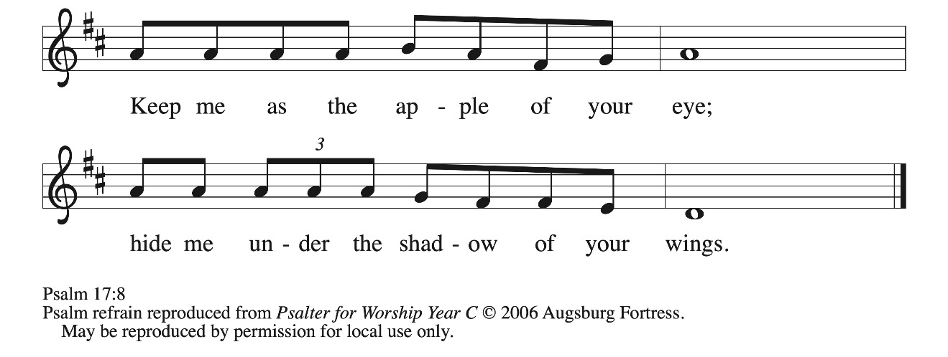
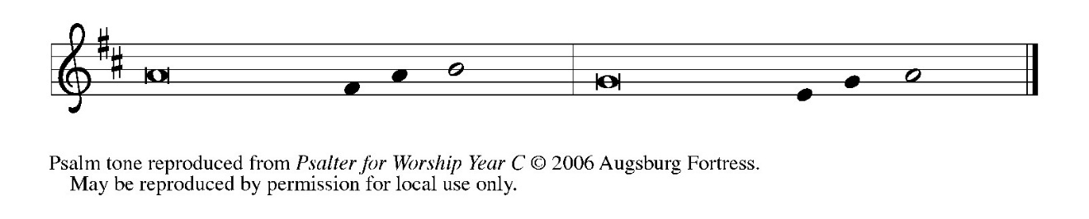
¹Hear a just cause, O Lord; give heed | to my cry;
listen to my prayer, which does not come from | lying lips.

²Let my vindication come forth | from Your presence;
let Your eyes be | fixed on justice.

³Examine my heart, visit | me by night,
melt me down; You will find no impuri- | ty in me.

⁴I have not regarded what | others do;
at the word of Your lips I have avoided the ways | of the violent. REFRAIN

⁵My footsteps hold fast to Your | well-worn path;
and my feet | do not slip.

⁶I call upon You, O God, for You will | answer me;
incline Your ear to me and | hear my words.

⁷Show me Your marvelous | lovingkindness,
O Savior of those who take refuge at Your right hand from those who | rise up against them.

⁸Keep me as the apple | of Your eye;
hide me under the shadow | of Your wings,

⁹from the wicked | who assault me,
from my deadly enemies | who surround me. REFRAIN

SECOND READING 2 Thessalonians 2: 1-5, 13-17

Paul writes to encourage the church at Thessalonica in a time of confusion and opposition. Here, the confusion concerned the return of Christ. Paul writes to those who were allowing their concern over Jesus' imminent return to divert them from the central teachings of the gospel.

As to the coming of our Lord Jesus Christ and our being gathered together to Him, we beg you, brothers and sisters, ²not to be quickly shaken in mind or alarmed, either by spirit or by word or by letter, as though from us, to the effect that the day of the Lord is already here. ³Let no one deceive you in any way; for that day will not come unless the rebellion comes first and the lawless one is revealed, the one destined for destruction.
⁴He opposes and exalts himself above every so-called god or object of worship, so that he takes his seat in the temple of God, declaring himself to be God. ⁵Do you not remember that I told you these things when I was still with you?
¹³But we must always give thanks to God for you, brothers and sisters beloved by the Lord, because God chose you as the first fruits for salvation through sanctification by the Spirit and through belief in the truth. ¹⁴For this purpose He called you through our proclamation of the good news, so that you may obtain the glory of our Lord Jesus Christ.
¹⁵So then, brothers and sisters, stand firm and hold fast to the traditions that you were taught by us, either by word of mouth or by our letter. ¹⁶Now may our Lord Jesus Christ Himself and God our Father, Who loved us and through grace gave us eternal comfort and good hope, ¹⁷comfort your hearts and strengthen them in every good work and word.

The Word of the Lord.

Thanks be to God.

As you are able please stand

THE VERSE
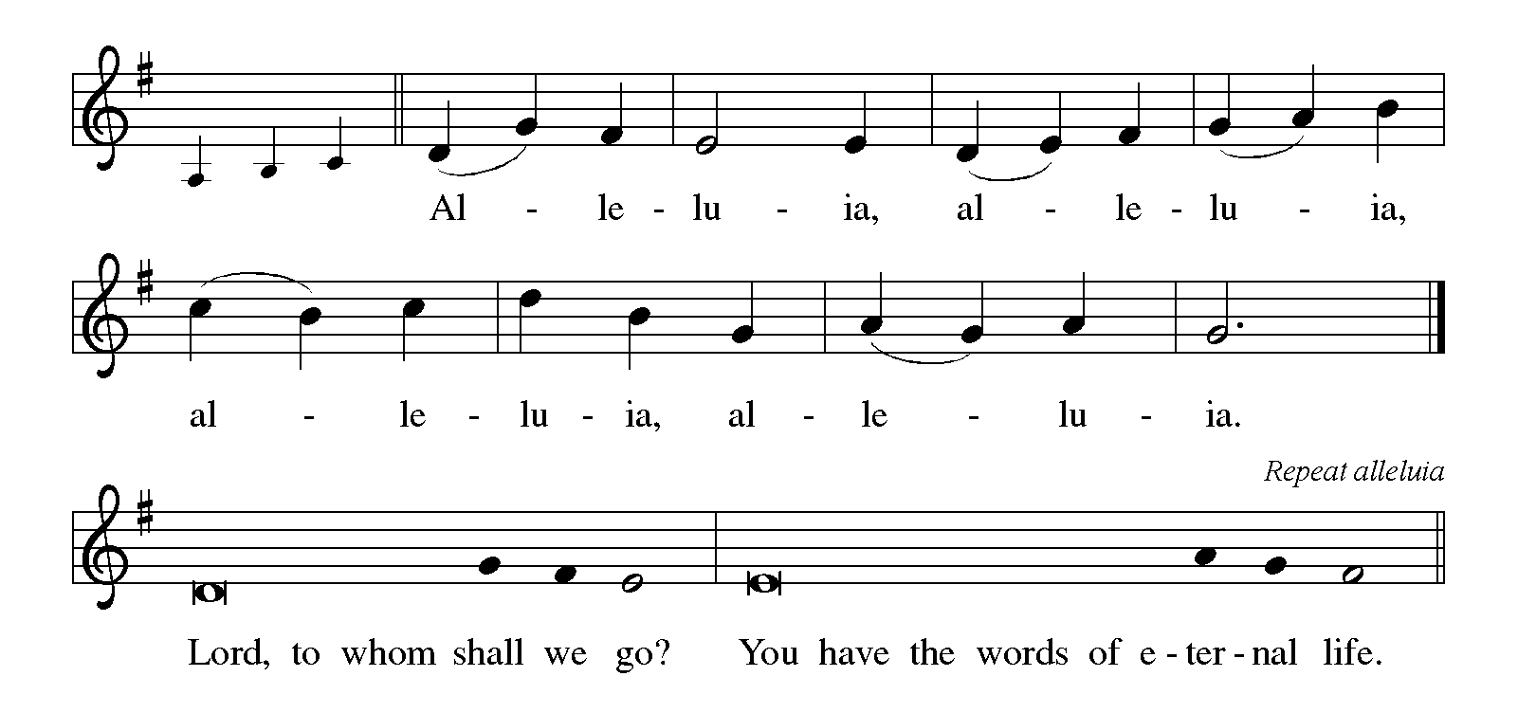

THE HOLY GOSPEL Luke 20: 27-38

The Sadducees, who do not believe in the resurrection of the dead, try to trap Jesus. They formulate the convoluted case of a serial widow who marries a succession of seven brothers. Jesus responds by teaching about God, to whom all are alive and in whom all relationships are fulfilled.

P: The Holy Gospel according to St. Luke, the twentieth chapter.

C: Glory to You, O Lord!

²⁷Some Sadducees, those who say there is no resurrection, came to Him ²⁸and asked Him a question, "Teacher, Moses wrote for us that if a man's brother dies, leaving a wife but no children, the man shall marry the widow and raise up children for his brother. ²⁹Now there were seven brothers; the first married, and died childless; ³⁰then the second ³¹and the third married her, and so in the same way all seven died childless. ³²Finally the woman also died. ³³In the resurrection, therefore, whose wife will the woman be? For the seven had married her."
³⁴Jesus said to them, "Those who belong to this age marry and are given in marriage; ³⁵but those who are considered worthy of a place in that age and in the resurrection from the dead neither marry nor are given in marriage. ³⁶Indeed they cannot die anymore, because they are like angels and are children of God, being children of the resurrection.
³⁷And the fact that the dead are raised Moses himself showed, in the story about the bush, where he speaks of the Lord as the God of Abraham, the God of Isaac, and the God of Jacob. ³⁸Now He is God not of the dead, but of the living; for to Him all of them are alive."
P: The Gospel of the Lord.

C: Praise to You, O Christ!

The assembly is seated

THE SERMON

Silence for reflection follows the sermon

As you are able please rise

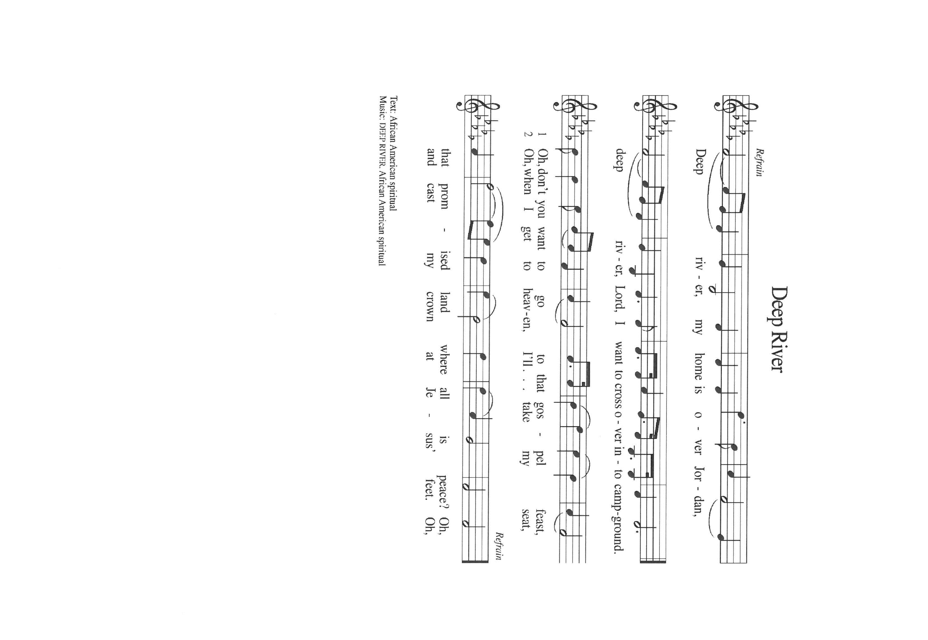
THE HYMN OF THE DAY Deep River

THE APOSTLES’ CREED

A: God has made us His people through our Baptism into Christ. Living together in trust
and faith, we confess our faith.

C: I believe in God, the Father almighty,
creator of heaven and earth.
I believe in Jesus Christ, His only Son, our Lord.
He was conceived by the power of the Holy Spirit
and born of the virgin Mary.
He suffered under Pontius Pilate,
was crucified, died, and was buried.
He descended into hell.
On the third day He rose again.
He ascended into heaven,
and is seated at the right hand of the Father.
He will come again to judge the living and the dead.

I believe in the Holy Spirit,
the holy catholic Church,
the communion of saints,
the forgiveness of sins,
the resurrection of the body,
and the life everlasting. Amen.

THE PRAYER OF THE CHURCH

A: Our God is the God of the living and not of the dead. Even as we live in the midst of
death, we are heartened by God’s promises and turn confidently to God in prayer for
the Church, the world, and all of God’s creation.

A: For the Church, that it may be a living witness to God’s love for all people and His
healing mercy to a world in need of Good News, let us pray to the Lord:

C: Lord, hear our prayer.

A: For responsible stewardship of God’s astounding creation, that future generations may
be sustained in their needs and praise God’s works, let us pray to the Lord:

C: Lord, hear our prayer.

A: For Christians persecuted throughout the world, especially in Afghanistan, Algeria,
Egypt, Indonesia, and Nigeria, that they may be protected and delivered from enemies
of God and evil systems of oppression, let us pray to the Lord:

C: Lord, hear our prayer.

A: For those who have suffered pain in their marriages and relationships, and children who
live with separated parents, that they may find God’s peace and strength to endure, let
us pray to the Lord:

C: Lord, hear our prayer.

A: For this assembly, that at our congregational meeting we may be guided by the Spirit’s
wisdom to elect leaders who will keep us faithful and fruitful in Your work, let us pray
to the Lord:

C: Lord, hear our prayer.

A: For the hungry, the homeless, the unemployed and underemployed, those recovering
from surgery, and the sick, especially: Major Payne; Christine Kiser; Shirley
Shikany Long; Shirley Freels; Martha Schroeder; Joyce Stark; Fred Weiss; David
Weiss; Jackie Gaines; John Bennitt; and Lucas Bradshaw that they may know
God’s lovingkindness and healing, let us pray to the Lord:

C: Lord, hear our prayer.

A: For those celebrating birthdays, especially: Jeff Timmrick that they may be filled with
grace this day and every day and grow in grace in the days ahead, let us pray to the
Lord:

C: Lord, hear our prayer.

A: That the dead may rest in God’s presence, with Martin, Bishop of Tours; Soren
Kierkegaard, teacher, whom we commemorate this Day, Sarah and Abraham, with
Moses and Miriam and all the saints, and that we may join the children of resurrection
and at the last see God face-to-face, let us pray to the Lord:

C: Lord, hear our prayer.

P: O God, promised of the ages, in the midst of all the anxieties and fears of life we ask
You to hear us as we pray for those who lives need hope until that Day when Your
glory appears and our joy will be full. We make our prayer in the name of Jesus, Who
lives with You and the Holy Spirit, one God, forever and ever.

C: Amen.
MEAL
THE PEACE

P: The peace of the Lord be with you always.

C: And also with you.

THE OFFERING

THE VOLUNTARY I Will Rejoice St. Paul Senior Choir
(B. Harlan)

As you are able please stand

THE OFFERTORY (see p. 9) Let the Vineyards Be Fruitful
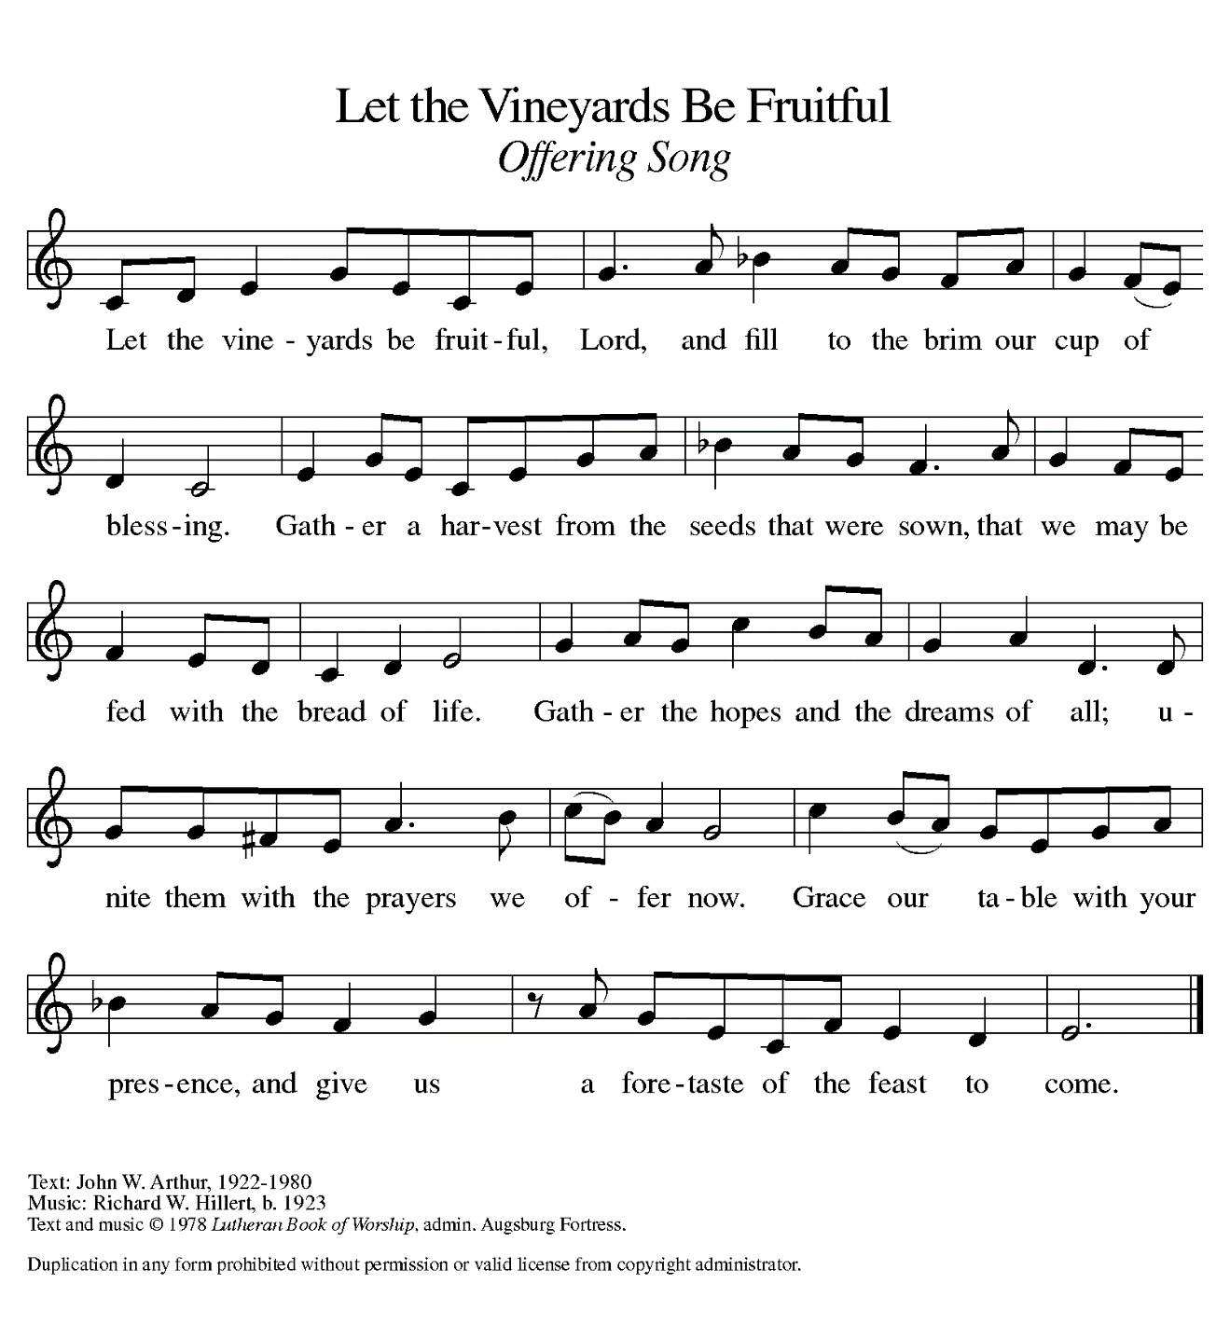
THE OFFERTORY PRAYER

A: Let us pray. Gracious God,

C: Your Word to us is Food indeed. Receive all we offer You this day, and let Your
loving-kindness be our eternal comfort and good hope. We ask this in the name
of Jesus the Lord. Amen.

THE GREAT THANKSGIVING

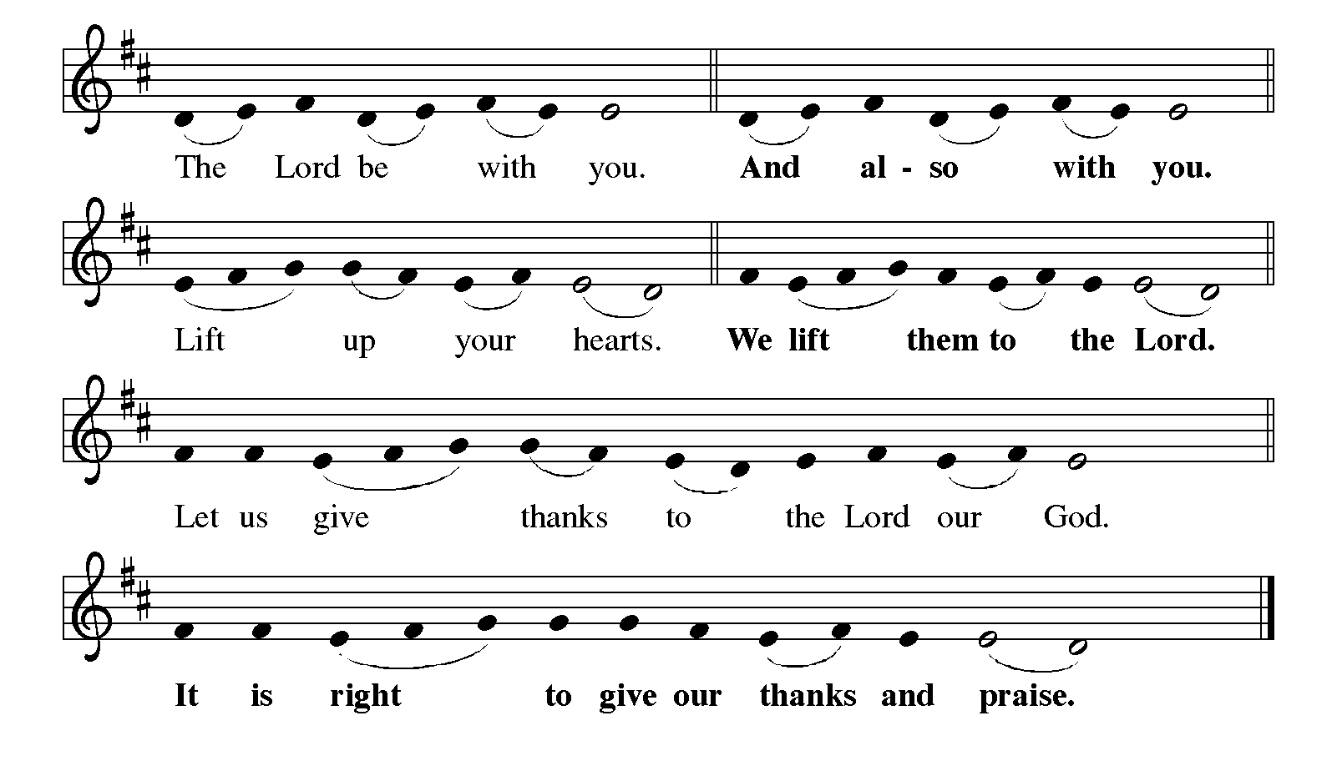 P: It is indeed right, our duty and our joy … join their unending hymn:
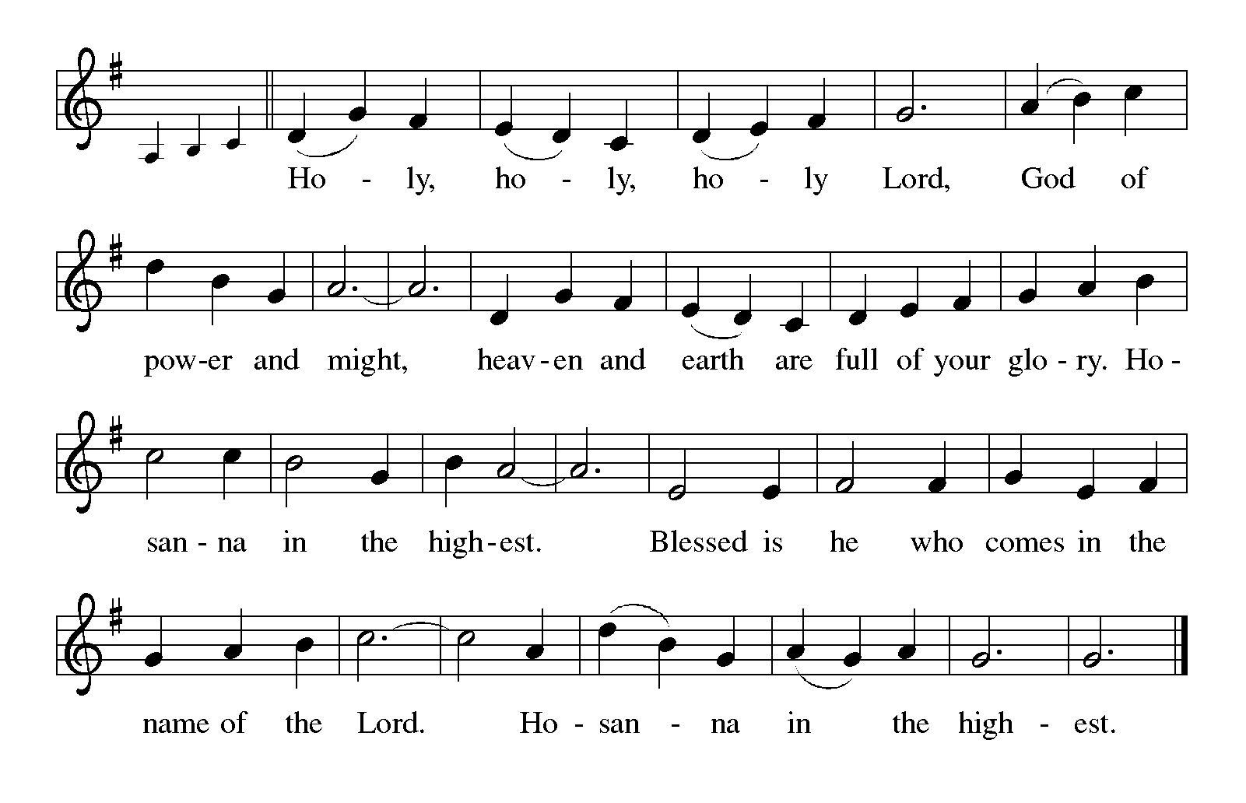P: God of time and eternity, the living and the dead, we thank and praise You because
in You the future is always bigger than the past, the splendor of Your coming glory always greater than the former.
You made a promise with Your people when you led them out of Egypt; You held
fast to that trust through waywardness and exile, and in Jesus You fulfilled
and embodied that covenant in flesh and blood.
In Him You love us, and through grace You give us eternal comfort and constant
hope.
God of wisdom and grace, You chose us as the firstfruits of salvation through
Your blessing.
Through the power of Your Holy Spirit make us a people who walk with Your
Son on the way of the cross and share with Him in the glory of
resurrection.
By that same Spirit, make this bread and cup be for us the Body and Blood of
Your Son Jesus Christ,
Who, in the night … “Do this for the remembrance of Me.”
As often as we eat … we proclaim the Lord’s death until He comes.

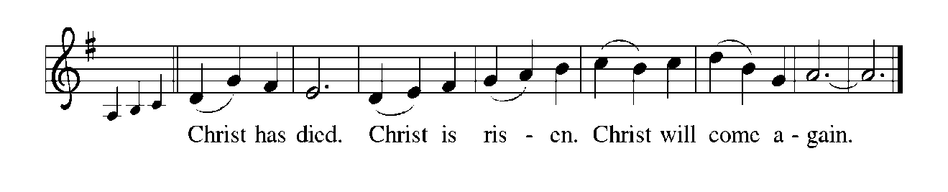
P: God of Abraham, Isaac, and Jacob, You have given us marriage as a sign of Your
heavenly will to be inseparable from us forever.
Bless any who find their marriage a source of grief instead of joy, sadness rather
than comfort, or pain instead of hope.
Be close to all who find themselves alone without the life-partner they feel called
to meet or without the one they fondly remember.
Heal those for whom home is or has been a place of fear and distress.
Make Your Church a community that fosters children of the resurrection, strengthened
in every work and word;
Until the heavens and earth are shaken, the nations are drawn to You, and You fill all
creation with the splendor of Your majesty,
God the One-in-Three: Father, Son, and Holy Spirit.
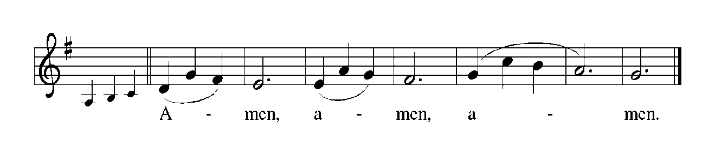THE LORD’S PRAYER

P: Gathered into one by the Holy Spirit, let us pray as Jesus taught us:

C: Our Father, Who art in heaven, hallowed be Thy name. Thy Kingdom come, Thy
will be done, on earth as it is in heaven. Give us this day our daily bread, and
forgive us our trespasses as we forgive those who trespass against us. And lead us
not into temptation, but deliver us from evil. For Thine is the Kingdom, and the
power, and the glory forever and ever. Amen.

INVITATION TO THE MEAL

P: This is the Lamb of God Who takes away the sin of the world. Blessed are those who
are called to the Supper of the Lamb. God’s holy gifts for God’s holy people. Come,
for all is now ready.

The assembly is seated

THE DISTRIBUTION

Those wishing to receive the Laying on of Hands, Anointing with Oil, and Prayer for Healing may go to Pastor at the side aisle
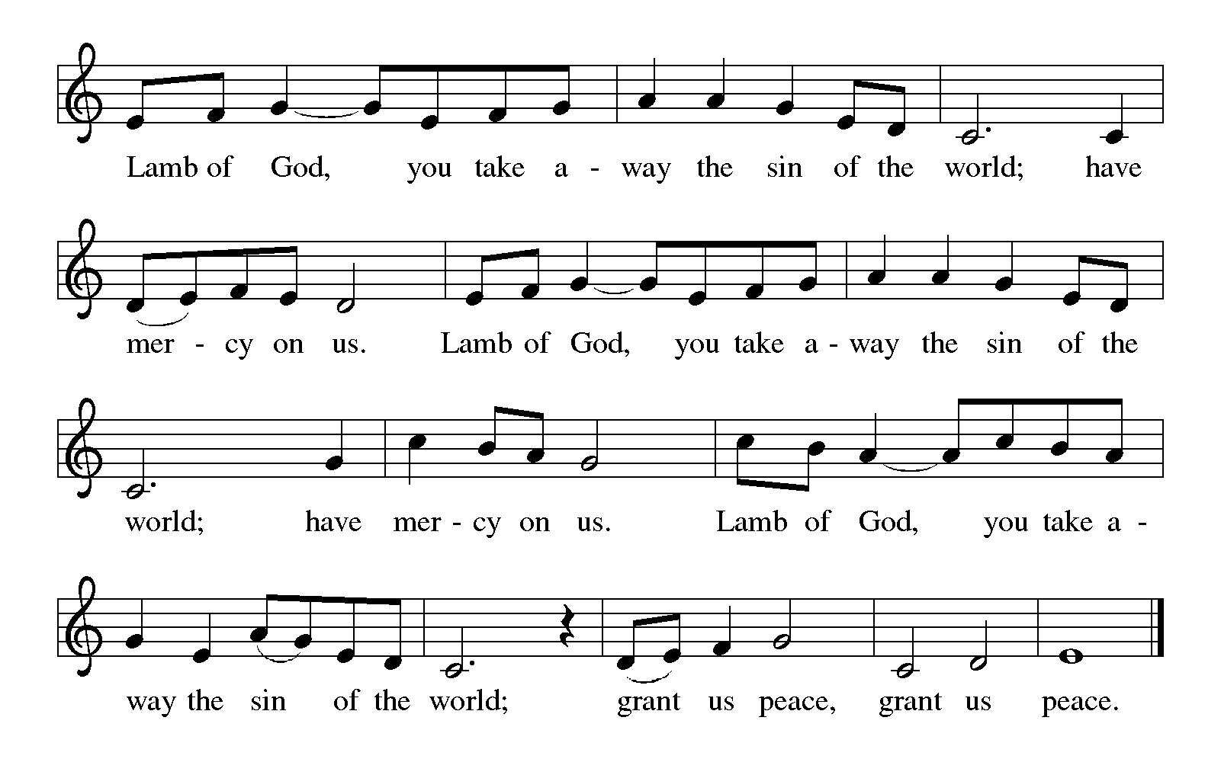
HYMN DURING DISTRIBUTION 619 I Know That My Redeemer Lives!
(Stanzas 1, 2, 7, 8)
NSB 88 There is A Redeemer
ELW 471 Let Us Break Bread Together
ELW 457 Waterlife
ELW 439 Soon & Very Soon
As you are able please rise

THE POST-COMMUNION BLESSING

P: The Body and Blood of our Lord Jesus Christ strengthen you and keep you in His grace.

C: Amen.

THE POST-COMMUNION PRAYER

A: Let us pray. Gracious God, once again You have blessed us with this heavenly Food.
By our eating and drinking, strengthen us that we may be persistent in faith and hope,
and equipped for every good work. Grant this through Christ our Lord.

C: Amen.
SENDING

THE BENEDICTION

P: Almighty God: Father, Son, and Holy Spirit bless you now and forever.

C: Amen.

THE SENDING HYMN 867 In Thee is Gladness

THE DISMISSAL

A: Go in peace. Remember the poor.

C: Thanks be to God!

POSTLUDE

To God Alone Be Glory

The Meditation is from Ruth Caspar, OP. Homilies for the Christian People. Quoted in
Sundays and Seasons Online. Copyright 2013 Augsburg Fortress.

The Prayers are adapted from Sundays and Seasons. Copyright 2013 Augsburg Fortress.,
and Intercessions for the Christian People. Gail Ramshaw, ed. (New York: Pueblo Publishing Company, 1988) 201

The Eucharistic Prayer is adapted from Eucharistic Prayers. Samuel Wells and Abigail
Kocher. (Grand Rapids: Eerdmann’s Publishing Company, 2016) 322-323.

ANNOUNCEMENTS

Please remember to mail your offering to the Church Office at 818 Franklin Street, Michigan City, IN 46360. Another alternative is to give on-line through Tithe.ly. Please see your closure letter for information on how to set up a Tithe.ly account.

St. Paul Members are reminded to have a loved one contact the office if you are hospitalized. Many times, the Pastor doesn’t know someone is in the hospital. If you call and leave a message, please tell us at which hospital the patient is located.

BIRTHDAYS: Jeff Timmrick (11/11)

PRAYER CONCERNS: Barry Anderson; John Bennitt; Sarah McNabb; Debbie Martin; Mark Tannehill; Kathy Stein; Jan Paholski; Laura Dovey; Grace Romine; Bill Hazelgrove; Al Levenhagen; Carl Wipperman; Major Payne and Carol Hazelgrove.

OFFICE HOURS: Libby will be in the office on Mondays, Wednesdays, and Fridays; volunteers will cover Tuesdays and Thursdays.

Monday & Wednesday 8:00 a.m. – 5 p.m.
Tuesday & Thursday 9:00 a.m. – 12:00 p.m.
Friday 8:00 a.m. – 12:00 p.m.

If you are listening to the worship broadcast on the radio and would like to watch the Sunday morning service live stream follow these steps:

(1) If you have You Tube available on your TV, search for
St. Paul Lutheran Church Michigan City, IN.

(2) The direct link on the computer is https://
www.youtube.com/channel/UC5AIPNaKr3QN50984jGOa1g.

(3) This link is also on the main page of the church’s website in
the church section and will continue to be posted weekly on the St.
Paul Facebook page.

And it will always be available on the radio broadcast Sunday mornings at 11:00 a.m.
on WEFM (95.9), and on the local cable access station #99 for the previous week’s
service on Sundays at 4:00 p.m. and the current service on Wednesdays at 7:00 p.m.
and Fridays at 8:30 p.m.

To send e-mail to the church office, please use the following addresses:

Pastor Mark Reshan: seniorpastor@stpaulmichigancity.com

Church Office Secretary (Libby Pollock): churchsecretary@stpaulmichigancity.com

Church Treasurer (Karen Fleming): finance@stpaulmichigancity.com

2025 Church Council:

Mark Reshan - Pastor

Janet Bakken – President

Donna Knoll – Vice President

Judy Hunt – Secretary

Karen Fleming – Treasurer

Members: Paul Brooks, Diane Egilske, Sue Koziel, Judy Mutchler, Jim Schraidt, Trish Sprague

Worship Attendance:

Saturday, November 1, 2025 @ 4:00 p.m. 31

Sunday, November 2, 2025 @ 9:00 a.m. 80

TOTAL 111

Copies of the minutes from the October 23, 2025 Church Council meeting are on the back table in the upper Narthex. It was approved by the council via email.

The Good News Newsletter: If you have an article or anything you want included in The Good News please send it to the following e-mail address: splcgoodnews@gmail.com. Pastor Pamela Thiede will be using this e-mail address to assemble The Good News each month. The deadline for getting information to Pastor Pamela will be the 20th of each month.

Sunday’s lessons are Malachi 4: 1-2a; Psalm 98: 1-9; 2 Thessalonians 3: 6-13; and Luke 21: 5-19 for those of you who like to study them in advance.
SAVE THE DATE!
TODAY, November 9th, our regular fall congregational meeting will be held in the St. Paul Room following the Sunday morning worship service with a true POTLUCK luncheon to follow. The primary item on the agenda will be the election of officers and council members. There will also be a financial report. We need not only your presence at the meeting but your willingness to step in and fill those seats. Please consider how you might be able to serve. We have many gifted members whose presence in leadership roles would greatly enrich our congregation. You might be one of them. Agree to serve.
NOVEMBER MISSION OF THE MONTH

The Mission of the Month for November: Nest Community Shelter, located at the old Sacred Heart Church, is a nonprofit organization delivering temporary emergency shelter for the homeless men and women (including women with children) in our community. Nest provides not just shelter but food and other resources. Nest is always in need of the following items:

-Bedding - blankets, pillows, pillow cases

-Food items – sugar, breakfast cereal, coffee, coffee filters, creamer, non-perishable goods

-Dining – 8 oz. foam cups, 12 oz. foam bowls, 6” & 9” plates, plastic flatware, paper towels, paper napkins, plastic wrap, aluminum foil, gallon Ziploc bags, large serving gloves

-Kitchen – 55 gallon trash bags, dish soap

-Hygiene items – liquid hand soap, hand sanitizer, all purpose cleaner, feminine hygiene products, toilet paper

Donations of goods can be placed in the bin in the Narthex. Monetary donations can be marked for Nest and placed in the offering plate. Noisy coin offering will also go toward the mission of the month. Thank you for your help in providing for those in need in our community!

December Mission of the Month – St. Paul Angel Tree
It’s beginning to look a lot like Christmas! We are starting our December mission a little early to ensure our gifts make it to their recipients by Christmas Day. A Mama’s Heart Ministry has provided us with names and wish lists of four children in our community who need assistance this Christmas. Please take a tag (or two) and shop for the item listed on the tag. Gifts can be returned wrapped or unwrapped, your preference. Please attach the angel tree tag to the gift. Toy tags have suggestions based on the child’s interests, but any age appropriate toy will do! Please return all gifts underneath the angel tree by Sunday, December 7th, to ensure everything can be delivered to the families by Christmas. Thank you for your generosity and Christmas spirit!

ACTIVITIES, EVENTS & MEETINGS
November 2025

Tuesday, November 4, 2025 @ 10:00 a.m. Altar Guild/Green Room
Wednesday, November 5, 2025 @ 9:15 a.m. Bible Study/Luther House
@ 10:00 a.m. God’s Purls/St. Paul Room
@ 4:30 p.m. Choir Rehearsal/Sanctuary
Thursday, November 6, 2025 FAITH CIRCLE/Green Room
Saturday, November 8, 2025 @ 4:00 p.m. 22 Pent Worship Service/Sanctuary

Sunday, November 9, 2025 @ 9:00 a.m. 22 Pent Worship Service/Sanctuary
Immediately following: FALL CONGREGATIONAL MEETING/St. Paul
Room with POTLUCK luncheon to follow/St. Paul Room
Monday, November 10, 2025 @ 1:00 p.m. HOPE CIRCLE/Green Room
Tuesday, November 11, 2025 @ 7:00 p.m. Estuary/Luther House
Wednesday, November 12, 2025 @ 9:15 a.m. Bible Study/Luther House
@ 10:00 a.m. God’s Purls/St. Paul Room
@ 11:00 a.m. – 9:00 p.m. GIVE BACK @ SWINGBELLY’S
@ 3:30 p.m. Worship & Music Mtg./Luther House
@ 4:30 p.m. Choir Rehearsal/Sanctuary
Thursday, November 13, 2025 @ 4:00 p.m. 150th Anniv. Mtg./Luther House
Saturday, November 15, 2025 @ 4:00 p.m. 23 Pent Worship Service/Sanctuary
Sunday, November 16, 2025 @ 9:00 a.m. 23 Pent Worship Service/Sanctuary with coffee after/ St. Paul Room with coffee after/St. Paul Room
Monday, November 17, 2025 @ 2:00 p.m. Finance Comm. Mtg./Luther House
@ 3:00 p.m. Executive Board Meeting/Luther House
Wednesday, November 19, 2025 @ 4:30 p.m. Choir Rehearsal/Sanctuary
Thursday, November 20, 2025 @ 3:00 p.m. Church Council Mtg./Luther House
Saturday, November 22, 2025 @ 4:00 p.m. CHRIST THE KING Worship Service/ Sanctuary

Sunday, November 23, 2025 @ 9:00 a.m. CHRIST THE KING Worship Sanctuary
with coffee after/St. Paul Room
Wednesday, November 26, 2025 @10:00 a.m. God’s Purls/St. Paul Room

Thank$ for $haring
Thanks to all who participate in the Give Back opportunities! We earned $250 at our Give Back On October 2, 2025 at Galveston. Our next Give Back will be at Swingbelly’s on Wednesday, November 12, 2025 from 11am—9 pm. Here are two coupons—one for you and one for a friend.

