**THE SIXTH SUNDAY AFTER EPIPHANY**

**February 16, 2025**

“The Sermon … (of Luke 6) expresses quite plainly that God views the world with different lenses. One could almost subtitle the sermon, “Survival of the Least Fit.” Strength, good looks, connections, and the competitive instinct may bring a person success in a society like ours; but those very qualities may block entrance to the kingdom of heaven. Dependence, sorrow, repentance—these are the steps to God’s kingdom.”

**Philip Yancey**

What Luke says to us describes precisely the scandal in which the present church is involved: the great scandal among us is the intercommunion of rich Christians who remain rich and poor Christians who remain poor while celebrating the same eucharist, taking no notice of the Christian model of sharing possessions, the sharing of the one cup of salvation among one another.

For this salvation also has social and economic consequences. Everyone, not just an elite group, has to be full enough to be able to laugh because salvation has happened to him or her. God wants life, and life in abundance, for all, not simply for one-third, of the world’s population. What about our abundance? That is Luke’s critical question, a concrete challenge to all of us, here and now.

**Edward Schillebeeckx, O.P.**

**✠ In the Name of Jesus ✠**

**✠ GATHERING ✠**

**INTRODUCTION**

*Blessings and curses abound on the sixth Sunday after Epiphany. We would do well to listen closely to whom the “blessed ares” and the “woe tos” are directed and to find our place in the crowd among those who desire to touch Jesus. The risen Christ stands among us in the mystery of the holy supper with an invitation to live in Him and the power to heal us all.*

**Cyril, monk, died 869; Methodius, bishop, died 885; missionaries to the Slavs**

*These two brothers from Thessalonika, Greece, were monks and were sent to bring Christianity to the Slavic people. In the course of their work they created a written language, inventing the Cyrillic alphabet for it, and translated the Bible and the liturgy.*

**PRELUDE**

**ANNOUNCEMENTS**

*As you are able please rise*

**GATHERING HYMN 717 *Let Justice Flow Like Streams***

**THE GREETING**

P: Arise; shine, for your light has come. The grace of our Lord Jesus Christ, the love of

God, and the communion of the Holy Spirit be with you all.

**C: And also with you.**

**THE HYMN OF PRAISE (see page 3)**

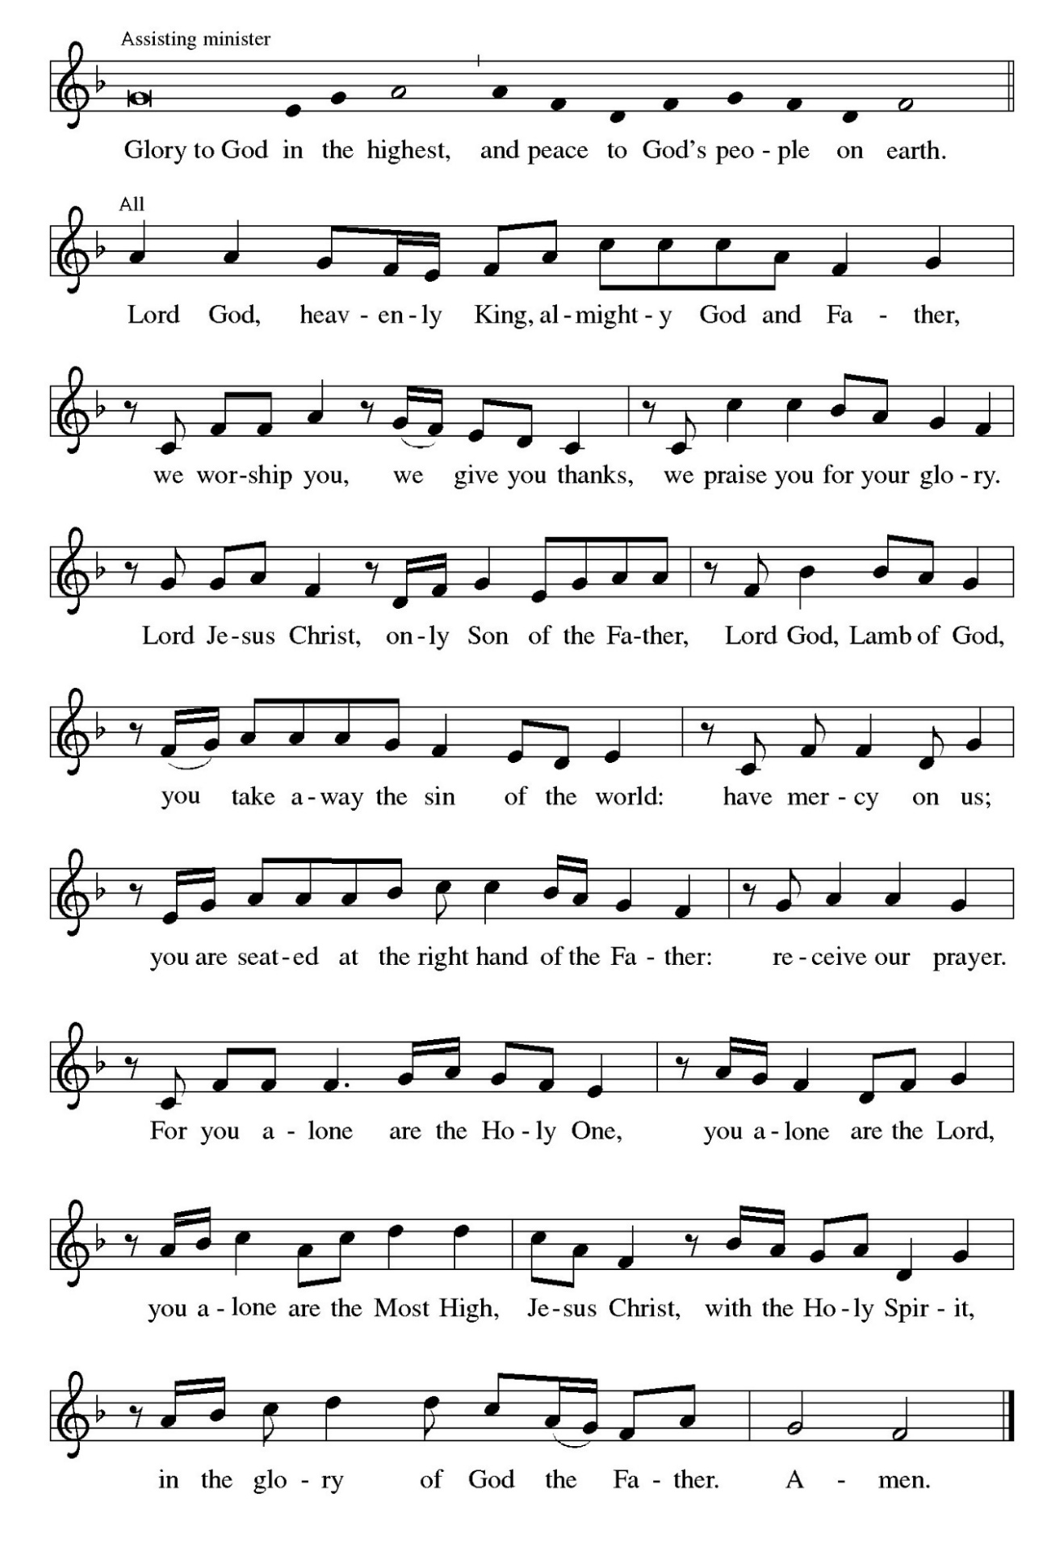

**THE PRAYER OF THE DAY**

P: The Lord be with you.

**C: And also with you.**

P: Let us pray. Living God, in Christ You make all things new. Transform the poverty of

our nature by the riches of your grace, and in the renewal of our lives make known

Your glory; through Jesus Christ, our Savior and Lord.

**C: Amen.**

*The assembly is seated*

**✠ WORD ✠**

**THE FIRST READING Jeremiah 17: 5-10**

*These verses compose a poem that is part of a larger collection of wisdom sayings (17:5-11) that contrast two ways of life. Life with God brings blessing; the power and vitality of God is active in our life. Life without God brings a curse, the power of death.*

Thus says the LORD:

Cursed are those who trust in mere mortals

and make mere flesh their strength,

whose hearts turn away from the LORD.

They shall be like a shrub in the desert,

and shall not see when relief comes.

They shall live in the parched places of the wilderness,

in an uninhabited salt land.

Blessed are those who trust in the LORD,

whose trust is the LORD.

They shall be like a tree planted by water,

sending out its roots by the stream.

It shall not fear when heat comes,

and its leaves shall stay green;

in the year of drought it is not anxious,

and it does not cease to bear fruit.

The heart is devious above all else;

it is perverse—

who can understand it?

I the LORD test the mind

and search the heart,

to give to all according to their ways,

according to the fruit of their doings.

A: The Word of the Lord.

**C: Thanks be to God.**

**THE PSALM: Psalm 1** Antiphon by Daniel Kallmann

Choir sings refrain first, followed immediately by the congregation

and as indicated

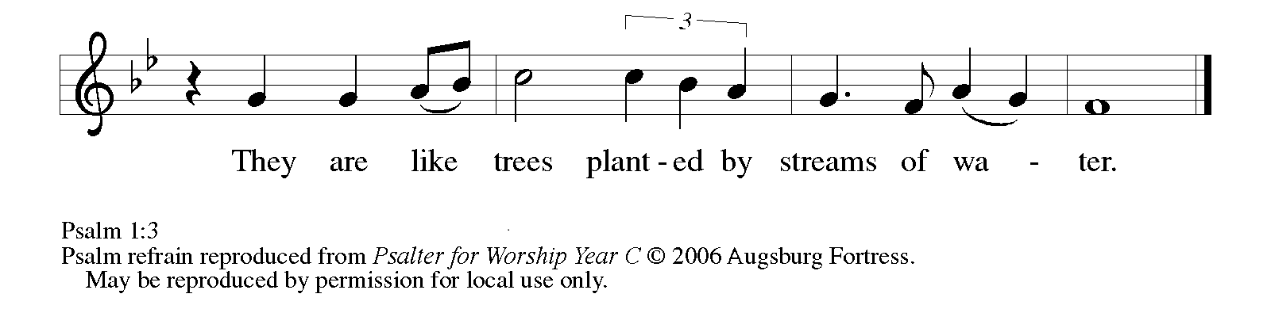

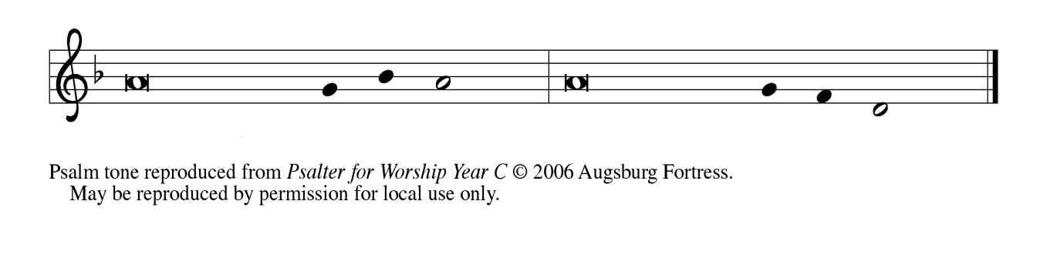

1Happy are they who have not walked in the counsel | of the wicked,  
  nor lingered in the way of sinners, nor sat in the seats | of the scornful!

 2**Their delight is in the law | of the Lord,**  
  **and they meditate on God’s teaching | day and night.** **REFRAIN**

 3They are like trees planted by streams of water, bearing fruit in due season, with leaves that | do not wither;  
  everything they | do shall prosper.

 4**It is not so | with the wicked;**  
  **they are like chaff which the wind | blows away.**

 5Therefore the wicked shall not stand upright when | judgment comes,  
  nor the sinner in the council | of the righteous.

 6**For the Lord knows the way | of the righteous,**  
  **but the way of the wicked shall | be destroyed. REFRAIN**

**THE SECOND READING 1 Corinthians 15: 12-20**

*For Paul, the resurrection of Christ is the basis for Christian hope. Because Christ has been raised, those who are in Christ know that they too will be raised to a new life beyond death.*

Now if Christ is proclaimed as raised from the dead,

how can some of you say there is no resurrection of the dead?

If there is no resurrection of the dead, then Christ has not been raised;

and if Christ has not been raised, then our proclamation has been

in vain and your faith has been in vain.

We are even found to be misrepresenting God, because we testified of God

that He raised Christ—Whom He did not raise if it is true

that the dead are not raised.

For if the dead are not raised, then Christ has not been raised.

If Christ has not been raised, your faith is futile and you are still

in your sins.

Then those also who have died in Christ have perished.

If for this life only we have hoped in Christ, we are of all people

most to be pitied.

But in fact Christ has been raised from the dead, the first fruits

of those who have died.

A: The Word of the Lord.

**C: Thanks be to God.**

*As you are able please rise*

**THE VERSE**

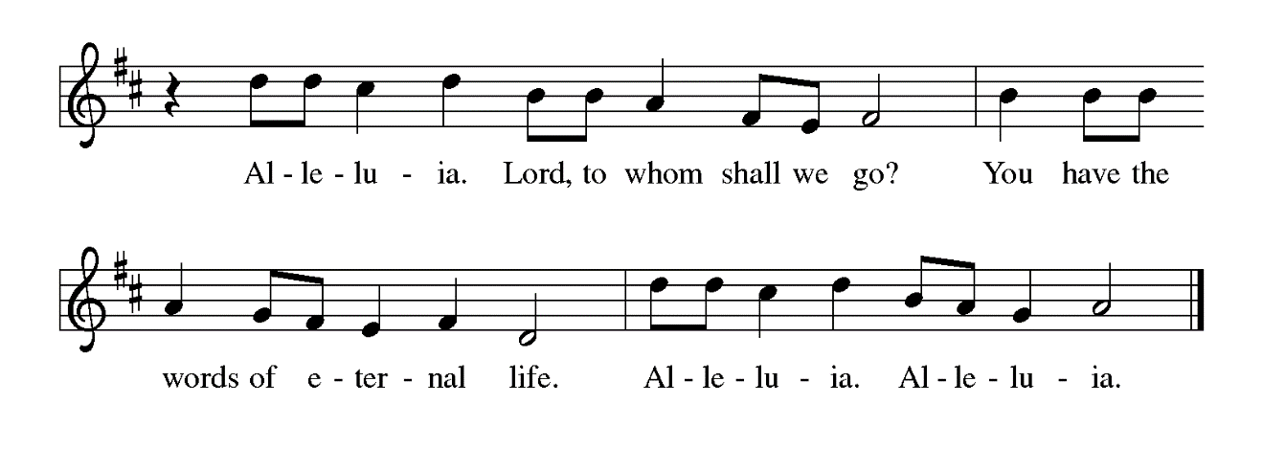

**THE HOLY GOSPEL Luke 6: 17-26**

*After choosing his twelve apostles, Jesus teaches a crowd of followers about the nature and demands of discipleship. He begins his great sermon with surprising statements about who is truly blessed in the eyes of God.*

P: The Holy Gospel according to St. Luke, the sixth chapter.

**C: Glory to you, O Lord!**

Jesus came down with the twelve and stood on a level place,

with a great crowd of His disciples and a great multitude of

people from all Judea, Jerusalem, and the coast of Tyre and Sidon.

They had come to hear Him and to be healed on their diseases, and those

who were troubled with unclean spirits were cured.

And all in the crowd were trying to touch Him, for power came out

from Him and healed all of them.

Then He looked up at His disciples and said:

“Blessed are you who are poor,

for yours is the kingdom of God.

Blessed are you who are hungry now,

for you will be filled.

Blessed are you who weep now,

for you will laugh.

Blessed are you when people hate you, and when they exclude you,

revile you, and defame you on account of the Son of Man.

Rejoice in that day and leap for you, for surely your reward is great in heaven;

for that is what their ancestors did to the prophets.

But woe to you who are rich,

for you have received your consolation.

Woe to you who are full now,

for you will be hungry.

Woe to you who are laughing now,

for you will mourn and weep.

Woe to you when all speak well of you, for that is what their

ancestors did to the false prophets.”

P: The Gospel of the Lord.

**C: Praise to you, O Christ!**

*The assembly is seated*

**THE SERMON** The Rev. Dr. Frederick Niedner, Jr.

*Silence for reflection follows the sermon*

*As you are able please rise*

**THE HYMN OF THE DAY NSB 70  *Open Our Eyes***

**THE APOSTLES’ CREED**

A: God has made us His people through our Baptism into Christ. Living together in trust

and hope, we confess our faith.

**C: I believe in God, the Father Almighty,**

**creator of heaven and earth.**

**I believe in Jesus Christ, His only Son, our Lord.**

**He was conceived by the power of the Holy Spirit,**

**and born of the Virgin Mary.**

**He suffered under Pontius Pilate,**

**was crucified, died, and was buried.**

**He descended into hell.**

**On the third day He rose again.**

**He ascended into heaven,**

**and is seated at the right hand of the Father.**

**He will come again to judge the living and the dead.**

**I believe in the Holy Spirit,**

**the holy catholic Church,**

**the communion of saints,**

**the forgiveness of sins,**

**the resurrection of the body,**

**and the life everlasting. Amen.**

**THE PRAYER OF THE CHURCH**

A: With all our heart and mind, let us offer our prayers to God for the Church, the world,

the sick and poor, and all those who seek the light of Christ.

A: That the Church may be strengthened wherever it is hated, reviled and persecuted by

the world because of its witness to Christ, especially in Afghanistan, Egypt, Iran, Iraq,

Saudi Arabia, and other places of intolerance, let us pray to the Lord:

**C: Lord, hear our prayer.**

A: That the work of Lutheran World Relief and other agencies might be blessed as they

bring help and hope to the poor, the hungry, victims of famine, drought, and disease,

let us pray to the Lord:

**C: Lord, hear our prayer.**

A: That this congregation would grow in its delight for your Word, so we will be like a

tree planted by streams of water, yielding fruits of compassionate service, let us pray

to the Lord:

**C: Lord, hear our prayer.**

A: That those troubled by loneliness, addiction, abuse, and sickness, especially: **Fred**

**Weiss; Jan Paholski; Laura Dovey; Joyce Stark; Venia Wendt; and Brian**

**Wiseman** might be touched by Jesus’ healing power, let us pray to the Lord:

**C: Lord, hear our prayer.**

A: That those celebrating anniversaries, especially **Tim and Laura Mellen; Mike and**

**Donna Knoll; and Chuck and Sherry Payne** may grow in grace this day and every

day and be filled with grace for the days ahead, let us pray to the Lord:

**C: Lord, hear our prayer.**

A: That with all the faithful baptized into Christ’s death, especially **Cyril, monk, and**

**Methodius, bishop,** whom we commemorate this Day we may also share in the glory

of His resurrection, let us pray to the Lord:

**C: Lord, hear our prayer.**

P: Give us, O God, tears of sorrow for this world and all who suffer in it. May our holy

laughter grow out of our trust that You are indeed Lord of heaven and earth. May we

leap for joy in You, as You hear and grant our petitions through Your Son, Jesus Christ

our Lord.

**C: Amen.**

**✠ MEAL ✠**

**THE PEACE**

P: The peace of the Lord be with you always.

**C: And also with you.**

*The assembly is seated*

**THE OFFERING**

**THE VOLUNTARY *Be Thou My Vision* St. Paul Senior Choir**

**(Irish Folk Song; Arr. C. Young)**

*As you are able please rise*

**THE OFFERTORY PRAYER**

A: Let us pray. Eternal God,

**C: You are the strength of the weak and the comfort of those who suffer. In grateful**

**devotion we bring these gifts to You. Receive them for the sake of Your Son, and**

**through this Feast of His body and blood turn our sickness into health and our**

**sorrow into joy. We ask this in the name of Jesus the Lord. Amen.**

**THE GREAT THANKSGIVING**

P: The Lord be with you.

**C: And also with you.**

P: Lift up your hearts.

**C: We lift them to the Lord.**

P: Let us give thanks to the Lord our God.

**C: It is right to give Him thanks and praise.**

P: Holy One, the Beginning and the End, the Giver of life:

Blessed are You for the birth of creation.

Blessed are You in the darkness and in the light.

Blessed are You for Your promise to Your people.

Blessed are You in the prophets’ hopes and dreams.

Blessed are You for Mary’s openness to Your will.

Blessed are You for Your Son Jesus, the Word made flesh.

In the night …Do this for the remembrance of Me.

As often as we eat this bread …we proclaim the Lord’s death until He comes.

**C: Christ has died.** **Christ is risen.** **Christ will come again.**

P: With this bread and cup we remember Your Word dwelling among us, full of grace

and truth.

We remember our new birth in His death and resurrection.

We look with hope for His coming.

Holy God, we long for Your Spirit.

Come among us.

Bless this meal.

May Your Word take flesh in us.

Awaken your people.

Fill us with Your light.

Bring the gift of peace on earth.

All praise and glory are Yours,

Holy One of Israel,

Word of God incarnate,

Power of the Most High,

one God, now and forever.

**C: Amen.**

**THE LORD’S PRAYER**

P: Because in Christ we have received the Spirit of adoption as beloved daughters and

sons, we dare to pray:

**C: Our Father in heaven, hallowed be Your name. Your Kingdom come. Your will**

**be done on earth as in heaven. Give us this day our daily bread, and forgive us**

**our sins as we forgive those who sin against us. Save us from the time of trial and**

**deliver us from evil, for the Kingdom, the power, and the glory are Yours, now**

**and forever. Amen.**

**INVITATION TO THE MEAL**

P: Behold the true Light of the world, the Beloved of God, anointed by the Spirit. Blessed

are those who are called to the Supper of the Lamb. God’s holy gifts for God’s holy

people. Come, for all is now ready.

*The assembly is seated*

**THE DISTRIBUTION**

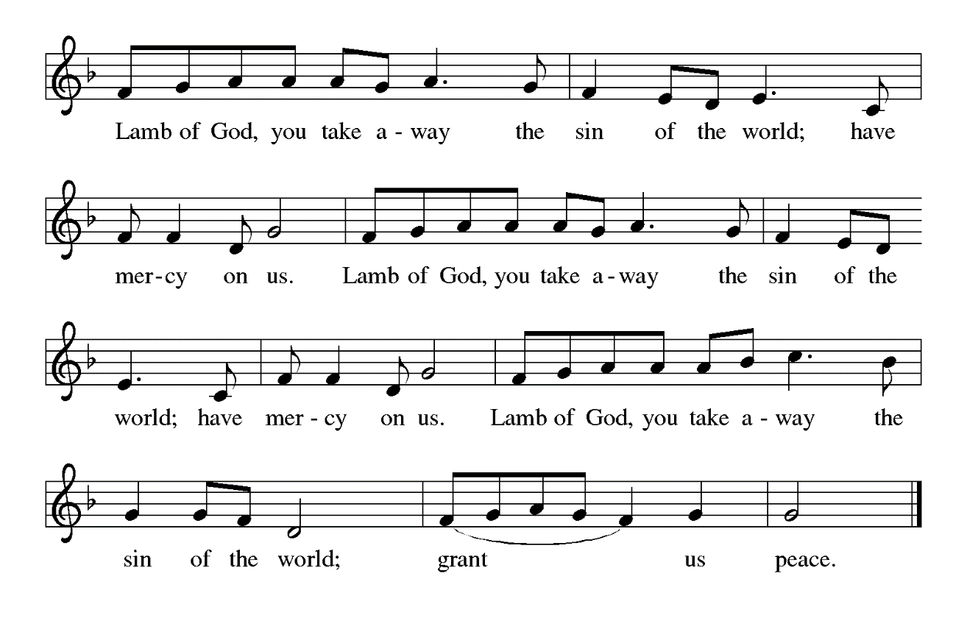

**HYMN DURING DISTRIBUTION 434 *Jesus Shall Reign***

**ELW 499 *We Come to the Hungry Feast***

**NSB 40 *God of the Poor***

**NSB 104 *You Are My Hiding Place***

*As you are able please rise*

**THE POST COMMUNION BLESSING**

P: The Body and Blood of our Lord Jesus Christ strengthen you and keep you in His

grace.

**C: Amen.**

**THE POST-COMMUNION PRAYER**

A: Let us pray. God the Lord, You give us a share in the one bread and the one cup and

make us one in Christ. Through our eating and drinking of this holy Sacrament

strengthen us to bring the laughter and joy of Your salvation to all the world. Grant

this through Christ our Lord.

**C: Amen.**

**✠ SENDING ✠**

**THE BENEDICTION**

P: Almighty God: Father, Son **✠** and Holy Spirit bless you now and forever.

**C: Amen.**

**THE SENDING SONG 547 *Send Forth by God’s Blessings***

**THE DISMISSAL**

A: You are servants of God; you are light to the nations.

Go in peace. Serve the Lord.

**C: Thanks be to God!**

**POSTLUDE**

**✠ To God Alone Be Glory✠**

The Meditation is from *Homiletics.* February 16, 1992; and *Sundays and Seasons Online.*

Copyright 2022 Augsburg Fortress.

**ANNOUNCEMENTS**

**Please remember to mail your offering to the Church Office** at 818 Franklin Street, Michigan City, IN 46360**.** Another alternative is to give on-line through Tithe.ly. Please see your closure letter for information on how to set up a Tithe.ly account.

**St. Paul Members are reminded to have** a loved one contact the office if you are hospitalized. Many times, the Pastor doesn’t know someone is in the hospital. If you call and leave a message, please tell us which hospital the patient is at.

**Anniversaries: Tim & Laura Mellen (2/20); Mike & Donna Knoll (2/21); and**

**Charles & Sherry Payne (2/21)**

**PRAYER CONCERNS:** Jeanie Boatman Shepple, Nolan Wilson, Debbie Martin, Mark Tannehill, Brian Wiseman, Kathy Stein, Danielle Schnell; Venia Wendt, Jan Paholski, Laura Dovey, and Grace Romine.

**OFFICE HOURS:** Libby will be in the office on Mondays, Wednesdays, and Fridays; volunteers will cover Tuesdays and Thursdays.

Monday & Wednesday 8:00 a.m. – 5 p.m.

Tuesday & Thursday 9:00 a.m. – 12:00 p.m.

Friday 8:00 a.m. – 12:00 p.m.

**If you are listening to the worship broadcast on the radio and would like to watch the Sunday morning service live stream follow these steps:**

(1) If you have You Tube available on your TV, search for

**St. Paul Lutheran Church Michigan City, IN.**

(2) The direct link on the computer is

https://www.youtube.com/channel/UC5AIPNaKr3QN50984jGOa1g.

   (3) This link is also on the main page of the church’s website in

the church section and will continue to be posted weekly on the St.

Paul Facebook page.

And it will always be available on the radio broadcast Sunday mornings at 11:00 a.m.

on WEFM (95.9), and on the local cable access station #99 for the previous week’s

service on Sundays at 4:00 p.m. and the current service on Wednesdays at 7:00 p.m.

and Fridays at 8:30 p.m.

**Next Sunday’s lessons are Genesis 45: 3-11, 15; Psalm 37: 1-11, 39-40; I Corinthians 15: 35-38, 42-50; Luke 6: 27-38** for those of you who like to study them in advance.

**To send e-mail to the church office**, please use the following addresses:

Pastor Mark Reshan: seniorpastor@stpaulmichigancity.com

Church Office Secretary (Libby Pollock): churchsecretary@stpaulmichigancity.com

Church Treasurer (Karen Fleming): finance@stpaulmichigancity.com

**The Good News Newsletter**: If you have an article or anything you want included

in **The Good News** please send it to the following e-mail address: splcgoodnews@gmail.com. Pastor Pamela Thiede will be using this e-mail address to assemble **The Good News** each month. The deadline for getting information to Pastor Pamela will be the 20th of each month.

**Worship Attendance:**

**Saturday, February 8, 2025 @ 4:00 p.m. 16**

**Sunday, February 9, 2025 @ 9:00 a.m. 64**

**TOTAL 80**

**Copies of the minutes from the January 23, 2025 Church Council meeting are on the back table in the upper Narthex. They were approved by the council via email. There were no Council meetings in the months of November or December, 2024.**

**FEBRUARY MISSION OF THE MONTH**

February Mission of the Month will be Lutheran Disaster Response for the Los Angeles wildfires. The fires have killed more than 24 people, destroyed over 12,000 structures, and burnt more than 60 square miles. Checks can be made out to St. Paul and placed in the offering plate marked for Lutheran Disaster Response. Noisy coin will also be used for the mission of the month.

**ThankYou!**

To everyone who brought blankets and contributed financially to the Caring Clothing Co-op for our Mission of the Month in January! We collected quite a few blankets to help people stay warm this winter and donated $485. And, thank you to those who helped drop off too! It was much appreciated!

**ACTIVITIES, EVENTS & MEETINGS**

**February 2025**

**Monday,** February 10, 2025 @ 1:00 p.m. Hope Circle/Green Room

@3:00 p.m. Choir Rehearsal/Sanctuary

**Tuesday,** February 11, 2025 @ 7:00 p.m. Estuary/Luther House

**Wednesday,** February 12, 2025 **NO BIBLE STUDY**

@ 10:00 a.m. God’s Purls/St. Paul Room

**Saturday,** February 15, 2025 @ 4:00 p.m. 6th Epiphany Worship Service

**Sunday,** February 16, 2025 @ 9:00 a.m. 6th Epiphany Worship Service

**Monday,** February 17, 2025 **OFFICE CLOSED for Presidents’ Day**

**Wednesday,** February 19, 2025 @ 9:15 a.m. Bible Study/Luther House

@10:00 a.m. God’s Purls/St. Paul Room

@3:30 p.m. Worship & Music Mtg./Luther House

@4:30 p.m. Choir Rehearsal/Sanctuary

**Saturday,** February 22, 2025 @ 4:00 p.m. 7th Epiphany Worship Service

**Sunday,** February 23, 2025 @ 9:00 a.m. 7th Epiphany Worship Service

**Monday,** February 24, 2025 @ 2:00 p.m. Finance Comm. Mtg./Luther House

@ 3:00 p.m. Executive Board Mtg./Luther House

**Wednesday,** February 26, 2025 @ 9:15 a.m. Bible Study/Luther House

@10:00 a.m. God’s Purls/ St. Paul Room

@4:30 p.m. Choir Rehearsal/Sanctuary

**Thursday,** February 27, 2025 @ 5:30 p.m. Church Council Mtg./St. Paul Room

**FYI:**

In response to the ever rising costs for postage we will be putting your copy

of the “Good News” in your hanging file folder in the narthex each month

from now on. Those of you who are unable to attend services on a regular

basis may still receive your copies through your email address or in the

U.S. mail. If you normally receive your copy of the newsletter via your

email address anyway, nothing will change for you. Thank you so much for

your understanding and cooperation!

**From The Salvation Army:**

We extend our sincere gratitude to your team for generously hosting an Angel Tree to benefit the Salvation Army’s toy shop this holiday season, and for all you do to support our mission of serving those in need. This year, The Salvation Army of Michigan City served 2,599 individuals who received food and toys for Christmas. This kind of impact would not be possible without the wonderful community support we have here in Michigan City. On behalf of those we serve during Christmas and throughout the year –

THANK YOU!

Wishing you God’s blessings in 2025,

Majors Dale and Becky Simmons

Corps Officers/Administrators

The Salvation Army of Michigan City